Smart Anomaly & Security System

1. Introduction
Every day, millions of people turn on taps for clean water, use electricity, and rely on factories to produce goods. Behind the scenes, huge digital systems keep everything running. But what if something unusual happens? What if a pump in a water plant suddenly starts running too fast? What if a machine in a factory sends fake messages? These unusual activities are called anomalies. Detecting and stopping them quickly is critical to avoid disasters. This project explores two solutions: detecting anomalies in water systems, and building trust in industrial machine communication.

2. Background: Why These Problems Matter
Our world runs on invisible connections. From a water plant in a city to a factory floor in a manufacturing hub, everything is tied together with digital signals. If attackers manipulate these, the consequences can be massive.

Why Water Systems?
Water supply is critical to life. If attackers change pump settings, water might overflow or run dry, entire neighborhoods might lose supply, or contaminants might enter the system.

Why Industrial IoT?
Factories have thousands of devices talking to each other. If one device sends fake commands, a production line could stop, workers could be at risk, and millions could be lost. Cybersecurity here is like putting strong locks on your doors — essential.

3. Part 1 – Detecting Attacks in Water Systems

3.1 Understanding the Challenge
Water systems are designed to be smooth and balanced. Pumps push water, valves open and close, sensors monitor flow. When everything works normally, it’s predictable. But attacks disturb this balance. A hacker could force a pump to overwork, trick sensors into showing false readings, or stop flow suddenly. The challenge is spotting these unusual behaviors early.

3.2 Our Approach (Simplified)
We used real-world water system data. The system was trained to understand 'normal water behavior'. Once trained, it could recognize what looks healthy and raise alarms when something looks off. Think of it like teaching a doctor to recognize a healthy heartbeat.

3.3 Results
The system achieved about 95% accuracy, meaning it usually recognized normal behavior correctly. Its precision was 79% — when it raised an alert, it was almost always right. However, recall was low (7%), meaning some attacks were missed.

Confusion Matrix
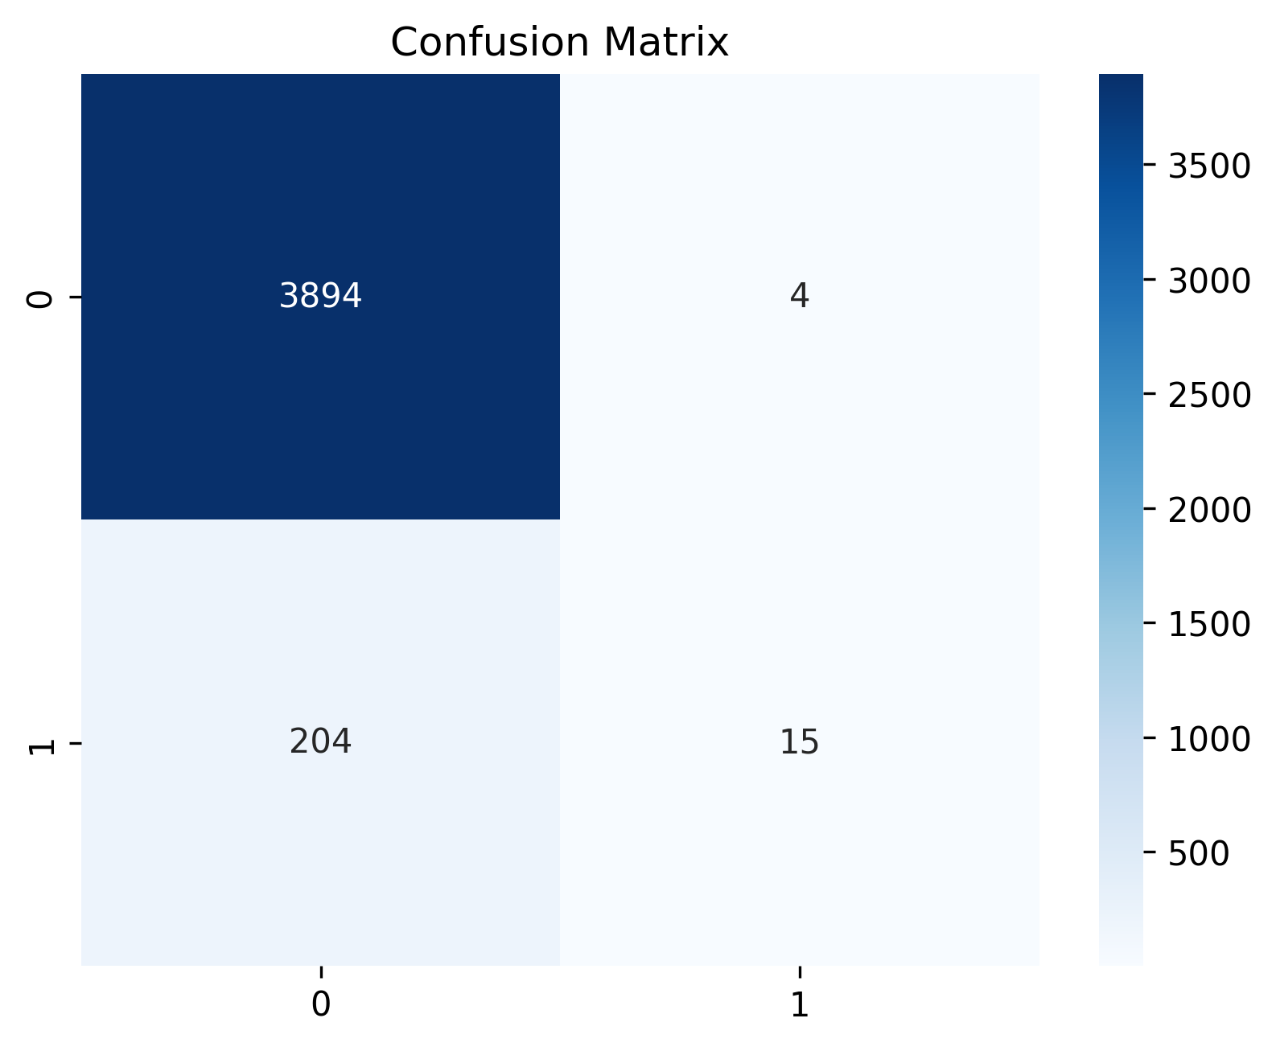

3.4 Why This Is Still Valuable
In real life, operators don’t want constant false alarms. This system provides reliable alerts even if it misses some attacks. It’s better to have fewer, more trustworthy warnings than too many false ones.

4. Part 2 – Securing Industrial IoT Systems

4.1 The Need for Trust
Industrial IoT (IIoT) is like a busy city where every machine constantly communicates. Messages flow nonstop: a robot arm reports it has placed a part, a conveyor belt replies it is ready. If one fake message enters, it can stop the chain. That’s why trust is essential.

4.2 Our Approach (Simplified Steps)
We built a trust pipeline:
1. Sealing messages, like stamping an envelope.
2. Verifying the stamp before entry.
3. Analyzing connections like a social network.
4. Allowing only safe, verified messages.

4.3 Edge and Cloud Work
The system splits work: the Edge (near machines) does quick checks, like a guard at a factory gate. The Cloud does big-picture analysis, like headquarters. Together, they balance speed and scale.

4.4 Outcome
Every message is double-checked. Suspicious activity is blocked. The system adapts and improves with new data, scaling easily from one site to many.

Prediction anomalies
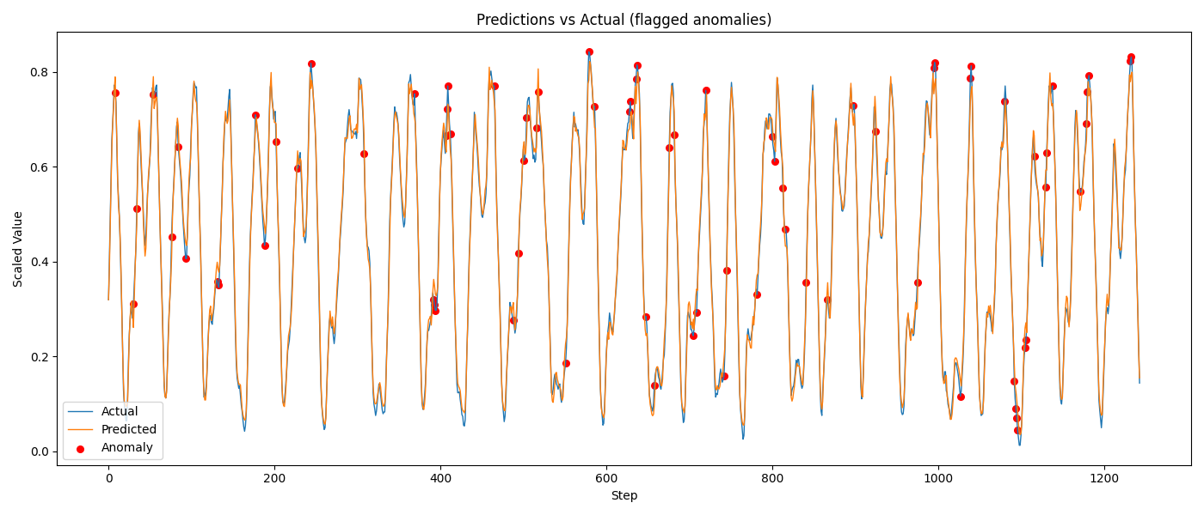

ROC Curve
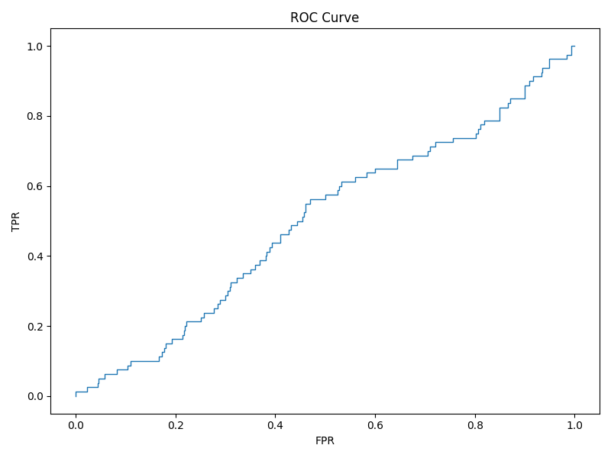

Trust Scores
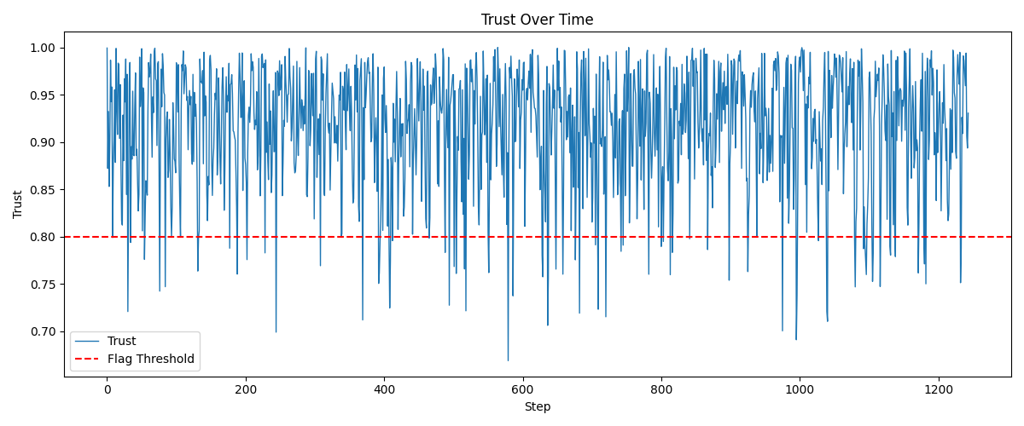

5. Benefits of Combining Both Approaches
Together, the two solutions form a double shield: anomaly detection spots strange behaviors, while trust verification ensures only safe data is accepted. This protects systems from both unexpected errors and deliberate attacks.

6. Challenges Faced
The water system detector sometimes misses attacks. The IoT trust system requires heavy cryptographic checks. Overall, balancing security, cost, and speed remains challenging.

7. Real-Life Scenarios
In a water plant, if a pump suddenly pumps twice the usual amount, the anomaly detector alerts. In a factory, if a machine sends a fake message, the trust system blocks it. In smart cities, if traffic signals send wrong timing, both systems prevent problems.

8. Future Improvements
We plan to improve recall in water anomaly detection, make cryptographic checks faster, extend the system to healthcare and finance, and build dashboards for operators to see alerts in real-time.

9. Conclusion
This project shows how anomaly detection and trust verification together protect critical systems. They make operations safer, smarter, and more trustworthy. From water plants to smart factories, these solutions safeguard the backbone of modern life.

