Function DATE_PICKER – Calendar using standard DBL or UI_Toolkit

This function presents a Calendar style Synergy window so the user can select a date using the mouse.
The function returns an Alpha field containing the date the user clicked on.
ENTRY = %DATE_PICKER ([Row],[Col],[Region/Format],[Heading],[DefaultDate],[Region],[Value]
This function will work for:
- Traditional DBL style code open (15,o,’TT:’)
- UI_Toolkit style code. xcall u_start
- It does not rely on the Terminal being open or initiated.

This function should build successfully for Synergy versions 8.0 onwards
Screen example:
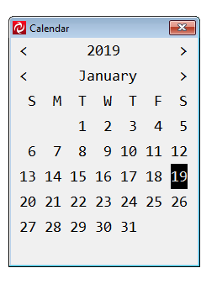
Click on year
for year window

Click on arrow
to advance one year

Click on arrow Click on Month
to previous month for month window

Default date or
Today’s date

This function only works on Windows as it requires mouse capability.
The simplest form of coding is: My_Date = %Date_Picker
The programmer can nominate the Calendar placement row and column, however the user can drag the window around within the Synergy container. Sub windows are anchored to the main Calendar window.
The user can navigate the “year” and the “month” by clicking on left “<” and right “>” arrows or by clicking on the actual year or month displayed when they will be presented with further selection windows. The year and month windows are anchored to the Calendar window.
The programmer can nominate the start/default date the calendar lands on with the default day highlighted or alternatively the function will automatically land on the current date if default not passed as parameter. The user can press Enter to select the highlighted date or click on any other day in the month presented or navigate to another year or month.
The programmer can nominate regional date formats as well as the format of the returned alpha value.

Default settings return the Alpha field containing the date in YYYYMMDD format.
The regional and formatting options are:

Setting Action Example
Y or Blank Return date in YYYYMMDD format Default setting
Y? Return date in YYYY?MM?DD format eg. Y/ YYYY/MM/DD
M Return date in MMDDYYYY format
M? Return date in MM?DD?YYYY format eg. M- MM-DD-YYYY
D Return date in DDMMYYYY format
D? Return date in DD?MM?YYYY format eg D/ DD/MM/YYYY
D~ Return date in DD MM YYYY format eg D~ DD MM YYYY
The ~ character has special meaning in the formatting in that it is translated to a space. It can be used in any of the formats Y~ D~ M~ to place a space as the formatting character between the Year Day and Month values, eg 12 31 2019

All parameters are Optional, they are:

- Placement Row – defaults to row 10
- Placement Column – defaults to col 30
- Regional and Formatting (Y, M, D, Y?, M?, D?) – defaults to Y
- Heading to put on top of Calendar – defaults to “Calendar”
- Default Date for Calendar to land on - defaults to today
- Default Date Format (Y, M, D) – defaults to Y
- Returned date in numeric format always as YYYYMMDD

Exit and Error states are returned in the Alpha value and also in parameter 7 if it is passed.

The returned values are:
Condition Alpha Parameter 7 Value
Exit Button “O_EXIT” -1
ESC Key “ESC” -2
Exit Click on X “EXIT” -3
Timeout “TIMEOUT” -4

There are several .defines in the code to enable standard settings:

Time_Out Time out value in seconds
Default value is 120 (2 minutes)
cannot be 0 or -1,
999 = no time out/forever

Exit_key Value for G_ENTNAM exit value
O_EXIT if using UI_TOOLKIT, can be set programmatically.

Default_iFType Default date format for returned alpha field
Set to Y = YYYYMMDD
Can be modified by parameter 3.

Default_iDType Default date format for incoming DefaultDate parameter
Set to Y = YYYYMMDD
Can be modified by parameter 6.
DATE_PICKER – Pick a date from a Calendar type input.
WT
Date = %DATE_PICKER ([Row],[Col],[Region/Format],[Heading],[DefaultDate],[Region],[Decimal]
Return Value
Date
An alpha field containing the Date selected by the user
Arguments
Row
Optional Placement Row

Col
Optional Placement Column

Region/Format
Optional Date format of incoming Default Date

Heading
Optional Box heading

DefaultDate
Optional Default Date the Calendar lands on

Region
Optional Regional format for returned Date value

Decimal
Optional returned date value in YYYYMMDD format (D8)

Discussion
This function returns the selected date from a Calendar style window
Default settings return the Alpha string containing the date in YYYYMMDD format.
The regional and formatting options are:
Y Return date in YYYYMMDD format Default setting
Y? Return date in YYYY?MM?DD format eg. Y/ YYYY/MM/DD
M Return date in MMDDYYYY format
M? Return date in MM?DD?YYYY format eg. M- MM-DD-YYYY
D Return date in DDMMYYYY format
D? Return date in DD?MM?YYYY format eg D/ DD/MM/YYYY
D~ Return date in DD MM YYYY format eg D~ DD MM YYYY
The ~ character has special meaning in the formatting in that it is translated to a space. It can be used in any of the formats Y~ D~ M~ to put a space as the formatting character between the Year Day and Month values, eg 12 31 2019

Exit and Error states are returned in the Alpha value and also in parameter 7 if it is passed.
The returned values are:
Condition Alpha Decimal
Parameter 7
Exit Button “O_EXIT” -1
ESC Key “ESC” -2
Exit Click on X “EXIT” -3
Timeout “TIMEOUT” -4

Example.

Record
DateStr ,A10
Window_ID ,I4
PROC
OPEN (15,O,’TT:’)
DateStr = %Date_Picker
WRITES (15,DateStr)

or

PROC
xcall u_start( ,,,,24,86)
xcall w_proc (wp_create,window_id,'MAIN',24,86)
xcall w_proc (wp_place,window_id,1,1)
DateStr = %Date_Picker
W_Disp (window_id,wd_writes,DateStr)

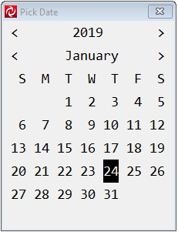
Screen examples.

Standard Screen the user lands on

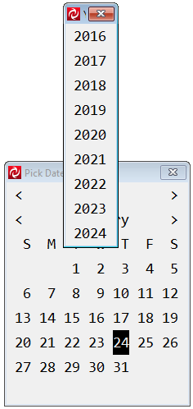

After clicking on the year value
(2019 in above example)

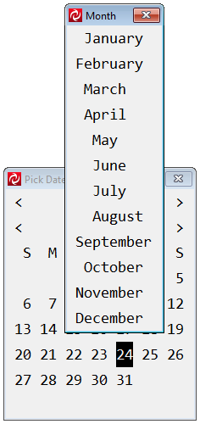

After clicking on the month value
(January in the example above)

