Power up

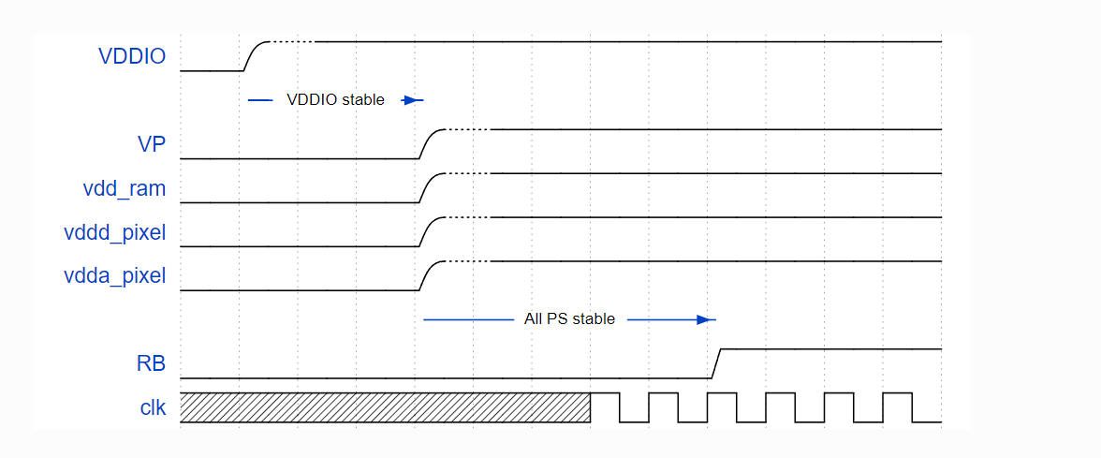
- When all Power Supplies are stable, release RB by setting it to logic ‘1’, with a rise time similar to CLK rise time.

The Top level of speck2, it has 9 cores
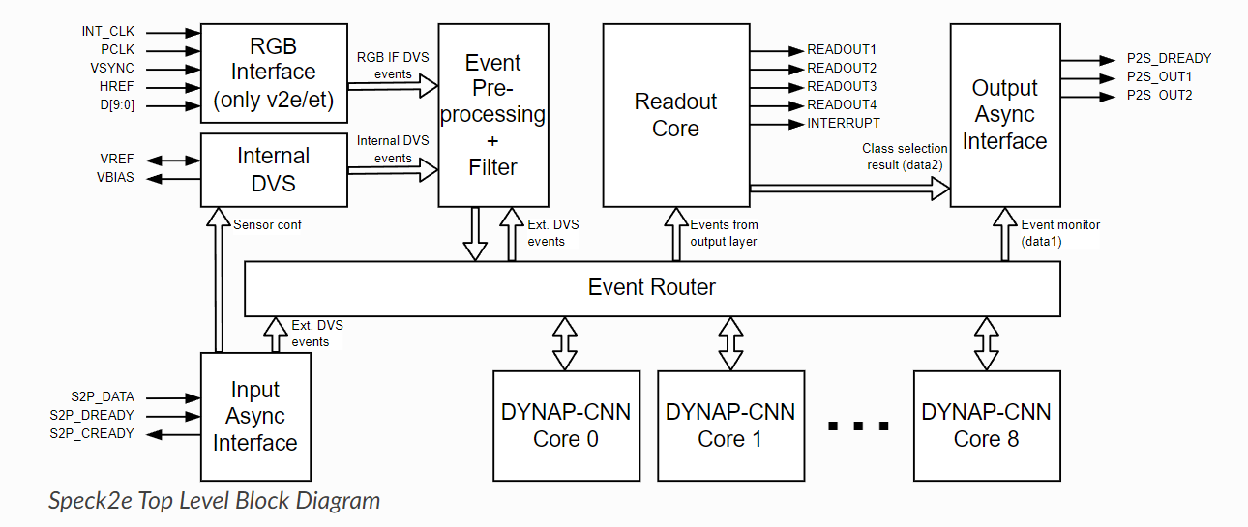
Input 128*128
The DVS Filter Block is included in the DVS pre-processing layer （multi-Parallel Computing）
filter checks the area defined by register bits
The time stamps are recorded using a 16-bit loop counter. Each count is triggered by the internal slow clock

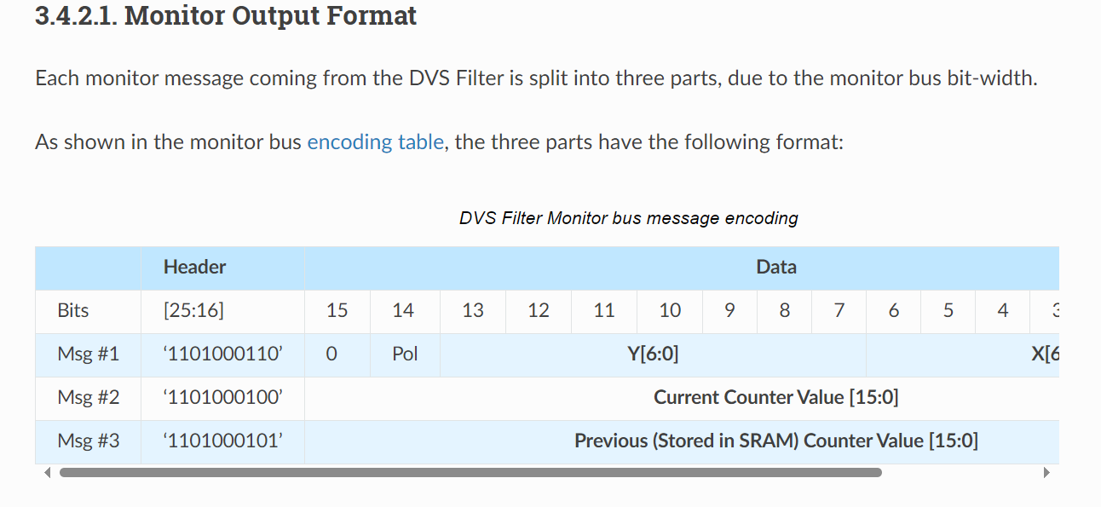

The general features of a convolutional layer：
- Max input dimension: 128x128
- Max feature output: size 64x64
- Max feature number: 1024
- Weight resolution: 8 bit
- Neuron state resolution: 16
- Max kernel size: 16x16
- Stride: {1,2,4,8} independent in X/Y
- Padding: [0..7] independent in X/Y
- Pooling: 1:1, 1:2, 1:4
- Fanout: of 2
- Total SRAM Size 0.98157 MB partioned between the 9 layers

Spi master and spi slave
- GPIO7 to GPIO10 pins are used for SPI Master pins always during the power-up. After download is finished, these pins are configured via the register setting in IOSEL[6:5] bits.
- GPIO11 to GPIO14 pins state during power-up is defined by ModeSel pin state. If it is connected to “high”, these pins are powered up as READOUT signals otherwise they can be used for SPI slave pins
- The states of GPIO11 to GPIO14 after download from external memory is complete is defined by IOSEL[4:3] register setting”

Internal DVS Sensor每个像素输出脉冲后，不应期

操作读取
In Speck2e, all internal SRAMs can be directly read/written only through the SPI and JTAG interfaces.

Spi master can directly access Sram through spi slave.

The JTAG interface for debugging and testing purposes.

Summary：
128*128的DVS相机捕捉事件。Speck芯片：事件经过预处理层，卷积层Noise filter and hot pixel rejection.，读取层 固定事件窗口均值针对最多15个神经元进行计算。提供这15个神经元的移动平均值中的最大值。阈值比较。过滤、平滑处理和阈值检测。（寄存器存储各种状态）（比较边缘的芯片）

Ps： 事件是x,y,polarity, 16-bit loop counter counter计时， 功能关闭。一次dma满记录id，嵌入式平台
Spi salve直接调用srams，桥接模式。flesh-spi master-stm32 register
芯片部分功能
最终的event stream 格式类型
Rgb inference
Jtag调试

• 使用ARM指令优化矩阵操作：
- 代码中使用了多种ARM的内联汇编指令（如__qadd8, __qadd16, __qadd, __sadd8, __sadd16, __ssub8, __ssub16, __qsub8, __qsub16, __qsub），这些指令用于实现快速的饱和加法和减法操作。这些操作在处理向量化数据（如8位、16位、32位整数）时特别高效，因为它们利用了ARM Cortex-M4处理器的DSP扩展。
• 位操作优化：
- 代码中的bin_int8和int8_bin函数利用位操作来实现8位数据和32位数据之间的转换。这种转换在某些矩阵运算中可以减少计算复杂度，提升执行速度。
- set_bit和get_bit函数通过位操作来设置和获取矩阵中的单个位。这些操作对于处理二进制矩阵数据非常高效。
• 查找表优化：
- 在汉明距离计算中，代码使用了查找表(ham_weight_lookup)来快速计算汉明重量。通过查找表预计算结果，可以大幅减少实际计算时的运算量，提升性能。
• 内存访问优化：
- 代码中通过直接访问矩阵数据指针(uint32_t* data = (uint32_t*) m->data)来进行矩阵操作，这种方法比通过高级语言的数组访问方式更高效，因为它减少了中间步骤和不必要的检查。
• 浮点运算优化：
- 在计算正弦和余弦函数时，代码使用了硬件支持的sinf函数，这些函数在浮点计算时可以提供较好的性能。

