Beyond Graph Scale: Auditing Size Confounding and Retained-Observation Robustness in Campaign Classification
Suryansh Singh  Department of Computer Science and Engineering  (Data Science)  Manipal Institute of Technology, Bengaluru, India  Reg. No. 245816214 | Devansh Kewlani  Department of Computer Science and Engineering  (Data Science)  Manipal Institute of Technology, Bengaluru, India  Reg. No. 245816052

Abstract—Benchmarks for detecting coordinated social-media campaigns usually report how well classifiers separate campaign events from organic trends, but they rarely check whether that separation depends on a nuisance property of the data. This paper audits the LEN-Small benchmark of Twitter engagement graphs for one such property, graph size. After a SHA-256 audit of the distributed archive, which contained 104 files including one byte-identical duplicate, the canonical cohort has 103 event graphs: 52 campaign and 51 comparison. Comparison graphs are much larger, with a median of 3,227 nodes against 506. A logistic regression given only the logarithm of the node count reaches a balanced accuracy of 0.874 (95% bootstrap interval 0.805 to 0.932) under event-level five-fold cross-validation, close to the 0.923 of a model that uses all scale, structural and content features. In an exploratory analysis of 16 pairs matched on log node count, which reduced the absolute standardized mean difference from 2.24 to 0.10, the scale model falls to 0.594 while content (0.750) and structural (0.688) features stay above chance, with wide intervals. When only 250, 500 or 1000 sampled edges per event are observed, models retrained on those views with all twelve features keep a balanced accuracy of at least 0.906, while frozen full-graph structural models score 0.598, 0.725 and 0.746, below the 0.757 to 0.784 they reach on the complete graphs of the same events. Because the two conditions use different feature sets, the gap between them is not attributed to retraining alone. Unadjusted accuracy on LEN-Small therefore largely reflects graph scale, and size-controlled, observation-aware results should be reported alongside it.
Keywords—coordinated campaigns, graph classification, benchmark validity, confounding, standardized mean difference, caliper matching, edge sampling, Twitter

Introduction
Coordinated inauthentic campaigns, such as organized efforts to push a hashtag into a platform's trending list, are commonly studied as engagement graphs: users are nodes and retweets, replies or quotes are directed edges. A classifier then labels a whole event graph as a campaign or as an organic trend. The Large Engagement Networks (LEN) benchmark [1] made this task reproducible by releasing labelled Twitter engagement graphs, and subsequent work has proposed graph-learning methods on it [2].
A benchmark score is only meaningful if the classifier is rewarded for the property of interest. In LEN-Small, campaign and comparison events were collected in different ways, so they may differ in ways unrelated to coordination. Graph size is the most obvious candidate: if one class is systematically larger, a model can score well by learning event volume. This is a measurement-validity question. A high score is not wrong, but it may not measure what the benchmark is taken to measure.
This paper addresses three research questions (RQs). RQ1: how much of the achievable accuracy on LEN-Small is reproduced by graph size alone? RQ2: when campaign and comparison graphs are matched on size, do structural and content features still separate the classes? RQ3: how do classifiers behave when only a fixed number of edges per event is observed, both when retrained on such views and when a full-graph model is applied unchanged?
The contributions are: (i) a reproducible audit of the distributed LEN-Small archive, including a duplicate graph and the resulting canonical cohort; (ii) evidence that a one-feature size baseline nearly matches the strongest feature-rich model; (iii) an exploratory size-matched sensitivity analysis with explicit balance diagnostics; and (iv) an edge-budget protocol that separates retraining on restricted views from transfer of a frozen full-graph model, with a fold-aligned frozen-model evaluation that corrects an earlier leakage error. The unit of analysis throughout is the event graph; no claims are made about individual accounts, bots or intent.

Related Work
Gopalakrishnan et al. [1] introduced LEN, a collection of Twitter engagement networks for classifying coordinated campaigns versus organic trends, together with LEN-Small, a reduced balanced subset distributed through the project's repository [3], and benchmarked graph classification methods on them. In follow-up work the same group proposed density-aware random walks for coordinated campaign detection [2]. The present study proposes no new detector and does not re-evaluate those models. It examines whether the benchmark's label signal is entangled with graph size, a factor that any model consuming size-dependent statistics can exploit.
The size-control analysis borrows from observational-study methodology, where matching on a confounder and checking covariate balance with the standardized mean difference (SMD) is standard practice [4], [5], and an absolute SMD of about 0.1 or less is commonly read as adequate balance [4]. Confidence intervals use the percentile bootstrap [6]. Models and graph statistics are implemented with scikit-learn [7] and NetworkX [8].

Dataset and Audit

Source and Unit of Analysis
The analysis uses the LEN-Small archive available to this project, which stores each event as a NetworkX node-link JSON file. Nodes are user accounts. Edges are directed engagement interactions carrying message text, a timestamp and an interaction count. The unit of analysis is one event graph with a binary label: campaign (1) or comparison, that is, organic trend (0). The archive contains no separate label file. Labels are taken from the file-name tokens _campaign_ and _noncampaign_, and ingestion stops with an error if a file carries neither. During ingestion, the embedding vectors attached to nodes and edges are discarded; only topology, message text, timestamps and interaction counts are kept, so no pretrained representation can enter the features.

Duplicate Audit and Canonical Cohort
The archive contains 104 JSON graph files. Ingestion computes a SHA-256 digest of every file before parsing it. Two files share a digest: two copies of the #SesimiziDuyanVarMı campaign graph (25,726,396 bytes) whose file names differ only in the Turkish dotless "ı" versus the ASCII "i". A name-based check would therefore count them as two events. One copy is retained after Unicode (NFC) normalization of file names, and the drop is logged. Keeping both would have counted one campaign twice. Because the copies are identical, under cross-validation one copy could also land in a training fold while the other is tested, so a model would be scored on an event it had already seen. The canonical cohort has 103 events: 52 campaign and 51 comparison. An automated validation step confirms these counts and checks that no graph is empty, that edge records are unique and that every event has message text. The 103 graphs contain 288,540 edges.
The dataset documentation [3] describes LEN-Small as 100 graphs (51 campaign and 49 non-campaign). The archive analysed here contains 104 files. The cause of this difference could not be determined from the available artifacts, and all results refer to the 103-event canonical cohort.

Graph-Size Imbalance
Table I and Fig. 1 summarize graph size by class. Comparison graphs are several times larger than campaign graphs in both nodes and edges, and their interquartile ranges barely overlap. On the log node count, the signed SMD between campaign and comparison events is -2.24. This is a separation of more than two pooled standard deviations, far larger than the imbalance usually tolerated in matched comparisons [4].
TABLE I. Graph Size by Class (N = 103)
Class | n | Nodes, median [IQR] | Nodes, mean | Edges, median [IQR] | Edges, mean
Campaign | 52 | 506 [273–824] | 662.2 | 1,078 [776–1,548] | 1,295.8
Comparison | 51 | 3,227 [1,622–4,916] | 3,479.2 | 3,769 [1,799–6,595] | 4,336.4

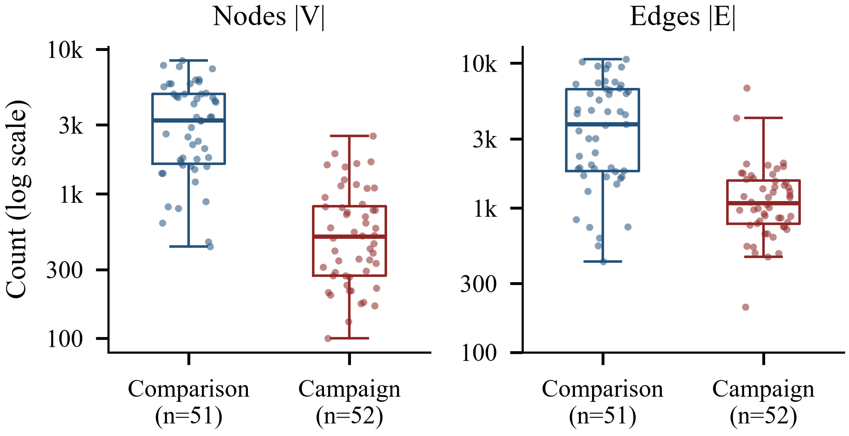
Fig. 1. Distribution of event-graph size by class on a logarithmic axis. Left: node count; right: edge count. Boxes show the interquartile range and median; points are individual events (comparison n = 51, campaign n = 52).

Methodology

Feature Groups
Features are computed per event graph G = (V, E). All are graph- or event-level summaries; no account identifiers, usernames or embeddings are used. The scale group consists of two log-transformed counts,
$$\begin{aligned}x_{N}=\ln\left(1+\left|V\right|\right), x_{E}=\ln\left(1+\left|E\right|\right)\#\left(1\right)\end{aligned}$$
The structural group contains seven statistics of the directed graph: density |E| / (|V|(|V| − 1)); reciprocity, the fraction of edges whose reverse edge is also present; the fraction of nodes in the largest weakly connected component; the Gini coefficients of the in-degree and of the out-degree distribution; and the median and maximum core number, computed on the undirected projection. For a non-negative vector x sorted so that x₍₁₎ ≤ … ≤ x_{(n)}, the Gini coefficient is
$$\begin{aligned}G\left(x\right)=\frac{2\sum_{i=1}^{n}{i x_{\left(i\right)}}-\left(n+1\right)\sum_{i=1}^{n}{x_{\left(i\right)}}}{n\sum_{i=1}^{n}{x_{\left(i\right)}}}\#\left(2\right)\end{aligned}$$
The content group contains three statistics of message text that has been lower-cased, stripped of URLs and whitespace-normalized. With T the multiset of cleaned messages and U its distinct messages, they are the exact-duplicate fraction 1 − |U|/|T|, the Gini coefficient (2) of the message frequency counts, and the sample standard deviation of whitespace token counts. The combined group contains all twelve features.
Timestamps are present on all 288,540 edges, but temporal features are disabled in the experiment configuration because the semantics of the timestamps (for example, interaction time versus collection time) had not been verified. No temporal information enters any reported model.

Models
Two classifiers are evaluated: logistic regression (LR) and histogram-based gradient-boosted trees (HGBT) [7]. The LR pipeline applies median imputation, standardization and L2-regularized logistic regression with balanced class weights. Its regularization strength C ∈ {0.01, 0.1, 1, 10} is selected by an inner three-fold stratified cross-validation on the training fold only, scoring balanced accuracy. HGBT uses fixed hyperparameters (100 iterations, maximum depth 4, balanced class weights) without tuning. Predictions use a 0.5 probability threshold. Experiment A trains both models on each feature group. Experiment B adds two scale-only baselines: B0a uses the log node count alone and B0b uses the log node and log edge counts. B0b has the same features as the scale group of Experiment A, and their results are identical.

Evaluation Protocol and Uncertainty
All experiments use stratified five-fold cross-validation at the event level (seed 42). Every event is predicted exactly once, by a model that did not see it in training. Imputation, scaling and hyperparameter selection are fitted inside each training fold. When an event has several sampled views (Section IV-E), all views of the event are assigned to that event's fold, and a unit test checks this property. The reported metrics are balanced accuracy (BA, the mean of the two class recalls), macro-F1, per-class recall and the area under the ROC curve (ROC-AUC), computed on the pooled out-of-fold predictions.
The 95% confidence intervals are percentile-bootstrap intervals [6] over events: 1,000 resamples (seed 7) of the fixed out-of-fold predictions. They describe the sampling variability of the evaluated events only. They do not account for the variability of refitting the models, for the particular fold split, for the dependence between matched pairs or for the dependence between events that share accounts; in this archive, 92.7% of accounts appear in more than one event. The intervals should therefore be read as approximate and are probably too narrow.

Size-Matched Cohort
To test whether non-scale features carry signal once size is controlled (RQ2), a cohort is matched on the log node count x_{N}. Campaign events are visited in a seeded random order (seed 42), and each is paired with the nearest unmatched comparison event if their difference lies within a caliper of 0.25 standard deviations of x_{N} over the full cohort (0.2859). Matching is one-to-one without replacement. Balance is measured with
$$\begin{aligned}\text{SMD}=\frac{{\overline{x}}_{\text{camp}}-{\overline{x}}_{\text{comp}}}{\sqrt{\frac{s_{\text{camp}}^{2}+s_{\text{comp}}^{2}}{2}}}\#\left(3\right)\end{aligned}$$
where the means and sample variances are taken within each class. Signed values are campaign minus comparison, so negative values mean that campaigns are smaller; the absolute value |SMD| is reported as the balance diagnostic. The models of Experiment A are re-run on the matched cohort (Experiment C) with a new stratified five-fold split of its events.

Restricted Edge-Observation Protocol
To study partial observation (RQ3), each eligible event is reduced to K ∈ {250, 500, 1000} edges sampled uniformly without replacement, with ten sampling seeds (100 to 109) per budget. An event is eligible for budget K if it has at least K edges. All features are recomputed from scratch on every sampled view, so full-graph counts never enter the views. For each budget, a stratified five-fold split of the eligible events is created. Two conditions are evaluated.
- D2 (retrained): an LR model is trained and tested on sampled views using all twelve features recomputed from the views, separately for each seed. The out-of-fold probabilities are averaged over the ten seeds per event before thresholding, which keeps the effective sample size at the number of events rather than the number of views.
- D1 (frozen): the five structural-group LR models fitted on full graphs in Experiment A are applied unchanged to the seven structural features of the sampled views. Each sampled event is scored only by the fold model whose full-cohort training fold excluded that event, so no frozen model scores a graph it was trained on. Probabilities are again averaged over seeds per event.
The two conditions therefore differ in feature set as well as in training regime: D2 uses all twelve features and D1 only the seven structural features. The D1 and D2 results are consequently not a controlled test of retraining, and their difference cannot be attributed to the training regime alone. As a reference for D1, the same frozen models are also scored on the complete graphs of each budget's eligible events. A budget is feasible only if five-fold stratified cross-validation can place an event of each class in every fold, which requires at least five eligible events per class. K = 2000 fails this condition and is excluded (Table IV). It marks the boundary of budgets this cohort can support rather than a failed experiment.

Experimental Results

Full Cohort: Scale Alone Nearly Matches All Features
Fig. 2 and Table II report the full-cohort results (RQ1). The log node count alone gives LR a BA of 0.874 [0.805, 0.932] and a ROC-AUC of 0.934; adding the log edge count gives 0.884. Using all twelve features raises BA to 0.923 [0.867, 0.971], an increase of 0.049 over the node-only baseline with substantially overlapping intervals. Structural (0.778) and content (0.787) features alone score below the size baseline. HGBT shows a similar pattern: its combined model reaches 0.932 against 0.845 for the log node count alone. In plain terms, most of the accuracy achievable on the full cohort can be reached by knowing how large each event graph is.
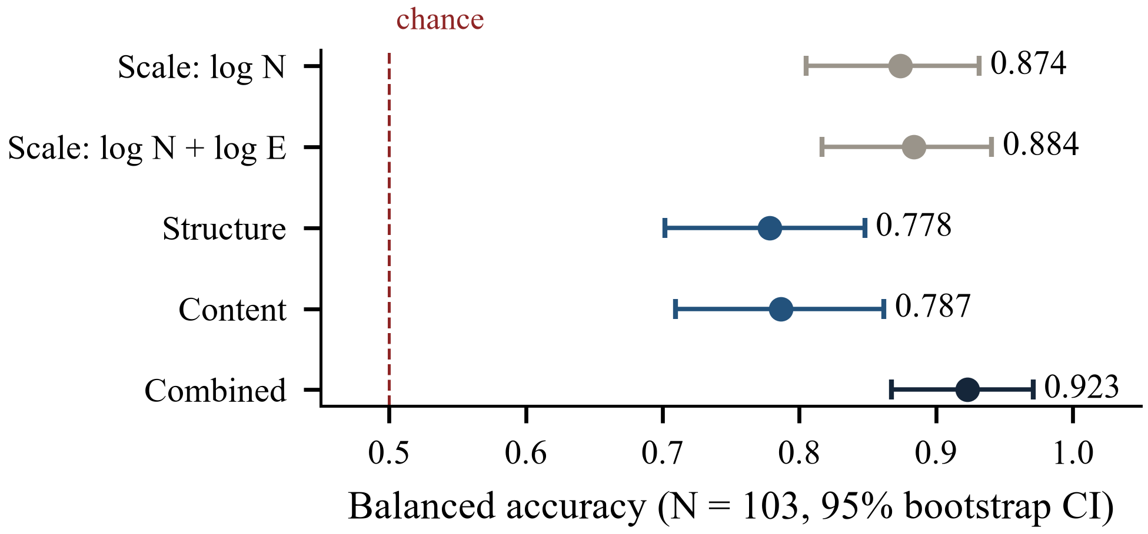
Fig. 2. Full-cohort balanced accuracy of logistic regression for each feature set (N = 103 events, out-of-fold, five-fold cross-validation). Error bars are 95% percentile-bootstrap intervals; the dashed line marks chance (0.5).
TABLE II. Full-Cohort Results (N = 103)
Features | Model | BA [95% CI] | Macro-F1 | ROC-AUC
log N | LR | 0.874 [0.805, 0.932] | 0.874 | 0.934
log N + log E | LR | 0.884 [0.817, 0.941] | 0.883 | 0.931
Structure | LR | 0.778 [0.702, 0.848] | 0.770 | 0.846
Content | LR | 0.787 [0.710, 0.862] | 0.786 | 0.859
Combined | LR | 0.923 [0.867, 0.971] | 0.922 | 0.986
log N | HGBT | 0.845 [0.768, 0.908] | 0.845 | 0.902
log N + log E | HGBT | 0.816 [0.733, 0.883] | 0.816 | 0.913
Structure | HGBT | 0.864 [0.793, 0.922] | 0.864 | 0.930
Content | HGBT | 0.796 [0.712, 0.865] | 0.796 | 0.862
Combined | HGBT | 0.932 [0.882, 0.977] | 0.932 | 0.958

Size-Matched Cohort
Matching retained 16 campaign–comparison pairs (32 events) and excluded 71 events whose sizes had no partner within the caliper. Table III shows that matching removed the imbalance on the matched variable: the signed SMD moved from -2.2374 to -0.0954 (|SMD| 2.24 to 0.10), and the class means of the log node count moved from 6.21 versus 7.92 to 6.98 versus 7.03.
On the matched cohort, the LR scale model (log node and log edge counts) falls from 0.884 on the full cohort to 0.594 [0.417, 0.753], an interval that includes chance. Content features reach 0.750 [0.598, 0.906] and structural features 0.688 [0.524, 0.857]; the combined model also reaches 0.750 (Fig. 3). These estimates suggest that some non-scale signal remains once size is balanced. With 32 events, however, every interval is wide, the structural interval nearly reaches chance, and the content and structural intervals overlap the scale interval. The HGBT models failed on this small cohort: in every feature group they predicted the campaign class for all events (BA 0.500). With about 25 training events per fold and the library's default minimum leaf size of 20 samples, the trees could not split, so the matched HGBT numbers are not interpreted.
TABLE III. Size-Matched Cohort: Balance and LR Results
Quantity | Full cohort | Matched cohort
Events (campaign / comparison) | 103 (52 / 51) | 32 (16 / 16)
Mean log node count, campaign / comparison | 6.21 / 7.92 | 6.98 / 7.03
Signed SMD (|SMD|) | -2.2374 (2.24) | -0.0954 (0.10)
BA, scale (log N + log E) | 0.884 [0.817, 0.941] | 0.594 [0.417, 0.753]
BA, structure | 0.778 [0.702, 0.848] | 0.688 [0.524, 0.857]
BA, content | 0.787 [0.710, 0.862] | 0.750 [0.598, 0.906]
BA, combined | 0.923 [0.867, 0.971] | 0.750 [0.592, 0.906]

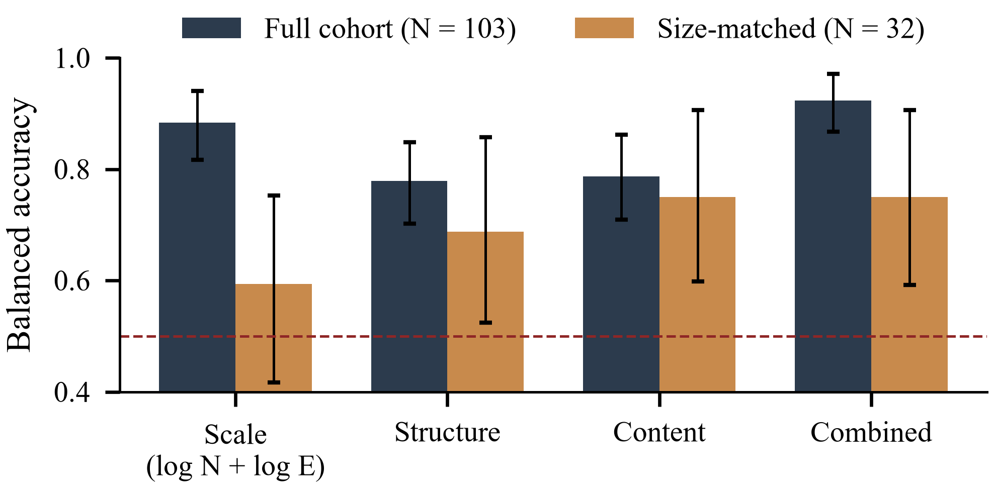
Fig. 3. Balanced accuracy of logistic regression on the full cohort (N = 103) and the size-matched cohort (N = 32) for the same feature groups; the scale group is log N + log E. Error bars are 95% percentile-bootstrap intervals; the dashed line marks chance.

Restricted Edge Observation
Table IV and Fig. 4 report the edge-budget experiments (RQ3). Models retrained on sampled views with all twelve features (D2) stay accurate at every feasible budget, with BA 0.941 at K = 250, 0.938 at K = 500 and 0.906 at K = 1000. The frozen full-graph structural models (D1), with each event scored only by the model that held it out, reach 0.598 [0.505, 0.685] at K = 250, 0.725 [0.639, 0.807] at K = 500 and 0.746 [0.650, 0.842] at K = 1000. On the complete graphs of the same eligible events, the same models score 0.784, 0.782 and 0.757. D1 is therefore well below its complete-graph reference at K = 250 and approaches it as the budget grows. D2 is higher than D1 at every budget, but because the two conditions use different feature sets this gap is not a controlled estimate of the effect of retraining (Section IV-E).
TABLE IV. Edge-Budget Eligibility and Balanced Accuracy [95% CI]
K | Eligible n (camp./comp.) | D2 retrained, 12 features | D1 frozen, 7 structural features | D1 models, complete graphsª
250 | 102 (51/51) | 0.941 [0.894, 0.984] | 0.598 [0.505, 0.685] | 0.784
500 | 98 (48/50) | 0.938 [0.888, 0.980] | 0.725 [0.639, 0.807] | 0.782
1000 | 73 (28/45) | 0.906 [0.829, 0.970] | 0.746 [0.650, 0.842] | 0.757
2000 | 36 (4/32) | infeasible | infeasible | —
ª Same frozen models and same eligible events, scored on complete graphs.
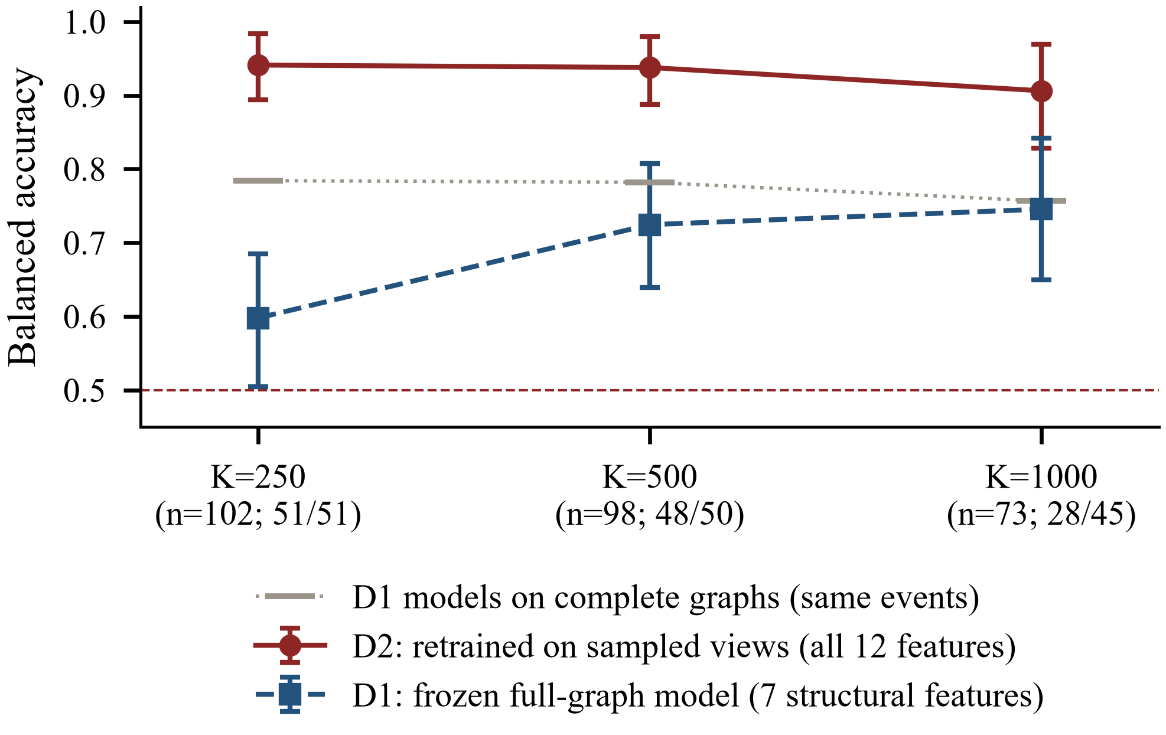
Fig. 4. Balanced accuracy under edge budgets K. D2: logistic regression retrained on views of K sampled edges using all twelve features. D1: full-graph structural logistic regression (seven features) applied without retraining, each event scored only by the fold model that held it out. Grey marks: the same D1 models on the complete graphs of the same events. Ten sampling seeds are averaged per event; axis labels give eligible events n (campaign/comparison). Error bars are 95% bootstrap intervals.

Discussion

What the Results Support
The full-cohort results support a narrow but practically important conclusion. On LEN-Small, a reported classification score cannot be read as evidence of detecting coordination unless it is compared with a size-only baseline. One logarithm of the node count achieves 0.874 BA, and the best feature-rich LR model improves on it by less than the width of either confidence interval. The confound has a plausible origin in how events were gathered: comparison events are broad national trends with thousands of participants, while campaigns are focused hashtag pushes. Any model whose inputs vary with graph size, which includes many unnormalized structural statistics, can exploit that difference.
The matched analysis is consistent with structural and content features carrying some information beyond size: the scale model drops to chance while content and structure stay above it. This is treated as exploratory sensitivity evidence rather than an estimate of the features' independent value. Matching kept only 32 of 103 events, drawn from the region where the size distributions overlap (the largest campaigns and the smallest comparison events), which may not represent either class. The matched intervals are wide and overlap one another. Matching balances the log node count only; other size-related quantities such as the edge count may remain imbalanced and were not separately diagnosed.
The D2 results show that, on this cohort, a few hundred sampled edges per event suffice for a retrained model to separate the classes. They do not show that the separation comes from coordination. The D2 feature set includes the node count of each sampled view, which still varies with how engagement is spread across users, so part of its accuracy may reflect the same size-related signal.

Transferability Under Restricted Observation
The corrected D1 results indicate that structural statistics computed on complete graphs transfer poorly to sparse observations, and that the loss shrinks as more of each graph is observed. On the same eligible events, the frozen models lose 0.186 BA at K = 250, 0.057 at K = 500 and 0.011 at K = 1000. At K = 500 and K = 1000 the interval of the sampled-view estimate includes the complete-graph value, so only the K = 250 loss is clearly distinguishable from no loss. Density, coreness and component structure change with the sampling rate, so a model calibrated on full graphs receives shifted inputs; at K = 1000 many eligible graphs are only modestly subsampled. A system that observes only part of an engagement graph should therefore be trained, or at least validated, on observations like those it will receive.
D2 exceeds D1 at every budget, but this is not evidence that retraining by itself recovers performance. D2 uses five features that D1 does not, including the log node count of each sampled view, which still carries size-related information. A like-for-like comparison would retrain the structural-group model on sampled views; that condition was not part of the executed protocol, and the present results do not establish a causal explanation for the D1-D2 gap.

What the Results Do Not Establish
The analysis does not show that any model detects coordinated behaviour, malicious accounts or intent. It does not show that size is the only confound, and it does not estimate the causal effect of any feature. It provides no evidence about false-positive rates or about deployment on other platforms, periods or collection procedures.

Threats to Validity and Limitations
Sample size. With 103 events, and 32 after matching, all estimates are imprecise, and small differences between models cannot be distinguished.
Limited overlap. Most events have no size-comparable partner in the other class, so the matched cohort covers a narrow and possibly atypical range of event sizes.
Uncertainty estimates. The bootstrap resamples fixed out-of-fold predictions. It ignores refitting variability, the dependence between matched pairs and the dependence created by accounts shared across events, so the intervals are likely too narrow.
Dataset version. The analysed archive (104 files, 103 unique events) differs from the documented LEN-Small description (100 graphs, 51/49) [3]. The results apply to the archive analysed.
Non-comparable restricted-observation conditions. D1 and D2 differ in both feature set and training regime, so their difference is descriptive rather than a controlled estimate of either factor.
Model scope. Only LR (tuned) and HGBT (untuned) with hand-crafted features were evaluated. Graph neural networks and the methods of [1], [2] were not re-evaluated, and their sensitivity to size may differ.
Temporal information. Temporal features were excluded because timestamp semantics were unverified. Coordination is often a temporal phenomenon, so this audit does not test whether temporal signals survive size control.
Labels. Labels are taken from file names as distributed and were not independently verified.

Reproducibility
The analysis is implemented in Python 3.12 with scikit-learn 1.9.0 [7], NetworkX 3.6.1 [8], pandas 3.0.6 and NumPy 1.26.4. All parameters (feature switches, caliper, budgets, seeds, folds, model grids and bootstrap settings) are read from a single configuration file. The command python run_pipeline.py runs ingestion, validation, matching, edge sampling, training and evaluation in sequence. The test suite (pytest tests/ -v, 17 tests) checks the canonical counts, the presence of SHA-256 digests, the absence of duplicate events, fold consistency of sampled views, sampling determinism and the consistency of the exported results. The tables and figures in this paper are regenerated from the stored predictions and metrics. Fixed seeds are used throughout: matching 42, cross-validation 42, edge sampling 100 to 109 and bootstrap 7. The raw archive is not redistributed; it is available from the LEN project [3].
Correction note. An earlier version of the D1 evaluation assigned each sampled event to a frozen model using the budget-specific fold split instead of the full-cohort split, so 26, 64 and 49 events at K = 250, 500 and 1000 were scored by a model trained on that event's complete graph, inflating D1 to 0.756 and 0.828 at K = 500 and 1000. The D1 values reported here were obtained by refitting the five frozen models, which reproduced the stored out-of-fold predictions exactly, and scoring each event only with the model that held it out (src/reevaluate_d1.py). The training script has been corrected accordingly. D2 and all other experiments were unaffected.

Conclusion and Future Work
On LEN-Small, graph size alone reproduces most of the classification accuracy achieved by richer features. Size-matched and observation-restricted analyses suggest that structural and content signals are not purely artefacts of size, but the evidence is exploratory and uncertain. Work on this benchmark should report a size-only baseline next to every model, report size-controlled results with balance diagnostics, and train on the observation regime it targets. Under restricted observation, frozen full-graph structural models lose most accuracy at the smallest budget, while models retrained on sampled views with all features remain accurate; the two conditions are not like-for-like. Immediate next steps are to add a structural-only retrained condition so that retraining can be assessed directly, to use resampling schemes that respect matched pairs and shared accounts, to verify timestamp semantics so that temporal features can be tested under size control, and to evaluate graph neural network models on the matched and budgeted cohorts.

References
- A. A. Gopalakrishnan, J. Hossain, T. Elmas, and A. E. Sariyüce, "Large engagement networks for classifying coordinated campaigns and organic Twitter trends," in Proc. Int. AAAI Conf. Web and Social Media (ICWSM), vol. 19, no. 1, pp. 688–702, 2025, doi: 10.1609/icwsm.v19i1.35839.
- A. A. Gopalakrishnan, J. Hossain, T. Elmas, and A. E. Sarıyüce, "Density-aware walks for coordinated campaign detection," 2025, arXiv:2506.13912. [Online]. Available: https://arxiv.org/abs/2506.13912
- "LEN: Large Engagement Networks," dataset repository. [Online]. Available: https://erdemub.github.io/large-engagement-network/
- P. C. Austin, "Balance diagnostics for comparing the distribution of baseline covariates between treatment groups in propensity-score matched samples," Statistics in Medicine, vol. 28, no. 25, pp. 3083–3107, 2009, doi: 10.1002/sim.3697.
- E. A. Stuart, "Matching methods for causal inference: A review and a look forward," Statistical Science, vol. 25, no. 1, pp. 1–21, 2010.
- B. Efron and R. J. Tibshirani, An Introduction to the Bootstrap. New York, NY, USA: Chapman & Hall, 1993.
- F. Pedregosa et al., "Scikit-learn: Machine learning in Python," J. Mach. Learn. Res., vol. 12, pp. 2825–2830, 2011.
- A. A. Hagberg, D. A. Schult, and P. J. Swart, "Exploring network structure, dynamics, and function using NetworkX," in Proc. 7th Python in Science Conf. (SciPy), 2008, pp. 11–15.

