This installation document accounts for you using a Windows machine. If you are using a Mac and are unsure how to install Python and VSCode on your Mac, please reach out to me directly.

1. For this learning hack we will be using Python 3.8 ([Install Python](https://www.python.org/ftp/python/3.9.5/python-3.9.5-amd64.exe)). You can technically use any version of python greater than 3.6 but the link in this document will download 3.8 which will work just fine. If you have a version older than 3.6, I recommend uninstalling that version and installing a new version. IMPORTANT!!! Make sure to select “Add Python 3.8 to PATH” in the below screenshot BEFORE clicking “Install Now”.

Having Python installed via Anaconda will not help you in this course. I do not recommend using Anaconda and I will not support issues you may have with it.

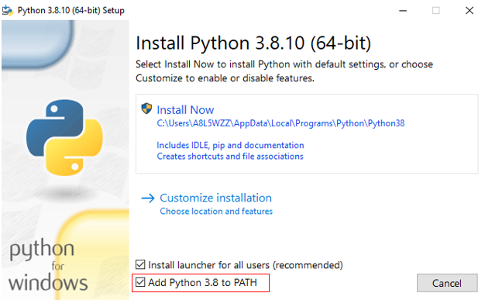

1. After Python installation is complete, open a PowerShell or cmd prompts and type:

python -V

If this command works (and prints out the version of Python installed) like the screenshot below, then Python was installed correctly, and you can move on to the next step. If the command errors with something like *“… command not recognized …”*; did you follow the important part in step 1? (if not, redo step 1), else close all instances of cmd prompt or PowerShell and reopen one to try the above command again. If this still doesn’t work, ping me before the learning hack (aguckenberger@mmm.com).  
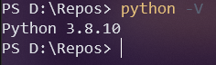

1. Next install [Visual Studio Code](https://code.visualstudio.com/) (hit the big blue button). This is what we will use to code/edit Python files. VS Code is a super powerful lightweight IDE (Integrated Development Environment) which has great functionality for working with any kind of textual file (not just Python files). What you installed in step 1 was Python which handles running Python code, but we need something to work with Python files. Basically, think of VS Code as the Microsoft Word for working with programming files. IMPORTANT!!! Most dialog windows you can just hit “next” on but watch out for the one shown below with a bunch of check boxes. Make sure your checkboxes match my checkboxes shown below. You can also check the “Create a desktop icon” one if you want but it’s not important.

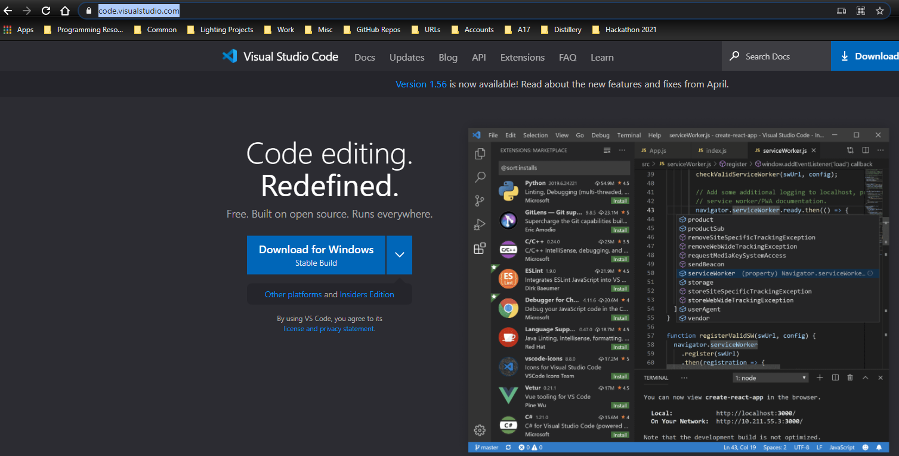

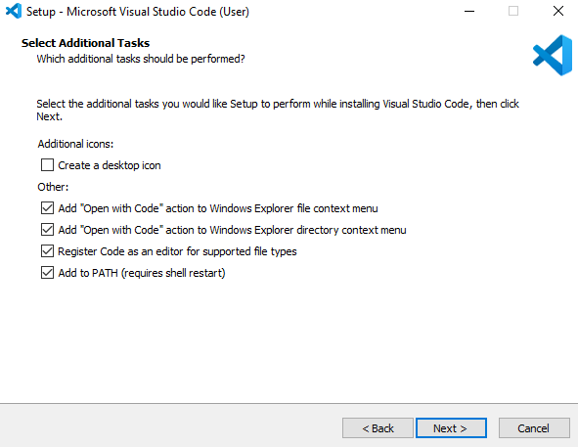

1. Once VS Code is installed, launch it, and add the Python extension (follow the numbers below). This will allow VS Code to recognize and work with Python files and do things like syntax highlighting (think grammar checking for MS Word). When you add the Python extension, a popup may appear on the bottom right saying something like “pylint is not installed, would you like to add it?”, just hit yes on any dialog that pops up when you add the Python extension.

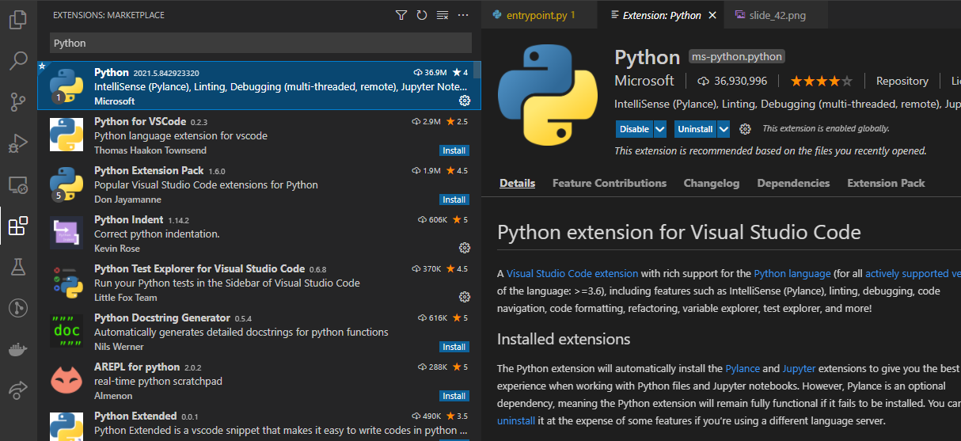

4- Should be an install button here ^

3

2

**1**

If you want a few more useful extensions that may be useful to add:

* Rainbow Brackets

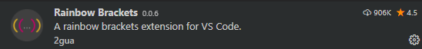

* Python Indent

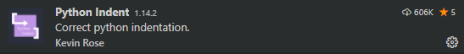

1. With that, you are ready for the learning hack. I will cover more on how to use the IDE during the learning hack. If you had issues with anything in this document feel free to ping me in teams (A8L5WZZ) or shoot me an email ([aguckenberger@mmm.com](mailto:aguckenberger@mmm.com)), but please do so before the learning hack.