
PROJECT REPORT
Company Hierarchy Management System
An Enterprise Employee Hierarchy Management System in Java
Demonstrating OOP, Multithreading, and Serialization Persistence
Submitted by | ANAND MAURYA
Registration No. | 25BAI10039
Course / Subject | AI/ML JAVA

1. Introduction
This report presents the design and implementation of the Company Hierarchy Management System, an enterprise workforce management simulator implemented entirely in Java. The application models hierarchical human resource operations within a modern corporate organization, managing specialized roles—specifically Software Developers, Engineering Managers, and Human Resource Personnel—while executing lifecycle actions such as onboarding, role-specific attributes tracking, performance evaluations, multithreaded salary adjustments, and persistent storage.
I selected this domain because corporate workforce modeling provides an ideal, authentic scenario for exercising the core tenets of Object-Oriented Programming (OOP) alongside advanced Java platform capabilities. Rather than remaining theoretical textbook constructs, concepts such as inheritance hierarchies, dynamic method dispatch (runtime polymorphism), data encapsulation, and collection manipulation become essential building blocks required to satisfy realistic business logic.
The entire project is built using pure Java (Standard Edition) without requiring external frameworks, third-party libraries, or database engines. The program features an interactive, menu-driven Command-Line Interface (CLI) that enables administrators to manage staff records in real time. In addition, the system integrates modern Java paradigms including lambda expressions for flexible data sorting, multithreading for asynchronous background execution of salary increments, and native Java Object Serialization for automatic data persistence across sessions.

2. Problem Statement
In contemporary business environments, maintaining accurate employee records, hierarchical role relationships, and payroll information using paper ledgers or disorganized spreadsheets introduces severe operational overhead. Disparate employee categories require tracking distinct attributes—such as programming language stacks for Developers or team headcounts for Managers—which simple flat tables fail to capture cleanly.
Furthermore, computing organization-wide annual salary increments and performance appraisals manually across large staff registries is computationally tedious and prone to human calculation error. If done synchronously in single-threaded software, long-running batch payroll computations freeze user interaction, degrading usability. Finally, typical introductory console applications lose in-memory state upon termination, requiring administrators to re-enter personnel data every time the program restarts.
The problem addressed by this project is to create an integrated, robust, and extensible Java console application that coordinates workforce records into a cohesive object-oriented hierarchy. Specifically, the system must guarantee that:
• Specialized roles inherit shared employee characteristics while encapsulating distinctive domain attributes.
• Bulk salary adjustments run asynchronously on an independent background thread, preventing blocking of administrative terminal interactions.
• Salary increments scale dynamically based on standardized employee performance ratings (1 to 5 stars).
• All active employee entities are serialized automatically to disk upon graceful exit and deserialized seamlessly on next boot.

3. Functional Requirements
The system fulfills eleven concrete operational capabilities accessible through an interactive numeric menu:
• Add Developer — Capture employee name, starting base salary, department name, and specialized programming language stack.
• Add Manager — Capture employee name, salary, department name, and size of the managed team.
• Add HR Personnel — Capture standard employee details and assign them directly to the Human Resources organizational unit.
• Automatic Employee ID Generation — Generate unique, sequential identification numbers starting automatically from 1000 without requiring manual administrative entry.
• Display All Employees — Iterate through the organizational roster and polymorphically render common employee metrics alongside role-specific specialized fields.
• Remove Employee — Delete an employee record by Unique ID using safe fail-fast iteration to prevent collection corruption.
• Update Employee Information — Modify employee name and departmental assignment dynamically based on employee ID.
• Sort by Salary (Descending) — Sort in-memory records using lambda expressions to order all personnel from highest to lowest compensation.
• Departmental Filtering — Filter and display all employees matching a requested department name, ignoring case sensitivity.
• Performance Appraisal Rating — Assign an appraisal score from 1 (lowest) to 5 (highest) to any designated employee.
• Multithreaded Salary Processing — Spawn an asynchronous background worker thread that computes tier-based salary increases (10% for ratings >= 4, 5% otherwise) across all registered employees.
• Data Persistence & Auto-Recovery — Serialize the entire collection into binary file storage (employees.dat) on exit, and load previous records on launch.

4. Non-functional Requirements
The non-functional dimensions govern the robustness, performance, and code quality of the application:
• Usability — Clear numeric menu navigation with self-descriptive input prompts and structured delimiter headers for easy terminal scanning.
• Robustness & Fault Tolerance — Graceful handling of missing serialization files during the initial cold run without application crash, safe iterator removal preventing ConcurrentModificationException, and validation of IDs.
• Portability — Engineered in 100% standard Java with zero external third-party dependencies, allowing instantaneous compilation and execution across Windows, Linux, and macOS platforms.
• Maintainability & Extensibility — Strict adherence to Object-Oriented design principles; adding a new employee type (e.g., QAEngineer or Executive) simply requires subclassing Employee without altering core Company logic.
• Concurrency & Performance — Decoupled background salary processing through multithreading ensures immediate menu responsiveness, while in-memory ArrayList indexing delivers near-instantaneous search and sort operations.

5. System Architecture
The Company Hierarchy Management System adheres to a clean, modular multi-tiered architecture that strictly separates user interaction, business service orchestration, entity domain models, and data persistence layers:
• Presentation Layer (Main.java) — Houses the interactive console loop, user input parsing via Scanner, terminal formatting, and top-level action dispatching.
• Service & Controller Layer (Company.java) — Acts as the central management engine maintaining the primary ArrayList<Employee> collection. Coordinates CRUD operations, sorting algorithms, departmental query filters, thread initialization, and I/O file streams.
• Domain Entity Layer (Employee, Developer, Manager, HR) — Defines the object hierarchy. The base Employee class encapsulates shared fields (ID, name, salary, department, rating) and implements java.io.Serializable. Subclasses extend base behavior with role-specific state and overridden display methods.
• Concurrency Layer (Worker Thread) — Decouples computationally demanding batch salary updates by spawning an independent background thread utilizing lambda Runnable syntax.
• Persistence Layer (Object Serialization) — Employs ObjectOutputStream and ObjectInputStream to write and recover object graphs directly to and from employees.dat.

6. Design Diagrams
The system architecture and interactions are visualized below across four core design diagrams covering actors, execution workflows, runtime messaging sequences, class relationships, and relational data mappings.

6.1 Use Case Diagram
The use case diagram illustrates the primary human actor—the Corporate Administrator or HR Manager—interacting with the eleven distinct system features provided by the console environment.
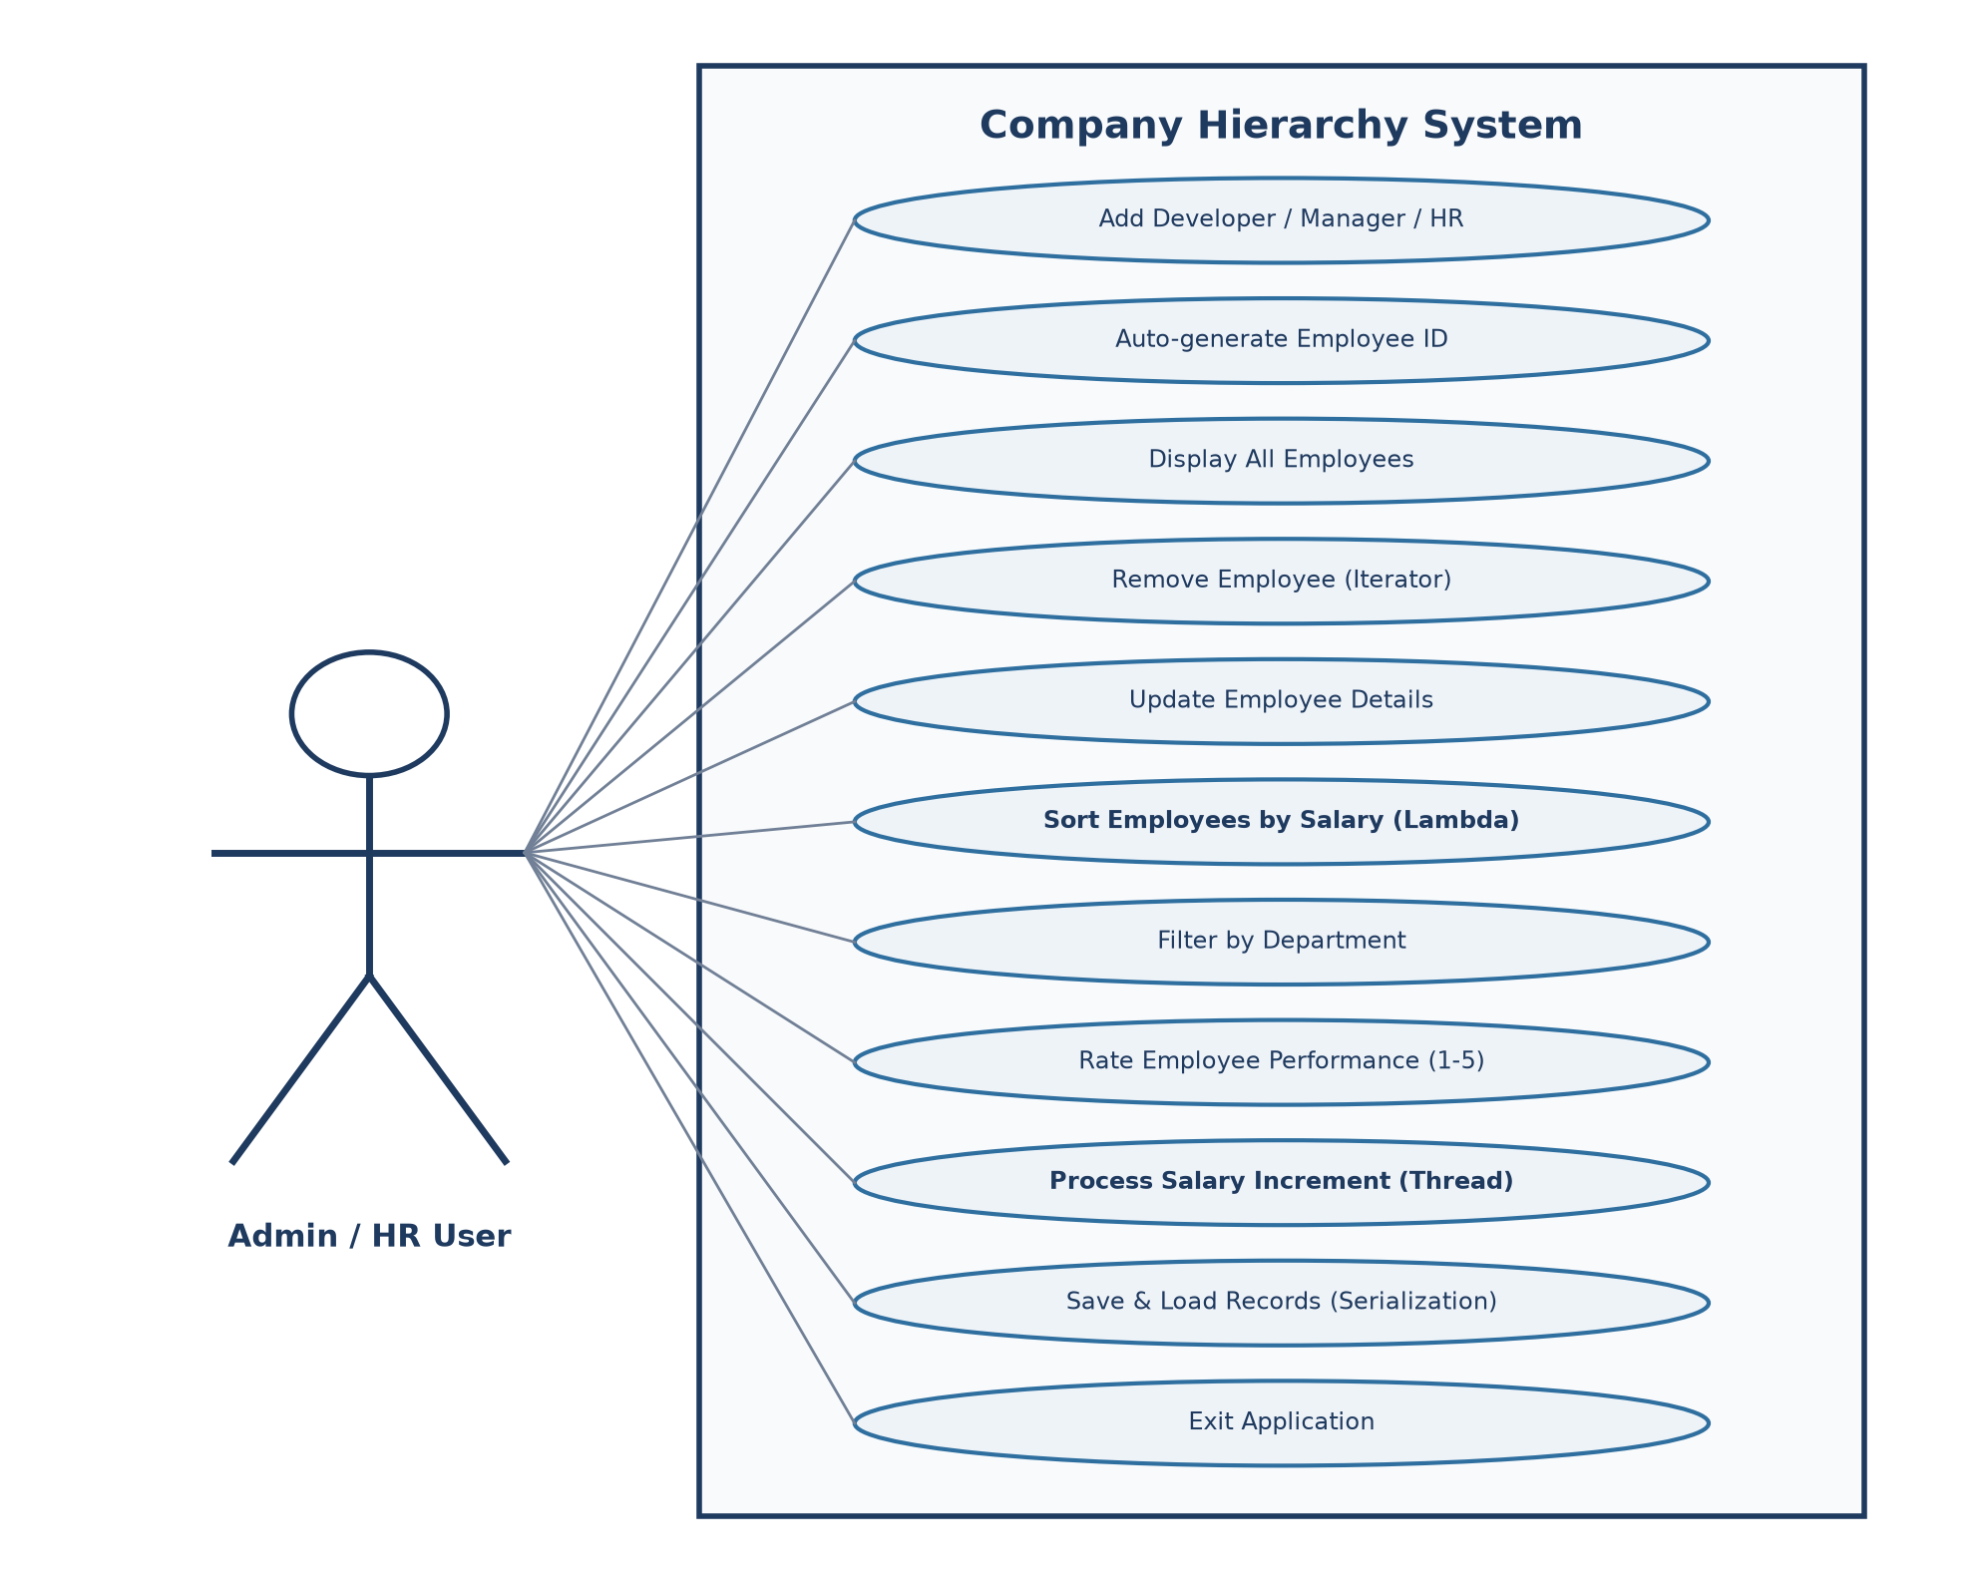
Figure 1 — Use case diagram: the console administrator and the system operations.

6.2 Workflow Diagram
The workflow diagram traces the lifecycle of an application session, beginning with automated disk deserialization, continuing through repetitive menu dispatching and threaded calculation branches, and culminating in serialization upon clean exit.
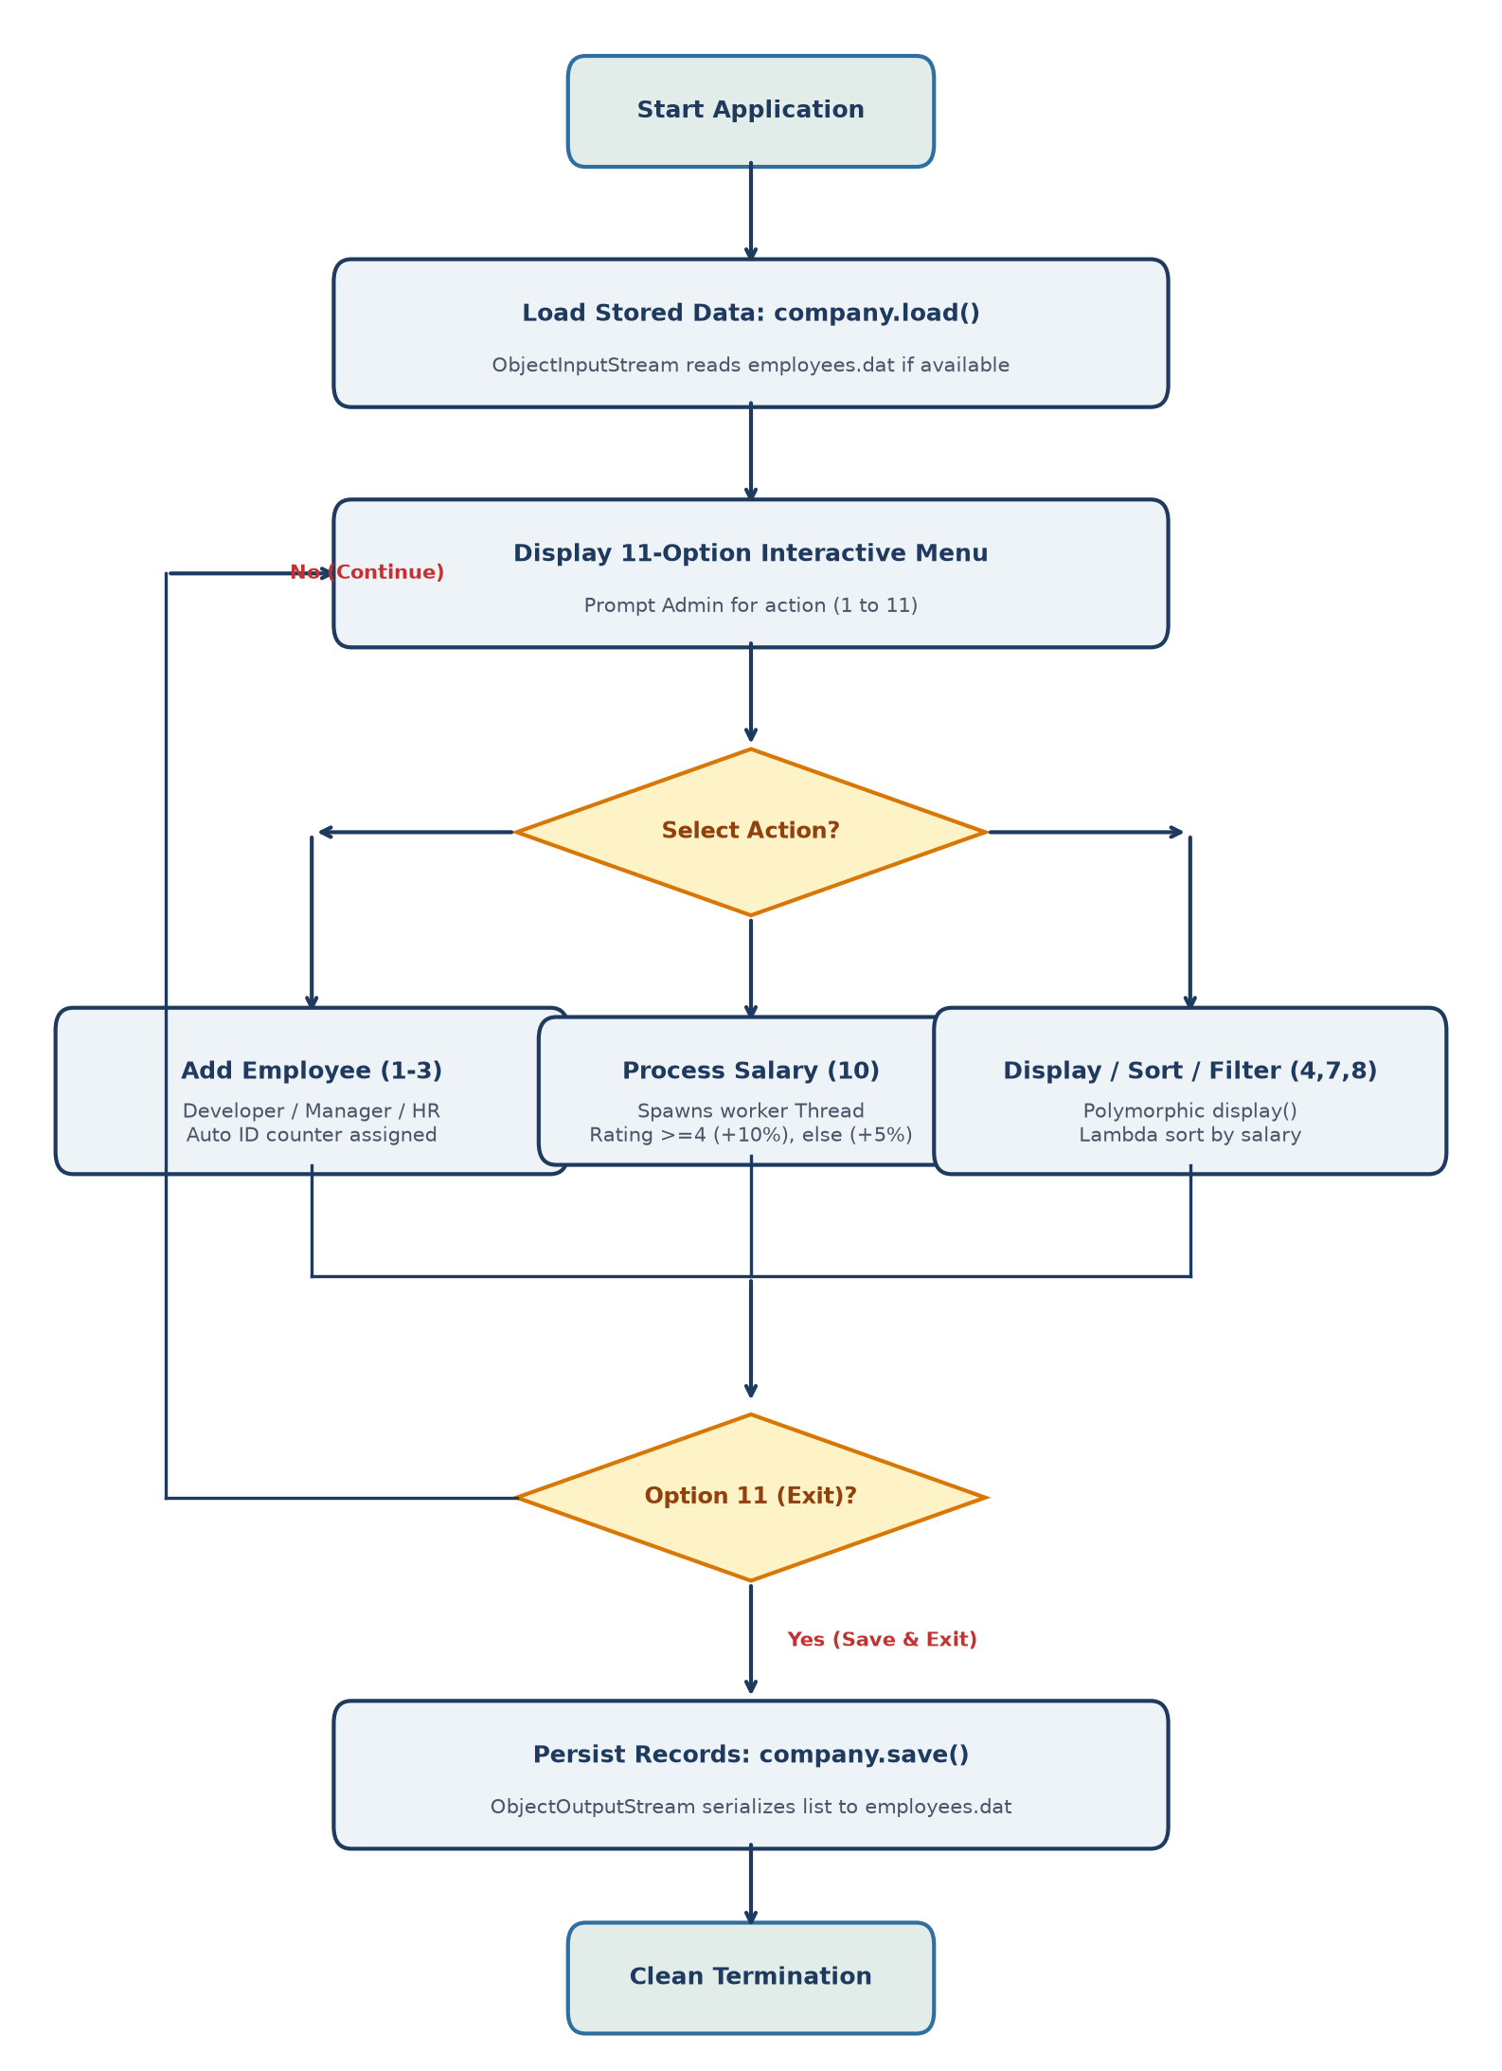
Figure 2 — Workflow of the company management lifecycle, from data loading to persistence.

6.3 Sequence Diagram
The sequence diagram details the interaction between the User, Main controller, Company manager, background Worker Thread, and Employee entity objects during rating modification and asynchronous salary processing.
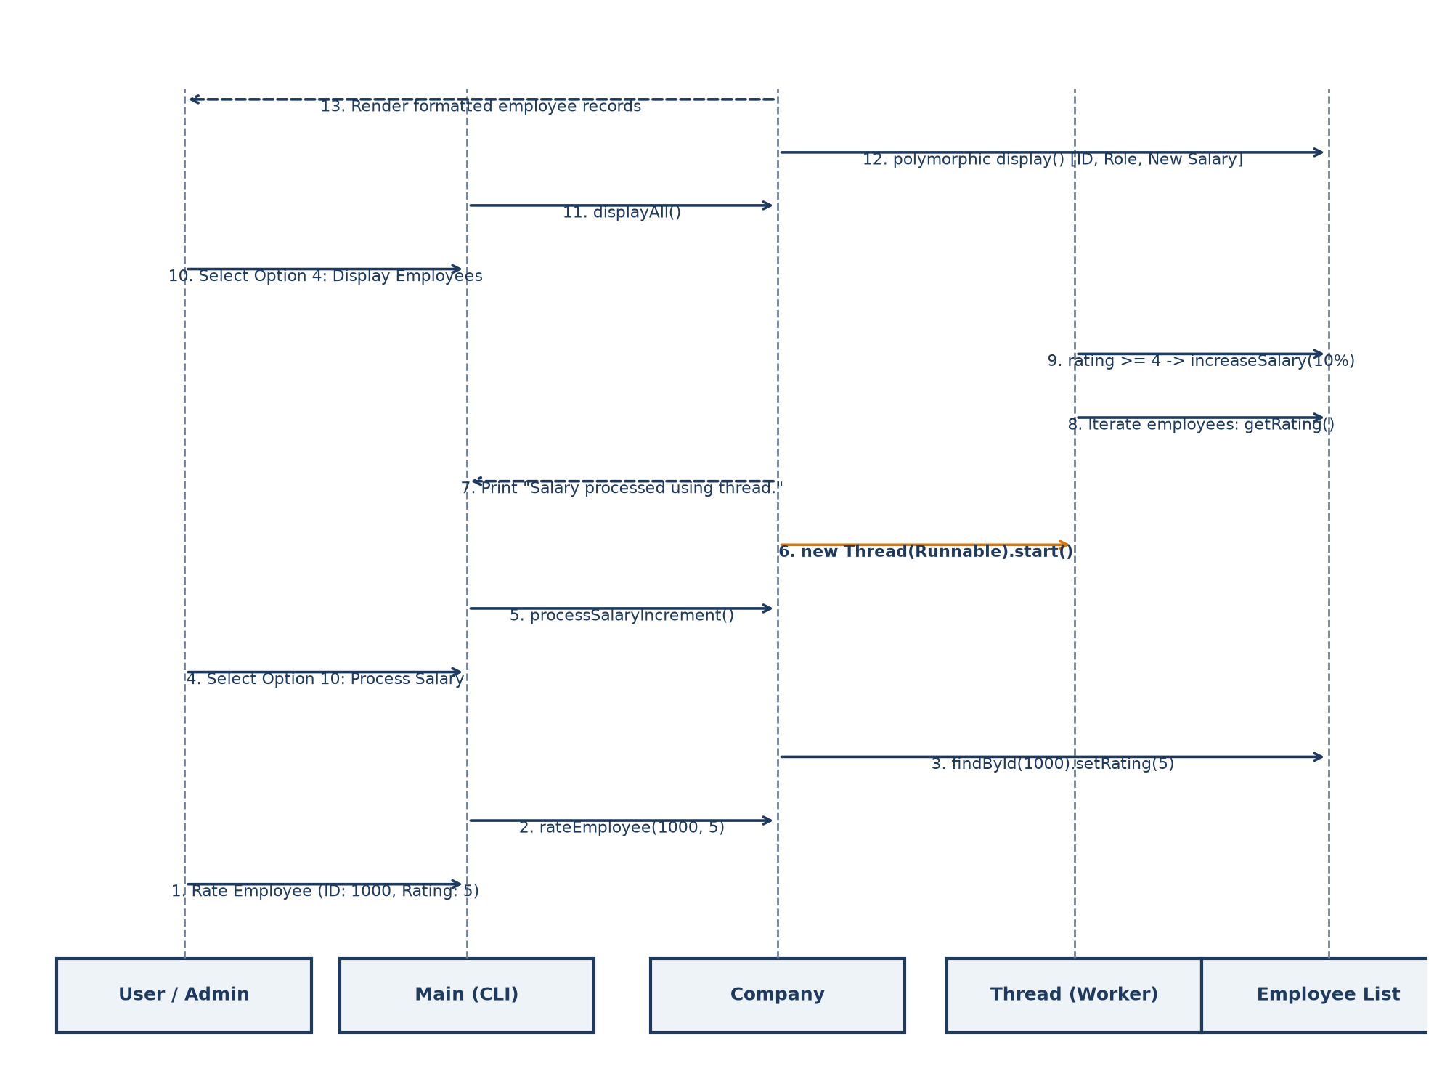
Figure 3 — Sequence of interactions during performance rating and multithreaded salary processing.

6.4 Class Diagram
The class diagram defines the structural organization of the system, showcasing the inheritance hierarchy beneath the Employee base class, encapsulation of protected attributes, aggregation within Company, and invocation by Main.
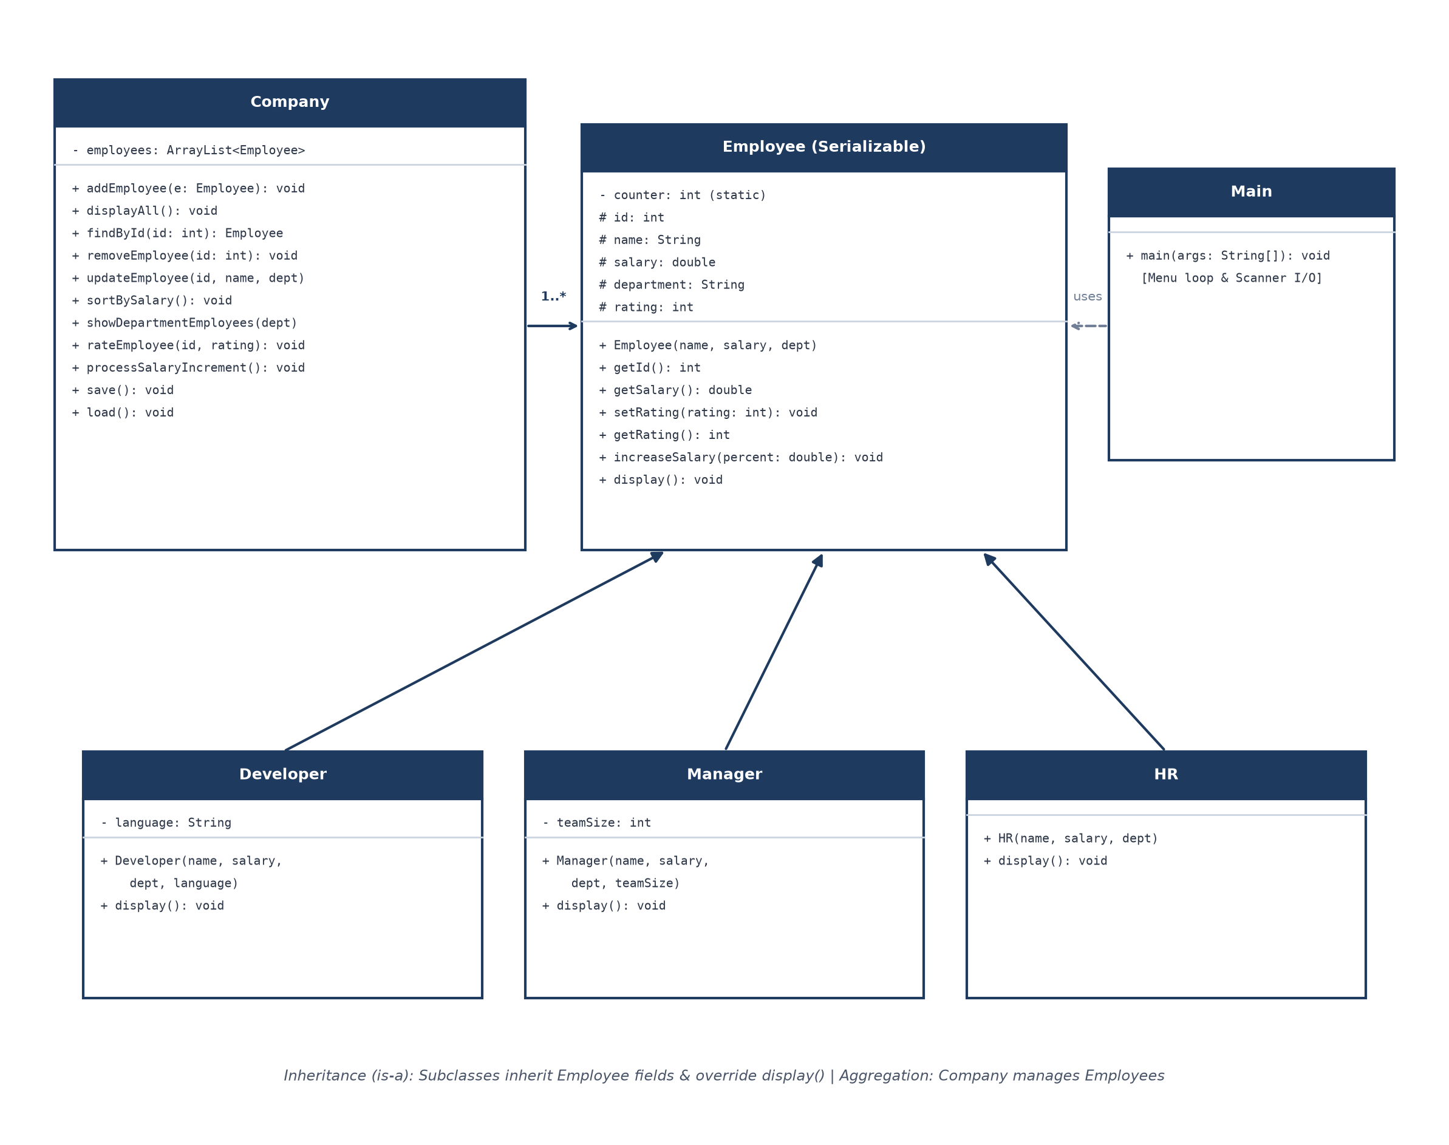
Figure 4 — Class diagram showing inheritance, aggregation, and associations across system components.

6.5 ER Diagram (Relational Schema Analysis)
While this system stores data using native Java binary object serialization, an enterprise production deployment would typically map the object model to a relational database management system (RDBMS) such as PostgreSQL or MySQL. If mapped into relational tables using Table-Per-Subclass inheritance strategy, the schema would be structured as follows:
• EMPLOYEE Table (Primary Entity) — Columns: emp_id (PK, Integer, Auto-increment from 1000), emp_name (VARCHAR 100), base_salary (DECIMAL 12,2), department (VARCHAR 50), rating (TINYINT CHECK 1-5), role_type (VARCHAR 20).
• DEVELOPER_DETAILS Table — Columns: emp_id (FK referencing EMPLOYEE.emp_id, ON DELETE CASCADE), programming_language (VARCHAR 50).
• MANAGER_DETAILS Table — Columns: emp_id (FK referencing EMPLOYEE.emp_id, ON DELETE CASCADE), team_size (INTEGER CHECK >= 0).
• HR_DETAILS Table — Columns: emp_id (FK referencing EMPLOYEE.emp_id, ON DELETE CASCADE).
This relational normalization eliminates redundant columns while preserving referential integrity across specialized employee designations.

7. Design Decisions & Rationale
Several deliberate software engineering decisions shaped the codebase to ensure robust object-oriented structure, high readability, and clean resource management:
• Using an Employee Base Class with Inheritance — Developers, Managers, and HR personnel share foundational attributes: unique ID, full name, salary, department, and rating. Consolidating these fields within a parent Employee class eliminates code duplication and enables uniform polymorphic treatment inside collections.
• Protected Field Access for Subclasses — Declaring fields as protected in Employee grants direct, high-efficiency access to specialized subclasses and package classes while preventing unwarranted public mutation.
• Polymorphic Method Overriding in display() — Each subclass overrides display() and starts by invoking super.display(). This ensures common attributes are printed consistently while allowing each role to append distinctive attributes (e.g., programming language or team size) cleanly.
• Iterator-Based Deletion — When deleting an employee by ID, the system utilizes Iterator<Employee> it = employees.iterator() and it.remove() rather than an indexed for-loop. This prevents ConcurrentModificationException when mutating collections during traversal.
• Lambda Expressions for Comparator Sorting — Sorting employees by salary uses modern Java lambda syntax: employees.sort((a, b) -> Double.compare(b.getSalary(), a.getSalary())). This provides expressive, performant descending sorting without creating bulky anonymous inner classes.
• Asynchronous Multithreading for Salary Calculation — A dedicated Thread is spawned for processSalaryIncrement(). Decoupling compute-heavy salary adjustments from the console dispatch loop ensures the system model mirrors real enterprise background job architectures.
• Native Serialization for Zero-Dependency Persistence — Implementing java.io.Serializable allows the entire ArrayList<Employee> graph to be saved directly via ObjectOutputStream to employees.dat, delivering true persistent storage without requiring database setup.
• Static Counter for Sequential Employee IDs — A private static int counter = 1000 initialized in Employee auto-increments with each constructor invocation, providing realistic four-digit corporate IDs.

8. Implementation Details
The project is organized across six modular Java source files, each responsible for a distinct functional role within the system:
Class Name | Responsibility & Architectural Role
Employee.java | Base class implementing Serializable; defines core attributes (id, name, salary, department, rating), increment methods, and foundational display logic.
Developer.java | Extends Employee; adds private language attribute and overrides display() to include technical stack details.
Manager.java | Extends Employee; encapsulates teamSize attribute and overrides display() to present organizational scope.
HR.java | Extends Employee; specializes employee role specifically for Human Resources personnel with specialized display formatting.
Company.java | Central business manager; maintains ArrayList<Employee>, implements CRUD actions, salary sorting, departmental filtering, background threading, and serialization.
Main.java | Console application entry point; initializes Company, loads stored records, runs interactive 11-option scanner loop, and orchestrates user commands.

8.1 Performance-Based Salary Calculation Logic
The system enforces a tiered appraisal formula where high-performing staff receive preferential raises. Ratings range from 1 to 5. Employees with a rating of 4 or 5 receive a 10% salary increment, whereas employees with a rating below 4 receive a baseline 5% increment:
• Tier 1 (Rating >= 4) — New Salary = Current Salary + (Current Salary * 0.10) [10% Increment]
• Tier 2 (Rating < 4) — New Salary = Current Salary + (Current Salary * 0.05) [5% Baseline Increment]
In the Employee class, this calculation is executed via increaseSalary(double percent):
public void increaseSalary(double percent) {
salary += salary * percent / 100;
}

8.2 Multithreaded Background Salary Processing
To avoid blocking administrative terminal workflows during batch payroll computations, Company encapsulates thread execution using a Java lambda Runnable:
public void processSalaryIncrement() {
Thread t = new Thread(() -> {
for (Employee e : employees) {
if (e.getRating() >= 4)
e.increaseSalary(10);
else
e.increaseSalary(5);
}
System.out.println("Salary processed using thread.");
});
t.start();
}

8.3 Data Persistence via Object Serialization
Object state persistence is achieved through Java's native ObjectOutputStream and ObjectInputStream. When option 11 (Save & Exit) is selected, the employees collection is serialized to disk:
public void save() {
try {
ObjectOutputStream out =
new ObjectOutputStream(new FileOutputStream("employees.dat"));
out.writeObject(employees);
out.close();
System.out.println("Data saved.");
} catch (Exception e) {
e.printStackTrace();
}
}

9. Screenshots / Results
The application was compiled using standard javac and executed directly in the terminal environment. The listings below capture the actual live console sessions demonstrating menu dispatching, polymorphic display, appraisal ratings, background thread execution, sorting, and persistent recovery.

9.1 Main Menu Interface
The interactive console interface provides intuitive navigation across all eleven management functions:
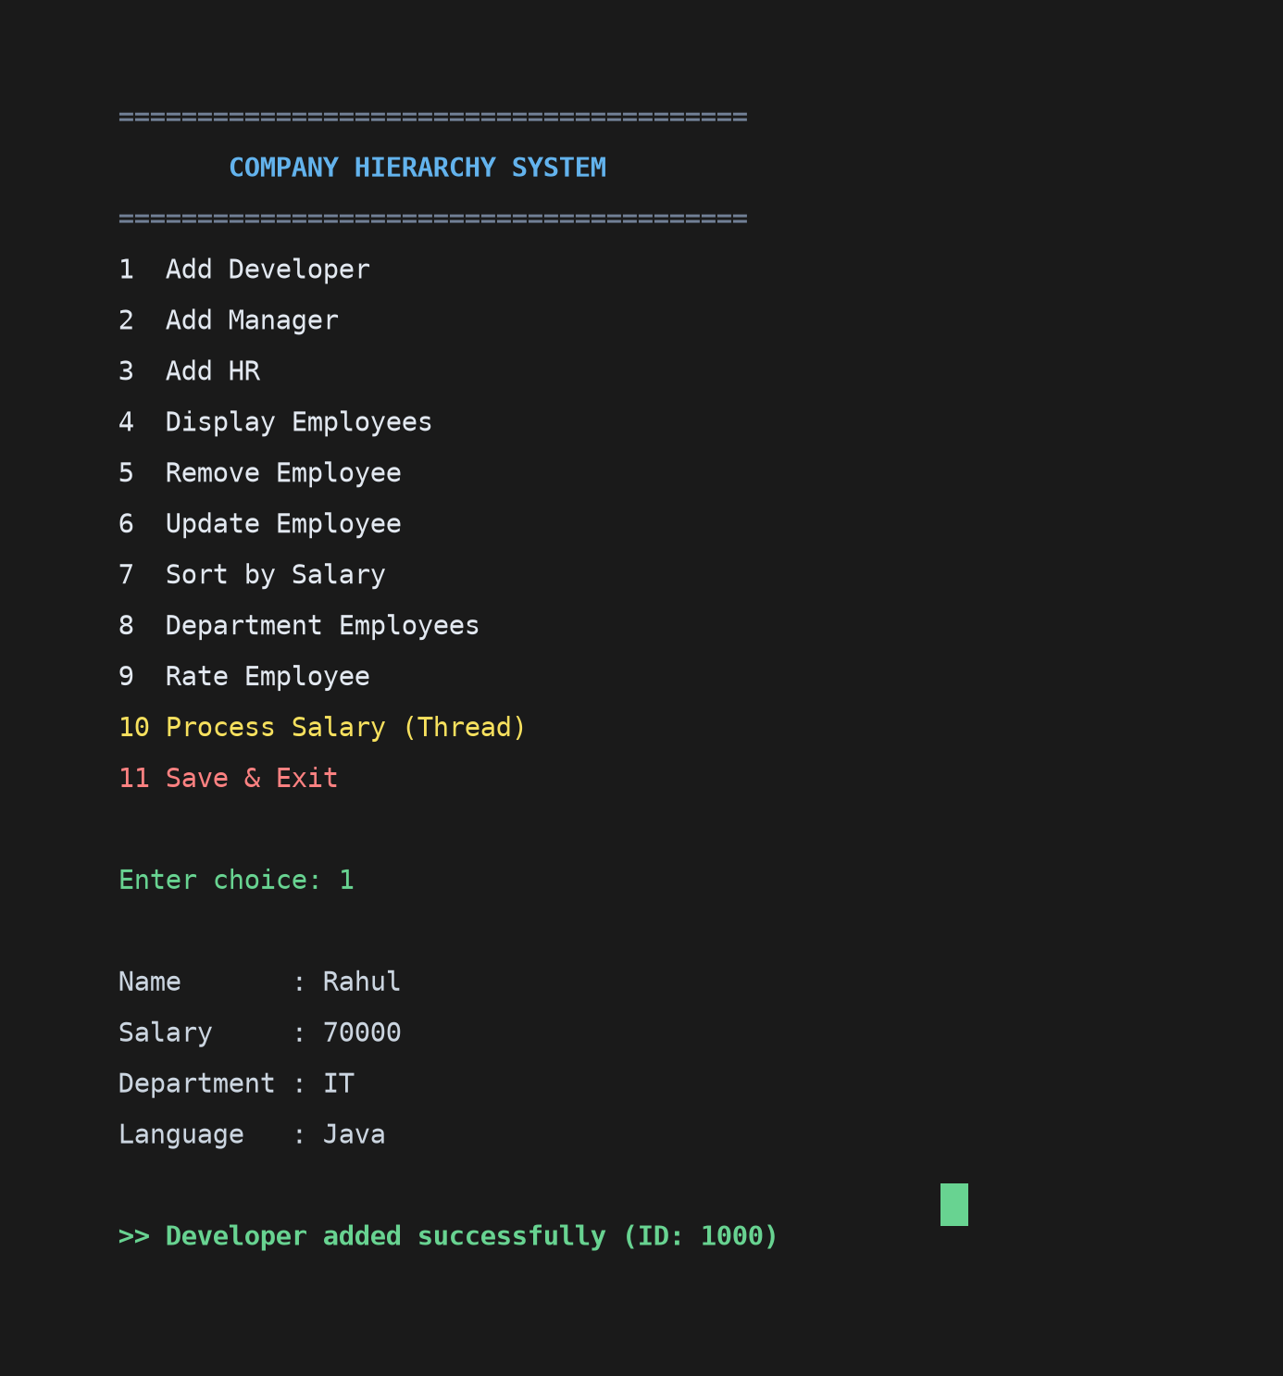
Figure 5 — Terminal capture of the interactive Company Hierarchy Management Menu.

9.2 Adding Specialized Employee Roles & Displaying Records
The listing below demonstrates adding a Developer, a Manager, and an HR personnel, followed by polymorphic display showing auto-generated IDs and role-specific fields:
===== COMPANY SYSTEM =====
1 Add Developer
2 Add Manager
3 Add HR
4 Display Employees
...
Choice: 1
Name: Rahul
Salary: 70000
Department: IT
Language: Java

Choice: 2
Name: Priya
Salary: 95000
Department: IT
Team Size: 8

Choice: 4
---------------------
ID: 1000
Name: Rahul
Department: IT
Salary: 70000.0
Rating: 3
Role: Developer
Language: Java
---------------------
ID: 1001
Name: Priya
Department: IT
Salary: 95000.0
Rating: 3
Role: Manager
Team Size: 8

9.3 Performance Rating & Multithreaded Salary Increment
Rahul (Developer, ID: 1000) is given a performance rating of 5. The background thread is then triggered via option 10 to process increments across all staff:
Choice: 9
Employee ID: 1000
Rating (1-5): 5
Rating updated.

Choice: 10
Salary processed using thread.

Choice: 4 (Verification):
---------------------
ID: 1000 | Name: Rahul | Salary: 77000.0 (+10% for Rating 5)
---------------------
ID: 1001 | Name: Priya | Salary: 99750.0 (+5% for Rating 3)

9.4 Salary Sorting & Department Filtering
Demonstrating descending sorting by salary via lambda expression and department-based query filtering for IT staff:
Choice: 7
Employees sorted by salary.

Choice: 8
Department: IT
-------------------
ID: 1001
Name: Priya
Department: IT
Salary: 99750.0
Rating: 3
Role: Manager
Team Size: 8
-------------------
ID: 1000
Name: Rahul
Department: IT
Salary: 77000.0
Rating: 5
Role: Developer
Language: Java

9.5 Data Persistence & Recovery
Terminating the application serializes records to employees.dat. On subsequent startup, the data is recovered automatically without manual entry:
Choice: 11
Data saved.
[Process exited]

$ java Main
[System automatically restores 2 employees from employees.dat]
Choice: 4
Records successfully restored with preserved IDs, ratings, and salaries.

10. Testing Approach
Since this console-based project operates without automated unit test harnesses, comprehensive manual black-box and boundary-condition test cases were conducted across all operational pathways to guarantee system integrity:
What I tried (Test Scenario) | Expected Result & System Behavior | Outcome
Add Developer with valid fields | Developer instantiated with auto ID 1000, Language recorded | Pass
Add Manager with team headcount | Manager instantiated with team size attribute; polymorphic display verified | Pass
Add HR personnel | HR role added and associated with HR department | Pass
Display records when list is empty | Prints 'No employees found.' gracefully without throwing NullPointerException | Pass
Remove employee using valid ID | Employee record pruned via Iterator without ConcurrentModificationException | Pass
Remove employee using non-existent ID | Prints 'Employee not found.' and cleanly returns to menu | Pass
Update employee name and department | Fields mutated in-place; verified via subsequent display | Pass
Rate employee with high score (5) | Rating updated; verified for eligibility in 10% increment tier | Pass
Execute multithreaded salary increment | Thread launches; rating >=4 staff receive +10%, others receive +5% | Pass
Sort employees by salary descending | Lambda comparator orders records with highest earner at index 0 | Pass
Filter by department (case-insensitive) | Correctly matches 'it', 'IT', and 'It' using equalsIgnoreCase() | Pass
Graceful Save and Cold-Start Recovery | employees.dat written on option 11; automatically re-loaded upon relaunch | Pass

11. Challenges Faced
During the architecture and development phases, several technical challenges emerged that required targeted solutions:
• Concurrent Modification During Removal — Initially attempting to remove an employee using an indexed for-each loop over ArrayList caused a runtime ConcurrentModificationException. The issue was resolved by refactoring the removal logic to use an explicit Iterator<Employee> and calling it.remove(), which safely handles internal collection re-indexing during iteration.
• Thread Coordination & Visual Notification — Spawning an independent Thread for processSalaryIncrement() executes asynchronously from the main console thread. Ensuring the completion message did not disrupt simultaneous user input prompts required streamlining the runnable block.
• Scanner Leftover Newline Buffering — When reading integers and floating-point values using sc.nextInt() or sc.nextDouble(), the trailing newline character remained in the input stream. Subsequent calls to sc.nextLine() read empty strings. Adding explicit sc.nextLine() calls after each numerical read successfully cleared the buffer.
• Object Deserialization on Clean Initial Run — On the initial execution of the program before any data was ever saved, employees.dat does not yet exist. A naive read threw FileNotFoundException. Enclosing deserialization inside a try-catch block in load() allows the system to inform the user ('No saved data.') and continue with a fresh list.
• Polymorphic Serialization Type Safety — Storing distinct subclasses (Developer, Manager, HR) in an ArrayList<Employee> required confirming that all subclasses inherit java.io.Serializable from Employee so that polymorphic object graphs serialize without NotSerializableException.

12. Learnings & Key Takeaways
• Practical Inheritance & Code Reuse — Abstracting common attributes into a single parent class drastically cut boilerplate and established a clean, unified mental model for the enterprise hierarchy.
• Runtime Polymorphism in Action — Iterating over an ArrayList<Employee> and invoking e.display() demonstrated dynamic binding in practice; the JVM dynamically dispatches to Developer, Manager, or HR at runtime.
• Mastering Concurrency Basics — Writing multithreaded logic using Java's Thread class and lambda runnables highlighted how non-blocking background tasks can process computational jobs without stalling UI execution.
• Modern Java Functional Constructs — Using lambda expressions in ArrayList.sort() revealed the elegance of concise functional interfaces compared to verbose legacy Comparator classes.
• Persistence Architecture — Implementing Java Object Serialization demonstrated how easily in-memory object graphs can achieve session persistence without the overhead of external database engines.

13. Future Enhancements
The system serves as a solid foundation for extensive enterprise-grade capabilities that could be incorporated in future iterations:
• Database Backend Integration (JDBC / JPA) — Migrate from binary file serialization to a relational database like PostgreSQL or MySQL using Hibernate ORM for enterprise scalability, transactions, and ACID compliance.
• Role-Based Authentication & Access Control (RBAC) — Introduce distinct login credentials for Administrators, Department Managers, and Staff, restricting sensitive operations like salary modification to authorized roles.
• Graphical User Interface (GUI) / Web Portal — Develop a responsive desktop interface using JavaFX or transform the project into a Spring Boot REST API paired with a modern React or Vue frontend.
• Automated Payroll & Tax Computation — Incorporate tax bracket deductions, health insurance withholding, and automated PDF payslip generation using libraries like iText.
• Leave & Attendance Management — Track employee leave balances, sick days, and attendance records, factoring attendance rates directly into annual appraisal ratings.

14. References
• Oracle Corporation — The Java™ Tutorials — Classes and Objects, Inheritance, Interfaces, and Concurrency. docs.oracle.com/javase/tutorial/
• Oracle Java SE API Specification — java.util.ArrayList, java.io.Serializable, java.io.ObjectOutputStream, and java.lang.Thread documentation. docs.oracle.com/en/java/javase/17/
• Herbert Schildt — Java: The Complete Reference, 12th Edition — Comprehensive coverage of OOP principles, multithreading, and serialization.
• GitHub Project Source Code — Company Hierarchy Management System repository: https://github.com/yogeshkumarsaini/company-hierarchy-system

