Android

Android is a mobile operating system based on a modified version of the Linux kernel and other open source software, designed primarily for touchscreen mobile devices such as smartphones and tablets. Android is developed by a consortium of developers known as the Open Handset Alliance and commercially sponsored by Google. It was unveiled in November 2007, with the first commercial Android device, the HTC Dream, being launched in September 2008.

Most versions of Android are proprietary. The core components are taken from the Android Open Source Project (AOSP), which is free and open-source software (FOSS) primarily licensed under the Apache License. When Android is installed on devices, ability to modify the otherwise FOSS software is usually restricted, either by not providing the corresponding source code or preventing reinstallation through technical measures, rendering the installed version proprietary. Most Android devices ship with additional proprietary software pre-installed most notably Google Mobile Services (GMS)[14] which includes core apps such as Google Chrome, the digital distribution platform Google Play, and associated Google Play Services development platform.

Android was founded in Palo Alto, California, in October 2003 by Andy Rubin, Rich Miner, Nick Sears, and Chris White.Rubin described the Android project as having "tremendous potential in developing smarter mobile devices that are more aware of its owner's location and preferences".[21] The early intentions of the company were to develop an advanced operating system for digital cameras, and this was the basis of its pitch to investors in April 2004.[22] The company then decided that the market for cameras was not large enough for its goals, and five months later it had diverted its efforts and was pitching Android as a handset operating system that would rival Symbian and Microsoft Windows Mobile.

Android is open to everyone: developers, designers and device makers. That means more people can experiment, imagine and create things the world has never seen.

Firebase

Firebase is a Backend-as-a-Service (Baas). It provides developers with a variety of tools and services to help them develop quality apps, grow their user base, and earn profit. It is built on Google’s infrastructure.

Firebase is categorized as a NoSQL database program, which stores data in JSON-like documents.

Features we used in project:

1. Authentication

It supports authentication using passwords, phone numbers, Google, Facebook, Twitter, and more. The Firebase Authentication (SDK) can be used to manually integrate one or more sign-in methods into an app. And in our app we used email authentication with the email and password by bind the project with firebase and use its functions.

1. Firestore database

Cloud Firestore is a NoSQL, document-oriented database. Unlike a SQL database, there are no tables or rows. Instead, you store data in documents, which are organized into collections.

Each document contains a set of key-value pairs. Cloud Firestore is optimized for storing large collections of small documents.

All documents must be stored in collections. Documents can contain subcollections and nested objects, both of which can include primitive fields like strings or complex objects like lists.

Collections and documents are created implicitly in Cloud Firestore. Simply assign data to a document within a collection. If either the collection or document does not exist, Cloud Firestore creates it.

* Documents

In Cloud Firestore, the unit of storage is the document. A document is a lightweight record that contains fields, which map to values. Each document is identified by a name.

In our project each user has a document stored with its data and each document is identify by the user ID all users stored in collection called users

So collections have documents and documents have the actual data

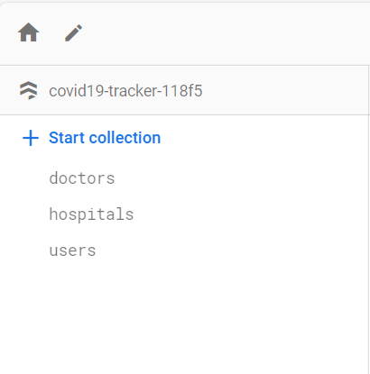We have 3 collection holding our data doctors, hospitals and users

* 1. 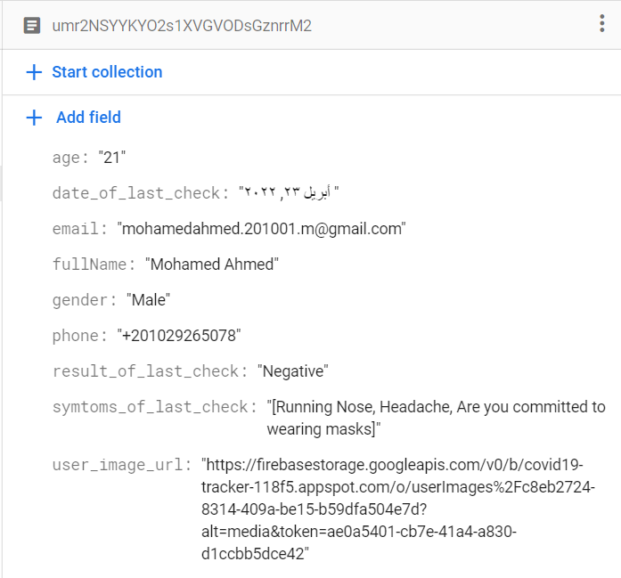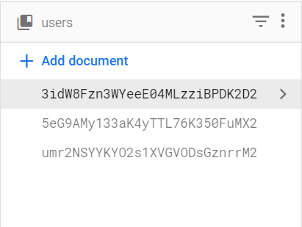Users for holding each user data. every user has his unique id and unique document.  
     and each document has the all user data. We save the name, email, phone, age and age and the other fields it’s result of the corona checkup questions and finally the image link to retrieve it in profile screen.
  2. Doctors
  3. Hospitals

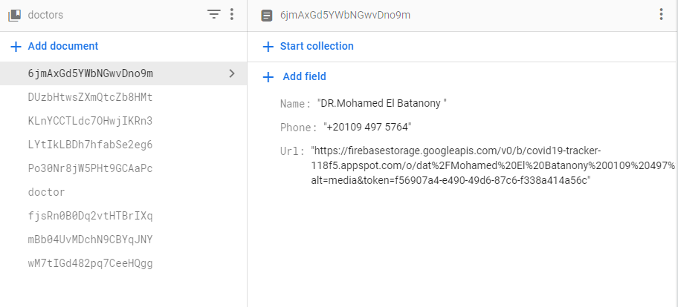

Each Data of doctor consist of (Name Phone Url of image)

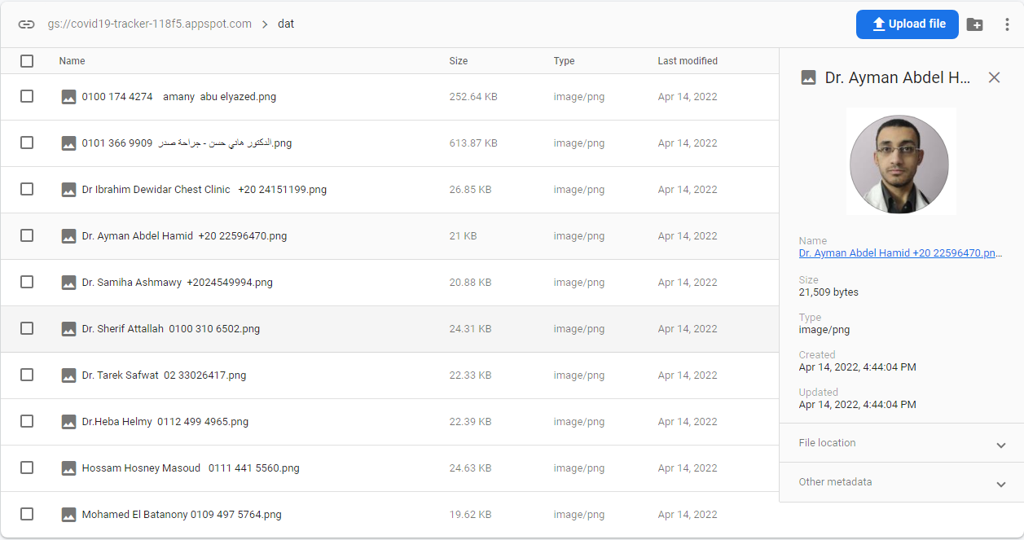 Every doctor has Url Image and invoked in our application

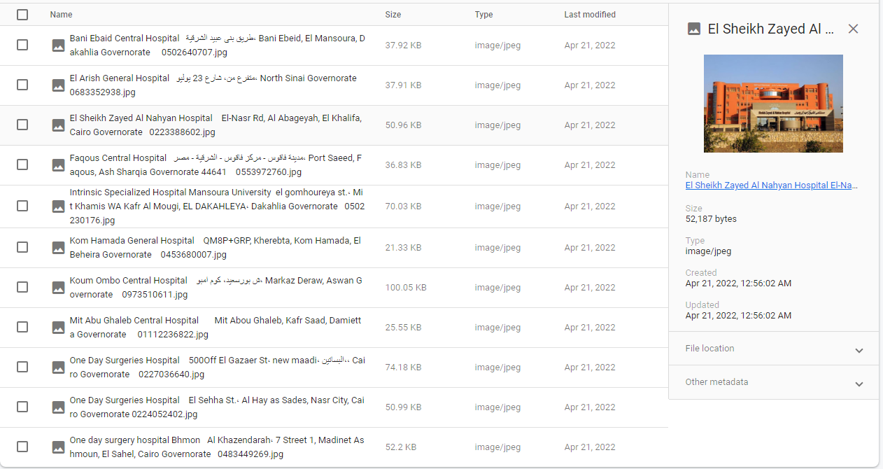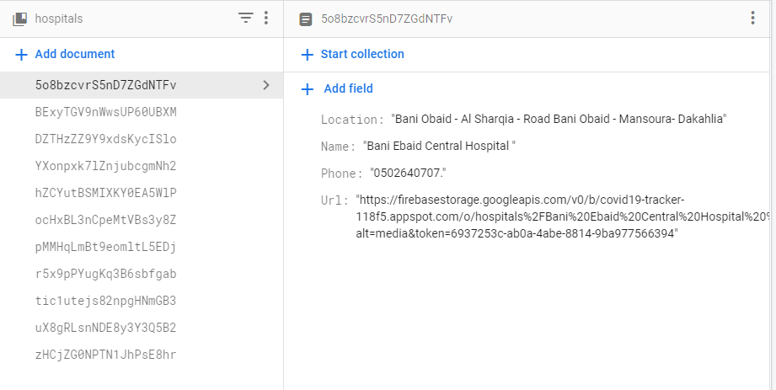Every hospital has data (Name- Location - Phone- Url Image)

every hospital has Image Url and invoked in our app in figruer()

1. 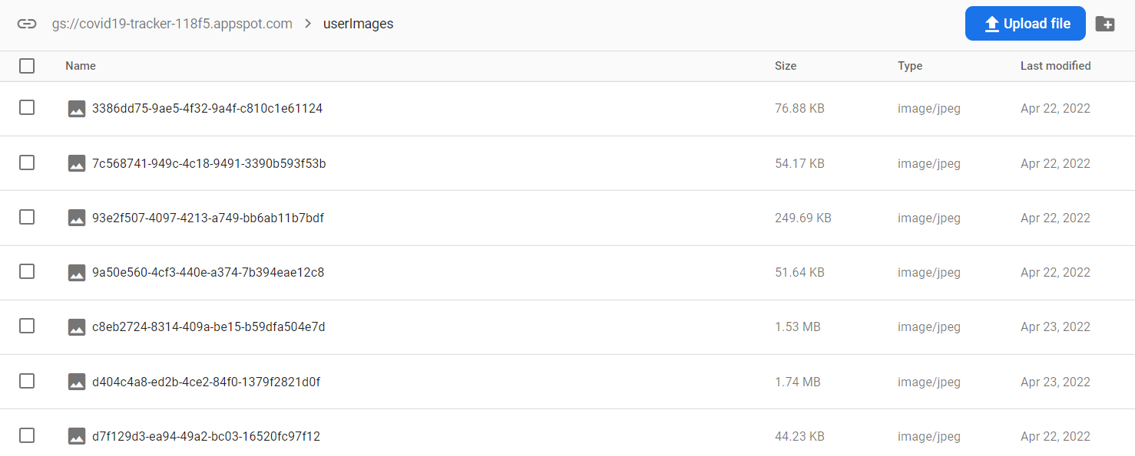Firebase Storage  
   Cloud Storage for Firebase is built for app developers who need to store and serve user-generated content, such as photos or videos. Cloud Storage for Firebase is a powerful, simple, and cost-effective object storage service built for Google scale. The Firebase SDKs for Cloud Storage add Google security to file uploads and downloads for your Firebase apps, regardless of network quality. We use storage mostly to save data. Like the user photo we upload and save it in storage then use it in our app in any time.   
     
   naser lw 7abb tdef 7aga

References

1. [*"Google's Android OS: Past, Present, and Future"*](https://www.phonearena.com/news/Googles-Android-OS-Past-Present-and-Future_id21273)*. PhoneArena. August 18, 2011.*[*Archived*](https://web.archive.org/web/20170313044444/http:/www.phonearena.com/news/Googles-Android-OS-Past-Present-and-Future_id21273)*from the original on March 13, 2017. Retrieved March 12, 2017.*
2. [*"Is Android Really Open Source? And Does It Even Matter?"*](https://www.makeuseof.com/tag/android-really-open-source-matter/)*. MakeUseOf. March 28, 2016.*
3. [*"Android – Google Mobile Services"*](https://www.android.com/gms/)*. Android. Retrieved October 21, 2018. While the Android Open Source Project (AOSP) provides common, device-level functionalities such as email and calling, GMS is not part of AOSP. GMS is only available through a license with Google [..] We ask GMS partners to pass a simple compatibility test and adhere to our compatibility requirements for their Android devices.*”
4. Hughes, Terry (July 28, 2014). ["Google and Android Are Not the Same... and That's a Good Thing"](https://appdevelopermagazine.com/google-and-android-are-not-the-same...-and-that's-a-good-thing/). *App Developer Magazine*. Retrieved July 29, 2020.
5. [*"Frequently Asked Questions"*](https://source.android.com/setup/start/faqs)*. Android Open Source Project. Retrieved January 4, 2021.*
6. *Simon, Michael (December 26, 2016).*[*"With Cyanogen dead, Google's control over Android is tighter than ever"*](https://www.greenbot.com/article/3153485/with-cyanogen-dead-googles-control-over-android-is-tighter-than-ever.html)*. www.greenbot.com. Retrieved January 4, 2021.*