This is a detail description for a Banking application project

asrat_minase_Po

Banking Application

1. Planning

Tentative work schedule for Application
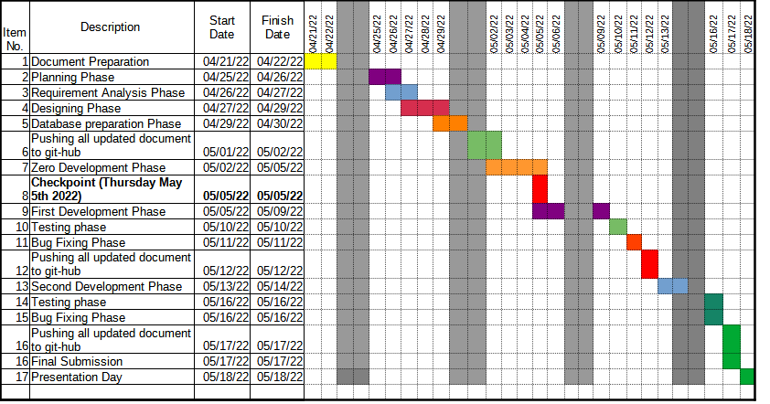

2.1 Analysis phase

2.1. Requirements

1) User Registration page
2) Login page with Validation
3) Landing page
4) Deposit funds into an account
5) Withdraw funds from an account (no over drafting!)
6) Create accounts per user
7) Transfer money between accounts

2.2 Defining the requirements

1) User Registration

a) First Name
b) last Name
c) DOB
d) Gender
e) Username
f) Password
e) Confirm Password – Validation
f) SSN
g) Address1
h) Address2
i) City
j) State
k) Zip-code
L) Register button
m) Checkbox (Accept terms and conditions)
n) Logout

2) Login page

a) Username
b) password
c) Login button
d) Sign up

If Account created and user logged in
-------------------------------------------------------

3) Landing page

a) Account Information tap
b) Transfer tap
C) Withdrawal tap
d) Deposit tap
e) Help tap
f) Account (here I will show a table of account type with their information
g) History (here I will show a table that shows the history of transaction)
h) Logout button

4) Deposit funds into an account

a) username
b) password
c) Login
d) Amount to deposit
e) Previous Balance
f) New Balance
g) Submit button
h) Logout Button

5) Withdraw funds from an account

a) username
b) password
c) Login
d) Amount to withdraw
e) Previous Balance
f) New Balance
g) Submit button
h) Logout Button

6) Create multiple accounts per user

a) Account type (drop down)- to choose from checking and savings
b) Account Number
C) Create button

7) Transfer money between accounts

a) Last Name
B) Account Number
C) Transfer Account
d) Amount to transfer
e) Submit button

3. Designing Phase

3.1. Login Page
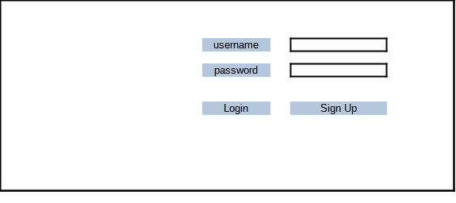
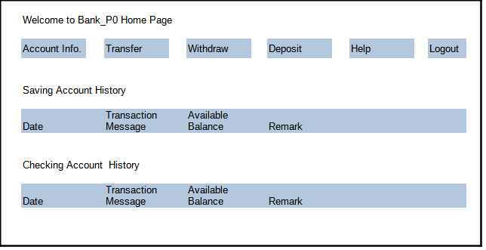
3.2. Home /Landing Page

3.3 User registration page

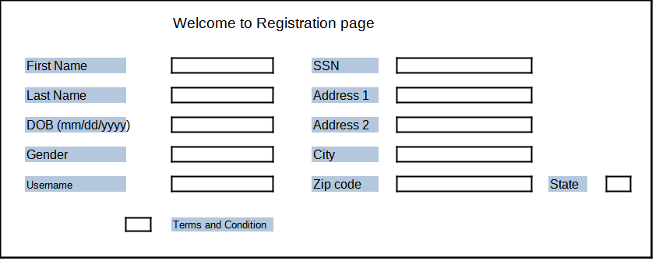
3.4. Deposit Page

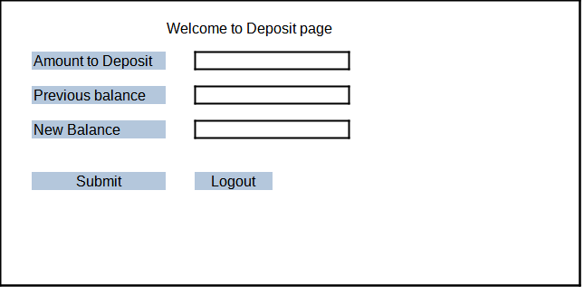

3.5 Withdrawal Page

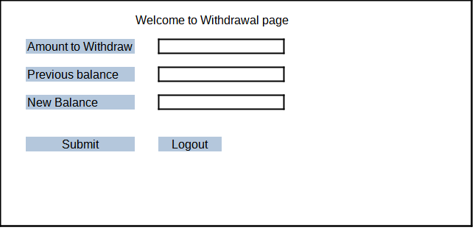
All data base must be completed here

4. Development phase

Here coding of the banking application must start

5. Testing Phase

Here the application will be tested

6. End of project P0.

