

**FINAL REPORT OF TERM PROJECT**

**CMSE 201**

**Fundamentals of Software Engineering**

**Team members**

**Mohamed, Elfaki, 22900158**

**Firas, Abdelgadir, 22703822**

**Mustapha, Gumel, 22900221**

**Youssef, Aboulebdeh, 22703966**

**GROUP NO: 04**

**PROJECT NAME: Stray Animals Tracking Application**

**PROJECT START DATE: 14.10.2023**

**PROJECT END DATE: 18.01.2024**

**SUPERVISOR: Prof. Dr. Duygu Çelik Ertuğrul**

**SEMESTER TERM: Fall** **2023/2024**

# ABSTRACT

The purpose of the final report is to provide comprehensive information about StrayAway which is 3 months in the making. The team consists of 4 members, Mohamed Omer (Project Manager/System Analyst), Firas Abdelgadir (Database developer), Youssef Aboulebdeh(Tester/Programmer) and Mustapha Ali (UI designer). The system provides a robust but simple way of helping stray animals by either reporting them or adopting, which fulfills the system’s main purpose of getting stray animals off the street by use of the community’s help. The system will have a large database with all stray animals and their locations which will also be constantly updated. The project aims to create a user-friendly platform which will increase the number of users. The procedures in the project span through different stages, in software planning and analysis, interviews between us and end users as well as experts will take place, the schedules will be documented using MS project. For the design stage we used Modelio and Figma to create diagrams as well as the UI which will act as guidance in the coding stage. For the coding stage we will use languages such as Java, CSS, HTML, JavaScript and Python to implement the functional requirements. The database system will be implemented through the use of SQL. For the testing segment we will use prominent testing tools to reach a broad range of test cases, as well as special cases. Testing will be carried out simultaneously with coding. Conclusively we have obtained a PPM report as well as an SRS report and Presentation, which will benefit the stakeholders and increase their understanding of the project and help assemble an application satisfying all needs.

* **Keywords:** Java, Animal adoption, Python, User-Friendly, Animal Tracking, Community-driven, Animal welfare,

# Table of Contents

ABSTRACT II

Table of Contents III

LIST OF FIGURES V

LIST OF TABLES VI

1. INTRODUCTION 1

2. PROJECT PLANNING AND MANAGEMENT 2

3. REQUIREMENTS ANALYSIS 3

3.1 Functional Requirements 3

3.2 Non-Functional Requirements 3

3.3 Realistic constraints 3

3.4 Ethical issues 3

4. DESIGN 4

4.1 High level design (architectural) 4

4.2 Software design 4

5. IMPLEMENTATION 5

5.1 Tools, technologies and platforms used 5

5.2 Algorithms 5

5.3 Standards 5

5.4 Detailed description of the implementation (coding) 5

6. TESTING 6

7. USER GUIDE OF THE SYSTEM 7

8. DISCUSSION 8

9. CONCLUSION 9

10. REFERENCES 10

APPENDICES 11

A. Instructions for installing the system 11

B. Code for the system 11

C. Other relevant material 11

# LIST OF FIGURES

* Figure 1: Work Break Down Structure (WBS)
* Figure 2: Gantt Chart
* Figure 3: Network Diagram
* Figure 4: Use-Case Diagram
* Figure 5: Activity Diagram
* Figure 6: BPMN Diagram
* Figure 7: Class Diagram
* Figure 8: State Machine Diagram
* Figure 9.1: Sequence Diagram

# LIST OF TABLES

* Table 1: Resource Levelling Matrices
* Table 2: Project Team Information
* Table 3: Project Packages Tables
* Table 4: Milestones
* Table 5: Procurement Tables
* Table 6: Project Economic Expectation
* Table 7: Instrument/Equipment/Software/Release Purchases
* Table 8: Quarterly Estimated Cost Form
* Table 9: PERT Analysis
* Table 10: PERT Calculation
* Table 11: PERT Results
* Table 12: Unadjusted Function Points Calculation
* Table 13: Technical Complexity Factor Calculation
* Table 14: Probabilities Of Finishing
* Table 15: Crashing Costs

# 1. INTRODUCTION

The issue at hand is the increasing number of strays in certain countries through the use of reporting their location to the application, which will be sent to our team and eventually the stray animal will be sent to the vet and then to a shelter where they can be adopted. The Application also has many features which will solve more problems which is the adopt feature which helps our users adopt the animal they want causing less stress on the animal shelters. Our goal is for this approach of the application to make it very simple and lead to much more users as well as satisfied users.

, many will benefit from the project including the community of the country of operation, the employees as well as veterinarians who will have more appointments. Other applications who previously attempted to solve all problems had limited features or didn't have a user-friendly UI, whereas we provide many features in combination with a user-friendly UI. Animal-lovers and non-lovers will benefit alike, due to less animals on the street as well as less animals suffering from lack of food and shelter causing them peace of mind.

We have researched the animal welfare market and came to many conclusions, some of which include how inefficient most of the apps were. Some of the apps have deployed the same reporting strategy but unlike StrayAway, the database wasn’t updated constantly, they all tried to deploy a user-friendly interface which for some apps wasn't received well. Other apps have tried to make the reporting process integrate seamlessly with the adoption process but most have failed, as well as attempts to increase the app’s community engagement which ultimately didn’t succeed which is why not many stray animal adoption apps are in the limelight.

This version of StrayAway is made to seamlessly collaborate with small as well as large-scale organizations seeking a positive impact in animal welfare. Collaborations will also be held with veterinarians, this app will cooperate with many companies, ultimately the app will succeed due to its community engagement and collaborative nature combined with a user-friendly UI.

# 2. PROJECT PLANNING AND MANAGEMENT

Purpose:

StrayAway aims to reduce the issue of stray animals on the streets through the use of a user-friendly, community-driven application.

Scope:

The scope of the app includes, reporting stray animals, tracking updates about their health and veterinarian appointments, adopting animals as well as scanning animals breeds.

Target Users:

* Volunteers/Pet Proprietors, Animal Welfare Organizations, App administrators

**A.1.1**

|  |  |
| --- | --- |
| **Project Number** | 4 |
| **Name of Project** | Stray Animals Tracking Mobile app |
| **Starting Date** | 14th October 2023 |
| **Ending Date** | 12’th January 2024 |
| **Time** | 3 months |

* **A.1.2**

|  |  |  |  |
| --- | --- | --- | --- |
| **Project Manager.** | | | |
| **Name Surname** | Mohamed Elfaki | ID No | 22900158 |
| **Title/Role** | Project Manager, System analyst | | |
| **Address** | Famagusta | | |
| **Phone** | +90 548 866 59 45 | | |
| **Email** | [Moh.omer24@gmail.com](mailto:Moh.omer24@gmail.com) | | |

* A.2 Group Information

# A.2.1

|  |  |  |  |
| --- | --- | --- | --- |
| **Student 1** | | | |
| **Name Surname** | Firas Abdelgadir | ID No | 22703822 |
| **Title/Role** | Database Developer | | |
| **Address** | Famagusta | | |
| **Phone** | +90(548)8669200 | | |
| **Email** | [firasnazar@gmail.com](mailto:firasnazar@gmail.com) | | |



|  |  |  |  |
| --- | --- | --- | --- |
| **Student 2** | | | |
| **Name Surname** | Mustapha Ali Gumel | ID No | 22900221 |
| **Title/Role** | User interface designer | | |
| **Address** | Famagusta | | |
| **Phone** | +234 9015388325 | | |
| **Email** | [Mustybinali08@gmail.com](mailto:Mustybinali08@gmail.com) | | |

|  |  |  |  |
| --- | --- | --- | --- |
| **Student 3** | | | |
| **Name Surname** | Youssef Raed Aboulebdeh | **ID No** | 22703966 |
| Title/Role | Tester , Programmer | | |
| Address | Famagusta | | |
| Phone | +90(539)132 2600 | | |
| Email | [Yousefabulebdah05@gmail.com](mailto:Yousefabulebdah05@gmail.com) | | |



# A.2.2

|  |
| --- |
| **List of Completed / Ongoing Projects of Team** |
| N/A |

* B.1 Introduction to Project
* **B.1.1**

|  |
| --- |
| **Summary of Project** |
| The new innovative stray pet tracker mobile app, with features which allow you to extend vulnerable stray animals a hand of help. The variety of features include reporting missing pets, adopting strays, donating to help the cause, purchasing pet Bluetooth trackers, booking veterinarian appointments as well as scanning the animals to identify their breeds, making this an all-in-one app.  The aim is to make pet adoption and reporting as easy and convenient as possible, while also accepting user feedback to improve experience. A user-centered app to ensure a seamless experience, join us to provide shelter and ease upon stray animals. |

# B.1.2

|  |
| --- |
| **Key Words** |
| * Animals, Animal adoption, Java, CSS, HTML, JavaScript, Python, Rescue Pets, Stray Animal report |

# B.1.3

|  |
| --- |
| **Aim of Project** |
| The project was originally started with the main aim of tackling the growing issue of stray animals on the street. Built to help animal lovers and non-lovers alike, this project strives to keep neighborhoods and streets clear of stray animals that require nourishment, as well as delivering professional veterinarian help to the animals that might need it. This project aims to significantly reduce the visual, noise as well as the environmental pollution that is caused by unwell animals, that may very well be carrying infectious diseases such as rabies, which raise health concerns. Failing to treat these sick animals may cause them to fall victim to their fatal diseases, which in turn increases animal carcasses in the open. |

# B.1.4

|  |
| --- |
| **Innovative Aspects/Contributions of Project** |
| This app offers a comprehensive solution for pet lovers, including novel features, such as breed scanning, pet tracking and other features combined to form one robust app.  The app is user-centered and highly values user feedback as well as expert input, ensuring the app stays relevant and responsive. |

# B.1.5

|  |
| --- |
| **Methods to be Applied** |
| **Planning and Analysis Stage**: For the first stage, we will be carrying out a wide search to discover the areas that are the most densely populated with stray animals. From that list, we will prioritize the regions that contain animals carrying infectious diseases. Targeted online advertisements will be implemented to grab the attention of a fixed target audience. This will help us ascertain who our potential users and customers are. Task planning and division will be done via MS Project and Lucid Chart.    **Design Stage:** We will be using Figma to illustrate how the user interface will look like on the mobile phone’s application. |

# B.1.6

|  |
| --- |
| **Economic and National Outcomes** |
| By promoting animal adoption this app reduces burdens upon animal shelters, which reduces average maintenance costs of animal shelters, alleviating financial resources usage for government-funded and non-profit organizations alike. In addition, neighborhoods and streets will also benefit due to the significant reductions in visual, noise, and environmental pollutions, as mentioned above. |

* B.2 Reason of Starting the Project, Methods and R&D Stages

# B.2.1

|  |
| --- |
| **1- Explain the reason of starting this project. (Max 500 charachter)** |
| This project started due to a gap in the market, the unsaturated market of pet apps. Another reason for starting is to tackle those problems which were not considered by others making an app with the same purpose, inaccurate reporting, which is solved by verifying user identity, as well as insufficient reporting information by encouraging users and marketing tactics. This project will solve all the above, serving as an all-in-one application with many uses such as breed scanner and more. |
| **2- Explain the purpose of this project.** | |
| The project was started for the sole purpose of helping those animals which have no food, shelter or even water. While many humans love animals, they may not be able to help provide these necessities to any animal at all. Other humans may just want these stray animals off the street, due to their sympathy, fear of diseases or just general discomfort.  In many countries it looked like no apparent solution existed, but we have thought up the perfect solution fulfilling for pet lovers and concerned residents alike. | |



|  |
| --- |
| **3- Explain**   * **output of project** * **national / international standards if exist** * **the specific objectives of the project** * **success criterias** * **realistic constraints** |
| An intuitive mobile application that seeks to please consumers is the project's anticipated result. The app satisfies users by allowing them to report findings of stray animals, especially those that may carry infectious diseases. In addition to that, users can also follow up on the animals they reported, to be assured that they are receiving the best treatment possible. The ISOs we hope to obey are:   * **ISO 9241-210:2010** - This standard offers recommendations for interactive systems and human-centered design, which can help you make sure your app is accessible and easy to use. * **ISO 27001:2013** - The best practices for information security management systems are described in this standard. If your app gathers and keeps user data, this is crucial since it contributes to data security and privacy. * **ISO/IEC 25062:2006** - Software product quality - Software engineering - Requirements for metrics assessing quality in use of software: This standard outlines specifications for gauging the usability and performance of applications by measuring the quality of the software in use. |
| **4- Explain**   * **the methods to be applied during R&D activities** * **applications** * **technics and tools to be used** * **standards to be followed under the workflow** |
| We will be using an incremental development model due to this project's nature of being user-centered, we will make use of user and experts feedback and opinions. We believe that using the Waterfall Model does not fulfill this purpose due to its lack of communication with the users and stakeholders. The stray animal tracker app may not be as saturated as other markets, though it does have apps in circulation, using a development model such as the agile model will cause the app to cater to user and stakeholders needs due to constant communication. Using the agile model will increase the app quality and reduce the risk that requirement changes cause.  Using an incremental model will also allow a release of the “beta” version of the app for even more feedback which allows the app to test reporting accuracy and improve any underlying system errors within.        **Explain, Project Workflow:**       1. **Feasibility and Pre-research:** Since this app is very community dependent, we will research users of similar systems and their wants, and their complaints about those systems. That will allow us to build a better system, using COCOMO to estimate costs and compensate them using crowdfunding, IPOs and other capital raising methods. Another important point is how much manpower is needed to complete the project without overworking the employees, as well as risk analysis and technical feasibility of features to be implemented.        1. **System Design:** As we are using incremental mode to design the system, we will lean towards the agile model which caters towards customers due to its feedback concentrated nature. The system will aim to be user-centered and constantly changing with user and expert feedback, we aim to innovate and constantly design new system functions that can be reviewed by our customers and stakeholders. Our system is to be designed focusing on the fundamental features first which will allow the release of a working “beta” edition which will allow user feedback early.          1. **Software development:** This phase consists of the coding part, in which the app will be coded in Java, and Python. The website will be coded in HTML, JavaScript and CSS In order to maximize efficiency and user retention due to less loading time. The Stray animal status data will be stored by usage of databases and calculations using SQL methods will determine which animal shelter is most suited by distance and resources to collect certain animals.        1. **Prototype implementation and testing work:** We will prototype system functionalities and test them one at a time and then combine them into larger system prototypes which allows all smaller prototypes to be tested concurrently and when those tests succeed, we can build on the prototypes, testing is done iteratively in this stage which will minimize errors and risk.        1. **Maintenance:** Maintenance of the product of this project is the single most important part due to its user-centered nature. We estimate that the maintenance cost will skyrocket above other costs, on the other hand it will also be the cause for most of the profit due to user retention and customer loyalty as a result of them feeling included. Our team will check for errors, bugs and unwanted features very frequently and work on fixing them according to the users' needs. We will keep in mind all past changes to further understand what our users want. |
| **5- Explain**   * **the contribution of national/international technological development if exist** * **starting a new research and development projects within or outside the team** * **launch new applications or research studies in different technology areas**     **With whom we can cooperate?**  **Expectations:**  **Published work:**  **Can your output be an input for other similar national/international projects?** |
| This platform will work with veterinary professionals, who are expected to help animals in critical condition and deliver them proper health care. Cooperation with animal control agencies can help implement effective animal welfare policies. Partnering with social media influencers will spread the message to people to get their attention and support the efforts in our work of helping and saving stray animals can contribute to addressing the issue on a national and international scale. This project can be valuable worldwide. |

* B.3 Innovative and Unique Aspects

# B.3.1

|  |
| --- |
| **1- Describe**   * **differences** * **advantages** * **superiority**   **compared to other similar projects.** |
| Our project's primary selling point is that it runs smoothly and enables users to handle stray animals and take practical action. Our system is versatile, as it allows individuals of all ages to use it without encountering any issues. Our software provides innovative features that you will not find in similar programs. The project will benefit significantly from maintaining the system's security, integrity, and accessibility thus, this will be our main priority. |

# B.4.1

|  |
| --- |
| **2- Who can contribute to this project in your team?** |
| * Project Manager/Systems Analyst * UI Designer * Database Developer * Network Designer * Programmer |

* C.1 Gantt Chart and Work Packages

# C.1.1 Gantt Chart

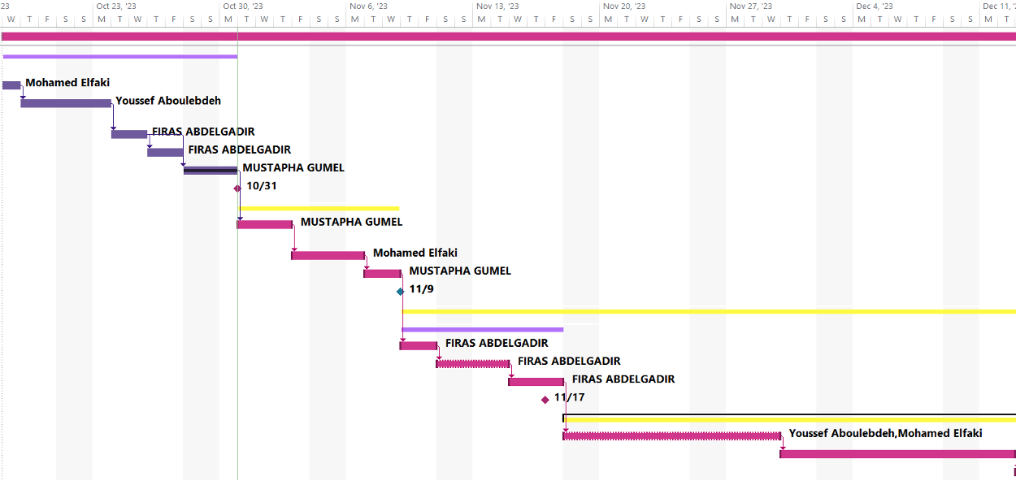

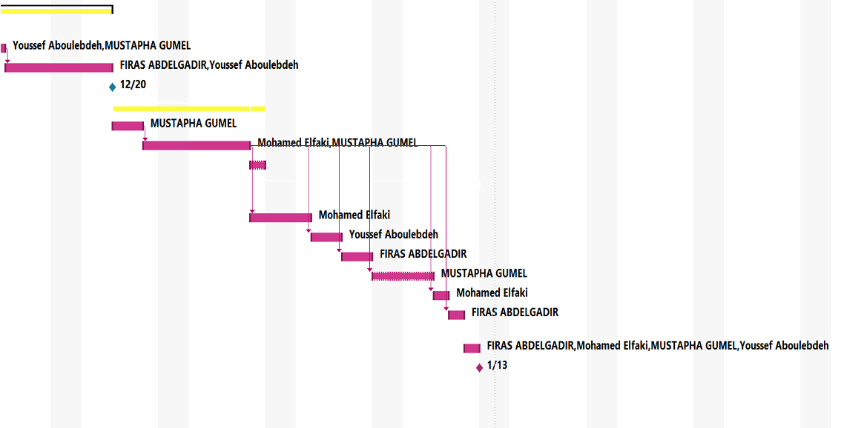

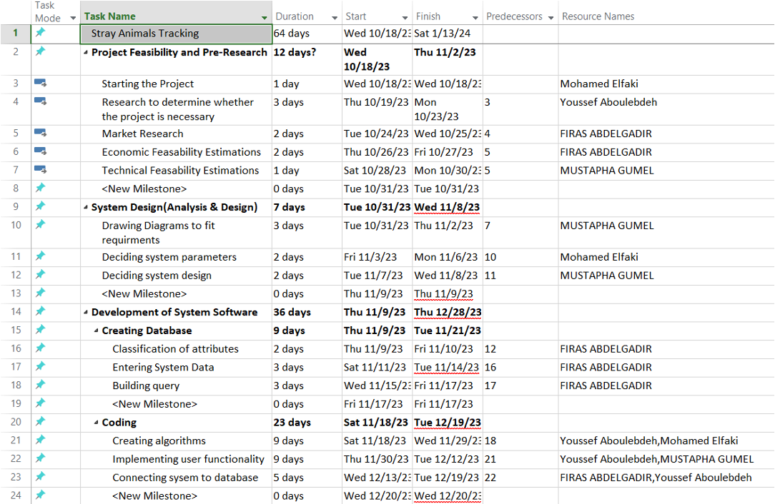

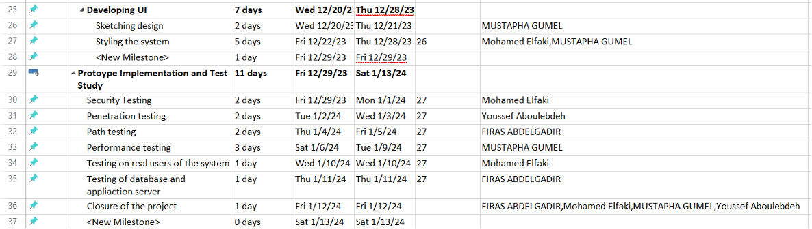



**C.1.2 List of Work Packages**

|  |  |
| --- | --- |
| **Work Package No** | 1 |
| **Work Package Name** | **Project Feasibility and Pre-Research (Feasibility Analysis)** |
| **Start-End Date and Time** | 10/18/23 - 11/2/23 |
| **Related Organizations** | - |
| **1- List the activities of work packages.** | | |
| **1.1 Project Process and Economic Feasibility:**   * In the phase of market research, we will be conducting thorough searches for similar projects to discover and analyze whether this system is really required. * Outlining the main risks that we may face during the production of the project * Approximating revenue and expenses for the project using COCOMO * Reaching a conclusion on whether the project is economically feasible, and whether it is profitable in the long run.   **1.2 Technological Feasibility:**   * Selecting the necessary technical foundation needed to operate the project * Deciding if the technology we have at the present time will be enough to satisfy all the project requirements and functionalities, and if not, whether or not obtaining said technology will significantly offset our projected expenses. | | |
| **2- Describe the methods and parameters that will be used for work package.** | | |
| To develop a stray animal tracking app that is completely functional, we will be conducting meticulous analysis of similar projects, as well as holding stakeholder and end-user meetings to learn about their expectations, suggestions, and points of view. The meetings will also allow us to learn about the possibility of the project being implemented, in terms of its technological and financial viability | | |
| **3- List the experiments, tests and analysis in the work package.** | | |
| * Examine comparable systems * Create a report with revenue and expense estimates. * Risk estimations * Distributing work tasks * Interview potential users for enhanced requirement specification | | |
| **4- List the output of work package and its success criterias.** | | |
| **Outputs:**   * Establishing a transparent task allocation and management hierarchy * Establishing an understanding about the Stray Animals project * Estimation of profits and costs   **Success Criteria:**   * Team being familiar with the project, and what’s expected of them. * Determining the project's profitability * Recognizing the dangers that the project faces | | |
| **5- Explain the relation of output with other work packages** | | |
| For the project to be successful, this work package is essential. Economic and Technological feasibility analysis sets clear expectations for the project moving forward. In addition, it makes the team aware of the risks that come with the project, and presents clear guidelines that will help mitigate, and perhaps even avoid, said risks. | | |



|  |  |
| --- | --- |
| **Work Package No** | 2 |
| **Work Package Name** | **Based System Design Technology (Analysis & Design stage)** |
| **Start-End Date and Time** | 10/31/23 - 11/8/23 |
| **Related Organizations** | - |
| **1- List the activities of work packages.** | | |
| * Requirement Specifications * Design of Systems * Hardware Study * System Evaluation * Data Flow Definitions | | |
| **2- Describe the methods and parameters that will be used for work package.** | | |
| * Dividing the group into more manageable subgroups * Producing Data Flow Diagram * Producing decision table and flowchart * Making a prototype | | |
| **3- List the experiments, tests and analysis in the work package.** | | |
| * Assembling design concepts * Creating samples * Preparing Logical Design * Preparing Physical Design | | |
| **4- List the output of work package and its success criteria.** | | |
| **Outputs:**   * Design entire software * Completing System Models and Diagrams   **Success Criteria:**   * Obtaining a structure that is designed to achieve the objectives * Creating remedies for the system's potential risks * Investigation of the system as a whole | | |
| **5- Explain the relation of output with other work packages** | | |
| This work package's output will serve as the foundation for the functionality of the subsequent work packages, especially the program development and implementation stages. For this purpose, the analysis and design stage must be done with utmost care, to ensure smooth workflow for the future stages. | | |

|  |  |
| --- | --- |
| **Work Package No** | 3 |
| **Work Package Name** | **Development of System Software (Development Stage)** |
| **Start-End Date and Time** | 11/9/23 - 12/28/24 |
| **Related Organizations** |  |
| **1- List the activities of work packages.** | | |
| * Develop a user-friendly software * Develop Database * Coding and developing algorithms * Implementing system requirements * Connecting system to the database | | |
| **2- Describe the methods and parameters that will be used for work package.** | | |
| * Relational database creation using SQL * For system structure, use HTML * CSS to style the system * Visual Studio Code as the IDE * Java and Python as the main programming languages | | |
| **3- List the experiments, tests and analysis in the work package.** | | |
| * Check if the requirements are compatible. * Check the system's functionality. * Unit Testing * Check algorithms for unnecessary codes | | |
| **4- List the output of work package and its success criterias.** | | |
| **Outputs:**   * A finished, working prototype of the system * All set for testing   **Success Criteria:**   * Completed interface that is user friendly * Well done database, and establishing a good connection between the system and the database * Reduced risk of errors | | |
| **5- Explain the relation of output with other work packages** | | |
| This work package's output offers a fully functional prototype, that is ready to be taken into the testing stage. | | |

|  |  |
| --- | --- |
| **Work Package No** | 4 |
| **Work Package Name** | **Prototype Implementation and Test Study and Maintenance (Test & Maintenance stage)** |
| **Start-End Date and Time** | 12/29/23 - 1/13/24 |
| **Related Organizations** |  |
| **1- List the activities of work packages.** | | |
| * Security Testing * Penetration Testing * Path Testing * Performance Testing * Testing the system with actual users * Testing of database as well as application server | | |
| **2- Describe the methods and parameters that will be used for work package.** | | |
| * Unit Testing * UI testing * Security Testing * Compatibility Testing * Performance Testing | | |
| **3- List the experiments, tests and analysis in the work package.** | | |
| * Test in various scenarios and situations. * Cross-platform testing | | |
| **4- List the output of work package and its success criterias.** | | |
| **Outputs:**   * Determine the system bugs * Produce error reports * Fix the bugs     **Success Criteria:**   * All of the system's modules operate correctly and in the desired way. | | |
| **5- Explain the relation of output with other work packages** | | |
| * Should the task package be completed correctly, at the end of the testing stage, the Stray Animals Tracking project will not only be ready to use, but it will also be reliable, secure, and user-friendly, and the only remaining step would be to release it to the public. | | |

# C.1.3 List of Milestones (should be matched in the Gantt chart)

|  |  |  |
| --- | --- | --- |
|  | **Description of Output** | **Expected Time Interval** |
| 1 | **Project Feasibility and Pre-Research** | **10/18/23 - 11/2/23** |
| 2 | **System Design (Analysis & Design)** | **10/31/23 - 11/8/23** |
| 3 | **Development of System Software** | **11/9/23 - 12/28/23** |
| 4 | **Prototype Implementation and Test Study** | **12/29/23 - 1/13/24** |
| 5 | **Closure of the project** | **1/12/24** |

* w

# C.1.4 List of Risks

* **Risk assessment Table**

|  |  |  |  |  |  |
| --- | --- | --- | --- | --- | --- |
| Risk Number | Risk Description | Risk Probability | Risk Effect | Risk Scores | B-Plan |
| R1 | Insufficient animal reporting data | 0.50 | 0.60 | 0.30 | Encourage users to report more and offer compensation for collected stray animals due to their report. |
| R2 | Low user engagement | 1.00 | 0.90 | 0.90 | Make the app user-friendly, with little ads and implement marketing strategies. |
| R3 | Project budget higher than expected | 0.40 | 1.00 | 0.40 | Use strategies such as crowdfunding and starting an IPO to sell shares to investors. |
| R4 | Inaccurate animal reporting data | 0.80 | 0.50 | 0.40 | Only allow users logged in with their email and phone number to report animals, a user rating system will be implemented to perceive how accurate every user’s animal reports are. |
| R5 | Data Security and privacy | 0.60 | 0.90 | 0.54 | Strong security measures such as encryption, privacy policies and user authentication. |
| R6 | Technical issues | 1.00 | 0.20 | 0.20 | Test the project repeatedly and perform quality assurance. |
| R7 | Users not always connected to the internet | 0.50 | 0.40 | 0.20 | Allow users to report animals offline and then upload those reports to the cloud when an internet connection is established |
| R8 | Outdated data | 0.80 | 0.30 | 0.24 | Our team will update the database regularly based on which strays have been adopted and users will be able to constantly update reports to inform the stray animal's new location or ensure the location hasn’t changed up to a certain date |

* **Risk Table**

|  |  |  |  |
| --- | --- | --- | --- |
| **Risk** | **Probability** | **Effects** | **Your Strategy** |
| 1.Insufficient animal reporting data | Moderate. | Tolerable | Encourage users to report more and offer compensation for collected stray animals due to their report. |
| 2.Low user engagement | High. | Serious | Make the app user-friendly, with little ads and implement marketing strategies. |
| 3.Project budget higher than expected | Moderate. | Serious | Use strategies such as crowdfunding and starting an IPO to sell shares to investors. |
| 4.Inaccurate animal reporting data | High. | Tolerable | Only allow users logged in with their email and phone number to report animals, a user rating system will be implemented to perceive how accurate every user’s animal reports are. |
| 5.Data Security and privacy | Moderate. | Serious | Strong security measures such as encryption, privacy policies and user authentication. |
| 6.Technical issues | High. | insignificant | Test the project repeatedly and perform quality assurance. |
| 7.Users not always connected to the internet | Moderate. | Tolerable | Allow users to report animals offline and then upload those reports to the cloud when an internet connection is established |
| 8.Outdated data | High. | insignificant | Our team will update the database regularly based on which strays have been adopted and users will be able to constantly update reports to inform the stray animal's new location or ensure the location hasn’t changed up to a certain date |

* C.2 Project Management and Organization

# C.2.1 Project Team

|  |  |  |  |  |  |  |
| --- | --- | --- | --- | --- | --- | --- |
| **Personnel Name** | **Title** | **ID** | **Education Status** | **Graduation Date** | **Date of Starting Work** | **Idea Owner** |
| Mohamed Elfaki | Project Manager / System Analyst | 22900158 | Undergraduate | 2026 | October 14th 2023 | Yes |
| Mustapha Ali Gumel | UI designer | 22900221 | Undergraduate | 2026 | October 14th 2023 | Yes |
| Firas Abdelgadir | Database developer | 22703822 | Undergraduate | 2026 | October 14th 2023 | Yes |
| Yousef aboulebdeh | Tester/Programmer | 22703966 | Undergraduate | 2026 | October 14th 2023 | Yes |

# C.2.2 Organization Scheme (an example is given below!)

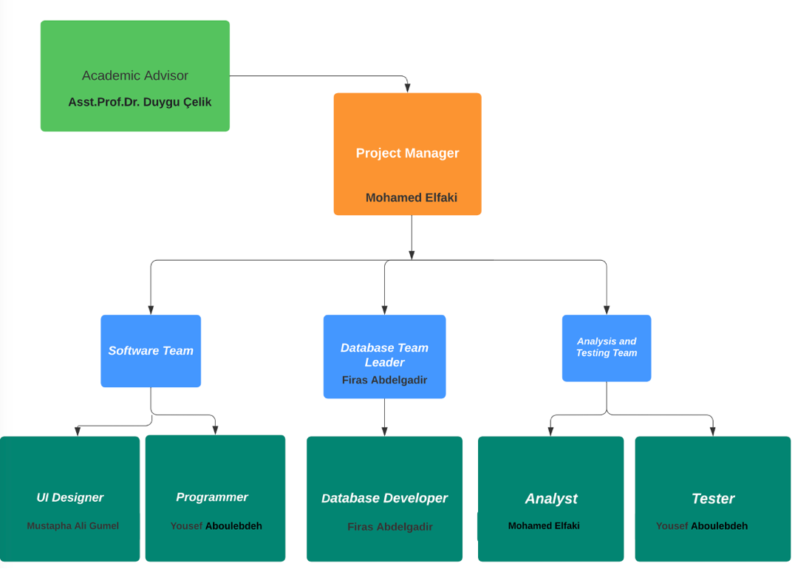

D.1 Economic Forecasts

|  |
| --- |
| **1- Evaluate the commercialization potential of project outcomes. List possible risks here?** |
| These are the factors be conceded and potential risks associated with commercializing stray animal tracking technology if this project is to be commercialized, the demands of the project will be high cause it will help a lot in bringing the solution to the stray animal problem and will provide pet lover to own one. The possible risks may involve data privacy, operational costs, natural and environmental factors; the essential objective is frequently social and moral, instead of profit driven. In any case, guaranteeing money related maintainability is basic to continue providing care for stray animals and tending to the related challenges. Cautious arranging, straightforwardness, and a center on the well-being of creatures are key to moderating dangers and improving the project's commercialization potential. |



|  |  |
| --- | --- |
| **2- List your expectations to your team which are come by your project** | |
| Time-to-market (month): | 12/01/2024 |
| The expected increase in sales revenue (%): | %8 |
| The expected increase in market share (%): | %7 |
| Time to start to gain: | 2 years after production |

D.2 National Outcomes

|  |
| --- |
| **1- Specify the output that may be subject to patent, utility model and industrial design registration in the project.** |
| 1. This app may be subject to utility model through its unique animal breed scanner, which is not found in any other stray animal care app. 2. It can also be subject to industrial design registration through its distinctive design consisting of pink and blue which gives you a one of a kind feel in combination with the app logo. 3. The app may also be subject to a patent due to its unique algorithm for connecting animal strays with their potential owners. |
| **2- Explain the potential of project and its outputs that may have an effect on social life, education, health and etc.** |
| 1. Life in society: The app creates public awareness to help stop people from walking past their doors, seeing stray animals, and continuing to move their ways mildly unworried. This app will help solve the problems of stray animals and I believe they can do much to help or are uncertain as to the actions they should take. 2. Education: This app will help in teaching pet owners about pets' behavior, welfare, safeties and can teach users the importance of caring for animals 3. Health: This app will help in reducing the spread of animal diseases outbreaks it is going to reduce the rate in which stray animals are being killed on the road and street etc. The app can contribute to mental health by fighting against animal suffering. |
| **3- Explain the positive and negative effects of project outputs for environment and human being.** |
| Regarding our favorable outcomes:   1. Animal welfare: This app is designed to trace and locate stray animals effectively to reduce the number of stray animals on the street and to have proper shelter and appropriate care. 2. Community engagement: This app brings about community engagement to work hard to identify and address the communities’ needs and concerns regarding the local stray animal population, to ensure that everyone has a voice in developing effective solutions. 3. This app has a future that helps identify and count the percentage of animal species in an area, state, county.     In the adverse outcomes we experience:   1. False information: some people may use the app just for fun to report stray animals for malicious reasons, and time wasting and potentially causing harm to innocent animals |

* (M013) Instrument / Equipment / Software / RELEASE PURCHASES

|  |  |  |  |  |  |  |  |  |  |  |  |
| --- | --- | --- | --- | --- | --- | --- | --- | --- | --- | --- | --- |
| **Project Name** | |  | | | | | | | | | |
| **Line no** | **Instrument / Equipment / Software / Publication Name** | | **No. of Item** | **Capacity** | **Technical specification** | **Purpose of Project Activities** | **Post-Project Place of Use / Purpose** | | **Unit Price (USD)** | **Unit Price (TL)** | **Total Amount (TL)** |
| **R & D** | **Production** |
| **1** | Internet Connection | | 1 |  | Min. 6Mpbs | Connection | Yes | Yes | 50 | 1400 | 1400 |
| **2** | Laptops | | 4 |  | Min 100GB storage, Min core i5/i7 intel or equivalent, more 4GB ram | Involved in every task since it’s the medium of project creation | Yes | Yes | 1000 | 28100 | 28100 |
| **3** | MS Project | | 1 |  | Project Task management software | Planning | Yes |  | 30 | 850 | 850 |
| **4** | Office 365 | | 1 |  | All useful office related programs | Management | Yes |  | 100 | 2800 | 2800 |
| **5** | SQL | | 1 |  | Database query tool | Database operations |  | Yes | 120 | 3400 | 3400 |
| **6** | JavaScript | | 1 |  | Coding language for developing the website | Coding |  | Yes | 80 | 2250 | 2250 |
| **7** | Visual Studio Code | | 1 |  | Coding IDE | Coding |  | Yes | 0 | 0 | 0 |
| **8** | Java | | 1 |  | Coding language for the app | Coding |  | Yes | 50 | 1400 | 1400 |
| **9** | Modelio | | 1 |  | Coding language for the app | Coding | Yes |  | 420 | 11900 | 11900 |
|  |  | |  |  |  |  |  |  |  | TOTAL | 52,100TL |
|  |  |  |  |  |  |  |  |  |  |  |  |

* (M030) Quarterly Estimated Cost Form (TL)

|  |  |  |  |  |
| --- | --- | --- | --- | --- |
| **Project Name : Stray Animals tracker app** | | | | |
| **Cost Item** | **2023-2024** | | **TOTAL**  **(TL)** | **TOTAL COST RATE OF CONTENTS (%)** |
| **I** | **II** |
| **Personnel** | 8,000 | 8,000 | 16,000 | 40% |
| **Travel** | - | - | - | - |
| **Instrument / Equipment / Software / Publications** | 4,000 | 4,000 | 8,000 | 5% |
| **Domestic Works Made By R & D and Testing Institutions** | 7,000 | 7,000 | 14,000 | 20% |
| **International Works Made By R & D and Testing Institutions** | - | - | - | - |
| **Domestic Services Procurement** | 10,000 | 10,000 | 20,000 | 5% |
| **Overseas Service Procurement** | - | - | - | - |
| **Material** | 18,000 | 18,000 | 36,000 | 30% |
| **TOTAL COST** | 47,000 | 47,000 | 94,000 | 100 |
| **CUMULATIVE COST** |  |  |  | 100 |
| **IN THE PROJECT TOTAL MAN-MONTH** | | | 94,000 | |

* APPENDIX
* Perform estimation of effort (Man/month), required total time duration, and required number of team members by using COCOMO approach (or other methods are possible).   
   **COCOMO Estimation**

|  |
| --- |
| We are calculating for JAVA Programming Language  The project we use the organic mode cause of the team members' numbers and does not require many codes. It carries minimal risk.  E = a(kloc)^b = 2.4(50) ^1.05 = 145.93PM  D= c(E)^d = 2.5(145.93) ^0.38 = 16.61M  SS = E/D = 145.93/ 16.61= 8.79 people  P = kloc/E = 50/145.93= 0.34KLOC/PM |

* CPM (Critical Path Management) analysis by using PERT (defining paths)
* Pert Analysis

|  |  |  |  |  |  |  |
| --- | --- | --- | --- | --- | --- | --- |
| Activity | Description | Optimistic Time | Most Likely Time | Pessimistic Time | Expected Time | Prerequisites |
| A | Project Feasibility and pre-research | 12 | 15 | 16 | 15 | - |
| B | System Design | 7 | 8 | 11 | 8 | A |
| C | Development of system software | 38 | 42 | 47 | 43 | B |
| D | Creating Database | 18 | 21 | 24 | 21 | C |
| E | Coding | 23 | 26 | 29 | 26 | D |
| F | Developing UI | 7 | 8 | 9 | 8 | E |
| G | Prototype Implementation | 4 | 5 | 7 | 5 | F |
| H | Test Study | 7 | 9 | 11 | 9 | F |
| I | Documentation | 1 | 2 | 3 | 2 | H, I |

* In this table, we used the pert expected time formula.
* (Optimistic Time + (4 * Most Likely Time) + Pessimistic Time) / 6 is the expected time.
* Critical Path Table

|  |  |  |
| --- | --- | --- |
| Paths | Calculations | Total expected time for each path |
| ABCDEFGI | 15+8+21+26+8+5+2 | 85 |
| ABCDEFHI | 15+8+21+26+8+9+2 | 89 (C.P) |

* The critical path is ABCDEFHI.
* Creating network diagram of the main tasks in WBS

Network Diagram

* 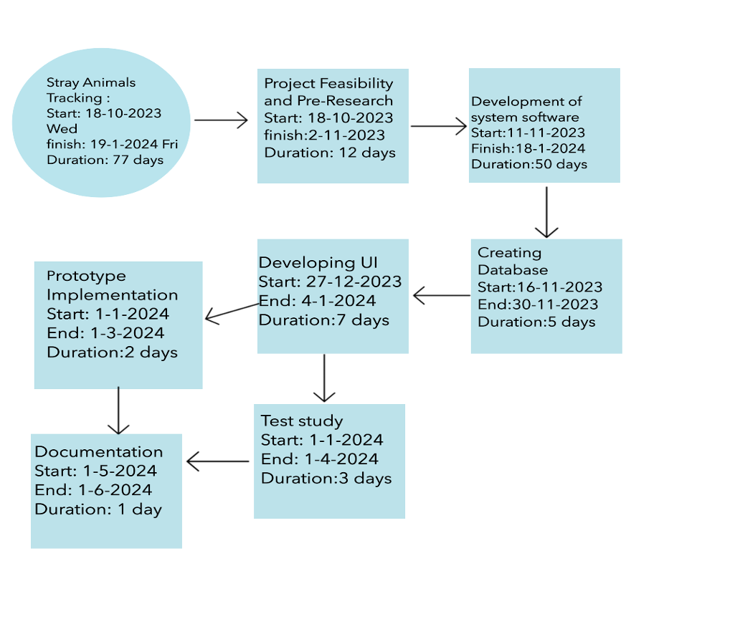Calculating probability of successful completion rate for each path

Variance for each activity

|  |  |  |  |  |
| --- | --- | --- | --- | --- |
| Tasks | Optimistic Time | Most Likely Time | Pessimistic Time | Variance of Each Tasks |
| A | 12 | 15 | 17 | 0.833 |
| B | 7 | 8 | 10 | 1.000 |
| C | 38 | 42 | 47 | 1.500 |
| D | 18 | 21 | 25 | 1.167 |
| E | 23 | 26 | 29 | 1.000 |
| F | 7 | 8 | 9 | 0.333 |
| G | 4 | 5 | 7 | 0.667 |
| H | 7 | 9 | 12 | 0.833 |
| I | 1 | 2 | 3 | 0.333 |

Variance formula is:

where p is the estimated pessimistic activity time.

where the activity time estimate, o, is optimistic.

Variance and Standard Deviations of Each Path

|  |  |  |  |
| --- | --- | --- | --- |
| Paths | Variance of each Activity | Total Variance of Each Path | Total Standard Deviation of Each Path |
| ABCDEFGI | 0.833+1+1.5+1.167+1+0.333+0.667+0.333 | 6.833 | 2.614 |
| ABCDEFHI | 0.833+1+1.5+1.167+1+0.333+0.833+0.333 | 6.999 | 2.646 |

The formula for the Total Standard Deviation of Each Path is:

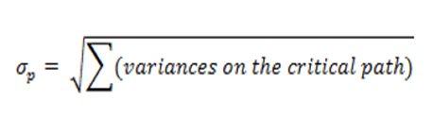

Probability of a Successful Completion

|  |  |  |  |  |  |  |
| --- | --- | --- | --- | --- | --- | --- |
| Paths | Paths specified Time | Total Expected Time for Each Path | Path Variance | Path Standard Deviation | Z-Values | Probability of Finishing |
| ABCDEFGI | 77 | 86 | 6.833 | 1.317 | 0.9049 | %90.5 |
| ABCDEFHI | 77 | 89 | 6.999 | 1.715 | 0.9573 | %95.7 |

* Z is equal to Path Standard Time / (Specified Time - Path Expected Time).
* Crashing approach, etc. techniques and the results can be written here.
* Reducing the time of the project (Crashing)

|  |  |  |  |  |  |  |
| --- | --- | --- | --- | --- | --- | --- |
| **Work Package Name** | **Crashing Time (days)** | **Normal Time (days)** | **Normal Cost (USD)** | **Crash Cost (USD)** | **Max no. of days to reduction** | **Reduce Cost Per day (USD)** |
| Project Feasibility and pre-research | 10 | 15 | $1000 | $1500 | 5 | $100 |
| System Design | 6 | 8 | $600 | $900 | 2 | $150 |
| Development of system software | 40 | 43 | $3000 | $4500 | 13 | $500 |
| Creating Database | 15 | 21 | $1500 | $2100 | 6 | $100 |
| Coding | 20 | 26 | $2000 | $2800 | 6 | $133 |
| Developing UI | 5 | 8 | $500 | $3000 | 3 | $833.33 |
| Prototype Implementation | 3 | 5 | $300 | $500 | 2 | $100 |
| Test Study | 8 | 9 | $600 | $900 | 3 | $300 |
| Documentation | 1 | 2 | $100 | $200 | 1 | $100 |

* Reduce Cost Per Day = (Crash Cost – Normal Cost) / (Normal Time – Crashing Time)

# 3. REQUIREMENTS ANALYSIS

## 3.1 Functional Requirements

## Product Perspective

Stray Away is a mobile application combined with a supporting website that revolutionizes the way we take care of helpless stray animals. The following figure sums up the outline, displaying the stakeholders and system interfaces. The system will be in mobile application form, as it is the device that will most likely be with our users when they need to report a stray animal sighting.

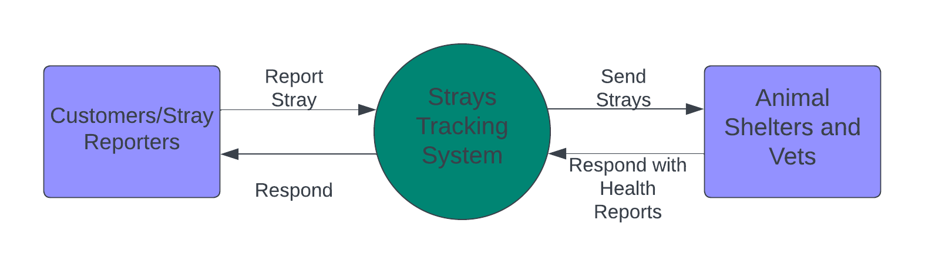

## Product Functions

* Log in
* Create an account /sign in
* View home page
* AI camera
* Search
* Cart
* Adoption
* Help
* About us
* Learn about animals
* Report
* Setting
* Donation
* Contact

## User Classes and Characteristics

* **App Administrators** are instrumental in keeping up the general well-being, safety, performance and usability of the StrayAway app, making their part basic for the success of the application.
* **Animal Welfare Organizations** play an important role in adopting stray animal tracking applications to enhance rescue operations, streamline care, and facilitate community engagement.
* **Pet Proprietors and Volunteers** would specifically contribute to the center capacities of the app, which incorporate detailing, protecting, and planning endeavors to assist stray animals.

## Operating Environment

The system requires the following software and hardware requirement platforms to run ideally:

Operating Systems: Windows 7 and above, macOS version 10 and above, Android version 7.0 and above, IOS 11 and above.

Web Browsers: Google Chrome, Mozilla Firefox, Brave Browser, Safari, Microsoft edge, Opera.

## Design and Implementation Constraints

Hardware limitations:

Processor: Intel core i3 equivalent or higher required

RAM: 2GB minimum

HDD/SSD storage: 5GB minimum

Other limitations: Java and JS embedded in HTML should be used to create the application, to be available through IntelliJ IDE then eventually displayed to the public through a server.

## User Documentation

The application will be delivered along with a user-guide for amateurs, guiding them throughout the functions of the system. A help guide will also be provided to address issues in future use.

## Assumptions and Dependencies

Assumptions:

The User is assumed to have an internet connection at least occasionally.

The Users system meets Hardware compatibility.

Dependency:

Web Brower compatibility for the website and device used.

App store and google play compatibility with the App and device.

# External Interface Requirements

## User Interfaces

Homepage will prompt the user to login or register

The system will notify the user if wrong credentials are entered.

New users will be provided with a tutorial (could be skipped).

There will be a navigation bar showing links to different sections for user-friendly exploration.

All interfaces will have a back button.

Custom pages for 404 errors or other common issues, providing guidance.

## Hardware Interfaces

Hardware should have internet access through LAN, WLAN, WAN and other network types. The Hardware should also meet the minimum Hardware limitations mentioned in 2.5 to enable them to reach the minimum required versions mentioned in 2.4 which ensures compatibility with StrayAway. The device should have location tracking capabilities in order to report the location of the stray animals and collect data more accurately.

## Software Interfaces

The StrayAway initiative is designed to work seamlessly with Windows 7 and later, macOS 10 and later, Android 7 and higher, as well as IOS 11 and newer. It utilizes a RDBMS for a user-friendly operation, and to simplify the process of maintaining, controlling, and updating the database.

## Communications Interfaces

To ensure efficient data transfer between StrayAway servers and the client application, HTTPS is used. HTTPS is used over HTTP due to its additional security. For other efficient file transfers as well as encryption FTPS is used. To send efficient emails, verification codes and others SMTP is used, on the other hand IMAP is used to receive messages. SSL is incorporated through the use HTTPS and FTPS as previously mentioned.

# System Features

## User Registration and Profiles

4.1.1 Description and Priority

Client enrollment and profiles are pivotal components of the StrayAway app. They play a critical role in building up a user's identity, empowering communication, and keeping up a strong community interior. The requirements of client enrollment and profiles are long and have got to be among the starting highlights executed inside the StayAway app.

4.1.2 Stimulus/Response Sequences

It makes a difference in recognizing potential focuses of interaction and responding, guaranteeing that the app reacts fittingly to client activities, though some functions may be automatically triggered.

3.1.1. User Requirements

REQ-1: New users shall be able to register a new account.

REQ-2: Users shall be able to change their profile username

REQ-3: Users shall be able to change their pet Wishlist.

REQ-4: Users shall be able to provide new contact information or edit it.

REQ-5: Users shall be able to turn on 2 factor authentication

REQ-6: Users shall be able to change the language of the app/website.

REQ-7: Users shall be able to change their password if forgotten.

## 3.1.2. Notifications and Alerts

Description and Priority

This helps in keeping the users updated and informed about the stray animal tracking app and overall priority is high, allowing users to customize their notification preferences is essential to avoid overwhelming them with information and ensure a positive user experience.

Stimulus/Response Sequences

The effectiveness of these sequences contributes to the overall success of the app in facilitating community engagement and improving the welfare of stray animals. Functions such prompting the user to turn on notifications will be done automatically by the system.

REQ-1: The user shall be able to customize the content of notification

REQ-2: The user shall have the option to receive notifications via email.

REQ-3: The user shall receive notifications promptly for timely information.

REQ-4: The notifications should be delivered in the user’s preferred language.

REQ-5: The user shall be able to turn off notifications and alerts.

REQ-6: The system shall provide clear instructions on how to enable and disable notifications.

3.1.3. Donation and Fundraising

Description and Priority

The donation and fundraising module are a high-priority module component of the StrayAway project, incorporating key features such as donation collection, donor management, reporting analytics, safety and security measures, user notifications, accessibility, user experience improvements, and considerations for performance and scalability. Its purpose is to establish a secure and user-friendly environment for streamlined donation management and successful fundraising initiatives, aligning seamlessly with the project's comprehensive objectives.

Stimulus/Response Sequences

We create a social media post that shows stray animals in need of help to call the attention of people who are interested and then we provide a link to a donation page, the response results in potential donations by the audience.

REQ-1: user shall be able to view their donation history.

REQ-2: user shall be able choose the amount they want to donate.

REQ-3: user shall be able to choose what payment method they want to use in the donation.

REQ-4: The user shall be able to share their donations on social media.

REQ-5: The user shall be able to see the donation goal and its current status.

REQ-6: The user shall be able to donate anonymously

REQ-7: The user shall have the option to make recurring donations.

3.1.4. Other Requirements

REQ-1: The user shall be able to search for reported stray animals by name, breed or by picture

REQ-2: The user shall be able to receive a notification for available pet ready for adoption

REQ-3: The user shall be able to update the status of reported animals' information

REQ-4: The user shall be able to see the location of the adoption centre

REQ-5: The user shall be able to receive notifications when new animals are reported

REQ-6: The user shall be able to apply to adopt a pet

REQ-7: The user shall be able to add picture to their profile

REQ-8: The user shall be able to edit their profile

REQ-9: The user shall be able to indicate whether the animal is friendly or aggressive.

REQ-10: Users shall be able to reset login password if needed.

REQ11: Users shall be able to Evaluate and review the accuracy of reported animal information.

REQ-12: Users shall be able to upload picture of stray when reporting stray.

REQ-13: Users shall be able to view the record of reported stray animals

REQ-14: Users shall be able to share donation post of social media

REQ-15: The user shall be able to book an appointment for your own pets

REQ-16: The user shall be able to view location of the veterinarians

REQ-17: The user shall be able to login using Instagram, Facebook, Twitter or Goole

REQ-18: The user shall be able to see full details about pet before adopting

## 3.2 Non-Functional Requirements

3.2.1. Performance Requirements

* The app should be able to run within a short time frame
* The system must be able to handle increasing numbers of concurrent users and transactions
* The system should be able to process a high volume of data efficiently
* The system should ensure that multiple users do not face significant delays
* The system should ensure that security measures do not have an undue impact on performance.
* The system should have the ability to handle hardware and software failure
* The system should have an availability of 95% to ensure the app is consistently available for customers

3.2.2. Safety Requirements

* Encryption is required for any communication between the information server of the framework and its clients that happens remotely.
* The system should be saving and backing up data in case of system failure to the clouds.
* The system should provide tips and guidelines to educate the user on how to use this app.
* The system should encrypt communication channels to protect unauthorized access to data.
* The system should implement secure account recovery to ensure legitimate users can regain the account if needed.

3.2.3. Security Requirements

* The system should encrypt sensitive data which includes user information, animals' data and others stored in the database.
* The system should allow users to share their location when necessary.
* The system should regularly backup data to ensure secure data.
* The system should provide tips to educate the user on how to protect the account.
* The system should create comprehensive logging to track user activity.

## 3.3 Realistic constraints

* Anyone can use our system as it is free of charge.
* Our project is mainly software based, but it also aids the environment by assisting stray animals, and mitigating potential environmental impacts associated with neglected animal populations.
* People above 7 years old can use our app, as it is easy to use and user-friendly.
* There aren’t any political constraints as everyone benefits from using our app.
* The ethical constraints in developing the app are aimed at assisting with stray animals. The project must prioritize the welfare of animals, ensuring that interventions are humane and respectful. Users get clear guidance on safely interacting with animals, and educational efforts focus on potential risks.
* The project will commence in Cyprus, and as it grows, more veterinarians and clinics will be involved. We will ensure that the ratio of vets and clinics to the area maintains consistency as the project expands.
* The software product is designed to be scalable, maintainable, and adaptable to evolving user needs and technological advancements, ensuring its effective use over the long term.

## 3.4 Ethical issues

* Privacy concern: This app collects and stores information about users, including where they are and what animals they have or interact with, this information may be used to track individuals’ movements or to identify them as animal lovers. If this data is not maintained and secure privacy concern may arise.
* Animal welfare implications: If the app encourages individuals to trap and remove stray animals from their surroundings, it might have a severe influence on animal welfare.
* Precision and dependability A faulty or untrustworthy software may cause users to waste time and money looking for stray animals that are not there.

## Business Rules

* The system should allow only verified users to add a report.
* The system should only update health status and vaccination records by authorized personnel.
* The user can only report strays if they have a slate of accurate report drafts.
* The system shall allow users to deactivate their accounts only after following certain steps.
* The system shall monitor the community chat and only filter inappropriate comments.

# 4. DESIGN

## 4.1 High level design (architectural)

**Use Case Diagram**

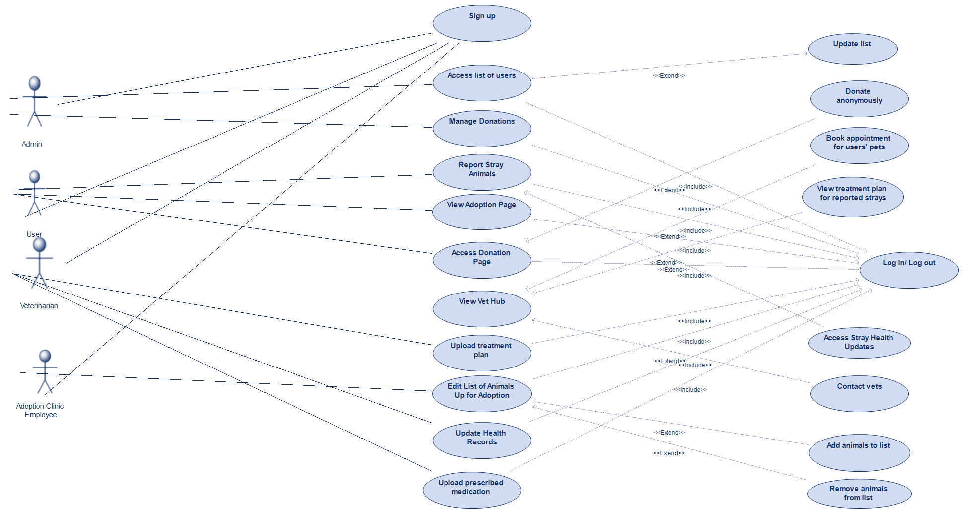

In the use case diagram, you can see our four actors, the user, admin, veterinarian and employee at the adoption clinic accessing and interacting with the main functionalities in our project, which consist of the additions <include> and <extend>.To execute any functionality, the actor must have already logged in to the system, which explains why we’ve implemented an <include> relationship between our main processes and the log in functionality. The only functionality that does not require an <include> relationship is the Create Account functionality, which makes sense as the user that already has an account can and should be able to sign in directly without having to create another account, which would be redundant. The next addition is the <extend> relationship, used to provide extra functionalities that become available once the extended functionality is executed, or” pressed on”. We’ve implemented this specific relationship for multiple of our functionalities, such as the Donate Anonymously functionality, which could only be executed if the user has already accessed the donation page, or the Access Stray Health Updates functionality, which could only be accessed if the user has already reported a stray animal before.

## Sequence Diagrams

**-For Signup Functionality:**

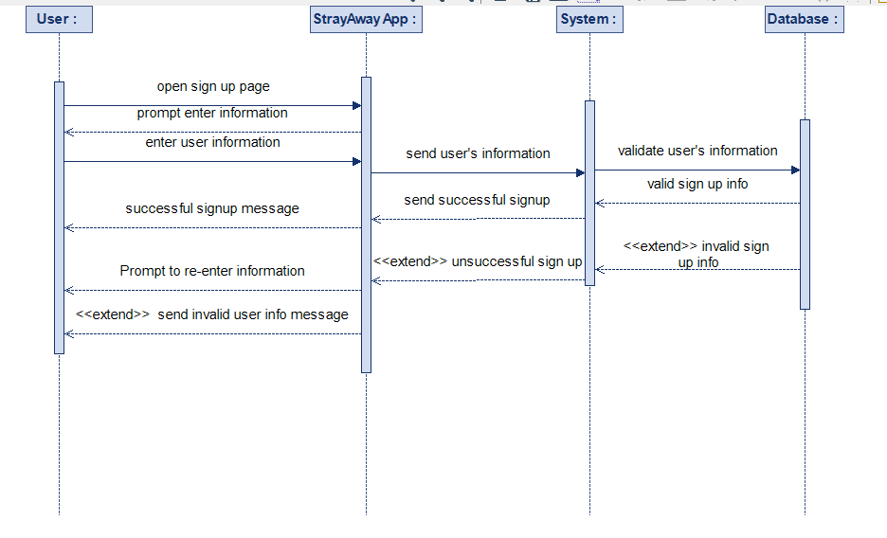

The sign-up process in the StrayAway App involves the user initiating registration, entering personal details, and submitting the information. The app then transfers this data to the system, which validates it for accuracy and completeness. If successful, the system creates a secure user account in the database and confirms the registration to the user. The user is then redirected to the main dashboard for app access. In case of errors, the system prompts the user for corrections. Possible enhancements include email verification and additional steps for a more robust sign-up process. An example interaction details the user tapping "Sign Up," filling the form, system validation, confirmation, and dashboard access upon successful registration.

**-For Login Functionality:**

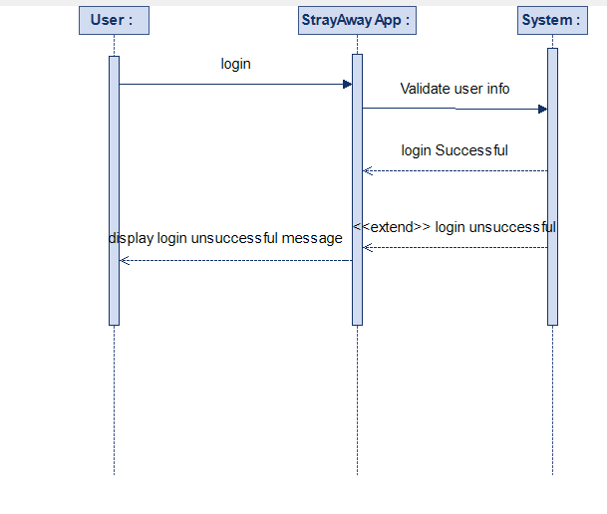

The login functionality in the StrayAway App involves a sequence of interactions among the user, app, system, and database. The user opens the login page, enters credentials, and the app sends this data to the system. The system validates the credentials, authenticates the user if valid, and sends a success message, redirecting the user to the main dashboard. In case of invalid credentials, the system prompts correction. Potential enhancements include additional security measures like OTP (one-time password) and an option to save login credentials. The diagram illustrates this process, highlighting the flow of messages and alternative scenarios for user interaction and system responses.

**-For Adoption Functionality:**

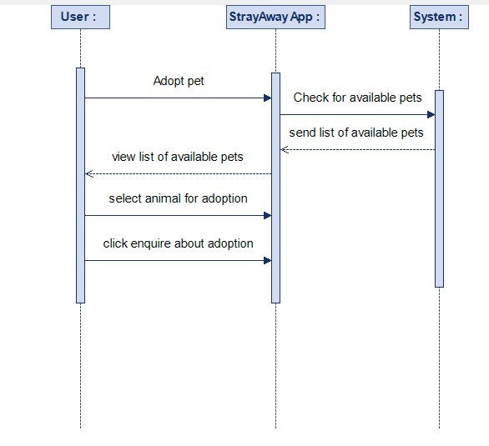

The Adoption Functionality in the StrayAway App involves interactions among the User, the App, the System, and the Database. The user opens the adoption page, views the list of available pets, and selects a pet. The app facilitates an adoption request, sending it to the system for validation. If valid, the system notifies the pet owner, who can approve or reject the request. If approved, the system updates the pet's status, and the user receives a notification to collect the pet. The alternative flow involves error correction and rejection notifications. Potential extensions include user preferences, detailed pet information, pre-adoption communication, and scheduling meetings. An example illustrates the user selecting a dog, enquiring about adoption, and successfully adopting the pet from the owner.

**-For Reporting Functionality:**

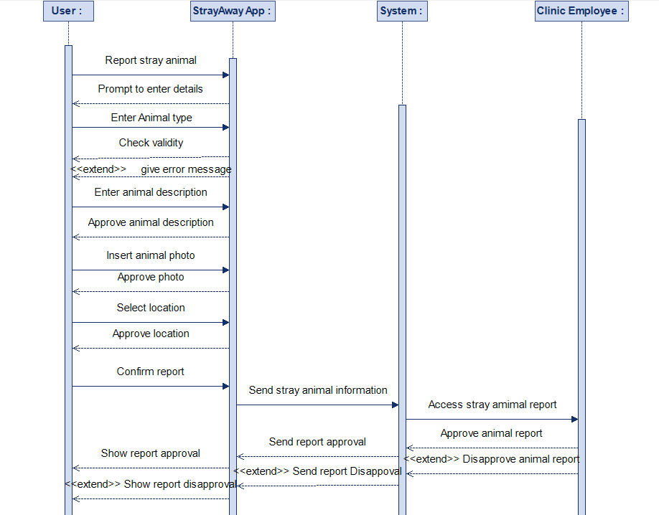

The StrayAway App's Reporting Functionality Sequence Diagram shows how the User, App, System, and Database interact with one another. The user opens the reporting page and provides details as well as a photo of the animal. The app sends this report to the system for validation. If valid, the system stores it in the database and notifies clinic employees. Clinic employees review the report and may take action by investigating the reported location. In case of an invalid report, the system discards the data. An example illustrates the user reporting an animal, the system validating if the report is legitimate and then storing the report, and clinic employees confirming the authenticity of the report and taking appropriate actions.

## -For Donation Functionality:

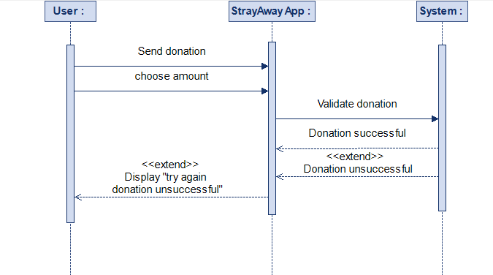

In the Donation Functionality, users start by opening the donation page on the StrayAway App. They pick an amount and payment method. The app sends this info to the system, which checks and processes the donation. If it goes through, the system updates the user's donation history and sends a confirmation. If there's an issue, the system asks the user to try again. If there's a mistake in the payment info, the system will ask to re-enter the correct information, users can also schedule recurring donations. For example, a user may donate $20 a month as a recurring donation which will be automatically taken from the users bank/PayPal account.

## Class Diagram

Additionally, we have also included a class diagram to illustrate how the structure of the system will look like, in terms of its classes, and more specifically, the attributes and methods of each class. At the top of the diagram, we have the superclass SystemUser with attributes and methods: userID , email, and phoneNum , login(), logout(), updateProfile(), all of which are shared with and inherited by the subclasses Veterinarian, AnimalCareVolunteer, Admin and AdoptionClinic. These subclasses are joined to their superclass by the relationship known as inheritance relationship. Furthermore, we’ve implemented some association relationships, such as between Veterinarian class and Stray Animal class, and between AnimalCareVolunteer class and Report Stray class. This relationship is used to explain that the instances of one class are logically related to the instances of the other class. The final type of relationship is aggregation relationship, which can be seen between Report Stray and Stray Animal classes. This relationship is used to illustrate that one class contains” the other class, and that one class is made up of instances of another class.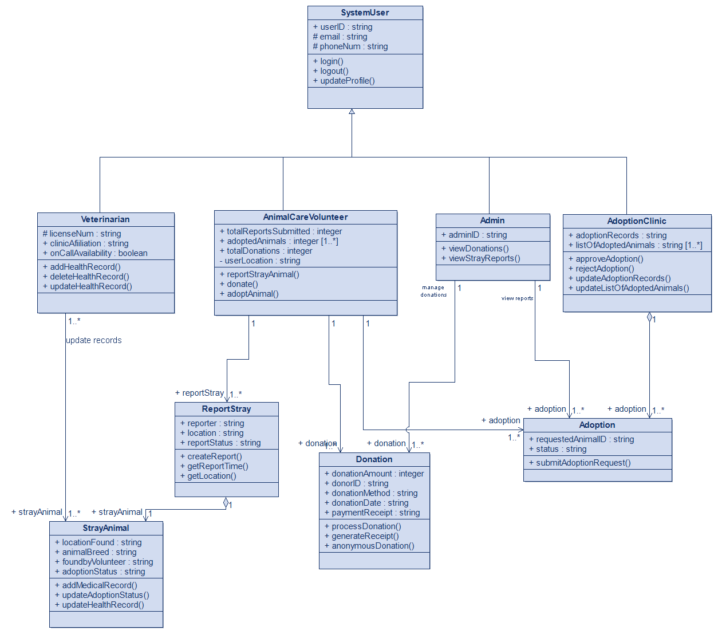

## Activity Diagram I for User

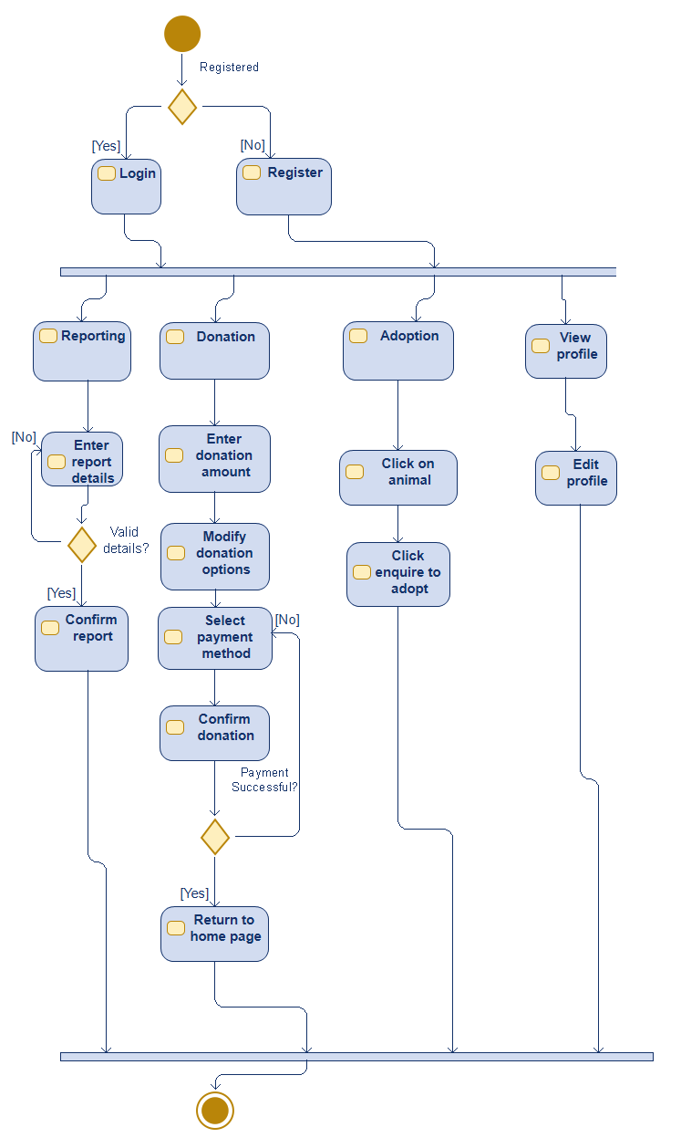

The figure above represents the activity diagram for the user. After the user logs in or registers depending on whether the user has a previous account, they can then view the home page where there are many options starting with reporting a stray animal. To report a stray, a user must submit the report details such as animal type, breed, location and photo and then confirm the report. The next option on the home page is donations in which the user will choose the amount they wish to donate, modify certain donation settings, select a payment method and finally confirm their donation. If the payment goes through the processes is ended, otherwise, the user is prompted to do the donation process again starting from selecting a payment method. Another option is the adoption page in which the user will be able to view the animals up for adoption and click on one to see its details and then give some information and finally go on to enquire to adopt the animal. Finally, the user can view their profile and change numerous profile settings and then exit back to the home page.

## Activity Diagram II for Adoption Clinic Worker

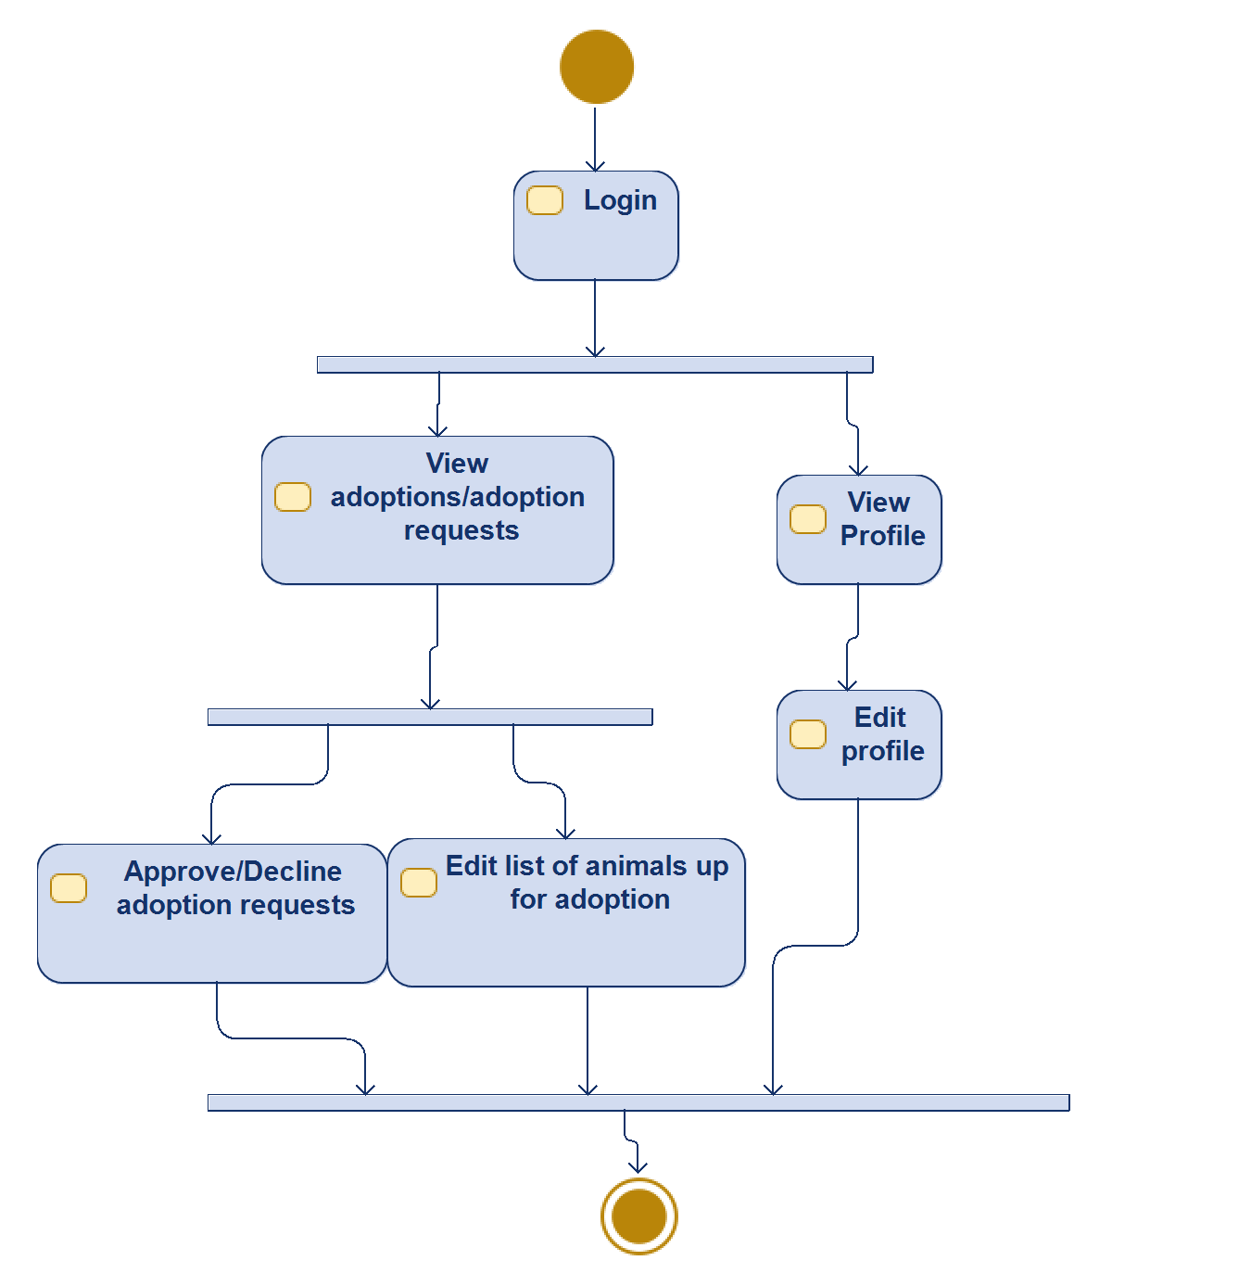

The figure above represents the activity diagram for an adoption clinic worker, after they log into the system. They can either view adoptions or adoption requests and then make decisions accordingly, such as approval or refusal of certain adoption requests, as well as the alteration of the list of animals up for adoption. In addition to that they can view and edit their profile.

## Activity Diagram III for Admin

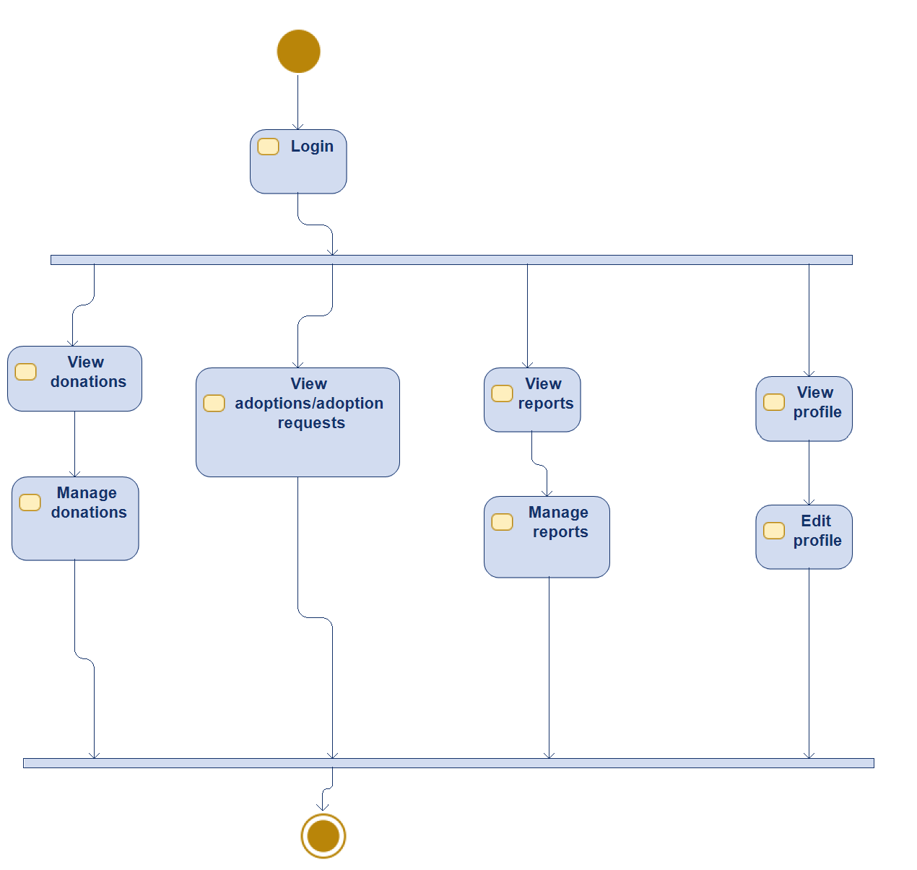

The figure above represents the activity diagram for the system's admin. Firstly, the admin logs in to the account to view the donations received from the application's users and manage them. The next option is for the admin to handle adoption requests from users. Additionally, the admin can view stray animal reports and manage them based on various criteria such as urgency, oldest to newest, etc. Finally, the admin can view their profile and edit profile information.

**Activity Diagram IV for Veterinarian**

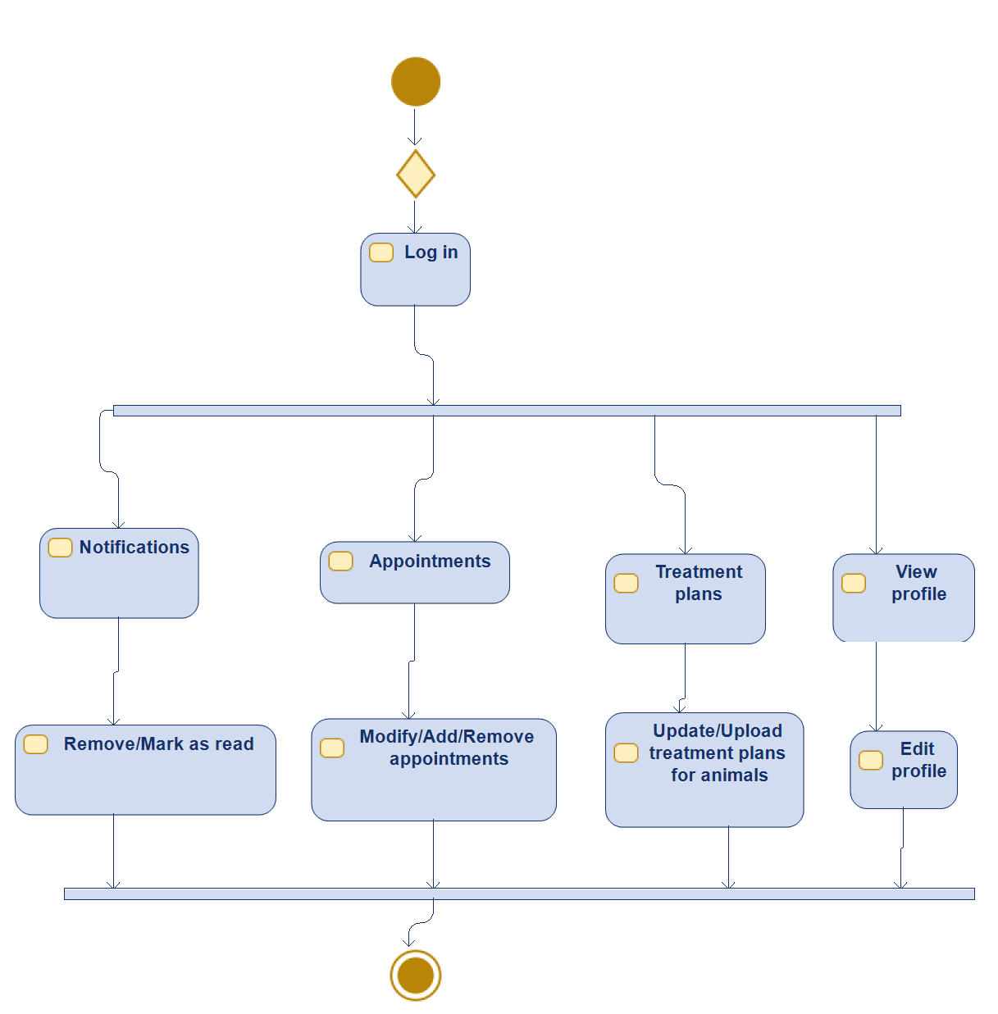

The above figure represents the activity diagram for veterinarian. First when the veterinarian logs into the system, they have a selection of options, one of which, is to check their notifications which can be removed or marked as read. Afterwards the vet may check the appointments scheduled by the adoption clinic employees. The vet can modify/add/remove the appointments. For the next option the vet can check the treatment plans made to the animals and update or upload new treatment plans for the animals examined. Finally, the veterinarian can view and edit profile information.

BPMN Diagram

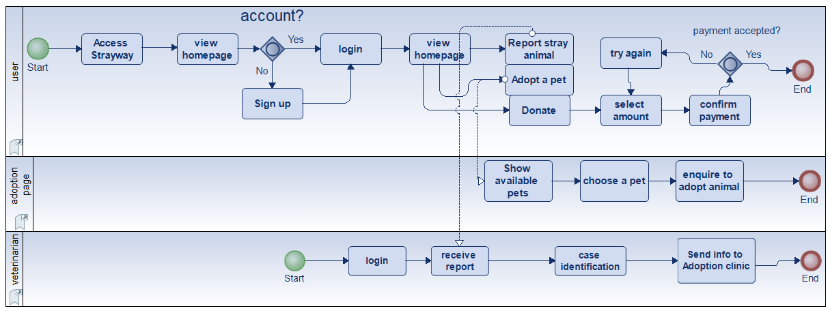

State Machine Diagram

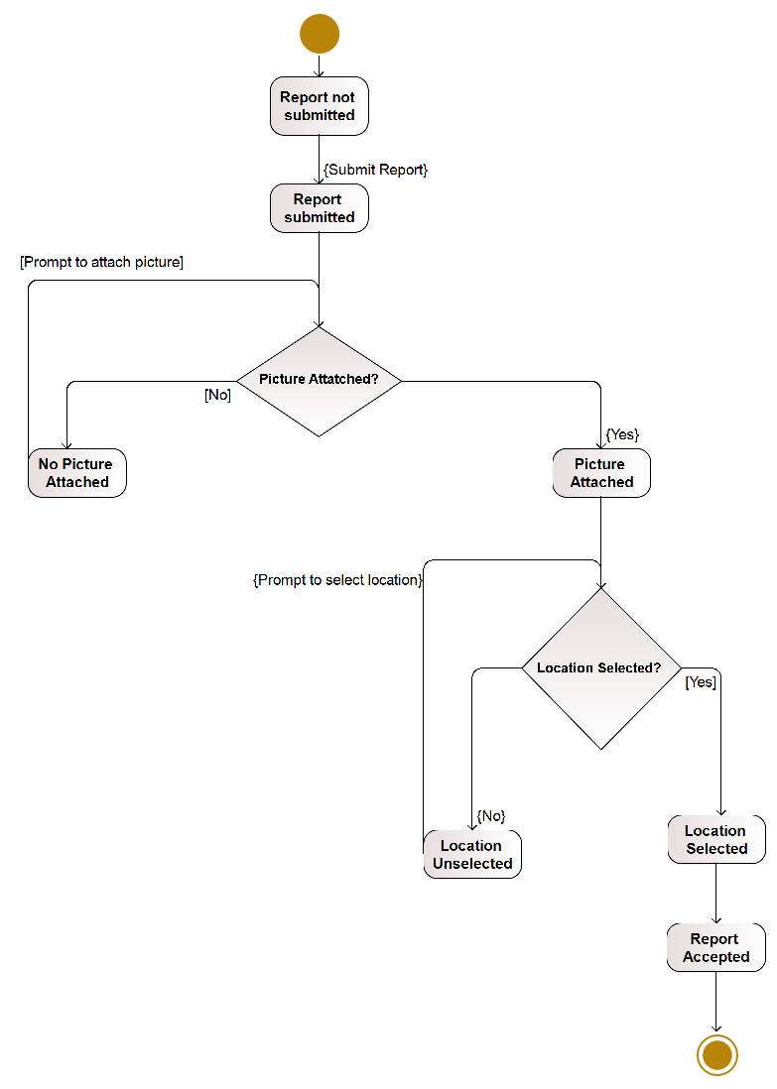

*figure 1*

This state machine diagram illustrates the reporting system when a user submits a report on stray animal it asks the user to attach a picture of the stray. If they do not attach a photo the system will not allow the user to proceed, afterwards the system asks the user to select their location, it is compulsory and the user cannot proceed without its selection, the system should then accept the report and then end the process.

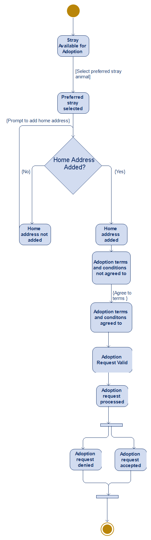

*figure 2*

This figure shows the adoption system after the user has viewed the available pets ready for adoption. The system asks the user to select their preferred pet and then the user is prompted to enter their home address, if the user does not enter their address they will be prompted again otherwise the system will proceed to adoption terms and conditions, the system then goes on to verify the request and then the adoption enquiry is processed by the adoption clinic workers to give their approval or denial, then the process ends.

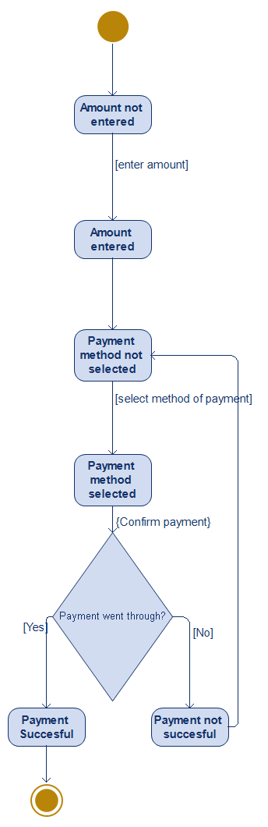

*figure 3*

Figure 3 shows donation system in which the user is prompted to enter the amount they want to donate, then the user should select the payment method. After selecting the payment method then the user confirms the payment, if the payment went through then the process is ended, otherwise the user is prompted to select a payment method again and confirm payment.

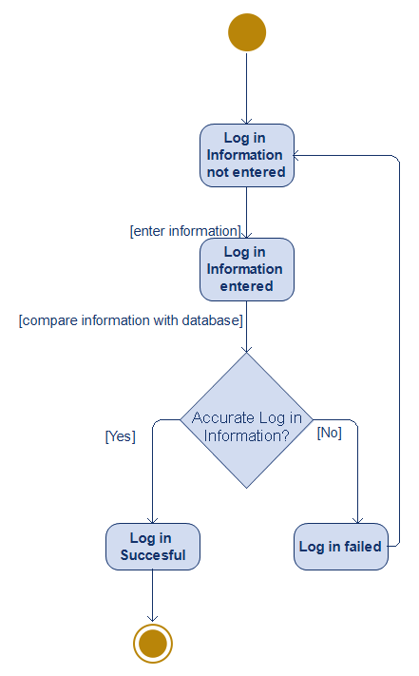

*figure 4*

This figure covers the log in functionality. The system waits for the user to enter their login information, if the user has entered in their login information the system checks if the users information is valid, if it’s invalid then it returns the user to the login bar, otherwise the user is logged in successful the process is ended.

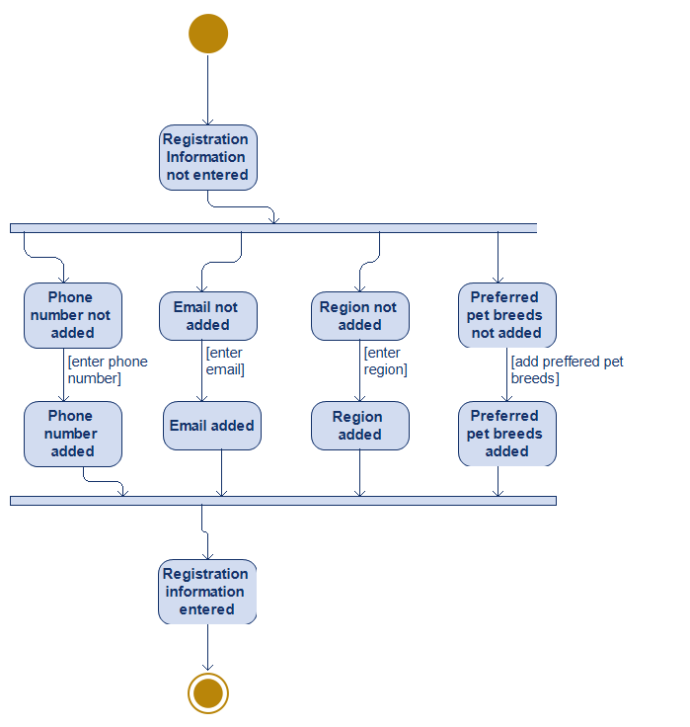

*figure 5*

This figure covers the sign-up functionality. The system prompt users to enter their details to sign up for the app the is asked to enter information such their phone numbers, email address, region and preferred pet breeds user must enter that information for his account to be registered if information has been entered the system exit and more to the log in.

## 4.2 Software design

Briefly, the sections 3 & 4 will include;

* 1. Functional Requirements
  2. Non-Functional Requirements
  3. General System Architecture Diagram
  4. UML Modelling
     1. Use Case Diagrams and Tables
     2. Sequence Diagrams
     3. Activity Diagrams
     4. BPMN diagrams
  5. DFD Diagrams (not required)
  6. E-R Diagrams (not required)
  7. Relationship diagrams (not required)
  8. Class diagrams
  9. Package diagram (not required)
  10. Physical Database Tables, and etc.

# 6. TESTING

The different segments of the application were tested separately and manually to inspect the system for any bugs or crashes that may occur as well as unexpected results. Expected outputs are compared to actual outputs and in case of any inaccuracies the code was modified. Testing will overall benefit the product and remove any unforeseen errors allowing the system to run smoothly. In addition, further testing may be needed to tend to any minor bugs that occur towards the end of the production process.

**TEST CASES:**

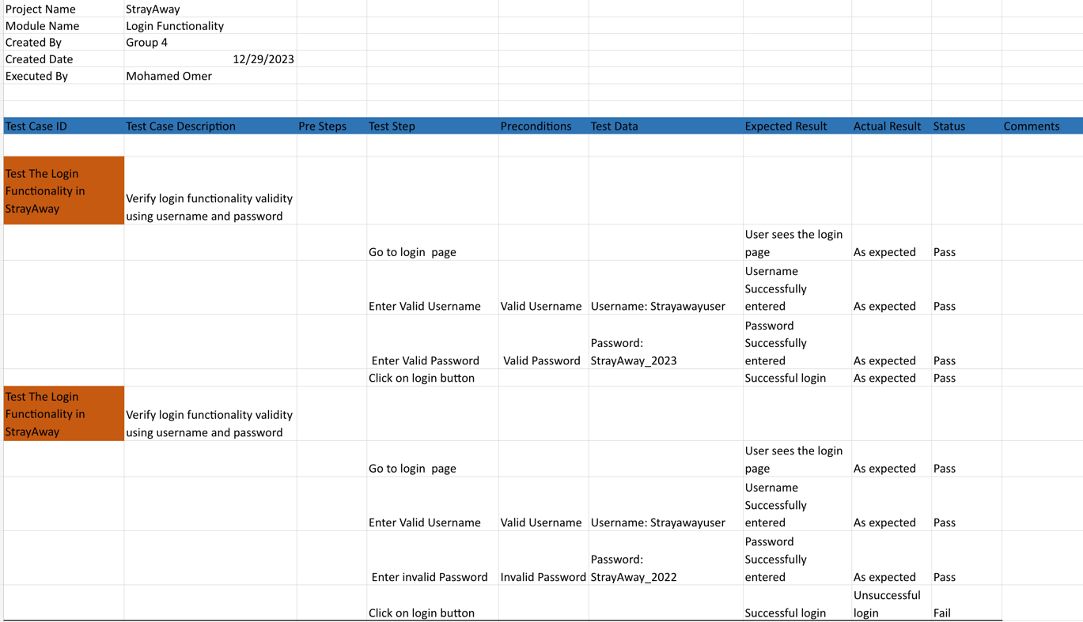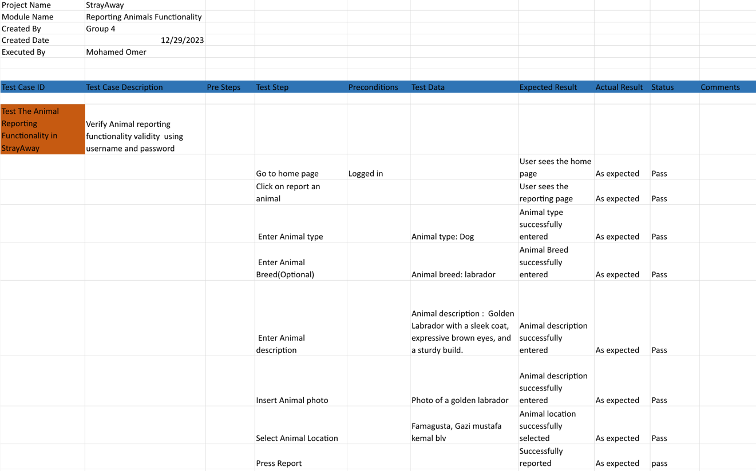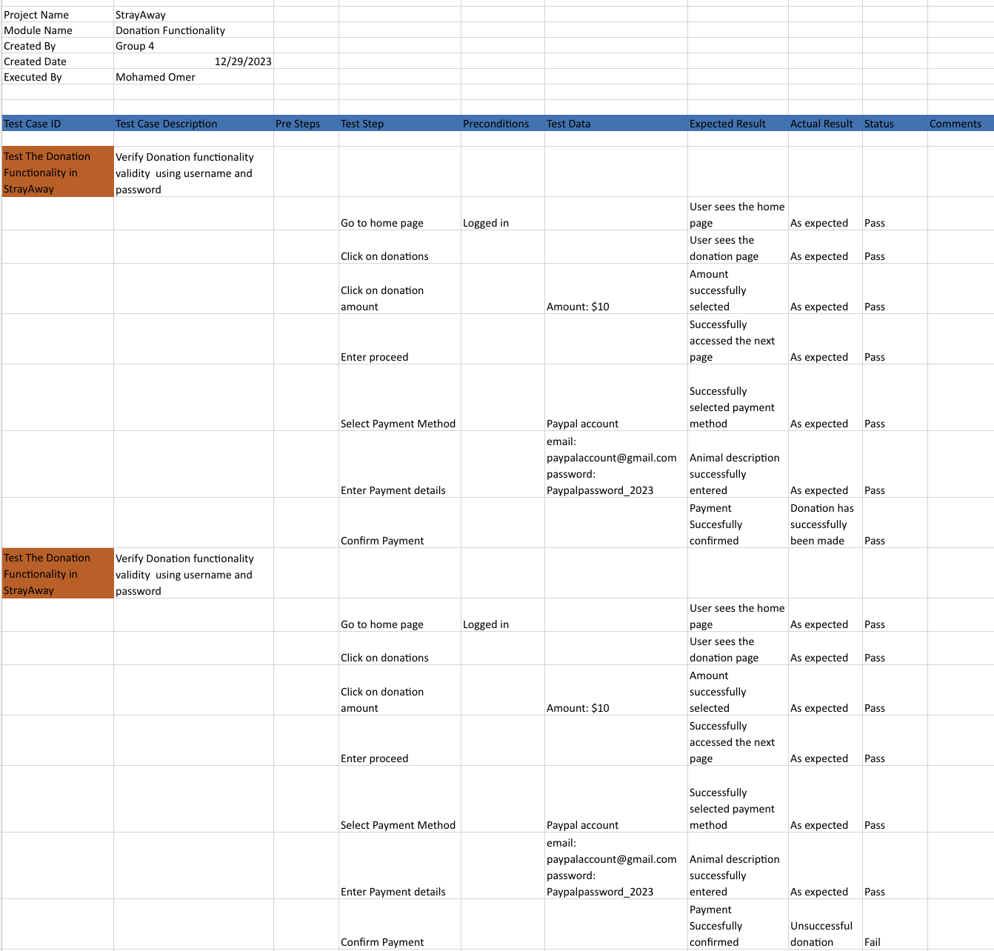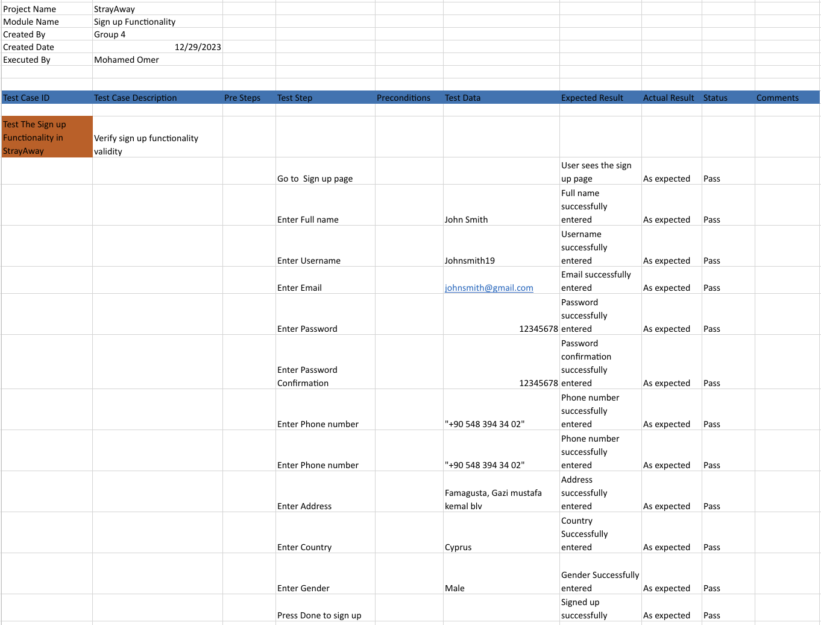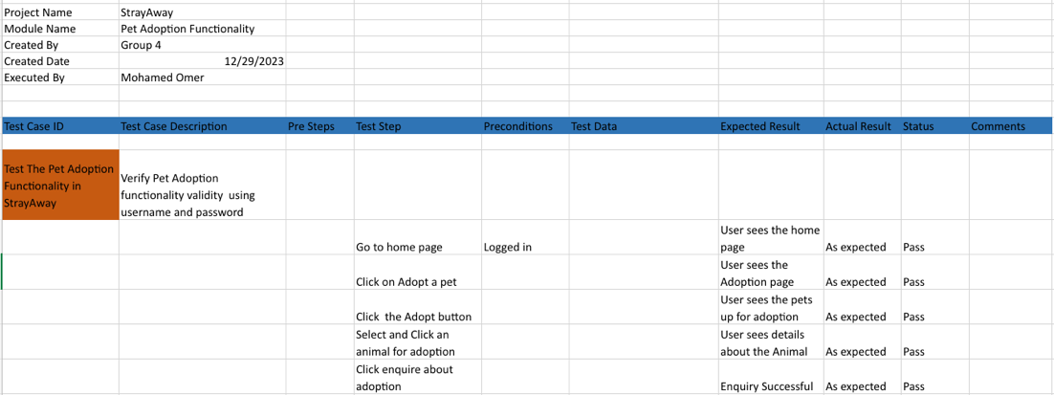

# 8. DISCUSSION

The StrayAway application is a non-profit project that aims to help stray animals off the streets, providing them with shelter and finding them the best possible new families. The project was initiated to address the issue of stray animals in the streets. Its goal is to clear neighbourhoods of stray animals by providing nourishment and professional veterinarian assistance. The project aims to reduce visual, noise, and environmental pollution caused by unwell animals carrying infectious diseases. This app provides a comprehensive solution for pet lovers. It includes special features like breed scanning, pet tracking, and other combined features to make it a complete application. The app focuses on users and values both customer and expert feedback to stay relevant and responsive. The project will initially launch in North Cyprus, with the possibility of expanding over time. The StrayAway project aims to help the environment by taking stray animals off the streets, therefore, this will make our surroundings look better and keep the animals safe. By achieving this, we want to make our community a cleaner and nicer place for everyone.

# 9. CONCLUSION

This project was started with the welfare of stray animals in mind. It presents a platform which allows users to express their passion for our furry friends. We believe that while it is a very ambitious project, the result could be very promising, with potential outcomes like tidier streets, due to the reduced visual and noise pollution, healthier animals leading to reduced risk of spread of infectious diseases, and more animals being put up for adoption. We also believe that this project could prove beneficial to non-animal lovers as well, as it helps take the strays off the streets.

Moreover, we have gained crucial knowledge and real-life experience relating to the planning and designing stages of the software development process. We learned how to use import software planning and designing programs such as Modelio , Microsoft Project, LucidChart and Figma. Working together in a group within tight deadlines has also instilled in us important qualities that are required in the professional workplace, such as teamwork and time management. To conclude, our dedicated efforts have resulted in an impactful platform, capable of making a significant change in the way we take care of stray animals.

# 10. REFERENCES

List your references. You should cite these mainly in the introduction part.

# APPENDICES

Appendix A: Glossary

SRS Report: Software Requirements Specification Document

HTML: Hypertext Markup Language

IDE: Integrated Development Environment

IEE: Institute of Electrical and Electronics Engineers

OS: Operating System

UI: User Interface

HTTP: Hypertext Transfer Protocol

DB: Database

JS: JavaScript

RDBMS: Relational Database Management System

MTBF: Mean Time Between Failure

MTTR: Mean Time To Repair

MLA: Modern Language Association.

SDLC: System Development Life Cycle.

## A. Instructions for installing the system

## B. Code for the system

## C. Other relevant material