|  |
| --- |
| **PROJECT PLANNING & MANAGEMENT FORM**  **CMSE201**  **GROUP NUMBER: 2**  **NAME OF PROJECT:** Stray Animals Tracking Mobile Application  **START DATE OF PROJE CT: 14th October 2023**  **END DATE OF PROJECT:**  **SUPERVISOR:** Assoc. Prof. Dr. Duygu Çelik Ertuğrul  **TERM OF SEMESTER: Fall** 2023/2024 |

A.1. Preliminary Project Information

# A.1.1

|  |  |
| --- | --- |
| **Project Number** | 4 |
| **Name of Project** | Stray Animals Tracking Mobile app |
| **Starting Date** | 14th October 2023 |
| **Ending Date** |  |
| **Time** | 3 months |

# A.1.2

|  |  |  |  |
| --- | --- | --- | --- |
| **Project Manager.** | | | |
| **Name Surname** | Mohamed Elfaki | ID No | 22900158 |
| **Title/Role** | Project Manager, System analyst | | |
| **Address** | Famagusta | | |
| **Phone** | +90 548 866 59 45 | | |
| **Email** | Moh.omer24@gmail.com | | |

A.2 Group Information

# A.2.1

|  |  |  |  |
| --- | --- | --- | --- |
| **Student 1** | | | |
| **Name Surname** | Firas Abdelgadir | ID No | 22703822 |
| **Title/Role** | Database Developer | | |
| **Address** | Famagusta | | |
| **Phone** | +90(548)8669200 | | |
| **Email** | firasnazar@gmail.com | | |

|  |  |  |  |
| --- | --- | --- | --- |
| **Student 2** | | | |
| **Name Surname** | Mustapha Ali Gumel | ID No | 22900221 |
| **Title/Role** | User interface designer | | |
| **Address** | Famagusta | | |
| **Phone** | +234 9015388325 | | |
| **Email** | Mustybinali08@gmail.com | | |

|  |  |  |  |
| --- | --- | --- | --- |
| **Student 3** | | | |
| **Name Surname** | Youssef Raed Aboulebdeh | **ID No** | 22703966 |
| Title/Role | Tester , Programmer | | |
| Address | Famagusta | | |
| Phone | +90(539)132 2600 | | |
| Email | Yousefabulebdah05@gmail.com | | |

# A.2.2

|  |
| --- |
| **List of Completed / Ongoing Projects of Team** |
| N/A |

B.1 Introduction to Project

# B.1.1

|  |
| --- |
| **Summary of Project** |
| The new innovative stray pet tracker mobile app, with features which allow you to extend vulnerable stray animals a hand of help. The variety of features include reporting missing pets, adopting strays, donating to help the cause, purchasing pet Bluetooth trackers, booking veterinarian appointments as well as scanning the animals to identify their breeds, making this an all-in-one app.  The aim is to make pet adoption and reporting as easy and convenient as possible, while also accepting user feedback to improve experience. A user-centered app to ensure a seamless experience, join us to provide shelter and ease upon stray animals. |

# B.1.2

|  |
| --- |
| **Key Words** |
| * Animals, Animal adoption, Java, CSS, HTML, JavaScript, Python, Rescue Pets, Stray Animal report |

# B.1.3

|  |
| --- |
| **Aim of Project** |
| The project was originally started with the main aim of tackling the growing issue of stray animals on the street. Built to help animal lovers and non-lovers alike, this project strives to keep neighborhoods and streets clear of stray animals that require nourishment, as well as delivering professional veterinarian help to the animals that might need it. This project aims to significantly reduce the visual, noise as well as the environmental pollution that is caused by unwell animals, that may very well be carrying infectious diseases such as rabies, which raise health concerns. Failing to treat these sick animals may cause them to fall victim to their fatal diseases, which in turn increases animal carcasses in the open. |

# B.1.4

|  |
| --- |
| **Innovative Aspects/Contributions of Project** |
| This app offers a comprehensive solution for pet lovers, including novel features, such as breed scanning, pet tracking and other features combined to form one robust app.  The app is user-centered and highly values user feedback as well as expert input, ensuring the app stays relevant and responsive. |

# B.1.5

|  |
| --- |
| **Methods to be Applied** |
| **Planning and Analysis Stage**: For the first stage, we will be carrying out a wide search to discover the areas that are the most densely populated with stray animals. From that list, we will prioritize the regions that contain animals carrying infectious diseases. Targeted online advertisements will be implemented to grab the attention of a fixed target audience. This will help us ascertain who our potential users and customers are. Task planning and division will be done via MS Project and Lucid Chart.  **Design Stage:** We will be using Modelio to illustrate how the user interface will look like on the mobile phone’s application. |

# B.1.6

|  |
| --- |
| **Economic and National Outcomes** |
| By promoting animal adoption this app reduces burdens upon animal shelters, which reduces average maintenance costs of animal shelters, alleviating financial resources usage for government-funded and non-profit organizations alike. In addition, neighborhoods and streets will also benefit due to the significant reductions in visual, noise, and environmental pollutions, as mentioned above. |

B.2 Reason of Starting the Project, Methods and R&D Stages

# B.2.1

|  |
| --- |
| **1- Explain the reason of starting this project. (Max 500 charachter)** |
| This project started due to a gap in the market, the unsaturated market of pet apps. Another reason for starting is to tackle those problems which were not considered by others making an app with the same purpose, inaccurate reporting, which is solved by verifying user identity, as well as insufficient reporting information by encouraging users and marketing tactics. This project will solve all the above, serving as an all-in-one application with many uses such as breed scanner and more. |

|  |
| --- |
| **2- Explain the purpose of this project.** |
| The project was started for the sole purpose of helping those animals which have no food, shelter or even water. While many humans love animals, they may not be able to help provide these necessities to any animal at all. Other humans may just want these stray animals off the street, due to their sympathy, fear of diseases or just general discomfort.  In many countries it looked like no apparent solution existed, but we have thought up the perfect solution fulfilling for pet lovers and concerned residents alike. |

|  |
| --- |
| **3- Explain**   * **output of project** * **national / international standards if exist** * **the specific objectives of the project** * **success criterias** * **realistic constraints** |
| An intuitive mobile application that seeks to please consumers is the project's anticipated result. The app satisfies users by allowing them to report findings of stray animals, especially those that may carry infectious diseases. In addition to that, users can also follow up on the animals they reported, to be assured that they are receiving the best treatment possible. The ISOs we hope to obey are:   * **ISO 9241-210:2010** - This standard offers recommendations for interactive systems and human-centered design, which can help you make sure your app is accessible and easy to use. * **ISO 27001:2013** - The best practices for information security management systems are described in this standard. If your app gathers and keeps user data, this is crucial since it contributes to data security and privacy. * **ISO/IEC 25062:2006** - Software product quality - Software engineering - Requirements for metrics assessing quality in use of software: This standard outlines specifications for gauging the usability and performance of applications by measuring the quality of the software in use. |
| **4- Explain**   * **the methods to be applied during R&D activities** * **applications** * **technics and tools to be used** * **standards to be followed under the workflow** |
| We will be using an incremental development model due to this project's nature of being user-centered, we will make use of user and experts feedback and opinions. We believe that using the Waterfall Model does not fulfill this purpose due to its lack of communication with the users and stakeholders. The stray animal tracker app may not be as saturated as other markets, though it does have apps in circulation, using a development model such as the agile model will cause the app to cater to user and stakeholders needs due to constant communication. Using the agile model will increase the app quality and reduce the risk that requirement changes cause.  Using an incremental model will also allow a release of the “beta” version of the app for even more feedback which allows the app to test reporting accuracy and improve any underlying system errors within.  **Explain, Project Workflow:**   1. **Feasibility and Pre-research:** Since this app is very community dependent, we will research users of similar systems and their wants, and their complaints about those systems. That will allow us to build a better system, using COCOMO to estimate costs and compensate them using crowdfunding, IPOs and other capital raising methods. Another important point is how much manpower is needed to complete the project without overworking the employees, as well as risk analysis and technical feasibility of features to be implemented. 2. **System Design:** As we are using incremental mode to design the system, we will lean towards the agile model which caters towards customers due to its feedback concentrated nature. The system will aim to be user-centered and constantly changing with user and expert feedback, we aim to innovate and constantly design new system functions that can be reviewed by our customers and stakeholders. Our system is to be designed focusing on the fundamental features first which will allow the release of a working “beta” edition which will allow user feedback early. 3. **Software development:** This phase consists of the coding part, in which the app will be coded in Java, and Python. The website will be coded in HTML, JavaScript and CSS In order to maximize efficiency and user retention due to less loading time. The Stray animal status data will be stored by usage of databases and calculations using SQL methods will determine which animal shelter is most suited by distance and resources to collect certain animals. 4. **Prototype implementation and testing work:** We will prototype system functionalities and test them one at a time and then combine them into larger system prototypes which allows all smaller prototypes to be tested concurrently and when those tests succeed, we can build on the prototypes, testing is done iteratively in this stage which will minimize errors and risk. 5. **Maintenance:** Maintenance of the product of this project is the single most important part due to its user-centered nature. We estimate that the maintenance cost will skyrocket above other costs, on the other hand it will also be the cause for most of the profit due to user retention and customer loyalty as a result of them feeling included. Our team will check for errors, bugs and unwanted features very frequently and work on fixing them according to the users' needs. We will keep in mind all past changes to further understand what our users want. |
| **5- Explain**   * **the contribution of national/international technological development if exist** * **starting a new research and development projects within or outside the team** * **launch new applications or research studies in different technology areas**   **With whom we can cooperate?**  **Expectations:**  **Published work:**  **Can your output be an input for other similar national/international projects?** |
| This platform will work with veterinary professionals, who are expected to help animals in critical condition and deliver them proper health care. Cooperation with animal control agencies can help implement effective animal welfare policies. Partnering with social media influencers will spread the message to people to get their attention and support the efforts in our work of helping and saving stray animals can contribute to addressing the issue on a national and international scale. This project can be valuable worldwide. |

B.3 Innovative and Unique Aspects

# B.3.1

|  |
| --- |
| **1- Describe**   * **differences** * **advantages** * **superiority**   **compared to other similar projects.** |
| Our project's primary selling point is that it runs smoothly and enables users to handle stray animals and take practical action. Our system is versatile, as it allows individuals of all ages to use it without encountering any issues. Our software provides innovative features that you will not find in similar programs. The project will benefit significantly from maintaining the system's security, integrity, and accessibility thus, this will be our main priority. |

# B.4.1

|  |
| --- |
| **2- Who can contribute to this project in your team?** |
| * Project Manager/Systems Analyst * UI Designer * Database Developer * Network Designer * Programmer |

C.1 Gantt Chart and Work Packages

# C.1.1 Gantt Chart

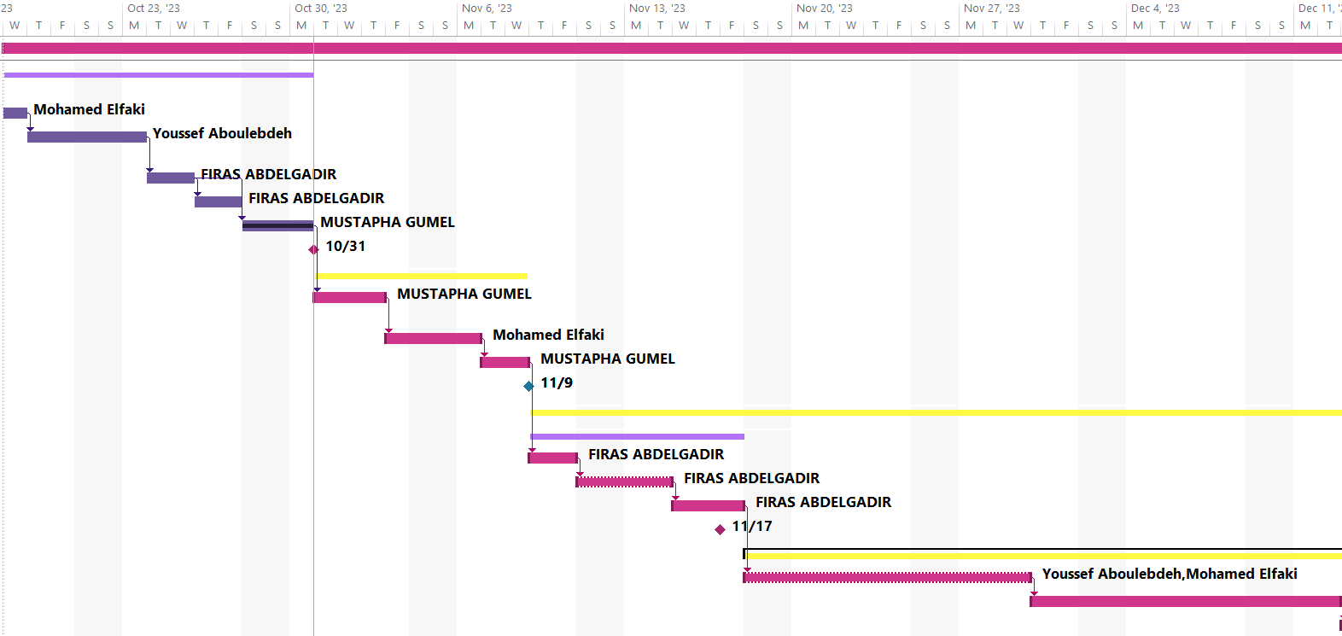

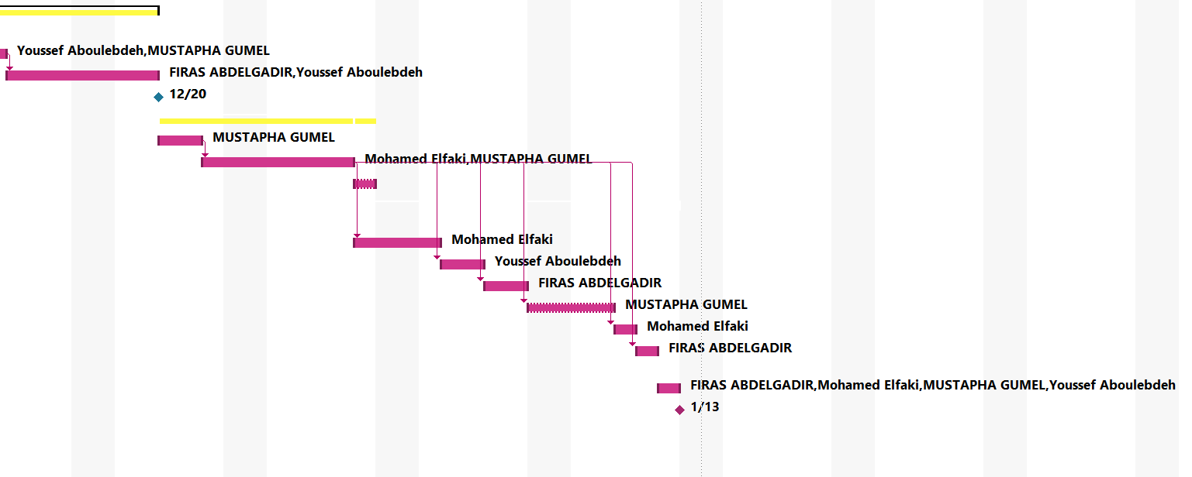

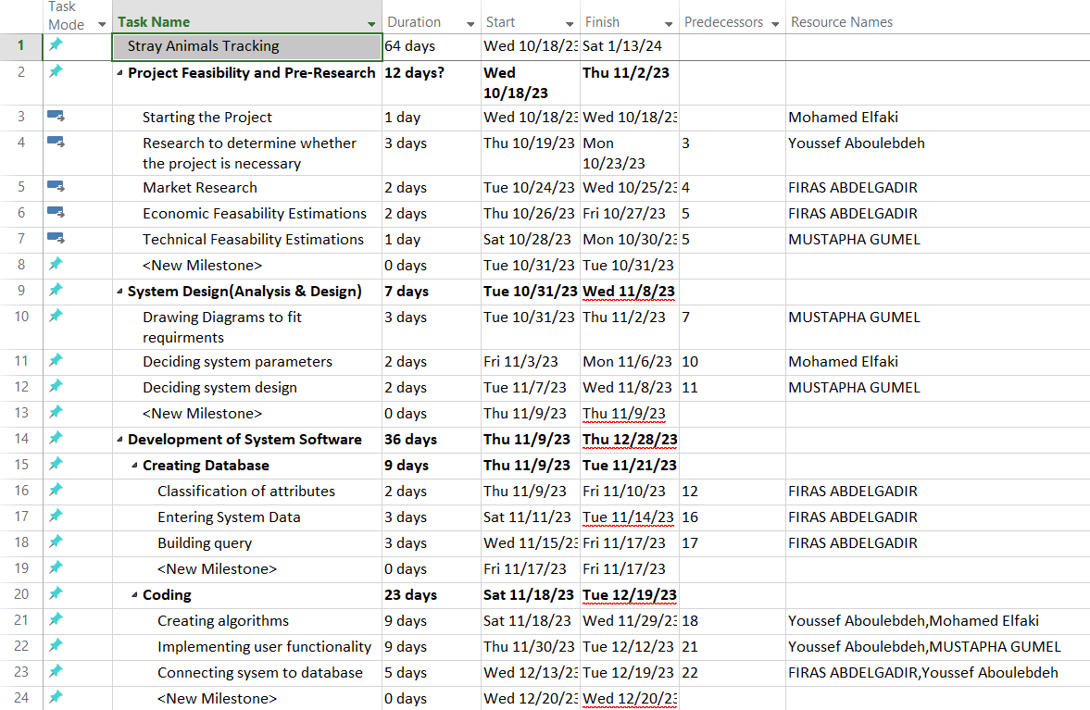

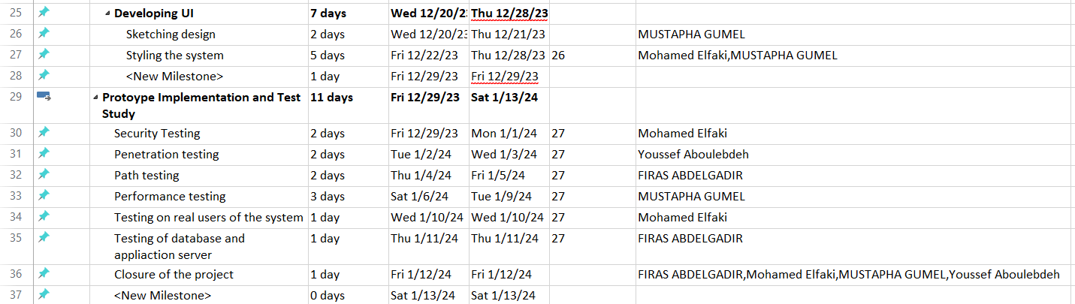

# C.1.2 List of Work Packages

|  |  |
| --- | --- |
| **Work Package No** | 1 |
| **Work Package Name** | **Project Feasibility and Pre-Research (Feasibility Analysis)** |
| **Start-End Date and Time** | 10/18/23 - 11/2/23 |
| **Related Organizations** | - |

|  |
| --- |
| **1- List the activities of work packages.** |
| **1.1 Project Process and Economic Feasibility:**   * In the phase of market research, we will be conducting thorough searches for similar projects to discover and analyze whether this system is really required. * Outlining the main risks that we may face during the production of the project * Approximating revenue and expenses for the project using COCOMO * Reaching a conclusion on whether the project is economically feasible, and whether it is profitable in the long run.   **1.2 Technological Feasibility:**   * Selecting the necessary technical foundation needed to operate the project * Deciding if the technology we have at the present time will be enough to satisfy all the project requirements and functionalities, and if not, whether or not obtaining said technology will significantly offset our projected expenses. |
| **2- Describe the methods and parameters that will be used for work package.** |
| To develop a stray animal tracking app that is completely functional, we will be conducting meticulous analysis of similar projects, as well as holding stakeholder and end-user meetings to learn about their expectations, suggestions, and points of view. The meetings will also allow us to learn about the possibility of the project being implemented, in terms of its technological and financial viability |
| **3- List the experiments, tests and analysis in the work package.** |
| * Examine comparable systems * Create a report with revenue and expense estimates. * Risk estimations * Distributing work tasks * Interview potential users for enhanced requirement specification |
| **4- List the output of work package and its success criterias.** |
| **Outputs:**   * Establishing a transparent task allocation and management hierarchy * Establishing an understanding about the Stray Animals project * Estimation of profits and costs   **Success Criteria:**   * Team being familiar with the project, and what’s expected of them. * determining the project's profitability * Recognising the dangers the project faces |
| **5- Explain the relation of output with other work packages** |
| For the project to be successful, this work package is essential. Economic and Technological feasibility analysis sets clear expectations for the project moving forward. In addition, it makes the team aware of the risks that come with the project, and presents clear guidelines that will help mitigate, and perhaps even avoid, said risks. |

|  |  |
| --- | --- |
| **Work Package No** | 2 |
| **Work Package Name** | **Based System Design Technology (Analysis & Design stage)** |
| **Start-End Date and Time** | 10/31/23 - 11/8/23 |
| **Related Organizations** | - |

|  |
| --- |
| **1- List the activities of work packages.** |
| * Requirement Specifications * Design of Systems * Hardware Study * System Evaluation * Data Flow Definitions |
| **2- Describe the methods and parameters that will be used for work package.** |
| * Dividing the group into more manageable subgroups * Producing Data Flow Diagram * Producing decision table and flowchart * Making a prototype |
| **3- List the experiments, tests and analysis in the work package.** |
| * Assembling design concepts * Creating samples * Preparing Logical Design * Preparing Physical Design |
| **4- List the output of work package and its success criteria.** |
| **Outputs:**   * Design entire software * Completing System Models and Diagrams   **Success Criteria:**   * Obtaining a structure that is designed to achieve the objectives * Creating remedies for the system's potential risks * Investigation of the system as a whole |
| **5- Explain the relation of output with other work packages** |
| This work package's output will serve as the foundation for the functionality of the subsequent work packages, especially the program development and implementation stages. For this purpose, the analysis and design stage must be done with utmost care, to ensure smooth workflow for the future stages. |

|  |  |
| --- | --- |
| **Work Package No** | 3 |
| **Work Package Name** | **Development of System Software (Development Stage)** |
| **Start-End Date and Time** | 11/9/23 - 12/28/24 |
| **Related Organizations** |  |

|  |
| --- |
| **1- List the activities of work packages.** |
| * Develop a user-friendly software * Develop Database * Coding and developing algorithms * Implementing system requirements * Connecting system to the database |
| **2- Describe the methods and parameters that will be used for work package.** |
| * Relational database creation using SQL * For system structure, use HTML * CSS to style the system * Visual Studio Code as the IDE * Java and Python as the main programming languages |
| **3- List the experiments, tests and analysis in the work package.** |
| * Check if the requirements are compatible. * Check the system's functionality. * Unit Testing * Check algorithms for unnecessary codes |
| **4- List the output of work package and its success criterias.** |
| **Outputs:**   * A finished, working prototype of the system * All set for testing   **Success Criteria:**   * Completed interface that is user friendly * Well done database, and establishing a good connection between the system and the database * Reduced risk of errors |
| **5- Explain the relation of output with other work packages** |
| This work package's output offers a fully functional prototype, that is ready to be taken into the testing stage. |

|  |  |
| --- | --- |
| **Work Package No** | 4 |
| **Work Package Name** | **Prototype Implementation and Test Study and Maintenance (Test & Maintenance stage)** |
| **Start-End Date and Time** | 12/29/23 - 1/13/24 |
| **Related Organizations** |  |

|  |
| --- |
| **1- List the activities of work packages.** |
| * Security Testing * Penetration Testing * Path Testing * Performance Testing * Testing the system with actual users * Testing of database as well as application server |
| **2- Describe the methods and parameters that will be used for work package.** |
| * Unit Testing * UI testing * Security Testing * Compatibility Testing * Performance Testing |
| **3- List the experiments, tests and analysis in the work package.** |
| * Test in various scenarios and situations. * Cross-platform testing |
| **4- List the output of work package and its success criterias.** |
| **Outputs:**   * Determine the system bugs * Produce error reports * Fix the bugs   **Success Criteria:**   * All of the system's modules operate correctly and in the desired way. |
| **5- Explain the relation of output with other work packages** |
| * Should the task package be completed correctly, at the end of the testing stage, the Stray Animals Tracking project will not only be ready to use, but it will also be reliable, secure, and user-friendly, and the only remaining step would be to release it to the public. |

# C.1.3 List of Milestones (should be matched in the Gantt chart)

|  |  |  |
| --- | --- | --- |
|  | **Description of Output** | **Expected Time Interval** |
| 1 | **Project Feasibility and Pre-Research** | **10/18/23 - 11/2/23** |
| 2 | **System Design (Analysis & Design)** | **10/31/23 - 11/8/23** |
| 3 | **Development of System Software** | **11/9/23 - 12/28/23** |
| 4 | **Prototype Implementation and Test Study** | **12/29/23 - 1/13/24** |
| 5 | **Closure of the project** | **1/12/24** |

w

# C.1.4 List of Risks

**Risk assessment Table**

|  |  |  |  |  |  |
| --- | --- | --- | --- | --- | --- |
| Risk Number | Risk Description | Risk Probability | Risk Effect | Risk Scores | B-Plan |
| R1 | Insufficient animal reporting data | 0.50 | 0.60 | 0.30 | Encourage users to report more and offer compensation for collected stray animals due to their report. |
| R2 | Low user engagement | 1.00 | 0.90 | 0.90 | Make the app user-friendly, with little ads and implement marketing strategies. |
| R3 | Project budget higher than expected | 0.40 | 1.00 | 0.40 | Use strategies such as crowdfunding and starting an IPO to sell shares to investors. |
| R4 | Inaccurate animal reporting data | 0.80 | 0.50 | 0.40 | Only allow users logged in with their email and phone number to report animals, a user rating system will be implemented to perceive how accurate every user’s animal reports are. |
| R5 | Data Security and privacy | 0.60 | 0.90 | 0.54 | Strong security measures such as encryption, privacy policies and user authentication. |
| R6 | Technical issues | 1.00 | 0.20 | 0.20 | Test the project repeatedly and perform quality assurance. |
| R7 | Users not always connected to the internet | 0.50 | 0.40 | 0.20 | Allow users to report animals offline and then upload those reports to the cloud when an internet connection is established |
| R8 | Outdated data | 0.80 | 0.30 | 0.24 | Our team will update the database regularly based on which strays have been adopted and users will be able to constantly update reports to inform the stray animal's new location or ensure the location hasn’t changed up to a certain date |

**Risk Table**

|  |  |  |  |
| --- | --- | --- | --- |
| Risk | Probability | Effects | Your Strategy |
| 1.Insufficient animal reporting data | Moderate. | Tolerable | Encourage users to report more and offer compensation for collected stray animals due to their report. |
| 2.Low user engagement | High. | Serious | Make the app user-friendly, with little ads and implement marketing strategies. |
| 3.Project budget higher than expected | Moderate. | Serious | Use strategies such as crowdfunding and starting an IPO to sell shares to investors. |
| 4.Inaccurate animal reporting data | High. | Tolerable | Only allow users logged in with their email and phone number to report animals, a user rating system will be implemented to perceive how accurate every user’s animal reports are. |
| 5.Data Security and privacy | Moderate. | Serious | Strong security measures such as encryption, privacy policies and user authentication. |
| 6.Technical issues | High. | insignificant | Test the project repeatedly and perform quality assurance. |
| 7.Users not always connected to the internet | Moderate. | Tolerable | Allow users to report animals offline and then upload those reports to the cloud when an internet connection is established |
| 8.Outdated data | High. | insignificant | Our team will update the database regularly based on which strays have been adopted and users will be able to constantly update reports to inform the stray animal's new location or ensure the location hasn’t changed up to a certain date |

C.2 Project Management and Organization

# C.2.1 Project Team

|  |  |  |  |  |  |  |
| --- | --- | --- | --- | --- | --- | --- |
| **Personnel Name** | **Title** | **ID** | **Education Status** | **Graduation Date** | **Date of Starting Work** | **Idea Owner** |
| Mohamed Elfaki | Project Manager / System Analyst | 22900158 | Undergraduate | 2026 | October 14th 2023 | Yes |
| Mustapha Ali Gumel | UI designer | 22900221 | Undergraduate | 2026 | October 14th 2023 | Yes |
| Firas Abdelgadir | Database developer | 22703822 | Undergraduate | 2026 | October 14th 2023 | Yes |
| Yousef aboulebdeh | Tester/Programmer | 22703966 | Undergraduate | 2026 | October 14th 2023 | Yes |

# C.2.2 Organization Scheme (an example is given below!)

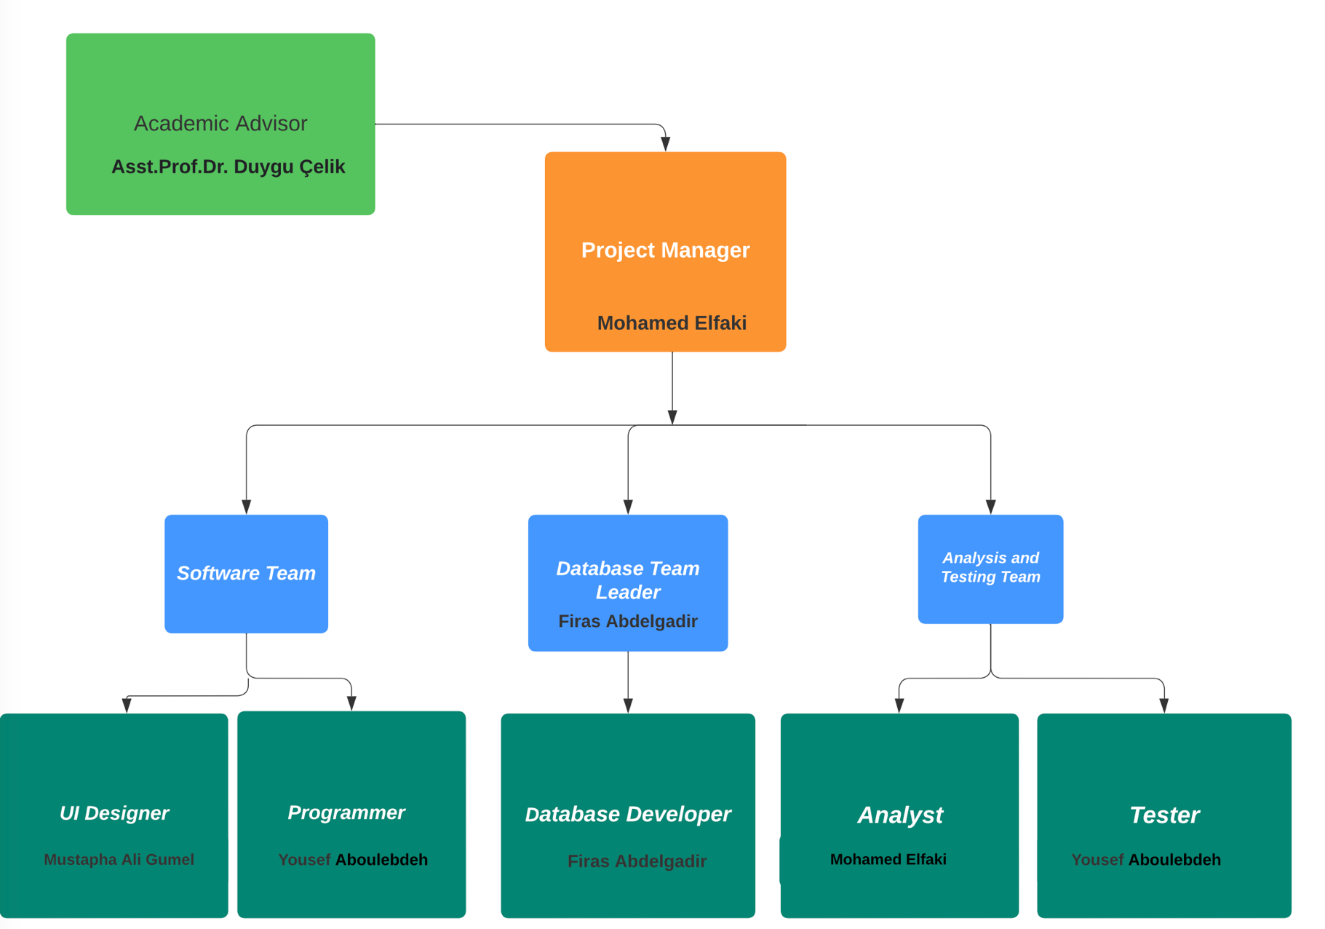

D.1 Economic Forecasts

|  |
| --- |
| **1- Evaluate the commercialization potential of project outcomes. List possible risks here?** |
| These are the factors be conceded and potential risks associated with commercializing stray animal tracking technology if this project is to be commercialized, the demands of the project will be high cause it will help a lot in bringing the solution to the stray animal problem and will provide pet lover to own one. The possible risks may involve data privacy, operational costs, natural and environmental factors; the essential objective is frequently social and moral, instead of profit driven. In any case, guaranteeing money related maintainability is basic to continue providing care for stray animals and tending to the related challenges. Cautious arranging, straightforwardness, and a center on the well-being of creatures are key to moderating dangers and improving the project's commercialization potential. |

|  |  |
| --- | --- |
| **2- List your expectations to your team which are come by your project** | |
| Time-to-market (month): | 12/01/2024 |
| The expected increase in sales revenue (%): | %8 |
| The expected increase in market share (%): | %7 |
| Time to start to gain: | 2 years after production |

D.2 National Outcomes

|  |
| --- |
| **1- Specify the output that may be subject to patent, utility model and industrial design registration in the project.** |
| 1. This app may be subject to utility model through its unique animal breed scanner, which is not found in any other stray animal care app. 2. It can also be subject to industrial design registration through its distinctive design consisting of pink and blue which gives you a one of a kind feel in combination with the app logo. 3. The app may also be subject to patent due to its unique algorithm for connecting animal strays with their potential owners. |
| **2- Explain the potential of project and its outputs that may have an effect on social life, education, health and etc.** |
| 1. Life in society: The app creates public awareness to help stop people from walking past their doors, seeing stray animals, and continuing to move their ways mildly unworried. This app will help solve the problems of stray animals and I believe they can do much to help or are uncertain as to the actions they should take. 2. Education: This app will help in teaching pet owners about pets' behavior, welfare, safeties and can teach users the importance of caring for animals 3. Health: This app will help in reducing the spread of animal diseases outbreaks it is going to reduce the rate in which stray animals are being killed on the road and street etc. The app can contribute to mental health by fighting against animal suffering. |
| **3- Explain the positive and negative effects of project outputs for environment and human being.** |
| Regarding our favourable outcomes:   1. Animal welfare: This app is designed to trace and locate stray animals effectively to reduce the number of stray animals on the street and to have proper shelter and appropriate care. 2. Community engagement: This app brings about community engagement to work hard to identify and address the communities’ needs and concerns regarding the local stray animal population, to ensure that everyone has a voice in developing effective solutions. 3. This app has a future that helps identify and count the percentage of animal species in an area, state, county.   In the adverse outcomes we experience:   1. False information: some people may use the app just for fun to report stray animals for malicious reasons, and time wasting and potentially causing harm to innocent animals |

(M013) Instrument / Equipment / Software / RELEASE PURCHASES

|  |  |  |  |  |  |  |  |  |  |  |  |
| --- | --- | --- | --- | --- | --- | --- | --- | --- | --- | --- | --- |
| **Project Name** | |  | | | | | | | | | |
| **Line no** | **Instrument / Equipment / Software / Publication Name** | | **No. of Item** | **Capacity** | **Technical specification** | **Purpose of Project Activities** | **Post-Project Place of Use / Purpose** | | **Unit Price (USD)** | **Unit Price (TL)** | **Total Amount (TL)** |
| **R & D** | **Production** |
| **1** | Internet Connection | | 1 |  | Min. 6Mpbs | Connection | Yes | Yes | 50 | 1400 | 1400 |
| **2** | Laptops | | 4 |  | Min 100GB storage, Min core i5/i7 intel or equivalent, more 4GB ram | Involved in every task since it’s the medium of project creation | Yes | Yes | 1000 | 28100 | 28100 |
| **3** | MS Project | | 1 |  | Project Task management software | Planning | Yes |  | 30 | 850 | 850 |
| **4** | Office 365 | | 1 |  | All useful office related programs | Management | Yes |  | 100 | 2800 | 2800 |
| **5** | SQL | | 1 |  | Database query tool | Database operations |  | Yes | 120 | 3400 | 3400 |
| **6** | JavaScript | | 1 |  | Coding language for developing the website | Coding |  | Yes | 80 | 2250 | 2250 |
| **7** | Visual Studio Code | | 1 |  | Coding IDE | Coding |  | Yes | 0 | 0 | 0 |
| **8** | Java | | 1 |  | Coding language for the app | Coding |  | Yes | 50 | 1400 | 1400 |
| **9** | Modelio | | 1 |  | Coding language for the app | Coding | Yes |  | 420 | 11900 | 11900 |
|  |  | |  |  |  |  |  |  |  | TOTAL | 52,100TL |

(M030) Quarterly Estimated Cost Form (TL)

|  |  |  |  |  |
| --- | --- | --- | --- | --- |
| **Project Name : Stray Animals tracker app** | | | | |
| **Cost Item** | **2023-2024** | | **TOTAL**  **(TL)** | **TOTAL COST RATE OF CONTENTS (%)** |
| **I** | **II** |
| **Personnel** | 8,000 | 8,000 | 16,000 | 40% |
| **Travel** | - | - | - | - |
| **Instrument / Equipment / Software / Publications** | 4,000 | 4,000 | 8,000 | 5% |
| **Domestic Works Made By R & D and Testing Institutions** | 7,000 | 7,000 | 14,000 | 20% |
| **International Works Made By R & D and Testing Institutions** | - | - | - | - |
| **Domestic Services Procurement** | 10,000 | 10,000 | 20,000 | 5% |
| **Overseas Service Procurement** | - | - | - | - |
| **Material** | 18,000 | 18,000 | 36,000 | 30% |
| **TOTAL COST** | 47,000 | 47,000 | 94,000 | 100 |
| **CUMULATIVE COST** |  |  |  | 100 |
| **IN THE PROJECT TOTAL MAN-MONTH** | | | 94,000 | |

APPENDIX

1. Perform estimation of effort (Man/month), required total time duration, and required number of team members by using COCOMO approach (or other methods are possible).   
    **COCOMO Estimation**

|  |
| --- |
| We are calculating for JAVA Programming Language  The project we use the organic mode cause of the team members' numbers and does not require many codes. It carries minimal risk.  E = a(kloc)^b = 2.4(50) ^1.05 = 145.93PM D= c(E)^d = 2.5(145.93) ^0.38 = 16.61M  SS = E/D = 145.93/ 16.61= 8.79 people  P = kloc/E = 50/145.93= 0.34KLOC/PM |

1. CPM (Critical Path Management) analysis by using PERT (defining paths)

Pert Analysis

|  |  |  |  |  |  |  |
| --- | --- | --- | --- | --- | --- | --- |
| Activity | Description | Optimistic Time | Most Likely Time | Pessimistic Time | Expected Time | Prerequisites |
| A | Project Feasibility and pre-research | 12 | 15 | 16 | 15 | - |
| B | System Design | 7 | 8 | 11 | 8 | A |
| C | Development of system software | 38 | 42 | 47 | 43 | B |
| D | Creating Database | 18 | 21 | 24 | 21 | C |
| E | Coding | 23 | 26 | 29 | 26 | D |
| F | Developing UI | 7 | 8 | 9 | 8 | E |
| G | Prototype Implementation | 4 | 5 | 7 | 5 | F |
| H | Test Study | 7 | 9 | 11 | 9 | F |
| I | Documentation | 1 | 2 | 3 | 2 | H, I |

In this table, we used the pert expected time formula.

(Optimistic Time + (4 * Most Likely Time) + Pessimistic Time) / 6 is the expected time.

Critical Path Table

|  |  |  |
| --- | --- | --- |
| Paths | Calculations | Total expected time for each path |
| ABCDEFGI | 15+8+21+26+8+5+2 | 85 |
| ABCDEFHI | 15+8+21+26+8+9+2 | 89 (C.P) |

The critical path is ABCDEFHI.

1. Creating network diagram of the main tasks in WBS

Network Diagram

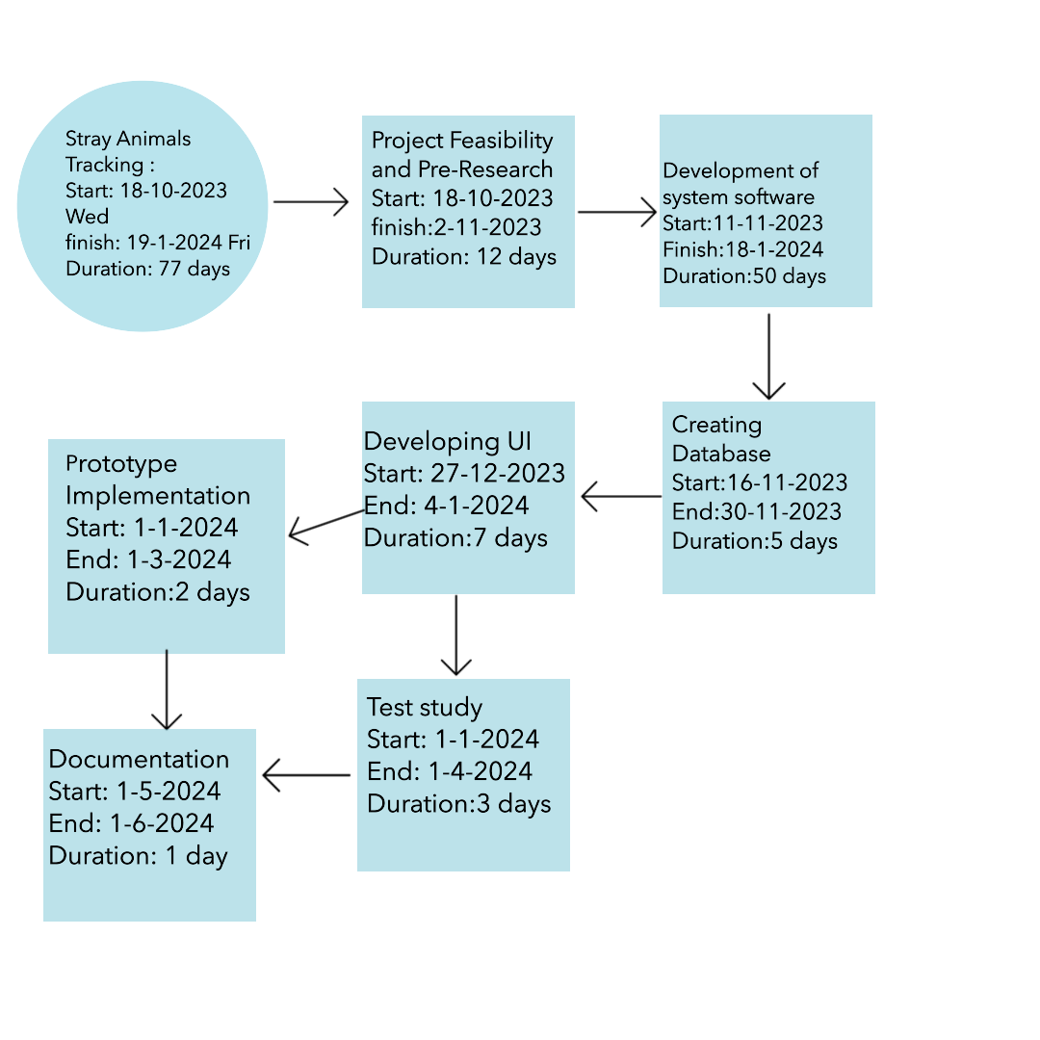

1. Calculating probability of successful completion rate for each path

Variance for each activity

|  |  |  |  |  |
| --- | --- | --- | --- | --- |
| Tasks | Optimistic Time | Most Likely Time | Pessimistic Time | Variance of Each Tasks |
| A | 12 | 15 | 17 | 0.833 |
| B | 7 | 8 | 10 | 1.000 |
| C | 38 | 42 | 47 | 1.500 |
| D | 18 | 21 | 25 | 1.167 |
| E | 23 | 26 | 29 | 1.000 |
| F | 7 | 8 | 9 | 0.333 |
| G | 4 | 5 | 7 | 0.667 |
| H | 7 | 9 | 12 | 0.833 |
| I | 1 | 2 | 3 | 0.333 |

Variance formula is:

* where p is the estimated pessimistic activity time.
* where the activity time estimate, o, is optimistic.

Variance and Standard Deviations of Each Path

|  |  |  |  |
| --- | --- | --- | --- |
| Paths | Variance of each Activity | Total Variance of Each Path | Total Standard Deviation of Each Path |
| ABCDEFGI | 0.833+1+1.5+1.167+1+0.333+0.667+0.333 | 6.833 | 2.614 |
| ABCDEFHI | 0.833+1+1.5+1.167+1+0.333+0.833+0.333 | 6.999 | 2.646 |

The formula for the Total Standard Deviation of Each Path is:

Probability of a Successful Completion

|  |  |  |  |  |  |  |
| --- | --- | --- | --- | --- | --- | --- |
| Paths | Paths specified Time | Total Expected Time for Each Path | Path Variance | Path Standard Deviation | Z-Values | Probability of Finishing |
| ABCDEFGI | 77 | 86 | 6.833 | 1.317 | 0.9049 | %90.5 |
| ABCDEFHI | 77 | 89 | 6.999 | 1.715 | 0.9573 | %95.7 |

Z is equal to Path Standard Time / (Specified Time - Path Expected Time).

1. Crashing approach, etc. techniques and the results can be written here.

Reducing the time of the project (Crashing)

|  |  |  |  |  |  |  |
| --- | --- | --- | --- | --- | --- | --- |
| **Work Package Name** | **Crashing Time (days)** | **Normal Time (days)** | **Normal Cost (USD)** | **Crash Cost (USD)** | **Max no. of days to reduction** | **Reduce Cost Per day (USD)** |
| Project Feasibility and pre-research | 10 | 15 | $1000 | $1500 | 5 | $100 |
| System Design | 6 | 8 | $600 | $900 | 2 | $150 |
| Development of system software | 40 | 43 | $3000 | $4500 | 13 | $500 |
| Creating Database | 15 | 21 | $1500 | $2100 | 6 | $100 |
| Coding | 20 | 26 | $2000 | $2800 | 6 | $133 |
| Developing UI | 5 | 8 | $500 | $3000 | 3 | $833.33 |
| Prototype Implementation | 3 | 5 | $300 | $500 | 2 | $100 |
| Test Study | 8 | 9 | $600 | $900 | 3 | $300 |
| Documentation | 1 | 2 | $100 | $200 | 1 | $100 |

Reduce Cost Per Day = (Crash Cost – Normal Cost) / (Normal Time – Crashing Time)