# 1. Introduction

## 1.1. Purpose

### 1.1.1. Delineate the Purpose of the SRS

The purpose of the SRS is to set forth a specification for the Testing Center Software. The old system (Scout) is antiquated and needs to be replaced.

### 1.1.2. Specify the Intended Audience

The audience is Kevin Twitchell, as the Software Engineering professor, as well as the Testing Center Administration.

## 1.2. Scope

### 1.2.1. Identify Software to be Produced by Name

The software suite we will be producing will be called Automated Testing Service (ATS).

### 1.2.2. Explain what the Software Product will and will not do

ATS will facilitate the entry and distribution of tests. This will consist of:

* Faculty entry of tests
* Management of test dates, availability, and closing times
* Retrieval of Student data from Jenzabar
* Student check-in
* Distribution, collection and analysis of tests
* Grading of tests and display of those grades in a manner consistent with FERPA
* Entry of grades into the BYU-Idaho I-Learn gradebook

ATS will not:

* Grade electronic or handwritten short answer or essay questions.

### 1.2.3. Application of the Software

#### 1.2.3.1. Relevant Benefits, Objectives, and Goals

The current software is antiquated and does not fill the scope of the problem. It is not sufficient to provide the flexibility and maintainability required. ATS will allow for scaling to larger distribution of testing services. ATS will simplify the test entry process and improve the faculty experience during test creation.

## 1.3. Definitions, Acronyms and Abbreviations (All)

* ATS - Automated Testing Service, the software suite we will develop
* ADA - Americans with Disabilities Act
* BYU-Idaho - Brigham Young University - Idaho
* EX - explanation of a requirement
* Faculty Member - a current staff member of BYU-Idaho
* FERPA – Family Educational Rights and Privacy Act of 1974
* I-Number – An unique nine digit identification number assigned to each Student at BYU-Idaho
* I-Card – An identification card given to students at BYU-Idaho, it contains the name, I-number and picture of a specific student
* I-Learn - web based learning management system for Faculty and Students at BYU-Idaho
* Jenzabar - BYU-Idaho’s main database for Students’ private information, I-Learn information, and class information
* Modern Browsers - Firefox 25, Chrome 30, and Internet Explorer 9+
* Remote Proctoring - Where a Student is proctored without requiring a proctor to be in the same room as the student. Remote Proctoring includes viewing students by camera and viewing Students’ computer screens.
* REQ - specific requirement that needs to be implemented
* Scantron - A device able to grade bubble tests
* SRS - Software Requirements Specification
* Student - a current enrolled student at the University of BYU-Idaho
* Testing Center or TC - Organization for taking tests, which is run from BYU-Idaho
* Testing Center Employee - a current staff member of BYU-Idaho’s Testing Center
* Testing Center Student Employee - a current junior staff member of BYU-Idaho’s Testing Center that is also enrolled as a student at the university.
* Student Profile - This includes I-Number, picture, age, gender, student classification and current classes enrolled in.

## 1.4. References

* ADA - http://www.ada.gov/
* FERPA - http://www.byui.edu/Student-records/ferpa/family-education-rights-and-privacy-act-%28ferpa%29
* I-Learn API - Also known as Agilix - http://gls.agilix.com/js/docs/#!/concept/overview
* Jenzabar API - http://www.franciscan.edu/imagebase/oit/docid1510/Web%20Administration%20Configuration%20Guide.pdf
* Testing Center - http://www.byui.edu/testing-services

## 1.5. Overview

This document gives an overview of the functionality of ATS. It describes the requirements needed for the development process.

### 1.5.1. What the Rest of the SRS Contains

Section 2, Overall Description, gives an overview of the product, which establishes a context for the technical requirements noted in Section 3, Requirement Specifications. Section 3 is written to explain the details of the functionality of this product. Both sections are written to describe the Testing Center Software in its entirety.

### 1.5.2. How the SRS is Organized

This document is organized by explaining the overall description of the software, more specifically system, user, hardware, software, and communication interfaces. The layout for the document is as follows:

Overall Description

* Product Perspective
* Product Functions
* User Characteristics
* Constraints
* Assumptions and Dependencies
* Apportioning of Requirements

Specific Requirements

* External Interfaces
* Functions
* Performance Requirements
* Logical Database Requirements
* Design Constraints
* Software System Attributes
* Organizing the specific requirements

# 2. Overall Description

## 2.1. Product Perspective

ATS shall be self-reliant for online testing. ATS shall rely on printers and Scantron devices for the printing and distribution of paper tests. ATS shall rely on monitors for the displaying of test results that are immediate. ATS shall rely on Jenzabar for the storage of Student information. ATS shall rely on a server for the storage of test results and statistics.

### 2.1.1. System Interfaces

ATS shall interface with existing school systems. These systems include I-Learn and Jenzabar. ATS shall interface with I-Learn to enable Faculty to edit and upload test scores. It shall also allow the Students to view their test scores. Within ATS, Faculty will have the option to make scores visible to the Student or hide them. ATS must interface with Jenzabar to retrieve existing Student data, including the Student I-Number, name, date of birth, class schedule, and Student picture. This data will be used for various verifications and system logins as explained in Section 3 of this document. ATS must be scalable and allow for future growth. Interfaces for desktop applications must be provided. ATS must be able to add new technology as it is introduced, i.e., mobile applications. See Section 3.1 for further details.

### 2.1.2. User Interfaces

ATS shall inform the user of any errors within the system. Students using computers for testing shall only have access to their test through ATS. There shall be a user interface for employees to check-in and check-out both electronic and paper tests. There shall be a user interface for Faculty to input tests, schedule tests, and make Student grades available to the Student interface. There shall be a user interface for Students to view their own test results.

### 2.1.3. Hardware Interfaces

ATS will interface with existing display monitors in the Testing Center. The existing Testing Center monitors are at the front of the Testing Center in the entry way and at the Testing Center exit. ATS will also offer a secure connection with other Testing Center computers, which may be at the Testing Center or at a satellite office to the Testing Center. Each Testing Center computer in the Student check-in area will have a number pad accessible to Students, who will enter their I-Number as part of the check-in process. ATS shall interface with a printer for printing documents. ATS shall also interface with the current Scantron device that translates paper tests to an electronic form. This interface must be scalable, allowing for one or more printers or Scantron devices. ATS must be able to identify paper tests.

### 2.1.4. Software Interfaces

ATS shall be compatible with client systems running Microsoft Windows 7 in 32 and 64 bit and above. ATS shall use a math engine to understand math symbols, make them printable, and allow Students to add them to their tests.

### 2.1.5. Communication Interfaces

HTML content served shall be compliant with Modern Browsers per University standards.

### 2.1.6. Memory Constraints

N/A

### 2.1.7. Operations

ATS shall have a period of inactivity when the Testing Center is closed, for scheduled maintenance and backups. No tests shall be allowed to be taken during this time. The Testing Center shall be able to set this period.

### 2.1.8. Site Adaptation Requirements

In the case of the installation of a satellite Testing Center, all test results, logging, actions, and problems shall be reported and logged to the main Testing Center ATS system.

## 2.2. Product Functions

ATS shall print paper tests and have a proctoring environment for electronic tests. ATS shall monitor the number of test booklets in circulation in order to reuse booklets that have previously been printed, to save printing costs. Tests shall be able to be taken on mobile devices administered by ATS. ATS shall be able to track equipment, which is checked in and out for Student use (i.e. dictionaries, calculators etc.).

## 2.3. User Characteristics

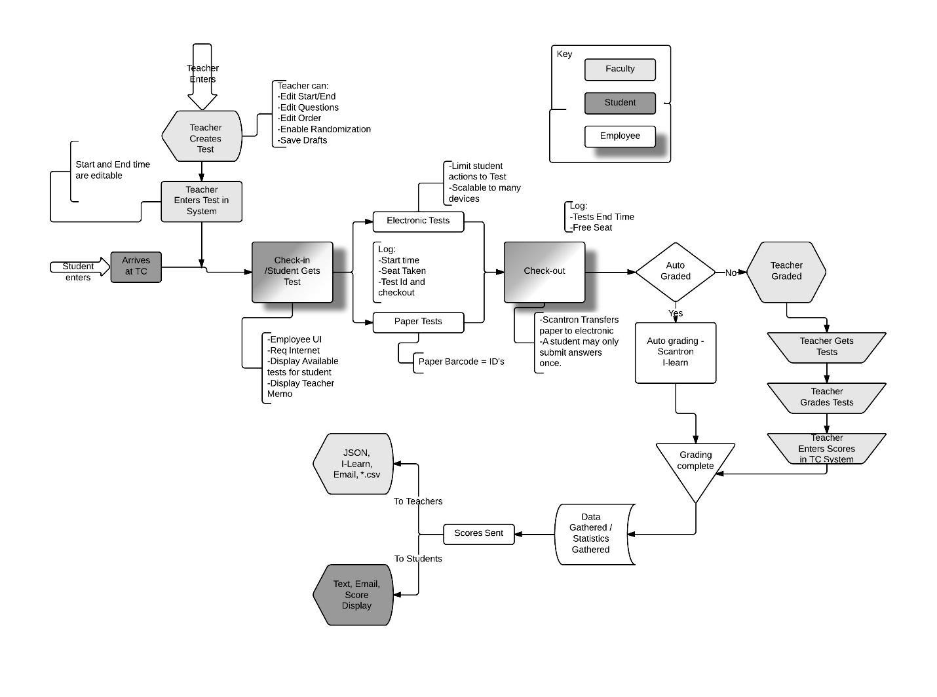

### 2.3.1 Students

Most Students have a basic understanding of technology and its uses. However, this level of understanding ranges from novice to expert. While there are some that have minimal expertise in technology, most will be familiar with web interfaces and Internet technologies. Students don’t like to wait in lines, therefore the process of procuring a test needs to be as efficient as possible. Many Students get extremely frustrated when unexpected things happen in regards to tests. This could include not knowing what they can bring to tests, system failure, and last minute changes to the schedules of tests. Once Students are done with their tests, they don’t like to wait to know their scores; they want their scores immediately.

### 2.3.2 Faculty

Many Faculty are novice users of modern technologies. Some are hostile to change and new technology. They want things done efficiently and without hassle. It is unreasonable, in most cases, to expect them spend more time submitting the test than it took to create it. Faculty will sometimes give up on services that don’t work the first time. The Faculty wants to know that there won’t be last minute problems with scheduling. These kinds of problems result in bad experiences and may cause Faculty to refuse to use the system. When Faculty are pressed for time, they don’t want to have to do repetitious and tedious tasks. Once their task is done, they like to have confirmation that it was done successfully. Faculty are also interested in the metrics of their tests, such as; the average score, the average time to take the test, and the most missed question. Since many of the Faculty may be uncomfortable with new technology, they don’t want to download or install new software. They have a strict purpose in mind when they use a system and don’t care for the extra features. They want to be able to make necessary changes on demand.

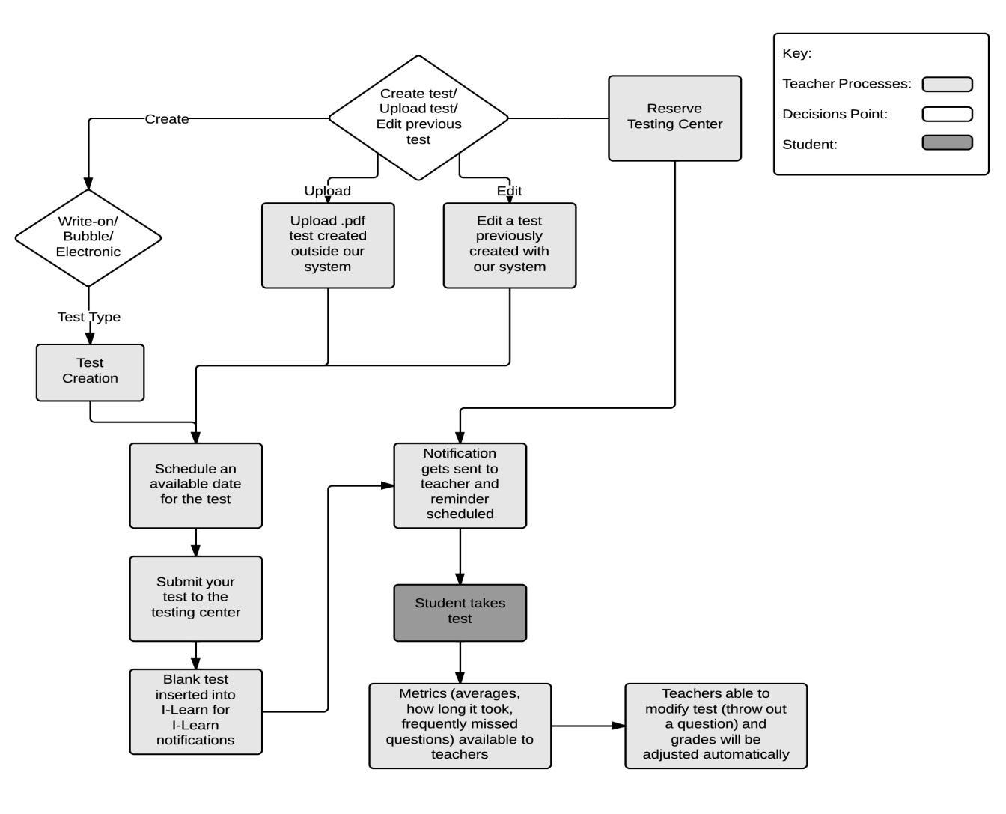

### 2.3.3 Testing Center Employees

The Testing Center Employees will be more familiar with the technology than most of the Students and Faculty. They have to be able to trust the system because of the amount of time they spend using it. They would prefer to have to interact with one interface only. They don’t want to have to deal with test pages getting mixed up. They don’t enjoy rushes of Students. Testing Center Employees also want to be able to perform their job to the best of their ability, whether this is proctoring an exam, handing out paper exams, checking Students in or out of the Testing Center. 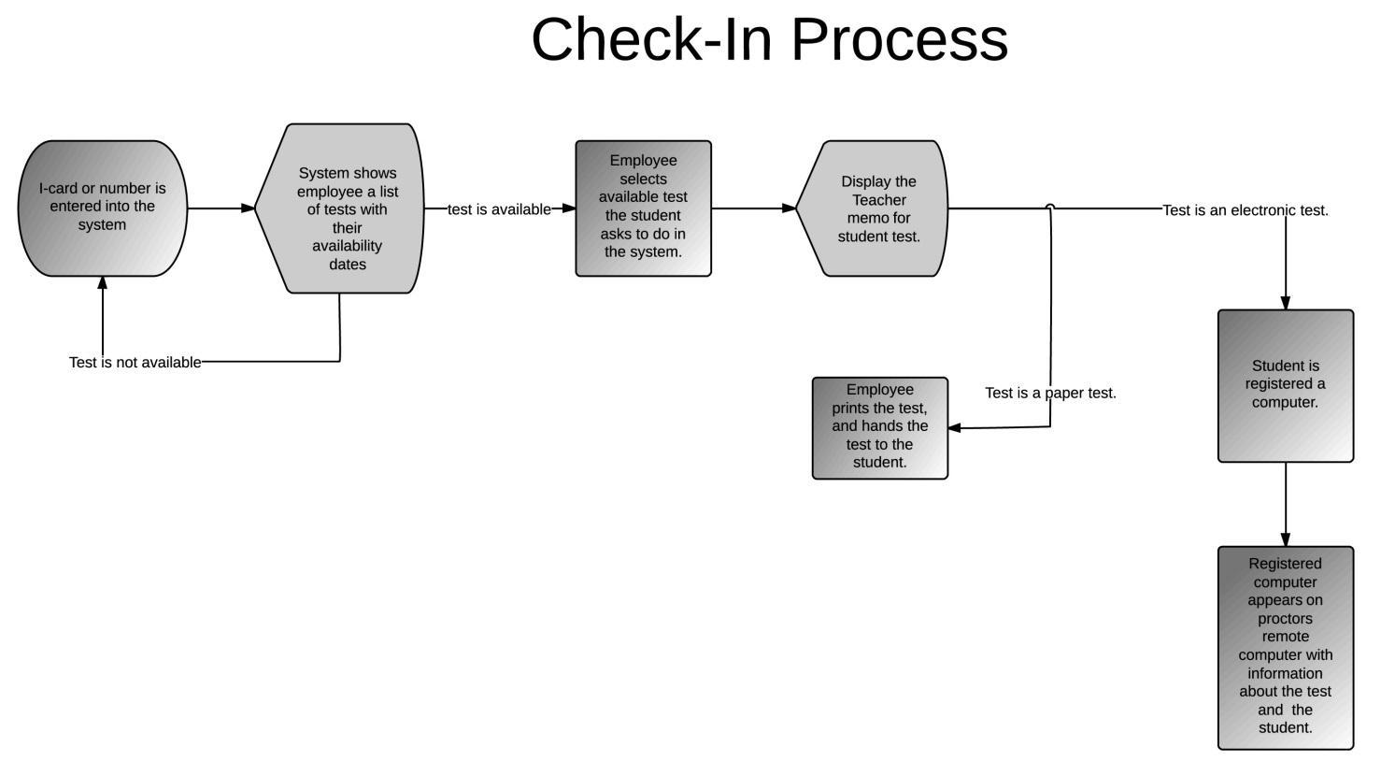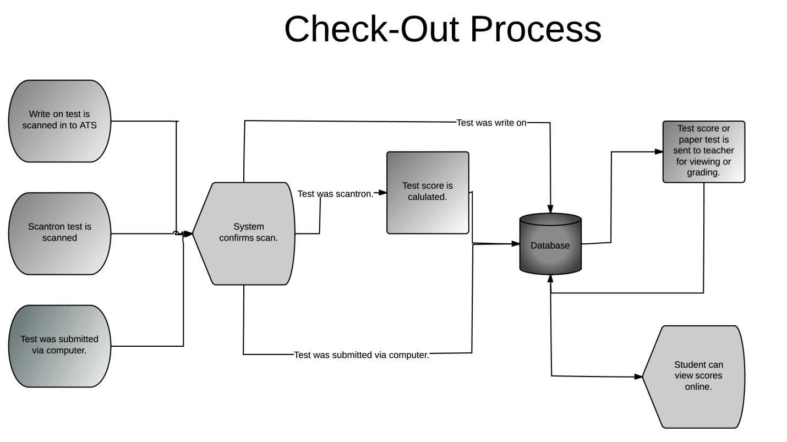

## 2.4. Constraints

ATS shall perform efficiently for the storage and delivery of test scores to Faculty and Students.

ATS must be written in a programming language currently being taught at BYU-Idaho. This will allow for Students and faculty to maintain the system.

ATS needs to interface with I-Learn, Jenzabar, and Scantron devices. I-Learn provides the online testing environment for the current system. The Scantron device reads in and evaluates the score sheets given for most paper tests. Jenzabar is the main system of BYU-Idaho for retrieving and storing Student information. ATS must be available for use through a web interface in order to allow for system access from any location within the IP domain of BYU-Idaho.

## 2.5. Assumptions and Dependencies

The different systems that are assumed to be operational outside of this project are as follows:

* Microsoft Windows OS - ATS will be developed to work with a system which is running the Microsoft Windows Operating System with a modern browser. ATS will support Microsoft Windows 7 in 32 and 64 bit and above.
* Jenzabar – ATS will retrieve the Student data from the Jenzabar system.
* I-Learn – Grades will be posted to the I-Learn system.
* Scantron – The Scantron will deliver its information to ATS where it will then be processed and used for test evaluation.
* The Grade Portal – The display at the exit of the Testing Center will display the results of completed tests.
* Printers – Printers will be available to print paper tests.

## 2.6. Apportioning of Requirements

ATS will provide both paper and online tests.

The online testing is currently provided through I-Learn. ATS shall provide online testing without interfacing with I-Learn.

ATS will be easily adapted for mobile devices.

# 3. Specific Requirements

## 3.1. External Interfaces

### 3.1.1 ATS Interfaces

#### ATS 3.1.1.001

REQ: ATS shall interface with I-Learn.

EX: Faculty needs to upload test scores to I-Learn, which can then be viewed by the Student. I-Learn will also provide the online platform for tests.

#### ATS 3.1.1.002

REQ: ATS shall interface with Jenzabar.

EX: Jenzabar contains the data for each Student. This data will be used for verifications and system logins.

#### ATS 3.1.1.003

REQ: ATS shall provide for desktop applications and new technologies.

EX: ATS needs to be able to work on the desktop computers currently used in the Testing Center, but be able to function on any new technologies that are to come.

### 3.1.2 User Interfaces

ATS 3.1.2.001

REQ: ATS shall inform of errors that occur during operation.

EX: Errors that occur during operation need to be displayed to the user in such a way that they can clearly see what the error was and how to correct it.

ATS 3.1.2.002

REQ: ATS shall provide an interface for employees to check Students into the Testing Center.

EX: This interface will allow a Testing Center Employee to view Student information at check-in. The information for each Student must contain verification of identity including I-Number, Photo ID, and tests allowed to take.

ATS 3.1.2.003

REQ: ATS shall provide an interface for employees to check a Student out of the Testing Center.

EX: The checkout process is to involve the turning in of test, scanning in answer sheets, and checking the Student out of the Testing Center.

ATS 3.1.2.004

REQ: ATS system shall provide an interface for faculty to input tests, schedule tests, make changes to tests, and make grades available for the Student interface.

EX: The faculty will need an interface where they can input the test questions and answers. They also need to be able to schedule a test, make changes to tests that are entered into the system, and make the grades available for Students once the tests have been completed.

ATS 3.1.2.005

REQ: ATS shall have an interface where Students can view their test results.

EX: ATS needs to provide a way for Students to see what their test results are once they have completed the test, after the Faculty Member has made the grades available.

### 3.1.3 Hardware Interfaces

ATS 3.1.3.001

REQ: ATS must interface with the Scantron Device.

EX: The Scantron evaluates the Bubble Sheet tests against the answer key, then delivers its data in electronic form to ATS for processing.

ATS 3.1.3.002

REQ: ATS must interface with multiple printers.

EX: Printers are used for paper tests and printing the cover sheet given to the Student.

ATS 3.1.3.003

REQ: ATS must interface with existing display monitors.

EX: These monitors are located at the entrance and exit of the Testing Center. The one at the entrance displays the active tests and news for the Testing Center. The monitor at the exit displays the scores of the past 20 Students that checked out of the Testing Center.

ATS 3.1.3.004

REQ: ATS must interface with a number pad.

EX: The number pad will be used to enter a Student’s I-Number as they check into the Testing Center. These number pads will be located at each computer used for check-in purposes.

### 3.1.4 Software Interfaces

ATS 3.1.4.001

REQ: ATS shall be developed to work with clients running Microsoft Windows 7 in 32 and 64 bit and above.

EX: The primary systems that ATS will be working with run the Microsoft Windows 7 in 32 and 64 bit and above.

ATS 3.1.4.002

REQ: ATS shall use a math engine that will understand math symbols and syntax.

EX: Using a math engine will enable Students to use math symbols, as well as, make it easier for Faculty to create tests; this will allow the tests to be printable, and the ability to add them to their electronic tests.

### 3.1.5 Communications Interfaces

ATS 3.1.5.001

REQ: HTML content shall be compatible with Modern Browsers.

EX: BYU-Idaho’s standard is limited to these browsers.

## 3.2. Functions

### 3.2.1 Student Requirements:

ATS 3.2.001

REQ: ATS shall provide information about the average waiting time before entering the line using the existing hardware (TV/Monitor/Web Camera).

EX: This will enable Students coming to the Testing Center to know how long the wait will be.

ATS 3.2.002

REQ: Students shall be able to review what they are allowed to bring to their test before arriving at the Testing Center.

EX: After the Student logs into ATS in a web browser, they will be able to see scheduled tests and review what they are allowed to bring to the test with them (calculator, note card, dictionary, etc.).

ATS 3.2.003

REQ: ATS shall provide the option for ADA Students to schedule tests.

EX: This will help ADA Students to avoid long lines at the Testing Center.

ATS 3.2.004

REQ: ATS shall not allow the ability to pause a test.

EX: Users will not be allowed the "save for later" option of an electronic test and Students will not be able to turn in a paper test, to take at a later time.

ATS 3.2.005

REQ: ATS shall display a list of each Student’s tests that already have been scheduled.

EX: Students need to be able to see what tests are scheduled in order to see when they can take a test.

ATS 3.2.006

REQ: ATS shall only allow a Student to take one test at a time.

EX: Faculty would like to effectively track how long it takes a Student to take a test. If a Student takes more than one test at a time, it is hard to gauge how long the test actually takes.

### 3.2.2 Faculty Requirements:

ATS 3.2.007

REQ: ATS shall allow Faculty to submit tests remotely.

EX: This will allow Faculty the option to change tests after submission.

ATS 3.2.008

REQ: ATS shall time each test.

EX: Faculty Members’ want to know how much time is needed for tests.

ATS 3.2.009

REQ: ATS shall return time statistics to the Faculty Member who created the test.

EX: Faculty Members’ want to know how much time is needed for their tests.

ATS 3.2.010

REQ: ATS shall not require the downloading of any form.

EX: The submission process is bothersome and requires saving tests then emailing them.

ATS 3.2.011

REQ: ATS shall give options for immediate access to Student test results.

EX: Faculty Members’ want a quicker turn-around time.

ATS 3.2.012

REQ: ATS shall offer multiple options for question formatting.

EX: Faculty Members’ want the ability to make a variety of tests with different formats to meet their needs.

ATS 3.2.013

REQ: ATS shall provide a way for creation of Scantron tests.

EX: Faculty Members’ want to be able to use Scantron software.

ATS 3.2.014

REQ: ATS shall allow Faculty to reuse old tests.

EX: Faculty Members’ want to be able to use old tests without having to resubmit them.

ATS 3.2.015

REQ: ATS shall allow Faculty to edit old tests for reuse.

EX: Faculty Members’ want the ability to edit old tests and reuse them for different classes.

ATS 3.2.016

REQ: ATS shall only show available dates for testing.

EX: When scheduling the Testing Center, available dates will allow Faculty to know open dates.

ATS 3.2.017

REQ: Faculty shall be able to select test dates when submitting tests.

EX: Faculty are in charge of selecting their own dates within the constraints of the program.

ATS 3.2.018

REQ: Faculty shall only be able to submit Scantron, write on, or computerized tests.

EX: The Testing Center does not want anything besides these forms of tests.

ATS 3.2.019

REQ: ATS shall provide test submission and test date selection in the same process.

EX: The Testing Center wants a single system that will allow the submission process to be simplified.

ATS 3.2.020

REQ: ATS shall provide test creation services.

EX: Faculty will have an “All-in-one” type application only needing one screen to fulfill their test submission needs.

ATS 3.2.021

REQ: ATS shall not hinder the proctoring of exams by enforcing a location on the Faculty submitting the test.

EX: Some faculty members don’t use the services because they prefer the control of testing in their class. e.g. The Testing Center environment doesn’t allow them to accomplish their “educational goals”.

ATS 3.2.022

REQ: ATS shall provide error checking for required fields during test creation.

EX: Faculty sometimes miss things and don't want to run through the whole form to see what box they missed. We need to be able to show them what parts they missed when submitting a test.

ATS 3.2.023

REQ: ATS shall notify, via email, of successful test submission to Faculty.

EX: Notification will allow the Testing Center and Faculty to know that a test has been submitted.

ATS 3.2.024

REQ: ATS shall notify, via email, of successful Testing Center reservation dates to Faculty.

EX: Notification will allow the Testing Center and Faculty to know that a test date has been reserved.

ATS 3.2.025

REQ: ATS shall schedule tests on a first come first serve basis.

EX: Faculty would like the opportunity to schedule their tests when desired (with the exception of finals week).

ATS 3.2.026

REQ: ATS shall allow for Faculty to change a test until a Student has begun taking that test.

EX: Faculty might want to remove questions from the test that were not covered in class or that were phrased poorly.

ATS 3.2.027

REQ: ATS shall not allow a Faculty Member to change a test after a Student has begun taking that test.

EX: Once a Student has begun a test, the test will be locked from modification in order to give all Students an equal chance.

ATS 3.2.028

REQ: ATS shall reflect the **change of test grades** on I-Learn.

EX: ATS will reflect the change in the case where a curve is desired, or when scores need to be corrected due to Faculty errors or ATS errors.

### 3.2.3 Employee Requirements:

ATS 3.2.029

REQ: ATS shall be able to look up a Student profile from Jenzabar.

EX: This provides a form of verification for the Testing Center Employee when a Student cannot produce an I-Card.

ATS 3.2.030

REQ: ATS shall provide notifications about paper tests.

EX: Testing Center Employees don't like that the current notifications are from two different services.

ATS 3.2.031

REQ: ATS shall provide notifications about electronic tests.

EX: Testing Center Employees want current notifications to be one service; currently this process is done from two different services.

ATS 3.2.032

REQ: ATS shall have employees log in with their credentials into a secure server before using the system.

EX: The log on is to distinguish between full time employees and student employees. It will also protect from non employees from tampering with tests.

### 3.2.4 Other Requirements:

ATS 3.2.032

REQ: ATS shall interact with I-Learn interfaces to upload Student grades.

EX: Once grades have been entered, ATS will interface with I-Learn so that Faculty and Students can see grades within I-Learn.

ATS 3.2.033

REQ: ATS shall interact with I-Learn interfaces to upload test statistics.

EX: Test statistics will be useful for Faculty to understand how the test scores ranged and this will be used for reporting. The statistical information may be broken down per Student or Test.

ATS 3.2.034

REQ: ATS shall be able to handle multiple testing locations.

EX: Multiple testing locations will be for busy hours and/or for remote testing locations using the same system as the Testing Center for check-ins and checkouts.

ATS 3.2.035

REQ: Scores, test dates, and tests shall be backed up daily.

EXP: For auditing purposes, these things need to be kept backed up.

## 3.3. Performance Requirements

ATS 3.3.001

REQ: ATS shall support 500 Students taking a test at any given time (either electronic or paper).

EX: There are large quantities of Students who need use of the testing facilities, and the rotation of Students currently taking tests is very rapid.

ATS 3.3.002

REQ: ATS shall support 30 employee terminals.

EX: At any given time, there are a certain number of employees distributing tests. This could increase or decrease depending on the current state of satellite centers and time during the semester.

ATS 3.3.003

REQ: User interface shall enable a Testing Center Employee with 1 month of experience to check out a test within 1 minute, 95% of the time.

EX: Wait time to enter the Testing Center can be greatly reduced if the Testing Center Employees are able to efficiently and accurately distribute tests.

ATS 3.3.004

REQ: A mobile device (Microsoft Surface) used for testing shall be available within 1 minute of check in to be distributed to the next available Student for test taking purposes.

EX: As the Testing Center moves toward an all-electronic testing environment, the need to be able to use a computer that a previous Student was using will increase. This transfer needs to happen as quickly as the tests can be distributed.

## 3.4. Logical Database Requirements

ATS 3.4.001

REQ: The ATS database will perform cleanup annually, removing already administered test dates.

EX: To avoid clutter that could slow down the system, we require this cleanup process yearly. This process will not remove metrics or tests that have not been complied into metrics (see ATS 3.4.005 and ATS 3.4.006)

ATS 3.4.002

REQ: ATS database shall distinguish between paper tests and electronic tests.

EX: For statistical purposes, the Testing Center would wish to know if the tests being taken were delivered electronically or by paper.

ATS 3.4.003

REQ: The ATS database shall store scores as a percentage ranging from 0% through 100%.

EX: This uniformity allows the Testing Center to avoid ambiguity on what a good or bad score is. Test scores may need to be transformed after submission in order to meet this requirement.

ATS 3.4.004

REQ: ATS shall provide the test taken, tests scores, time the test was taken, and length of the test for access to internal systems for metrics.

EX: The Testing Center Employees requested that these items be available for metrics. These metrics would only be available to authorized Testing Center Employees and Faculty.

ATS 3.4.005

REQ: ATS shall not delete metrics stored in the database.

EX: Metrics must be kept for the life of the system so that they can be recalled.

ATS 3.4.006

REQ: ATS shall not delete test information from the ATS database until metrics are compiled for that test.

EX: Any biases must be avoided by ensuring that no test is skipped over.

ATS 3.4.007

REQ: Database information shall be written in the English language.

EX: BYU-Idaho’s standard is that the spoken language is English. For maintainability purposes, the database must also be written in English.

ATS 3.4.008

REQ: ATS database will only reveal test scores through the ATS system in FERPA compliant manners.

EX: To avoid potential problems with FERPA, the system should not disclose scores in any manner that is not secured through the already FERPA compliant ATS system. This ensures that the database will never be the problem, if FERPA confidentiality is breached.

ATS 3.4.009

REQ: ATS shall be the only program to access the ATS database.

EX: Any other application must go through ATS. This ensures that the database will not breach any BYU-Idaho or Federal education standards.

ATS 3.4.010

REQ: The ATS database will only be accessible by ATS administrators and developers of ATS.

EX: ATS developers and administrators will only be allowed access in compliance with FERPA and BYU-Idaho regulations on the privacy of Student data.

ATS 3.4.011

REQ: The ATS database shall provide a history of actions taken by ATS.

EX: Logging of when the test is taken, how the test is taken, when the test is checked out, when the test is checked back in, how long the test took, and the score are all important in resolving potential disputes or accounts of cheating. For this reason, all actions shall be logged and stored in the secure database.

ATS 3.4.012

REQ: The ATS database shall store previous tests from Faculty for reuse.

EX: The database will keep each Faculty Member’s tests for future reuse.

ATS 3.4.013

REQ: The ATS database shall allow Faculty full access their previously used tests.

EX: The database will allow for Faculty to make revisions of their tests and save it as a new revision.

## 3.5. Design Constraints

ATS 3.5.001

REQ: ATS shall perform at 100% reliability with regard to Student records and score tracking.

EX: The result of ATS misrepresenting any Student information and test scores would lead to many undesirable things such as poor grade and possibly repeat of the class.

ATS 3.5.002

REQ: ATS shall work with client computers running Microsoft Windows 7 in 32 and 64 bit and above.

EX: The client computers in which the ATS application resides will have Microsoft Windows 7 in 32 and 64 bit and above. ATS must be able to work on a Microsoft Windows 7 in 32 and 64 bit and above.

### 3.5.1. Standards Compliance

ATS 3.5.1.001

REQ: ATS shall comply with all FERPA privacy standards.

EX: All the information that ATS retrieves about Students and faculty must be kept confidential in accordance to the FERPA laws.

ATS 3.5.1.002

REQ: ATS shall comply with all database standards of the Jenzabar system.

EX: Inputs and outputs of ATS must comply with the standards set by the Jenzabar system; otherwise it will not be able to communicate with Jenzabar.

ATS 3.5.1.003

REQ: ATS shall comply with the I-Learn interface standards.

EX: I-Learn is currently used to host online testing. It also stores and allows Students access to grades. The data from the ATS must be in the format designated by I-Learn.

## 3.6. Software System Attributes

### 3.6.1. Reliability

ATS 3.6.1.001

REQ: ATS shall provide confirmation of a successful test submission to the test taker.

EX: ATS will display a confirmation of a successful submission. This allows the test taker to know that their answers and/or test have been received by the system.

ATS 3.6.1.002

REQ: ATS shall provide an error if test score submission is hindered or stopped.

EX: ATS will display an error of why the test score submission failed.

### 3.6.2. Availability

ATS 3.6.2.001

REQ: ATS shall be inaccessible for Student testing services when there are no employees present. (this excludes the viewing of submitted scores).

EX: In the event ATS runs into an error or detects possible cheating, ATS needs to be able to contact employees. For this reason, ATS will only perform testing during business hours.

ATS 3.6.2.002

REQ: ATS shall allow scheduled (ADA) Student ATS exams only be allowed during their scheduled time.

EX: Scheduled tests will be the result of ADA compliance and will require additional setup by Employees; it would be hard for Testing Center Employees or ATS to accommodate ADA compliance at last minute.

### 3.6.3. Security

ATS 3.6.3.001

REQ: ATS shall allow for Remote Proctoring.

EX: This is an added level of security allowing proctors to see students in other manner besides just walking around.

ATS 3.6.3.002

REQ: Student name, I-number and the test they are taking shall be available to proctors participating in Remote Proctoring.

EX: If a someone is caught cheating via Remote Proctoring the proctor must be able to identify the Student for further disciplinary actions as the university requires.

ATS 3.6.3.003

REQ: ATS shall notify Testing Center Employees of detected attempts of cheating.

EX: There are certain items that are obvious flags for cheating, such as the testing program losing focus and other programs being opened. It helps proctors know when this happens so that they can direct their attention toward it and determine quickly if cheating is actually occurring.

ATS 3.6.3.004

REQ: ATS shall allow for designated, non-faculty personnel to review assessments.

EXP: Some Faculty Members’ don’t use the testing services frequently, this is due because they create writing tests. This allows them to look over or have their TA look over the test, before it is given.

ATS 3.6.3.005

REQ: ATS shall allow Students to take exams only for classes they are currently enrolled in.

EXP: There have been some issues where Students were given the wrong exam or the wrong key was used to grade an exam.

### 3.6.4. Maintainability

ATS 3.6.4.001

REQ: ATS shall be programmed in a language taught at BYU-Idaho.

EXP: We need the system to be developed in a language that is understood by the Students/Faculty of BYU-Idaho. This will allow ATS to be more easily maintained in the future. The current system was programmed in PIC Basic, which is a language that is not well known. For this reason, it is hard to maintain the system.

### 3.6.5. Portability

ATS 3.6.5.001

REQ: ATS shall be able to interface with satellite centers which can use additional computers for administering tests.

EX: The Testing Center has times of high traffic (midterms, finals, etc.). Past semesters show that computer tests are in high demand during these times. Allowing satellite centers to be set up can prevent congestion of the Testing Center during times of anticipated high traffic of Students.

## 3.7. Organizing the specific requirements

The Organization we have chosen is by user class. The user classes are:

* Student
* Faculty
* Employee
* Other

# 4. Appendices

## 4.1. Appendix A: Employees

### 4.1.1 Questionnaires

4.1.1.1 Senior Testing Center Employee Questionnaires

1. What irritates you about the current system?
2. What steps can be simplified in the current system?
3. What parts of the current system do you wish were automated?
4. What do you think about students registering for their test/seat before coming in?
5. How would it help/hinder your work, if all tests were created/edited/taken online?
6. Would you prefer all tests taken online and remove pen and paper tests?
7. What is the most frequent process you go through?
8. What is the most time consuming process?
9. What is the most difficult process?
10. What irritates you about the current system?
11. What steps can be simplified in the current system?
12. How would it help/hinder your work, if all tests were created/edited/taken online?
13. What is the current and why is it a problem?
14. What is the current process for taking a test (creation to checkout)?
15. What programs are used with Scout to perform the tasks need to run the TC?
16. What would you like the one program to have built into it?

4.1.1.2 Junior Testing Center Employee Questionnaires

1. How can the current system be improved?
2. What steps can be simplified in the current system?
3. What parts of the current system do you wish were automated?
4. What parts of the current system cause delays?
5. How would it help/hinder your work, if all tests were created/edited/taken online?

### 4.1.2 Summary

4.1.2.1 Senior Testing Center Employee Summaries

1. We found that the employees are irritated by the fact that the current system does not interface directly with online tests, and many programs are needed to effectively run the testing center.
2. We found that the current system is so outdated that it needs more than one program to maintain all the functions that are needed in the testing center
3. We found that the Testing Center employees would like to have the test input automated to speed up the process of test submittal.
4. We found that the Testing Center employees are open to the idea of students reserving seats, but have yet to find a good solution that will work.
5. We found that if all tests were based online, this would open new opportunities and options for tests in the future.
6. We found that the Testing Center would like to move to all online tests to be more efficient and provide more opportunities for ways to test.
7. We found that most of the times spent by Senior Employees is in assigning tests to certain keys, and putting them in the system.
8. We found that the most time consuming process is assigning point values to questions.
9. We found that the most difficult process is assigning point values to questions.
10. We found that the Testing Center Employees are most irritated by:
    1. Editing scoring
    2. Editing questions when they have only one question per screen
    3. How unfamiliar the current system is to other systems
11. We found that the Testing Center would like to have the following steps simplified:
    1. Finding deadlines for different sections of the same test
    2. Editing the tests without having to switch between different screens
    3. Connecting the test information sheet into the program
12. We found that the Senior Testing Center Employees would like to have teachers more in charge of correcting their own tests. The less time they spend worrying about corrections, they can do their jobs better. They would also be able to cut back on the number of employees needed to save money.
13. We found that the Senior Testing Center Employees have the following problems with the current system:
    1. The only two people who know picBasic (the language of Scout) are retired
    2. They want to be able to have more computer based tests to improve security
    3. Scout does know how many people currently taking a test
    4. Scout does not keep track of any metrics, all metrics are done by hand
14. The current step by step process is as follows:
    1. The Faculty Members create test and test key
    2. The Testing Center checks the dates submitted by teachers to avoid overbooking the testing center
    3. Enter test data into Scout
       1. There could be an upwards of 19 fields for the Testing Center Employee to change
    4. Put on the wall of tests
15. Currently the Testing Center uses the following programs:
    1. PowerPoint: test schedule
    2. Exam Stat: psychometrics
    3. Java applets: picture look up
    4. Ems: ADA scheduling
    5. Outlook: communications
    6. Scout: test entry/ delivery/ number keeping/ records
16. We found that the new system should provide these services:
    1. Scheduling
    2. Testing
    3. Analysis
    4. Test score delivery

4.1.2.2 Junior Testing Center Employee Summaries

1. We found that the Junior Testing Center Employees would like to have the system improved by:
   1. The system needs to give better feedback to the student and instructor.
   2. Clarifying proctoring rotation to reduce delays
2. We found that Testing Center Employees would like to simplify how teachers create and submit tests. The system needs to allow them to do it on their own and not go through the Testing Center Secretary.
3. We found that Testing Center Employees would like the selection of Booklet Numbers should be automated.
4. We found that delays are caused by:
   1. Sorting tests into files
   2. Using the current scanners to check Testing Center Equipment in and out of inventory
5. We found that Junior Testing Center Employees think that the deployment of online test would:
   1. Hinder work because the teacher did not put in information correctly. This happens often.
   2. Cause less printing and quicker filing on the computer removing many delays.
   3. Would require more proctors to cover both the scanning of the room and putting in the passwords for online tests.
   4. Students can cheat with online tests by clicking “save for later” then walk out of the testing center and do it at home.
   5. If the system ever goes down the TC would have to close down causing major problems.

## 4.2. Appendix B: Faculty

### 4.2.1 Questionnaires

1. On average, how many times do you use the school's testing services each semester?
2. How long does it take for you to submit a test to the Testing Center?
3. Is this a satisfactory amount of time?
4. Why do you not use the Testing Center?
5. Are there things you would like to change about the Testing Center Process?
6. What do you like about the Testing Center?

### 4.2.2 Summary

1. We found that Faculty usually use the Testing Center about 7 or more times in a semester.
2. We found that it usually takes less than 15 minutes to submit a test to the Testing Center.
3. We found that most Faculty were satisfactory with how long it takes to submit a test.
4. We found that Faculty don’t use the Testing Center due to:
   1. Many Faculty Members don’t use the Testing Center because they make students write papers, rather than having to deal with the Testing Center
   2. Faculty want a quicker turn around
   3. Faculty don’t want to deal with the hassle of the Testing Center
   4. Faculty don’t believe that tests are useful in assessing Students
5. We found that Faculty wanted to change the following about the Testing Center:
   1. Faculty want an easier way of submitting tests
   2. Faculty want a more convenient way of submitting tests
   3. Faculty want better statistics about the tests
   4. Faculty want a better way to schedule tests
   5. Faculty want something that interfaces with I-Learn
   6. Faculty want a better way to make bubble tests
   7. Faculty want errors in the submittal process to be more prevalent
6. We found that Faculty like the following about the Testing Center:
   1. Faculty like that the Testing Center is trying to meet their needs
   2. Faculty like that the Testing Center provides a way to test outside of class on the Student’s schedule
   3. Faculty like that they can submit tests online
   4. Faculty like that they can have proctored tests

## 4.3 Appendix C: Students

### 4.3.1 Questionnaires

1. Would you like an option to schedule a time to take your test?
2. Is waiting in line at the testing center a problem for you??
3. What information would be useful to know when entering the line?
4. How long is your average wait in the Testing Center Line?
5. Have you ever tried to look at your grades from the testing center web site?
6. Do you ever look at the screen outside the testing center exit door (to know your test score)?
7. How would you like to be informed about your test results?
8. How often do you have to go to the testing center to take a test?
9. Do you get stressed when you wait in line?
10. Do you have any problems when arriving at the testing center? what are they?
11. Would you prefer an option to use your I-number instead of your I-card?
12. Would you be opposed to taking your test in a different location given the facilities to do so?
13. Do you prefer paper or online tests (both in the testing center)? Why?
14. When taking an online test would you prefer a touch screen/stylus interface?

### 4.3.2 Summary

1. We found that students like the idea of scheduling a time to take a test.
2. Generally students do not have a problem with lines in the Testing Center.
3. The most requested item of information wanted before entering the Testing Center is how long the line will be. The second most requested item is the ability to look at what items are allowed on their tests before entering the Testing Center.
4. We found that Students only have to wait 5-10 min to take any given test in the Testing Center.
5. Students are generally unaware of the ability to view grades outside of the testing center.
6. Most Students view their score at the screen as existing the testing center.
7. Students were well divided in their preferred method of receiving test scores. Some asked for a score display, some text and other through e-mail.
8. The average Student visits the Testing Center once or twice a month.
9. The presence of a line at the Testing Center does not stress out Students.
10. Initial problems when arriving at the testing center are rare and easily remedied by the Testing Center Employees, for example, if you forget a pencil, the Testing Center will let you buy one.
11. We found most Students would prefer to just enter their I-number so that they wouldn’t have to carry their I-card.
12. There were no Students that had opposition to taking their tests in alternate locations.
13. We found that Students preferred to take online tests over paper tests, however noted that some classes, like math class, are best taken in paper form.
14. Most Students like the idea of a stylus/touch screen device to take tests.