

Clustering Analysis of Fast Ion Driven Instabilities

John Gresl1  
William Heidbrink1Shaun Haskey2  
Boyd Blackwell3

1*Department of Physics and Astronomy, University of California Irvine, California 92612, USA*2*Princeton Plasma Physics Lab, Princeton University, New Jersey 08540, USA*  
3*Plasma Research Laboratory, Research School of Physics and Engineering, The Australian National University, Canberra, ACT 0200, Australia*

Submitted: xxxxx

# Abstract

Beam ions often drive Alfvén eigenmodes and other instabilities unstable in DIII-D. Many of these modes have been unambiguously identified but some frequently occurring features have been neglected. In this work, datamining and analysis techniques1 that successfully analyzed magnetics data from the H-1NF Heliac are applied to arrays of magnetic and electron cyclotron emission (ECE) data from DIII-D. The clustering techniques group instabilities with similar toroidal magnetic features into clusters of identical mode numbers. Similar analysis is performed on DIII-D’s poloidal magnetic array and ECE probes. Something about ECE results here, later.

# Introduction

Plasma is one of the four fundamental states of matter and makes up an estimated 99% of the matter in the observable universe. A plasma can be thought of as an quasineutral medium of unbound positively and negatively charged particles. These moving charged particles generate local magnetic fields which affect the motion of other nearby particles leading to *collective behavior*, or motion that depends on the physical state of the plasma in local regions.

Harnessing nuclear fusion is one of the prime motivators of studying plasma physics. Nuclear fusion produces more energy per amount of fuel than any other available fuel source. For instance, one gallon of heavy water (water with all of the hydrogen atoms replaced with deuterium atoms) provides 10,000 times more energy when fused than a gallon of gasoline. Deuterium-tritium (D-T) plasmas are known as the most efficient plasma for energy production due to their high mass-to-charge ratio, making it easier to overcome the weak force and fuse together. There are four main reactions that occur in D-T plasmas.

Above, D is a deuterium ion, T is a tritium ion, p is a proton, n is a neutron, and is a nucleus.

Many research plasmas require temperatures on the order of 108 K, making the plasma hot enough to destroy anything it comes into contact with2. For this reason, strong magnetic fields are used to shape and contain the plasma. The introduction of these magnetic fields, while necessary, can lead to some undesirable effects such as unwanted resonances, instabilities, and particles escaping from the plasma and colliding with the inner walls. The study of these interactions is crucial for creating higher quality magnetically confined plasmas.

# Background Physics

Cyclotron Motion

Charged particles trapped in magnetic fields exhibit circular orbits and is known as cyclotron motion. For a non-stationary particle moving at velocity, , with charge, , in a magnetic field, , the force, is equal to:

It is easy to show that there is no work done by this force.

Since is perpendicular to both and , where W is work. The total energy of the particle does not change. We can rewrite velocity in terms of a new basis

where and represent the components of velocity perpendicular and parallel to the magnetic field, respectively. We can then rewrite .

We can say goes to zero since its magnitude, , is equal to 0 since is parallel to by definition.

This force causes charged particles to rotate in circles as they travel along magnetic field lines, all while keeping their parallel velocity constant (see figure 1). Equating the magnetic force to the centripetal force and solving for the radius of curvature yields an expression for the radius of curvature of this gyrating charge known as the Larmor radius, .

From the Larmor radius, one can also determine a parameter known as the cyclotron frequency, :

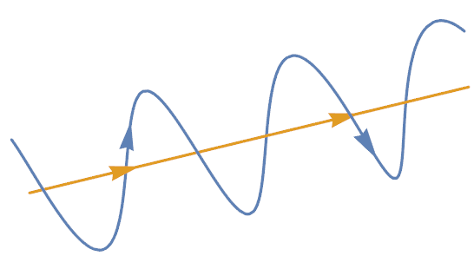

Figure 1. Graphical representation of the path of a charged particle (blue) travelling along a magnetic field line (yellow).

When electrons undergo cyclotron motion, they emit radiation in the form of photons. This is known as electron cyclotron emission (ECE) and is an important diagnostic when studying plasmas.

Alfvén Waves and Eigenmodes

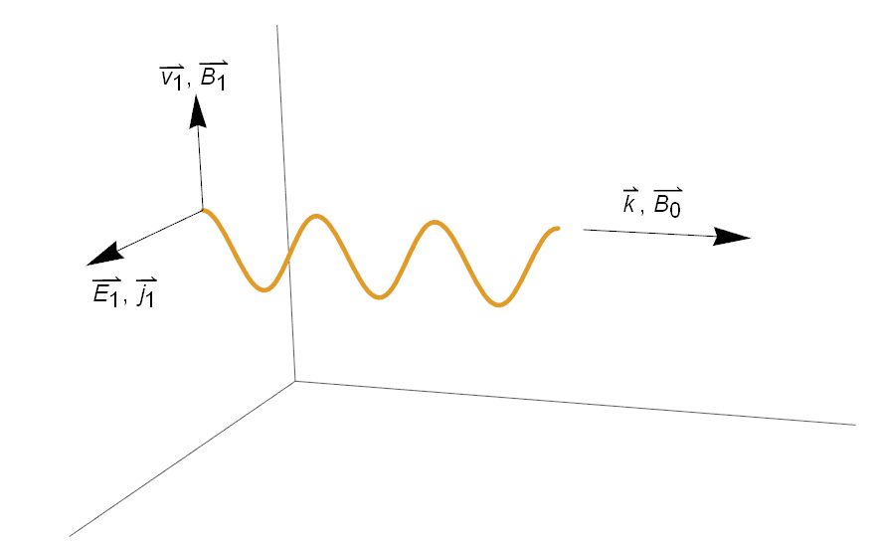

Figure 2. Geometry of an Alfvén wave. The was along , and perpendicular to and and perpendicular to both and .

Alfvén waves are low-frequency (relative to ) travelling oscillation that travels along a magnetic field line3. The motion of an Alfvén wave is analogous to a wave travelling along a stretched string. In this analogy, the tension in the magnetic field lines is the same as the tension in the string, and the Alfvén wave is the result of the “plucking” of the string.

From Maxwell’s equations, we can derive the velocity at which these Alfvén waves travel to be . [See appendix A for actual derivation]. The Alfvén velocity refers to the characteristic speed in which perturbations of the lines of the force travel.

Particles within the plasma may interact undesirably with the external magnetic fields creating modes or local instabilities. Many of these instabilities are detrimental to the plasma’s health and can sometimes cause energetic particles to escape the plasma and damage expensive equipment on the inner walls. For our experiment, we are interested in the particles that become trapped, or locked, in the Alfvén waves and refer to them as Alfvén eigenmodes (AE’s).

**Bibliography**

1. Haskey, S. R., Blackwell, B. D. & Pretty, D. G. Clustering of periodic multichannel timeseries data with application to plasma fluctuations. *Comput. Phys. Commun.* **185,** 1669–1680 (2014).

2. Heidbrink, W. W. Basic physics of Alfvn instabilities driven by energetic particles in toroidally confined plasmas. *Phys. Plasmas* **15,** (2008).

3. Chen, F. F. *Introduction to Plasma Physics and Controlled Fusion*. (Springer, 1984).

# Appendix

A. Derivation of Alfvén Velocity

Refer to figure 2 for definitions of variables and terms. From Maxwell’s equations, we have

|  |  |  |
| --- | --- | --- |
|  |  | [] |

Since is only oriented in the  direction and is only oriented in the direction, only the x component if nontrivial. Our equation becomes

|  |  |  |
| --- | --- | --- |
|  |  | [] |

The thermal motion of the particles is not important, so we can use the solution to the ion equation of motion, [3], with equal to zero.

|  |  |  |
| --- | --- | --- |
|  |  | [] |

Which separates into

|  |  |  |
| --- | --- | --- |
|  |  | []  [] |

Solving for explicitly in [5] yields

|  |  |  |
| --- | --- | --- |
|  |  | [] |

We can plug this into [4] and solve for

|  |  |  |
| --- | --- | --- |
|  |  | [] |

Which is the velocity of the ions in the x direction. To find the electron velocity, we consider the transformation where and the limit where

|  |  |  |
| --- | --- | --- |
|  |  | [] |

This term goes to zero since the ; the Larmor gyrations are negligible so the electrons only have an drift in the y direction. Substituting [7] and [8] into [2] yields

|  |  |  |
| --- | --- | --- |
|  |  | []  [] |

where is the square of the ion plasma frequency.

Now, we take into consideration the fact that Alfvén wave frequencies are much below the ion cyclotron frequency, . In this limit, [10] becomes

|  |  |  |
| --- | --- | --- |
|  |  | [] |

|  |  |  |
| --- | --- | --- |
|  |  | [] |

where is the mass density. Recall that and [12] becomes

|  |  |  |
| --- | --- | --- |
|  |  | [] |

The denominator of [13] can be recognized as the relative dielectric constant for low frequency perpendicular motions, .

|  |  |  |
| --- | --- | --- |
|  |  | [] |

is much larger than one for most laboratory plasmas3, so [13] can be approximated as

|  |  |  |
| --- | --- | --- |
|  |  | [] |

And we have arrived at our result for the Alfvén velocity.

|  |  |  |
| --- | --- | --- |
|  |  | [] |