|  |  |  |  |
| --- | --- | --- | --- |
|  | Shot | Time Window (ms) |  |
|  | 153071 | 2800 – 3000 |  |
|  | 153072 | 2800 – 3000 |  |
|  | 152932 | 2500 – 2700 |  |
|  | 152938 | 3000 – 3200 |  |
|  | 157399 | 2300 – 2500 |  |
|  | 157400 | 2300 – 2500 |  |
|  | 157401 | 2300 – 2500 |  |
|  | 157402 | 2300 – 2500 |  |

**[~]. Verification Process**

**Table [~].1:** Summary of shots and time windows used. A 200 ms wide time window was used for each shot.

When developing a new method, it is in good practice to routinely test said method on a sample set of data where you can already predict the outcome. This becomes increasingly more important as the complexity of your problem increases. For this reason, we collected a series of shots (Table [~].1) which have already been extensively studied1,2. Each shot in our sample set had a steady n=2 neoclassical tearing mode (NTM) instability throughout the entire 200 ms time window (Figure [~].2).

On the left two graphs of figure [~].2, the dark blue n=2 region represents a steady NTM. On the right two graphs of figure [~].2, we can see that the corresponding n=2 points are grouped into red and green clusters. [I’m planning to go through and try to find out why the NTM is being split into two clusters and resolve it.]

**Figure [~].2:** A graphical comparison of two shots from our sample set. Plots of calculated toroidal mode number (left) and plots of different clusters as determined by PyFusion over a spectogram (right). Different colors on the right represent different clusters. (** Remake this plot since it doesn’t look very nice…**)

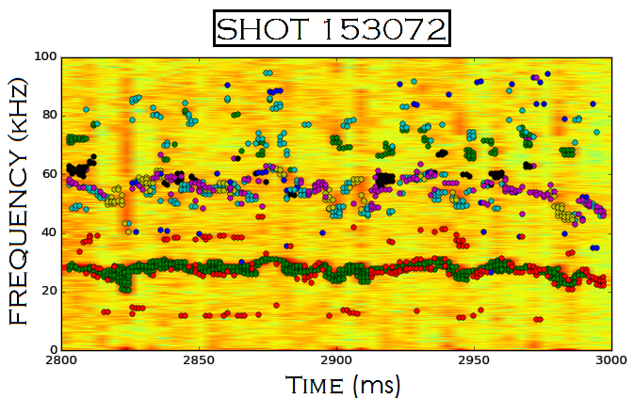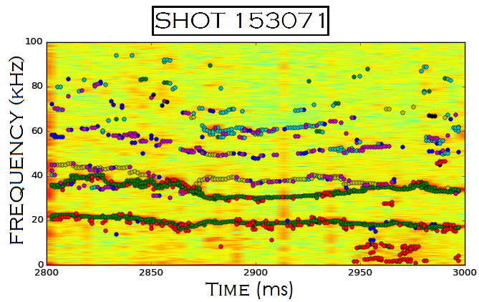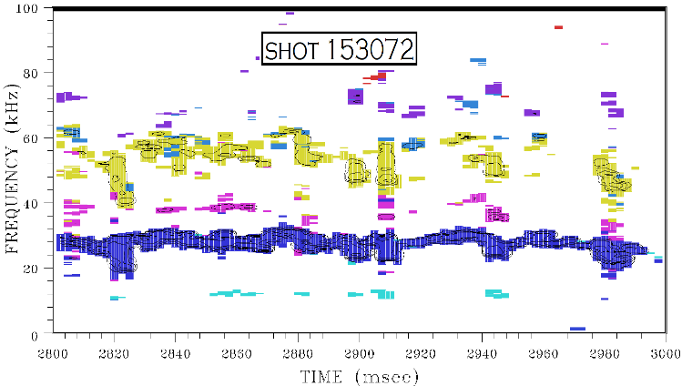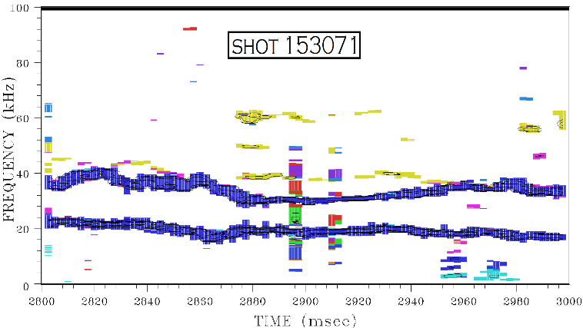

n=

Bibliography

1. Popov, A. M. *et al.* Simulation of neoclassical tearing modes (NTMs) in the DIII-D tokamak. I. NTM excitation. *Phys. Plasmas* **9,** 4205 (2002).

2. Prater, R. *et al.* Stabilization and prevention of the 2/1 neoclassical tearing mode for improved performance in {DIII-D}. *Nucl. Fusion* **47,** 371 (2007).