**Software Requirements Specification**

**Version 1.0**

**October 11, 2019**

**SOSA: Simultaneous Objective/Subjective Assessment**



**Justin Frazey**

**Jeffrey Neal**

**Richard Boutin**

**Gregory Disser**

**Pedro Marrero**

**Table of Contents [ToC]**

**1. Introduction 3**

1.1 Purpose **3**

1.2 Scope **3**

1.3 Definitions, Acronyms, and Abbreviations **3**

1.4 References **4**

1.5 Overview **4**

**2. Overall Description 4**

2.1 Product Perspective **5**

2.1.1 System Interfaces **5**

2.1.2 Interfaces **5**

2.1.3 Software Interfaces **5**

2.1.4 Communication Interfaces **5**

2.1.5 Memory Constraints **5**

2.1.6 Operations **6**

2.1.7 Site Adaptation Requirements **6**

2.2 Product Functions **6**

2.3 User Characteristics **7**

2.4 Constraints **8**

2.5 Assumptions and Dependencies **8**

2.6 Apportioning of Requirements **8**

**3. Specific Requirements 8**

3.1 External Interfaces **8**

3.2 Functions **8**

3.3 Performance Requirements **14**

3.4 Physical Database Requirements **14**

3.5 Logical Database Requirements **14**

3.6 Organized Specific Requirements **14**

3.6.1 User Class **14**

3.6.2 Objects **14**

3.6.3 Features **14**

3.6.4 Functional Hierarchy **16**

**4. Change Management Process 18**

4.1 Methodology **18**

# 1. Introduction

## 1.1 Purpose

This document will address the requirements of the SOSA web application. To do this, it will detail the use cases that the client desires with explanations of the actors. This document will also include a system diagram, a database diagram, and a basic graphical user interface diagram from the subject and administrator point of view along with definitions of the terms used.

## 1.2 Scope

SOSA is a research tool that quantifies a subject’s interaction with various stimuli presented in a graphical user interface. Subjects are exposed to stimuli via admin-generated experiments. It will provide a document of quantified data to the admin, or researcher, upon the completion of a subject’s experiment. It will not provide experiment data to unauthorized users; as a result, it will avoid any HIPAA violations. Researchers can use this tool to gain a better understanding of a subject’s psychological state.

## 1.3 Definitions, Acronyms, and Abbreviations

|  |  |
| --- | --- |
| **Term** | **Definition** |
| SOSA | Simultaneous Objective/Subjective Assessment. This is the system detailed in the document. |
| User | Any person who accesses SOSA in any capacity. The User will be classified as either subject or administrator. |
| Subject | A user that may only participate in experiments. |
| Administrator (Admin) | A user that can create and participate in SOSA experiments. For ease of reading, we will hereafter abbreviate this term to admin. |
| Stimulus | An object that is placed on the experiment board. This is the main focus of the GUI that subjects will interact with. The experiment’s results are drawn from the positions of these objects on the board. |
| HIPAA | Health Insurance Portability and Accountability Act of 1996. This law defines data security requirements that SOSA must meet and follow. |
| User Interface (UI) | The means by which the user interacts with SOSA. For ease of reading, we will hereafter abbreviate this term to UI. |

## 1.4 References

The formatting of this Software Requirements Specification is provided by IEEE 830-1993.

A copy of this document can be obtained through the Georgia Southern Folio system or from the following link:

https://standards.ieee.org/standard/830-1993.html

## 1.5 Overview

This SRS contains the requirements supplementing information as formatted by IEEE 830 standards.

If you are concerned with the specific requirements of the project, please see section 3.2.

If you want a general overview of how the project will handle the requirements, please see section 3.5.3 and 3.5.4.

# 2. Overall Description

Web-SOSA is an evolution of the stand-alone SOSA that has been in use for years. As a result, the requirements of Web-SOSA are the features and capabilities of the original stand-alone SOSA. In addition, SOSA will be used by medical professionals, namely Dr. Webster, thus another factor affecting these requirements are the researcher's preferences. Lastly, Web-SOSA will transfer vital subject information across the web and therefore must comply with HIPAA standards.

## 

## 2.1 Product Perspective

Web-SOSA is designed to be a long term replacement for the current stand-alone SOSA. As it is a tool designed for specific research requirements and has no other competition. Web-SOSA will require hosting from an online service provider and must be able to work or be updated with changing hosts.

In addition, the final portion of Web-SOSA will require working with an email client and various web browsers.

### **2.1.1 System Interfaces**

There are no existing system interfaces that require implementation.

### **2.1.2 Interfaces**

The major interfaces of the system will be the website, mailing server, and image hosting server. The subjects will gain access to the website via a link delivered by a mailing server. The system will utilize a mailing server to invite subjects to begin their tailored experiments. The mailing server shall be able to receive a custom text and destination addresses. The website will utilize an image hosting service such as Cloudinary. The image hosting service shall be able to receive custom images and store custom images for retrieval.

### **2.1.3 Software Interfaces**

This section excluded, as the client has not specified any systems for use. Our interfaces shall be documented as part of design.

**2.1.4 Communications Interfaces**

This section is left empty as we are using no custom protocols, and all communication protocols being used are used transparently.

### **2.1.5 Memory Constraints**

Memory is assumed to be 2GB or higher on end-user systems, as this is half the national average of memory. Therefore, we can assume minimal constraints on SOSA Standalone. SOSA Web will be hosted on Google servers, so we expect minimal constraints there as well.

### **2.1.6 Operations**

The only major responsibility required by the user is to keep track of their login information. Other than that most operations will be handled by the software.

### **2.1.7 Site Adaptation Requirements**

As this product is designed for web browser use, the only adaption required when changing work stations would be that a web browser is installed in order to access Web-SOSA.

## 2.2 Product Functions

Admin Case

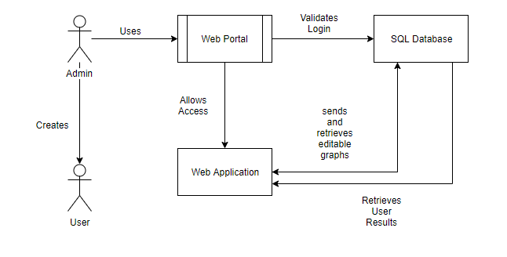

User Case

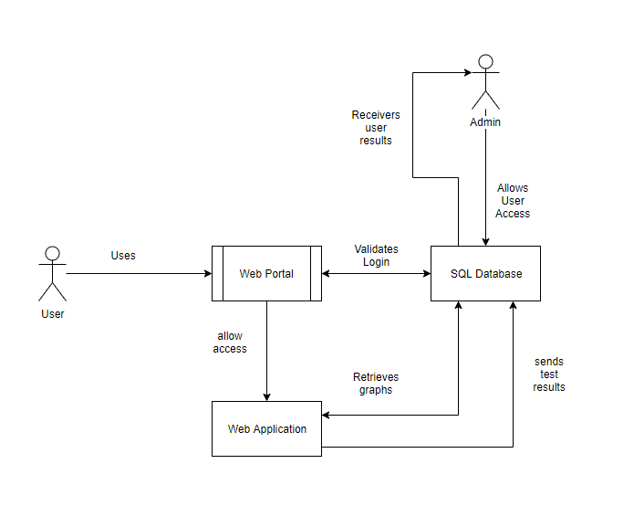

The system will allow the user to login using a username and password they have chosen. The system will allow the user to create an experiment consisting of a set of stimuli and a board that will be saved to a database and connected to their account. The system will allow the user to create multiple orders of these stimuli that will also be saved to the database. The system will allow the user to edit these experiments at a later time. The system will allow the user to send these experiments to a subject via email. The system will return the results of the experiment to the user.

## 2.3 User Characteristics

The product is designed for psychology study purposes, such that the operators generally have a strong psychology background. Operators may include but are not limited to Masters, and or Ph.D. level education in psychology. The operators are provided a UI as psychology graduates and doctors are assumed to not have as strong as a technology background; however, it is assumed the operators are custom to standard computers and UI.

The subjects performing the experiment are under the discretion of the operators of the psychological experiment. However, it is safe to assume subjects have knowledge of basic computer UI.

## 2.4 Constraints

Our primary constraint will be data oriented, as the data will be psychological in nature. This means we will need to follow HIPAA policies on how we store personally identifying information for participants. This means that all data which can be used to identify a person must be stored and transmitted securely using encryption.

## 2.5 Assumptions and Dependencies

As Web-SOSA is browser-based, it will come with an assumption that users will interact with it through a common browser, specifically Firefox, Google Chrome, or Internet Explorer. Beyond this, no feature environments will be supported or adapted for.

Standalone SOSA will have a dependency on Java SE 1.8 being accessible on the system that the software will be run on.

## 2.6 Apportioning of Requirements

All of the requirements are expected to be delivered in the final version of the system, as such this section will contain no further information.

# 

# 3. Specific Requirements

## 3.1 External Interfaces

We should plan on using Cloudinary for any image hosting and Sendgrid for image and mailing services

## 3.2 Functions

|  |
| --- |
| **Requirement One** |
| Title: Login Ability |
| Description: Al1 admins shall be able to log into the software; the application shall be able to distinguish if the user is an admin or a subject. |

|  |
| --- |
| **Requirement Two** |
| Title: Creation Ability |
| Description: All users shall be able to create an account that can be accessed via a username and password at a later time. |

|  |
| --- |
| **Requirement Three** |
| Title: Saving Board |
| Description: An admin shall be allowed to save the created board to his/her storage for future use in the system. |

|  |
| --- |
| **Requirement Four** |
| Title: Board Size |
| Description: Board should be a consistent size, throughout the viewing. |

|  |
| --- |
| **Requirement Five** |
| Title: Board Size |
| Description: All admins shall be able to create and edit the test board. The test  board shall be able to be changed in tilt, rotation, and/or zoom based on the admin's and  experiment specifications. Additionally, the admin will have the ability to customize the  appearance of the board by editing the color of the background. |

|  |
| --- |
| **Requirement Six** |
| Title: Stimuli Creation |
| Description: All admins shall be able to create stimuli for a test. This will include the ability to change colors of stimuli on the board using shaders and RGB saturation. Admins and subjects shall be able to move and place the stimuli objects on the board for tests. |

|  |
| --- |
| **Requirement Seven** |
| Title: Board Resize |
| Description: Admins should be able to choose a size at which to render the experiment board. |

|  |
| --- |
| **Requirement Eight** |
| Title: User Experiment URL |
| Description: Admins shall be able to distribute a uniquely generated URL to subjects of their choice. The generated URL is created based on the stimulus set and board that is chosen when creating an experiment. |

|  |
| --- |
| **Requirement Nine** |
| Title: Results Access |
| Description: When the user has completed the experiment, the admin who set up the test shall be able to gain access to the testing results. |

|  |
| --- |
| **Requirement Ten** |
| Title: Peg Manipulation |
| Description: The user shall be able to manipulate pegs along the cartesian plane. These pegs' coordinates shall be used in the experiment results; determining which stimulus is being used and the location it is placed relative to the starting point. |

|  |
| --- |
| **Requirement Eleven** |
| Title: Results Formatting |
| Description: The results shall be formatted as an Excel spreadsheet. They will include the  following: the test's date and time, experiment name, subject's unique identifier, the  timestamps, coordinates, name and id of each movement of a stimulus, the final coordinates of each stimulus, and the distances from each stimulus to every other stimulus. |

|  |
| --- |
| **Requirement Twelve** |
| Title: Stimulus Set Creation |
| Description: All admins shall be able to create stimulus sets which shall be able to hold  individual stimuli created by the admin. |

|  |
| --- |
| **Requirement Thirteen** |
| Title: Create Experiment |
| Description: All admins shall be able to create an experiment by combining a combination of one previously created and saved board and one stimulus set. |

|  |
| --- |
| **Requirement Fourteen** |
| Title: Ease-of-use GUI |
| Description: The GUI is created in an intuitive and accessible way that allows for ease-of-use of the users when interacting with different elements and pages of SOSA. |

|  |
| --- |
| **Requirement Fifteen** |
| Title: Anonymizing Subjects |
| Description: SOSA shall retain anonymous results of experiments by storing only a unique  identifier created by the subject and no other personal information of the subject. |

|  |
| --- |
| **Requirement Sixteen** |
| Title: Preview of Experiment |
| Description: Admins shall have the ability to view a preview of the selected board and  stimulus set before creating and ftnahzing an experiment. |

|  |
| --- |
| **Requirement Seventeen** |
| Title: Experiment Configuration |
| Description: Admins shall have the ability to customize certain parameters on a subject by subject basis, such as the Stim Order to use, the preview image to use, and whether to hide the Board background image or not. The system should also be able to allow the user to apply a board/board image tint.  Admins should also be able to lock the camera tilt, rotation, and zoom. |

|  |
| --- |
| **Requirement Eighteen** |
| Title: Save Experiment Configuration |
| Description: Admins shall have the ability to save Experiment Configurations, for later reuse for that experiment. |

|  |
| --- |
| **Requirement Nineteen** |
| Title: Load Experiment Configuration |
| Description: Admins shall have the ability to load previously saved configurations, for now, other researchers should not be able to load another researcher’s configurations.  Also, configurations should be specific to each different experiment. |

|  |
| --- |
| **Requirement Twenty** |
| Title: Experiment Rollout |
| Description: Admins shall have the ability to rollout experiment links to all subjects. This should be done via an email system, based on invitation links |

|  |
| --- |
| **Requirement Twenty One** |
| Title: Peg Tracking |
| Description: Admins should have the ability to view the “moves” of any peg during any particular experiment they have distributed. A move shall consist of the following attributes:   * start time * end time * start position (In an understandable format) * end position (In an understandable format)   Moves shall be grouped together by stim into a Move List, for secure storage as part of an Experiment Result. |

|  |
| --- |
| **Requirement Twenty Two** |
| Title: Experiment Time Tracking |
| Description: Admins should have the ability to view certain key start times of an experiment run. This can include, but may not be limited to:   1. Subject Initial Preview time (Time subject hit the button to advance to preview) 2. Subject Experiment Start time (Time subject actually started experiment) 3. Subject Experiment Load Date (Time the subject clicked invite link) |

|  |
| --- |
| **Requirement Twenty Three** |
| Title: Experiment Aux Tracking |
| Description: Admins shall be able to have access to the following auxiliary information:   * Subject Anon Unique Identifier * Experiment Name * Background Image URL |

|  |
| --- |
| **Requirement Twenty Four** |
| Title: Update Notifications |
| Description:  An admin shall receive a notification upon the following events:   * Completion of Experiment and Results available * Password Reset   An admin should also receive notification upon the following events:   * Experiment Closed Prematurely * Cancellation of Experiment |

|  |
| --- |
| **Requirement Twenty Five** |
| Title: Sign up Securely |
| Description: All first-time admins when creating a new account shall have secure password  storage. Based on HIPAA regulations. |

|  |
| --- |
| **Requirement Twenty Six** |
| Title: Not Available in Mobile- Limit Window Size |
| Description: Screen size shall be limited to only allow access to the website and its features for all users and pages on desktop fullscreen. |

## 

## 3.3 Performance Requirements

1. Page load times should be less than 3 seconds on any given transition.
2. The experiment design interface should have a responsiveness of less than 500 milliseconds.
3. Rendering of the stimuli should be completed in less than 500 milliseconds.
4. Dragging or any other manipulation of the stimuli should have a responsiveness of less than 500 milliseconds

## 3.4 Physical Database Requirements

The Database server shall be hosted on a standalone server, and therefore will need consideration in the creation of the deployment diagram.

## 3.5 Logical Database Requirements

The database shall be able to store test values, invitation identifiers, and randomly-generated user identifiers. The significance of storing invitation IDs is to keep a record of links to tests and to keep experiment tables separate from results. The database shall also be able to deliver scores to the admin upon completion of a test.

## 3.6 Organized Specific Requirements

## 3.6.1 User Class

In SOSA, the main classes will be admins and users. The admins have logins and can create experiments, the subjects are only allowed to take part in experiments they have been invited to by an admin.

## 3.6.2 Objects

This section is omitted as our project does not have real-world objects with logical counterparts in our system.

## 3.6.3 Features

|  |
| --- |
| **Feature One** |
| Title: Admin |
| Description: An admin shall be allowed to save the created board to his/her storage for future use in the system. |

|  |
| --- |
| **Feature Two** |
| Title: Creating Experiment |
| Description: An admin shall be allowed to create experiments through the creation of boards and stimuli as well as the arranging of the order the subject views them in. |

|  |
| --- |
| **Feature Three** |
| Title: Taking Experiment |
| Description: An subject shall be allowed to view the experiment provided by the creator whilst the program records relevant data. |

|  |
| --- |
| **Feature Four** |
| Title: Saving Experiment |
| Description: An admin shall be allowed to save the entire experiment as a whole so that it may be opened by another by the provided link, or reopened for later editing and or use. |

|  |
| --- |
| **Feature Five** |
| Title: Administer Experiment |
| Description: An admin shall be allowed to administer an experiment. This shall include the ability to define an experiment configuration, along with a way to notify the selected participants. |

|  |
| --- |
| **Feature Six** |
| Title: Results Access |
| Description: The system should act a portal for admins, and shall allow them to view their results in a nice structured manner. The aim is to store the data in a ‘feedable’ format. Later on we can expose an interface to feed the anonymized data for more complex analytical functions. |

## 3.6.4 Functional Hierarchy

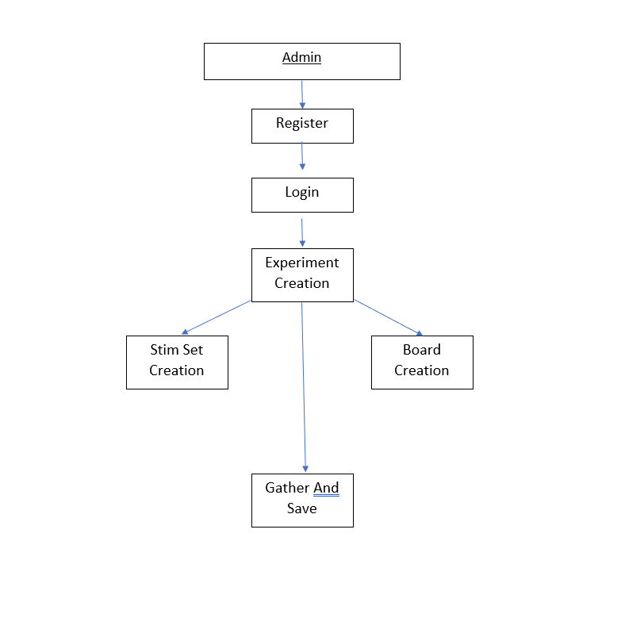

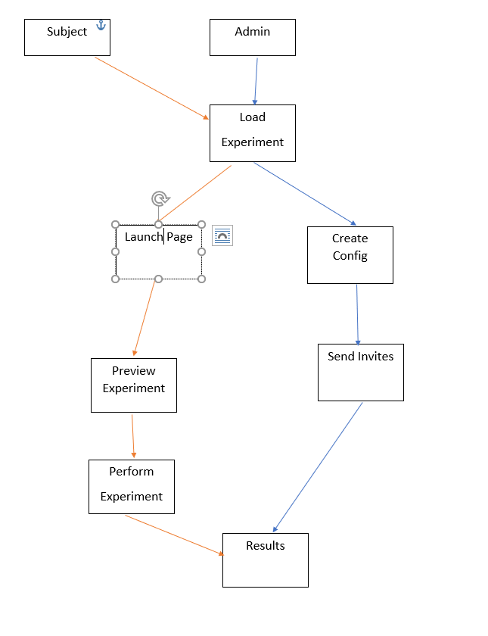

# 4. Change Management Process

## 4.1 Methodology

Our team has decided to use a modified version of the AGILE development methodology. Work on the project is done in 2-week sprints with 2 weeks between each to get feedback from the client, plan the next sprint, and give time to manage work from other classes and projects. Sprints are managed through JIRA software.

Every 2 weeks we meet with our client to inform progress and get feedback on current work and incorporate adjustments into planning and design.

The modified version comes from making additional changes and documentation not normally present in AGILE methodology. This was done to ease the passing on of the project to future groups and aid in the evaluation of work done by our group.