# Individual Final Assessment

## INTRODUCTION

The purpose of this exercise is to create a simple account management system that uses technologies that you need to independently research. Below is a minimum set of requirements and example wireframes of a sample application. This is your chance to impress so please feel free to add more functionality and change the look and feel as you see fit.

## REQUIREMENT

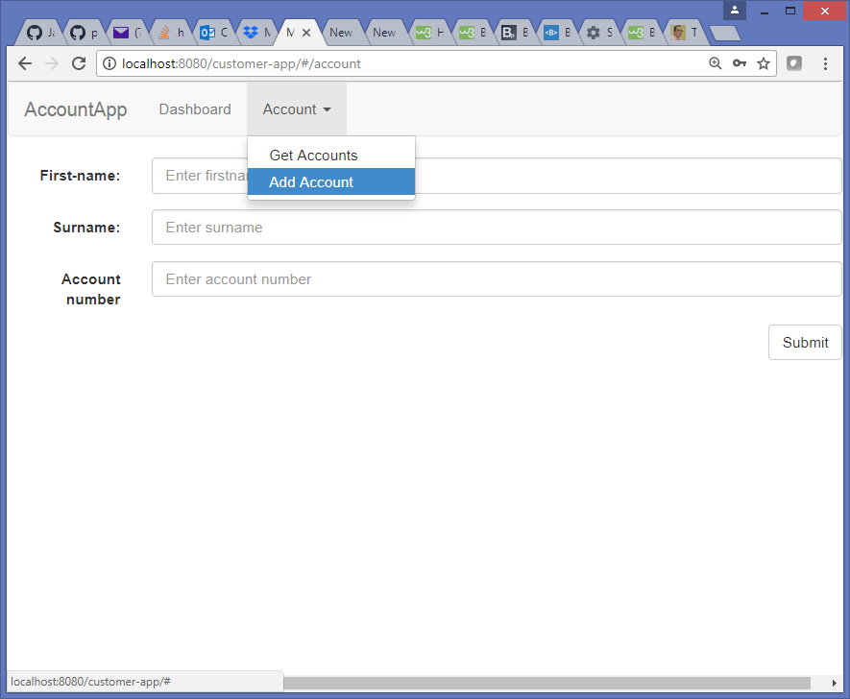Create a page that can add new accounts. The following is an example of a minimum viable feature:

Create a page that can delete an account. The following is an example of a minimum viable feature:

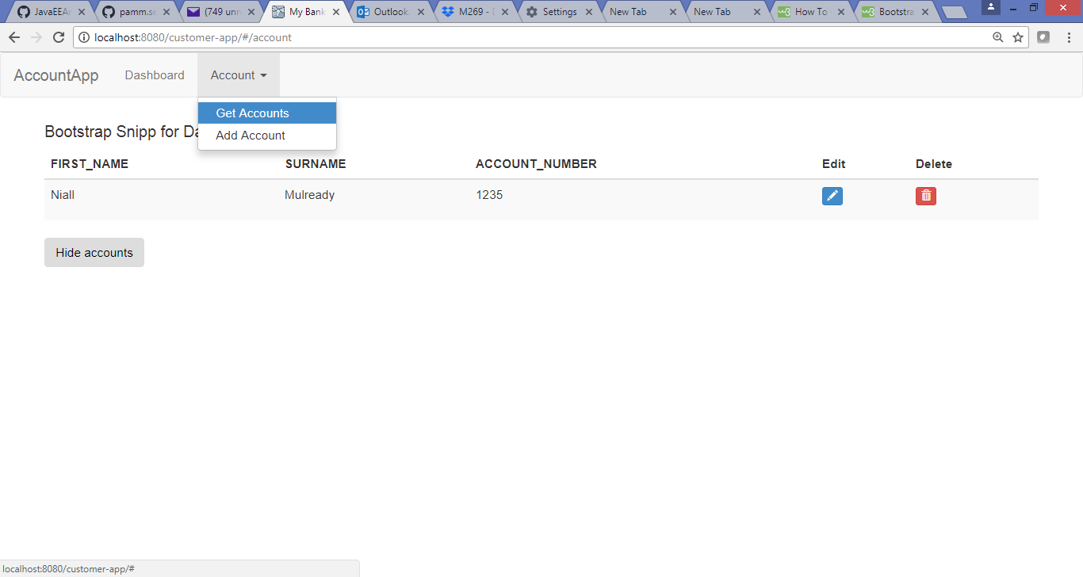

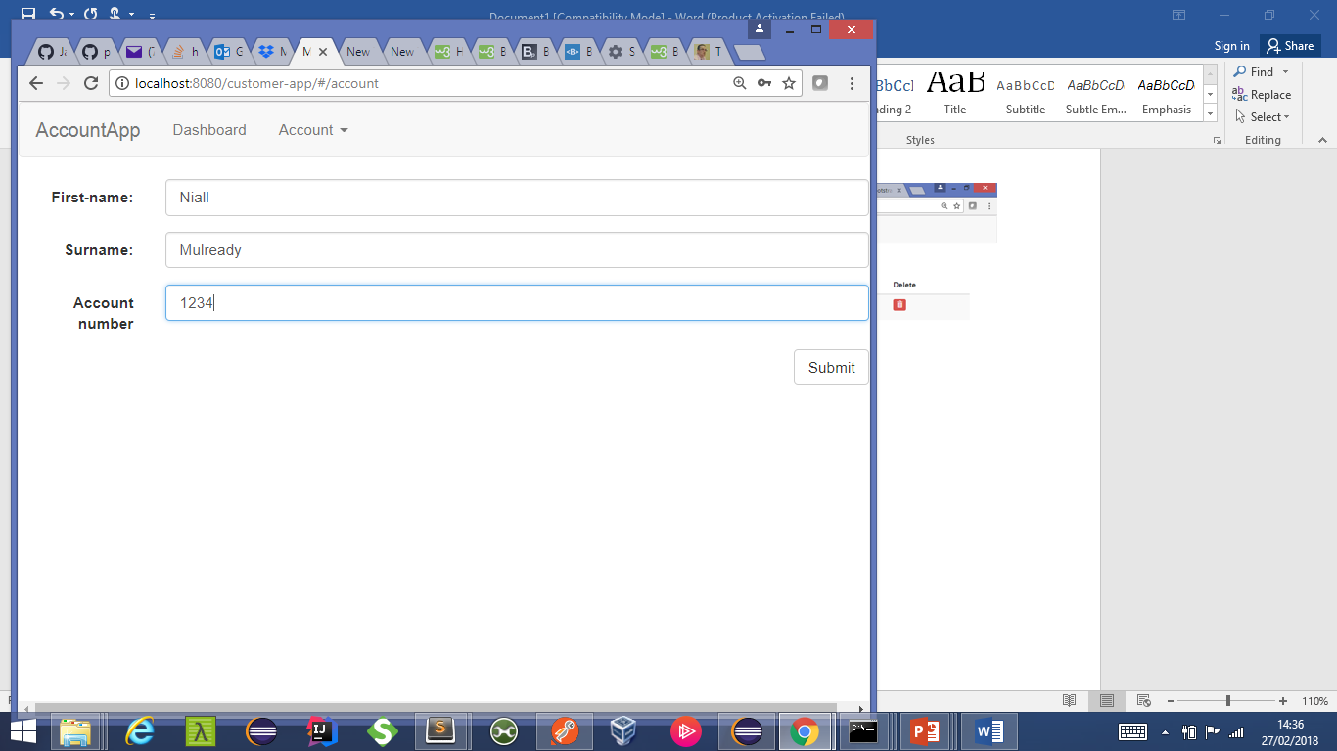Create a page where a user can edit an account. Pressing the edit button could bring up an implementation similar to the following. The following is an example of a minimum viable feature:

## ADDITIONAL INFORMATION

1. This application must persist account information using an appropriate technology.
2. For this system you need to use the following technology set:
   1. Spring Boot (https://spring.io/projects/spring-boot)
   2. Angular (Not AngularJS they are different https://angular.io/)
3. You should use TDD and ensure your GITHUB commits reflect this.
4. This is an individual project and the delivery deadline is 1200 on 25th June.