The following plots correspond to Figure 5 in the section “Capturing Chemical Reaction Diversity” (which is based on Reaxys data) specifically analysing the USPTO dataset.

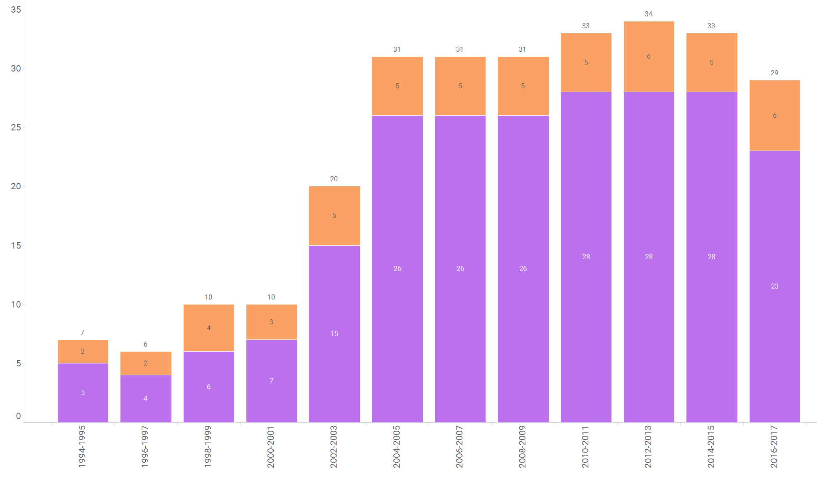

Figure 5a: Suzuki Coupling Reactions—USPTO
The distribution observed here closely mirrors the trends in the Reaxys dataset described in the main manuscript. Notably, the USPTO data reveals a pronounced increase in the diversity of the halide chemical environments involved in Suzuki coupling reactions. However, the onset of this increase is temporally distinct: while the Reaxys dataset indicates a sharp rise in diversity between 1994 and 1997, the USPTO dataset suggests this shift occurred later, around 2000 to 2003.

Figure 5b: C–C Decarboxylative Coupling Reactions—USPTO
In contrast to the Suzuki plot and corresponding Reaxys data, the number of USPTO entries for C–C decarboxylative coupling reactions is markedly lower—only 94 usable data points were identified in this dataset. Due to the limited sample size, no meaningful trends are discussed for this reaction type.

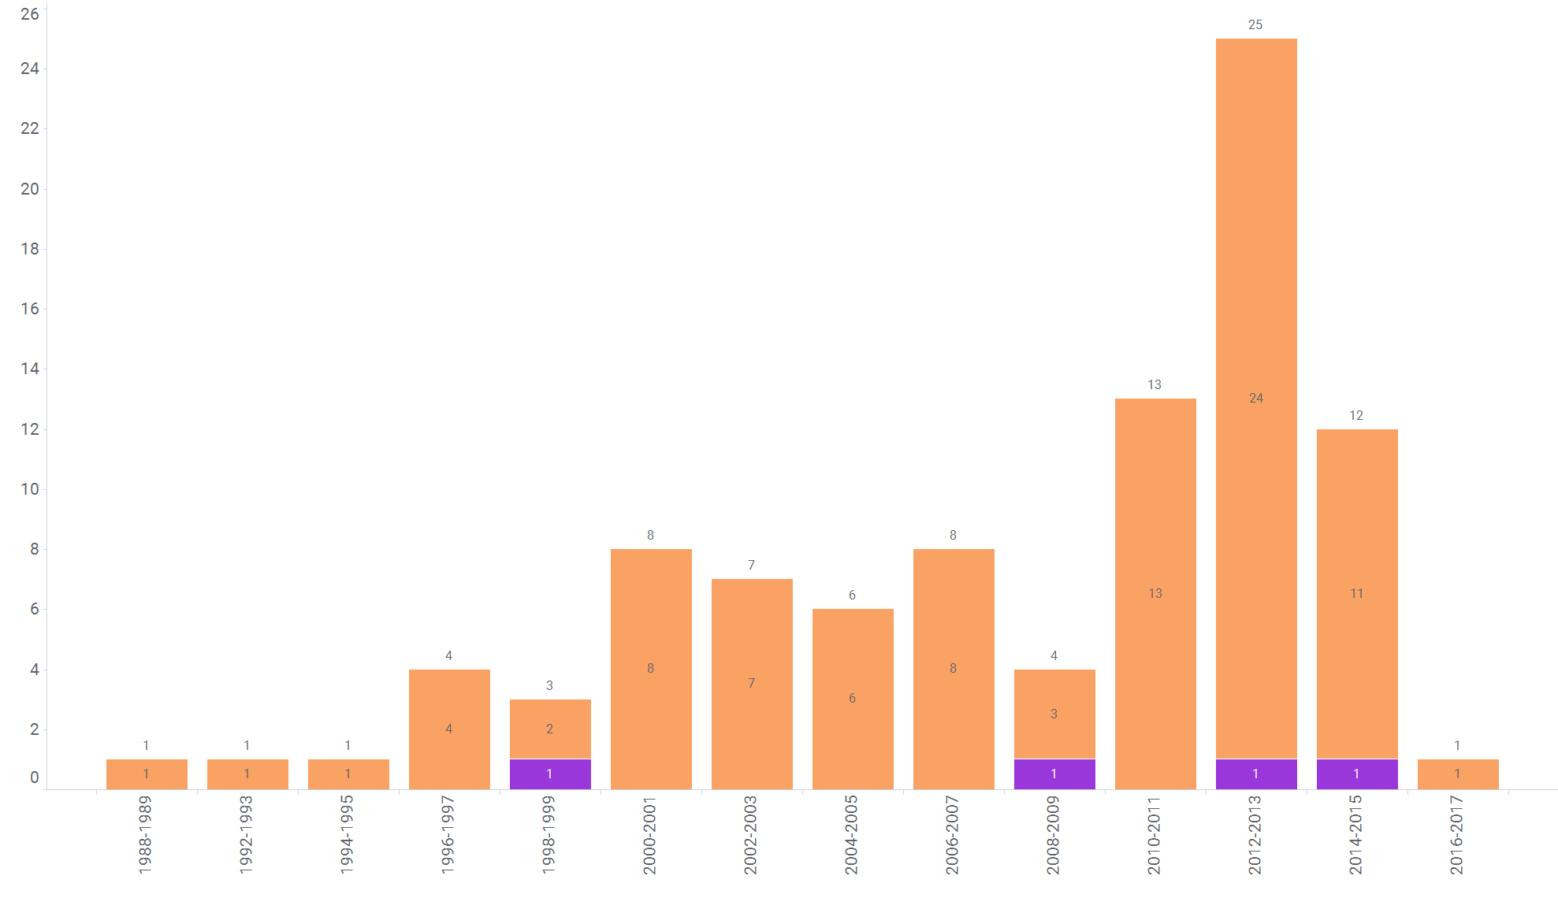

Figure 5. Distribution of the USPTO reaction data with res pect to the years (binned per 2 years for enhancing the plot clarity, for 2 reaction types (a) Suzuki, (b) C–C decarboxylative coupling. The numbers in the bars indicate the number of unique SMARTS-RX, the colour classification is related to the ontology level 2.

