CAS SciFinder Task History

September 10, 2026, 11:33 AM

Initiating Search

Search: | Structure Search  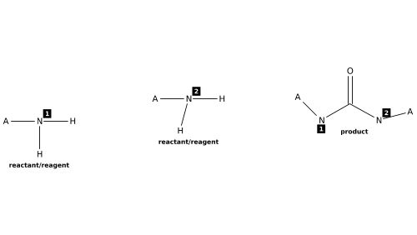

Filtered By:
Structure Match: Substructure
Yield: 90-100%, 80-89%, 70-79%, 50-69%
Number of Steps: 1
Reaction Mapping: Mapping Data Available
Document Type: Journal
Language: English
Publication Name: Journal of Medicinal Chemistry, European Journal of Medicinal Chemistry, Bioorganic & Medicinal Chemistry Letters, Bioorganic & Medicinal Chemistry, Journal of Organic Chemistry, Organic Letters, Angewandte Chemie, International Edition, Journal of the American Chemical Society, Organic & Biomolecular Chemistry, Journal of Combinatorial Chemistry, Medicinal Chemistry Research

Search Tasks

1. Exported: Returned Reaction Results + Filters (3,906) View Results

View in CAS SciFinder

Reactions (98)

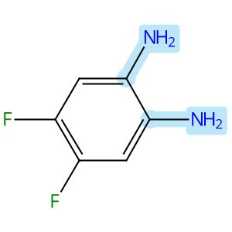 |  | 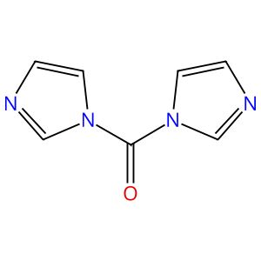 |  | 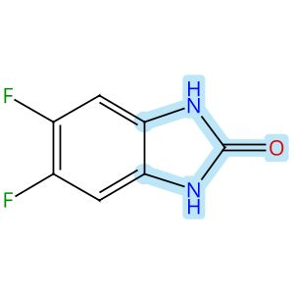

Scheme 1 (Reaction 1 of 1):

Step 1, Yield: 98%

Development of Benzimidazole-Based BZ-30 as an Orally Bioavailable Broad-Spectrum Inhibitor of SARS-CoV-2

By: Kaur, Simran; Brar, Deshkanwar S.; Joshi, Akshay; Singh, Nittu; Chawla, Ravneet S.; Kumar, Sahil; Dhiman, Sumit; Nandi, Utpal; Ringe, Rajesh P.; Thakur, Krishan G.; Chaudhari, Vinod D.

10.1021/acs.jmedchem.6c00365
View All Sources in CAS SciFinder
Company/Organization: Division of Medicinal Chemistry, Council of Scientific and Industrial Research-Institute of Microbial Technology (CSIR-IMTECH), Chandigarh, 160036, India
Source: Journal of Medicinal Chemistry (2026), 69(8), 9537-9557

Step 1
CAS Reaction Number: 31-614-CAS-50120165
Stage | Reagents | Catalysts | Solvents | Conditions
1 |  |  |  | 4 h, 35 °C
  -
  -
  Tetrahydrofuran

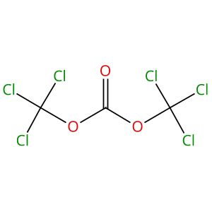 |  | 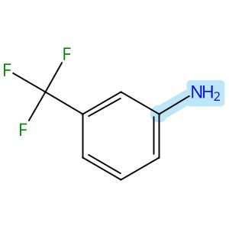 |  | 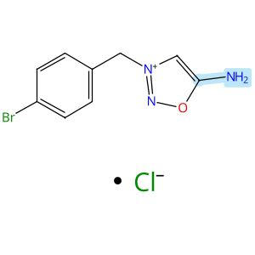
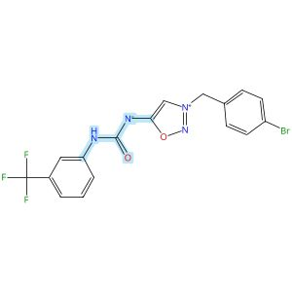

Scheme 2 (Reaction 1 of 1):

Step 1, Yield: 96%

Discovery and Optimization of IRBM-Z-2, an Allosteric Zika Virus NS2B-NS3 Protease Inhibitor Exhibiting In Vivo Efficacy

By: Torrente, Esther; Quotadamo, Antonio; Corio, Alessandra; Ferrigno, Federica; Ievoli, Giovanni; Montalbetti, Christian; Vasile, Silvana; Graziani, Rita; Paonessa, Giacomo; Alli, Cristina; Bisbocci, Monica; Veneziano, Maria; Proto, Giulia; Orsale, Maria Vittoria; di Marco, Annalise; Toniatti, Carlo; Ontoria, Jesus M.

10.1021/acs.jmedchem.6c00476
View All Sources in CAS SciFinder
Company/Organization: Drug Discovery, Medicinal Chemistry Unit, Rome, 00071, Italy
Source: Journal of Medicinal Chemistry (2026), 69(11), 13492-13503

Step 1
CAS Reaction Number: 31-614-CAS-51245220
Stage | Reagents | Catalysts | Solvents | Conditions
1 |  |  |  | 20 min, rt
  Diisopropylethylamine
  -
  Tetrahydrofuran
2 |  |  |  | 0 °C; 10 min, rt
  -
  -
  -
Experimental Protocols
Synthetic Methods
Products | Urea, N-[3-[(4-bromophenyl)methyl]-1,2,3-oxadiazolium-5-yl]-N′-[3-(trifluoromethyl)phenyl]-, inner salt, Yield: 96%
Reactants | 3-(Trifluoromethyl)aniline  Triphosgene  1,2,3-Oxadiazolium, 5-amino-3-[(4-bromophenyl)methyl]-, chloride (1:1)
Reagents | Diisopropylethylamine
Solvents | Tetrahydrofuran
Procedure
  1. | Stir a solution of bis(trichloromethyl)carbonate (0.34 mmol, 1 equiv.), the 3-(trifluoromethyl)aniline (0.69 mmol, 2 equiv.), and DIPEA (1.4 mmol, 4.0 equiv.) in dry THF (2.6 mL, 0.13 M) at room temperature for 20 minutes.
  2. | Add the mixture dropwise to a stirring suspension of the 5-amino-3-(4-bromobenzyl)-1,2,3-oxadiazol-3-ium chloride (0.34 mmol, 1 equiv.) in dry THF (2 mL, 0.17 M) at 0°C.
  3. | Add DIPEA (1.4 mmol, 4 equiv.) to the mixture.
  4. | Stir the reaction mixture at room temperature for 10 minutes.
  5. | Dilute the mixture with H₂O.
  6. | Extract the mixture twice with EtOAc.
  7. | Wash the organic layers with brine.
  8. | Dry the organic layers over Na₂SO₄.
  9. | Filter the mixture.
  10. | Concentrate the filtrate in vacuo to obtain a residue.
  11. | Purify the crude by flash chromatography or preparative HPLC to obtain (3-(4-bromobenzyl)-1,2,3-oxadiazol-3-ium-5-yl)((3-(trifluoromethyl)phenyl) carbamoyl)amide.
Transformation | - Acylation of Nitrogen Nucleophiles by Acyl/ Thioacyl/ Carbamoyl Halides and Analogs
Characterization Data
Urea, N-[3-[(4-bromophenyl)methyl]-1,2,3-oxadiazolium-5-yl]-N′-[3-(trifluoromethyl)phenyl]-, inner salt
Proton NMR Spectrum | (400 MHz, DMSO-d₆) δ 9.71 (s, 1H), 8.23 (s, 1H), 8.21 (s, 1H), 7.72 (br d, J= 8.3 Hz, 1H), 7.68 (br d, J= 7.7 Hz, 2H), 7.54 (br d, J= 8.1 Hz, 2H), 7.44 (br t, J= 7.9 Hz, 1H), 7.22 (br d, J= 7.7 Hz, 1H), 5.78 (s, 2H)
Fluorine-19 NMR | (377 MHz, DMSO-d₆) δ -61.29 (s, 3F)
Mass Spectrum | LCMS (ES⁺) calculated for C₁₇H₁₂BrF₃N₄O₂ 440.01, 442.01; found 441, 443 (M+H)⁺
RT | 2.03 min
State | yellow solid
CAS Method Number 3-614-CAS-51325628

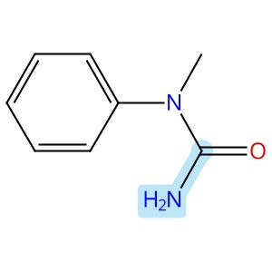 |  | 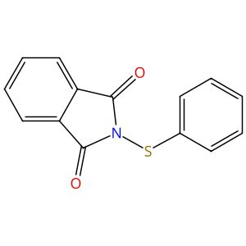 |  | 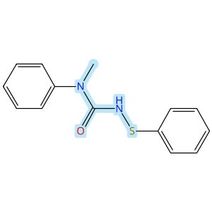

Scheme 3 (Reaction 1 of 1):

Step 1, Yield: 94%

Iron-Catalyzed Asymmetric NH2-Amination of Sulfenamides

By: Fan, Fang-Xu; Jia, Si-Ming; Mo, Zhenbo; Wang, Fei

10.1002/anie.1625296
View All Sources in CAS SciFinder
Company/Organization: State Key Laboratory of Elemento-Organic Chemistry, Frontiers Science Center For New Organic Matter, College of Chemistry, Nankai University, Tianjin, China
Source: Angewandte Chemie, International Edition (2026), 65(33), e1625296

Step 1
CAS Reaction Number: 31-614-CAS-51296073
Stage | Reagents | Catalysts | Solvents | Conditions
1 |  |  |  | 0 °C; 0 °C → rt; 30 min, rt; rt → 0 °C
  Sodium hydride
  -
  Tetrahydrofuran
2 |  |  |  | 0 °C; overnight, 0 °C → rt
  -
  -
  -
3 |  |  |  | rt
  Ammonium chloride
  -
  Water
Experimental Protocols
Synthetic Methods
Products | Urea, N-methyl-N-phenyl-N′-(phenylthio)-, Yield: 94%
Reactants | N-Methyl-N-phenylurea  2-(Phenylthio)-1H-isoindole-1,3(2H)-dione
Reagents | Sodium hydride  Ammonium chloride
Solvents | Tetrahydrofuran  Water
Procedure
  1. | Add amide (1.1 equiv.), to a flame-dry 250 mL round-bottomed flask, equipped with a stir bar, under N2.
  2. | Add THF (0.1 M).
  3. | Cool the solution to 0°C.
  4. | Add NaH (2.5 equiv.) and warm the resulting mixture to room temperature.
  5. | Stir for 30 min.
  6. | Cool the mixture to 0°C.
  7. | Add 2-(phenylthio)isoindoline-1, 3-dione (1.0 equiv.)
  8. | Warm the mixture to room temperature and stir until reaction completion as determine by TLC.
  9. | Dilute the mixture slowly with sat. aq. NH₄Cl with stirring until white precipitates dissolve.
  10. | Extract the resulting solution with EtOAc (three times).
  11. | Wash the combined organic layers with brine, dry (Na₂SO₄) and concentrate.
  12. | Purify the crude residue by flash column chromatography with PE/EA (3/1) as elute.
Characterization Data
Urea, N-methyl-N-phenyl-N′-(phenylthio)-
Proton NMR Spectrum | (400 MHz, CDCl3) δ 7.50- 7.44 (m, 2H), 7.40- 7.34 (m, 1H), 7.32- 7.27 (m, 4H), 7.26 - 7.21 (m, 2H), 7.20- 7.12 (m, 1H), 5.65 (br, 1H), 3.35 (s, 3H)
Carbon-13 NMR | (151 MHz, CDCl3) δ 156.6, 142.5, 140.2, 130.4, 128.9, 128.2, 127.5, 126.3, 124.4, 38.4
HRMS | (ESI) calculated for C₁₄H₁₅N₂OS+ [M+H]+ 259.0900, found 259.0899
State | yellow solid
CAS Method Number 3-614-CAS-51652570

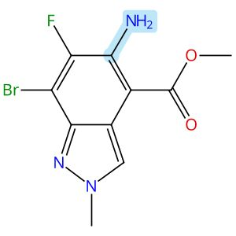 |  | 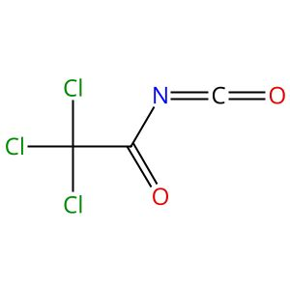 |  | 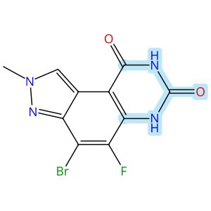

Scheme 4 (Reaction 1 of 1):

Step 1, Yield: 91%

Discovery of Pyrazoloquinazoline Analogues as Orally Bioavailable KRAS-G12D Inhibitors

By: Song, Jiyoung; Jang, Eunsung; Cho, Gyeonghi; Jung, Hoiyun; Cho, Minchang; Park, Chuneung; Kim, Jihun; Ki, Soyoung; Hong, Beomjin; Koh, Ilkyoo; Cho, Hyunho; Lim, Seona; Moon, Mi Jin; Hwang, Sungwan; Park, Hyun-Ju; Singh, Pargat; Kim, In Su

10.1021/acs.jmedchem.5c02840
View All Sources in CAS SciFinder
Company/Organization: School of Pharmacy, Sungkyunkwan University, Suwon, 16419, Korea, Republic of
Source: Journal of Medicinal Chemistry (2026), 69(1), 466-487

Step 1
CAS Reaction Number: 31-614-CAS-48683022
Stage | Reagents | Catalysts | Solvents | Conditions
1 |  |  |  | 0 °C; 2 h, rt
  -
  -
  Tetrahydrofuran
2 |  |  |  | 2 h, 40 °C
  Ammonium hydroxide
  -
  Methanol
  Water
Experimental Protocols
Synthetic Methods
Products | 2H-Pyrazolo[4,3-f]quinazoline-7,9(6H,8H)-dione, 4-bromo-5-fluoro-2-methyl-, Yield: 91%
Reactants | Trichloroacetyl isocyanate  2H-Indazole-4-carboxylic acid, 5-amino-7-bromo-6-fluoro-2-methyl-, methyl ester
Reagents | Ammonium hydroxide
Solvents | Tetrahydrofuran  Methanol  Water
Procedure
  1. | Charge an oven-dried round-bottom flask with a solution of N-methylated intermediate (9.7 g, 32.1 mmol, 100 mol %, 1.0 equiv) in THF (100 mL) and add 2,2,2-trichloroacetyl isocyanate (7.62 mL, 64.2 mmol, 200 mol %, 2.0 equiv) dropwise at 0°C.
  2. | Stir the resulting mixture at room temperature for 2 h under N₂ atmosphere.
  3. | Concentrate the reaction mixture in vacuo after the consumption of starting material indicated by TLC.
  4. | Stir the crude solid in a mixture of 28% NH₄OH (100 mL, 727 mmol, 2200 mol %, 22.0 equiv) and MeOH (100 mL) at 40°C for 2 h.
  5. | Concentrate the reaction mixture in vacuo to provide crude product which triturate with MeOH (100 mL) at room temperature for 30 min.
Transformation | - Hydrolysis or Hydrogenolysis of Amides/ Imides/ Carbamates
Scale | gram
Characterization Data
2H-Pyrazolo[4,3-f]quinazoline-7,9(6H,8H)-dione, 4-bromo-5-fluoro-2-methyl-
Proton NMR Spectrum | (400MHz, CD3SOCD3): δ 8.72 (s, 1H), 4.19 (s, 3H)
HRMS | (ESI) [M + H]+ calcd for C₁₀H₇BrFN₄O₂, 314.0; found, 314.8
CAS Method Number 3-614-CAS-51195031

 |  | 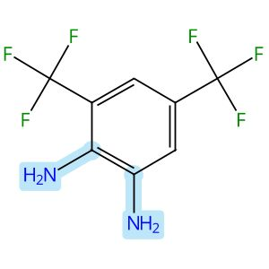 |  | 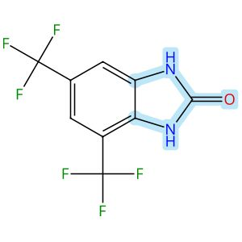

Scheme 5 (Reaction 1 of 1):

Step 1, Yield: 91%

Development of Benzimidazole-Based BZ-30 as an Orally Bioavailable Broad-Spectrum Inhibitor of SARS-CoV-2

By: Kaur, Simran; Brar, Deshkanwar S.; Joshi, Akshay; Singh, Nittu; Chawla, Ravneet S.; Kumar, Sahil; Dhiman, Sumit; Nandi, Utpal; Ringe, Rajesh P.; Thakur, Krishan G.; Chaudhari, Vinod D.

10.1021/acs.jmedchem.6c00365
View All Sources in CAS SciFinder
Company/Organization: Division of Medicinal Chemistry, Council of Scientific and Industrial Research-Institute of Microbial Technology (CSIR-IMTECH), Chandigarh, 160036, India
Source: Journal of Medicinal Chemistry (2026), 69(8), 9537-9557

Step 1
CAS Reaction Number: 31-614-CAS-50120163
Stage | Reagents | Catalysts | Solvents | Conditions
1 |  |  |  | 4 h, 35 °C
  -
  -
  Tetrahydrofuran

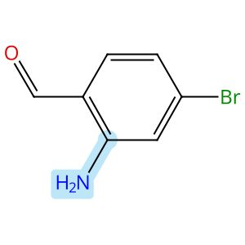 |  | 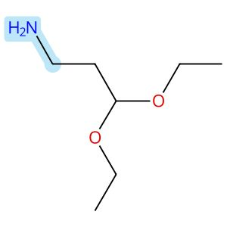
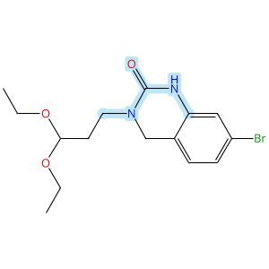

Scheme 6 (Reaction 1 of 1):

Step 1, Yield: 91%

Enantioselective Intramolecular C-H Alkylation Catalyzed by a Nonsymmetric Chiral Cobalt Porphyrin

By: Buchelt, Christoph; Breitenlechner, Stefan; Zuber, Julian; Huber, Stefan M.; Bach, Thorsten

10.1021/jacs.5c19047
View All Sources in CAS SciFinder
Company/Organization: School of Natural Sciences, Department of Chemistry and Catalysis Research Center (CRC), Technische Universitaet Muenchen, Garching, 85747, Germany
Source: Journal of the American Chemical Society (2026), 148(1), 93-98

Step 1
CAS Reaction Number: 31-614-CAS-48658839
Stage | Reagents | Catalysts | Solvents | Conditions
1 |  |  |  | 4 h, 20 °C
  -
  -
  Methanol
2 |  |  |  | 20 °C; 16 h, 20 °C
  Sodium borohydride
  -
  -
3 |  |  |  | 16 h, 60 °C
  -
  -
  Tetrahydrofuran
Experimental Protocols
Synthetic Methods
Products | 2(1H)-Quinazolinone, 7-bromo-3-(3,3-diethoxypropyl)-3,4-dihydro-, Yield: 91%
Reactants | 1-Amino-3,3-diethoxypropane  2-Amino-4-bromobenzaldehyde  1,1′-Carbonyldiimidazole
Reagents | Sodium borohydride
Solvents | Methanol  Tetrahydrofuran
Procedure
  1. | Add the corresponding amine (1.05 equiv.) to a solution of 2-amino-4-bromobenzaldehyde (6.63 g, 20.0 mmol, 1.00 equiv.) in MeOH (500 mM).
  2. | Stir the corresponding solution at 20°C for 4 hours.
  3. | Add NaBH₄ (2.00 equiv.) to the reaction mixture while the temperature maintaining using a water bath.
  4. | Stir the mixture for 16 hours.
  5. | Add H₂O (5 mL) to the reaction mixture.
  6. | Remove the organic solvent under reduced pressure.
  7. | Redissolve the residue in CH₂Cl₂ (30 mL) and H₂O (30 mL).
  8. | Wash the aqueous layer with CH₂Cl₂ (2 x 30 mL).
  9. | Dry the combined organic layers over Na₂SO₄.
  10. | Filter the mixture.
  11. | Remove the solvent under reduced pressure.
  12. | Redissolve the amine in THF (150 mM).
  13. | Add CDI (1.20 equiv.) in one portion to the mixture.
  14. | Stir the mixture at 60°C for 16 hours.
  15. | Cool the mixture to room temperature.
  16. | Wash the organic layer with saturated LiOH solution (50 mL), aqueous citric acid solution (10 wt%, 50 mL), H₂O (50 mL) and brine (40 mL).
  17. | Dry the organic layer over Na₂SO₄.
  18. | Filter the mixture.
  19. | Remove the solvent under reduced pressure.
  20. | Purify the crude by automated flash column chromatography (CH₂Cl₂/MeOH = 49/1 → 19/1) to obtain 7-bromo-3-(3,3-diethoxypropyl)-3,4-dihydroquinazolin-2(1H)-one.
Transformation | - Reductive Alkylation of Ammonia or Amines  - Acylation of Nitrogen Nucleophiles by Acyl/ Thioacyl/ Carbamoyl Halides and Analogs
Scale | gram
Characterization Data
2(1H)-Quinazolinone, 7-bromo-3-(3,3-diethoxypropyl)-3,4-dihydro-
Proton NMR Spectrum | (500 MHz, CDCl₃): δ [ppm] = 1.20 (t, ³J= 7.1 Hz, 6H, CH₃), 1.93 - 1.99 (m, 2H, H-2’), 3.48 - 3.55 (m, 4H, H-1’, OCH₂a), 3.67 (dq, ²J= 9.4 Hz, ³J= 7.1 Hz, 2H, OCH₂b), 4.41 (s, 2H, H-4), 4.59 (t, ³J= 5.6 Hz, 1H, H-3’), 6.85 (d, ⁴J= 1.8 Hz, 1H, H-8), 6.89 (d, ³J= 8.0 Hz, 1H, H-5), 7.04 (dd, ³J= 8.0 Hz, ⁴J= 1.8 Hz, 1H, H-6), 7.55 (bs, 1H, NH)
Carbon-13 NMR | (126 MHz, CDCl₃): δ [ppm] = 154.1 (C-2), 138.6 (C-8a), 127.0 (C-5), 124.8 (C-6), 121.6 (C-4a), 116.8 (C-7), 116.5 (C-8), 101.4 (C-3’), 61.8 (OCH₂), 48.7 (C-4), 43.7 (C-1’), 31.4 (C-2’), 15.5 (CH₃)
IR Absorption Spectrum | (ATR): v [cm⁻¹] = 3334 (w, N-H), 2975 (w, C-H), 2931 (w, C-H), 2878 (w, C-H), 1662 (m, C=O), 1601 (m, C=C), 1517 (m, C=C), 1455 (m), 1316 (m), 1158 (m), 1120 (m, C-O), 1060 (vs, C-Br), 882 (m), 787 (m, C-H), 768 (m, C-H), 759 (m, C-H), 700 (m)
HRMS | (+ESI): calc. for C₁₅H₂₁BrN₂NaO₃ [M+Na]⁺: 379.0628; found: 379.0630
Melting Point | 100-102°C
R_{f} | 0.19 (CH2Cl2/ac = 9/1) [UV, KMnO4]
State | colorless solid
CAS Method Number 3-614-CAS-48801478

 |  | 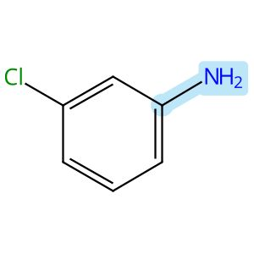 |  | 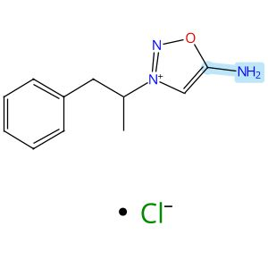
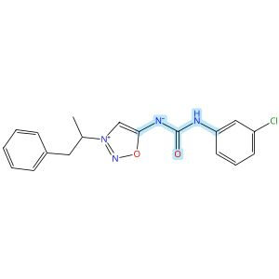

Scheme 7 (Reaction 1 of 1):

Step 1, Yield: 89%

Discovery and Optimization of IRBM-Z-2, an Allosteric Zika Virus NS2B-NS3 Protease Inhibitor Exhibiting In Vivo Efficacy

By: Torrente, Esther; Quotadamo, Antonio; Corio, Alessandra; Ferrigno, Federica; Ievoli, Giovanni; Montalbetti, Christian; Vasile, Silvana; Graziani, Rita; Paonessa, Giacomo; Alli, Cristina; Bisbocci, Monica; Veneziano, Maria; Proto, Giulia; Orsale, Maria Vittoria; di Marco, Annalise; Toniatti, Carlo; Ontoria, Jesus M.

10.1021/acs.jmedchem.6c00476
View All Sources in CAS SciFinder
Company/Organization: Drug Discovery, Medicinal Chemistry Unit, Rome, 00071, Italy
Source: Journal of Medicinal Chemistry (2026), 69(11), 13492-13503

Step 1
CAS Reaction Number: 31-614-CAS-51245229
Stage | Reagents | Catalysts | Solvents | Conditions
1 |  |  |  | 20 min, rt
  Diisopropylethylamine
  -
  Tetrahydrofuran
2 |  |  |  | 0 °C; 10 min, rt
  -
  -
  -
Experimental Protocols
Synthetic Methods
Products | 1,2,3-Oxadiazolium, 5-[[[(3-chlorophenyl)amino]carbonyl]amino]-3-(1-methyl-2-phenylethyl)-, inner salt, Yield: 89%
Reactants | 3-Chloroaniline  Triphosgene  Sydnophene
Reagents | Diisopropylethylamine
Solvents | Tetrahydrofuran
Procedure
  1. | Stir a solution of bis(trichloromethyl)carbonate (0.34 mmol, 1 equiv.), the corresponding aniline (0.69 mmol, 2 equiv.), and DIPEA (1.4 mmol, 4.0 equiv.) in dry THF (2.6 mL, 0.13 M) at room temperature for 20 minutes.
  2. | Add the mixture dropwise to a stirring suspension of the 5-amino-3-(1-phenylpropan-2-yl)-1,2,3-oxadiazol-3-ium chloride (0.34 mmol, 1 equiv.) in dry THF (2 mL, 0.17 M) at 0°C.
  3. | Add DIPEA (1.4 mmol, 4 equiv.) to the mixture.
  4. | Stir the reaction mixture at room temperature for 10 minutes.
  5. | Dilute the mixture with H₂O.
  6. | Extract the mixture twice with EtOAc.
  7. | Wash the organic layers with brine.
  8. | Dry the organic layers over Na₂SO₄.
  9. | Filter the mixture.
  10. | Concentrate the filtrate in vacuo to obtain a residue.
  11. | Purify the crude by flash chromatography or preparative HPLC to obtain ((3-chlorophenyl)carbamoyl)(3-(1-phenylpropan-2-yl)-1,2,3-oxadiazol-3-ium-5-yl)amide.
Transformation | - Acylation of Nitrogen Nucleophiles by Acyl/ Thioacyl/ Carbamoyl Halides and Analogs
Characterization Data
1,2,3-Oxadiazolium, 5-[[[(3-chlorophenyl)amino]carbonyl]amino]-3-(1-methyl-2-phenylethyl)-, inner salt
Proton NMR Spectrum | (400 MHz, DMSO-d₆) δ 9.54 (s, 1H), 8.30 (s, 1H), 7.88 (t, J= 2.0 Hz, 1H), 7.45 (dd, J= 8.3, 1.1 Hz, 1H), 7.32-7.21 (m, 6H), 6.94 (dd, J= 7.9, 1.1 Hz, 1H), 5.20-5.12 (m, 1H), 3.33-3.28 (m, 2H), 1.66 (d, J= 6.6 Hz, 3H)
Mass Spectrum | LCMS (ES⁺) calculated for C₁₈H₁₇ClN₄O₂ 356.10; found 357 (M+H)⁺
RT | 1.92 min
State | white solid
CAS Method Number 3-614-CAS-51325670

 |  | 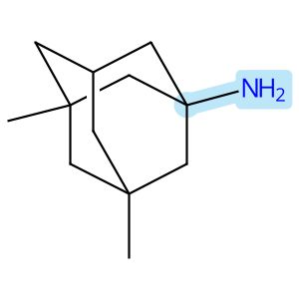 |  | 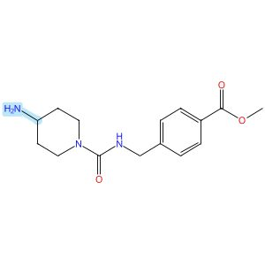  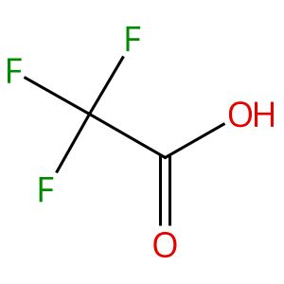
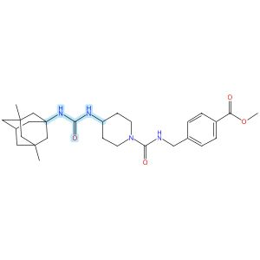

Scheme 8 (Reaction 1 of 1):

Step 1, Yield: 89%

Design and synthesis of novel sEH inhibitors for the treatment of acute lung injury

By: Xu, Huashen; Ma, Ruiyi; Morisseau, Christophe; Dong, Xinyue; Zhuang, Junning; Wang, Zhe; Liu, Fuqin; Xu, Dong; Chen, Lu; Zhang, Maoying; Zhu, Zhihui; Liu, Xinran; Jiang, Huiwen; Liu, Zhongbo; Hammock, Bruce D.; Cao, Ruolin; Chen, Guoliang

10.1016/j.ejmech.2026.118773
View All Sources in CAS SciFinder
Company/Organization: Key Laboratory of Structure-Based Drug Design & Discovery of Ministry of Education, School of Pharmaceutical Engineering, Shenyang Pharmaceutical University, Shenyang, 110016, China
Source: European Journal of Medicinal Chemistry (2026), 309, 118773

Step 1
CAS Reaction Number: 31-614-CAS-49705453
Stage | Reagents | Catalysts | Solvents | Conditions
1 |  |  |  | 1 h, < -10 °C; -10 °C → rt; 30 min, rt
  Triethylamine
  -
  Dichloromethane
2 |  |  |  | 0.5 h, rt; overnight, rt
  Triethylamine
  -
  Dichloromethane
Experimental Protocols
Synthetic Methods
Products | 3124392-73-7, Yield: 89%
Reactants | Memantine  Triphosgene  3124392-72-6
Reagents | Triethylamine
Solvents | Dichloromethane
Procedure
  1. | Add a solution of Memantine (0.15 g, 0.82 mmol, 1.0 eq) and Et₃N (0.25 g, 2.46 mmol, 3.0 eq) in DCM (20 mL) dropwise over 1 h to a thick slurry of triphosgene (0.12 g, 0.41 mmol, 0.5 eq) in DCM (10 mL) in a cold trap while maintaining the temperature below 10°C.
  2. | Remove the cold bath and warm the mixture to room temperature and stir for 30 min.
  3. | Add a slurry of Intermediate (0.3 g, 0.74 mmol, 0.9 eq) and Et₃N (0.42 g, 4.1 mmol, 5.0 eq) in DCM (20 mL) in small portions over 0.5 h at room temperature.
  4. | Stir the reaction mixture overnight.
  5. | Wash the reaction mixture with 10% aq HCl (1 x 20 mL).
  6. | Dry the organic layer over anhydrous MgSO₄ and concentrate under reduced pressure.
Transformation | - Acylation of Nitrogen Nucleophiles by Acyl/ Thioacyl/ Carbamoyl Halides and Analogs
CAS Method Number 3-614-CAS-50079804

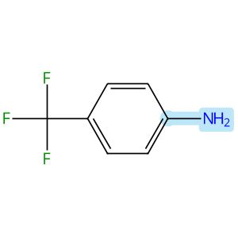

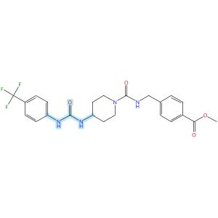

Scheme 9 (Reaction 1 of 1):

Step 1, Yield: 87%

Design and synthesis of novel sEH inhibitors for the treatment of acute lung injury

By: Xu, Huashen; Ma, Ruiyi; Morisseau, Christophe; Dong, Xinyue; Zhuang, Junning; Wang, Zhe; Liu, Fuqin; Xu, Dong; Chen, Lu; Zhang, Maoying; Zhu, Zhihui; Liu, Xinran; Jiang, Huiwen; Liu, Zhongbo; Hammock, Bruce D.; Cao, Ruolin; Chen, Guoliang

10.1016/j.ejmech.2026.118773
View All Sources in CAS SciFinder
Company/Organization: Key Laboratory of Structure-Based Drug Design & Discovery of Ministry of Education, School of Pharmaceutical Engineering, Shenyang Pharmaceutical University, Shenyang, 110016, China
Source: European Journal of Medicinal Chemistry (2026), 309, 118773

Step 1
CAS Reaction Number: 31-614-CAS-49705469
Stage | Reagents | Catalysts | Solvents | Conditions
1 |  |  |  | 1 h, < -10 °C; -10 °C → rt; 30 min, rt
  Triethylamine
  -
  Dichloromethane
2 |  |  |  | 0.5 h, rt; overnight, rt
  Triethylamine
  -
  Dichloromethane
Experimental Protocols
Synthetic Methods
Products | 3124392-85-1, Yield: 87%
Reactants | 4-(Trifluoromethyl)aniline  Triphosgene  3124392-72-6
Reagents | Triethylamine
Solvents | Dichloromethane
Procedure
  1. | Add a solution of Memantine (0.15 g, 0.82 mmol, 1.0 eq) and Et₃N (0.25 g, 2.46 mmol, 3.0 eq) in DCM (20 mL) dropwise over 1 h to a thick slurry of triphosgene (0.12 g, 0.41 mmol, 0.5 eq) in DCM (10 mL) in a cold trap while maintaining the temperature below 10°C.
  2. | Remove the cold bath and warm the mixture to room temperature and stir for 30 min.
  3. | Add a slurry of Intermediate (0.3 g, 0.74 mmol, 0.9 eq) and Et₃N (0.42 g, 4.1 mmol, 5.0 eq) in DCM (20 mL) in small portions over 0.5 h at room temperature.
  4. | Stir the reaction mixture overnight.
  5. | Wash the reaction mixture with 10% aq HCl (1 x 20 mL).
  6. | Dry the organic layer over anhydrous MgSO₄ and concentrate under reduced pressure.
Transformation | - Acylation of Nitrogen Nucleophiles by Acyl/ Thioacyl/ Carbamoyl Halides and Analogs
CAS Method Number 3-614-CAS-50079837

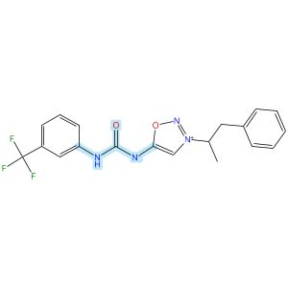

Scheme 10 (Reaction 1 of 1):

Step 1, Yield: 87%

Discovery and Optimization of IRBM-Z-2, an Allosteric Zika Virus NS2B-NS3 Protease Inhibitor Exhibiting In Vivo Efficacy

By: Torrente, Esther; Quotadamo, Antonio; Corio, Alessandra; Ferrigno, Federica; Ievoli, Giovanni; Montalbetti, Christian; Vasile, Silvana; Graziani, Rita; Paonessa, Giacomo; Alli, Cristina; Bisbocci, Monica; Veneziano, Maria; Proto, Giulia; Orsale, Maria Vittoria; di Marco, Annalise; Toniatti, Carlo; Ontoria, Jesus M.

10.1021/acs.jmedchem.6c00476
View All Sources in CAS SciFinder
Company/Organization: Drug Discovery, Medicinal Chemistry Unit, Rome, 00071, Italy
Source: Journal of Medicinal Chemistry (2026), 69(11), 13492-13503

Step 1
CAS Reaction Number: 31-614-CAS-51245219
Stage | Reagents | Catalysts | Solvents | Conditions
1 |  |  |  | 20 min, rt
  Diisopropylethylamine
  -
  Tetrahydrofuran
2 |  |  |  | 0 °C; 10 min, rt
  -
  -
  -
Experimental Protocols
Synthetic Methods
Products | 1,2,3-Oxadiazolium, 3-(1-methyl-2-phenylethyl)-5-[[[[3-(trifluoromethyl)phenyl]amino]carbonyl]amino]-, inner salt, Yield: 87%
Reactants | 3-(Trifluoromethyl)aniline  Triphosgene  Sydnophene
Reagents | Diisopropylethylamine
Solvents | Tetrahydrofuran
Procedure
  1. | Stir a solution of bis(trichloromethyl)carbonate (0.34 mmol, 1 equiv.), the 3-(trifluoromethyl)aniline (0.69 mmol, 2 equiv.), and DIPEA (1.4 mmol, 4.0 equiv.) in dry THF (2.6 mL, 0.13 M) at room temperature for 20 minutes.
  2. | Add the mixture dropwise to a stirring suspension of the 5-amino-3-(1-phenylpropan-2-yl)-1,2,3-oxadiazol-3-ium chloride (0.34 mmol, 1 equiv.) in dry THF (2 mL, 0.17 M) at 0°C.
  3. | Add DIPEA (1.4 mmol, 4 equiv.) to the mixture.
  4. | Stir the reaction mixture at room temperature for 10 minutes.
  5. | Dilute the mixture with H₂O.
  6. | Extract the mixture twice with EtOAc.
  7. | Wash the organic layers with brine.
  8. | Dry the organic layers over Na₂SO₄.
  9. | Filter the mixture.
  10. | Concentrate the filtrate in vacuo to obtain a residue.
  11. | Purify the crude by flash chromatography or preparative HPLC to obtain (3-(1-phenylpropan-2-yl)-1,2,3-oxadiazol-3-ium-5-yl)((3-(trifluoromethyl)phenyl)carbamoyl)amide.
Transformation | - Acylation of Nitrogen Nucleophiles by Acyl/ Thioacyl/ Carbamoyl Halides and Analogs
Characterization Data
1,2,3-Oxadiazolium, 3-(1-methyl-2-phenylethyl)-5-[[[[3-(trifluoromethyl)phenyl]amino]carbonyl]amino]-, inner salt
Proton NMR Spectrum | (400 MHz, DMSO-d₆) δ 9.65 (s, 1H), 8.32 (s, 1H), 8.27 (br s, 1H), 7.68 (br d, J= 8.0 Hz, 1H), 7.43 (t, J= 8.0 Hz, 1H), 7.31-7.27 (m, 2H), 7.24-7.19 (m, 4H), 5.16-5.11 (m, 1H), 3.32 (m, 2H), 1.65 (d, J= 8.0 Hz, 3H)
Fluorine-19 NMR | (377 MHz, DMSO-d₆) δ -61.28 (s, 3F)
HRMS | m/z calculated for C₁₉H₁₇F₃N₄O₂ (M+H)⁺ 391.13764, found 391.13771
Mass Spectrum | LCMS (ES⁺) m/z calculated for C₁₉H₁₇F₃N₄O₂ 390.13; found 391 (M+H)⁺
RT | 2.00 min
State | light-yellow solid
CAS Method Number 3-614-CAS-51325639

 |  | 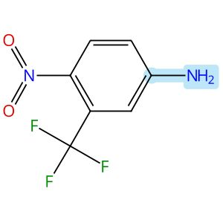 |  | 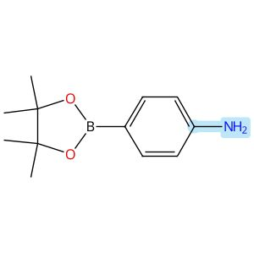
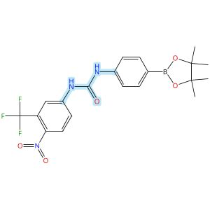

Scheme 11 (Reaction 1 of 1):

Step 1, Yield: 85%

Discovery of drug target for vascular normalization through multifunctional photoaffinity probes

By: Li, Yanchen; Wang, Jin; Zhang, Junyu; Liu, Tingting; Shan, Yuanyuan; Zhang, Jie

10.1016/j.ejmech.2025.118465
View All Sources in CAS SciFinder
Company/Organization: School of Pharmacy, Health Science Center, Xi’an Jiaotong University, Xi’an, 710061, China
Source: European Journal of Medicinal Chemistry (2026), 303, 118465

Step 1
CAS Reaction Number: 31-614-CAS-48750894
Stage | Reagents | Catalysts | Solvents | Conditions
1 |  |  |  | 0 °C; 15 min, 0 °C
  -
  -
  Dichloromethane
2 |  |  |  | 0 °C; 15 min, 0 °C
  Triethylamine
  -
  Dichloromethane
3 |  |  |  | 0 °C; 40 min, 0 °C
  Triethylamine
  -
  Dichloromethane
Experimental Protocols
Synthetic Methods
Products | Urea, N-[4-nitro-3-(trifluoromethyl)phenyl]-N′-[4-(4,4,5,5-tetramethyl-1,3,2-dioxaborolan-2-yl)phenyl]-, Yield: 85%
Reactants | 4-Nitro-3-(trifluoromethyl)aniline  Triphosgene  (4,4,5,5-Tetramethyl-1,3,2-dioxaborolan-2-yl)aniline
Reagents | Triethylamine
Solvents | Dichloromethane
Procedure
  1. | Dissolve 0.8 g of triphosgene (2.74 mmol, 1 eq) with 20 mL of anhydrous DCM under the condition of ice bath.
  2. | Stir the mixture for 5 minutes.
  3. | Add 10 mL of DCM solution of 1.41 g of 5-amino-2-nitrobenzotrifluoride (6.85 mmol, 2.5 eq) slowly to the mixture.
  4. | Stir the mixture for 15 minutes.
  5. | Add 10 mL of DCM solution of 1.1 mL of triethylamine (8.22 mmol, 3 eq) dropwise to the system.
  6. | Stir the mixture for 5 minutes.
  7. | Add 10 mL of DCM solution of 1.5 g of 4- aminophenylboronic acid pinacol ester (6.85 mmol, 2.5 eq) and 1.1 mL of triethylamine (8.22 mmol, 3 eq) dropwise to the system.
  8. | Stir the mixture for 40 minutes.
  9. | Purify the residue by column chromatography (petroleum ether: ethyl acetate=30:1) to afford 1-(4- nitro-3-(trifluoromethyl)phenyl)-3-(4-(4,4,5,5-tetramethyl-1,3,2-dioxaborolan-2- yl)phenyl)urea.
Transformation | - Acylation of Nitrogen Nucleophiles by Acyl/ Thioacyl/ Carbamoyl Halides and Analogs
Scale | gram
Characterization Data
Urea, N-[4-nitro-3-(trifluoromethyl)phenyl]-N′-[4-(4,4,5,5-tetramethyl-1,3,2-dioxaborolan-2-yl)phenyl]-
Mass Spectrum | LRMS-ESI (M+H⁺) calcd 452.15; found 452.10
CAS Method Number 3-614-CAS-50074944

 |  | 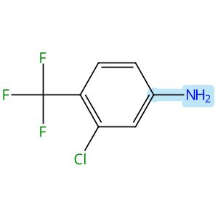 |  | 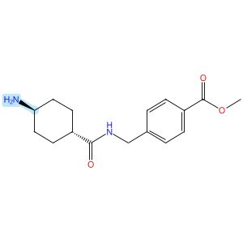  Relative stereochemistry shown
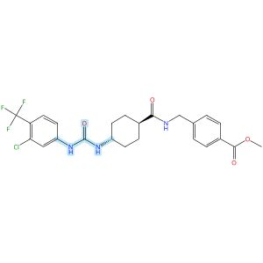
Relative stereochemistry shown

Scheme 12 (Reaction 1 of 1):

Step 1, Yield: 85%

Design and synthesis of novel sEH inhibitors for the treatment of acute lung injury

By: Xu, Huashen; Ma, Ruiyi; Morisseau, Christophe; Dong, Xinyue; Zhuang, Junning; Wang, Zhe; Liu, Fuqin; Xu, Dong; Chen, Lu; Zhang, Maoying; Zhu, Zhihui; Liu, Xinran; Jiang, Huiwen; Liu, Zhongbo; Hammock, Bruce D.; Cao, Ruolin; Chen, Guoliang

10.1016/j.ejmech.2026.118773
View All Sources in CAS SciFinder
Company/Organization: Key Laboratory of Structure-Based Drug Design & Discovery of Ministry of Education, School of Pharmaceutical Engineering, Shenyang Pharmaceutical University, Shenyang, 110016, China
Source: European Journal of Medicinal Chemistry (2026), 309, 118773

Step 1
CAS Reaction Number: 31-614-CAS-49705387
Stage | Reagents | Catalysts | Solvents | Conditions
1 |  |  |  | 1 h, < -10 °C; -10 °C → rt; 30 min, rt
  Triethylamine
  -
  Dichloromethane
2 |  |  |  | 0.5 h, rt; overnight, rt
  Triethylamine
  -
  Dichloromethane
Experimental Protocols
Synthetic Methods
Products | 3124391-98-3, Yield: 85%
Reactants | 3-Chloro-4-trifluoromethylaniline  Triphosgene  3124391-96-1
Reagents | Triethylamine
Solvents | Dichloromethane
Procedure
  1. | Add a solution of reactant (0.2 g, 0.93 mmol, 1.0 eq) and Et₃N (0.28 g, 2.78 mmol, 3.0 eq) in DCM (20 mL) dropwise over 1 h to a thick slurry of triphosgene (0.14 g, 0.46 mmol, 0.5 eq) in DCM (10 mL) in a cold trap while maintaining the temperature below 10°C.
  2. | Remove the cold bath and warm the mixture to room temperature and stir for 30 min.
  3. | Add a slurry of Intermediate (0.30 g, 0.74 mmol, 0.8 eq) and Et₃N (0.56 g, 5.56 mmol, 6.0 eq) in DCM (20 mL) in small portions over 0.5 h at room temperature.
  4. | Stir the reaction mixture overnight.
  5. | Wash the reaction mixture with 10% aq HCl (1 x 20 mL).
  6. | Dry the organic layer over anhydrous MgSO₄ and concentrate under reduced pressure.
Transformation | - Acylation of Nitrogen Nucleophiles by Acyl/ Thioacyl/ Carbamoyl Halides and Analogs
Scale | gram
Characterization Data
3124391-98-3
Mass Spectrum | ESI-MS m/z: 534.1 [M+Na] +
State | White solid
CAS Method Number 3-614-CAS-50079519

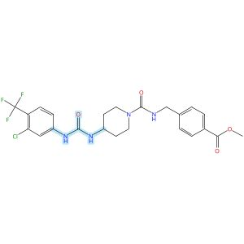

Scheme 13 (Reaction 1 of 1):

Step 1, Yield: 85%

Design and synthesis of novel sEH inhibitors for the treatment of acute lung injury

By: Xu, Huashen; Ma, Ruiyi; Morisseau, Christophe; Dong, Xinyue; Zhuang, Junning; Wang, Zhe; Liu, Fuqin; Xu, Dong; Chen, Lu; Zhang, Maoying; Zhu, Zhihui; Liu, Xinran; Jiang, Huiwen; Liu, Zhongbo; Hammock, Bruce D.; Cao, Ruolin; Chen, Guoliang

10.1016/j.ejmech.2026.118773
View All Sources in CAS SciFinder
Company/Organization: Key Laboratory of Structure-Based Drug Design & Discovery of Ministry of Education, School of Pharmaceutical Engineering, Shenyang Pharmaceutical University, Shenyang, 110016, China
Source: European Journal of Medicinal Chemistry (2026), 309, 118773

Step 1
CAS Reaction Number: 31-614-CAS-49705465
Stage | Reagents | Catalysts | Solvents | Conditions
1 |  |  |  | 1 h, < -10 °C; -10 °C → rt; 30 min, rt
  Triethylamine
  -
  Dichloromethane
2 |  |  |  | 0.5 h, rt; overnight, rt
  Triethylamine
  -
  Dichloromethane
Experimental Protocols
Synthetic Methods
Products | 3124392-80-6, Yield: 85%
Reactants | 3-Chloro-4-trifluoromethylaniline  Triphosgene  3124392-72-6
Reagents | Triethylamine
Solvents | Dichloromethane
Procedure
  1. | Add a solution of Memantine (0.15 g, 0.82 mmol, 1.0 eq) and Et₃N (0.25 g, 2.46 mmol, 3.0 eq) in DCM (20 mL) dropwise over 1 h to a thick slurry of triphosgene (0.12 g, 0.41 mmol, 0.5 eq) in DCM (10 mL) in a cold trap while maintaining the temperature below 10°C.
  2. | Remove the cold bath and warm the mixture to room temperature and stir for 30 min.
  3. | Add a slurry of Intermediate (0.3 g, 0.74 mmol, 0.9 eq) and Et₃N (0.42 g, 4.1 mmol, 5.0 eq) in DCM (20 mL) in small portions over 0.5 h at room temperature.
  4. | Stir the reaction mixture overnight.
  5. | Wash the reaction mixture with 10% aq HCl (1 x 20 mL).
  6. | Dry the organic layer over anhydrous MgSO₄ and concentrate under reduced pressure.
Transformation | - Acylation of Nitrogen Nucleophiles by Acyl/ Thioacyl/ Carbamoyl Halides and Analogs
CAS Method Number 3-614-CAS-50079821

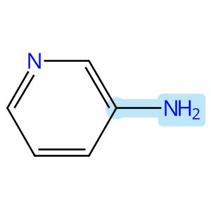

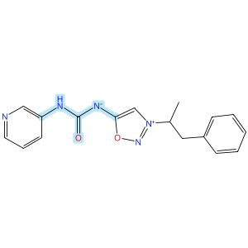

Scheme 14 (Reaction 1 of 1):

Step 1, Yield: 85%

Discovery and Optimization of IRBM-Z-2, an Allosteric Zika Virus NS2B-NS3 Protease Inhibitor Exhibiting In Vivo Efficacy

By: Torrente, Esther; Quotadamo, Antonio; Corio, Alessandra; Ferrigno, Federica; Ievoli, Giovanni; Montalbetti, Christian; Vasile, Silvana; Graziani, Rita; Paonessa, Giacomo; Alli, Cristina; Bisbocci, Monica; Veneziano, Maria; Proto, Giulia; Orsale, Maria Vittoria; di Marco, Annalise; Toniatti, Carlo; Ontoria, Jesus M.

10.1021/acs.jmedchem.6c00476
View All Sources in CAS SciFinder
Company/Organization: Drug Discovery, Medicinal Chemistry Unit, Rome, 00071, Italy
Source: Journal of Medicinal Chemistry (2026), 69(11), 13492-13503

Step 1
CAS Reaction Number: 31-614-CAS-51245221
Stage | Reagents | Catalysts | Solvents | Conditions
1 |  |  |  | 20 min, rt
  Diisopropylethylamine
  -
  Tetrahydrofuran
2 |  |  |  | 0 °C; 10 min, rt
  -
  -
  -
Experimental Protocols
Synthetic Methods
Products | Urea, N-[3-(1-methyl-2-phenylethyl)-1,2,3-oxadiazolium-5-yl]-N′-3-pyridinyl-, inner salt, Yield: 85%
Reactants | 3-Aminopyridine  Triphosgene  Sydnophene
Reagents | Diisopropylethylamine
Solvents | Tetrahydrofuran
Procedure
  1. | Stir a solution of bis(trichloromethyl)carbonate (0.34 mmol, 1 equiv.), the corresponding aniline (0.69 mmol, 2 equiv.), and DIPEA (1.4 mmol, 4.0 equiv.) in dry THF (2.6 mL, 0.13 M) at room temperature for 20 minutes.
  2. | Add the mixture dropwise to a stirring suspension of the 5-amino-3-(1-phenylpropan-2-yl)-1,2,3-oxadiazol-3-ium chloride (0.34 mmol, 1 equiv.) in dry THF (2 mL, 0.17 M) at 0°C.
  3. | Add DIPEA (1.4 mmol, 4 equiv.) to the mixture.
  4. | Stir the reaction mixture at room temperature for 10 minutes.
  5. | Dilute the mixture with H₂O.
  6. | Extract the mixture twice with EtOAc.
  7. | Wash the organic layers with brine.
  8. | Dry the organic layers over Na₂SO₄.
  9. | Filter the mixture.
  10. | Concentrate the filtrate in vacuo to obtain a residue.
  11. | Purify the crude by flash chromatography or preparative HPLC to obtain (3-(1-phenylpropan-2-yl)-1,2,3-oxadiazol-3-ium-5-yl)(pyridin-3-ylcarbamoyl)amide.
Transformation | - Acylation of Nitrogen Nucleophiles by Acyl/ Thioacyl/ Carbamoyl Halides and Analogs
Characterization Data
Urea, N-[3-(1-methyl-2-phenylethyl)-1,2,3-oxadiazolium-5-yl]-N′-3-pyridinyl-, inner salt
Proton NMR Spectrum | (400 MHz, DMSO-d₆) δ 10.14 (s, 1H), 9.16 (d, J= 2.0 Hz, 1H), 8.42 (d, J= 5.3 Hz, 1H), 8.36 (br d, J= 8.8 Hz, 1H), 8.34 (s, 1H), 7.83 (dd, J= 5.5, 8.6 Hz, 1H), 7.37-7.25 (m, 2H), 7.25-7.17 (m, 3H), 5.28-5.15 (m, 1H), 3.32 (br d, J= 7.5 Hz, 2H), 1.67 (d, J= 6.8 Hz, 3H)
Fluorine-19 NMR | (377 MHz, DMSO-d₆) δ -59.98 (s, 3F)
Mass Spectrum | LCMS (ES⁺) calculated for C₁₇H₁₇N₅O₂ 323.14; found 324.27 (M+H)⁺
RT | 1.04 min
State | white powder
CAS Method Number 3-614-CAS-51325684

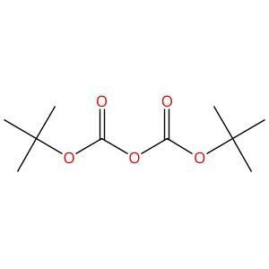 |  | 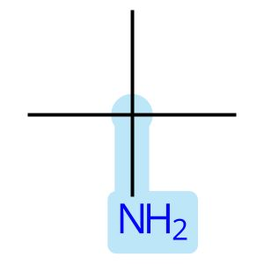
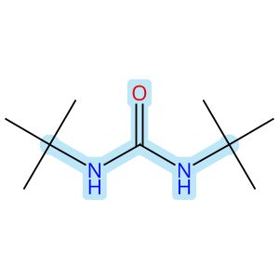

Scheme 15 (Reaction 1 of 3):

Step 1, Yield: 84%

Palladium-catalyzed direct amination of N-(quinolin-8-yl)-1H-indole-3-carboxamides

By: Wang, Xiaolong; Cao, Yan; Wang, Linqi; Wang, Jianwei; Ying, Jun

10.1039/d6ob00431h
View All Sources in CAS SciFinder
Company/Organization: School of Chemistry and Chemical Engineering, Zhejiang Sci-Tech University, Hangzhou, 310018, China
Source: Organic & Biomolecular Chemistry (2026), 24(19), 4039-4043

Step 1
CAS Reaction Number: 31-614-CAS-50508797
Stage | Reagents | Catalysts | Solvents | Conditions
1 |  |  |  | 3 h, rt
  -
  Dabco
  -
Experimental Protocols
Synthetic Methods
Products | N,N′-Bis(1,1-dimethylethyl)urea, Yield: 84%
Reactants | tert-Butylamine  Di-tert-butyl dicarbonate
Catalysts | Dabco
Procedure
  1. | Add (Boc)₂O (11.5 mL, 50 mmol) carefully to a solution of t-butylamine (100 mmol, DABCO (560 mg, 5 mmol, 0.1 equivalent) in CH₂Cl₂ (50 mL).
  2. | Stir the solution at room temperature for 3 hours.
  3. | Cool the reaction mixture to 0°C.
  4. | Add hexane to the mixture.
  5. | Collect the resulting solid.
  6. | Wash the solid further with cold water and diethyl ether.
Transformation | - Acylation of Nitrogen Nucleophiles by Acyl/ Thioacyl/ Carbamoyl Halides and Analogs  - Acylation of Nitrogen Nucleophiles by Anhydrides or Dicarbonates
Scale | milligram
Characterization Data
N,N′-Bis(1,1-dimethylethyl)urea
State | white solid
CAS Method Number 3-614-CAS-50666374

Scheme 15 (Reaction 2 of 3):

Step 1, Yield: 84%

Palladium-Catalyzed Tandem Synthesis of Fused Spiroquinolinones from Bicyclobutyl Amides

By: Pu, Chunxue; Wang, Jianwei; Cao, Yan; Wang, Xiaolong; Ying, Jun

10.1021/acs.orglett.6c00744
View All Sources in CAS SciFinder
Company/Organization: School of Chemistry and Chemical Engineering, Zhejiang Sci-Tech University, Hangzhou, 310018, China
Source: Organic Letters (2026), 28(12), 3890-3894

Step 1
CAS Reaction Number: 31-614-CAS-49720171
Stage | Reagents | Catalysts | Solvents | Conditions
1 |  |  |  | 3 h, rt
  Dabco
  -
  Dichloromethane
Experimental Protocols
Synthetic Methods
Products | N,N′-Bis(1,1-dimethylethyl)urea, Yield: 84%
Reactants | tert-Butylamine  Di-tert-butyl dicarbonate
Reagents | Dabco
Solvents | Dichloromethane
Procedure
  1. | Add (Boc)₂O (11.5 mL, 50 mmol) carefully to a solution of t-butylamine (100 mmol), DABCO (560 mg, 5 mmol, 0.1 equivalent) in CH₂Cl₂(50 mL).
  2. | Stir the solution at room temperature for 3 hours.
  3. | Cool the reaction mixture to 0°C.
  4. | Add hexane to the reaction mixture.
  5. | Collect the resulting solid.
  6. | Wash the resulting solid further with cold water and diethyl ether.
Transformation | - Acylation of Nitrogen Nucleophiles by Acyl/ Thioacyl/ Carbamoyl Halides and Analogs  - Acylation of Nitrogen Nucleophiles by Anhydrides or Dicarbonates
Scale | milligram
Characterization Data
N,N′-Bis(1,1-dimethylethyl)urea
State | white solid
CAS Method Number 3-614-CAS-49766440

Scheme 15 (Reaction 3 of 3):

Step 1, Yield: 84%

Synthesis of Polysubstituted Pyrroles via (2 + 2 + 1) Cyclization of Enone Oxime Ethers with Alkynes and Diaziridinone

By: Zeng, Qing-Ying; Zhang, Yun-Qian; Cheng, Xiao-Ya; Xu, Hui; Dai, Hui-Xiong

10.1021/acs.joc.5c01879
View All Sources in CAS SciFinder
Company/Organization: School of Pharmaceutical Science and Technology, Hangzhou Institute of Advanced Study, Hangzhou, 310024, China
Source: Journal of Organic Chemistry (2026), 91(3), 1271-1275

Step 1
CAS Reaction Number: 31-614-CAS-48889242
Stage | Reagents | Catalysts | Solvents | Conditions
1 |  |  |  | 0 °C; 3 h, rt
  Dabco
  -
  Dichloromethane
Experimental Protocols
Synthetic Methods
Products | N,N′-Bis(1,1-dimethylethyl)urea, Yield: 83%
Reactants | tert-Butylamine  Di-tert-butyl dicarbonate
Reagents | Dabco
Solvents | Dichloromethane
Procedure
  1. | Charge a 250 mL reaction flask with tert-butylamine (7.3 g, 0.1 mol), DCM (150 mL), DABCO (1.12 g, 10 mmol).
  2. | Add (Boc)2O (11.5 mL, 50 mol) to the reaction mixture at 0°C.
  3. | Stir the reaction mixture at room temperature for 3 hours.
  4. | Add petroleum ether (100 mL) to the mixture.
  5. | Precipitate the white solid.
  6. | Filter the white solid.
  7. | Wash the white solid with ice water and ether.
  8. | Dry the white solid under reduced pressure to obtain the product.
Transformation | - Acylation of Nitrogen Nucleophiles by Acyl/ Thioacyl/ Carbamoyl Halides and Analogs  - Acylation of Nitrogen Nucleophiles by Anhydrides or Dicarbonates
Scale | gram
CAS Method Number 3-614-CAS-48983782

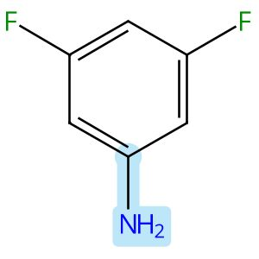

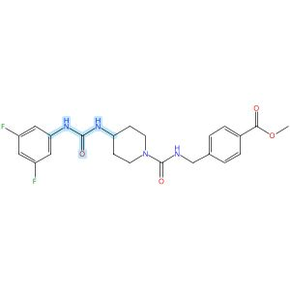

Scheme 16 (Reaction 1 of 1):

Step 1, Yield: 84%

Design and synthesis of novel sEH inhibitors for the treatment of acute lung injury

By: Xu, Huashen; Ma, Ruiyi; Morisseau, Christophe; Dong, Xinyue; Zhuang, Junning; Wang, Zhe; Liu, Fuqin; Xu, Dong; Chen, Lu; Zhang, Maoying; Zhu, Zhihui; Liu, Xinran; Jiang, Huiwen; Liu, Zhongbo; Hammock, Bruce D.; Cao, Ruolin; Chen, Guoliang

10.1016/j.ejmech.2026.118773
View All Sources in CAS SciFinder
Company/Organization: Key Laboratory of Structure-Based Drug Design & Discovery of Ministry of Education, School of Pharmaceutical Engineering, Shenyang Pharmaceutical University, Shenyang, 110016, China
Source: European Journal of Medicinal Chemistry (2026), 309, 118773

Step 1
CAS Reaction Number: 31-614-CAS-49705457
Stage | Reagents | Catalysts | Solvents | Conditions
1 |  |  |  | 1 h, < -10 °C; -10 °C → rt; 30 min, rt
  Triethylamine
  -
  Dichloromethane
2 |  |  |  | 0.5 h, rt; overnight, rt
  Triethylamine
  -
  Dichloromethane
Experimental Protocols
Synthetic Methods
Products | 3124392-77-1, Yield: 84%
Reactants | 3,5-Difluoroaniline  Triphosgene  3124392-72-6
Reagents | Triethylamine
Solvents | Dichloromethane
Procedure
  1. | Add a solution of Memantine (0.15 g, 0.82 mmol, 1.0 eq) and Et₃N (0.25 g, 2.46 mmol, 3.0 eq) in DCM (20 mL) dropwise over 1 h to a thick slurry of triphosgene (0.12 g, 0.41 mmol, 0.5 eq) in DCM (10 mL) in a cold trap while maintaining the temperature below 10°C.
  2. | Remove the cold bath and warm the mixture to room temperature and stir for 30 min.
  3. | Add a slurry of Intermediate (0.3 g, 0.74 mmol, 0.9 eq) and Et₃N (0.42 g, 4.1 mmol, 5.0 eq) in DCM (20 mL) in small portions over 0.5 h at room temperature.
  4. | Stir the reaction mixture overnight.
  5. | Wash the reaction mixture with 10% aq HCl (1 x 20 mL).
  6. | Dry the organic layer over anhydrous MgSO₄ and concentrate under reduced pressure.
Transformation | - Acylation of Nitrogen Nucleophiles by Acyl/ Thioacyl/ Carbamoyl Halides and Analogs
CAS Method Number 3-614-CAS-50079814

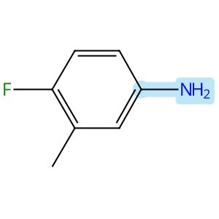

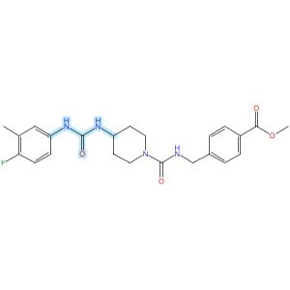

Scheme 17 (Reaction 1 of 1):

Step 1, Yield: 84%

Design and synthesis of novel sEH inhibitors for the treatment of acute lung injury

By: Xu, Huashen; Ma, Ruiyi; Morisseau, Christophe; Dong, Xinyue; Zhuang, Junning; Wang, Zhe; Liu, Fuqin; Xu, Dong; Chen, Lu; Zhang, Maoying; Zhu, Zhihui; Liu, Xinran; Jiang, Huiwen; Liu, Zhongbo; Hammock, Bruce D.; Cao, Ruolin; Chen, Guoliang

10.1016/j.ejmech.2026.118773
View All Sources in CAS SciFinder
Company/Organization: Key Laboratory of Structure-Based Drug Design & Discovery of Ministry of Education, School of Pharmaceutical Engineering, Shenyang Pharmaceutical University, Shenyang, 110016, China
Source: European Journal of Medicinal Chemistry (2026), 309, 118773

Step 1
CAS Reaction Number: 31-614-CAS-49705462
Stage | Reagents | Catalysts | Solvents | Conditions
1 |  |  |  | 1 h, < -10 °C; -10 °C → rt; 30 min, rt
  Triethylamine
  -
  Dichloromethane
2 |  |  |  | 0.5 h, rt; overnight, rt
  Triethylamine
  -
  Dichloromethane
Experimental Protocols
Synthetic Methods
Products | 3124392-75-9, Yield: 84%
Reactants | 4-Fluoro-3-methylaniline  Triphosgene  3124392-72-6
Reagents | Triethylamine
Solvents | Dichloromethane
Procedure
  1. | Add a solution of Memantine (0.15 g, 0.82 mmol, 1.0 eq) and Et₃N (0.25 g, 2.46 mmol, 3.0 eq) in DCM (20 mL) dropwise over 1 h to a thick slurry of triphosgene (0.12 g, 0.41 mmol, 0.5 eq) in DCM (10 mL) in a cold trap while maintaining the temperature below 10°C.
  2. | Remove the cold bath and warm the mixture to room temperature and stir for 30 min.
  3. | Add a slurry of Intermediate (0.3 g, 0.74 mmol, 0.9 eq) and Et₃N (0.42 g, 4.1 mmol, 5.0 eq) in DCM (20 mL) in small portions over 0.5 h at room temperature.
  4. | Stir the reaction mixture overnight.
  5. | Wash the reaction mixture with 10% aq HCl (1 x 20 mL).
  6. | Dry the organic layer over anhydrous MgSO₄ and concentrate under reduced pressure.
Transformation | - Acylation of Nitrogen Nucleophiles by Acyl/ Thioacyl/ Carbamoyl Halides and Analogs
CAS Method Number 3-614-CAS-50079807

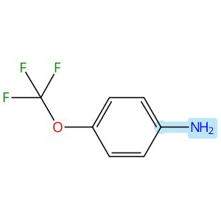

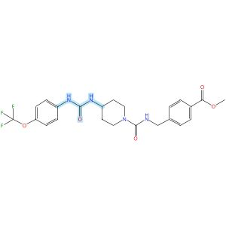

Scheme 18 (Reaction 1 of 1):

Step 1, Yield: 84%

Design and synthesis of novel sEH inhibitors for the treatment of acute lung injury

By: Xu, Huashen; Ma, Ruiyi; Morisseau, Christophe; Dong, Xinyue; Zhuang, Junning; Wang, Zhe; Liu, Fuqin; Xu, Dong; Chen, Lu; Zhang, Maoying; Zhu, Zhihui; Liu, Xinran; Jiang, Huiwen; Liu, Zhongbo; Hammock, Bruce D.; Cao, Ruolin; Chen, Guoliang

10.1016/j.ejmech.2026.118773
View All Sources in CAS SciFinder
Company/Organization: Key Laboratory of Structure-Based Drug Design & Discovery of Ministry of Education, School of Pharmaceutical Engineering, Shenyang Pharmaceutical University, Shenyang, 110016, China
Source: European Journal of Medicinal Chemistry (2026), 309, 118773

Step 1
CAS Reaction Number: 31-614-CAS-49705472
Stage | Reagents | Catalysts | Solvents | Conditions
1 |  |  |  | 1 h, < -10 °C; -10 °C → rt; 30 min, rt
  Triethylamine
  -
  Dichloromethane
2 |  |  |  | 0.5 h, rt; overnight, rt
  Triethylamine
  -
  Dichloromethane
Experimental Protocols
Synthetic Methods
Products | 3124392-84-0, Yield: 84%
Reactants | 4-(Trifluoromethoxy)aniline  Triphosgene  3124392-72-6
Reagents | Triethylamine
Solvents | Dichloromethane
Procedure
  1. | Add a solution of Memantine (0.15 g, 0.82 mmol, 1.0 eq) and Et₃N (0.25 g, 2.46 mmol, 3.0 eq) in DCM (20 mL) dropwise over 1 h to a thick slurry of triphosgene (0.12 g, 0.41 mmol, 0.5 eq) in DCM (10 mL) in a cold trap while maintaining the temperature below 10°C.
  2. | Remove the cold bath and warm the mixture to room temperature and stir for 30 min.
  3. | Add a slurry of Intermediate (0.3 g, 0.74 mmol, 0.9 eq) and Et₃N (0.42 g, 4.1 mmol, 5.0 eq) in DCM (20 mL) in small portions over 0.5 h at room temperature.
  4. | Stir the reaction mixture overnight.
  5. | Wash the reaction mixture with 10% aq HCl (1 x 20 mL).
  6. | Dry the organic layer over anhydrous MgSO₄ and concentrate under reduced pressure.
Transformation | - Acylation of Nitrogen Nucleophiles by Acyl/ Thioacyl/ Carbamoyl Halides and Analogs
CAS Method Number 3-614-CAS-50079833

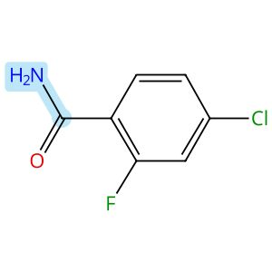 |  | 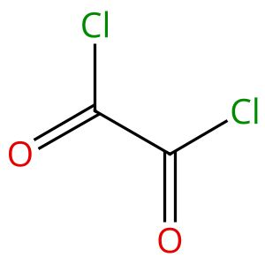
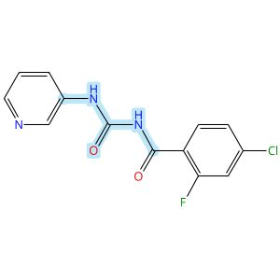

Scheme 19 (Reaction 1 of 1):

Step 1, Yield: 83%

Design, Synthesis, and Preclinical Evaluation of a PET Tracer Targeting Methionine Adenosyltransferase 2A

By: Jiang, Zeng; Huang, Yong; Chen, Hualong; Yu, Ziyue; Cheng, Xuebo; Liu, Yajing; Wu, Zehui

10.1021/acs.jmedchem.5c02532
View All Sources in CAS SciFinder
Company/Organization: Beijing Institute of Brain Disorders, Beijing Key Laboratory of Innovation and Translation of Central Nervous System Radiopharmaceuticals, Capital Medical University, Beijing, 100069, China
Source: Journal of Medicinal Chemistry (2026), 69(3), 2575-2598

Step 1
CAS Reaction Number: 31-614-CAS-49099051
Stage | Reagents | Catalysts | Solvents | Conditions
1 |  |  |  | rt; 45 min, 80 °C; 80 °C → rt
  -
  -
  1,2-Dichloroethane
2 |  |  |  | 4 h, rt
  -
  -
  -
3 |  |  |  | 10 min, rt
  Sodium bicarbonate
  -
  Water
Experimental Protocols
Synthetic Methods
Products | 4-Chloro-2-fluoro-N-[(3-pyridinylamino)carbonyl]benzamide, Yield: 83%
Reactants | Oxalyl chloride  4-Chloro-2-fluorobenzamide  3-Aminopyridine
Reagents | Sodium bicarbonate
Solvents | 1,2-Dichloroethane  Water
Procedure
  1. | Add oxalyl chloride (804 mg, 6.34 mmol, 1.1 eq) to a solution of 4-chloro-2-fluorobenzamide (1.00 g, 5.76 mmol, 1 eq) in DCE (20 mL) at room temperature.
  2. | Stir the mixture at 80°C for 45 minutes.
  3. | Cool the reaction to room temperature.
  4. | Add 3-aminopyridine (1.08 g, 11.52 mmol) to the mixture.
  5. | Stir the mixture at room temperature for 4 hours.
  6. | Add saturated NaHCO₃ solution (100 mL) to the mixture.
  7. | Stir the mixture for 10 minutes.
  8. | Filter the mixture.
  9. | Wash the solid with water.
  10. | Dry the residue to obtain 4-chloro-2-fluoro-N-(pyridin-3-yl-carbamoyl)-benzamide.
Transformation | - Acylation of Nitrogen Nucleophiles by Acyl/ Thioacyl/ Carbamoyl Halides and Analogs
Scale | gram
Characterization Data
4-Chloro-2-fluoro-N-[(3-pyridinylamino)carbonyl]benzamide
Proton NMR Spectrum | (300 MHz, DMSO-d₆) δ 11.22 (s, 1H), 10.72-10.38 (m, 1H), 8.89-8.68 (m, 1H), 8.33 (s, 1H), 8.18-7.97 (m, 1H), 7.74 (t, J = 8.0 Hz, 1H), 7.64 (d, J = 10.2 Hz, 1H), 7.50-7.35 (m, 2H)
HRMS | calcd for C₁₃H₁₀ClFN₃O₂⁺, 294.0440[M + H]⁺, found: 294.0442
CAS Method Number 3-614-CAS-50415940

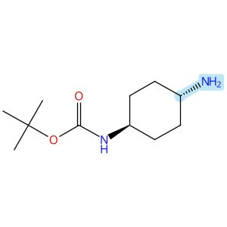  Relative stereochemistry shown |  |  |  | 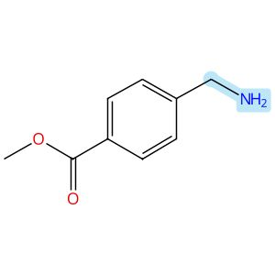
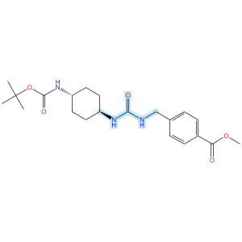
Relative stereochemistry shown

Scheme 20 (Reaction 1 of 1):

Step 1, Yield: 83%

Design and synthesis of novel sEH inhibitors for the treatment of acute lung injury

By: Xu, Huashen; Ma, Ruiyi; Morisseau, Christophe; Dong, Xinyue; Zhuang, Junning; Wang, Zhe; Liu, Fuqin; Xu, Dong; Chen, Lu; Zhang, Maoying; Zhu, Zhihui; Liu, Xinran; Jiang, Huiwen; Liu, Zhongbo; Hammock, Bruce D.; Cao, Ruolin; Chen, Guoliang

10.1016/j.ejmech.2026.118773
View All Sources in CAS SciFinder
Company/Organization: Key Laboratory of Structure-Based Drug Design & Discovery of Ministry of Education, School of Pharmaceutical Engineering, Shenyang Pharmaceutical University, Shenyang, 110016, China
Source: European Journal of Medicinal Chemistry (2026), 309, 118773

Step 1
CAS Reaction Number: 31-614-CAS-49705430
Stage | Reagents | Catalysts | Solvents | Conditions
1 |  |  |  | 1 h, < -10 °C; -10 °C → rt; 30 min, rt
  Triethylamine
  -
  Dichloromethane
2 |  |  |  | 0.5 h, rt; overnight, rt
  Triethylamine
  -
  Dichloromethane
Experimental Protocols
Synthetic Methods
Products | 3124392-44-2, Yield: 83%
Reactants | Triphosgene  1,1-Dimethylethyl N-(trans-4-aminocyclohexyl)carbamate  Methyl 4-(aminomethyl)benzoate
Reagents | Triethylamine
Solvents | Dichloromethane
Procedure
  1. | Add a solution of Intermediate (0.50 g, 2.33 mmol, 1.0 eq) and Et₃N (0.71 g, 6.99 mmol, 3.0 eq) in DCM (20 mL) dropwise over 1 h to a thick slurry of triphosgene (0.35 g, 1.2 mmol) in DCM (10 mL) in a cold trap while maintaining the temperature below 10°C.
  2. | Remove the cold bath and warm the mixture to room temperature and stir for 30 min.
  3. | Add a slurry of methyl 4-(aminomethyl)benzoate (0.38 g, 1.86 mmol, 0.8 eq) and Et₃N (0.94 g, 9.32 mmol, 4.0 eq) in DCM (20 mL) in small portions over 0.5 h at room temperature.
  4. | Stir the reaction mixture overnight.
  5. | Wash the reaction mixture with 10% aq HCl (1 x20 mL).
  6. | Dry the organic layer over anhydrous MgSO₄ and concentrate under reduced pressure.
Transformation | - Acylation of Nitrogen Nucleophiles by Acyl/ Thioacyl/ Carbamoyl Halides and Analogs
Characterization Data
3124392-44-2
Mass Spectrum | ESI-MS m/z: 404.0 [M H]-
State | white solid
CAS Method Number 3-614-CAS-50079693

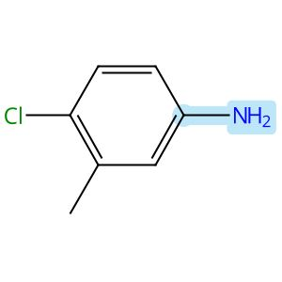

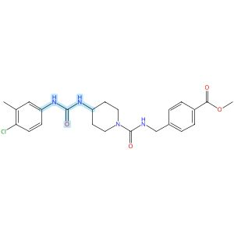

Scheme 21 (Reaction 1 of 1):

Step 1, Yield: 83%

Design and synthesis of novel sEH inhibitors for the treatment of acute lung injury

By: Xu, Huashen; Ma, Ruiyi; Morisseau, Christophe; Dong, Xinyue; Zhuang, Junning; Wang, Zhe; Liu, Fuqin; Xu, Dong; Chen, Lu; Zhang, Maoying; Zhu, Zhihui; Liu, Xinran; Jiang, Huiwen; Liu, Zhongbo; Hammock, Bruce D.; Cao, Ruolin; Chen, Guoliang

10.1016/j.ejmech.2026.118773
View All Sources in CAS SciFinder
Company/Organization: Key Laboratory of Structure-Based Drug Design & Discovery of Ministry of Education, School of Pharmaceutical Engineering, Shenyang Pharmaceutical University, Shenyang, 110016, China
Source: European Journal of Medicinal Chemistry (2026), 309, 118773

Step 1
CAS Reaction Number: 31-614-CAS-49705468
Stage | Reagents | Catalysts | Solvents | Conditions
1 |  |  |  | 1 h, < -10 °C; -10 °C → rt; 30 min, rt
  Triethylamine
  -
  Dichloromethane
2 |  |  |  | 0.5 h, rt; overnight, rt
  Triethylamine
  -
  Dichloromethane
Experimental Protocols
Synthetic Methods
Products | 3124392-81-7, Yield: 83%
Reactants | 4-Chloro-3-methylaniline  Triphosgene  3124392-72-6
Reagents | Triethylamine
Solvents | Dichloromethane
Procedure
  1. | Add a solution of Memantine (0.15 g, 0.82 mmol, 1.0 eq) and Et₃N (0.25 g, 2.46 mmol, 3.0 eq) in DCM (20 mL) dropwise over 1 h to a thick slurry of triphosgene (0.12 g, 0.41 mmol, 0.5 eq) in DCM (10 mL) in a cold trap while maintaining the temperature below 10°C.
  2. | Remove the cold bath and warm the mixture to room temperature and stir for 30 min.
  3. | Add a slurry of Intermediate (0.3 g, 0.74 mmol, 0.9 eq) and Et₃N (0.42 g, 4.1 mmol, 5.0 eq) in DCM (20 mL) in small portions over 0.5 h at room temperature.
  4. | Stir the reaction mixture overnight.
  5. | Wash the reaction mixture with 10% aq HCl (1 x 20 mL).
  6. | Dry the organic layer over anhydrous MgSO₄ and concentrate under reduced pressure.
Transformation | - Acylation of Nitrogen Nucleophiles by Acyl/ Thioacyl/ Carbamoyl Halides and Analogs
CAS Method Number 3-614-CAS-50079822

 |  | 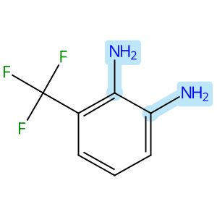 |  | 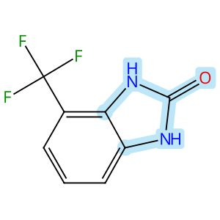

Scheme 22 (Reaction 1 of 1):

Step 1, Yield: 83%

Development of Benzimidazole-Based BZ-30 as an Orally Bioavailable Broad-Spectrum Inhibitor of SARS-CoV-2

By: Kaur, Simran; Brar, Deshkanwar S.; Joshi, Akshay; Singh, Nittu; Chawla, Ravneet S.; Kumar, Sahil; Dhiman, Sumit; Nandi, Utpal; Ringe, Rajesh P.; Thakur, Krishan G.; Chaudhari, Vinod D.

10.1021/acs.jmedchem.6c00365
View All Sources in CAS SciFinder
Company/Organization: Division of Medicinal Chemistry, Council of Scientific and Industrial Research-Institute of Microbial Technology (CSIR-IMTECH), Chandigarh, 160036, India
Source: Journal of Medicinal Chemistry (2026), 69(8), 9537-9557

Step 1
CAS Reaction Number: 31-614-CAS-50120159
Stage | Reagents | Catalysts | Solvents | Conditions
1 |  |  |  | 4 h, 35 °C
  -
  -
  Tetrahydrofuran

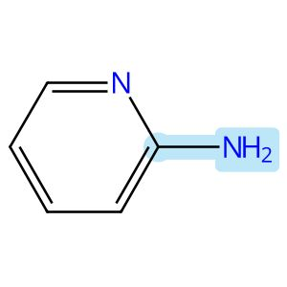

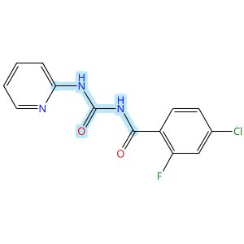

Scheme 23 (Reaction 1 of 1):

Step 1, Yield: 82%

Design, Synthesis, and Preclinical Evaluation of a PET Tracer Targeting Methionine Adenosyltransferase 2A

By: Jiang, Zeng; Huang, Yong; Chen, Hualong; Yu, Ziyue; Cheng, Xuebo; Liu, Yajing; Wu, Zehui

10.1021/acs.jmedchem.5c02532
View All Sources in CAS SciFinder
Company/Organization: Beijing Institute of Brain Disorders, Beijing Key Laboratory of Innovation and Translation of Central Nervous System Radiopharmaceuticals, Capital Medical University, Beijing, 100069, China
Source: Journal of Medicinal Chemistry (2026), 69(3), 2575-2598

Step 1
CAS Reaction Number: 31-614-CAS-49099057
Stage | Reagents | Catalysts | Solvents | Conditions
1 |  |  |  | rt; 45 min, 80 °C; 80 °C → rt
  -
  -
  1,2-Dichloroethane
2 |  |  |  | 4 h, rt
  -
  -
  -
3 |  |  |  | 10 min, rt
  Sodium bicarbonate
  -
  Water
Experimental Protocols
Synthetic Methods
Products | 3116764-46-3, Yield: 82%
Reactants | Oxalyl chloride  4-Chloro-2-fluorobenzamide  2-Aminopyridine
Reagents | Sodium bicarbonate
Solvents | 1,2-Dichloroethane  Water
Procedure
  1. | Add oxalyl chloride (0.80 g, 6.34 mmol) to a solution of 4-chloro-2-fluorobenzamide (1.00 g, 5.76 mmol, 1 eq) in DCE (20 mL) at room temperature.
  2. | Stir the mixture at 80°C for 45 minutes.
  3. | Cool the reaction to room temperature.
  4. | Add 2-aminopyridine (1.08 g, 11.52 mmol) to the mixture.
  5. | Stir the mixture at room temperature for 4 hours.
  6. | Add saturated NaHCO₃ solution (100 mL) to the mixture.
  7. | Stir the mixture for 10 minutes.
  8. | Filter the mixture.
  9. | Wash the solid with water.
  10. | Dry the residue to obtain 4-chloro-2-fluoro-N-(pyridin-2-yl-carbamoyl)-benzamide.
Transformation | - Acylation of Nitrogen Nucleophiles by Acyl/ Thioacyl/ Carbamoyl Halides and Analogs
Scale | gram
Characterization Data
3116764-46-3
Proton NMR Spectrum | (300 MHz, DMSO-d₆) δ 11.35 (s, 1H), 10.80 (s, 1H), 8.33 (dd, J = 4.9, 1.0 Hz, 1H), 7.98 (d, J = 8.3 Hz, 1H), 7.87-7.80 (m, 1H), 7.75 (t, J = 8.0 Hz, 1H), 7.66-7.61 (m, 1H), 7.45 (dd, J = 8.3, 2.0 Hz, 1H), 7.16-7.11 (m, 1H)
HRMS | calcd for C₁₃H₁₀ClFN₃O₂⁺, 294.0440[M + H]⁺, found: 294.0444
CAS Method Number 3-614-CAS-50415951

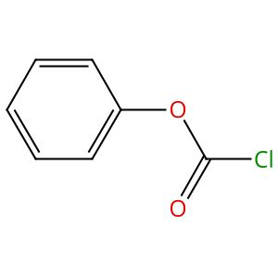 |  | 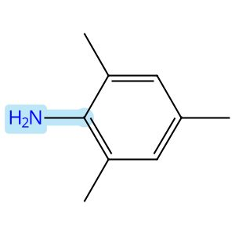 |  | 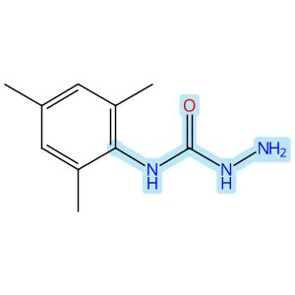

Scheme 24 (Reaction 1 of 1):

Step 1, Yield: 82%

Functionality-Matched Semicarbazone Reagents Allow Access to X-ray Quality Crystals and Solids of Diverse Organic Molecules

By: Sherman, Emily R.; Johnson, Jeffrey S.

10.1021/acs.orglett.6c01328
View All Sources in CAS SciFinder
Company/Organization: Department of Chemistry, University of North Carolina at Chapel Hill, Chapel Hill, North Carolina, 27599-3290, United States
Source: Organic Letters (2026), 28(19), 6048-6053

Step 1
CAS Reaction Number: 31-614-CAS-51011648
Stage | Reagents | Catalysts | Solvents | Conditions
1 |  |  |  | 0.5 h, 0 °C; 18 h, 0 °C → rt
  Triethylamine
  -
  Dichloromethane
2 |  |  |  | rt
  -
  -
  Water
3 |  |  |  | 2 d, rt
  Hydrazine hydrate (1:1)
  -
  Acetonitrile
Experimental Protocols
Synthetic Methods
Products | N-(2,4,6-Trimethylphenyl)hydrazinecarboxamide, Yield: 82%
Reactants | 2,4,6-Trimethylaniline  Phenyl chloroformate
Reagents | Triethylamine  Hydrazine hydrate (1:1)
Solvents | Dichloromethane  Water  Acetonitrile
Procedure
  1. | Add 2,4,6-trimethylaniline (10.0 mL, 1.0 equiv, 73.96 mmol) to a flame-dried 500 mL round bottomed flask.
  2. | Add anhydrous DCM (148.0 mL, 0.5 M) and anhydrous Et₃N (22.7 mL, 2.2 equiv, 162.8 mmol) to the flask.
  3. | Cool the mixture to 0°C.
  4. | Add phenyl carbonochloridate (177.6 mmol, 2.4 equiv, 27.81 g, 22.4 mL) to the reaction mixture.
  5. | Stir the reaction mixture at 0°C for 0.5 hours.
  6. | Warm the reaction mixture to room temperature over 18 hours.
  7. | Quench the reaction mixture with water (20 mL).
  8. | Extract the reaction mixture with DCM (80 mL x 3).
  9. | Wash the combined organic phases with brine (80 mL).
  10. | Dry the reaction mixture over anhydrous Na₂SO₄.
  11. | Filter the reaction mixture.
  12. | Concentrate the reaction mixture in vacuo.
  13. | Rinse the light brown solid with hexanes (3 x 30 mL) to obtain a white solid.
  14. | Add hydrazine hydrate (1.7 equiv) to a solution of phenylcarbamate (1 equiv, 74.00 mmol) in acetonitrile (640 mL, 0.10 M).
  15. | Stir the reaction mixture at room temperature for 2 days.
  16. | Remove solvents under reduced pressure.
  17. | Purify the crude product by column chromatography using 10-40% EtOAc/hexanes to obtain N-mesitylhydrazinecarboxamide.
Characterization Data
N-(2,4,6-Trimethylphenyl)hydrazinecarboxamide
Proton NMR Spectrum | (400 MHz, DMSO) δ 7.71 (s, 1H), 7.14 (s, 1H), 6.83 (s, 2H), 4.28 (s, 2H), 2.20 (s, 3H), 2.11 (s, 5H)
R_{f} | TLC (50% EtOAc/Hexanes) 0.60 (UV)
State | white solid
CAS Method Number 3-614-CAS-51192437

 |  | 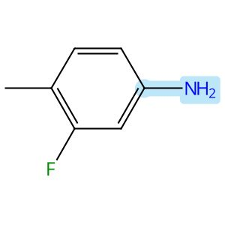 |  | 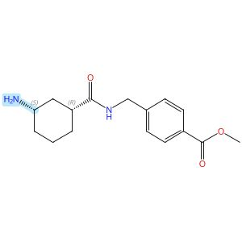  Absolute stereochemistry shown
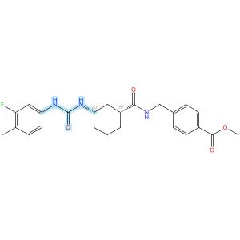
Absolute stereochemistry shown

Scheme 25 (Reaction 1 of 1):

Step 1, Yield: 82%

Design and synthesis of novel sEH inhibitors for the treatment of acute lung injury

By: Xu, Huashen; Ma, Ruiyi; Morisseau, Christophe; Dong, Xinyue; Zhuang, Junning; Wang, Zhe; Liu, Fuqin; Xu, Dong; Chen, Lu; Zhang, Maoying; Zhu, Zhihui; Liu, Xinran; Jiang, Huiwen; Liu, Zhongbo; Hammock, Bruce D.; Cao, Ruolin; Chen, Guoliang

10.1016/j.ejmech.2026.118773
View All Sources in CAS SciFinder
Company/Organization: Key Laboratory of Structure-Based Drug Design & Discovery of Ministry of Education, School of Pharmaceutical Engineering, Shenyang Pharmaceutical University, Shenyang, 110016, China
Source: European Journal of Medicinal Chemistry (2026), 309, 118773

Step 1
CAS Reaction Number: 31-614-CAS-49705414
Stage | Reagents | Catalysts | Solvents | Conditions
1 |  |  |  | 1 h, < -10 °C; -10 °C → rt; 30 min, rt
  Triethylamine
  -
  Dichloromethane
2 |  |  |  | 0.5 h, rt; overnight, rt
  Triethylamine
  -
  Dichloromethane
Experimental Protocols
Synthetic Methods
Products | 3124392-28-2, Yield: 82%
Reactants | 3-Fluoro-4-methylaniline  Triphosgene  3124392-21-5
Reagents | Triethylamine
Solvents | Dichloromethane
Procedure
  1. | Add a solution of Memantine (0.2 g, 0.93 mmol, 1.0 eq) and Et₃N (0.28 g, 2.78 mmol, 3.0 eq) in DCM (20 mL) dropwise over 1 h to a thick slurry of triphosgene (0.14 g, 0.46 mmol, 0.5 eq) in DCM (10 mL) in a cold trap while maintaining the temperature below 10°C.
  2. | Remove the cold bath and warm the mixture to rt and stir for 30 min.
  3. | Add a slurry of Intermediate (0.30 g, 0.74 mmol, 0.8 eq) and Et₃N (0.56 g, 5.56 mmol, 6.0 eq) in DCM (20 mL) in small portions over 0.5 h at room temperature.
  4. | Stir the reaction mixture overnight.
  5. | Wash the reaction mixture with 10% aq HCl (1 x 20 mL).
  6. | Dry the organic layer over anhydrous MgSO₄ and concentrate under reduced pressure.
Transformation | - Acylation of Nitrogen Nucleophiles by Acyl/ Thioacyl/ Carbamoyl Halides and Analogs
Scale | gram
Characterization Data
3124392-28-2
State | White solid
CAS Method Number 3-614-CAS-50079631

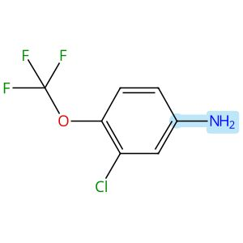 |  |  |  | 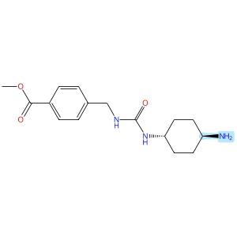  Relative stereochemistry shown
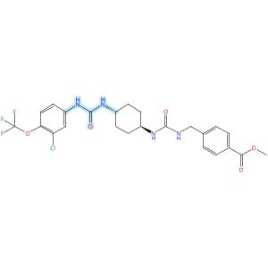
Relative stereochemistry shown

Scheme 26 (Reaction 1 of 1):

Step 1, Yield: 82%

Design and synthesis of novel sEH inhibitors for the treatment of acute lung injury

By: Xu, Huashen; Ma, Ruiyi; Morisseau, Christophe; Dong, Xinyue; Zhuang, Junning; Wang, Zhe; Liu, Fuqin; Xu, Dong; Chen, Lu; Zhang, Maoying; Zhu, Zhihui; Liu, Xinran; Jiang, Huiwen; Liu, Zhongbo; Hammock, Bruce D.; Cao, Ruolin; Chen, Guoliang

10.1016/j.ejmech.2026.118773
View All Sources in CAS SciFinder
Company/Organization: Key Laboratory of Structure-Based Drug Design & Discovery of Ministry of Education, School of Pharmaceutical Engineering, Shenyang Pharmaceutical University, Shenyang, 110016, China
Source: European Journal of Medicinal Chemistry (2026), 309, 118773

Step 1
CAS Reaction Number: 31-614-CAS-49705441
Stage | Reagents | Catalysts | Solvents | Conditions
1 |  |  |  | 1 h, < -10 °C; -10 °C → rt; 30 min, rt
  Triethylamine
  -
  Dichloromethane
2 |  |  |  | 0.5 h, rt; overnight, rt
  Triethylamine
  -
  Dichloromethane
Experimental Protocols
Synthetic Methods
Products | 3124392-56-6, Yield: 82%
Reactants | Triphosgene  3-Chloro-4-(trifluoromethoxy)benzenamine  3124392-46-4
Reagents | Triethylamine
Solvents | Dichloromethane
Procedure
  1. | Add a solution of 4-chloro-3-(trifluoromethyl)aniline (94 mg, 0.48 mmol, 1.0 eq) and Et₃N (0.15 g, 1.44 mmol, 3.0 eq) in DCM (20 mL) dropwise over 1 h to a thick slurry of triphosgene (71 mg, 0.24 mmol, 0.5 eq) in DCM (10 mL) in a cold trap while maintaining the temperature below 10°C.
  2. | Remove the cold bath and warm the mixture to room temperature and stir for 30 min.
  3. | Add a slurry of Intermediate (0.2 g, 0.48 mmol, 1.0 eq) and Et₃N (0.48 g, 4.8 mmol, 10.0 eq) in DCM (20 mL) in small portions over 0.5 h at room temperature.
  4. | Stir the reaction mixture overnight.
  5. | Wash the reaction mixture with 10% aq HCl (1 x20 mL).
  6. | Dry the organic layer over anhydrous MgSO₄ and concentrate under reduced pressure.
Transformation | - Acylation of Nitrogen Nucleophiles by Acyl/ Thioacyl/ Carbamoyl Halides and Analogs
CAS Method Number 3-614-CAS-50079741

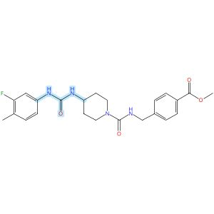

Scheme 27 (Reaction 1 of 1):

Step 1, Yield: 82%

Design and synthesis of novel sEH inhibitors for the treatment of acute lung injury

By: Xu, Huashen; Ma, Ruiyi; Morisseau, Christophe; Dong, Xinyue; Zhuang, Junning; Wang, Zhe; Liu, Fuqin; Xu, Dong; Chen, Lu; Zhang, Maoying; Zhu, Zhihui; Liu, Xinran; Jiang, Huiwen; Liu, Zhongbo; Hammock, Bruce D.; Cao, Ruolin; Chen, Guoliang

10.1016/j.ejmech.2026.118773
View All Sources in CAS SciFinder
Company/Organization: Key Laboratory of Structure-Based Drug Design & Discovery of Ministry of Education, School of Pharmaceutical Engineering, Shenyang Pharmaceutical University, Shenyang, 110016, China
Source: European Journal of Medicinal Chemistry (2026), 309, 118773

Step 1
CAS Reaction Number: 31-614-CAS-49705464
Stage | Reagents | Catalysts | Solvents | Conditions
1 |  |  |  | 1 h, < -10 °C; -10 °C → rt; 30 min, rt
  Triethylamine
  -
  Dichloromethane
2 |  |  |  | 0.5 h, rt; overnight, rt
  Triethylamine
  -
  Dichloromethane
Experimental Protocols
Synthetic Methods
Products | 3124392-76-0, Yield: 82%
Reactants | 3-Fluoro-4-methylaniline  Triphosgene  3124392-72-6
Reagents | Triethylamine
Solvents | Dichloromethane
Procedure
  1. | Add a solution of Memantine (0.15 g, 0.82 mmol, 1.0 eq) and Et₃N (0.25 g, 2.46 mmol, 3.0 eq) in DCM (20 mL) dropwise over 1 h to a thick slurry of triphosgene (0.12 g, 0.41 mmol, 0.5 eq) in DCM (10 mL) in a cold trap while maintaining the temperature below 10°C.
  2. | Remove the cold bath and warm the mixture to room temperature and stir for 30 min.
  3. | Add a slurry of Intermediate (0.3 g, 0.74 mmol, 0.9 eq) and Et₃N (0.42 g, 4.1 mmol, 5.0 eq) in DCM (20 mL) in small portions over 0.5 h at room temperature.
  4. | Stir the reaction mixture overnight.
  5. | Wash the reaction mixture with 10% aq HCl (1 x 20 mL).
  6. | Dry the organic layer over anhydrous MgSO₄ and concentrate under reduced pressure.
CAS Method Number 3-614-CAS-50079810

 |  | 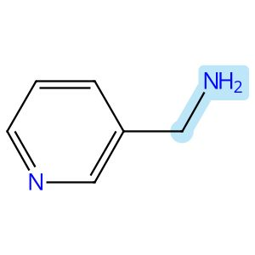 |  | 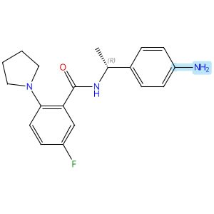  Absolute stereochemistry shown
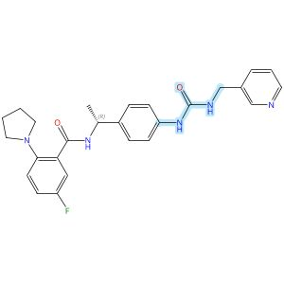
Absolute stereochemistry shown

Scheme 28 (Reaction 1 of 1):

Step 1, Yield: 82%

Discovery of potent o-aminobenzoamide-based NAMPT inhibitors for targeting NAPRT-deficient gastric cancer

By: Yang, Heng; Li, Zhiyi; Peng, Huiqian; shen, Lixian; Li, Zhen; Zhu, Lejing; Ding, Rifan; Shi, Yiting; Liu, Yuting; Zhang, Miao; Zhuo, Linsheng; Yang, Meiling; Wang, Zhen; Jiang, Weifan

10.1021/acs.jmedchem.5c02564
View All Sources in CAS SciFinder
Company/Organization: School of Pharmaceutical Science, Hengyang Medical School, University of South China, Hunan, 421001, China
Source: Journal of Medicinal Chemistry (2026), 69(3), 2625-2646

Step 1
CAS Reaction Number: 31-614-CAS-49296545
Stage | Reagents | Catalysts | Solvents | Conditions
1 |  |  |  | 30 min, 0 °C
  Pyridine
  -
  Dichloromethane
2 |  |  |  | 30 min, 0 °C
  -
  -
  Dichloromethane
3 |  |  |  | 4 h, rt
  -
  -
  -
Experimental Protocols
Synthetic Methods
Products | 3126998-20-4, Yield: 82%
Reactants | Triphosgene  3-Pyridinemethanamine  Benzamide, N-[(1R)-1-(4-aminophenyl)ethyl]-5-fluoro-2-(1-pyrrolidinyl)-
Reagents | Pyridine
Solvents | Dichloromethane
Procedure
  1. | Combine the triphosgene (1 mmol, 1 equiv) and pyridine (6.8 mmol, 6.8 equiv) in DCM (10 mL).
  2. | Cool the reaction mixture to 0°C in a brine ice bath for 30 minutes.
  3. | Add pyridine derivative (1 M in DCM, 3.4 mmol, 3.4 equiv) to the mixture.
  4. | Stir the reaction mixture for 30 minutes.
  5. | Add (R)-N-(1-(4-aminophenyl)ethyl)-5-fluoro-2-(pyrrolidin-1-yl)benzamide (1 M in DCM, 3.4 mmol, 3.4 equiv) to the mixture.
  6. | Stir the resulting reaction mixture at room temperature for 4 hours.
  7. | Dilute the mixture with DCM.
  8. | Wash the mixture with saturated ammonium chloride.
  9. | Dry the residue over anhydrous sodium sulfate.
  10. | Filter the mixture.
  11. | Concentrate the filtrate in vacuo.
  12. | Purify the crude by sample column chromatography (DCM/MeOH = 25:1) to obtain (R)-5-fluoro-N-(1-(4-(3-(pyridin-3-ylmethyl)ureido)-phenyl)ethyl)-2-(pyrrolidin-1-yl)benzamide.
Transformation | - Acylation of Nitrogen Nucleophiles by Acyl/ Thioacyl/ Carbamoyl Halides and Analogs
Characterization Data
3126998-20-4
Proton NMR Spectrum | (500 MHz, DMSO-d₆): δ 8.90 (d, J = 8.1 Hz, 1H), 8.58 (s, 1H), 8.52 (s, 1H), 8.45 (d, J = 3.6 Hz, 1H), 7.70 (d, J = 7.6 Hz, 1H), 7.38-7.32 (m, 3H), 7.27-7.21 (m, 2H), 7.09 (td, J = 8.6, 3.2 Hz, 1H), 7.02 (dd, J = 9.0, 3.2 Hz, 1H), 6.76 (dd, J = 9.1, 4.6 Hz, 1H), 6.67 (t, J = 6.0 Hz, 1H), 4.99 (p, J = 7.1 Hz, 1H), 4.31 (d, J = 5.9 Hz, 2H), 3.05-2.98 (m, 4H), 1.78-1.71 (m, 4H), 1.39 (d, J = 7.0 Hz, 3H)
Carbon-13 NMR | (125 MHz, DMSO-d₆): δ 167.0, 155.3, 148.7, 148.0 (d, J = 2.5 Hz), 143.1 (d, J = 1.6 Hz), 139.0, 137.1, 135.9, 134.9, 126.5, 125.2 (d, J = 5.7 Hz), 123.5, 117.7, 116.4 (d, J = 21.6 Hz), 115.9 (d, J = 7.2 Hz), 115.4 (d, J = 23.0 Hz), 50.00, 47.9, 40.5, 24.9, 22.0
Fluorine-19 NMR | (471 MHz, DMSO-d₆) δ - 128.45
HRMS | calcd for C₂₆H₂₈N₅O₂F [M + Na]⁺ 484.2125; found 484.2128
Melting Point | 149-150°C
State | maple solid
CAS Method Number 3-614-CAS-50424818

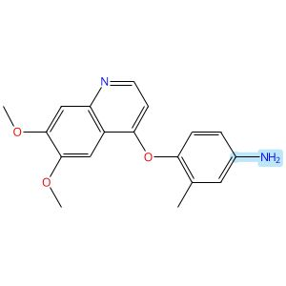 |  |  |  | 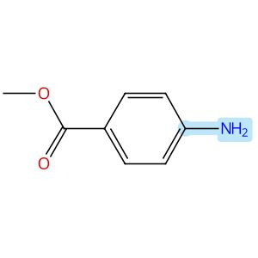
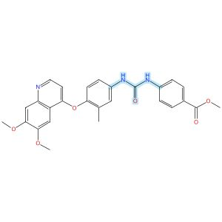

Scheme 29 (Reaction 1 of 1):

Step 1, Yield: 82%

Structure-Based Design and Free Energy Perturbation-Guided Synthesis of Novel VEGFR2 and HDAC Dual Inhibitors with Potent Antitumor Efficacy

By: Li, Yaxin; Liu, Sisi; Hu, Sha; Zhang, Ranran; Wang, Xiaoli; Xu, Jiamin; Yao, Keke; Lu, Chenxuan; Li, Guofeng; Wu, Zhigang; Guo, Chunyan; Yang, Leifu; Hu, Liming

10.1021/acs.jmedchem.5c01650
View All Sources in CAS SciFinder
Company/Organization: Beijing Key Laboratory of Environmental and Oncology, College of Chemistry and Life Science, Beijing University of Technology, Beijing, 100124, China
Source: Journal of Medicinal Chemistry (2026), 69(4), 3762-3778

Step 1
CAS Reaction Number: 31-614-CAS-49395396
Stage | Reagents | Catalysts | Solvents | Conditions
1 |  |  |  | 0 °C
  Triethylamine
  -
  Dichloromethane
2 |  |  |  | 0 °C
  -
  -
  Dichloromethane
Experimental Protocols
Synthetic Methods
Products | Benzoic acid, 4-[[[[4-[(6,7-dimethoxy-4-quinolinyl)oxy]-3-methylphenyl]amino]carbonyl]amino]-, methyl ester, Yield: 82%
Reactants | Triphosgene  4-[(6,7-Dimethoxy-4-quinolinyl)oxy]-3-methylbenzenamine  Methyl 4-aminobenzoate
Reagents | Triethylamine
Solvents | Dichloromethane
Procedure
  1. | Add triethylamine (4.0 equiv) to a solution of quinoline aniline derivative (1.0 equiv) and triphosgene (0.5 equiv) in 5 mL of dichloromethane, held in an ice-water bath, slowly dropwise.
  2. | Monitor complete consumption of the starting materials.
  3. | Add a solution of aniline or benzylamine (1.0 equiv) in 3 mL of dichloromethane dropwise to the reaction mixture.
  4. | Monitor the progress of the reaction by TLC.
  5. | Filter the solid.
  6. | Purify the solid by column chromatography to obtain methyl 4-(3-(4-((6,7-dimethoxyquinolin-4-yl)- oxy)-3-methylphenyl)ureido)benzoate.
Transformation | - Acylation of Nitrogen Nucleophiles by Acyl/ Thioacyl/ Carbamoyl Halides and Analogs
Characterization Data
Benzoic acid, 4-[[[[4-[(6,7-dimethoxy-4-quinolinyl)oxy]-3-methylphenyl]amino]carbonyl]amino]-, methyl ester
Proton NMR Spectrum | (400 MHz, DMSO-d₆): δ (ppm) 9.15 (s, 1H), 8.90 (s, 1H), 8.45 (d, J = 5.2 Hz, 1H), 7.90 (d, J = 8.8 Hz, 2H), 7.61 (d, J = 8.8 Hz, 2H), 7.57 (s, 1H), 7.54 (d, J = 2.6 Hz, 1H), 7.43 (dd, J = 8.7, 2.7 Hz, 1H), 7.40 (s, 1H), 7.15 (d, J = 8.7 Hz, 1H), 6.30 (d, J = 5.2 Hz, 1H), 3.96 (s, 3H), 3.95 (s, 3H), 3.82 (s, 3H), 2.10 (s, 3H)
Mass Spectrum | MS (ESI⁺): calcd for C₂₇H₂₆N₃O₆ [M + H]⁺, 488.2; found, 488.2
State | white solid
CAS Method Number 3-614-CAS-50096419

Relative stereochemistry shown

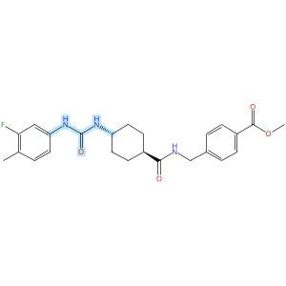
Relative stereochemistry shown

Scheme 30 (Reaction 1 of 1):

Step 1, Yield: 81%

Design and synthesis of novel sEH inhibitors for the treatment of acute lung injury

By: Xu, Huashen; Ma, Ruiyi; Morisseau, Christophe; Dong, Xinyue; Zhuang, Junning; Wang, Zhe; Liu, Fuqin; Xu, Dong; Chen, Lu; Zhang, Maoying; Zhu, Zhihui; Liu, Xinran; Jiang, Huiwen; Liu, Zhongbo; Hammock, Bruce D.; Cao, Ruolin; Chen, Guoliang

10.1016/j.ejmech.2026.118773
View All Sources in CAS SciFinder
Company/Organization: Key Laboratory of Structure-Based Drug Design & Discovery of Ministry of Education, School of Pharmaceutical Engineering, Shenyang Pharmaceutical University, Shenyang, 110016, China
Source: European Journal of Medicinal Chemistry (2026), 309, 118773

Step 1
CAS Reaction Number: 31-614-CAS-49705389
Stage | Reagents | Catalysts | Solvents | Conditions
1 |  |  |  | 1 h, < -10 °C; -10 °C → rt; 30 min, rt
  Triethylamine
  -
  Dichloromethane
2 |  |  |  | 0.5 h, rt; overnight, rt
  Triethylamine
  -
  Dichloromethane
Experimental Protocols
Synthetic Methods
Products | 3124392-03-3, Yield: 81%
Reactants | 3-Fluoro-4-methylaniline  Triphosgene  3124391-96-1
Reagents | Triethylamine
Solvents | Dichloromethane
Procedure
  1. | Add a solution of reactant (0.2 g, 0.93 mmol, 1.0 eq) and Et₃N (0.28 g, 2.78 mmol, 3.0 eq) in DCM (20 mL) dropwise over 1 h to a thick slurry of triphosgene (0.14 g, 0.46 mmol, 0.5 eq) in DCM (10 mL) in a cold trap while maintaining the temperature below 10°C.
  2. | Remove the cold bath and warm the mixture to room temperature and stir for 30 min.
  3. | Add a slurry of Intermediate (0.30 g, 0.74 mmol, 0.8 eq) and Et₃N (0.56 g, 5.56 mmol, 6.0 eq) in DCM (20 mL) in small portions over 0.5 h at room temperature.
  4. | Stir the reaction mixture overnight.
  5. | Wash the reaction mixture with 10% aq HCl (1 x 20 mL).
  6. | Dry the organic layer over anhydrous MgSO₄ and concentrate under reduced pressure.
Transformation | - Acylation of Nitrogen Nucleophiles by Acyl/ Thioacyl/ Carbamoyl Halides and Analogs
Scale | gram
Characterization Data
3124392-03-3
Mass Spectrum | ESI-MS m/z: 440.0 [M H]-
State | White solid
CAS Method Number 3-614-CAS-50079535

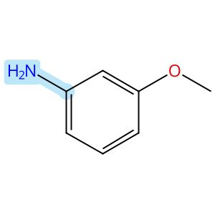

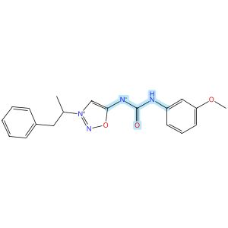

Scheme 31 (Reaction 1 of 1):

Step 1, Yield: 81%

Discovery and Optimization of IRBM-Z-2, an Allosteric Zika Virus NS2B-NS3 Protease Inhibitor Exhibiting In Vivo Efficacy

By: Torrente, Esther; Quotadamo, Antonio; Corio, Alessandra; Ferrigno, Federica; Ievoli, Giovanni; Montalbetti, Christian; Vasile, Silvana; Graziani, Rita; Paonessa, Giacomo; Alli, Cristina; Bisbocci, Monica; Veneziano, Maria; Proto, Giulia; Orsale, Maria Vittoria; di Marco, Annalise; Toniatti, Carlo; Ontoria, Jesus M.

10.1021/acs.jmedchem.6c00476
View All Sources in CAS SciFinder
Company/Organization: Drug Discovery, Medicinal Chemistry Unit, Rome, 00071, Italy
Source: Journal of Medicinal Chemistry (2026), 69(11), 13492-13503

Step 1
CAS Reaction Number: 31-614-CAS-51245228
Stage | Reagents | Catalysts | Solvents | Conditions
1 |  |  |  | 20 min, rt
  Diisopropylethylamine
  -
  Tetrahydrofuran
2 |  |  |  | 0 °C; 10 min, rt
  -
  -
  -
Experimental Protocols
Synthetic Methods
Products | Urea, N-(3-methoxyphenyl)-N′-[3-(1-methyl-2-phenylethyl)-1,2,3-oxadiazolium-5-yl]-, inner salt, Yield: 81%
Reactants | 3-Methoxyaniline  Triphosgene  Sydnophene
Reagents | Diisopropylethylamine
Solvents | Tetrahydrofuran
Procedure
  1. | Stir a solution of bis(trichloromethyl)carbonate (0.34 mmol, 1 equiv.), the corresponding aniline (0.69 mmol, 2 equiv.), and DIPEA (1.4 mmol, 4.0 equiv.) in dry THF (2.6 mL, 0.13 M) at room temperature for 20 minutes.
  2. | Add the mixture dropwise to a stirring suspension of the 5-amino-3-(1-phenylpropan-2-yl)-1,2,3-oxadiazol-3-ium chloride (0.34 mmol, 1 equiv.) in dry THF (2 mL, 0.17 M) at 0°C.
  3. | Add DIPEA (1.4 mmol, 4 equiv.) to the mixture.
  4. | Stir the reaction mixture at room temperature for 10 minutes.
  5. | Dilute the mixture with H₂O.
  6. | Extract the mixture twice with EtOAc.
  7. | Wash the organic layers with brine.
  8. | Dry the organic layers over Na₂SO₄.
  9. | Filter the mixture.
  10. | Concentrate the filtrate in vacuo to obtain a residue.
  11. | Purify the crude by flash chromatography or preparative HPLC to obtain ((3-methoxyphenyl)carbamoyl)(3-(1-phenylpropan-2-yl)-1,2,3-oxadiazol-3-ium-5-yl)amide.
Transformation | - Acylation of Nitrogen Nucleophiles by Acyl/ Thioacyl/ Carbamoyl Halides and Analogs
Characterization Data
Urea, N-(3-methoxyphenyl)-N′-[3-(1-methyl-2-phenylethyl)-1,2,3-oxadiazolium-5-yl]-, inner salt
Proton NMR Spectrum | (400 MHz, DMSO-d₆) δ 9.30 (s, 1H), 8.29 (s, 1H), 7.42 (s, 1H), 7.35-7.27 (m, 2H), 7.26 - 7.18 (m, 3H), 7.15- 7.07 (m, 2H), 6.52-6.44 (m, 1H), 5.25-5.08 (m, 1H), 3.71 (s, 3H), 3.38-3.23 (m, 2H), 1.65 (d, J= 6.6 Hz, 3H)
Fluorine-19 NMR | (377 MHz, DMSO-d₆) δ -61.23 (s, 3F)
Mass Spectrum | LCMS (ES⁺) calculated for C₁₉H₂₀N₄O₃ 352.15; found 353 (M+H)⁺
RT | 1.65 min
State | white powder
CAS Method Number 3-614-CAS-51325680

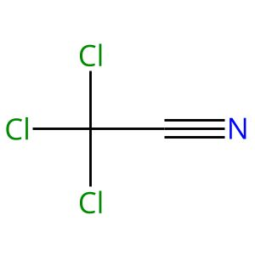 |  | 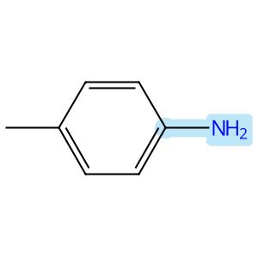 |  | 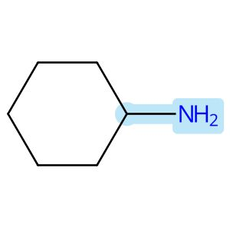
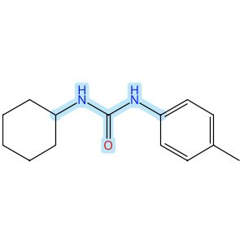

Scheme 32 (Reaction 1 of 1):

Step 1, Yield: 80%

An Efficient and Scalable Approach to Functionalized Urea via Bench-Stable Amidine Building Blocks

By: Zheng, Xiaoping; Xu, Shenting; Jin, Jia; Zhang, Kui; Cai, Lingchao

10.1021/acs.joc.6c00809
View All Sources in CAS SciFinder
Company/Organization: State Key Laboratory for Development and Utilization of Forest Food Resources, Jiangsu Co-Innovation Center of Efficient Processing and Utilization of Forest Resources, International Innovation Center for Forest Chemicals and Materials, Jiangsu Province Key Laboratory of Green Biomass-Based Fuels, Nanjing Forestry University, Nanjing, 210037, China
Source: Journal of Organic Chemistry (2026), 91(27), 9419-9428

Step 1
CAS Reaction Number: 31-614-CAS-51312477
Stage | Reagents | Catalysts | Solvents | Conditions
1 |  |  |  | 64 h, rt
  -
  -
  -
2 |  |  |  | 3 h, 80 °C
  Potassium carbonate
  Water
  2-Mercaptopyridine
  Dimethyl sulfoxide

Notes: green chemistry, no solvent in stage 1, water is coming from solvent
Experimental Protocols
Synthetic Methods
Products | N-Cyclohexyl-N′-(4-methylphenyl)urea, Yield: 80%
Reactants | 4-Methylaniline  Trichloroacetonitrile  Cyclohexylamine
Reagents | Potassium carbonate  Water
Catalysts | 2-Mercaptopyridine
Solvents | Dimethyl sulfoxide
Procedure
  1. | Stir a mixture of trichloroacetonitrile (24.0 mmol) and aniline derivative (20 mmol) for 64 hours.
  2. | Stir the mixture at room temperature and monitor the reaction by TLC.
  3. | Purify the crude residue by recrystallization in DCM.
  4. | Add trichloroacetamidine derivative (0.11 mmol), amine derivative (0.1 mmol), 2-mercaptopyridine (10 mol%), K₂CO₃ (1.5 equiv) and DMSO (0.03 M) in a flask equipped with a magnetic stirrer bar.
  5. | Stir the reaction mixture at 80°C for 3 h and cool.
  6. | Dilute the reaction mixture with saturated brine (15 mL) and extract with EtOAc (4*10 mL).
  7. | Dry the combined organic fractions over anhydrous Na₂SO₄, filter and concentrate on a rotary evaporator.
  8. | Purify the crude residue by column chromatography on silica gel (EtOAc/hexane, gradient from 1/15 to 1/3) to obtain the product.
Scale | gram
CAS Method Number 3-614-CAS-51796120

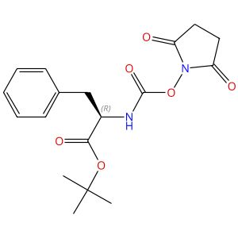  Absolute stereochemistry shown |  | 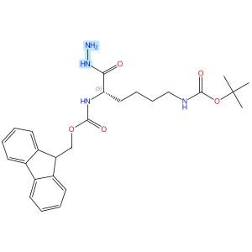  Absolute stereochemistry shown |  | 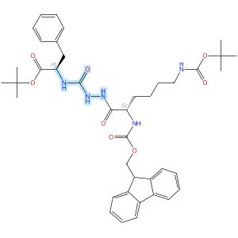  Absolute stereochemistry shown

Scheme 33 (Reaction 1 of 1):

Step 1, Yield: 80%

Scaling Azapeptide with N-Fmoc-Aza-Tripeptide from Resonant Acoustic Mixing of N-Fmoc-Amino Hydrazide and N-Succinimidyl Carbamate

By: Quagliata, Michael; Desjardins-Michaud, Justin; Maarouf-Mesli, Nassim; Boccino, Ida; Bigdeli, Zahra; Polyak, Felix; Lubell, William D.

10.1021/acs.orglett.6c00458
View All Sources in CAS SciFinder
Company/Organization: Departement de Chimie, Universite de Montreal, Montreal, Quebec, H2 V 0B3, Canada
Source: Organic Letters (2026), 28(11), 3510-3516

Step 1
CAS Reaction Number: 31-614-CAS-51513834
Stage | Reagents | Catalysts | Solvents | Conditions
1 |  |  |  | 25 min, 60 °C
  4-Methylmorpholine
  HOAt
  -
  -
2 |  |  |  | 10 min, 60 °C
  N,N-Dimethylethylenediamine
  -
  -

Notes: green chemistry-process simplification, sealed vial used
Experimental Protocols
Synthetic Methods
Products | 3139238-04-0, Yield: 80%
Reactants | N⁶-[(1,1-Dimethylethoxy)carbonyl]-N²-[(9H-fluoren-9-ylmethoxy)carbonyl]-L-lysine hydrazide  D-Phenylalanine, N-[[(2,5-dioxo-1-pyrrolidinyl)oxy]carbonyl]-, 1,1-dimethylethyl ester
Reagents | 4-Methylmorpholine  HOAt  N,N-Dimethylethylenediamine
Procedure
  1. | Add a suspension of Fmoc-Lys(Boc)-NHNH₂ (0.24 g, 0.5 mmol, 100 mol%), Suoc-D-Phe-OtBu (0.24 g, 0.65 mmol, 130 mol%) and HOAt (0.007 g, 0.05 mmol, 10 mol%) in NMM (0.65 mL, η= 1.3 mL/g).
  2. | Subject to the RAM conditions (60 g0 for 25min).
  3. | Open the vial and add (H₃C)₂N(CH₂)₂NH₂ (0.014g, 0.16 mmol, 32mol%) to the reaction mixture.
  4. | Seal the vial and subject to the RAM at 60 g0 for 10 min.
  5. | Transfer the reaction mixture to a separatory funnel using EtOAc (20 mL) and wash with H₂O (10 mL).
  6. | Extract the aqueous phase with EtOAc (2x 20 mL).
  7. | Wash the combined organic layer with 1M HCl (3x 20 mL), NaHCO3sat.(3 x20 mL), H₂O (20 mL) and brine (20 mL), dry over Na₂SO₄, filter and evaporate.
  8. | Deposit the residue on a pad of silica gel (d = 2 cm, h = 10 cm, packed with 20%EtOAc in hexanes).
  9. | Wash the pad with 20% EtOAc in hexanes (50 mL).
  10. | Elution with 80%EtOAc (100 mL) and evaporate the collected fractions under reduced pressure.
Characterization Data
3139238-04-0
Proton NMR Spectrum | (400 MHz, CD₃OD)δ 7.80 (d, 2H, J= 7.6 Hz), 7.70- 7.67(m, 2H), 7.41- 7.37(m,2H), 7.32 - 7.29(m, 2H), 7.26- 7.16(m, 5H), 4.44- 4.39(m,3H),4.27- 4.23(m, 1H), 4.03- 3.99(m,1H),3.09- 3.00(m,4H), 1.82- 1.65 (m, 2H), 1.51- 1.37 (m, 4H), 1.43 (s, 9H), 1.30 (s, 9H)
Carbon-13 NMR | (100 MHz, CD₃OD)δ 174.9, 172.7, 160.2,158.6, 158.2, 145.4,145.2, 142.7,142.6, 138.2, 130.6, 129.4, 128.8, 128.2, 127.7, 126.3, 120.9, 82.8, 79.9, 68.3, 56.4, 55.6, 41.0, 39.1, 32.1, 30.2, 28.8, 28.2, 24.3
HRMS | (ESI+ - TOF)m/[ M + H]+calcd for [C₄₀H₅₁N₅O₈+ H]+, 730.3810 found 730.3837
R_{f} | 0.42 (7:3 EtOAc/hexanes, visualized using UV light or KMnO4)
State | white powder
CAS Method Number 3-614-CAS-51721593

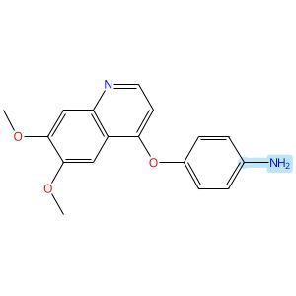

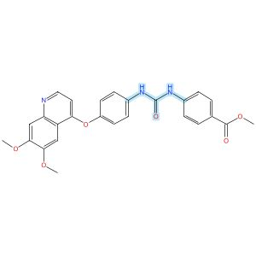

Scheme 34 (Reaction 1 of 1):

Step 1, Yield: 80%

Structure-Based Design and Free Energy Perturbation-Guided Synthesis of Novel VEGFR2 and HDAC Dual Inhibitors with Potent Antitumor Efficacy

By: Li, Yaxin; Liu, Sisi; Hu, Sha; Zhang, Ranran; Wang, Xiaoli; Xu, Jiamin; Yao, Keke; Lu, Chenxuan; Li, Guofeng; Wu, Zhigang; Guo, Chunyan; Yang, Leifu; Hu, Liming

10.1021/acs.jmedchem.5c01650
View All Sources in CAS SciFinder
Company/Organization: Beijing Key Laboratory of Environmental and Oncology, College of Chemistry and Life Science, Beijing University of Technology, Beijing, 100124, China
Source: Journal of Medicinal Chemistry (2026), 69(4), 3762-3778

Step 1
CAS Reaction Number: 31-614-CAS-49395399
Stage | Reagents | Catalysts | Solvents | Conditions
1 |  |  |  | 0 °C
  Triethylamine
  -
  Dichloromethane
2 |  |  |  | 0 °C
  -
  -
  Dichloromethane
Experimental Protocols
Synthetic Methods
Products | Benzoic acid, 4-[[[[4-[(6,7-dimethoxy-4-quinolinyl)oxy]phenyl]amino]carbonyl]amino]-, methyl ester, Yield: 80%
Reactants | Triphosgene  4-[(6,7-Dimethoxyquinolin-4-yl)oxy]aniline  Methyl 4-aminobenzoate
Reagents | Triethylamine
Solvents | Dichloromethane
Procedure
  1. | Add triethylamine (4.0 equiv) to a solution of quinoline aniline derivative (1.0 equiv) and triphosgene (0.5 equiv) in 5 mL of dichloromethane, held in an ice-water bath, slowly dropwise.
  2. | Monitor complete consumption of the starting materials.
  3. | Add a solution of aniline or benzylamine (1.0 equiv) in 3 mL of dichloromethane dropwise to the reaction mixture.
  4. | Monitor the progress of the reaction by TLC.
  5. | Filter the solid.
  6. | Purify the solid by column chromatography to obtain methyl 4-(3-(4-((6,7-dimethoxyquinolin-4-yl)-oxy)phenyl)ureido)benzoate.
Transformation | - Acylation of Nitrogen Nucleophiles by Acyl/ Thioacyl/ Carbamoyl Halides and Analogs
Characterization Data
Benzoic acid, 4-[[[[4-[(6,7-dimethoxy-4-quinolinyl)oxy]phenyl]amino]carbonyl]amino]-, methyl ester
Proton NMR Spectrum | (400 MHz, DMSO-d₆): δ (ppm) 9.16 (s, 1H), 8.98 (s, 1H), 8.47 (d, J = 5.3 Hz, 1H), 7.91 (d, J = 8.8 Hz, 2H), 7.61 (d, J = 8.8 Hz, 4H), 7.52 (s, 1H), 7.40 (s, 1H), 7.23 (d, J = 8.9 Hz, 2H), 6.45 (d, J = 5.2 Hz, 1H), 3.95 (s, 3H), 3.94 (s, 3H), 3.82 (s, 3H)
Mass Spectrum | MS (ESI⁺): calcd for C₂₆H₂₄N₃O₆ [M + H]⁺, 474.2; found, 474.2
State | white solid
CAS Method Number 3-614-CAS-50096413

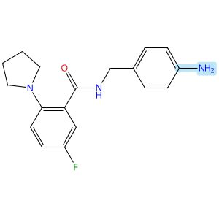

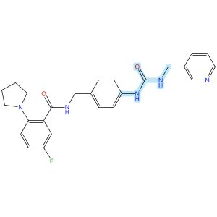

Scheme 35 (Reaction 1 of 1):

Step 1, Yield: 80%

Discovery of potent o-aminobenzoamide-based NAMPT inhibitors for targeting NAPRT-deficient gastric cancer

By: Yang, Heng; Li, Zhiyi; Peng, Huiqian; shen, Lixian; Li, Zhen; Zhu, Lejing; Ding, Rifan; Shi, Yiting; Liu, Yuting; Zhang, Miao; Zhuo, Linsheng; Yang, Meiling; Wang, Zhen; Jiang, Weifan

10.1021/acs.jmedchem.5c02564
View All Sources in CAS SciFinder
Company/Organization: School of Pharmaceutical Science, Hengyang Medical School, University of South China, Hunan, 421001, China
Source: Journal of Medicinal Chemistry (2026), 69(3), 2625-2646

Step 1
CAS Reaction Number: 31-614-CAS-49296539
Stage | Reagents | Catalysts | Solvents | Conditions
1 |  |  |  | 30 min, 0 °C
  Pyridine
  -
  Dichloromethane
2 |  |  |  | 30 min, 0 °C
  -
  -
  Dichloromethane
3 |  |  |  | 4 h, rt
  -
  -
  -
Experimental Protocols
Synthetic Methods
Products | Benzamide, 5-fluoro-N-[[4-[[[(3-pyridinylmethyl)amino]carbonyl]amino]phenyl]methyl]-2-(1-pyrrolidinyl)-, Yield: 80%
Reactants | Triphosgene  3-Pyridinemethanamine  Benzamide, N-[(4-aminophenyl)methyl]-5-fluoro-2-(1-pyrrolidinyl)-
Reagents | Pyridine
Solvents | Dichloromethane
Procedure
  1. | Combine the triphosgene (1 mmol, 1 equiv) and pyridine (6.8 mmol, 6.8 equiv) in DCM (10 mL).
  2. | Cool the reaction mixture to 0°C in a brine ice bath for 30 minutes.
  3. | Add 3-(aminomethyl)pyridine derivative (1 M in DCM, 3.4 mmol, 3.4 equiv) to the mixture.
  4. | Stir the reaction mixture for 30 minutes.
  5. | Add the corresponding amine (1 M in DCM, 3.4 mmol, 3.4 equiv) to the mixture.
  6. | Stir the resulting reaction mixture at room temperature for 4 hours.
  7. | Dilute the mixture with DCM.
  8. | Wash the mixture with saturated ammonium chloride.
  9. | Dry the residue over anhydrous sodium sulfate.
  10. | Filter the mixture.
  11. | Concentrate the filtrate in vacuo.
  12. | Purify the crude by sample column chromatography (DCM/MeOH = 25:1) to obtain 5-fluoro-N-(4-(3-(pyridin-3-ylmethyl)ureido)benzyl)-2-(pyrrolidin-1-yl)benzamide.
Transformation | - Acylation of Nitrogen Nucleophiles by Acyl/ Thioacyl/ Carbamoyl Halides and Analogs
Characterization Data
Benzamide, 5-fluoro-N-[[4-[[[(3-pyridinylmethyl)amino]carbonyl]amino]phenyl]methyl]-2-(1-pyrrolidinyl)-
Proton NMR Spectrum | (500 MHz, CDCl₃): δ 9.67 (t, J = 5.7 Hz, 1H), 8.43 (s, 2H), 8.41 (d, J = 4.9 Hz, 2H), 7.68 (s, 1H), 7.61 (dt, J = 7.9, 2.1 Hz, 1H), 7.60-7.56 (m, 1H), 7.21-7.15 (m, 3H), 7.13-7.10 (m, 2H), 7.06-7.04 (m, 1H), 7.04 (d, J = 1.8 Hz, 1H), 6.11 (t, J = 6.0 Hz, 1H), 4.46 (d, J = 5.7 Hz, 2H), 4.35 (d, J = 5.7 Hz, 2H), 2.99-2.93 (m, 4H), 1.77-1.72 (m, 4H)
Carbon-13 NMR | (125 MHz, CDCl₃): δ 166.9, 158.4 (d, J = 242.6 Hz), 156.1, 148.8, 148.5, 144.8 (d, J = 2.3 Hz), 138.6, 135.7, 135.3, 132.5, 128.4, 128.3 (d, J = 6.5 Hz), 123.7, 120.8 (d, J = 7.4 Hz), 120.1, 118.7 (d, J = 22.4 Hz), 117.7 (d, J = 23.9 Hz), 53.1, 43.5, 41.5, 24.6
Fluorine-19 NMR | (471 MHz, CDCl₃): δ - 119.99
HRMS | calcd for C₂₅H₂₆N₅O₂F [M + H]⁺ 448.2149; found 448.2151
Melting Point | 80-81°C
State | yellow solid
CAS Method Number 3-614-CAS-50424738

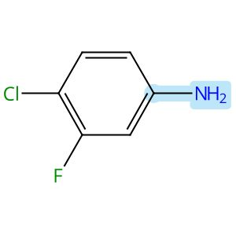

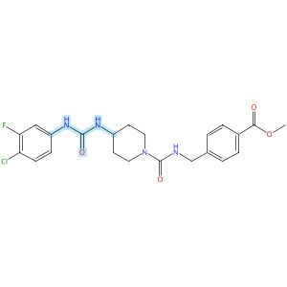

Scheme 36 (Reaction 1 of 1):

Step 1, Yield: 80%

Design and synthesis of novel sEH inhibitors for the treatment of acute lung injury

By: Xu, Huashen; Ma, Ruiyi; Morisseau, Christophe; Dong, Xinyue; Zhuang, Junning; Wang, Zhe; Liu, Fuqin; Xu, Dong; Chen, Lu; Zhang, Maoying; Zhu, Zhihui; Liu, Xinran; Jiang, Huiwen; Liu, Zhongbo; Hammock, Bruce D.; Cao, Ruolin; Chen, Guoliang

10.1016/j.ejmech.2026.118773
View All Sources in CAS SciFinder
Company/Organization: Key Laboratory of Structure-Based Drug Design & Discovery of Ministry of Education, School of Pharmaceutical Engineering, Shenyang Pharmaceutical University, Shenyang, 110016, China
Source: European Journal of Medicinal Chemistry (2026), 309, 118773

Step 1
CAS Reaction Number: 31-614-CAS-49705467
Stage | Reagents | Catalysts | Solvents | Conditions
1 |  |  |  | 1 h, < -10 °C; -10 °C → rt; 30 min, rt
  Triethylamine
  -
  Dichloromethane
2 |  |  |  | 0.5 h, rt; overnight, rt
  Triethylamine
  -
  Dichloromethane
Experimental Protocols
Synthetic Methods
Products | 3124392-78-2, Yield: 80%
Reactants | 4-Chloro-3-fluorobenzenamine  Triphosgene  3124392-72-6
Reagents | Triethylamine
Solvents | Dichloromethane
Procedure
  1. | Add a solution of Memantine (0.15 g, 0.82 mmol, 1.0 eq) and Et₃N (0.25 g, 2.46 mmol, 3.0 eq) in DCM (20 mL) dropwise over 1 h to a thick slurry of triphosgene (0.12 g, 0.41 mmol, 0.5 eq) in DCM (10 mL) in a cold trap while maintaining the temperature below 10°C.
  2. | Remove the cold bath and warm the mixture to room temperature and stir for 30 min.
  3. | Add a slurry of Intermediate (0.3 g, 0.74 mmol, 0.9 eq) and Et₃N (0.42 g, 4.1 mmol, 5.0 eq) in DCM (20 mL) in small portions over 0.5 h at room temperature.
  4. | Stir the reaction mixture overnight.
  5. | Wash the reaction mixture with 10% aq HCl (1 x 20 mL).
  6. | Dry the organic layer over anhydrous MgSO₄ and concentrate under reduced pressure.
Transformation | - Acylation of Nitrogen Nucleophiles by Acyl/ Thioacyl/ Carbamoyl Halides and Analogs
CAS Method Number 3-614-CAS-50079816

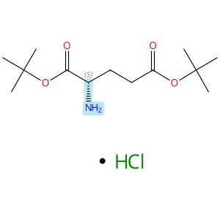  Absolute stereochemistry shown |  |  |  | 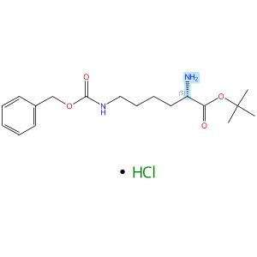  Absolute stereochemistry shown,  Rotation (+)
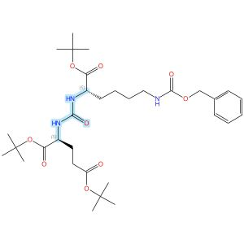
Absolute stereochemistry shown

Scheme 37 (Reaction 1 of 1):

Step 1, Yield: 79%

A series of conjugates based on prostate-specific membrane antigen ligands with the chelating agent DOTA: synthesis, radiolabeling, and biological activity

By: Butakova, N. S.; Uspenskaia, A. A.; Zyk, N. Y.; Petrov, S. A.; Popovicheva, K. A.; Lunev, A. S.; Petrosova, K. A.; Mitrofanov, I. A.; Ivashkovskaya, M. N.; Evteev, S. A.; Ivanenkov, Y. A.; Beloglazkina, E. K.; Larenkov, A. A.; Machulkin, A. E.

10.1016/j.ejmech.2025.118433
View All Sources in CAS SciFinder
Company/Organization: Chemistry Dept., GSP-1, Lomonosov Moscow State University, Moscow, 119991, Russian Federation
Source: European Journal of Medicinal Chemistry (2026), 303, 118433

Step 1
CAS Reaction Number: 31-614-CAS-48751142
Stage | Reagents | Catalysts | Solvents | Conditions
1 |  |  |  | -78 °C
  Diisopropylethylamine
  -
  Dichloromethane
2 |  |  |  | -
  Diisopropylethylamine
  -
  Dichloromethane

Notes: literature preparation

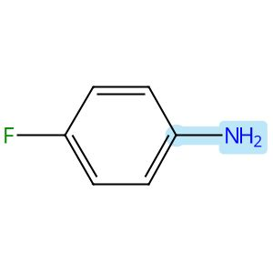

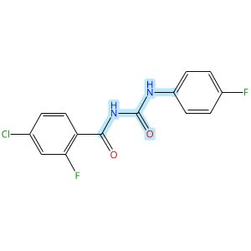

Scheme 38 (Reaction 1 of 1):

Step 1, Yield: 79%

Design, Synthesis, and Preclinical Evaluation of a PET Tracer Targeting Methionine Adenosyltransferase 2A

By: Jiang, Zeng; Huang, Yong; Chen, Hualong; Yu, Ziyue; Cheng, Xuebo; Liu, Yajing; Wu, Zehui

10.1021/acs.jmedchem.5c02532
View All Sources in CAS SciFinder
Company/Organization: Beijing Institute of Brain Disorders, Beijing Key Laboratory of Innovation and Translation of Central Nervous System Radiopharmaceuticals, Capital Medical University, Beijing, 100069, China
Source: Journal of Medicinal Chemistry (2026), 69(3), 2575-2598

Step 1
CAS Reaction Number: 31-614-CAS-49099062
Stage | Reagents | Catalysts | Solvents | Conditions
1 |  |  |  | rt; 30 min, 80 °C; 80 °C → rt
  -
  -
  1,2-Dichloroethane
2 |  |  |  | 1 h, rt
  -
  -
  -
3 |  |  |  | 10 min, rt
  Sodium bicarbonate
  -
  Water
Experimental Protocols
Synthetic Methods
Products | 4-Chloro-2-fluoro-N-[[(4-fluorophenyl)amino]carbonyl]benzamide, Yield: 79%
Reactants | Oxalyl chloride  4-Chloro-2-fluorobenzamide  4-Fluoroaniline
Reagents | Sodium bicarbonate
Solvents | 1,2-Dichloroethane  Water
Procedure
  1. | Dissolve 4-chloro-2-fluorobenzamide (1 g, 5.76 mmol) in 20 mL of DCE.
  2. | Add oxalyl chloride (0.8 g, 6.34 mmol) to the mixture at room temperature.
  3. | Stir the mixture at 80°C for 30 minutes.
  4. | Cool the mixture to room temperature.
  5. | Add p-fluoroaniline (1.28 g, 11.5 mmol) to the mixture.
  6. | Stir the mixture continuously at room temperature for 1 hour.
  7. | Add 100 mL of saturated NaHCO₃ solution to the mixture.
  8. | Stir the mixture for 10 minutes.
  9. | Filter the mixture.
  10. | Wash the filter cake with water.
  11. | Dry the residue to afford 4-chloro-2-fluoro-N-((4-fluorophenyl)carbamoyl)-benzamide.
Transformation | - Acylation of Nitrogen Nucleophiles by Acyl/ Thioacyl/ Carbamoyl Halides and Analogs
Scale | gram
Characterization Data
4-Chloro-2-fluoro-N-[[(4-fluorophenyl)amino]carbonyl]benzamide
Proton NMR Spectrum | (300 MHz, CDCl₃) δ 10.57 (s, 1H), 8.72 (d, J = 12.9 Hz, 1H), 8.05 (t, J = 8.4 Hz, 1H), 7.51 (dd, J = 8.8, 4.7 Hz, 2H), 7.35 (d, J = 8.5 Hz, 1H), 7.31-7.27 (m, 1H), 7.05 (t, J = 8.6 Hz, 2H)
HRMS | calcd for C₁₄H₁₀ClF₂N₂O₂⁺, 311.0393[M + H]⁺, found: 311.0396
State | white solid
CAS Method Number 3-614-CAS-50416084

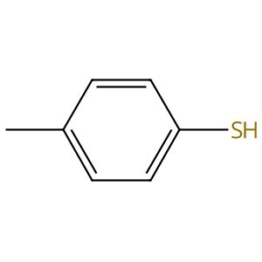 |  | 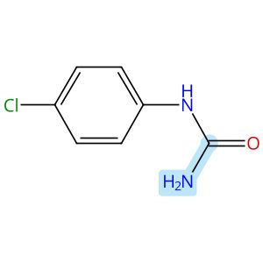 |  | 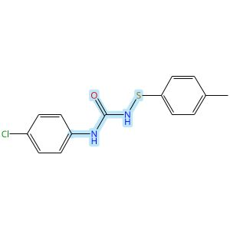

Scheme 39 (Reaction 1 of 1):

Step 1, Yield: 79%

Iron-Catalyzed Asymmetric NH2-Amination of Sulfenamides

By: Fan, Fang-Xu; Jia, Si-Ming; Mo, Zhenbo; Wang, Fei

10.1002/anie.1625296
View All Sources in CAS SciFinder
Company/Organization: State Key Laboratory of Elemento-Organic Chemistry, Frontiers Science Center For New Organic Matter, College of Chemistry, Nankai University, Tianjin, China
Source: Angewandte Chemie, International Edition (2026), 65(33), e1625296

Step 1
CAS Reaction Number: 31-614-CAS-51296152
Stage | Reagents | Catalysts | Solvents | Conditions
1 |  |  |  | 10 min, rt; 30 min, rt
  Chlorosuccinimide
  -
  Toluene
2 |  |  |  | rt; 12 h, rt
  Triethylamine
  -
  Toluene
3 |  |  |  | -
  Sodium bicarbonate
  -
  Water
4 |  |  |  | 0 °C; 0 °C → rt; 30 min, rt; rt → 0 °C
  Sodium hydride
  -
  Tetrahydrofuran
5 |  |  |  | 0 °C; overnight, 0 °C → rt
  -
  -
  -
6 |  |  |  | rt
  Ammonium chloride
  -
  Water

Notes: see experimental details, intermediate from stage 3 added in stage 5
Experimental Protocols
Synthetic Methods
Products | Urea, N-(4-chlorophenyl)-N′-[(4-methylphenyl)thio]-, Yield: 79%
Reactants | 4-Methylbenzenethiol  4-Chlorophenylurea
Reagents | Chlorosuccinimide  Triethylamine  Sodium bicarbonate  Sodium hydride  Ammonium chloride
Solvents | Toluene  Water  Tetrahydrofuran
Procedure
  1. | Add N-chlorosuccinimide and dry toluene (0.2 M), to an oven dry round bottomed flask.
  2. | Stir the solution at room temperature for 10 minutes.
  3. | Add 1.0 equiv.of thiol to the reaction mixture via syringe.
  4. | Allow the reaction to stir at room temperature for 30 min.
  5. | Add 1.0 equiv. of triethylamine in dry toluene (0.2 M) dropwise to the reaction mixture.
  6. | Stir at room temperature for additional 12 h.
  7. | Add of triethylamine in dry toluene (0.2 M) dropwise to the reaction mixture.
  8. | Stir at room temperature for additional 12 h.
  9. | After completion as monitor by TLC, quench the reaction mixture with 10 mL saturated aqueous NaHCO₃ and extract with DCM.
  10. | Dry the combined organic layer over anhydrous Na₂SO₄ and concentrate.
  11. | Purify the resultant by column chromatography.
  12. | Add amide (1.1 equiv.), to a flame-dry 250 mL round-bottomed flask, equipped with a stir bar, under N2.
  13. | Add THF (0.1 M).
  14. | Cool the solution to 0°C.
  15. | Add NaH (2.5 equiv.) and warm the resulting mixture to room temperature.
  16. | Stir for 30 min.
  17. | Cool the mixture to 0°C.
  18. | Add 2-(phenylthio)isoindoline-1, 3-dione (1.0 equiv.)
  19. | Warm the mixture to room temperature and stir until reaction completion as determine by TLC.
  20. | Dilute the mixture slowly with sat. aq. NH₄Cl with stirring until white precipitates dissolve.
  21. | Extract the resulting solution with EtOAc (three times).
  22. | Wash the combined organic layers with brine, dry (Na₂SO₄) and concentrate.
  23. | Purify the crude residue by flash column chromatography with PE/EA (5/1) as elute.
Characterization Data
Urea, N-(4-chlorophenyl)-N′-[(4-methylphenyl)thio]-
Proton NMR Spectrum | (400 MHz,DMSO) δ 9.11 (br, 1H), 8.18 (br, 1H), 7.50 (d,J = 8.7 Hz, 2H), 7.31 (d,J = 8.9 Hz, 2H), 7.18 (d,J = 8.7 Hz,2H), 7.15 (d,J = 8.7 Hz, 2H), 2.26 (s, 3H)
Carbon-13 NMR | (151 MHz, DMSO) δ 155.7, 138.9, 137.6, 136.0, 130.0, 129.0, 126.4, 124.3, 120.8, 21.0
HRMS | (ESI) calculated forC14H14ClN2OS+ [M+H]+ 293.0510, found293.0517
State | white solid
CAS Method Number 3-614-CAS-51653014

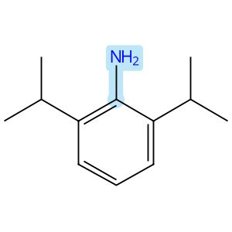 |  |  |  | 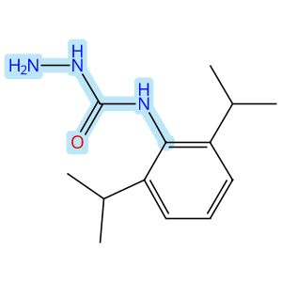

Scheme 40 (Reaction 1 of 1):

Step 1, Yield: 79%

Functionality-Matched Semicarbazone Reagents Allow Access to X-ray Quality Crystals and Solids of Diverse Organic Molecules

By: Sherman, Emily R.; Johnson, Jeffrey S.

10.1021/acs.orglett.6c01328
View All Sources in CAS SciFinder
Company/Organization: Department of Chemistry, University of North Carolina at Chapel Hill, Chapel Hill, North Carolina, 27599-3290, United States
Source: Organic Letters (2026), 28(19), 6048-6053

Step 1
CAS Reaction Number: 31-614-CAS-51011649
Stage | Reagents | Catalysts | Solvents | Conditions
1 |  |  |  | 0.5 h, 0 °C; 18 h, 0 °C → rt
  Triethylamine
  -
  Dichloromethane
2 |  |  |  | rt
  -
  -
  Water
3 |  |  |  | 2 d, rt
  Hydrazine hydrate (1:1)
  -
  Acetonitrile
Experimental Protocols
Synthetic Methods
Products | N-[2,6-Bis(1-methylethyl)phenyl]hydrazinecarboxamide, Yield: 79%
Reactants | Phenyl chloroformate  2,6-Diisopropylaniline
Reagents | Triethylamine  Hydrazine hydrate (1:1)
Solvents | Dichloromethane  Water  Acetonitrile
Procedure
  1. | Add 2,6-diisopropyl aniline (14.0 mL, 1.0 equiv, 74.00 mmol) to a flame-dried 500 mL round bottomed flask.
  2. | Add anhydrous DCM (148.0 mL, 0.5 M) and anhydrous Et₃N (22.7 mL, 2.2 equiv, 162.8 mmol) to the flask.
  3. | Cool the mixture to 0°C.
  4. | Add phenyl carbonochloridate (177.6 mmol, 2.4 equiv, 27.81 g, 22.4 mL) to the reaction mixture.
  5. | Stir the reaction mixture at 0°C for 0.5 hours.
  6. | Warm the reaction mixture to room temperature over 18 hours.
  7. | Quench the reaction mixture with water (20 mL).
  8. | Extract the reaction mixture with DCM (80 mL x 3).
  9. | Wash the combined organic phases with brine (80 mL).
  10. | Dry the reaction mixture over anhydrous Na₂SO₄.
  11. | Filter the reaction mixture.
  12. | Concentrate the reaction mixture in vacuo.
  13. | Rinse the light brown solid with hexanes (3 x 30 mL) to obtain a white solid.
  14. | Add hydrazine hydrate (1.7 equiv) to a solution of phenylcarbamate (1 equiv, 74.00 mmol) in acetonitrile (640 mL, 0.10 M).
  15. | Stir the reaction mixture at room temperature for 2 days.
  16. | Remove solvents under reduced pressure.
  17. | Purify the crude product by column chromatography using 10-40% EtOAc/hexanes to obtain N-(2,6-diisopropylphenyl)hydrazinecarboxamide.
Scale | milligram
Characterization Data
N-[2,6-Bis(1-methylethyl)phenyl]hydrazinecarboxamide
Proton NMR Spectrum | (400 MHz, CDCl₃) δ 7.29 (t, J= 7.7 Hz, 1H), 7.18 (d, J= 7.7 Hz, 2H), 6.06 (bs, 2H), 3.83 (bs, 1H), 3.19 (heptet, J= 6.9 Hz, 2H), 1.21 (d, J= 6.9 Hz, 12H)
Carbon-13 NMR | (151 MHz, DMSO) δ 152.6, 139.0, 123.5, 119.4, 114.8, 20.2, 14.5
HRMS | (ESI): [M + H]⁺ Calculated for C₁₃H₂₂N₃O+: 236.1757; Found: 236.1755
Melting Point | 202-205°C
R_{f} | TLC (40% EtOAc/Hexanes) 0.17 (UV)
State | white solid
CAS Method Number 3-614-CAS-51192451

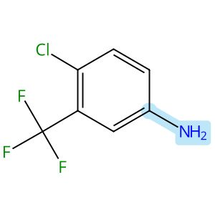

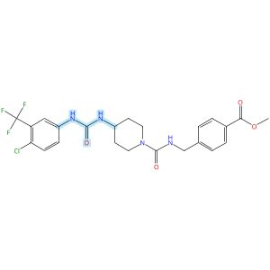

Scheme 41 (Reaction 1 of 1):

Step 1, Yield: 79%

Design and synthesis of novel sEH inhibitors for the treatment of acute lung injury

By: Xu, Huashen; Ma, Ruiyi; Morisseau, Christophe; Dong, Xinyue; Zhuang, Junning; Wang, Zhe; Liu, Fuqin; Xu, Dong; Chen, Lu; Zhang, Maoying; Zhu, Zhihui; Liu, Xinran; Jiang, Huiwen; Liu, Zhongbo; Hammock, Bruce D.; Cao, Ruolin; Chen, Guoliang

10.1016/j.ejmech.2026.118773
View All Sources in CAS SciFinder
Company/Organization: Key Laboratory of Structure-Based Drug Design & Discovery of Ministry of Education, School of Pharmaceutical Engineering, Shenyang Pharmaceutical University, Shenyang, 110016, China
Source: European Journal of Medicinal Chemistry (2026), 309, 118773

Step 1
CAS Reaction Number: 31-614-CAS-49705452
Stage | Reagents | Catalysts | Solvents | Conditions
1 |  |  |  | 1 h, < -10 °C; -10 °C → rt; 30 min, rt
  Triethylamine
  -
  Dichloromethane
2 |  |  |  | 0.5 h, rt; overnight, rt
  Triethylamine
  -
  Dichloromethane
Experimental Protocols
Synthetic Methods
Products | 3124392-74-8, Yield: 79%
Reactants | 4-Chloro-3-(trifluoromethyl)aniline  Triphosgene  3124392-72-6
Reagents | Triethylamine
Solvents | Dichloromethane
Procedure
  1. | Add a solution of Memantine (0.15 g, 0.82 mmol, 1.0 eq) and Et₃N (0.25 g, 2.46 mmol, 3.0 eq) in DCM (20 mL) dropwise over 1 h to a thick slurry of triphosgene (0.12 g, 0.41 mmol, 0.5 eq) in DCM (10 mL) in a cold trap while maintaining the temperature below 10°C.
  2. | Remove the cold bath and warm the mixture to room temperature and stir for 30 min.
  3. | Add a slurry of Intermediate (0.3 g, 0.74 mmol, 0.9 eq) and Et₃N (0.42 g, 4.1 mmol, 5.0 eq) in DCM (20 mL) in small portions over 0.5 h at room temperature.
  4. | Stir the reaction mixture overnight.
  5. | Wash the reaction mixture with 10% aq HCl (1 x 20 mL).
  6. | Dry the organic layer over anhydrous MgSO₄ and concentrate under reduced pressure.
Transformation | - Acylation of Nitrogen Nucleophiles by Acyl/ Thioacyl/ Carbamoyl Halides and Analogs
CAS Method Number 3-614-CAS-50079806

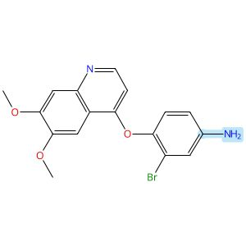

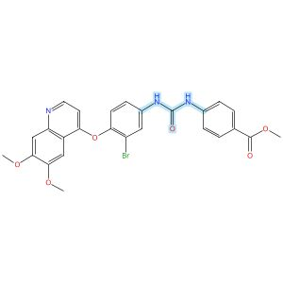

Scheme 42 (Reaction 1 of 1):

Step 1, Yield: 79%

Structure-Based Design and Free Energy Perturbation-Guided Synthesis of Novel VEGFR2 and HDAC Dual Inhibitors with Potent Antitumor Efficacy

By: Li, Yaxin; Liu, Sisi; Hu, Sha; Zhang, Ranran; Wang, Xiaoli; Xu, Jiamin; Yao, Keke; Lu, Chenxuan; Li, Guofeng; Wu, Zhigang; Guo, Chunyan; Yang, Leifu; Hu, Liming

10.1021/acs.jmedchem.5c01650
View All Sources in CAS SciFinder
Company/Organization: Beijing Key Laboratory of Environmental and Oncology, College of Chemistry and Life Science, Beijing University of Technology, Beijing, 100124, China
Source: Journal of Medicinal Chemistry (2026), 69(4), 3762-3778

Step 1
CAS Reaction Number: 31-614-CAS-49395395
Stage | Reagents | Catalysts | Solvents | Conditions
1 |  |  |  | 0 °C
  Triethylamine
  -
  Dichloromethane
2 |  |  |  | 0 °C
  -
  -
  Dichloromethane
Experimental Protocols
Synthetic Methods
Products | Benzoic acid, 4-[[[[3-bromo-4-[(6,7-dimethoxy-4-quinolinyl)oxy]phenyl]amino]carbonyl]amino]-, methyl ester, Yield: 79%
Reactants | Triphosgene  Benzenamine, 3-bromo-4-[(6,7-dimethoxy-4-quinolinyl)oxy]-  Methyl 4-aminobenzoate
Reagents | Triethylamine
Solvents | Dichloromethane
Procedure
  1. | Add triethylamine (4.0 equiv) to a solution of quinoline aniline derivative (1.0 equiv) and triphosgene (0.5 equiv) in 5 mL of dichloromethane, held in an ice-water bath, slowly dropwise.
  2. | Monitor complete consumption of the starting materials.
  3. | Add a solution of aniline or benzylamine (1.0 equiv) in 3 mL of dichloromethane dropwise to the reaction mixture.
  4. | Monitor the progress of the reaction by TLC.
  5. | Filter the solid.
  6. | Purify the solid by column chromatography to obtain methyl 4-(3-(3-bromo-4-((6,7-dimethoxyquinolin-4-yl)oxy)phenyl)ureido)benzoate.
Transformation | - Acylation of Nitrogen Nucleophiles by Acyl/ Thioacyl/ Carbamoyl Halides and Analogs
Characterization Data
Benzoic acid, 4-[[[[3-bromo-4-[(6,7-dimethoxy-4-quinolinyl)oxy]phenyl]amino]carbonyl]amino]-, methyl ester
Proton NMR Spectrum | (400 MHz, DMSO-d₆): δ (ppm) 9.27 (s, 1H), 9.16 (s, 1H), 8.48 (d, J = 5.2 Hz, 1H), 8.09 (d, J = 2.5 Hz, 1H), 7.91 (d, J = 8.8 Hz, 2H), 7.62 (d, J = 8.8 Hz, 2H), 7.55 (s, 1H), 7.50 (dd, J = 8.9, 2.5 Hz, 1H), 7.42 (s, 1H), 7.39 (d, J = 8.8 Hz, 1H), 6.35 (d, J = 5.2 Hz, 1H), 3.96 (s, 3H), 3.95 (s, 3H), 3.83 (s, 3H)
Mass Spectrum | MS (ESI⁺): calcd for C₂₆H₂₃BrN₃O₆ [M + H]⁺, 552.1; found, 552.2
State | white solid
CAS Method Number 3-614-CAS-50096417

 |  | 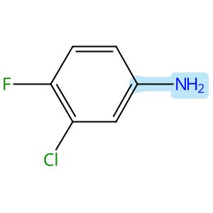 |  | 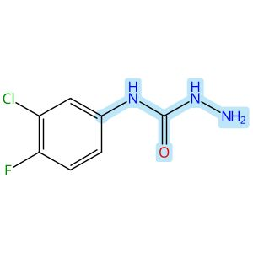

Scheme 43 (Reaction 1 of 1):

Step 1, Yield: 79%

Design, synthesis, anticancer evaluation, biological screening, and computational study of novel 6,7-dimethoxyquinazoline derivatives as VEGFR-2 inhibitors and apoptotic inducers

By: Aref, Mostafa M. A.; Abdallah, Abdallah E.; Dahab, Mohammed A.; Mohamed, Abeer A.; Celik, Ismail; Bawazir, Wafa A.; Mansoure, Ahd A.; Alnami, Aisha Taib; Abdelhamed, Mennatullah N.; El-Zahabi, Mohamed Ayman

10.1016/j.ejmech.2025.118187
View All Sources in CAS SciFinder
Company/Organization: Pharmaceutical Medicinal Chemistry & Drug Design Department, Faculty of Pharmacy (Boys), Al-Azhar University, Cairo, 11884, Egypt
Source: European Journal of Medicinal Chemistry (2026), 301, 118187

Step 1
CAS Reaction Number: 31-614-CAS-47564244
Stage | Reagents | Catalysts | Solvents | Conditions
1 |  |  |  | 30 min, 0 - 5 °C
  -
  -
  Dichloromethane
2 |  |  |  | 0 - 5 °C; 2 h, rt
  Triethylamine
  -
  -
3 |  |  |  | overnight, rt
  Hydrazine hydrate (1:1)
  -
  -
Experimental Protocols
Synthetic Methods
Products | N-(3-Chloro-4-fluorophenyl)hydrazinecarboxamide, Yield: 79%
Reactants | 3-Chloro-4-fluoroaniline  Triphosgene
Reagents | Triethylamine  Hydrazine hydrate (1:1)
Solvents | Dichloromethane
Procedure
  1. | Dissolve triphosgene (5.0 mmol, 1.48 g) in DCM (30 mL) and add 3-chloro-4-fluoroaniline (10.0 mmol) in DCM (20 mL) dropwise to the above solution at 0-5°C for 30 min.
  2. | Gauranga2 after the aryl primary aniline reacted completely and (DCM: MeOH, 95:5), TEA (25.0 mmol, 2.53g) was added dropwise to the mixture and stir for 2 h at RT (monitored by TLC).
  3. | Pour the formed mixture of isocyanates into a flask containing hydrazine hydrate (12 mmol) and stir at ambient temperature overnight.
  4. | Filter the resulting white precipitate washed with DCM and recrystallize from ethanol.
Scale | gram
Characterization Data
N-(3-Chloro-4-fluorophenyl)hydrazinecarboxamide
Melting Point | 93-94 oC
CAS Method Number 3-614-CAS-49967054

Relative stereochemistry shown

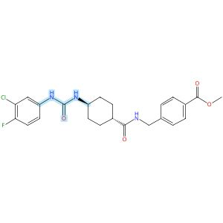
Relative stereochemistry shown

Scheme 44 (Reaction 1 of 1):

Step 1, Yield: 78%

Design and synthesis of novel sEH inhibitors for the treatment of acute lung injury

By: Xu, Huashen; Ma, Ruiyi; Morisseau, Christophe; Dong, Xinyue; Zhuang, Junning; Wang, Zhe; Liu, Fuqin; Xu, Dong; Chen, Lu; Zhang, Maoying; Zhu, Zhihui; Liu, Xinran; Jiang, Huiwen; Liu, Zhongbo; Hammock, Bruce D.; Cao, Ruolin; Chen, Guoliang

10.1016/j.ejmech.2026.118773
View All Sources in CAS SciFinder
Company/Organization: Key Laboratory of Structure-Based Drug Design & Discovery of Ministry of Education, School of Pharmaceutical Engineering, Shenyang Pharmaceutical University, Shenyang, 110016, China
Source: European Journal of Medicinal Chemistry (2026), 309, 118773

Step 1
CAS Reaction Number: 31-614-CAS-49705390
Stage | Reagents | Catalysts | Solvents | Conditions
1 |  |  |  | 1 h, < -10 °C; -10 °C → rt; 30 min, rt
  Triethylamine
  -
  Dichloromethane
2 |  |  |  | 0.5 h, rt; overnight, rt
  Triethylamine
  -
  Dichloromethane
Experimental Protocols
Synthetic Methods
Products | 3124391-99-4, Yield: 78%
Reactants | 3-Chloro-4-fluoroaniline  Triphosgene  3124391-96-1
Reagents | Triethylamine
Solvents | Dichloromethane
Procedure
  1. | Add a solution of reactant (0.2 g, 0.93 mmol, 1.0 eq) and Et₃N (0.28 g, 2.78 mmol, 3.0 eq) in DCM (20 mL) dropwise over 1 h to a thick slurry of triphosgene (0.14 g, 0.46 mmol, 0.5 eq) in DCM (10 mL) in a cold trap while maintaining the temperature below 10°C.
  2. | Remove the cold bath and warm the mixture to room temperature and stir for 30 min.
  3. | Add a slurry of Intermediate (0.30 g, 0.74 mmol, 0.8 eq) and Et₃N (0.56 g, 5.56 mmol, 6.0 eq) in DCM (20 mL) in small portions over 0.5 h at room temperature.
  4. | Stir the reaction mixture overnight.
  5. | Wash the reaction mixture with 10% aq HCl (1 x 20 mL).
  6. | Dry the organic layer over anhydrous MgSO₄ and concentrate under reduced pressure.
Transformation | - Acylation of Nitrogen Nucleophiles by Acyl/ Thioacyl/ Carbamoyl Halides and Analogs
Scale | gram
Characterization Data
3124391-99-4
Mass Spectrum | ESI-MS m/z: 459.9 [M H]-
State | White solid
CAS Method Number 3-614-CAS-50079522

Absolute stereochemistry shown

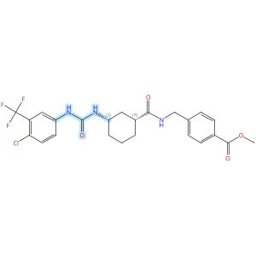
Absolute stereochemistry shown

Scheme 45 (Reaction 1 of 1):

Step 1, Yield: 78%

Design and synthesis of novel sEH inhibitors for the treatment of acute lung injury

By: Xu, Huashen; Ma, Ruiyi; Morisseau, Christophe; Dong, Xinyue; Zhuang, Junning; Wang, Zhe; Liu, Fuqin; Xu, Dong; Chen, Lu; Zhang, Maoying; Zhu, Zhihui; Liu, Xinran; Jiang, Huiwen; Liu, Zhongbo; Hammock, Bruce D.; Cao, Ruolin; Chen, Guoliang

10.1016/j.ejmech.2026.118773
View All Sources in CAS SciFinder
Company/Organization: Key Laboratory of Structure-Based Drug Design & Discovery of Ministry of Education, School of Pharmaceutical Engineering, Shenyang Pharmaceutical University, Shenyang, 110016, China
Source: European Journal of Medicinal Chemistry (2026), 309, 118773

Step 1
CAS Reaction Number: 31-614-CAS-49705418
Stage | Reagents | Catalysts | Solvents | Conditions
1 |  |  |  | 1 h, < -10 °C; -10 °C → rt; 30 min, rt
  Triethylamine
  -
  Dichloromethane
2 |  |  |  | 0.5 h, rt; overnight, rt
  Triethylamine
  -
  Dichloromethane
Experimental Protocols
Synthetic Methods
Products | 3124392-27-1, Yield: 78%
Reactants | 4-Chloro-3-(trifluoromethyl)aniline  Triphosgene  3124392-21-5
Reagents | Triethylamine
Solvents | Dichloromethane
Procedure
  1. | Add a solution of Memantine (0.2 g, 0.93 mmol, 1.0 eq) and Et₃N (0.28 g, 2.78 mmol, 3.0 eq) in DCM (20 mL) dropwise over 1 h to a thick slurry of triphosgene (0.14 g, 0.46 mmol, 0.5 eq) in DCM (10 mL) in a cold trap while maintaining the temperature below 10°C.
  2. | Remove the cold bath and warm the mixture to rt and stir for 30 min.
  3. | Add a slurry of Intermediate (0.30 g, 0.74 mmol, 0.8 eq) and Et₃N (0.56 g, 5.56 mmol, 6.0 eq) in DCM (20 mL) in small portions over 0.5 h at room temperature.
  4. | Stir the reaction mixture overnight.
  5. | Wash the reaction mixture with 10% aq HCl (1 x 20 mL).
  6. | Dry the organic layer over anhydrous MgSO₄ and concentrate under reduced pressure.
Transformation | - Acylation of Nitrogen Nucleophiles by Acyl/ Thioacyl/ Carbamoyl Halides and Analogs
Scale | gram
Characterization Data
3124392-27-1
State | White solid
CAS Method Number 3-614-CAS-50079630

Absolute stereochemistry shown

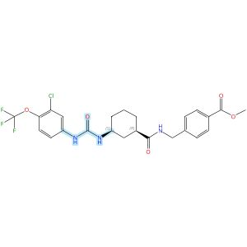
Absolute stereochemistry shown

Scheme 46 (Reaction 1 of 1):

Step 1, Yield: 78%

Design and synthesis of novel sEH inhibitors for the treatment of acute lung injury

By: Xu, Huashen; Ma, Ruiyi; Morisseau, Christophe; Dong, Xinyue; Zhuang, Junning; Wang, Zhe; Liu, Fuqin; Xu, Dong; Chen, Lu; Zhang, Maoying; Zhu, Zhihui; Liu, Xinran; Jiang, Huiwen; Liu, Zhongbo; Hammock, Bruce D.; Cao, Ruolin; Chen, Guoliang

10.1016/j.ejmech.2026.118773
View All Sources in CAS SciFinder
Company/Organization: Key Laboratory of Structure-Based Drug Design & Discovery of Ministry of Education, School of Pharmaceutical Engineering, Shenyang Pharmaceutical University, Shenyang, 110016, China
Source: European Journal of Medicinal Chemistry (2026), 309, 118773

Step 1
CAS Reaction Number: 31-614-CAS-49705421
Stage | Reagents | Catalysts | Solvents | Conditions
1 |  |  |  | 1 h, < -10 °C; -10 °C → rt; 30 min, rt
  Triethylamine
  -
  Dichloromethane
2 |  |  |  | 0.5 h, rt; overnight, rt
  Triethylamine
  -
  Dichloromethane
Experimental Protocols
Synthetic Methods
Products | 3124392-30-6, Yield: 78%
Reactants | Triphosgene  3-Chloro-4-(trifluoromethoxy)benzenamine  3124392-21-5
Reagents | Triethylamine
Solvents | Dichloromethane
Procedure
  1. | Add a solution of Memantine (0.2 g, 0.93 mmol, 1.0 eq) and Et₃N (0.28 g, 2.78 mmol, 3.0 eq) in DCM (20 mL) dropwise over 1 h to a thick slurry of triphosgene (0.14 g, 0.46 mmol, 0.5 eq) in DCM (10 mL) in a cold trap while maintaining the temperature below 10°C.
  2. | Remove the cold bath and warm the mixture to rt and stir for 30 min.
  3. | Add a slurry of Intermediate (0.30 g, 0.74 mmol, 0.8 eq) and Et₃N (0.56 g, 5.56 mmol, 6.0 eq) in DCM (20 mL) in small portions over 0.5 h at room temperature.
  4. | Stir the reaction mixture overnight.
  5. | Wash the reaction mixture with 10% aq HCl (1 x 20 mL).
  6. | Dry the organic layer over anhydrous MgSO₄ and concentrate under reduced pressure.
Transformation | - Acylation of Nitrogen Nucleophiles by Acyl/ Thioacyl/ Carbamoyl Halides and Analogs
Scale | gram
Characterization Data
3124392-30-6
State | White solid
CAS Method Number 3-614-CAS-50079642

Relative stereochemistry shown

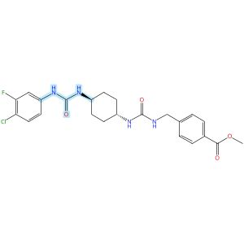
Relative stereochemistry shown

Scheme 47 (Reaction 1 of 1):

Step 1, Yield: 78%

Design and synthesis of novel sEH inhibitors for the treatment of acute lung injury

By: Xu, Huashen; Ma, Ruiyi; Morisseau, Christophe; Dong, Xinyue; Zhuang, Junning; Wang, Zhe; Liu, Fuqin; Xu, Dong; Chen, Lu; Zhang, Maoying; Zhu, Zhihui; Liu, Xinran; Jiang, Huiwen; Liu, Zhongbo; Hammock, Bruce D.; Cao, Ruolin; Chen, Guoliang

10.1016/j.ejmech.2026.118773
View All Sources in CAS SciFinder
Company/Organization: Key Laboratory of Structure-Based Drug Design & Discovery of Ministry of Education, School of Pharmaceutical Engineering, Shenyang Pharmaceutical University, Shenyang, 110016, China
Source: European Journal of Medicinal Chemistry (2026), 309, 118773

Step 1
CAS Reaction Number: 31-614-CAS-49705436
Stage | Reagents | Catalysts | Solvents | Conditions
1 |  |  |  | 1 h, < -10 °C; -10 °C → rt; 30 min, rt
  Triethylamine
  -
  Dichloromethane
2 |  |  |  | 0.5 h, rt; overnight, rt
  Triethylamine
  -
  Dichloromethane
Experimental Protocols
Synthetic Methods
Products | 3124392-51-1, Yield: 78%
Reactants | 4-Chloro-3-fluorobenzenamine  Triphosgene  3124392-46-4
Reagents | Triethylamine
Solvents | Dichloromethane
Procedure
  1. | Add a solution of 4-chloro-3-(trifluoromethyl)aniline (94 mg, 0.48 mmol, 1.0 eq) and Et₃N (0.15 g, 1.44 mmol, 3.0 eq) in DCM (20 mL) dropwise over 1 h to a thick slurry of triphosgene (71 mg, 0.24 mmol, 0.5 eq) in DCM (10 mL) in a cold trap while maintaining the temperature below 10°C.
  2. | Remove the cold bath and warm the mixture to room temperature and stir for 30 min.
  3. | Add a slurry of Intermediate (0.2 g, 0.48 mmol, 1.0 eq) and Et₃N (0.48 g, 4.8 mmol, 10.0 eq) in DCM (20 mL) in small portions over 0.5 h at room temperature.
  4. | Stir the reaction mixture overnight.
  5. | Wash the reaction mixture with 10% aq HCl (1 x20 mL).
  6. | Dry the organic layer over anhydrous MgSO₄ and concentrate under reduced pressure.
Transformation | - Acylation of Nitrogen Nucleophiles by Acyl/ Thioacyl/ Carbamoyl Halides and Analogs
CAS Method Number 3-614-CAS-50079712

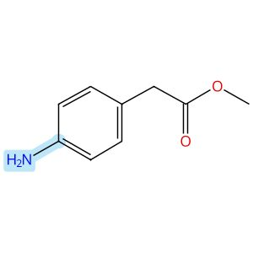

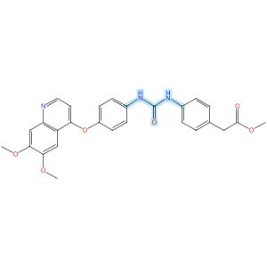

Scheme 48 (Reaction 1 of 1):

Step 1, Yield: 77%

Structure-Based Design and Free Energy Perturbation-Guided Synthesis of Novel VEGFR2 and HDAC Dual Inhibitors with Potent Antitumor Efficacy

By: Li, Yaxin; Liu, Sisi; Hu, Sha; Zhang, Ranran; Wang, Xiaoli; Xu, Jiamin; Yao, Keke; Lu, Chenxuan; Li, Guofeng; Wu, Zhigang; Guo, Chunyan; Yang, Leifu; Hu, Liming

10.1021/acs.jmedchem.5c01650
View All Sources in CAS SciFinder
Company/Organization: Beijing Key Laboratory of Environmental and Oncology, College of Chemistry and Life Science, Beijing University of Technology, Beijing, 100124, China
Source: Journal of Medicinal Chemistry (2026), 69(4), 3762-3778

Step 1
CAS Reaction Number: 31-614-CAS-49395382
Stage | Reagents | Catalysts | Solvents | Conditions
1 |  |  |  | 0 °C
  Triethylamine
  -
  Dichloromethane
2 |  |  |  | 0 °C
  -
  -
  Dichloromethane
Experimental Protocols
Synthetic Methods
Products | Benzeneacetic acid, 4-[[[[4-[(6,7-dimethoxy-4-quinolinyl)oxy]phenyl]amino]carbonyl]amino]-, methyl ester, Yield: 77%
Reactants | Triphosgene  4-[(6,7-Dimethoxyquinolin-4-yl)oxy]aniline  Benzeneacetic acid, 4-amino-, methyl ester
Reagents | Triethylamine
Solvents | Dichloromethane
Procedure
  1. | Add triethylamine (4.0 equiv) to a solution of quinoline aniline derivative (1.0 equiv) and triphosgene (0.5 equiv) in 5 mL of dichloromethane, held in an ice-water bath, slowly dropwise.
  2. | Monitor complete consumption of the starting materials.
  3. | Add a solution of aniline or benzylamine (1.0 equiv) in 3 mL of dichloromethane dropwise to the reaction mixture.
  4. | Monitor the progress of the reaction by TLC.
  5. | Filter the solid.
  6. | Purify the solid by column chromatography to obtain methyl 2-(4-(3-(4-((6,7-dimethoxyquinolin-4-yl)oxy)phenyl)ureido)phenyl)acetate.
Transformation | - Acylation of Nitrogen Nucleophiles by Acyl/ Thioacyl/ Carbamoyl Halides and Analogs
Characterization Data
Benzeneacetic acid, 4-[[[[4-[(6,7-dimethoxy-4-quinolinyl)oxy]phenyl]amino]carbonyl]amino]-, methyl ester
Proton NMR Spectrum | (400 MHz, DMSO-d₆): δ (ppm) 8.81 (s, 1H), 8.69 (s, 1H), 8.47 (d, J = 5.2 Hz, 1H), 7.59 (d, J = 8.8 Hz, 2H), 7.52 (s, 1H), 7.42 (d, J = 8.3 Hz, 2H), 7.40 (s, 1H), 7.21 (d, J = 8.8 Hz, 2H), 7.18 (d, J = 8.1 Hz, 2H), 6.45 (d, J = 5.3 Hz, 1H), 3.95 (s, 3H), 3.94 (s, 3H), 3.62 (s, 5H)
Mass Spectrum | MS (ESI⁺): calcd for C₂₇H₂₆N₃O₆ [M + H]⁺, 488.2; found, 488.2
State | white solid
CAS Method Number 3-614-CAS-50096402

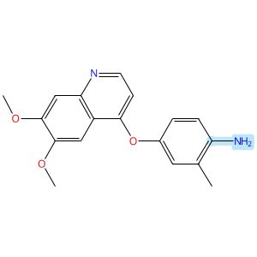

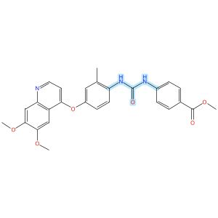

Scheme 49 (Reaction 1 of 1):

Step 1, Yield: 77%

Structure-Based Design and Free Energy Perturbation-Guided Synthesis of Novel VEGFR2 and HDAC Dual Inhibitors with Potent Antitumor Efficacy

By: Li, Yaxin; Liu, Sisi; Hu, Sha; Zhang, Ranran; Wang, Xiaoli; Xu, Jiamin; Yao, Keke; Lu, Chenxuan; Li, Guofeng; Wu, Zhigang; Guo, Chunyan; Yang, Leifu; Hu, Liming

10.1021/acs.jmedchem.5c01650
View All Sources in CAS SciFinder
Company/Organization: Beijing Key Laboratory of Environmental and Oncology, College of Chemistry and Life Science, Beijing University of Technology, Beijing, 100124, China
Source: Journal of Medicinal Chemistry (2026), 69(4), 3762-3778

Step 1
CAS Reaction Number: 31-614-CAS-49395405
Stage | Reagents | Catalysts | Solvents | Conditions
1 |  |  |  | 0 °C
  Triethylamine
  -
  Dichloromethane
2 |  |  |  | 0 °C
  -
  -
  Dichloromethane
Experimental Protocols
Synthetic Methods
Products | Benzoic acid, 4-[[[[4-[(6,7-dimethoxy-4-quinolinyl)oxy]-2-methylphenyl]amino]carbonyl]amino]-, methyl ester, Yield: 77%
Reactants | Triphosgene  4-[(6,7-Dimethoxy-4-quinolyl)oxy]-2-methylaniline  Methyl 4-aminobenzoate
Reagents | Triethylamine
Solvents | Dichloromethane
Procedure
  1. | Add triethylamine (4.0 equiv) to a solution of quinoline aniline derivative (1.0 equiv) and triphosgene (0.5 equiv) in 5 mL of dichloromethane, held in an ice-water bath, slowly dropwise.
  2. | Monitor complete consumption of the starting materials.
  3. | Add a solution of aniline or benzylamine (1.0 equiv) in 3 mL of dichloromethane dropwise to the reaction mixture.
  4. | Monitor the progress of the reaction by TLC.
  5. | Filter the solid.
  6. | Purify the solid by column chromatography to obtain methyl 4-(3-(4-((6,7-dimethoxyquinolin-4-yl)- oxy)-2-methylphenyl)ureido)benzoate.
Transformation | - Acylation of Nitrogen Nucleophiles by Acyl/ Thioacyl/ Carbamoyl Halides and Analogs
Characterization Data
Benzoic acid, 4-[[[[4-[(6,7-dimethoxy-4-quinolinyl)oxy]-2-methylphenyl]amino]carbonyl]amino]-, methyl ester
Proton NMR Spectrum | (400 MHz, DMSO-d₆): δ (ppm) 9.47 (s, 1H), 8.48 (d, J = 5.3 Hz, 1H), 8.17 (s, 1H), 7.93 (d, J = 8.8 Hz, 1H), 7.91 (d, J = 8.8 Hz, 2H), 7.62 (d, J = 8.8 Hz, 2H), 7.51 (s, 1H), 7.40 (s, 1H), 7.16 (d, J = 2.8 Hz, 1H), 7.10 (dd, J = 8.8, 2.9 Hz, 1H), 6.47 (d, J = 5.2 Hz, 1H), 3.95 (s, 3H), 3.94 (s, 3H), 3.82 (s, 3H), 2.30 (s, 3H)
Mass Spectrum | MS (ESI⁺): calcd for C₂₇H₂₆N₃O₆ [M + H]⁺, 488.2; found, 488.2
State | white solid
CAS Method Number 3-614-CAS-50096425

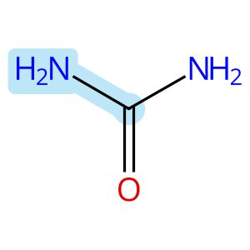 |  | 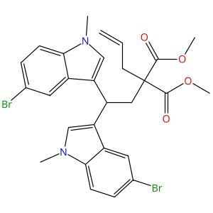 |  | 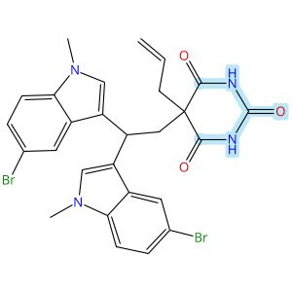

Scheme 50 (Reaction 1 of 1):

Step 1, Yield: 77%

The Succinimide Group as a Traceless Activator for Lewis Acid-Catalyzed Diarylative Ring-Opening of Cyclopropanes with Carbazoles and Electron-Rich Arenes

By: Zhang, Chao; Zhan, Zixian; Sun, Dongru; Zhai, Hongbin; Zhao, Hua; Zhao, Yufen

10.1021/acs.joc.5c02573
View All Sources in CAS SciFinder
Company/Organization: Institute of Drug Discovery Technology, Qian Xuesen Collaborative Research Center of Astrochemistry and Space Life Sciences, Ningbo University, Zhejiang, 315211, China
Source: Journal of Organic Chemistry (2026), 91(1), 522-533

Step 1
CAS Reaction Number: 31-614-CAS-48728665
Stage | Reagents | Catalysts | Solvents | Conditions
1 |  |  |  | 1 h, 0 °C
  Sodium hydride
  -
  Dimethylformamide
2 |  |  |  | 0 °C; overnight, rt
  -
  -
  Dimethylformamide
3 |  |  |  | -
  Ammonium chloride
  -
  Water
Experimental Protocols
Synthetic Methods
Products | 2,4,6(1H,3H,5H)-Pyrimidinetrione, 5-[2,2-bis(5-bromo-1-methyl-1H-indol-3-yl)ethyl]-5-(2-propen-1-yl)-, Yield: 77%
Reactants | Urea  Propanedioic acid, 2-[2,2-bis(5-bromo-1-methyl-1H-indol-3-yl)ethyl]-2-(2-propen-1-yl)-, 1,3-dimethyl ester
Reagents | Sodium hydride  Ammonium chloride
Solvents | Dimethylformamide  Water
Procedure
  1. | Add NaH (60% dispersion in mineral oil, 1.0 mmol, 5.0 equiv,) to a suspension of urea (2.0 mmol, 10.0 equiv.) in dry DMF (0.7 mL) at 0°C under N₂ atmosphere.
  2. | Stir the mixture for 1.0 h and treat with a solution of reactant (0.2mmol, 1.0 equiv,) in DMF (0.2 mL) dropwise at 0°C.
  3. | Stir the reaction mixture at room temperature overnight.
  4. | Add saturated aqueous NH₄Cl to quench the reaction.
  5. | Extract the aqueous layer with ethyl acetate for three times.
  6. | Wash the combined organic layers with brine, dry over Na₂SO₄ and concentrate under vacuum.
  7. | Purify the resultant residue by column chromatography.
Transformation | - Acylation of Nitrogen Nucleophiles with Carboxylic Esters and Analogs
Characterization Data
2,4,6(1H,3H,5H)-Pyrimidinetrione, 5-[2,2-bis(5-bromo-1-methyl-1H-indol-3-yl)ethyl]-5-(2-propen-1-yl)-
Proton NMR Spectrum | (500 MHz, CDCl₃): δ 7.76 (s, 2H), 7.69 (s, 2H), 7.25 (d, J= 8.5 Hz, 2H), 7.11 (d, J = 8.5 Hz, 2H), 6.87 (s, 2H), 5.60-5.48 (m, 1H), 5.14 (d, J= 17.0 Hz, 1H), 5.10 (d, J= 10.0 Hz, 1H), 4.48 (t, J= 8.5 Hz, 1H), 3.69 (s, 6H), 2.99 (d, J= 8.0 Hz, 2H), 2.75 (d, J= 7.5 Hz, 2H)
Carbon-13 NMR | (125 MHz, CDCl₃): δ 171.3, 147.8, 135.9, 129.8, 128.6, 128.4, 125.0, 122.2, 121.7, 115.3, 112.8, 111.0, 55.7, 45.4, 43.8, 33.1, 31.0
HRMS | (ESI-TOF) [M + H]+ calcd for [C₂₇H₂₅Br₂N₄O₃]+, 611.0293; found, 611.0285
Melting Point | : 209-211°C
State | White solid
CAS Method Number 3-614-CAS-48849541

Relative stereochemistry shown

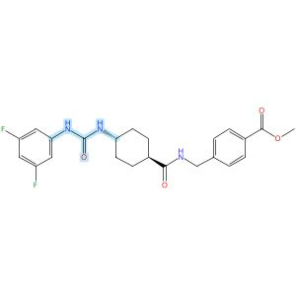
Relative stereochemistry shown

Scheme 51 (Reaction 1 of 1):

Step 1, Yield: 77%

Design and synthesis of novel sEH inhibitors for the treatment of acute lung injury

By: Xu, Huashen; Ma, Ruiyi; Morisseau, Christophe; Dong, Xinyue; Zhuang, Junning; Wang, Zhe; Liu, Fuqin; Xu, Dong; Chen, Lu; Zhang, Maoying; Zhu, Zhihui; Liu, Xinran; Jiang, Huiwen; Liu, Zhongbo; Hammock, Bruce D.; Cao, Ruolin; Chen, Guoliang

10.1016/j.ejmech.2026.118773
View All Sources in CAS SciFinder
Company/Organization: Key Laboratory of Structure-Based Drug Design & Discovery of Ministry of Education, School of Pharmaceutical Engineering, Shenyang Pharmaceutical University, Shenyang, 110016, China
Source: European Journal of Medicinal Chemistry (2026), 309, 118773

Step 1
CAS Reaction Number: 31-614-CAS-49705400
Stage | Reagents | Catalysts | Solvents | Conditions
1 |  |  |  | 1 h, < -10 °C; -10 °C → rt; 30 min, rt
  Triethylamine
  -
  Dichloromethane
2 |  |  |  | 0.5 h, rt; overnight, rt
  Triethylamine
  -
  Dichloromethane
Experimental Protocols
Synthetic Methods
Products | 3124392-04-4, Yield: 77%
Reactants | 3,5-Difluoroaniline  Triphosgene  3124391-96-1
Reagents | Triethylamine
Solvents | Dichloromethane
Procedure
  1. | Add a solution of reactant (0.2 g, 0.93 mmol, 1.0 eq) and Et₃N (0.28 g, 2.78 mmol, 3.0 eq) in DCM (20 mL) dropwise over 1 h to a thick slurry of triphosgene (0.14 g, 0.46 mmol, 0.5 eq) in DCM (10 mL) in a cold trap while maintaining the temperature below 10°C.
  2. | Remove the cold bath and warm the mixture to room temperature and stir for 30 min.
  3. | Add a slurry of Intermediate (0.30 g, 0.74 mmol, 0.8 eq) and Et₃N (0.56 g, 5.56 mmol, 6.0 eq) in DCM (20 mL) in small portions over 0.5 h at room temperature.
  4. | Stir the reaction mixture overnight.
  5. | Wash the reaction mixture with 10% aq HCl (1 x 20 mL).
  6. | Dry the organic layer over anhydrous MgSO₄ and concentrate under reduced pressure.
Scale | gram
Characterization Data
3124392-04-4
Mass Spectrum | ESI-MS m/z: 444.0 [M H]-
State | White solid
CAS Method Number 3-614-CAS-50079539

Relative stereochemistry shown

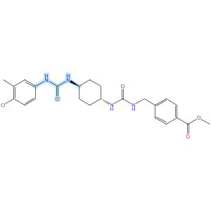
Relative stereochemistry shown

Scheme 52 (Reaction 1 of 1):

Step 1, Yield: 77%

Design and synthesis of novel sEH inhibitors for the treatment of acute lung injury

By: Xu, Huashen; Ma, Ruiyi; Morisseau, Christophe; Dong, Xinyue; Zhuang, Junning; Wang, Zhe; Liu, Fuqin; Xu, Dong; Chen, Lu; Zhang, Maoying; Zhu, Zhihui; Liu, Xinran; Jiang, Huiwen; Liu, Zhongbo; Hammock, Bruce D.; Cao, Ruolin; Chen, Guoliang

10.1016/j.ejmech.2026.118773
View All Sources in CAS SciFinder
Company/Organization: Key Laboratory of Structure-Based Drug Design & Discovery of Ministry of Education, School of Pharmaceutical Engineering, Shenyang Pharmaceutical University, Shenyang, 110016, China
Source: European Journal of Medicinal Chemistry (2026), 309, 118773

Step 1
CAS Reaction Number: 31-614-CAS-49705438
Stage | Reagents | Catalysts | Solvents | Conditions
1 |  |  |  | 1 h, < -10 °C; -10 °C → rt; 30 min, rt
  Triethylamine
  -
  Dichloromethane
2 |  |  |  | 0.5 h, rt; overnight, rt
  Triethylamine
  -
  Dichloromethane
Experimental Protocols
Synthetic Methods
Products | 3124392-54-4, Yield: 77%
Reactants | 4-Chloro-3-methylaniline  Triphosgene  3124392-46-4
Reagents | Triethylamine
Solvents | Dichloromethane
Procedure
  1. | Add a solution of 4-chloro-3-(trifluoromethyl)aniline (94 mg, 0.48 mmol, 1.0 eq) and Et₃N (0.15 g, 1.44 mmol, 3.0 eq) in DCM (20 mL) dropwise over 1 h to a thick slurry of triphosgene (71 mg, 0.24 mmol, 0.5 eq) in DCM (10 mL) in a cold trap while maintaining the temperature below 10°C.
  2. | Remove the cold bath and warm the mixture to room temperature and stir for 30 min.
  3. | Add a slurry of Intermediate (0.2 g, 0.48 mmol, 1.0 eq) and Et₃N (0.48 g, 4.8 mmol, 10.0 eq) in DCM (20 mL) in small portions over 0.5 h at room temperature.
  4. | Stir the reaction mixture overnight.
  5. | Wash the reaction mixture with 10% aq HCl (1 x20 mL).
  6. | Dry the organic layer over anhydrous MgSO₄ and concentrate under reduced pressure.
Transformation | - Acylation of Nitrogen Nucleophiles by Acyl/ Thioacyl/ Carbamoyl Halides and Analogs
CAS Method Number 3-614-CAS-50079729

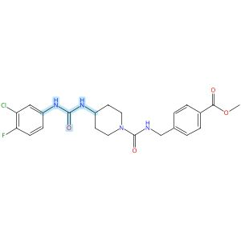

Scheme 53 (Reaction 1 of 1):

Step 1, Yield: 77%

Design and synthesis of novel sEH inhibitors for the treatment of acute lung injury

By: Xu, Huashen; Ma, Ruiyi; Morisseau, Christophe; Dong, Xinyue; Zhuang, Junning; Wang, Zhe; Liu, Fuqin; Xu, Dong; Chen, Lu; Zhang, Maoying; Zhu, Zhihui; Liu, Xinran; Jiang, Huiwen; Liu, Zhongbo; Hammock, Bruce D.; Cao, Ruolin; Chen, Guoliang

10.1016/j.ejmech.2026.118773
View All Sources in CAS SciFinder
Company/Organization: Key Laboratory of Structure-Based Drug Design & Discovery of Ministry of Education, School of Pharmaceutical Engineering, Shenyang Pharmaceutical University, Shenyang, 110016, China
Source: European Journal of Medicinal Chemistry (2026), 309, 118773

Step 1
CAS Reaction Number: 31-614-CAS-49705463
Stage | Reagents | Catalysts | Solvents | Conditions
1 |  |  |  | 1 h, < -10 °C; -10 °C → rt; 30 min, rt
  Triethylamine
  -
  Dichloromethane
2 |  |  |  | 0.5 h, rt; overnight, rt
  Triethylamine
  -
  Dichloromethane
Experimental Protocols
Synthetic Methods
Products | 3124392-79-3, Yield: 77%
Reactants | 3-Chloro-4-fluoroaniline  Triphosgene  3124392-72-6
Reagents | Triethylamine
Solvents | Dichloromethane
Procedure
  1. | Add a solution of Memantine (0.15 g, 0.82 mmol, 1.0 eq) and Et₃N (0.25 g, 2.46 mmol, 3.0 eq) in DCM (20 mL) dropwise over 1 h to a thick slurry of triphosgene (0.12 g, 0.41 mmol, 0.5 eq) in DCM (10 mL) in a cold trap while maintaining the temperature below 10°C.
  2. | Remove the cold bath and warm the mixture to room temperature and stir for 30 min.
  3. | Add a slurry of Intermediate (0.3 g, 0.74 mmol, 0.9 eq) and Et₃N (0.42 g, 4.1 mmol, 5.0 eq) in DCM (20 mL) in small portions over 0.5 h at room temperature.
  4. | Stir the reaction mixture overnight.
  5. | Wash the reaction mixture with 10% aq HCl (1 x 20 mL).
  6. | Dry the organic layer over anhydrous MgSO₄ and concentrate under reduced pressure.
Transformation | - Acylation of Nitrogen Nucleophiles by Acyl/ Thioacyl/ Carbamoyl Halides and Analogs
CAS Method Number 3-614-CAS-50079818

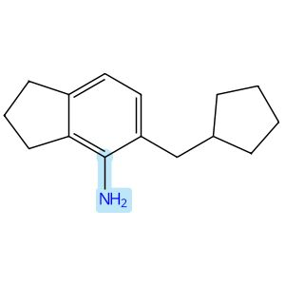 |  | 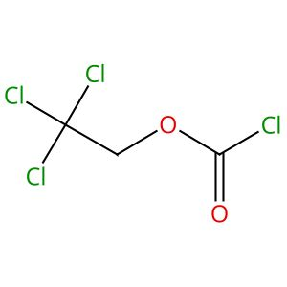 |  | 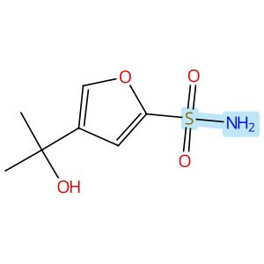
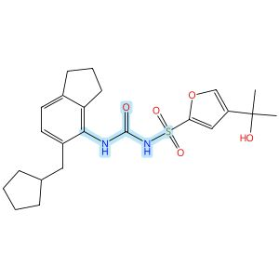

Scheme 54 (Reaction 1 of 1):

Step 1, Yield: 76%

Discovery of novel and potent NLRP3 inflammasome inhibitors with new lipophilic moieties

By: Chu, Hongzhu; Wei, Yonggang; Zhao, Hongchuan; Ye, Fei; Qian, Xinying; Su, Huilin; Sun, Ying; Zhang, Jing; Jia, Zhilong; Li, Zhiyong; Liang, Xueya

10.1016/j.ejmech.2025.118227
View All Sources in CAS SciFinder
Company/Organization: No. 14, Tianshun Street, Kangbaida (Sichuan) Biotechnology Co. Ltd., Huayang Street, Chengdu, 610213, China
Source: European Journal of Medicinal Chemistry (2026), 301, 118227

Step 1
CAS Reaction Number: 31-614-CAS-47753144
Stage | Reagents | Catalysts | Solvents | Conditions
1 |  |  |  | 1 h, rt
  Diisopropylethylamine
  -
  Dichloromethane
2 |  |  |  | rt
  Water
  -
  -
3 |  |  |  | 0 °C
  Sodium hydride
  -
  Tetrahydrofuran
4 |  |  |  | 0 °C; 2 h, rt
  -
  -
  Tetrahydrofuran
5 |  |  |  | rt
  Water
  -
  -

Notes: intermediate from stage 2 added in stage 4 (stage 4)
Experimental Protocols
Synthetic Methods
Products | N-[[[5-(Cyclopentylmethyl)-2,3-dihydro-1H-inden-4-yl]amino]carbonyl]-4-(1-hydroxy-1-methylethyl)-2-furansulfonamide, Yield: 76%
Reactants | 2,2,2-Trichloroethyl chloroformate  5-(Cyclopentylmethyl)-2,3-dihydro-1H-inden-4-amine  4-(1-Hydroxy-1-methylethyl)-2-furansulfonamide
Reagents | Diisopropylethylamine  Water  Sodium hydride
Solvents | Dichloromethane  Tetrahydrofuran
Procedure
  1. | Add 2,2,2-trichloroethyl chloroformate (69 mg, 0.32 mmol) to a stirred solution of amine (58 mg, 0.27 mmol) and N,N-diisopropylethylamine (52 mg, 0.4 mmol) in DCM at room temperature.
  2. | Stir the reaction mixture for 1 hour at room temperature.
  3. | Quench the reaction with water.
  4. | Extract the reaction mixture with ethyl acetate three times.
  5. | Dry the combined organic layers over anhydrous sodium sulfate.
  6. | Filter the mixture and concentrate in vacuo.
  7. | Add sodium hydride (13 mg, 0.54 mmol) in portions to a stirred solution of sulfonamide (55 mg, 0.27 mmol) in THF at 0°C.
  8. | Add the Troc intermediate solution in THF dropwise into the mixture of sulfonamide at 0°C.
  9. | Stir the resulting reaction mixture for 2 hours at room temperature.
  10. | Quench the reaction mixture with water.
  11. | Extract the mixture with ethyl acetate for three times.
  12. | Dry the combined organic layers over anhydrous sodium sulfate.
  13. | Filter the mixture and concentrate in vacuo.
  14. | Purify the residue by MPLC to obtain N-((5-(cyclopentylmethyl)-2,3-dihydro-1H-inden-4-yl)carbamoyl)-4-(2-hydroxypropan-2-yl)furan-2-sulfonamide.
Scale | milligram
Characterization Data
N-[[[5-(Cyclopentylmethyl)-2,3-dihydro-1H-inden-4-yl]amino]carbonyl]-4-(1-hydroxy-1-methylethyl)-2-furansulfonamide
Proton NMR Spectrum | (400 MHz, DMSO-d₆) δ 7.95 (br s, 1H), 7.74 (s, 1H), 7.17 (s, 1H), 7.02 (d, J = 7.6 Hz, 1H), 6.97 - 6.92 (m, 2H), 5.10 (s, 1H), 2.82 (t, J = 7.4 Hz, 2H), 2.58 (t, J = 7.4 Hz, 2H), 2.44 (d, J = 7.4 Hz, 2H), 1.96 - 1.88 (m, 3H), 1.61 - 1.52 (m, 4H), 1.47 - 1.41 (m, 2H), 1.38 (s, 6H), 1.16 - 1.04 (m, 2H)
Carbon-13 NMR | (101 MHz, DMSO-d₆) δ 152.2, 142.7, 142.2, 140.7, 137.4, 137.0, 136.1, 128.4, 122.7, 112.5, 67.0, 37.1, 32.9, 32.6, 32.4, 31.5, 31.4, 31.2, 25.1, 24.9, 24.8
HRMS | (ESI): Calcd for C₂₃H₃₀N₂O₅S [M+H]⁺ 447.1948. Found: 447.1947
State | white solid
CAS Method Number 3-614-CAS-49951517

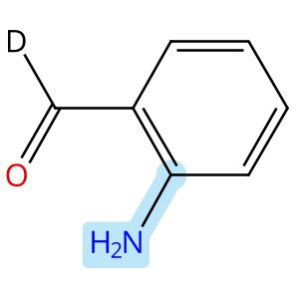

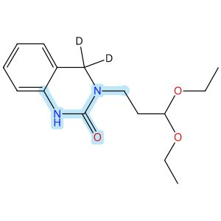

Scheme 55 (Reaction 1 of 1):

Step 1, Yield: 76%

Enantioselective Intramolecular C-H Alkylation Catalyzed by a Nonsymmetric Chiral Cobalt Porphyrin

By: Buchelt, Christoph; Breitenlechner, Stefan; Zuber, Julian; Huber, Stefan M.; Bach, Thorsten

10.1021/jacs.5c19047
View All Sources in CAS SciFinder
Company/Organization: School of Natural Sciences, Department of Chemistry and Catalysis Research Center (CRC), Technische Universitaet Muenchen, Garching, 85747, Germany
Source: Journal of the American Chemical Society (2026), 148(1), 93-98

Step 1
CAS Reaction Number: 31-614-CAS-48658980
Stage | Reagents | Catalysts | Solvents | Conditions
1 |  |  |  | 4 h, 20 °C
  -
  -
  Methanol
2 |  |  |  | 20 °C; 16 h, 20 °C
  Sodium borodeuteride
  -
  -
3 |  |  |  | 16 h, 60 °C
  -
  -
  Tetrahydrofuran
Experimental Protocols
Synthetic Methods
Products | 3113603-21-4, Yield: 76%
Reactants | 1-Amino-3,3-diethoxypropane  2560562-06-1  1,1′-Carbonyldiimidazole
Reagents | Sodium borodeuteride
Solvents | Methanol  Tetrahydrofuran
Procedure
  1. | Add the corresponding amine (1.05 equiv.) to a solution of 2-aminobenzaldehyde (900 mg, 7.37 mmol, 1.00 equiv, 1.00 equiv.) in MeOH (500 mM).
  2. | Stir the corresponding solution at 20°C for 4 hours.
  3. | Add NaBD₄ (2.00 equiv.) to the reaction mixture while the temperature maintaining using a water bath.
  4. | Stir the mixture for 16 hours.
  5. | Add H₂O (5 mL) to the reaction mixture.
  6. | Remove the organic solvent under reduced pressure.
  7. | Redissolve the residue in CH₂Cl₂ (30 mL) and H₂O (30 mL).
  8. | Wash the aqueous layer with CH₂Cl₂ (2 x 30 mL).
  9. | Dry the combined organic layers over Na₂SO₄.
  10. | Filter the mixture.
  11. | Remove the solvent under reduced pressure.
  12. | Redissolve the amine in THF (150 mM).
  13. | Add CDI (1.20 equiv.) in one portion to the mixture.
  14. | Stir the mixture at 60°C for 16 hours.
  15. | Cool the mixture to room temperature.
  16. | Wash the organic layer with saturated LiOH solution (50 mL), aqueous citric acid solution (10 wt%, 50 mL), H₂O (50 mL) and brine (40 mL).
  17. | Dry the organic layer over Na₂SO₄.
  18. | Filter the mixture.
  19. | Remove the solvent under reduced pressure.
  20. | Purify the crude by automated flash column chromatography (CH₂Cl₂/MeOH = 49/1 → 19/1) to obtain 3-(3,3-Diethoxypropyl)-3,4-dihydroquinazolin-2(1H)-one-4,4-d₂.
Transformation | - Reductive Alkylation of Ammonia or Amines  - Acylation of Nitrogen Nucleophiles by Acyl/ Thioacyl/ Carbamoyl Halides and Analogs
Scale | milligram
Characterization Data
3113603-21-4
Proton NMR Spectrum | (500 MHz, CDCl₃): δ [ppm] = 1.20 (d, ³J 7.1 Hz, 6H, CH₃), 1.95 - 1.99 (m, 2H, H-2’), 3.49 - 3.55 (m, 4H, OCH₂a, C-1’), 3.67 (dq, ²J= 9.4 Hz, ³J 7.1 Hz, 2H, OCH₂b), 4.59 (t, ³J 5.6 Hz, 1H, H-3’), 6.68 (dd, 7.7 Hz, ⁴J= 1.1 Hz, 1H, H-8), 6.92 (virt. td, ³J ≈ ³J 7.7 Hz, ⁴J= 1.1 Hz, 1H, H-6), 7.03 (dd, ³J 7.7 Hz, ⁴J= 1.4 Hz, 1H, H-5), 7.15 (virt. td, ³J ≈ ³J 7.7 Hz, ⁴J= 1.4 Hz, 1H, H-7), 7.33 (bs, 1H, NH)
Carbon-13 NMR | (126 MHz, CDCl₃): δ [ppm] = 154.3 (C-2), 137.1 (C-8a), 128.3 (C-7), 125.6 (C-5), 122.0 (C-6), 117.7 (C-4a), 113.5 (C-8), 101.4 (C-3’), 61.7 (OCH₂), 48.4 (C-4), 43.6 (C-1’), 31.4 (C-2’), 15.5 (CH₃)
IR Absorption Spectrum | (ATR): v [cm⁻¹] = 3425 (w, N-H), 2974 (w, C-H), 2930 (w, C-H), 2878 (w, C-H), 1668 (m, C=O), 1603 (m, C=C), 1529 (w, C=C), 1511 (w, C=C), 1457 (m), 1122 (s, C-O), 1114 (s), 1056 (vs), 1021 (m), 839 (w), 750 (vs, C-H), 722 (w. C-H)
HRMS | (+ESI): calc. for C₁₅H₂₀D₂N₂NaO₃ [M+Na]⁺: 303.1648; found: 303.1645
Melting Point | 57-59°C
R_{f} | 0.35 (CH2Cl2/ac = 4/1) [UV, KMnO4]
State | pale-yellow solid
CAS Method Number 3-614-CAS-48802582

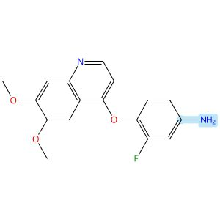

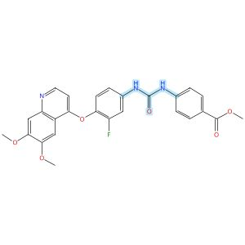

Scheme 56 (Reaction 1 of 1):

Step 1, Yield: 76%

Structure-Based Design and Free Energy Perturbation-Guided Synthesis of Novel VEGFR2 and HDAC Dual Inhibitors with Potent Antitumor Efficacy

By: Li, Yaxin; Liu, Sisi; Hu, Sha; Zhang, Ranran; Wang, Xiaoli; Xu, Jiamin; Yao, Keke; Lu, Chenxuan; Li, Guofeng; Wu, Zhigang; Guo, Chunyan; Yang, Leifu; Hu, Liming

10.1021/acs.jmedchem.5c01650
View All Sources in CAS SciFinder
Company/Organization: Beijing Key Laboratory of Environmental and Oncology, College of Chemistry and Life Science, Beijing University of Technology, Beijing, 100124, China
Source: Journal of Medicinal Chemistry (2026), 69(4), 3762-3778

Step 1
CAS Reaction Number: 31-614-CAS-49395393
Stage | Reagents | Catalysts | Solvents | Conditions
1 |  |  |  | 0 °C
  Triethylamine
  -
  Dichloromethane
2 |  |  |  | 0 °C
  -
  -
  Dichloromethane
Experimental Protocols
Synthetic Methods
Products | Benzoic acid, 4-[[[[4-[(6,7-dimethoxy-4-quinolinyl)oxy]-3-fluorophenyl]amino]carbonyl]amino]-, methyl ester, Yield: 76%
Reactants | Triphosgene  4-[(6,7-Dimethoxy-4-quinolyl)oxy]-3-fluoroaniline  Methyl 4-aminobenzoate
Reagents | Triethylamine
Solvents | Dichloromethane
Procedure
  1. | Add triethylamine (4.0 equiv) to a solution of quinoline aniline derivative (1.0 equiv) and triphosgene (0.5 equiv) in 5 mL of dichloromethane, held in an ice-water bath, slowly dropwise.
  2. | Monitor complete consumption of the starting materials.
  3. | Add a solution of aniline or benzylamine (1.0 equiv) in 3 mL of dichloromethane dropwise to the reaction mixture.
  4. | Monitor the progress of the reaction by TLC.
  5. | Filter the solid.
  6. | Purify the solid by column chromatography to obtain methyl 4-(3-(4-((6,7-dimethoxyquinolin-4-yl)-oxy)-3-fluorophenyl)ureido)benzoate.
Transformation | - Acylation of Nitrogen Nucleophiles by Acyl/ Thioacyl/ Carbamoyl Halides and Analogs
Characterization Data
Benzoic acid, 4-[[[[4-[(6,7-dimethoxy-4-quinolinyl)oxy]-3-fluorophenyl]amino]carbonyl]amino]-, methyl ester
Proton NMR Spectrum | (400 MHz, DMSO-d₆): δ (ppm) 9.24 (s, 1H), 9.17 (s, 1H), 8.49 (d, J = 5.2 Hz, 1H), 7.92 (d, J = 8.8 Hz, 2H), 7.77 (dd, J = 13.2, 2.5 Hz, 1H), 7.62 (d, J = 8.8 Hz, 2H), 7.54 (s, 1H), 7.41 (t, J = 12.0 Hz, 2H), 7.30 (d, J = 8.9 Hz, 1H), 6.46 (d, J = 5.1 Hz, 1H), 3.96 (s, 6H), 3.83 (s, 3H)
Mass Spectrum | MS (ESI⁺): calcd for C₂₆H₂₃FN₃O₆ [M + H]⁺, 492.2; found, 492.2
State | white solid
CAS Method Number 3-614-CAS-50096414

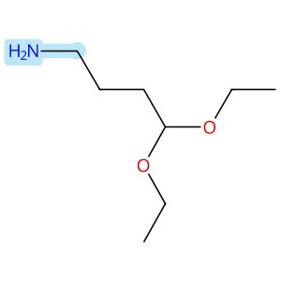 |  | 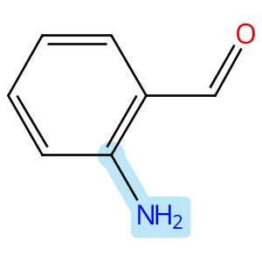
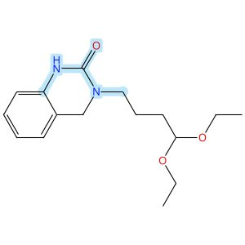

Scheme 57 (Reaction 1 of 1):

Step 1, Yield: 76%

Enantioselective Intramolecular C-H Alkylation Catalyzed by a Nonsymmetric Chiral Cobalt Porphyrin

By: Buchelt, Christoph; Breitenlechner, Stefan; Zuber, Julian; Huber, Stefan M.; Bach, Thorsten

10.1021/jacs.5c19047
View All Sources in CAS SciFinder
Company/Organization: School of Natural Sciences, Department of Chemistry and Catalysis Research Center (CRC), Technische Universitaet Muenchen, Garching, 85747, Germany
Source: Journal of the American Chemical Society (2026), 148(1), 93-98

Step 1
CAS Reaction Number: 31-614-CAS-48658833
Stage | Reagents | Catalysts | Solvents | Conditions
1 |  |  |  | 4 h, 20 °C
  -
  -
  Methanol
2 |  |  |  | 20 °C; 16 h, 20 °C
  Sodium borohydride
  -
  -
3 |  |  |  | 16 h, 60 °C
  -
  -
  Tetrahydrofuran
Experimental Protocols
Synthetic Methods
Products | 2(1H)-Quinazolinone, 3-(4,4-diethoxybutyl)-3,4-dihydro-, Yield: 76%
Reactants | 2-Aminobenzaldehyde  4,4-Diethoxy-1-butanamine  1,1′-Carbonyldiimidazole
Reagents | Sodium borohydride
Solvents | Methanol  Tetrahydrofuran
Procedure
  1. | Add the corresponding amine (1.05 equiv.) to a solution of 2-aminobenzaldehyde (2.13 g, 8.00 mmol, 1.00 equiv.) in MeOH (500 mM).
  2. | Stir the corresponding solution at 20°C for 4 hours.
  3. | Add NaBH₄ (2.00 equiv.) to the reaction mixture while the temperature maintaining using a water bath.
  4. | Stir the mixture for 16 hours.
  5. | Add H₂O (5 mL) to the reaction mixture.
  6. | Remove the organic solvent under reduced pressure.
  7. | Redissolve the residue in CH₂Cl₂ (30 mL) and H₂O (30 mL).
  8. | Wash the aqueous layer with CH₂Cl₂ (2 x 30 mL).
  9. | Dry the combined organic layers over Na₂SO₄.
  10. | Filter the mixture.
  11. | Remove the solvent under reduced pressure.
  12. | Redissolve the amine in THF (150 mM).
  13. | Add CDI (1.20 equiv.) in one portion to the mixture.
  14. | Stir the mixture at 60°C for 16 hours.
  15. | Cool the mixture to room temperature.
  16. | Wash the organic layer with saturated LiOH solution (50 mL), aqueous citric acid solution (10 wt%, 50 mL), H₂O (50 mL) and brine (40 mL).
  17. | Dry the organic layer over Na₂SO₄.
  18. | Filter the mixture.
  19. | Remove the solvent under reduced pressure.
  20. | Purify the crude by automated flash column chromatography (CH₂Cl₂/MeOH = 49/1 → 19/1) to obtain 3-(4,4-Diethoxybutyl)-3,4-dihydroquinazolin-2(1H)-one.
Transformation | - Reductive Alkylation of Ammonia or Amines  - Acylation of Nitrogen Nucleophiles by Acyl/ Thioacyl/ Carbamoyl Halides and Analogs
Scale | gram
Characterization Data
2(1H)-Quinazolinone, 3-(4,4-diethoxybutyl)-3,4-dihydro-
Proton NMR Spectrum | (500 MHz, CDCl₃): δ [ppm] = 1.20 (t, ³J 7.1 Hz, 6H, CH₃), 1.64 - 1.75 (m, 4H, H-2’, H-3’), 3.44 - 3.53 (m, 4H, H-1’, OCH₂a), 3.64 (dq, ²J= 9.5 Hz, ³J 7.1 Hz, 2H, OCH₂b), 4.45 (s, 2H, H-4), 4.52 (t, ³J 5.3 Hz, 1H, H-4’), 6.65 - 6.69 (m, 1H, H-8), 6.93 (virt. td, ³J ≈ ³J 7.5 Hz, ⁴J= 1.1 Hz, 1H, H-6), 7.03 (d, ³J 7.5 Hz, 1H, H-5), 7.08 - 7.18 (m, 2H, H-7, NH)
Carbon-13 NMR | (126 MHz, CDCl₃): δ [ppm] = 154.2 (C-2), 137.0 (C-8a), 128.4 (C-7), 125.7 (C-5), 122.1 (C-6), 117.8 (C-4a), 113.5 (C-8), 102.8 (C-4’), 61.5 (OCH₂), 48.7 (C-4), 47.0 (C-1’), 31.0 (C-2’), 22.3 (C-3’), 15.5 (CH₃)
IR Absorption Spectrum | (ATR): v [cm⁻¹] = 3204 (w, N-H), 2971 (w, C-H), 2929 (w, C-H), 2869 (w, C-H), 1660 (vs, C=O), 1608 (s, C=C), 1522 (w, C=C), 1512 (w, C=C), 1457 (s), 1341 (s), 1217 (s), 1116 (s, C-O), 1000 (m), 843 (m), 793 (m), 753 (vs, C-H), 726 (m, C-H), 714 (m)
HRMS | (+ESI): calc. for C₁₆H₂₄N₂NaO₃ [M+Na]⁺: 315.1679; found: 315.1677
Melting Point | 77-79°C
R_{f} | 0.45 (Hex/EtOAc = 2/3) [UV, KMnO4]
State | colorless solid
CAS Method Number 3-614-CAS-48801626

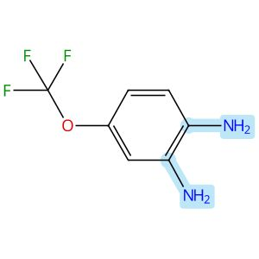 |  |  |  | 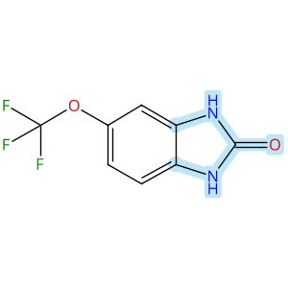

Scheme 58 (Reaction 1 of 1):

Step 1, Yield: 76%

Development of Benzimidazole-Based BZ-30 as an Orally Bioavailable Broad-Spectrum Inhibitor of SARS-CoV-2

By: Kaur, Simran; Brar, Deshkanwar S.; Joshi, Akshay; Singh, Nittu; Chawla, Ravneet S.; Kumar, Sahil; Dhiman, Sumit; Nandi, Utpal; Ringe, Rajesh P.; Thakur, Krishan G.; Chaudhari, Vinod D.

10.1021/acs.jmedchem.6c00365
View All Sources in CAS SciFinder
Company/Organization: Division of Medicinal Chemistry, Council of Scientific and Industrial Research-Institute of Microbial Technology (CSIR-IMTECH), Chandigarh, 160036, India
Source: Journal of Medicinal Chemistry (2026), 69(8), 9537-9557

Step 1
CAS Reaction Number: 31-614-CAS-50120146
Stage | Reagents | Catalysts | Solvents | Conditions
1 |  |  |  | 4 h, 35 °C
  -
  -
  Tetrahydrofuran
Experimental Protocols
Synthetic Methods
Products | 1,3-Dihydro-5-(trifluoromethoxy)-2H-benzimidazol-2-one, Yield: 76%
Reactants | 1,1′-Carbonyldiimidazole  4-Trifluoromethoxybenzene-1,2-diamine
Solvents | Tetrahydrofuran
Procedure
  1. | Add, to a stirred solution of 4-(trifluoromethoxy)benzene-1,2diamine (350 mg, 1.82 mmol, 1 equiv) in THF (15 mL), 1 1’carbonylbis-1H-imidazole (1.78 g, 0.011 mol, 6 equiv).
  2. | Stir this mixture at 35°C for 4 h.
  3. | Concentrate the vessel contents in vacuo, after the completion of reaction.
  4. | Purify the crude compound by flash column chromatography.
CAS Method Number 3-614-CAS-50193182

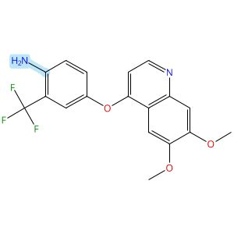

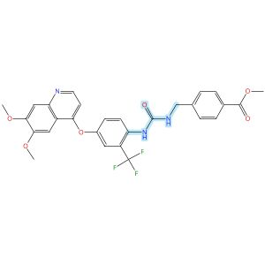

Scheme 59 (Reaction 1 of 1):

Step 1, Yield: 75%

Structure-Based Design and Free Energy Perturbation-Guided Synthesis of Novel VEGFR2 and HDAC Dual Inhibitors with Potent Antitumor Efficacy

By: Li, Yaxin; Liu, Sisi; Hu, Sha; Zhang, Ranran; Wang, Xiaoli; Xu, Jiamin; Yao, Keke; Lu, Chenxuan; Li, Guofeng; Wu, Zhigang; Guo, Chunyan; Yang, Leifu; Hu, Liming

10.1021/acs.jmedchem.5c01650
View All Sources in CAS SciFinder
Company/Organization: Beijing Key Laboratory of Environmental and Oncology, College of Chemistry and Life Science, Beijing University of Technology, Beijing, 100124, China
Source: Journal of Medicinal Chemistry (2026), 69(4), 3762-3778

Step 1
CAS Reaction Number: 31-614-CAS-49395390
Stage | Reagents | Catalysts | Solvents | Conditions
1 |  |  |  | 0 °C
  Triethylamine
  -
  Dichloromethane
2 |  |  |  | 0 °C
  -
  -
  Dichloromethane
Experimental Protocols
Synthetic Methods
Products | Benzoic acid, 4-[[[[[4-[(6,7-dimethoxy-4-quinolinyl)oxy]-2-(trifluoromethyl)phenyl]amino]carbonyl]amino]methyl]-, methyl ester, Yield: 75%
Reactants | Triphosgene  4-[(6,7-Dimethoxy-4-quinolinyl)oxy]-2-(trifluoromethyl)benzenamine  Methyl 4-(aminomethyl)benzoate
Reagents | Triethylamine
Solvents | Dichloromethane
Procedure
  1. | Add triethylamine (4.0 equiv) to a solution of quinoline aniline derivative (1.0 equiv) and triphosgene (0.5 equiv) in 5 mL of dichloromethane, held in an ice-water bath, slowly dropwise.
  2. | Monitor complete consumption of the starting materials.
  3. | Add a solution of aniline or benzylamine (1.0 equiv) in 3 mL of dichloromethane dropwise to the reaction mixture.
  4. | Monitor the progress of the reaction by TLC.
  5. | Filter the solid.
  6. | Purify the solid by column chromatography to obtain methyl 4-((3-(4-((6,7-dimethoxyquinolin-4-yl)-oxy)-2-(trifluoromethyl)phenyl)ureido)methybenzoate.
Transformation | - Acylation of Nitrogen Nucleophiles by Acyl/ Thioacyl/ Carbamoyl Halides and Analogs
Characterization Data
Benzoic acid, 4-[[[[[4-[(6,7-dimethoxy-4-quinolinyl)oxy]-2-(trifluoromethyl)phenyl]amino]carbonyl]amino]methyl]-, methyl ester
Proton NMR Spectrum | (400 MHz, DMSO-d₆): δ (ppm) 8.51 (d, J = 5.2 Hz, 1H), 8.07-8.05 (m, 2H), 7.96 (d, J = 8.2 Hz, 2H), 7.57 (d, J = 2.8 Hz, 1H), 7.55 (s, 1H), 7.52 (d, J = 3.2 Hz, 1H), 7.51 (s, 1H), 7.46 (d, J = 8.0 Hz, 2H), 7.41 (s, 1H), 6.55 (d, J = 5.2 Hz, 1H), 4.43 (d, J = 5.8 Hz, 2H), 3.96 (s, 3H), 3.93 (s, 3H), 3.86 (s, 3H)
Mass Spectrum | M/Z(ESI⁺). m/z: calcd for C₂₈H₂₅F₃N₃O₆ [M + H]⁺, 556.2; found, 556.2
State | white solid
CAS Method Number 3-614-CAS-50096407

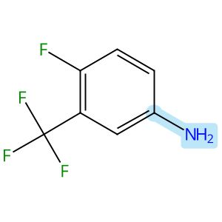

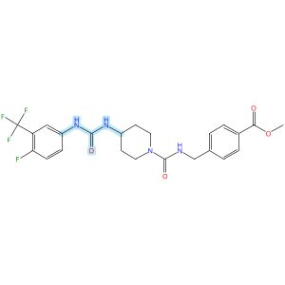

Scheme 60 (Reaction 1 of 1):

Step 1, Yield: 75%

Design and synthesis of novel sEH inhibitors for the treatment of acute lung injury

By: Xu, Huashen; Ma, Ruiyi; Morisseau, Christophe; Dong, Xinyue; Zhuang, Junning; Wang, Zhe; Liu, Fuqin; Xu, Dong; Chen, Lu; Zhang, Maoying; Zhu, Zhihui; Liu, Xinran; Jiang, Huiwen; Liu, Zhongbo; Hammock, Bruce D.; Cao, Ruolin; Chen, Guoliang

10.1016/j.ejmech.2026.118773
View All Sources in CAS SciFinder
Company/Organization: Key Laboratory of Structure-Based Drug Design & Discovery of Ministry of Education, School of Pharmaceutical Engineering, Shenyang Pharmaceutical University, Shenyang, 110016, China
Source: European Journal of Medicinal Chemistry (2026), 309, 118773

Step 1
CAS Reaction Number: 31-614-CAS-49705471
Stage | Reagents | Catalysts | Solvents | Conditions
1 |  |  |  | 1 h, < -10 °C; -10 °C → rt; 30 min, rt
  Triethylamine
  -
  Dichloromethane
2 |  |  |  | 0.5 h, rt; overnight, rt
  Triethylamine
  -
  Dichloromethane
Experimental Protocols
Synthetic Methods
Products | 3124392-82-8, Yield: 75%
Reactants | 4-Fluoro-3-(trifluoromethyl)aniline  Triphosgene  3124392-72-6
Reagents | Triethylamine
Solvents | Dichloromethane
Procedure
  1. | Add a solution of Memantine (0.15 g, 0.82 mmol, 1.0 eq) and Et₃N (0.25 g, 2.46 mmol, 3.0 eq) in DCM (20 mL) dropwise over 1 h to a thick slurry of triphosgene (0.12 g, 0.41 mmol, 0.5 eq) in DCM (10 mL) in a cold trap while maintaining the temperature below 10°C.
  2. | Remove the cold bath and warm the mixture to room temperature and stir for 30 min.
  3. | Add a slurry of Intermediate (0.3 g, 0.74 mmol, 0.9 eq) and Et₃N (0.42 g, 4.1 mmol, 5.0 eq) in DCM (20 mL) in small portions over 0.5 h at room temperature.
  4. | Stir the reaction mixture overnight.
  5. | Wash the reaction mixture with 10% aq HCl (1 x 20 mL).
  6. | Dry the organic layer over anhydrous MgSO₄ and concentrate under reduced pressure.
Transformation | - Acylation of Nitrogen Nucleophiles by Acyl/ Thioacyl/ Carbamoyl Halides and Analogs
CAS Method Number 3-614-CAS-50079826

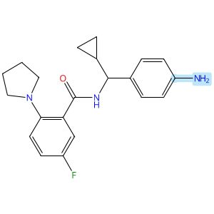

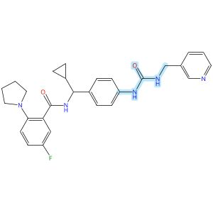

Scheme 61 (Reaction 1 of 1):

Step 1, Yield: 75%

Discovery of potent o-aminobenzoamide-based NAMPT inhibitors for targeting NAPRT-deficient gastric cancer

By: Yang, Heng; Li, Zhiyi; Peng, Huiqian; shen, Lixian; Li, Zhen; Zhu, Lejing; Ding, Rifan; Shi, Yiting; Liu, Yuting; Zhang, Miao; Zhuo, Linsheng; Yang, Meiling; Wang, Zhen; Jiang, Weifan

10.1021/acs.jmedchem.5c02564
View All Sources in CAS SciFinder
Company/Organization: School of Pharmaceutical Science, Hengyang Medical School, University of South China, Hunan, 421001, China
Source: Journal of Medicinal Chemistry (2026), 69(3), 2625-2646

Step 1
CAS Reaction Number: 31-614-CAS-49296547
Stage | Reagents | Catalysts | Solvents | Conditions
1 |  |  |  | 30 min, 0 °C
  Pyridine
  -
  Dichloromethane
2 |  |  |  | 30 min, 0 °C
  -
  -
  Dichloromethane
3 |  |  |  | 4 h, rt
  -
  -
  -
Experimental Protocols
Synthetic Methods
Products | Benzamide, N-[cyclopropyl[4-[[[(3-pyridinylmethyl)amino]carbonyl]amino]phenyl]methyl]-5-fluoro-2-(1-pyrrolidinyl)-, Yield: 75%
Reactants | Triphosgene  3-Pyridinemethanamine  Benzamide, N-[(4-aminophenyl)cyclopropylmethyl]-5-fluoro-2-(1-pyrrolidinyl)-
Reagents | Pyridine
Solvents | Dichloromethane
Procedure
  1. | Combine the triphosgene (1 mmol, 1 equiv) and pyridine (6.8 mmol, 6.8 equiv) in DCM (10 mL).
  2. | Cool the reaction mixture to 0°C in a brine ice bath for 30 minutes.
  3. | Add pyridine derivative (1 M in DCM, 3.4 mmol, 3.4 equiv) to the mixture.
  4. | Stir the reaction mixture for 30 minutes.
  5. | Add the corresponding amine (1 M in DCM, 3.4 mmol, 3.4 equiv) to the mixture.
  6. | Stir the resulting reaction mixture at room temperature for 4 hours.
  7. | Dilute the mixture with DCM.
  8. | Wash the mixture with saturated ammonium chloride.
  9. | Dry the residue over anhydrous sodium sulfate.
  10. | Filter the mixture.
  11. | Concentrate the filtrate in vacuo.
  12. | Purify the crude by sample column chromatography (DCM/MeOH = 25:1) to obtain N-(cyclopropyl(4-(3-(pyridin-3-ylmethyl)ureido)-phenyl)methyl)-5-fluoro-2-(pyrrolidin-1-yl)benzamide.
Transformation | - Acylation of Nitrogen Nucleophiles by Acyl/ Thioacyl/ Carbamoyl Halides and Analogs
Characterization Data
Benzamide, N-[cyclopropyl[4-[[[(3-pyridinylmethyl)amino]carbonyl]amino]phenyl]methyl]-5-fluoro-2-(1-pyrrolidinyl)-
Proton NMR Spectrum | (500 MHz, DMSO-d₆): δ 9.10 (d, J = 8.4 Hz, 1H), 8.58 (s, 1H), 8.52 (s, 1H), 8.45 (d, J = 3.9 Hz, 1H), 7.70 (dt, J = 7.8, 2.0 Hz, 1H), 7.38-7.31 (m, 3H), 7.29-7.25 (m, 2H), 7.10 (td, J = 8.6, 3.2 Hz, 1H), 6.99 (dd, J = 9.0, 3.2 Hz, 1H), 6.78 (dd, J = 9.1, 4.6 Hz, 1H), 6.68 (t, J = 6.0 Hz, 1H), 4.32 (d, J = 5.9 Hz, 2H), 4.27 (t, J = 8.8 Hz, 1H), 3.11-3.03 (m, 4H), 1.81-1.74 (m, 4H), 1.24-1.19 (m, 1H), 0.55-0.45 (m, 2H), 0.40-0.30 (m, 2H)
Carbon-13 NMR | (125 MHz, DMSO-d₆): δ 167.0, 155.3, 154.2 (d, J = 234.0 Hz), 148.7, 148.0, 143.1, 139.0, 135.9, 135.9, 135.0, 127.0, 125.2 (d, J = 4.2 Hz), 123.5, 117.7, 116.5 (d, J = 21.3 Hz), 116.0 (d, J = 6.9 Hz), 115.4 (d, J = 23.0 Hz), 56.6, 50.1, 40.5, 24.9, 17.0, 3.9, 3.6
Fluorine-19 NMR | (471 MHz, DMSO-d₆) δ - 128.37
HRMS | calcd for C₂₈H₃₀N₅O₂F [M + Na]⁺ 510.2281; found 510.2283
Melting Point | 221-222°C
State | white solid
CAS Method Number 3-614-CAS-50424790

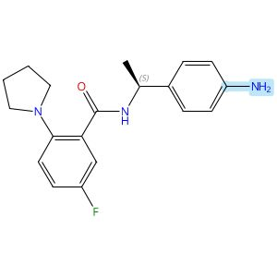
Absolute stereochemistry shown

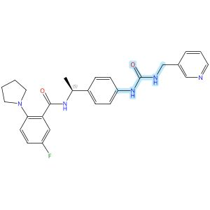
Absolute stereochemistry shown

Scheme 62 (Reaction 1 of 1):

Step 1, Yield: 75%

Discovery of potent o-aminobenzoamide-based NAMPT inhibitors for targeting NAPRT-deficient gastric cancer

By: Yang, Heng; Li, Zhiyi; Peng, Huiqian; shen, Lixian; Li, Zhen; Zhu, Lejing; Ding, Rifan; Shi, Yiting; Liu, Yuting; Zhang, Miao; Zhuo, Linsheng; Yang, Meiling; Wang, Zhen; Jiang, Weifan

10.1021/acs.jmedchem.5c02564
View All Sources in CAS SciFinder
Company/Organization: School of Pharmaceutical Science, Hengyang Medical School, University of South China, Hunan, 421001, China
Source: Journal of Medicinal Chemistry (2026), 69(3), 2625-2646

Step 1
CAS Reaction Number: 31-614-CAS-49296550
Stage | Reagents | Catalysts | Solvents | Conditions
1 |  |  |  | 30 min, 0 °C
  Pyridine
  -
  Dichloromethane
2 |  |  |  | 30 min, 0 °C
  -
  -
  Dichloromethane
3 |  |  |  | 4 h, rt
  -
  -
  -
Experimental Protocols
Synthetic Methods
Products | Benzamide, 5-fluoro-N-[(1S)-1-[4-[[[(3-pyridinylmethyl)amino]carbonyl]amino]phenyl]ethyl]-2-(1-pyrrolidinyl)-, Yield: 75%
Reactants | Triphosgene  3-Pyridinemethanamine  Benzamide, N-[(1S)-1-(4-aminophenyl)ethyl]-5-fluoro-2-(1-pyrrolidinyl)-
Reagents | Pyridine
Solvents | Dichloromethane
Procedure
  1. | Combine the triphosgene (1 mmol, 1 equiv) and pyridine (6.8 mmol, 6.8 equiv) in DCM (10 mL).
  2. | Cool the reaction mixture to 0°C in a brine ice bath for 30 minutes.
  3. | Add pyridine derivative (1 M in DCM, 3.4 mmol, 3.4 equiv) to the mixture.
  4. | Stir the reaction mixture for 30 minutes.
  5. | Add (S)-N-(1-(4-aminophenyl)ethyl)-5-fluoro-2-(pyrrolidin-1-yl)benzamide (1 M in DCM, 3.4 mmol, 3.4 equiv) to the mixture.
  6. | Stir the resulting reaction mixture at room temperature for 4 hours.
  7. | Dilute the mixture with DCM.
  8. | Wash the mixture with saturated ammonium chloride.
  9. | Dry the residue over anhydrous sodium sulfate.
  10. | Filter the mixture.
  11. | Concentrate the filtrate in vacuo.
  12. | Purify the crude by sample column chromatography (DCM/MeOH = 25:1) to obtain (S)-5-fluoro-N-(1-(4-(3-(pyridin-3-ylmethyl)ureido)-phenyl)ethyl)-2-(pyrrolidin-1-yl)benzamide.
Characterization Data
Benzamide, 5-fluoro-N-[(1S)-1-[4-[[[(3-pyridinylmethyl)amino]carbonyl]amino]phenyl]ethyl]-2-(1-pyrrolidinyl)-
Proton NMR Spectrum | (500 MHz, CDCl₃): δ 9.89 (d, J = 7.3 Hz, 1H), 8.44-8.37 (m, 2H), 7.70 (s, 1H), 7.59 (dt, J = 7.9, 2.0 Hz, 1H), 7.55 (dd, J = 9.3, 3.0 Hz, 1H), 7.17 (dd, J = 7.9, 4.8 Hz, 1H), 7.15- 7.11 (m, 2H), 7.11-7.08 (m, 2H), 7.07-7.00 (m, 2H), 6.21 (t, J = 6.0 Hz, 1H), 5.08 (p, J = 6.9 Hz, 1H), 4.31 (qd, J = 15.4, 5.9 Hz, 2H), 3.03-2.94 (m, 4H), 1.86-1.76 (m, 4H), 1.46 (d, J = 6.9 Hz, 3H)
Carbon-13 NMR | (125 MHz, CDCl₃): δ 165.8, 158.8 (d, J = 242.9 Hz), 156.1, 148.8, 148.5, 144.8 (d, J = 2.7 Hz), 138.4, 137.7, 135.6, 135.4, 128.8 (d, J = 6.8 Hz), 126.5, 123.7, 121.4 (d, J = 7.3 Hz), 120.2, 118.7 (d, J = 22.4 Hz), 117.1 (d, J = 24.1 Hz), 53.3, 49.1, 41.5, 24.6, 22.3
Fluorine-19 NMR | (471 MHz, CDCl₃): δ - 119.15
HRMS | calcd for C₂₆H₂₈N₅O₂F [M + Na]⁺ 484.2125; found 484.2127
Melting Point | 142-143°C
State | pale yellow solid
CAS Method Number 3-614-CAS-50424813

Absolute stereochemistry shown

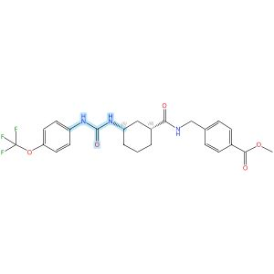
Absolute stereochemistry shown

Scheme 63 (Reaction 1 of 1):

Step 1, Yield: 75%

Design and synthesis of novel sEH inhibitors for the treatment of acute lung injury

By: Xu, Huashen; Ma, Ruiyi; Morisseau, Christophe; Dong, Xinyue; Zhuang, Junning; Wang, Zhe; Liu, Fuqin; Xu, Dong; Chen, Lu; Zhang, Maoying; Zhu, Zhihui; Liu, Xinran; Jiang, Huiwen; Liu, Zhongbo; Hammock, Bruce D.; Cao, Ruolin; Chen, Guoliang

10.1016/j.ejmech.2026.118773
View All Sources in CAS SciFinder
Company/Organization: Key Laboratory of Structure-Based Drug Design & Discovery of Ministry of Education, School of Pharmaceutical Engineering, Shenyang Pharmaceutical University, Shenyang, 110016, China
Source: European Journal of Medicinal Chemistry (2026), 309, 118773

Step 1
CAS Reaction Number: 31-614-CAS-49705416
Stage | Reagents | Catalysts | Solvents | Conditions
1 |  |  |  | 1 h, < -10 °C; -10 °C → rt; 30 min, rt
  Triethylamine
  -
  Dichloromethane
2 |  |  |  | 0.5 h, rt; overnight, rt
  Triethylamine
  -
  Dichloromethane
Experimental Protocols
Synthetic Methods
Products | 3124392-32-8, Yield: 75%
Reactants | 4-(Trifluoromethoxy)aniline  Triphosgene  3124392-21-5
Reagents | Triethylamine
Solvents | Dichloromethane
Procedure
  1. | Add a solution of Memantine (0.2 g, 0.93 mmol, 1.0 eq) and Et₃N (0.28 g, 2.78 mmol, 3.0 eq) in DCM (20 mL) dropwise over 1 h to a thick slurry of triphosgene (0.14 g, 0.46 mmol, 0.5 eq) in DCM (10 mL) in a cold trap while maintaining the temperature below 10°C.
  2. | Remove the cold bath and warm the mixture to rt and stir for 30 min.
  3. | Add a slurry of Intermediate (0.30 g, 0.74 mmol, 0.8 eq) and Et₃N (0.56 g, 5.56 mmol, 6.0 eq) in DCM (20 mL) in small portions over 0.5 h at room temperature.
  4. | Stir the reaction mixture overnight.
  5. | Wash the reaction mixture with 10% aq HCl (1 x 20 mL).
  6. | Dry the organic layer over anhydrous MgSO₄ and concentrate under reduced pressure.
Transformation | - Acylation of Nitrogen Nucleophiles by Acyl/ Thioacyl/ Carbamoyl Halides and Analogs
Scale | gram
Characterization Data
3124392-32-8
State | White solid
CAS Method Number 3-614-CAS-50079649

Relative stereochemistry shown

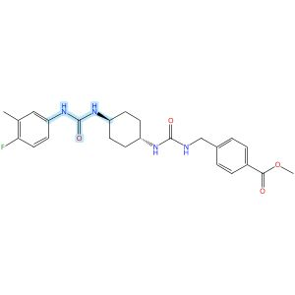
Relative stereochemistry shown

Scheme 64 (Reaction 1 of 1):

Step 1, Yield: 75%

Design and synthesis of novel sEH inhibitors for the treatment of acute lung injury

By: Xu, Huashen; Ma, Ruiyi; Morisseau, Christophe; Dong, Xinyue; Zhuang, Junning; Wang, Zhe; Liu, Fuqin; Xu, Dong; Chen, Lu; Zhang, Maoying; Zhu, Zhihui; Liu, Xinran; Jiang, Huiwen; Liu, Zhongbo; Hammock, Bruce D.; Cao, Ruolin; Chen, Guoliang

10.1016/j.ejmech.2026.118773
View All Sources in CAS SciFinder
Company/Organization: Key Laboratory of Structure-Based Drug Design & Discovery of Ministry of Education, School of Pharmaceutical Engineering, Shenyang Pharmaceutical University, Shenyang, 110016, China
Source: European Journal of Medicinal Chemistry (2026), 309, 118773

Step 1
CAS Reaction Number: 31-614-CAS-49705431
Stage | Reagents | Catalysts | Solvents | Conditions
1 |  |  |  | 1 h, < -10 °C; -10 °C → rt; 30 min, rt
  Triethylamine
  -
  Dichloromethane
2 |  |  |  | 0.5 h, rt; overnight, rt
  Triethylamine
  -
  Dichloromethane
Experimental Protocols
Synthetic Methods
Products | 3124392-48-6, Yield: 75%
Reactants | 4-Fluoro-3-methylaniline  Triphosgene  3124392-46-4
Reagents | Triethylamine
Solvents | Dichloromethane
Procedure
  1. | Add a solution of 4-chloro-3-(trifluoromethyl)aniline (94 mg, 0.48 mmol, 1.0 eq) and Et₃N (0.15 g, 1.44 mmol, 3.0 eq) in DCM (20 mL) dropwise over 1 h to a thick slurry of triphosgene (71 mg, 0.24 mmol, 0.5 eq) in DCM (10 mL) in a cold trap while maintaining the temperature below 10°C.
  2. | Remove the cold bath and warm the mixture to room temperature and stir for 30 min.
  3. | Add a slurry of Intermediate (0.2 g, 0.48 mmol, 1.0 eq) and Et₃N (0.48 g, 4.8 mmol, 10.0 eq) in DCM (20 mL) in small portions over 0.5 h at room temperature.
  4. | Stir the reaction mixture overnight.
  5. | Wash the reaction mixture with 10% aq HCl (1 x20 mL).
  6. | Dry the organic layer over anhydrous MgSO₄ and concentrate under reduced pressure.
CAS Method Number 3-614-CAS-50079704

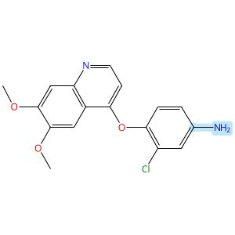

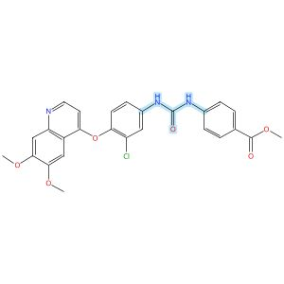

Scheme 65 (Reaction 1 of 1):

Step 1, Yield: 75%

Structure-Based Design and Free Energy Perturbation-Guided Synthesis of Novel VEGFR2 and HDAC Dual Inhibitors with Potent Antitumor Efficacy

By: Li, Yaxin; Liu, Sisi; Hu, Sha; Zhang, Ranran; Wang, Xiaoli; Xu, Jiamin; Yao, Keke; Lu, Chenxuan; Li, Guofeng; Wu, Zhigang; Guo, Chunyan; Yang, Leifu; Hu, Liming

10.1021/acs.jmedchem.5c01650
View All Sources in CAS SciFinder
Company/Organization: Beijing Key Laboratory of Environmental and Oncology, College of Chemistry and Life Science, Beijing University of Technology, Beijing, 100124, China
Source: Journal of Medicinal Chemistry (2026), 69(4), 3762-3778

Step 1
CAS Reaction Number: 31-614-CAS-49395401
Stage | Reagents | Catalysts | Solvents | Conditions
1 |  |  |  | 0 °C
  Triethylamine
  -
  Dichloromethane
2 |  |  |  | 0 °C
  -
  -
  Dichloromethane
Experimental Protocols
Synthetic Methods
Products | Benzoic acid, 4-[[[[3-chloro-4-[(6,7-dimethoxy-4-quinolinyl)oxy]phenyl]amino]carbonyl]amino]-, methyl ester, Yield: 75%
Reactants | Triphosgene  3-Chloro-4-[(6,7-dimethoxy-4-quinolyl)oxy]aniline  Methyl 4-aminobenzoate
Reagents | Triethylamine
Solvents | Dichloromethane
Procedure
  1. | Add triethylamine (4.0 equiv) to a solution of quinoline aniline derivative (1.0 equiv) and triphosgene (0.5 equiv) in 5 mL of dichloromethane, held in an ice-water bath, slowly dropwise.
  2. | Monitor complete consumption of the starting materials.
  3. | Add a solution of aniline or benzylamine (1.0 equiv) in 3 mL of dichloromethane dropwise to the reaction mixture.
  4. | Monitor the progress of the reaction by TLC.
  5. | Filter the solid.
  6. | Purify the solid by column chromatography to obtain methyl 4-(3-(3-chloro-4-((6,7-dimethoxyquinolin-4-yl)oxy)phenyl)ureido)benzoate.
Transformation | - Acylation of Nitrogen Nucleophiles by Acyl/ Thioacyl/ Carbamoyl Halides and Analogs
Characterization Data
Benzoic acid, 4-[[[[3-chloro-4-[(6,7-dimethoxy-4-quinolinyl)oxy]phenyl]amino]carbonyl]amino]-, methyl ester
Proton NMR Spectrum | (400 MHz, DMSO-d₆): δ (ppm) 9.25 (s, 1H), 9.15 (s, 1H), 8.48 (d, J = 5.2 Hz, 1H), 7.95 (d, J = 2.5 Hz, 1H), 7.91 (d, J = 8.8 Hz, 2H), 7.62 (d, J = 8.8 Hz, 2H), 7.54 (s, 1H), 7.47 (dd, J = 8.9, 2.5 Hz, 1H), 7.44-7.39 (m, 2H), 6.36 (d, J = 5.2 Hz, 1H), 3.96 (s, 6H), 3.83 (s, 3H)
Mass Spectrum | MS (ESI⁺): calcd for C₂₆H₂₃ClN₃O₆ [M + H]⁺, 508.1; found, 508.2
State | white solid
CAS Method Number 3-614-CAS-50096416

 |  | 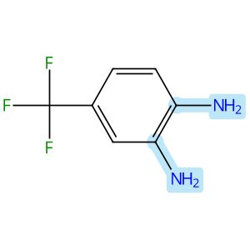 |  | 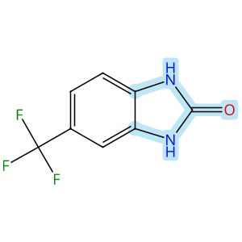

Scheme 66 (Reaction 1 of 1):

Step 1, Yield: 75%

Development of Benzimidazole-Based BZ-30 as an Orally Bioavailable Broad-Spectrum Inhibitor of SARS-CoV-2

By: Kaur, Simran; Brar, Deshkanwar S.; Joshi, Akshay; Singh, Nittu; Chawla, Ravneet S.; Kumar, Sahil; Dhiman, Sumit; Nandi, Utpal; Ringe, Rajesh P.; Thakur, Krishan G.; Chaudhari, Vinod D.

10.1021/acs.jmedchem.6c00365
View All Sources in CAS SciFinder
Company/Organization: Division of Medicinal Chemistry, Council of Scientific and Industrial Research-Institute of Microbial Technology (CSIR-IMTECH), Chandigarh, 160036, India
Source: Journal of Medicinal Chemistry (2026), 69(8), 9537-9557

Step 1
CAS Reaction Number: 31-614-CAS-50120154
Stage | Reagents | Catalysts | Solvents | Conditions
1 |  |  |  | 4 h, 35 °C
  -
  -
  Tetrahydrofuran

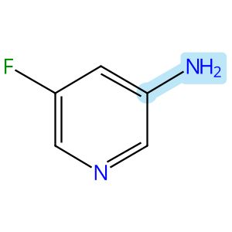

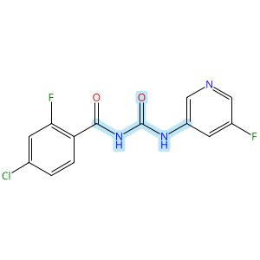

Scheme 67 (Reaction 1 of 1):

Step 1, Yield: 74%

Design, Synthesis, and Preclinical Evaluation of a PET Tracer Targeting Methionine Adenosyltransferase 2A

By: Jiang, Zeng; Huang, Yong; Chen, Hualong; Yu, Ziyue; Cheng, Xuebo; Liu, Yajing; Wu, Zehui

10.1021/acs.jmedchem.5c02532
View All Sources in CAS SciFinder
Company/Organization: Beijing Institute of Brain Disorders, Beijing Key Laboratory of Innovation and Translation of Central Nervous System Radiopharmaceuticals, Capital Medical University, Beijing, 100069, China
Source: Journal of Medicinal Chemistry (2026), 69(3), 2575-2598

Step 1
CAS Reaction Number: 31-614-CAS-49099064
Stage | Reagents | Catalysts | Solvents | Conditions
1 |  |  |  | rt; 30 min, 80 °C; 80 °C → rt
  -
  -
  1,2-Dichloroethane
2 |  |  |  | 1 h, rt
  -
  -
  -
3 |  |  |  | 10 min, rt
  Sodium bicarbonate
  -
  Water
Experimental Protocols
Synthetic Methods
Products | Benzamide, 4-chloro-2-fluoro-N-[[(5-fluoro-3-pyridinyl)amino]carbonyl]-, Yield: 74%
Reactants | Oxalyl chloride  4-Chloro-2-fluorobenzamide  5-Fluoropyridin-3-amine
Reagents | Sodium bicarbonate
Solvents | 1,2-Dichloroethane  Water
Procedure
  1. | Dissolve 4-chloro-2-fluorobenzamide (500 mg, 2.88 mmol) in 20 mL of DCE.
  2. | Add oxalyl chloride (402 mg, 3.17 mmol) to the mixture at room temperature.
  3. | Stir the mixture at 80°C for 30 minutes.
  4. | Cool the mixture to room temperature.
  5. | Add 3-amino-5-fluoro-pyridine (969 mg, 8.64 mmol) to the mixture.
  6. | Stir the mixture continuously at room temperature for 1 hour.
  7. | Add 100 mL of saturated NaHCO₃ solution to the mixture.
  8. | Stir the mixture for 10 minutes.
  9. | Filter the mixture.
  10. | Wash the filter cake with water.
  11. | Dry the residue to afford 4-chloro-2-fluoro-N-((5-fluoropyridin-3-yl)-carbamoyl)benzamide.
Transformation | - Acylation of Nitrogen Nucleophiles by Acyl/ Thioacyl/ Carbamoyl Halides and Analogs
Scale | milligram
Characterization Data
Benzamide, 4-chloro-2-fluoro-N-[[(5-fluoro-3-pyridinyl)amino]carbonyl]-
Proton NMR Spectrum | (300 MHz, DMSO-d₆) δ 11.30 (s, 1H), 10.58 (s, 1H), 8.63 (s, 1H), 8.33 (d, J = 2.5 Hz, 1H), 8.07-8.01 (m, 1H), 7.74 (t, J = 8.0 Hz, 1H), 7.65 (dd, J = 10.3, 1.8 Hz, 1H), 7.45 (dd, J = 8.3, 1.7 Hz, 1H)
HRMS | calcd for C₁₃H₉ClF₂N₃O₂⁺, 312.0346[M + H]⁺, found: 312.0348
State | white solid
CAS Method Number 3-614-CAS-50416092

Relative stereochemistry shown

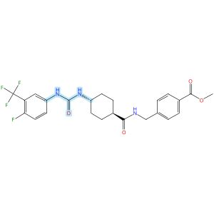
Relative stereochemistry shown

Scheme 68 (Reaction 1 of 1):

Step 1, Yield: 74%

Design and synthesis of novel sEH inhibitors for the treatment of acute lung injury

By: Xu, Huashen; Ma, Ruiyi; Morisseau, Christophe; Dong, Xinyue; Zhuang, Junning; Wang, Zhe; Liu, Fuqin; Xu, Dong; Chen, Lu; Zhang, Maoying; Zhu, Zhihui; Liu, Xinran; Jiang, Huiwen; Liu, Zhongbo; Hammock, Bruce D.; Cao, Ruolin; Chen, Guoliang

10.1016/j.ejmech.2026.118773
View All Sources in CAS SciFinder
Company/Organization: Key Laboratory of Structure-Based Drug Design & Discovery of Ministry of Education, School of Pharmaceutical Engineering, Shenyang Pharmaceutical University, Shenyang, 110016, China
Source: European Journal of Medicinal Chemistry (2026), 309, 118773

Step 1
CAS Reaction Number: 31-614-CAS-49705398
Stage | Reagents | Catalysts | Solvents | Conditions
1 |  |  |  | 1 h, < -10 °C; -10 °C → rt; 30 min, rt
  Triethylamine
  -
  Dichloromethane
2 |  |  |  | 0.5 h, rt; overnight, rt
  Triethylamine
  -
  Dichloromethane
Experimental Protocols
Synthetic Methods
Products | 3124392-01-1, Yield: 74%
Reactants | 4-Fluoro-3-(trifluoromethyl)aniline  Triphosgene  3124391-96-1
Reagents | Triethylamine
Solvents | Dichloromethane
Procedure
  1. | Add a solution of reactant (0.2 g, 0.93 mmol, 1.0 eq) and Et₃N (0.28 g, 2.78 mmol, 3.0 eq) in DCM (20 mL) dropwise over 1 h to a thick slurry of triphosgene (0.14 g, 0.46 mmol, 0.5 eq) in DCM (10 mL) in a cold trap while maintaining the temperature below 10°C.
  2. | Remove the cold bath and warm the mixture to room temperature and stir for 30 min.
  3. | Add a slurry of Intermediate (0.30 g, 0.74 mmol, 0.8 eq) and Et₃N (0.56 g, 5.56 mmol, 6.0 eq) in DCM (20 mL) in small portions over 0.5 h at room temperature.
  4. | Stir the reaction mixture overnight.
  5. | Wash the reaction mixture with 10% aq HCl (1 x 20 mL).
  6. | Dry the organic layer over anhydrous MgSO₄ and concentrate under reduced pressure.
Transformation | - Acylation of Nitrogen Nucleophiles by Acyl/ Thioacyl/ Carbamoyl Halides and Analogs
Scale | gram
Characterization Data
3124392-01-1
Mass Spectrum | ESI-MS m/z: 494.0 [M H]-
State | White solid
CAS Method Number 3-614-CAS-50079527

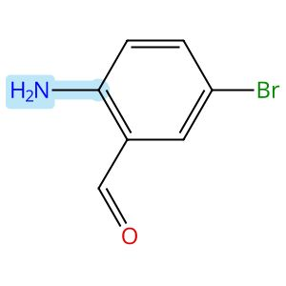

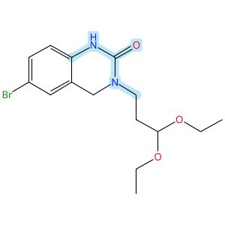

Scheme 69 (Reaction 1 of 1):

Step 1, Yield: 74%

Enantioselective Intramolecular C-H Alkylation Catalyzed by a Nonsymmetric Chiral Cobalt Porphyrin

By: Buchelt, Christoph; Breitenlechner, Stefan; Zuber, Julian; Huber, Stefan M.; Bach, Thorsten

10.1021/jacs.5c19047
View All Sources in CAS SciFinder
Company/Organization: School of Natural Sciences, Department of Chemistry and Catalysis Research Center (CRC), Technische Universitaet Muenchen, Garching, 85747, Germany
Source: Journal of the American Chemical Society (2026), 148(1), 93-98

Step 1
CAS Reaction Number: 31-614-CAS-48658843
Stage | Reagents | Catalysts | Solvents | Conditions
1 |  |  |  | 4 h, 20 °C
  -
  -
  Methanol
2 |  |  |  | 20 °C; 16 h, 20 °C
  Sodium borohydride
  -
  -
3 |  |  |  | 16 h, 60 °C
  -
  -
  Tetrahydrofuran
Experimental Protocols
Synthetic Methods
Products | 2(1H)-Quinazolinone, 6-bromo-3-(3,3-diethoxypropyl)-3,4-dihydro-, Yield: 74%
Reactants | 2-Amino-5-bromobenzaldehyde  1-Amino-3,3-diethoxypropane  1,1′-Carbonyldiimidazole
Reagents | Sodium borohydride
Solvents | Methanol  Tetrahydrofuran
Procedure
  1. | Add the corresponding amine (1.05 equiv.) to a solution of 2-amino-5-bromobenzaldehyde (1.66 g, 5.00 mmol, 1.00 equiv.) in MeOH (500 mM).
  2. | Stir the corresponding solution at 20°C for 4 hours.
  3. | Add NaBH₄ (2.00 equiv.) to the reaction mixture while the temperature maintaining using a water bath.
  4. | Stir the mixture for 16 hours.
  5. | Add H₂O (5 mL) to the reaction mixture.
  6. | Remove the organic solvent under reduced pressure.
  7. | Redissolve the residue in CH₂Cl₂ (30 mL) and H₂O (30 mL).
  8. | Wash the aqueous layer with CH₂Cl₂ (2 x 30 mL).
  9. | Dry the combined organic layers over Na₂SO₄.
  10. | Filter the mixture.
  11. | Remove the solvent under reduced pressure.
  12. | Redissolve the amine in THF (150 mM).
  13. | Add CDI (1.20 equiv.) in one portion to the mixture.
  14. | Stir the mixture at 60°C for 16 hours.
  15. | Cool the mixture to room temperature.
  16. | Wash the organic layer with saturated LiOH solution (50 mL), aqueous citric acid solution (10 wt%, 50 mL), H₂O (50 mL) and brine (40 mL).
  17. | Dry the organic layer over Na₂SO₄.
  18. | Filter the mixture.
  19. | Remove the solvent under reduced pressure.
  20. | Purify the crude by automated flash column chromatography (CH₂Cl₂/MeOH = 49/1 → 19/1) to obtain 6-bromo-3-(3,3-diethoxypropyl)-3,4-dihydroquinazolin-2(1H)-one.
Transformation | - Reductive Alkylation of Ammonia or Amines  - Acylation of Nitrogen Nucleophiles by Acyl/ Thioacyl/ Carbamoyl Halides and Analogs
Scale | gram
Characterization Data
2(1H)-Quinazolinone, 6-bromo-3-(3,3-diethoxypropyl)-3,4-dihydro-
Proton NMR Spectrum | (500 MHz, CDCl₃): δ [ppm] = 1.20 (t, ³J= 7.0 Hz, 6H, CH₃), 1.92 - 1.98 (m, 2H, H-2’), 3.47 - 3.55 (m, 4H, H-1’, OCH₂a), 3.67 (dq, ²J= 9.2 Hz, ³J= 7.0 Hz, 2H, OCH₂b), 4.43 (s, 2H, H-4), 4.58 (t, ³J= 5.6 Hz, 1H, H-3’), 6.75 (d, ³J= 8.4 Hz, 1H, H-8), 7.16 (d, ⁴J= 2.1 Hz, 1H, H-5), 7.25 (dd, ³J= 8.4 Hz, ⁴J= 2.1 Hz, 1H, H-7), 7.40 (bs, 1H, NH)
Carbon-13 NMR | (126 MHz, CDCl₃): δ [ppm] = 154.1 (C-2), 136.3 (C-8a), 131.2 (C-7), 128.5 (C-5), 119.9 (C-4a), 115.2 (C-8), 114.0 (C-6), 101.3 (C-3’), 61.7 (OCH₂), 48.6 (C-4), 43.7 (C-1’), 31.4 (C-2’), 15.5 (CH₃)
IR Absorption Spectrum | (ATR): v [cm⁻¹] = 3198 (w, N-H), 2974 (w, C-H), 2928 (w, C-H), 2900 (w, C-H), 1667 (vs, C=O), 1612 (w), 1601 (w, C=C), 1515 (s, C=C), 1472 (m), 1343 (w), 1276 (w), 1114 (s, C-O), 1064 (vs, C-Br), 945 (w818 (vs), 800 (m), 742 (m, C-H), 706 (w)
HRMS | (+ESI): calc. for C₁₅H₂₁BrN₂NaO₃ [M+Na]⁺: 379.0628; found: 379.0630
Melting Point | 132-134°C
R_{f} | 0.13 (CH2Cl2/ac = 9/1) [UV, KMnO4]
State | colorless solid
CAS Method Number 3-614-CAS-48801466

Relative stereochemistry shown

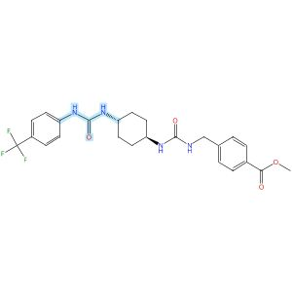
Relative stereochemistry shown

Scheme 70 (Reaction 1 of 1):

Step 1, Yield: 74%

Design and synthesis of novel sEH inhibitors for the treatment of acute lung injury

By: Xu, Huashen; Ma, Ruiyi; Morisseau, Christophe; Dong, Xinyue; Zhuang, Junning; Wang, Zhe; Liu, Fuqin; Xu, Dong; Chen, Lu; Zhang, Maoying; Zhu, Zhihui; Liu, Xinran; Jiang, Huiwen; Liu, Zhongbo; Hammock, Bruce D.; Cao, Ruolin; Chen, Guoliang

10.1016/j.ejmech.2026.118773
View All Sources in CAS SciFinder
Company/Organization: Key Laboratory of Structure-Based Drug Design & Discovery of Ministry of Education, School of Pharmaceutical Engineering, Shenyang Pharmaceutical University, Shenyang, 110016, China
Source: European Journal of Medicinal Chemistry (2026), 309, 118773

Step 1
CAS Reaction Number: 31-614-CAS-49705451
Stage | Reagents | Catalysts | Solvents | Conditions
1 |  |  |  | 1 h, < -10 °C; -10 °C → rt; 30 min, rt
  Triethylamine
  -
  Dichloromethane
2 |  |  |  | 0.5 h, rt; overnight, rt
  Triethylamine
  -
  Dichloromethane
Experimental Protocols
Synthetic Methods
Products | 3124392-58-8, Yield: 74%
Reactants | 4-(Trifluoromethyl)aniline  Triphosgene  3124392-46-4
Reagents | Triethylamine
Solvents | Dichloromethane
Procedure
  1. | Add a solution of 4-chloro-3-(trifluoromethyl)aniline (94 mg, 0.48 mmol, 1.0 eq) and Et₃N (0.15 g, 1.44 mmol, 3.0 eq) in DCM (20 mL) dropwise over 1 h to a thick slurry of triphosgene (71 mg, 0.24 mmol, 0.5 eq) in DCM (10 mL) in a cold trap while maintaining the temperature below 10°C.
  2. | Remove the cold bath and warm the mixture to room temperature and stir for 30 min.
  3. | Add a slurry of Intermediate (0.2 g, 0.48 mmol, 1.0 eq) and Et₃N (0.48 g, 4.8 mmol, 10.0 eq) in DCM (20 mL) in small portions over 0.5 h at room temperature.
  4. | Stir the reaction mixture overnight.
  5. | Wash the reaction mixture with 10% aq HCl (1 x20 mL).
  6. | Dry the organic layer over anhydrous MgSO₄ and concentrate under reduced pressure.
Transformation | - Acylation of Nitrogen Nucleophiles by Acyl/ Thioacyl/ Carbamoyl Halides and Analogs
CAS Method Number 3-614-CAS-50079752

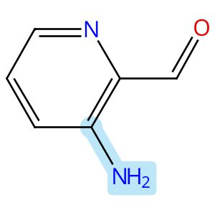

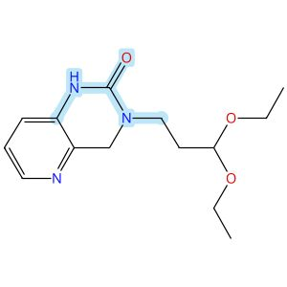

Scheme 71 (Reaction 1 of 1):

Step 1, Yield: 74%

Enantioselective Intramolecular C-H Alkylation Catalyzed by a Nonsymmetric Chiral Cobalt Porphyrin

By: Buchelt, Christoph; Breitenlechner, Stefan; Zuber, Julian; Huber, Stefan M.; Bach, Thorsten

10.1021/jacs.5c19047
View All Sources in CAS SciFinder
Company/Organization: School of Natural Sciences, Department of Chemistry and Catalysis Research Center (CRC), Technische Universitaet Muenchen, Garching, 85747, Germany
Source: Journal of the American Chemical Society (2026), 148(1), 93-98

Step 1
CAS Reaction Number: 31-614-CAS-48658838
Stage | Reagents | Catalysts | Solvents | Conditions
1 |  |  |  | 4 h, 20 °C
  -
  -
  Methanol
2 |  |  |  | 20 °C; 16 h, 20 °C
  Sodium borohydride
  -
  -
3 |  |  |  | 16 h, 60 °C
  -
  -
  Tetrahydrofuran
Experimental Protocols
Synthetic Methods
Products | 3113602-99-3, Yield: 74%
Reactants | 1-Amino-3,3-diethoxypropane  3-Amino-2-pyridinecarboxaldehyde  1,1′-Carbonyldiimidazole
Reagents | Sodium borohydride
Solvents | Methanol  Tetrahydrofuran
Procedure
  1. | Add the corresponding amine (1.05 equiv.) to a solution of 2-amino-picolinaldehyde (1.20 g, 4.74 mmol, 1.00 equiv.) in MeOH (500 mM).
  2. | Stir the corresponding solution at 20°C for 4 hours.
  3. | Add NaBH₄ (2.00 equiv.) to the reaction mixture while the temperature maintaining using a water bath.
  4. | Stir the mixture for 16 hours.
  5. | Add H₂O (5 mL) to the reaction mixture.
  6. | Remove the organic solvent under reduced pressure.
  7. | Redissolve the residue in CH₂Cl₂ (30 mL) and H₂O (30 mL).
  8. | Wash the aqueous layer with CH₂Cl₂ (2 x 30 mL).
  9. | Dry the combined organic layers over Na₂SO₄.
  10. | Filter the mixture.
  11. | Remove the solvent under reduced pressure.
  12. | Redissolve the amine in THF (150 mM).
  13. | Add CDI (1.20 equiv.) in one portion to the mixture.
  14. | Stir the mixture at 60°C for 16 hours.
  15. | Cool the mixture to room temperature.
  16. | Wash the organic layer with saturated LiOH solution (50 mL), aqueous citric acid solution (10 wt%, 50 mL), H₂O (50 mL) and brine (40 mL).
  17. | Dry the organic layer over Na₂SO₄.
  18. | Filter the mixture.
  19. | Remove the solvent under reduced pressure.
  20. | Purify the crude by automated flash column chromatography (CH₂Cl₂/MeOH = 49/1 → 19/1) to obtain 3-(3,3-Diethoxypropyl)-3,4-dihydropyrido[2,3-d]pyrimidin-2(1H)-one.
Transformation | - Reductive Alkylation of Ammonia or Amines  - Acylation of Nitrogen Nucleophiles by Acyl/ Thioacyl/ Carbamoyl Halides and Analogs
Scale | gram
Characterization Data
3113602-99-3
Proton NMR Spectrum | (500 MHz, CDCl₃): δ [ppm] = 1.20 (t, ³J= 7.0 Hz, 6H, CH₃), 1.96 - 2.02 (m, 2H, H-2’), 3.48 - 3.57 (m, 4H, H-1’, OCH₂a), 3.67 (dq, ²J= 9.3 Hz, ³J= 7.0 Hz, 2H, OCH₂b), 4.59 (s, 2H, H-4), 4.61 (t, ³J= 5.7 Hz, 1H, H-3’), 6.99 (dd, ³J= 8.1 Hz, ⁴J= 1.4 Hz, 1H, H-8), 7.09 (dd, ³J= 8.1 Hz, ³J= 4.8 Hz, 1H, H-7), 7.83 (bs, 1H, NH), 8.14 (dd, ³J= 4.8 Hz, ⁴J= 1.4 Hz, 1H, H-6)
Carbon-13 NMR | (126 MHz, CDCl₃): δ [ppm] = 153.7 (C-2), 142.3 (C-6), 138.7 (C-4a), 133.3 (C-8a), 123.2 (C-7), 120.3 (C-8), 101.2 (C-3’), 61.5 (OCH₂), 51.3 (C-4), 43.8 (C-1’), 31.2 (C-2’), 15. (CH₃)
IR Absorption Spectrum | (ATR): v [cm⁻¹] = 3341 (w, N-H), 2971 (m, C-H), 2930 (m, C-H), 2898 (m, C-H), 1679 (s, C=O), 1610 (m, C=C), 1598 (m, C=C), 1516 (s, C=C), 1459 (s), 1381 (m), 1253 (m), 1118 (s, C-O), 1024 (s), 885 (m), 795 (vs), 757 (s, C-H), 744 (m, C-H), 730 (s, C-H), 719 (s)
HRMS | (+ESI): calc. for C₁₄H₂₁N₃NaO₃ [M+Na]⁺: 302.1475; found: 302.1473
Melting Point | 125-127°C
R_{f} | 0.15 (CH2Cl2/ac = 9/1) [UV, KMnO4]
State | colorless solid
CAS Method Number 3-614-CAS-48801578

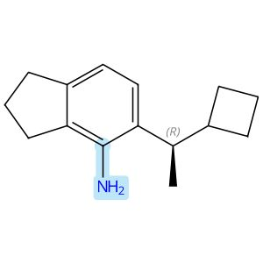
Absolute stereochemistry shown

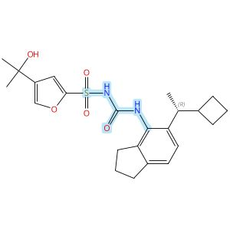
Absolute stereochemistry shown

Scheme 72 (Reaction 1 of 1):

Step 1, Yield: 73%

Discovery of novel and potent NLRP3 inflammasome inhibitors with new lipophilic moieties

By: Chu, Hongzhu; Wei, Yonggang; Zhao, Hongchuan; Ye, Fei; Qian, Xinying; Su, Huilin; Sun, Ying; Zhang, Jing; Jia, Zhilong; Li, Zhiyong; Liang, Xueya

10.1016/j.ejmech.2025.118227
View All Sources in CAS SciFinder
Company/Organization: No. 14, Tianshun Street, Kangbaida (Sichuan) Biotechnology Co. Ltd., Huayang Street, Chengdu, 610213, China
Source: European Journal of Medicinal Chemistry (2026), 301, 118227

Step 1
CAS Reaction Number: 31-614-CAS-47753135
Stage | Reagents | Catalysts | Solvents | Conditions
1 |  |  |  | 1 h, rt
  Diisopropylethylamine
  -
  Dichloromethane
2 |  |  |  | rt
  Water
  -
  -
3 |  |  |  | 0 °C
  Sodium hydride
  -
  Tetrahydrofuran
4 |  |  |  | 0 °C; 2 h, rt
  -
  -
  Tetrahydrofuran
5 |  |  |  | rt
  Water
  -
  -

Notes: intermediate from stage 2 added in stage 4 (stage 4)
Experimental Protocols
Synthetic Methods
Products | N-[[[5-[(1R)-1-Cyclobutylethyl]-2,3-dihydro-1H-inden-4-yl]amino]carbonyl]-4-(1-hydroxy-1-methylethyl)-2-furansulfonamide, Yield: 73%
Reactants | 2,2,2-Trichloroethyl chloroformate  5-[(1R)-1-Cyclobutylethyl]-2,3-dihydro-1H-inden-4-amine  4-(1-Hydroxy-1-methylethyl)-2-furansulfonamide
Reagents | Diisopropylethylamine  Water  Sodium hydride
Solvents | Dichloromethane  Tetrahydrofuran
Procedure
  1. | Add 2,2,2-trichloroethyl chloroformate (70 mg, 0.330 mmol) to a stirred solution of amine (50 mg, 0.23 mmol) and N,N-diisopropylethylamine (45 mg, 0.35 mmol) in DCM at room temperature.
  2. | Stir the reaction mixture for 1 hour at room temperature.
  3. | Quench the reaction with water.
  4. | Extract the reaction mixture with ethyl acetate three times.
  5. | Dry the combined organic layers over anhydrous sodium sulfate.
  6. | Filter the mixture and concentrate in vacuo.
  7. | Add sodium hydride (11 mg, 0.46 mmol) in portions to a stirred solution of sulfonamide (47 mg, 0.23 mmol) in THF at 0°C.
  8. | Add the Troc intermediate solution in THF dropwise into the mixture of sulfonamide at 0°C.
  9. | Stir the resulting reaction mixture for 2 hours at room temperature.
  10. | Quench the reaction mixture with water.
  11. | Extract the mixture with ethyl acetate for three times.
  12. | Dry the combined organic layers over anhydrous sodium sulfate.
  13. | Filter the mixture and concentrate in vacuo.
  14. | Purify the residue by MPLC to obtain (R)-N-((5-(1-cyclobutylethyl)-2,3-dihydro-1H-inden-4-yl)carbamoyl)-4-(2-hydroxypropan-2-yl)furan-2-sulfonamide.
Scale | milligram
Characterization Data
N-[[[5-[(1R)-1-Cyclobutylethyl]-2,3-dihydro-1H-inden-4-yl]amino]carbonyl]-4-(1-hydroxy-1-methylethyl)-2-furansulfonamide
Proton NMR Spectrum | (400 MHz, DMSO-d₆) δ 7.60 (br s, 1H), 7.32 (s, 1H), 6.92 (d, J = 7.7 Hz, 1H), 6.84 (d, J = 7.7 Hz, 1H), 6.65 (s, 1H), 4.92 (s, 1H), 3.01 - 2.91 (m, 1H), 2.78 (t, J = 7.5 Hz, 2H), 2.67 (q, J = 7.5 Hz, 2H), 2.46 - 2.38 (m, 1H), 2.08 - 1.98 (m, 1H), 1.96 - 1.85 (m, 2H), 1.73 - 1.59 (m, 4H), 1.52 - 1.42 (m, 1H), 1.35 (s, 6H), 0.93 (d, J = 6.8 Hz, 3H)
Carbon-13 NMR | (101 MHz, DMSO-d₆) δ 155.6, 142.2, 140.9, 139.8, 137.3, 135.7, 134.3, 123.6, 121.0, 109.1, 66.6, 41.2, 32.5, 31.1, 31.1, 27.0, 26.3, 24.5, 19.1, 17.0
HRMS | (ESI): Calcd for C₂₃H₃₀N₂O₅S [M+H]⁺ 447.1948. Found: 447.1946
State | white solid
CAS Method Number 3-614-CAS-49951471

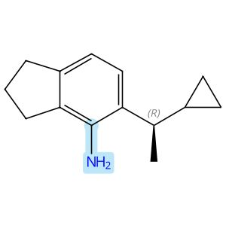  Absolute stereochemistry shown |  |  |  | 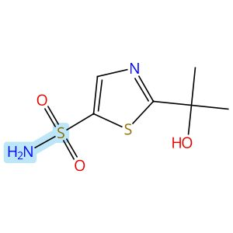
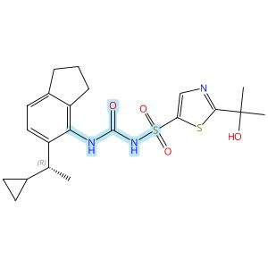
Absolute stereochemistry shown

Scheme 73 (Reaction 1 of 1):

Step 1, Yield: 73%

Discovery of novel and potent NLRP3 inflammasome inhibitors with new lipophilic moieties

By: Chu, Hongzhu; Wei, Yonggang; Zhao, Hongchuan; Ye, Fei; Qian, Xinying; Su, Huilin; Sun, Ying; Zhang, Jing; Jia, Zhilong; Li, Zhiyong; Liang, Xueya

10.1016/j.ejmech.2025.118227
View All Sources in CAS SciFinder
Company/Organization: No. 14, Tianshun Street, Kangbaida (Sichuan) Biotechnology Co. Ltd., Huayang Street, Chengdu, 610213, China
Source: European Journal of Medicinal Chemistry (2026), 301, 118227

Step 1
CAS Reaction Number: 31-614-CAS-47753177
Stage | Reagents | Catalysts | Solvents | Conditions
1 |  |  |  | 1 h, rt
  Diisopropylethylamine
  -
  Dichloromethane
2 |  |  |  | rt
  Water
  -
  -
3 |  |  |  | 0 °C
  Sodium hydride
  -
  Tetrahydrofuran
4 |  |  |  | 0 °C; 2 h, rt
  -
  -
  Tetrahydrofuran
5 |  |  |  | rt
  Water
  -
  -

Notes: intermediate from stage 2 added in stage 4 (stage 4)
Experimental Protocols
Synthetic Methods
Products | N-[[[5-[(1R)-1-Cyclopropylethyl]-2,3-dihydro-1H-inden-4-yl]amino]carbonyl]-2-(1-hydroxy-1-methylethyl)-5-thiazolesulfonamide, Yield: 73%
Reactants | 2,2,2-Trichloroethyl chloroformate  5-[(1R)-1-Cyclopropylethyl]-2,3-dihydro-1H-inden-4-amine  2-(1-Hydroxy-1-methylethyl)-5-thiazolesulfonamide
Reagents | Diisopropylethylamine  Water  Sodium hydride
Solvents | Dichloromethane  Tetrahydrofuran
Procedure
  1. | Add 2,2,2-trichloroethyl chloroformate (77 mg, 0.36 mmol) to a stirred solution of amine (61 mg, 0.30 mmol) and N,N-diisopropylethylamine (58 mg, 0.45 mmol) in DCM at room temperature.
  2. | Stir the reaction mixture for 1 hour at room temperature.
  3. | Quench the reaction with water.
  4. | Extract the reaction mixture with ethyl acetate three times.
  5. | Dry the combined organic layers over anhydrous sodium sulfate.
  6. | Filter the mixture and concentrate in vacuo.
  7. | Add sodium hydride (14 mg, 0.60 mmol) in portions to a stirred solution of sulfonamide (66 mg, 0.30 mmol) in THF at 0°C.
  8. | Add the Troc intermediate solution in THF dropwise into the mixture of sulfonamide at 0°C.
  9. | Stir the resulting reaction mixture for 2 hours at room temperature.
  10. | Quench the reaction mixture with water.
  11. | Extract the mixture with ethyl acetate for three times.
  12. | Dry the combined organic layers over anhydrous sodium sulfate.
  13. | Filter the mixture and concentrate in vacuo.
  14. | Purify the residue by MPLC to obtain (R)-N-((5-(1-cyclopropylethyl)-2,3-dihydro-1H-inden-4-yl)carbamoyl)-2-(2-hydroxypropan-2-yl)thiazole-5-sulfonamide.
Scale | milligram
Characterization Data
N-[[[5-[(1R)-1-Cyclopropylethyl]-2,3-dihydro-1H-inden-4-yl]amino]carbonyl]-2-(1-hydroxy-1-methylethyl)-5-thiazolesulfonamide
Proton NMR Spectrum | (400 MHz, DMSO-d₆) δ 8.19 (s, 1H), 8.01 (br s, 1H), 7.15 (d, J = 7.8 Hz, 1H), 7.10 (d, J = 7.8 Hz, 1H), 6.33 (s, 1H), 2.83 (t, J = 7.4 Hz, 2H), 2.59 - 2.55 (m, 2H), 2.13 - 2.04 (m, 1H), 1.97 - 1.88 (m, 2H), 1.51 (s, 6H), 1.07 (d, J = 6.9 Hz, 3H), 0.96 - 0.87 (m, 1H), 0.45 - 0.39 (m, 1H), 0.21 - 0.14 (m, 1H), 0.07 - 0.01 (m, 1H), -0.07 - -0.12 (m, 1H)
Carbon-13 NMR | (101 MHz, DMSO-d₆) δ 150.8, 147.9, 142.4, 142.3, 142.1, 135.9, 130.4, 125.3, 123.4, 72.9, 38.4, 32.9, 31.1, 30.7, 25.0, 21.8, 18.1, 5.1, 4.2
HRMS | (ESI): Calcd for C₂₁H₂₇N₃O₄S₂ [M+H]⁺ 450.1516. Found: 450.1501
State | white solid
CAS Method Number 3-614-CAS-49951628

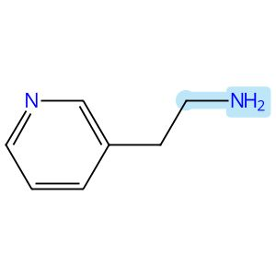

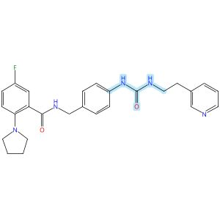

Scheme 74 (Reaction 1 of 1):

Step 1, Yield: 73%

Discovery of potent o-aminobenzoamide-based NAMPT inhibitors for targeting NAPRT-deficient gastric cancer

By: Yang, Heng; Li, Zhiyi; Peng, Huiqian; shen, Lixian; Li, Zhen; Zhu, Lejing; Ding, Rifan; Shi, Yiting; Liu, Yuting; Zhang, Miao; Zhuo, Linsheng; Yang, Meiling; Wang, Zhen; Jiang, Weifan

10.1021/acs.jmedchem.5c02564
View All Sources in CAS SciFinder
Company/Organization: School of Pharmaceutical Science, Hengyang Medical School, University of South China, Hunan, 421001, China
Source: Journal of Medicinal Chemistry (2026), 69(3), 2625-2646

Step 1
CAS Reaction Number: 31-614-CAS-49296546
Stage | Reagents | Catalysts | Solvents | Conditions
1 |  |  |  | 30 min, 0 °C
  Pyridine
  -
  Dichloromethane
2 |  |  |  | 30 min, 0 °C
  -
  -
  Dichloromethane
3 |  |  |  | 4 h, rt
  -
  -
  -
Experimental Protocols
Synthetic Methods
Products | Benzamide, 5-fluoro-N-[[4-[[[[2-(3-pyridinyl)ethyl]amino]carbonyl]amino]phenyl]methyl]-2-(1-pyrrolidinyl)-, Yield: 73%
Reactants | Triphosgene  3-Pyridineethanamine  Benzamide, N-[(4-aminophenyl)methyl]-5-fluoro-2-(1-pyrrolidinyl)-
Reagents | Pyridine
Solvents | Dichloromethane
Procedure
  1. | Combine the triphosgene (1 mmol, 1 equiv) and pyridine (6.8 mmol, 6.8 equiv) in DCM (10 mL).
  2. | Cool the reaction mixture to 0°C in a brine ice bath for 30 minutes.
  3. | Add pyridine derivative (1 M in DCM, 3.4 mmol, 3.4 equiv) to the mixture.
  4. | Stir the reaction mixture for 30 minutes.
  5. | Add the corresponding amine (1 M in DCM, 3.4 mmol, 3.4 equiv) to the mixture.
  6. | Stir the resulting reaction mixture at room temperature for 4 hours.
  7. | Dilute the mixture with DCM.
  8. | Wash the mixture with saturated ammonium chloride.
  9. | Dry the residue over anhydrous sodium sulfate.
  10. | Filter the mixture.
  11. | Concentrate the filtrate in vacuo.
  12. | Purify the crude by sample column chromatography (DCM/MeOH = 25:1) to obtain 5-fluoro-N-(4-(3-(2-(pyridin-3-yl)ethyl)ureido)benzyl)-2-(pyrrolidin-1-yl)benzamide.
Transformation | - Acylation of Nitrogen Nucleophiles by Acyl/ Thioacyl/ Carbamoyl Halides and Analogs
Characterization Data
Benzamide, 5-fluoro-N-[[4-[[[[2-(3-pyridinyl)ethyl]amino]carbonyl]amino]phenyl]methyl]-2-(1-pyrrolidinyl)-
Proton NMR Spectrum | (500 MHz, CDCl₃):9.67 (t, J = 5.7 Hz, 1H), 8.36 (s, 2H), 7.65-7.61 (m, 1H), 7.58 (s, 1H), 7.53 (dt, J = 7.8, 2.0 Hz, 1H), 7.23-7.21 (m, 1H), 7.20-7.18 (m, 2H), 7.16-7.13 (m, 2H), 7.07 (d, J = 1.8 Hz, 1H), 7.06-7.05 (m, 1H), 5.69 (t, J = 5.9 Hz, 1H), 4.47 (d, J = 5.6 Hz, 2H), 3.44 (q, J = 6.6 Hz, 2H), 2.99-2.95 (m, 4H), 2.79 (t, J = 6.9 Hz, 2H), 1.77-1.73 (m, 4H)
Carbon-13 NMR | (125 MHz, CDCl₃): δ 166.6, 158.6 (d, J = 242.6 Hz), 156.0, 149.87, 147.5, 144.8 (d, J = 2.8 Hz), 138.8, 136.9, 135.2, 132.4, 128.6, 128.5 (d, J = 6.9 Hz), 123.8, 120.9 (d, J = 7.5 Hz), 119.9, 118.6 (d, J = 22.4 Hz), 117.2 (d, J = 24.0 Hz), 53.1, 43.6, 41.0, 33.7, 24.6
Fluorine-19 NMR | (471 MHz, CDCl₃): δ - 119.86
HRMS | calcd for C₂₆H₂₈N₅O₂F [M + H]⁺ 462.2305; found 462.2308
Melting Point | 121-122°C
State | yellow solid
CAS Method Number 3-614-CAS-50424752

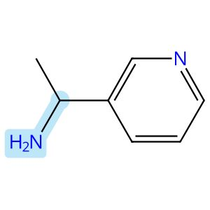

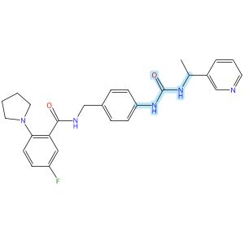

Scheme 75 (Reaction 1 of 1):

Step 1, Yield: 73%

Discovery of potent o-aminobenzoamide-based NAMPT inhibitors for targeting NAPRT-deficient gastric cancer

By: Yang, Heng; Li, Zhiyi; Peng, Huiqian; shen, Lixian; Li, Zhen; Zhu, Lejing; Ding, Rifan; Shi, Yiting; Liu, Yuting; Zhang, Miao; Zhuo, Linsheng; Yang, Meiling; Wang, Zhen; Jiang, Weifan

10.1021/acs.jmedchem.5c02564
View All Sources in CAS SciFinder
Company/Organization: School of Pharmaceutical Science, Hengyang Medical School, University of South China, Hunan, 421001, China
Source: Journal of Medicinal Chemistry (2026), 69(3), 2625-2646

Step 1
CAS Reaction Number: 31-614-CAS-49296540
Stage | Reagents | Catalysts | Solvents | Conditions
1 |  |  |  | 30 min, 0 °C
  Pyridine
  -
  Dichloromethane
2 |  |  |  | 30 min, 0 °C
  -
  -
  Dichloromethane
3 |  |  |  | 4 h, rt
  -
  -
  -
Experimental Protocols
Synthetic Methods
Products | Benzamide, 5-fluoro-N-[[4-[[[[1-(3-pyridinyl)ethyl]amino]carbonyl]amino]phenyl]methyl]-2-(1-pyrrolidinyl)-, Yield: 73%
Reactants | Triphosgene  α-Methyl-3-pyridinemethanamine  Benzamide, N-[(4-aminophenyl)methyl]-5-fluoro-2-(1-pyrrolidinyl)-
Reagents | Pyridine
Solvents | Dichloromethane
Procedure
  1. | Combine the triphosgene (1 mmol, 1 equiv) and pyridine (6.8 mmol, 6.8 equiv) in DCM (10 mL).
  2. | Cool the reaction mixture to 0°C in a brine ice bath for 30 minutes.
  3. | Add pyridine derivative (1 M in DCM, 3.4 mmol, 3.4 equiv) to the mixture.
  4. | Stir the reaction mixture for 30 minutes.
  5. | Add the corresponding amine (1 M in DCM, 3.4 mmol, 3.4 equiv) to the mixture.
  6. | Stir the resulting reaction mixture at room temperature for 4 hours.
  7. | Dilute the mixture with DCM.
  8. | Wash the mixture with saturated ammonium chloride.
  9. | Dry the residue over anhydrous sodium sulfate.
  10. | Filter the mixture.
  11. | Concentrate the filtrate in vacuo.
  12. | Purify the crude by sample column chromatography (DCM/MeOH = 25:1) to obtain 5-fluoro-N-(4-(3-(1-(pyridin-3-yl)ethyl)ureido)benzyl)-2-(pyrrolidin-1-yl)benzamide.
Transformation | - Acylation of Nitrogen Nucleophiles by Acyl/ Thioacyl/ Carbamoyl Halides and Analogs
Characterization Data
Benzamide, 5-fluoro-N-[[4-[[[[1-(3-pyridinyl)ethyl]amino]carbonyl]amino]phenyl]methyl]-2-(1-pyrrolidinyl)-
Proton NMR Spectrum | (500 MHz, CDCl₃): δ 9.67 (t, J = 5.7 Hz, 1H), 8.46 (d, J = 2.3 Hz, 1H), 8.35 (dd, J = 4.9, 1.6 Hz, 1H), 7.91 (s, 1H), 7.60-7.56 (m, 2H), 7.18-7.14 (m, 3H), 7.11-7.08 (m, 2H), 7.08- 7.00 (m, 3H), 6.26 (d, J = 7.4 Hz, 1H), 4.95 (p, J = 7.0 Hz, 1H), 4.45 (d, J = 5.6 Hz, 2H), 2.98-2.94 (m, 4H), 1.74-1.70 (m, 4H), 1.36 (d, J = 7.0 Hz, 3H)
Carbon-13 NMR | (125 MHz, CDCl₃): δ 167.0 (d, J = 1.8 Hz), 158.3 (d, J = 242.3 Hz), 155.4, 148.1, 147.5, 144.7 (d, J = 2.5 Hz), 140.4, 138.9, 134.3, 132.0, 128.5, 128.2 (d, J = 6.5 Hz), 123.7, 120.7 (d, J = 7.4 Hz), 119.6, 118.6 (d, J = 22.2 Hz), 117.0 (d, J = 24.0 Hz), 53.0, 47.6, 43.6, 24.6, 22.6
Fluorine-19 NMR | (471 MHz, CDCl₃): δ - 120.38
HRMS | calcd for C₂₆H₂₈N₅O₂F [M + H]⁺ 462.2305; found 462.2307
Melting Point | 114-115°C
State | pale yellow solid
CAS Method Number 3-614-CAS-50424770

Absolute stereochemistry shown

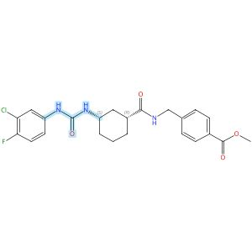
Absolute stereochemistry shown

Scheme 76 (Reaction 1 of 1):

Step 1, Yield: 73%

Design and synthesis of novel sEH inhibitors for the treatment of acute lung injury

By: Xu, Huashen; Ma, Ruiyi; Morisseau, Christophe; Dong, Xinyue; Zhuang, Junning; Wang, Zhe; Liu, Fuqin; Xu, Dong; Chen, Lu; Zhang, Maoying; Zhu, Zhihui; Liu, Xinran; Jiang, Huiwen; Liu, Zhongbo; Hammock, Bruce D.; Cao, Ruolin; Chen, Guoliang

10.1016/j.ejmech.2026.118773
View All Sources in CAS SciFinder
Company/Organization: Key Laboratory of Structure-Based Drug Design & Discovery of Ministry of Education, School of Pharmaceutical Engineering, Shenyang Pharmaceutical University, Shenyang, 110016, China
Source: European Journal of Medicinal Chemistry (2026), 309, 118773

Step 1
CAS Reaction Number: 31-614-CAS-49705409
Stage | Reagents | Catalysts | Solvents | Conditions
1 |  |  |  | 1 h, < -10 °C; -10 °C → rt; 30 min, rt
  Triethylamine
  -
  Dichloromethane
2 |  |  |  | 0.5 h, rt; overnight, rt
  Triethylamine
  -
  Dichloromethane
Experimental Protocols
Synthetic Methods
Products | 3124392-24-8, Yield: 73%
Reactants | 3-Chloro-4-fluoroaniline  Triphosgene  3124392-21-5
Reagents | Triethylamine
Solvents | Dichloromethane
Procedure
  1. | Add a solution of Memantine (0.2 g, 0.93 mmol, 1.0 eq) and Et₃N (0.28 g, 2.78 mmol, 3.0 eq) in DCM (20 mL) dropwise over 1 h to a thick slurry of triphosgene (0.14 g, 0.46 mmol, 0.5 eq) in DCM (10 mL) in a cold trap while maintaining the temperature below 10°C.
  2. | Remove the cold bath and warm the mixture to rt and stir for 30 min.
  3. | Add a slurry of Intermediate (0.30 g, 0.74 mmol, 0.8 eq) and Et₃N (0.56 g, 5.56 mmol, 6.0 eq) in DCM (20 mL) in small portions over 0.5 h at room temperature.
  4. | Stir the reaction mixture overnight.
  5. | Wash the reaction mixture with 10% aq HCl (1 x 20 mL).
  6. | Dry the organic layer over anhydrous MgSO₄ and concentrate under reduced pressure.
Transformation | - Acylation of Nitrogen Nucleophiles by Acyl/ Thioacyl/ Carbamoyl Halides and Analogs
Scale | gram
Characterization Data
3124392-24-8
State | White solid
CAS Method Number 3-614-CAS-50079622

Absolute stereochemistry shown

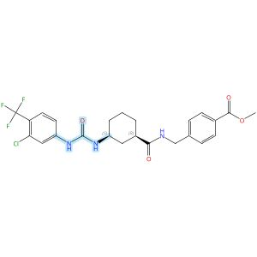
Absolute stereochemistry shown

Scheme 77 (Reaction 1 of 1):

Step 1, Yield: 73%

Design and synthesis of novel sEH inhibitors for the treatment of acute lung injury

By: Xu, Huashen; Ma, Ruiyi; Morisseau, Christophe; Dong, Xinyue; Zhuang, Junning; Wang, Zhe; Liu, Fuqin; Xu, Dong; Chen, Lu; Zhang, Maoying; Zhu, Zhihui; Liu, Xinran; Jiang, Huiwen; Liu, Zhongbo; Hammock, Bruce D.; Cao, Ruolin; Chen, Guoliang

10.1016/j.ejmech.2026.118773
View All Sources in CAS SciFinder
Company/Organization: Key Laboratory of Structure-Based Drug Design & Discovery of Ministry of Education, School of Pharmaceutical Engineering, Shenyang Pharmaceutical University, Shenyang, 110016, China
Source: European Journal of Medicinal Chemistry (2026), 309, 118773

Step 1
CAS Reaction Number: 31-614-CAS-49705412
Stage | Reagents | Catalysts | Solvents | Conditions
1 |  |  |  | 1 h, < -10 °C; -10 °C → rt; 30 min, rt
  Triethylamine
  -
  Dichloromethane
2 |  |  |  | 0.5 h, rt; overnight, rt
  Triethylamine
  -
  Dichloromethane
Experimental Protocols
Synthetic Methods
Products | 3124392-23-7, Yield: 73%
Reactants | 3-Chloro-4-trifluoromethylaniline  Triphosgene  3124392-21-5
Reagents | Triethylamine
Solvents | Dichloromethane
Procedure
  1. | Add a solution of Memantine (0.2 g, 0.93 mmol, 1.0 eq) and Et₃N (0.28 g, 2.78 mmol, 3.0 eq) in DCM (20 mL) dropwise over 1 h to a thick slurry of triphosgene (0.14 g, 0.46 mmol, 0.5 eq) in DCM (10 mL) in a cold trap while maintaining the temperature below 10°C.
  2. | Remove the cold bath and warm the mixture to rt and stir for 30 min.
  3. | Add a slurry of Intermediate (0.30 g, 0.74 mmol, 0.8 eq) and Et₃N (0.56 g, 5.56 mmol, 6.0 eq) in DCM (20 mL) in small portions over 0.5 h at room temperature.
  4. | Stir the reaction mixture overnight.
  5. | Wash the reaction mixture with 10% aq HCl (1 x 20 mL).
  6. | Dry the organic layer over anhydrous MgSO₄ and concentrate under reduced pressure.
Transformation | - Acylation of Nitrogen Nucleophiles by Acyl/ Thioacyl/ Carbamoyl Halides and Analogs
Scale | gram
Characterization Data
3124392-23-7
State | White solid
CAS Method Number 3-614-CAS-50079618

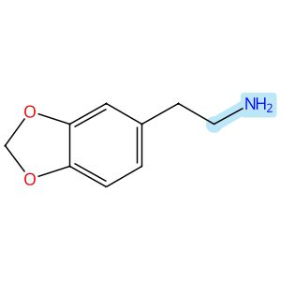

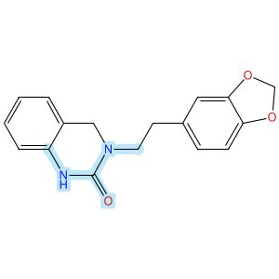

Scheme 78 (Reaction 1 of 1):

Step 1, Yield: 72%

Enantioselective Intramolecular C-H Alkylation Catalyzed by a Nonsymmetric Chiral Cobalt Porphyrin

By: Buchelt, Christoph; Breitenlechner, Stefan; Zuber, Julian; Huber, Stefan M.; Bach, Thorsten

10.1021/jacs.5c19047
View All Sources in CAS SciFinder
Company/Organization: School of Natural Sciences, Department of Chemistry and Catalysis Research Center (CRC), Technische Universitaet Muenchen, Garching, 85747, Germany
Source: Journal of the American Chemical Society (2026), 148(1), 93-98

Step 1
CAS Reaction Number: 31-614-CAS-48658845
Stage | Reagents | Catalysts | Solvents | Conditions
1 |  |  |  | 4 h, 20 °C
  -
  -
  Methanol
2 |  |  |  | 20 °C; 16 h, 20 °C
  Sodium borohydride
  -
  -
3 |  |  |  | 16 h, 60 °C
  -
  -
  Tetrahydrofuran
Experimental Protocols
Synthetic Methods
Products | 2(1H)-Quinazolinone, 3-[2-(1,3-benzodioxol-5-yl)ethyl]-3,4-dihydro-, Yield: 72%
Reactants | 2-Aminobenzaldehyde  1,3-Benzodioxole-5-ethanamine  1,1′-Carbonyldiimidazole
Reagents | Sodium borohydride
Solvents | Methanol  Tetrahydrofuran
Procedure
  1. | Add the homopiperonylamine (607 mg, 3.68 mmol, 1.05 equiv.) to a solution of 2-aminobenzaldehyde (424 mg, 3.50 mmol, 1.00 equiv.) in MeOH (500 mM).
  2. | Stir the corresponding solution at 20°C for 4 hours.
  3. | Add NaBH₄ (2.00 equiv.) to the reaction mixture while the temperature maintaining using a water bath.
  4. | Stir the mixture for 16 hours.
  5. | Add H₂O (5 mL) to the reaction mixture.
  6. | Remove the organic solvent under reduced pressure.
  7. | Redissolve the residue in CH₂Cl₂ (30 mL) and H₂O (30 mL).
  8. | Wash the aqueous layer with CH₂Cl₂ (2 x 30 mL).
  9. | Dry the combined organic layers over Na₂SO₄.
  10. | Filter the mixture.
  11. | Remove the solvent under reduced pressure.
  12. | Redissolve the amine in THF (150 mM).
  13. | Add CDI (1.20 equiv.) in one portion to the mixture.
  14. | Stir the mixture at 60°C for 16 hours.
  15. | Cool the mixture to room temperature.
  16. | Wash the organic layer with saturated LiOH solution (50 mL), aqueous citric acid solution (10 wt%, 50 mL), H₂O (50 mL) and brine (40 mL).
  17. | Dry the organic layer over Na₂SO₄.
  18. | Filter the mixture.
  19. | Remove the solvent under reduced pressure.
  20. | Purify the crude by automated flash column chromatography (CH₂Cl₂/MeOH = 49/1 → 19/1) to obtain 3-(2-(benzo[d][1,3]dioxol-5-yl)ethyl)-3,4-dihydroquinazolin-2(1H)-one.
Transformation | - Reductive Alkylation of Ammonia or Amines  - Acylation of Nitrogen Nucleophiles by Acyl/ Thioacyl/ Carbamoyl Halides and Analogs
Scale | milligram
Characterization Data
2(1H)-Quinazolinone, 3-[2-(1,3-benzodioxol-5-yl)ethyl]-3,4-dihydro-
Proton NMR Spectrum | (500 MHz, CDCl₃): δ [ppm] = 2.84 - 2.89 (m, 2H, H-2’), 3.58 - 3.63 (m, 2H, H-1’), 4.35 (s, 2H, H-4), 5.92 (s, 2H, H-2’’), 6.67 (dd, ³J 7.6 Hz, ⁴J= 1.1 Hz, 1H, H-8), 6.69 (dd, ³J 7.9 Hz, ⁴J= 1.6 Hz, 1H, H-6’’), 6.73 (d, ³J 7.9 Hz, 1H, H-7’’), 6.75 (d, ⁴J= 1.6 Hz, 1H, H-4’’), 6.89 (bs, 1H, NH), 6.92 (virt. td. ³J ≈ ³J 7.6 Hz, ⁴J= 1.1 Hz, 1H, H-6), 6.97 (d, ³J 7.6 Hz, 1H, H-5), 7.16 (virt. td, ³J ≈ ³J 7.6 Hz, ⁴J= 1.5 Hz, 1H, H-7)
Carbon-13 NMR | (126 MHz, CDCl₃): δ [ppm] = 154.1 (C-2), 147.8 (C-3a’’), 146.2 (C-7a’’), 137.0 (C-8a), 132.9 (C-5’’), 128.4 (C-7), 125.6 (C-5), 122.1 (C-6), 121.9 (C-6’’), 117.7 (C-4a), 113.6 (C-8), 109.4 (C-4’’), 108.5 (C-7’’), 101.0 (C-2’’), 49.6 (C-1’), 49.6 (C-4), 33.6 (C-2’)
IR Absorption Spectrum | (ATR): v [cm⁻¹] = 3204 (w, N-H), 2980 (w, C-H), 2921 (w, C-H), 2881 (w, C-H), 2856 (w, C-H), 1662 (m, C=O), 1604 (m, C=C), 1519 (m, C=C), 1505 (m, C=C), 1441 (m), 1318 (m), 1237 (m, C-O), 1118 (m, C-O), 975 (s), 858 (s), 781 (s, C-H), 751 (s, C-H), 745 (s, C-H), 730 (s), 706 (vs)
HRMS | (+ESI): calc. for C₁₇H₁₇N₂O₃ [M+H]⁺: 297.1234; found: 297.1236
Melting Point | 183-185°C
R_{f} | 0.25 (CH2Cl2/ac = 9/1) [UV, KMnO4]
State | colorless solid
CAS Method Number 3-614-CAS-48801646

Absolute stereochemistry shown

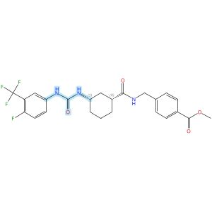
Absolute stereochemistry shown

Scheme 79 (Reaction 1 of 1):

Step 1, Yield: 72%

Design and synthesis of novel sEH inhibitors for the treatment of acute lung injury

By: Xu, Huashen; Ma, Ruiyi; Morisseau, Christophe; Dong, Xinyue; Zhuang, Junning; Wang, Zhe; Liu, Fuqin; Xu, Dong; Chen, Lu; Zhang, Maoying; Zhu, Zhihui; Liu, Xinran; Jiang, Huiwen; Liu, Zhongbo; Hammock, Bruce D.; Cao, Ruolin; Chen, Guoliang

10.1016/j.ejmech.2026.118773
View All Sources in CAS SciFinder
Company/Organization: Key Laboratory of Structure-Based Drug Design & Discovery of Ministry of Education, School of Pharmaceutical Engineering, Shenyang Pharmaceutical University, Shenyang, 110016, China
Source: European Journal of Medicinal Chemistry (2026), 309, 118773

Step 1
CAS Reaction Number: 31-614-CAS-49705410
Stage | Reagents | Catalysts | Solvents | Conditions
1 |  |  |  | 1 h, < -10 °C; -10 °C → rt; 30 min, rt
  Triethylamine
  -
  Dichloromethane
2 |  |  |  | 0.5 h, rt; overnight, rt
  Triethylamine
  -
  Dichloromethane
Experimental Protocols
Synthetic Methods
Products | 3124392-26-0, Yield: 72%
Reactants | 4-Fluoro-3-(trifluoromethyl)aniline  Triphosgene  3124392-21-5
Reagents | Triethylamine
Solvents | Dichloromethane
Procedure
  1. | Add a solution of Memantine (0.2 g, 0.93 mmol, 1.0 eq) and Et₃N (0.28 g, 2.78 mmol, 3.0 eq) in DCM (20 mL) dropwise over 1 h to a thick slurry of triphosgene (0.14 g, 0.46 mmol, 0.5 eq) in DCM (10 mL) in a cold trap while maintaining the temperature below 10°C.
  2. | Remove the cold bath and warm the mixture to rt and stir for 30 min.
  3. | Add a slurry of Intermediate (0.30 g, 0.74 mmol, 0.8 eq) and Et₃N (0.56 g, 5.56 mmol, 6.0 eq) in DCM (20 mL) in small portions over 0.5 h at room temperature.
  4. | Stir the reaction mixture overnight.
  5. | Wash the reaction mixture with 10% aq HCl (1 x 20 mL).
  6. | Dry the organic layer over anhydrous MgSO₄ and concentrate under reduced pressure.
Transformation | - Acylation of Nitrogen Nucleophiles by Acyl/ Thioacyl/ Carbamoyl Halides and Analogs
Scale | gram
Characterization Data
3124392-26-0
Mass Spectrum | ESI-MS m/z: 518.2 [M+Na] +
State | White solid
CAS Method Number 3-614-CAS-50079628

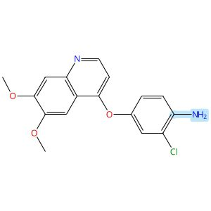

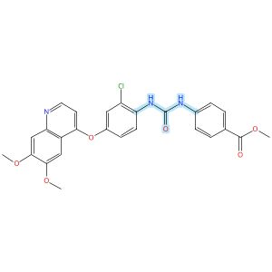

Scheme 80 (Reaction 1 of 1):

Step 1, Yield: 72%

Structure-Based Design and Free Energy Perturbation-Guided Synthesis of Novel VEGFR2 and HDAC Dual Inhibitors with Potent Antitumor Efficacy

By: Li, Yaxin; Liu, Sisi; Hu, Sha; Zhang, Ranran; Wang, Xiaoli; Xu, Jiamin; Yao, Keke; Lu, Chenxuan; Li, Guofeng; Wu, Zhigang; Guo, Chunyan; Yang, Leifu; Hu, Liming

10.1021/acs.jmedchem.5c01650
View All Sources in CAS SciFinder
Company/Organization: Beijing Key Laboratory of Environmental and Oncology, College of Chemistry and Life Science, Beijing University of Technology, Beijing, 100124, China
Source: Journal of Medicinal Chemistry (2026), 69(4), 3762-3778

Step 1
CAS Reaction Number: 31-614-CAS-49395398
Stage | Reagents | Catalysts | Solvents | Conditions
1 |  |  |  | 0 °C
  Triethylamine
  -
  Dichloromethane
2 |  |  |  | 0 °C
  -
  -
  Dichloromethane
Experimental Protocols
Synthetic Methods
Products | Benzoic acid, 4-[[[[2-chloro-4-[(6,7-dimethoxy-4-quinolinyl)oxy]phenyl]amino]carbonyl]amino]-, methyl ester, Yield: 72%
Reactants | Triphosgene  2-Chloro-4-[(6,7-dimethoxy-4-quinolinyl)oxy]benzenamine  Methyl 4-aminobenzoate
Reagents | Triethylamine
Solvents | Dichloromethane
Procedure
  1. | Add triethylamine (4.0 equiv) to a solution of quinoline aniline derivative (1.0 equiv) and triphosgene (0.5 equiv) in 5 mL of dichloromethane, held in an ice-water bath, slowly dropwise.
  2. | Monitor complete consumption of the starting materials.
  3. | Add a solution of aniline or benzylamine (1.0 equiv) in 3 mL of dichloromethane dropwise to the reaction mixture.
  4. | Monitor the progress of the reaction by TLC.
  5. | Filter the solid.
  6. | Purify the solid by column chromatography to obtain methyl 4-(3-(2-chloro-4-((6,7-dimethoxyquinolin-4-yl)oxy)phenyl)ureido)benzoate.
Transformation | - Acylation of Nitrogen Nucleophiles by Acyl/ Thioacyl/ Carbamoyl Halides and Analogs
Characterization Data
Benzoic acid, 4-[[[[2-chloro-4-[(6,7-dimethoxy-4-quinolinyl)oxy]phenyl]amino]carbonyl]amino]-, methyl ester
Proton NMR Spectrum | (400 MHz, DMSO-d₆): δ (ppm) 9.83 (s, 1H), 8.54 (s, 1H), 8.50 (d, J = 5.2 Hz, 1H), 8.26 (d, J = 9.1 Hz, 1H), 7.92 (d, J = 8.8 Hz, 2H), 7.62 (d, J = 8.8 Hz, 2H), 7.53 (d, J = 2.7 Hz, 1H), 7.49 (s, 1H), 7.41 (s, 1H), 7.28 (dd, J = 9.1, 2.8 Hz, 1H), 6.55 (d, J = 5.3 Hz, 1H), 3.95 (s, 3H), 3.93 (s, 3H), 3.82 (s, 3H)
Mass Spectrum | MS (ESI⁺): calcd for C₂₆H₂₃ClN₃O₆ [M + H]⁺, 508.1; found, 508.2
State | white solid
CAS Method Number 3-614-CAS-50096423

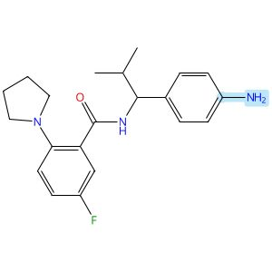

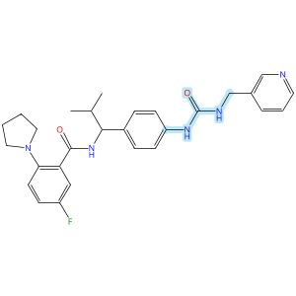

Scheme 81 (Reaction 1 of 1):

Step 1, Yield: 72%

Discovery of potent o-aminobenzoamide-based NAMPT inhibitors for targeting NAPRT-deficient gastric cancer

By: Yang, Heng; Li, Zhiyi; Peng, Huiqian; shen, Lixian; Li, Zhen; Zhu, Lejing; Ding, Rifan; Shi, Yiting; Liu, Yuting; Zhang, Miao; Zhuo, Linsheng; Yang, Meiling; Wang, Zhen; Jiang, Weifan

10.1021/acs.jmedchem.5c02564
View All Sources in CAS SciFinder
Company/Organization: School of Pharmaceutical Science, Hengyang Medical School, University of South China, Hunan, 421001, China
Source: Journal of Medicinal Chemistry (2026), 69(3), 2625-2646

Step 1
CAS Reaction Number: 31-614-CAS-49296549
Stage | Reagents | Catalysts | Solvents | Conditions
1 |  |  |  | 30 min, 0 °C
  Pyridine
  -
  Dichloromethane
2 |  |  |  | 30 min, 0 °C
  -
  -
  Dichloromethane
3 |  |  |  | 4 h, rt
  -
  -
  -
Experimental Protocols
Synthetic Methods
Products | Benzamide, 5-fluoro-N-[2-methyl-1-[4-[[[(3-pyridinylmethyl)amino]carbonyl]amino]phenyl]propyl]-2-(1-pyrrolidinyl)-, Yield: 72%
Reactants | Triphosgene  3-Pyridinemethanamine  Benzamide, N-[1-(4-aminophenyl)-2-methylpropyl]-5-fluoro-2-(1-pyrrolidinyl)-
Reagents | Pyridine
Solvents | Dichloromethane
Procedure
  1. | Combine the triphosgene (1 mmol, 1 equiv) and pyridine (6.8 mmol, 6.8 equiv) in DCM (10 mL).
  2. | Cool the reaction mixture to 0°C in a brine ice bath for 30 minutes.
  3. | Add pyridine derivative (1 M in DCM, 3.4 mmol, 3.4 equiv) to the mixture.
  4. | Stir the reaction mixture for 30 minutes.
  5. | Add the corresponding amine (1 M in DCM, 3.4 mmol, 3.4 equiv) to the mixture.
  6. | Stir the resulting reaction mixture at room temperature for 4 hours.
  7. | Dilute the mixture with DCM.
  8. | Wash the mixture with saturated ammonium chloride.
  9. | Dry the residue over anhydrous sodium sulfate.
  10. | Filter the mixture.
  11. | Concentrate the filtrate in vacuo.
  12. | Purify the crude by sample column chromatography (DCM/MeOH = 25:1) to obtain 5-fluoro-N-(2-methyl-1-(4-(3-(pyridin-3-ylmethyl)-ureido)phenyl)propyl)-2-(pyrrolidin-1-yl)benzamide.
Transformation | - Acylation of Nitrogen Nucleophiles by Acyl/ Thioacyl/ Carbamoyl Halides and Analogs
Characterization Data
Benzamide, 5-fluoro-N-[2-methyl-1-[4-[[[(3-pyridinylmethyl)amino]carbonyl]amino]phenyl]propyl]-2-(1-pyrrolidinyl)-
Proton NMR Spectrum | (500 MHz, CDCl₃): δ 10.59 (d, J = 8.0 Hz, 1H), 8.47 (s, 1H), 8.43 (d, J = 4.2 Hz, 1H), 7.80-7.71 (m, 2H), 7.66 (dd, J = 9.5, 3.2 Hz, 1H), 7.26-7.20 (m, 2H), 7.14-7.09 (m, 1H), 7.09-7.05 (m, 2H), 7.02-6.98 (m, 2H), 6.42 (t, J = 5.9 Hz, 1H), 4.69 (t, J = 7.6 Hz, 1H), 4.46-4.38 (m, 2H), 3.12-3.04 (m, 4H), 1.99-1.95 (m, 4H), 1.28-1.23 (m, 1H), 0.94 (d, J = 6.7 Hz, 3H), 0.82 (d, J = 6.7 Hz, 3H)
Carbon-13 NMR | (125 MHz, CDCl₃): δ 165.9, 159.4 (d, J = 244.5 Hz), 156.2, 148.1, 147.6, 145.5 (d, J = 3.0 Hz), 138.3, 136.6, 136.2, 135.6, 129.6 (d, J = 6.4 Hz), 127.3, 124.0, 123.0 (d, J = 7.8 Hz), 119.7, 119.1 (d, J = 22.3 Hz), 117.2 (d, J = 23.7 Hz), 60.7, 42.1, 54.3, 33.8, 24.9, 19.9, 19.1
Fluorine-19 NMR | (471 MHz, CDCl₃): δ - 117.60
HRMS | calcd for C₂₈H₃₂N₅O₂F [M + Na]⁺ 512.2438; found 512.2441
Melting Point | 213-214°C
State | white solid
CAS Method Number 3-614-CAS-50424788

Absolute stereochemistry shown

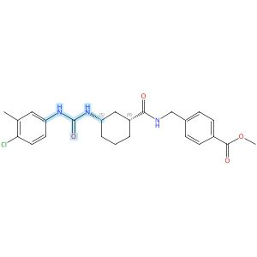
Absolute stereochemistry shown

Scheme 82 (Reaction 1 of 1):

Step 1, Yield: 72%

Design and synthesis of novel sEH inhibitors for the treatment of acute lung injury

By: Xu, Huashen; Ma, Ruiyi; Morisseau, Christophe; Dong, Xinyue; Zhuang, Junning; Wang, Zhe; Liu, Fuqin; Xu, Dong; Chen, Lu; Zhang, Maoying; Zhu, Zhihui; Liu, Xinran; Jiang, Huiwen; Liu, Zhongbo; Hammock, Bruce D.; Cao, Ruolin; Chen, Guoliang

10.1016/j.ejmech.2026.118773
View All Sources in CAS SciFinder
Company/Organization: Key Laboratory of Structure-Based Drug Design & Discovery of Ministry of Education, School of Pharmaceutical Engineering, Shenyang Pharmaceutical University, Shenyang, 110016, China
Source: European Journal of Medicinal Chemistry (2026), 309, 118773

Step 1
CAS Reaction Number: 31-614-CAS-49705419
Stage | Reagents | Catalysts | Solvents | Conditions
1 |  |  |  | 1 h, < -10 °C; -10 °C → rt; 30 min, rt
  Triethylamine
  -
  Dichloromethane
2 |  |  |  | 0.5 h, rt; overnight, rt
  Triethylamine
  -
  Dichloromethane
Experimental Protocols
Synthetic Methods
Products | 3124392-31-7, Yield: 72%
Reactants | 4-Chloro-3-methylaniline  Triphosgene  3124392-21-5
Reagents | Triethylamine
Solvents | Dichloromethane
Procedure
  1. | Add a solution of Memantine (0.2 g, 0.93 mmol, 1.0 eq) and Et₃N (0.28 g, 2.78 mmol, 3.0 eq) in DCM (20 mL) dropwise over 1 h to a thick slurry of triphosgene (0.14 g, 0.46 mmol, 0.5 eq) in DCM (10 mL) in a cold trap while maintaining the temperature below 10°C.
  2. | Remove the cold bath and warm the mixture to rt and stir for 30 min.
  3. | Add a slurry of Intermediate (0.30 g, 0.74 mmol, 0.8 eq) and Et₃N (0.56 g, 5.56 mmol, 6.0 eq) in DCM (20 mL) in small portions over 0.5 h at room temperature.
  4. | Stir the reaction mixture overnight.
  5. | Wash the reaction mixture with 10% aq HCl (1 x 20 mL).
  6. | Dry the organic layer over anhydrous MgSO₄ and concentrate under reduced pressure.
Transformation | - Acylation of Nitrogen Nucleophiles by Acyl/ Thioacyl/ Carbamoyl Halides and Analogs
Scale | gram
Characterization Data
3124392-31-7
State | White solid
CAS Method Number 3-614-CAS-50079645

Relative stereochemistry shown

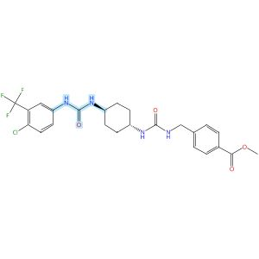
Relative stereochemistry shown

Scheme 83 (Reaction 1 of 1):

Step 1, Yield: 72%

Design and synthesis of novel sEH inhibitors for the treatment of acute lung injury

By: Xu, Huashen; Ma, Ruiyi; Morisseau, Christophe; Dong, Xinyue; Zhuang, Junning; Wang, Zhe; Liu, Fuqin; Xu, Dong; Chen, Lu; Zhang, Maoying; Zhu, Zhihui; Liu, Xinran; Jiang, Huiwen; Liu, Zhongbo; Hammock, Bruce D.; Cao, Ruolin; Chen, Guoliang

10.1016/j.ejmech.2026.118773
View All Sources in CAS SciFinder
Company/Organization: Key Laboratory of Structure-Based Drug Design & Discovery of Ministry of Education, School of Pharmaceutical Engineering, Shenyang Pharmaceutical University, Shenyang, 110016, China
Source: European Journal of Medicinal Chemistry (2026), 309, 118773

Step 1
CAS Reaction Number: 31-614-CAS-49705437
Stage | Reagents | Catalysts | Solvents | Conditions
1 |  |  |  | 1 h, < -10 °C; -10 °C → rt; 30 min, rt
  Triethylamine
  -
  Dichloromethane
2 |  |  |  | 0.5 h, rt; overnight, rt
  Triethylamine
  -
  Dichloromethane
Experimental Protocols
Synthetic Methods
Products | 3124392-47-5, Yield: 72%
Reactants | 4-Chloro-3-(trifluoromethyl)aniline  Triphosgene  3124392-46-4
Reagents | Triethylamine
Solvents | Dichloromethane
Procedure
  1. | Add a solution of 4-chloro-3-(trifluoromethyl)aniline (94 mg, 0.48 mmol, 1.0 eq) and Et₃N (0.15 g, 1.44 mmol, 3.0 eq) in DCM (20 mL) dropwise over 1 h to a thick slurry of triphosgene (71 mg, 0.24 mmol, 0.5 eq) in DCM (10 mL) in a cold trap while maintaining the temperature below 10°C.
  2. | Remove the cold bath and warm the mixture to room temperature and stir for 30 min.
  3. | Add a slurry of Intermediate (0.2 g, 0.48 mmol, 1.0 eq) and Et₃N (0.48 g, 4.8 mmol, 10.0 eq) in DCM (20 mL) in small portions over 0.5 h at room temperature.
  4. | Stir the reaction mixture overnight.
  5. | Wash the reaction mixture with 10% aq HCl (1 x20 mL).
  6. | Dry the organic layer over anhydrous MgSO₄ and concentrate under reduced pressure.
Transformation | - Acylation of Nitrogen Nucleophiles by Acyl/ Thioacyl/ Carbamoyl Halides and Analogs
CAS Method Number 3-614-CAS-50079700

Relative stereochemistry shown

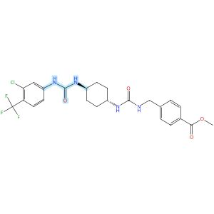
Relative stereochemistry shown

Scheme 84 (Reaction 1 of 1):

Step 1, Yield: 72%

Design and synthesis of novel sEH inhibitors for the treatment of acute lung injury

By: Xu, Huashen; Ma, Ruiyi; Morisseau, Christophe; Dong, Xinyue; Zhuang, Junning; Wang, Zhe; Liu, Fuqin; Xu, Dong; Chen, Lu; Zhang, Maoying; Zhu, Zhihui; Liu, Xinran; Jiang, Huiwen; Liu, Zhongbo; Hammock, Bruce D.; Cao, Ruolin; Chen, Guoliang

10.1016/j.ejmech.2026.118773
View All Sources in CAS SciFinder
Company/Organization: Key Laboratory of Structure-Based Drug Design & Discovery of Ministry of Education, School of Pharmaceutical Engineering, Shenyang Pharmaceutical University, Shenyang, 110016, China
Source: European Journal of Medicinal Chemistry (2026), 309, 118773

Step 1
CAS Reaction Number: 31-614-CAS-49705440
Stage | Reagents | Catalysts | Solvents | Conditions
1 |  |  |  | 1 h, < -10 °C; -10 °C → rt; 30 min, rt
  Triethylamine
  -
  Dichloromethane
2 |  |  |  | 0.5 h, rt; overnight, rt
  Triethylamine
  -
  Dichloromethane
Experimental Protocols
Synthetic Methods
Products | 3124392-53-3, Yield: 72%
Reactants | 3-Chloro-4-trifluoromethylaniline  Triphosgene  3124392-46-4
Reagents | Triethylamine
Solvents | Dichloromethane
Procedure
  1. | Add a solution of 4-chloro-3-(trifluoromethyl)aniline (94 mg, 0.48 mmol, 1.0 eq) and Et₃N (0.15 g, 1.44 mmol, 3.0 eq) in DCM (20 mL) dropwise over 1 h to a thick slurry of triphosgene (71 mg, 0.24 mmol, 0.5 eq) in DCM (10 mL) in a cold trap while maintaining the temperature below 10°C.
  2. | Remove the cold bath and warm the mixture to room temperature and stir for 30 min.
  3. | Add a slurry of Intermediate (0.2 g, 0.48 mmol, 1.0 eq) and Et₃N (0.48 g, 4.8 mmol, 10.0 eq) in DCM (20 mL) in small portions over 0.5 h at room temperature.
  4. | Stir the reaction mixture overnight.
  5. | Wash the reaction mixture with 10% aq HCl (1 x20 mL).
  6. | Dry the organic layer over anhydrous MgSO₄ and concentrate under reduced pressure.
Transformation | - Acylation of Nitrogen Nucleophiles by Acyl/ Thioacyl/ Carbamoyl Halides and Analogs
CAS Method Number 3-614-CAS-50079723

Relative stereochemistry shown

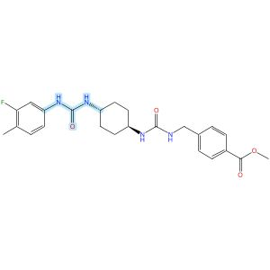
Relative stereochemistry shown

Scheme 85 (Reaction 1 of 1):

Step 1, Yield: 72%

Design and synthesis of novel sEH inhibitors for the treatment of acute lung injury

By: Xu, Huashen; Ma, Ruiyi; Morisseau, Christophe; Dong, Xinyue; Zhuang, Junning; Wang, Zhe; Liu, Fuqin; Xu, Dong; Chen, Lu; Zhang, Maoying; Zhu, Zhihui; Liu, Xinran; Jiang, Huiwen; Liu, Zhongbo; Hammock, Bruce D.; Cao, Ruolin; Chen, Guoliang

10.1016/j.ejmech.2026.118773
View All Sources in CAS SciFinder
Company/Organization: Key Laboratory of Structure-Based Drug Design & Discovery of Ministry of Education, School of Pharmaceutical Engineering, Shenyang Pharmaceutical University, Shenyang, 110016, China
Source: European Journal of Medicinal Chemistry (2026), 309, 118773

Step 1
CAS Reaction Number: 31-614-CAS-49705434
Stage | Reagents | Catalysts | Solvents | Conditions
1 |  |  |  | 1 h, < -10 °C; -10 °C → rt; 30 min, rt
  Triethylamine
  -
  Dichloromethane
2 |  |  |  | 0.5 h, rt; overnight, rt
  Triethylamine
  -
  Dichloromethane
Experimental Protocols
Synthetic Methods
Products | 3124392-49-7, Yield: 72%
Reactants | 3-Fluoro-4-methylaniline  Triphosgene  3124392-46-4
Reagents | Triethylamine
Solvents | Dichloromethane
Procedure
  1. | Add a solution of 4-chloro-3-(trifluoromethyl)aniline (94 mg, 0.48 mmol, 1.0 eq) and Et₃N (0.15 g, 1.44 mmol, 3.0 eq) in DCM (20 mL) dropwise over 1 h to a thick slurry of triphosgene (71 mg, 0.24 mmol, 0.5 eq) in DCM (10 mL) in a cold trap while maintaining the temperature below 10°C.
  2. | Remove the cold bath and warm the mixture to room temperature and stir for 30 min.
  3. | Add a slurry of Intermediate (0.2 g, 0.48 mmol, 1.0 eq) and Et₃N (0.48 g, 4.8 mmol, 10.0 eq) in DCM (20 mL) in small portions over 0.5 h at room temperature.
  4. | Stir the reaction mixture overnight.
  5. | Wash the reaction mixture with 10% aq HCl (1 x20 mL).
  6. | Dry the organic layer over anhydrous MgSO₄ and concentrate under reduced pressure.
Transformation | - Acylation of Nitrogen Nucleophiles by Acyl/ Thioacyl/ Carbamoyl Halides and Analogs
CAS Method Number 3-614-CAS-50079706

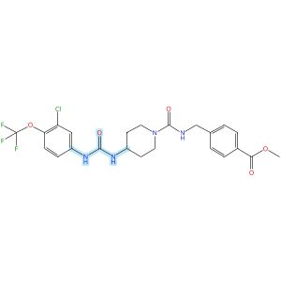

Scheme 86 (Reaction 1 of 1):

Step 1, Yield: 72%

Design and synthesis of novel sEH inhibitors for the treatment of acute lung injury

By: Xu, Huashen; Ma, Ruiyi; Morisseau, Christophe; Dong, Xinyue; Zhuang, Junning; Wang, Zhe; Liu, Fuqin; Xu, Dong; Chen, Lu; Zhang, Maoying; Zhu, Zhihui; Liu, Xinran; Jiang, Huiwen; Liu, Zhongbo; Hammock, Bruce D.; Cao, Ruolin; Chen, Guoliang

10.1016/j.ejmech.2026.118773
View All Sources in CAS SciFinder
Company/Organization: Key Laboratory of Structure-Based Drug Design & Discovery of Ministry of Education, School of Pharmaceutical Engineering, Shenyang Pharmaceutical University, Shenyang, 110016, China
Source: European Journal of Medicinal Chemistry (2026), 309, 118773

Step 1
CAS Reaction Number: 31-614-CAS-49705466
Stage | Reagents | Catalysts | Solvents | Conditions
1 |  |  |  | 1 h, < -10 °C; -10 °C → rt; 30 min, rt
  Triethylamine
  -
  Dichloromethane
2 |  |  |  | 0.5 h, rt; overnight, rt
  Triethylamine
  -
  Dichloromethane
Experimental Protocols
Synthetic Methods
Products | 3124392-83-9, Yield: 72%
Reactants | Triphosgene  3-Chloro-4-(trifluoromethoxy)benzenamine  3124392-72-6
Reagents | Triethylamine
Solvents | Dichloromethane
Procedure
  1. | Add a solution of Memantine (0.15 g, 0.82 mmol, 1.0 eq) and Et₃N (0.25 g, 2.46 mmol, 3.0 eq) in DCM (20 mL) dropwise over 1 h to a thick slurry of triphosgene (0.12 g, 0.41 mmol, 0.5 eq) in DCM (10 mL) in a cold trap while maintaining the temperature below 10°C.
  2. | Remove the cold bath and warm the mixture to room temperature and stir for 30 min.
  3. | Add a slurry of Intermediate (0.3 g, 0.74 mmol, 0.9 eq) and Et₃N (0.42 g, 4.1 mmol, 5.0 eq) in DCM (20 mL) in small portions over 0.5 h at room temperature.
  4. | Stir the reaction mixture overnight.
  5. | Wash the reaction mixture with 10% aq HCl (1 x 20 mL).
  6. | Dry the organic layer over anhydrous MgSO₄ and concentrate under reduced pressure.
Transformation | - Acylation of Nitrogen Nucleophiles by Acyl/ Thioacyl/ Carbamoyl Halides and Analogs
CAS Method Number 3-614-CAS-50079830

Absolute stereochemistry shown |  |  |  | 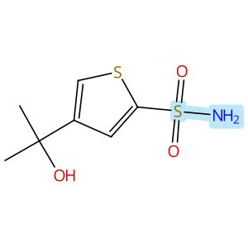
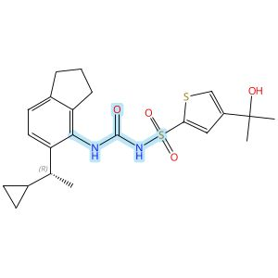
Absolute stereochemistry shown

Scheme 87 (Reaction 1 of 1):

Step 1, Yield: 71%

Discovery of novel and potent NLRP3 inflammasome inhibitors with new lipophilic moieties

By: Chu, Hongzhu; Wei, Yonggang; Zhao, Hongchuan; Ye, Fei; Qian, Xinying; Su, Huilin; Sun, Ying; Zhang, Jing; Jia, Zhilong; Li, Zhiyong; Liang, Xueya

10.1016/j.ejmech.2025.118227
View All Sources in CAS SciFinder
Company/Organization: No. 14, Tianshun Street, Kangbaida (Sichuan) Biotechnology Co. Ltd., Huayang Street, Chengdu, 610213, China
Source: European Journal of Medicinal Chemistry (2026), 301, 118227

Step 1
CAS Reaction Number: 31-614-CAS-47753157
Stage | Reagents | Catalysts | Solvents | Conditions
1 |  |  |  | 1 h, rt
  Diisopropylethylamine
  -
  Dichloromethane
2 |  |  |  | rt
  Water
  -
  -
3 |  |  |  | 0 °C
  Sodium hydride
  -
  Tetrahydrofuran
4 |  |  |  | 0 °C; 2 h, rt
  -
  -
  Tetrahydrofuran
5 |  |  |  | rt
  Water
  -
  -

Notes: intermediate from stage 2 added in stage 4 (stage 4)
Experimental Protocols
Synthetic Methods
Products | N-[[[5-[(1R)-1-Cyclopropylethyl]-2,3-dihydro-1H-inden-4-yl]amino]carbonyl]-4-(1-hydroxy-1-methylethyl)-2-thiophenesulfonamide, Yield: 71%
Reactants | 2,2,2-Trichloroethyl chloroformate  5-[(1R)-1-Cyclopropylethyl]-2,3-dihydro-1H-inden-4-amine  4-(1-Hydroxy-1-methylethyl)-2-thiophenesulfonamide
Reagents | Diisopropylethylamine  Water  Sodium hydride
Solvents | Dichloromethane  Tetrahydrofuran
Procedure
  1. | Add 2,2,2-trichloroethyl chloroformate (53 mg, 0.25 mmol) to a stirred solution of amine (42 mg, 0.21 mmol) and N,N-diisopropylethylamine (41 mg, 0.32 mmol) in DCM at room temperature.
  2. | Stir the reaction mixture for 1 hour at room temperature.
  3. | Quench the reaction with water.
  4. | Extract the reaction mixture with ethyl acetate three times.
  5. | Dry the combined organic layers over anhydrous sodium sulfate.
  6. | Filter the mixture and concentrate in vacuo.
  7. | Add sodium hydride (10 mg, 0.42 mmol) in portions to a stirred solution of sulfonamide (47 mg, 0.21 mmol) in THF at 0°C.
  8. | Add the Troc intermediate solution in THF dropwise into the mixture of sulfonamide at 0°C.
  9. | Stir the resulting reaction mixture for 2 hours at room temperature.
  10. | Quench the reaction mixture with water.
  11. | Extract the mixture with ethyl acetate for three times.
  12. | Dry the combined organic layers over anhydrous sodium sulfate.
  13. | Filter the mixture and concentrate in vacuo.
  14. | Purify the residue by MPLC to obtain (R)-N-((5-(1-cyclopropylethyl)-2,3-dihydro-1H-inden-4-yl)carbamoyl)-4-(2-hydroxypropan-2-yl)thiophene-2-sulfonamide.
Scale | milligram
Characterization Data
N-[[[5-[(1R)-1-Cyclopropylethyl]-2,3-dihydro-1H-inden-4-yl]amino]carbonyl]-4-(1-hydroxy-1-methylethyl)-2-thiophenesulfonamide
Proton NMR Spectrum | (400 MHz, DMSO-d₆) δ 7.91 (br s, 1H), 7.71 (d, J = 1.9 Hz, 1H), 7.68 (d, J = 1.9 Hz, 1H), 7.15 (d, J = 7.9 Hz, 1H), 7.10 (d, J = 7.9 Hz, 1H), 5.23 (s, 1H), 2.82 (t, J = 7.4 Hz, 2H), 2.59 - 2.52 (m, 2H), 2.17 - 2.06 (m, 1H), 1.93 - 1.89 (m, 2H), 1.41 (s, 6H), 1.09 (d, J = 6.9 Hz, 3H), 0.96 - 0.89 (m, 1H), 0.47 - 0.40 (m, 1H), 0.24 - 0.15 (m, 1H), 0.07 - 0.02 (m, 1H), -0.05 - -0.10 (m, 1H)
Carbon-13 NMR | (101 MHz, DMSO-d₆) δ 152.9, 142.3, 141.9, 132.1, 130.5, 129.3, 126.6, 125.3, 125.0, 123.2, 112.8, 69.9, 38.4, 32.9, 31.9, 31.1, 25.0, 21.8, 18.1, 5.1, 4.2
HRMS | (ESI): Calcd for C₂₂H₂₈N₂O₄S₂ [M+H]⁺ 449.1563. Found: 449.1576
State | white solid
CAS Method Number 3-614-CAS-49951609

Absolute stereochemistry shown |  |  |  | 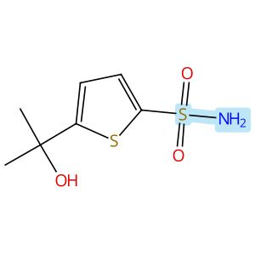
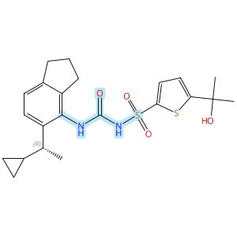
Absolute stereochemistry shown

Scheme 88 (Reaction 1 of 1):

Step 1, Yield: 71%

Discovery of novel and potent NLRP3 inflammasome inhibitors with new lipophilic moieties

By: Chu, Hongzhu; Wei, Yonggang; Zhao, Hongchuan; Ye, Fei; Qian, Xinying; Su, Huilin; Sun, Ying; Zhang, Jing; Jia, Zhilong; Li, Zhiyong; Liang, Xueya

10.1016/j.ejmech.2025.118227
View All Sources in CAS SciFinder
Company/Organization: No. 14, Tianshun Street, Kangbaida (Sichuan) Biotechnology Co. Ltd., Huayang Street, Chengdu, 610213, China
Source: European Journal of Medicinal Chemistry (2026), 301, 118227

Step 1
CAS Reaction Number: 31-614-CAS-47753168
Stage | Reagents | Catalysts | Solvents | Conditions
1 |  |  |  | 1 h, rt
  Diisopropylethylamine
  -
  Dichloromethane
2 |  |  |  | rt
  Water
  -
  -
3 |  |  |  | 0 °C
  Sodium hydride
  -
  Tetrahydrofuran
4 |  |  |  | 0 °C; 2 h, rt
  -
  -
  Tetrahydrofuran
5 |  |  |  | rt
  Water
  -
  -

Notes: intermediate from stage 2 added in stage 4 (stage 4)
Experimental Protocols
Synthetic Methods
Products | N-[[[5-[(1R)-1-Cyclopropylethyl]-2,3-dihydro-1H-inden-4-yl]amino]carbonyl]-5-(1-hydroxy-1-methylethyl)-2-thiophenesulfonamide, Yield: 71%
Reactants | 2,2,2-Trichloroethyl chloroformate  5-[(1R)-1-Cyclopropylethyl]-2,3-dihydro-1H-inden-4-amine  2-Thiophenesulfonamide, 5-(1-hydroxy-1-methylethyl)-
Reagents | Diisopropylethylamine  Water  Sodium hydride
Solvents | Dichloromethane  Tetrahydrofuran
Procedure
  1. | Add 2,2,2-trichloroethyl chloroformate (70 mg, 0.330 mmol) to a stirred solution of amine (49 mg, 0.24 mmol) and N,N-diisopropylethylamine (46 mg, 0.36 mmol) in DCM at room temperature.
  2. | Stir the reaction mixture for 1 hour at room temperature.
  3. | Quench the reaction with water.
  4. | Extract the reaction mixture with ethyl acetate three times.
  5. | Dry the combined organic layers over anhydrous sodium sulfate.
  6. | Filter the mixture and concentrate in vacuo.
  7. | Add sodium hydride (12 mg, 0.48 mmol) in portions to a stirred solution of sulfonamide (53 mg, 0.24 mmol) in THF at 0°C.
  8. | Add the Troc intermediate solution in THF dropwise into the mixture of sulfonamide at 0°C.
  9. | Stir the resulting reaction mixture for 2 hours at room temperature.
  10. | Quench the reaction mixture with water.
  11. | Extract the mixture with ethyl acetate for three times.
  12. | Dry the combined organic layers over anhydrous sodium sulfate.
  13. | Filter the mixture and concentrate in vacuo.
  14. | Purify the residue by MPLC to obtain (R)-N-((5-(1-cyclopropylethyl)-2,3-dihydro-1H-inden-4-yl)carbamoyl)-5-(2-hydroxypropan-2-yl)thiophene-2-sulfonamide.
Scale | milligram
Characterization Data
N-[[[5-[(1R)-1-Cyclopropylethyl]-2,3-dihydro-1H-inden-4-yl]amino]carbonyl]-5-(1-hydroxy-1-methylethyl)-2-thiophenesulfonamide
Proton NMR Spectrum | (400 MHz, DMSO-d₆) δ 7.42 (br s, 1H), 7.15 (d, J = 3.6 Hz, 1H), 7.07 (d, J = 7.7 Hz, 1H), 6.96 (d, J = 7.7 Hz, 1H), 6.71 (d, J = 3.6 Hz, 1H), 5.45 (s, 1H), 2.79 (t, J = 7.4 Hz, 2H), 2.67 (t, J = 7.4 Hz, 2H), 2.36 - 2.23 (m, 1H), 1.97 - 1.80 (m, 2H), 1.47 (s, 6H), 1.09 (d, J = 6.9 Hz, 3H), 0.97 - 0.88 (m, 1H), 0.48 - 0.39 (m, 1H), 0.23 - 0.14 (m, 1H), 0.06 - 0.01 (m, 2H)
Carbon-13 NMR | (101 MHz, DMSO-d₆) δ 158.1, 146.6, 142.0, 141.5, 140.9, 133.6, 126.9, 124.0, 120.9, 119.8, 69.8, 37.5, 32.4, 31.0, 24.6, 21.6, 20.7, 17.8, 14.0, 4.6, 3.8
HRMS | (ESI): Calcd for C₂₂H₂₈N₂O₄S₂ [M+H]⁺ 449.1563. Found: 449.1577
State | white solid
CAS Method Number 3-614-CAS-49951614

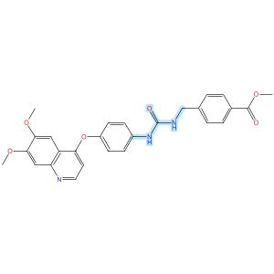

Scheme 89 (Reaction 1 of 1):

Step 1, Yield: 71%

Structure-Based Design and Free Energy Perturbation-Guided Synthesis of Novel VEGFR2 and HDAC Dual Inhibitors with Potent Antitumor Efficacy

By: Li, Yaxin; Liu, Sisi; Hu, Sha; Zhang, Ranran; Wang, Xiaoli; Xu, Jiamin; Yao, Keke; Lu, Chenxuan; Li, Guofeng; Wu, Zhigang; Guo, Chunyan; Yang, Leifu; Hu, Liming

10.1021/acs.jmedchem.5c01650
View All Sources in CAS SciFinder
Company/Organization: Beijing Key Laboratory of Environmental and Oncology, College of Chemistry and Life Science, Beijing University of Technology, Beijing, 100124, China
Source: Journal of Medicinal Chemistry (2026), 69(4), 3762-3778

Step 1
CAS Reaction Number: 31-614-CAS-49395389
Stage | Reagents | Catalysts | Solvents | Conditions
1 |  |  |  | 0 °C
  Triethylamine
  -
  Dichloromethane
2 |  |  |  | 0 °C
  -
  -
  Dichloromethane
Experimental Protocols
Synthetic Methods
Products | 3124575-06-7, Yield: 71%
Reactants | Triphosgene  4-[(6,7-Dimethoxyquinolin-4-yl)oxy]aniline  Methyl 4-(aminomethyl)benzoate
Reagents | Triethylamine
Solvents | Dichloromethane
Procedure
  1. | Add triethylamine (4.0 equiv) to a solution of quinoline aniline derivative (1.0 equiv) and triphosgene (0.5 equiv) in 5 mL of dichloromethane, held in an ice-water bath, slowly dropwise.
  2. | Monitor complete consumption of the starting materials.
  3. | Add a solution of aniline or benzylamine (1.0 equiv) in 3 mL of dichloromethane dropwise to the reaction mixture.
  4. | Monitor the progress of the reaction by TLC.
  5. | Filter the solid.
  6. | Purify the solid by column chromatography to obtain methyl 4-((3-(4-((6,7-dimethoxyquinolin-4-yl)-oxy)phenyl)ureido)methyl)benzoate.
Transformation | - Acylation of Nitrogen Nucleophiles by Acyl/ Thioacyl/ Carbamoyl Halides and Analogs
Characterization Data
3124575-06-7
Proton NMR Spectrum | (400 MHz, DMSO-d₆): δ (ppm) 9.04 (s, 1H), 8.45 (d, J = 5.3 Hz, 1H), 7.95 (d, J = 7.9 Hz, 2H), 7.56 (d, J = 8.5 Hz, 2H), 7.52 (s, 1H), 7.46 (d, J = 7.9 Hz, 2H), 7.39 (s, 1H), 7.15 (d, J = 8.4 Hz, 2H), 6.93 (t, J = 6.1 Hz, 1H), 6.41 (d, J = 5.2 Hz, 1H), 4.41 (d, J = 5.9 Hz, 2H), 3.94 (s, 3H), 3.94 (s, 3H), 3.85 (s, 3H)
Mass Spectrum | MS (ESI⁺): calcd for C₂₇H₂₆N₃O₆ [M + H]⁺, 488.2; found, 488.2
State | white solid
CAS Method Number 3-614-CAS-50096405

Relative stereochemistry shown

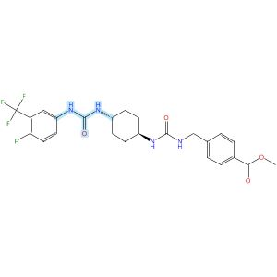
Relative stereochemistry shown

Scheme 90 (Reaction 1 of 1):

Step 1, Yield: 71%

Design and synthesis of novel sEH inhibitors for the treatment of acute lung injury

By: Xu, Huashen; Ma, Ruiyi; Morisseau, Christophe; Dong, Xinyue; Zhuang, Junning; Wang, Zhe; Liu, Fuqin; Xu, Dong; Chen, Lu; Zhang, Maoying; Zhu, Zhihui; Liu, Xinran; Jiang, Huiwen; Liu, Zhongbo; Hammock, Bruce D.; Cao, Ruolin; Chen, Guoliang

10.1016/j.ejmech.2026.118773
View All Sources in CAS SciFinder
Company/Organization: Key Laboratory of Structure-Based Drug Design & Discovery of Ministry of Education, School of Pharmaceutical Engineering, Shenyang Pharmaceutical University, Shenyang, 110016, China
Source: European Journal of Medicinal Chemistry (2026), 309, 118773

Step 1
CAS Reaction Number: 31-614-CAS-49705442
Stage | Reagents | Catalysts | Solvents | Conditions
1 |  |  |  | 1 h, < -10 °C; -10 °C → rt; 30 min, rt
  Triethylamine
  -
  Dichloromethane
2 |  |  |  | 0.5 h, rt; overnight, rt
  Triethylamine
  -
  Dichloromethane
Experimental Protocols
Synthetic Methods
Products | 3124392-55-5, Yield: 71%
Reactants | 4-Fluoro-3-(trifluoromethyl)aniline  Triphosgene  3124392-46-4
Reagents | Triethylamine
Solvents | Dichloromethane
Procedure
  1. | Add a solution of 4-chloro-3-(trifluoromethyl)aniline (94 mg, 0.48 mmol, 1.0 eq) and Et₃N (0.15 g, 1.44 mmol, 3.0 eq) in DCM (20 mL) dropwise over 1 h to a thick slurry of triphosgene (71 mg, 0.24 mmol, 0.5 eq) in DCM (10 mL) in a cold trap while maintaining the temperature below 10°C.
  2. | Remove the cold bath and warm the mixture to room temperature and stir for 30 min.
  3. | Add a slurry of Intermediate (0.2 g, 0.48 mmol, 1.0 eq) and Et₃N (0.48 g, 4.8 mmol, 10.0 eq) in DCM (20 mL) in small portions over 0.5 h at room temperature.
  4. | Stir the reaction mixture overnight.
  5. | Wash the reaction mixture with 10% aq HCl (1 x20 mL).
  6. | Dry the organic layer over anhydrous MgSO₄ and concentrate under reduced pressure.
Transformation | - Acylation of Nitrogen Nucleophiles by Acyl/ Thioacyl/ Carbamoyl Halides and Analogs
CAS Method Number 3-614-CAS-50079734

Relative stereochemistry shown

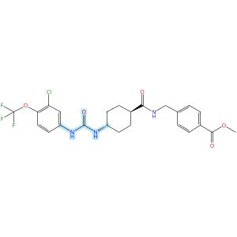
Relative stereochemistry shown

Scheme 91 (Reaction 1 of 1):

Step 1, Yield: 71%

Design and synthesis of novel sEH inhibitors for the treatment of acute lung injury

By: Xu, Huashen; Ma, Ruiyi; Morisseau, Christophe; Dong, Xinyue; Zhuang, Junning; Wang, Zhe; Liu, Fuqin; Xu, Dong; Chen, Lu; Zhang, Maoying; Zhu, Zhihui; Liu, Xinran; Jiang, Huiwen; Liu, Zhongbo; Hammock, Bruce D.; Cao, Ruolin; Chen, Guoliang

10.1016/j.ejmech.2026.118773
View All Sources in CAS SciFinder
Company/Organization: Key Laboratory of Structure-Based Drug Design & Discovery of Ministry of Education, School of Pharmaceutical Engineering, Shenyang Pharmaceutical University, Shenyang, 110016, China
Source: European Journal of Medicinal Chemistry (2026), 309, 118773

Step 1
CAS Reaction Number: 31-614-CAS-49705394
Stage | Reagents | Catalysts | Solvents | Conditions
1 |  |  |  | 1 h, < -10 °C; -10 °C → rt; 30 min, rt
  Triethylamine
  -
  Dichloromethane
2 |  |  |  | 0.5 h, rt; overnight, rt
  Triethylamine
  -
  Dichloromethane
Experimental Protocols
Synthetic Methods
Products | 3124392-05-5, Yield: 71%
Reactants | Triphosgene  3-Chloro-4-(trifluoromethoxy)benzenamine  3124391-96-1
Reagents | Triethylamine
Solvents | Dichloromethane
Procedure
  1. | Add a solution of reactant (0.2 g, 0.93 mmol, 1.0 eq) and Et₃N (0.28 g, 2.78 mmol, 3.0 eq) in DCM (20 mL) dropwise over 1 h to a thick slurry of triphosgene (0.14 g, 0.46 mmol, 0.5 eq) in DCM (10 mL) in a cold trap while maintaining the temperature below 10°C.
  2. | Remove the cold bath and warm the mixture to room temperature and stir for 30 min.
  3. | Add a slurry of Intermediate (0.30 g, 0.74 mmol, 0.8 eq) and Et₃N (0.56 g, 5.56 mmol, 6.0 eq) in DCM (20 mL) in small portions over 0.5 h at room temperature.
  4. | Stir the reaction mixture overnight.
  5. | Wash the reaction mixture with 10% aq HCl (1 x 20 mL).
  6. | Dry the organic layer over anhydrous MgSO₄ and concentrate under reduced pressure.
Transformation | - Acylation of Nitrogen Nucleophiles by Acyl/ Thioacyl/ Carbamoyl Halides and Analogs
Scale | gram
Characterization Data
3124392-05-5
Mass Spectrum | ESI-MS m/z: 525.9 [M H]-
State | White solid
CAS Method Number 3-614-CAS-50079542

Relative stereochemistry shown

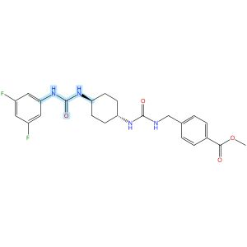
Relative stereochemistry shown

Scheme 92 (Reaction 1 of 1):

Step 1, Yield: 71%

Design and synthesis of novel sEH inhibitors for the treatment of acute lung injury

By: Xu, Huashen; Ma, Ruiyi; Morisseau, Christophe; Dong, Xinyue; Zhuang, Junning; Wang, Zhe; Liu, Fuqin; Xu, Dong; Chen, Lu; Zhang, Maoying; Zhu, Zhihui; Liu, Xinran; Jiang, Huiwen; Liu, Zhongbo; Hammock, Bruce D.; Cao, Ruolin; Chen, Guoliang

10.1016/j.ejmech.2026.118773
View All Sources in CAS SciFinder
Company/Organization: Key Laboratory of Structure-Based Drug Design & Discovery of Ministry of Education, School of Pharmaceutical Engineering, Shenyang Pharmaceutical University, Shenyang, 110016, China
Source: European Journal of Medicinal Chemistry (2026), 309, 118773

Step 1
CAS Reaction Number: 31-614-CAS-49705439
Stage | Reagents | Catalysts | Solvents | Conditions
1 |  |  |  | 1 h, < -10 °C; -10 °C → rt; 30 min, rt
  Triethylamine
  -
  Dichloromethane
2 |  |  |  | 0.5 h, rt; overnight, rt
  Triethylamine
  -
  Dichloromethane
Experimental Protocols
Synthetic Methods
Products | 3124392-50-0, Yield: 71%
Reactants | 3,5-Difluoroaniline  Triphosgene  3124392-46-4
Reagents | Triethylamine
Solvents | Dichloromethane
Procedure
  1. | Add a solution of 4-chloro-3-(trifluoromethyl)aniline (94 mg, 0.48 mmol, 1.0 eq) and Et₃N (0.15 g, 1.44 mmol, 3.0 eq) in DCM (20 mL) dropwise over 1 h to a thick slurry of triphosgene (71 mg, 0.24 mmol, 0.5 eq) in DCM (10 mL) in a cold trap while maintaining the temperature below 10°C.
  2. | Remove the cold bath and warm the mixture to room temperature and stir for 30 min.
  3. | Add a slurry of Intermediate (0.2 g, 0.48 mmol, 1.0 eq) and Et₃N (0.48 g, 4.8 mmol, 10.0 eq) in DCM (20 mL) in small portions over 0.5 h at room temperature.
  4. | Stir the reaction mixture overnight.
  5. | Wash the reaction mixture with 10% aq HCl (1 x20 mL).
  6. | Dry the organic layer over anhydrous MgSO₄ and concentrate under reduced pressure.
Transformation | - Acylation of Nitrogen Nucleophiles by Acyl/ Thioacyl/ Carbamoyl Halides and Analogs
CAS Method Number 3-614-CAS-50079710

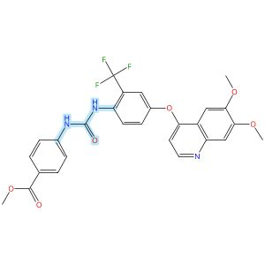

Scheme 93 (Reaction 1 of 1):

Step 1, Yield: 71%

Structure-Based Design and Free Energy Perturbation-Guided Synthesis of Novel VEGFR2 and HDAC Dual Inhibitors with Potent Antitumor Efficacy

By: Li, Yaxin; Liu, Sisi; Hu, Sha; Zhang, Ranran; Wang, Xiaoli; Xu, Jiamin; Yao, Keke; Lu, Chenxuan; Li, Guofeng; Wu, Zhigang; Guo, Chunyan; Yang, Leifu; Hu, Liming

10.1021/acs.jmedchem.5c01650
View All Sources in CAS SciFinder
Company/Organization: Beijing Key Laboratory of Environmental and Oncology, College of Chemistry and Life Science, Beijing University of Technology, Beijing, 100124, China
Source: Journal of Medicinal Chemistry (2026), 69(4), 3762-3778

Step 1
CAS Reaction Number: 31-614-CAS-49395403
Stage | Reagents | Catalysts | Solvents | Conditions
1 |  |  |  | 0 °C
  Triethylamine
  -
  Dichloromethane
2 |  |  |  | 0 °C
  -
  -
  Dichloromethane
Experimental Protocols
Synthetic Methods
Products | Benzoic acid, 4-[[[[4-[(6,7-dimethoxy-4-quinolinyl)oxy]-2-(trifluoromethyl)phenyl]amino]carbonyl]amino]-, methyl ester, Yield: 71%
Reactants | Triphosgene  4-[(6,7-Dimethoxy-4-quinolinyl)oxy]-2-(trifluoromethyl)benzenamine  Methyl 4-aminobenzoate
Reagents | Triethylamine
Solvents | Dichloromethane
Procedure
  1. | Add triethylamine (4.0 equiv) to a solution of quinoline aniline derivative (1.0 equiv) and triphosgene (0.5 equiv) in 5 mL of dichloromethane, held in an ice-water bath, slowly dropwise.
  2. | Monitor complete consumption of the starting materials.
  3. | Add a solution of aniline or benzylamine (1.0 equiv) in 3 mL of dichloromethane dropwise to the reaction mixture.
  4. | Monitor the progress of the reaction by TLC.
  5. | Filter the solid.
  6. | Purify the solid by column chromatography to obtain methyl 4-(3-(4-((6,7-dimethoxyquinolin-4-yl)- oxy)-2-(trifluoromethyl)phenyl)ureido)benzoate.
Transformation | - Acylation of Nitrogen Nucleophiles by Acyl/ Thioacyl/ Carbamoyl Halides and Analogs
Characterization Data
Benzoic acid, 4-[[[[4-[(6,7-dimethoxy-4-quinolinyl)oxy]-2-(trifluoromethyl)phenyl]amino]carbonyl]amino]-, methyl ester
Proton NMR Spectrum | (400 MHz, DMSO-d₆): δ (ppm) 9.75 (s, 1H), 8.53 (d, J = 5.2 Hz, 1H), 8.31 (s, 1H), 8.03 (d, J = 8.9 Hz, 1H), 7.92 (d, J = 8.8 Hz, 2H), 7.65 (d, J = 2.8 Hz, 1H), 7.63 (s, 1H), 7.61-7.58 (m, 2H), 7.52 (s, 1H), 7.42 (s, 1H), 6.60 (d, J = 5.2 Hz, 1H), 3.96 (s, 3H), 3.94 (s, 3H), 3.82 (s, 3H)
Mass Spectrum | MS (ESI⁺): calcd for C₂₇H₂₃F₃N₃O₆ [M + H]⁺, 542.2; found, 542.2
State | white solid
CAS Method Number 3-614-CAS-50096427

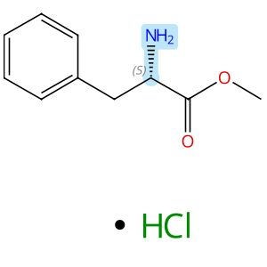  Absolute stereochemistry shown,  Rotation (+) |  |  |  | 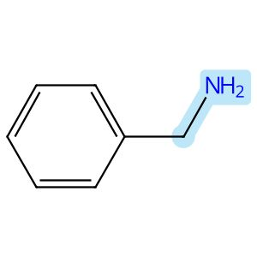
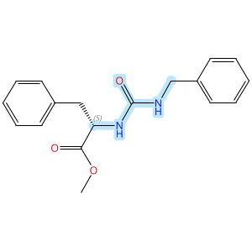
Absolute stereochemistry shown,

Rotation (+)

Scheme 94 (Reaction 1 of 1):

Step 1, Yield: 70%

Peptidomimetic α,β-Unsaturated Ethyl Esters Are Irreversible Inactivators of Human Cathepsin L and Are Potent Inhibitors of SARS-CoV-2 in Cellular Models of COVID-19

By: Kumar, Vivek; Drelich, Aleksandra; Chenna, Bala C.; Rademacher, Andrew; Kemp, Alexandria M.; Saenkham-Huntsinger, Panatda; Scott, Elena; Laganowsky, Arthur; Tseng, Chien-Te; Meek, Thomas D.

10.1021/acs.jmedchem.5c03172
View All Sources in CAS SciFinder
Company/Organization: Department of Biochemistry and Biophysics, Texas A&M University, College Station, Texas, 77843, United States
Source: Journal of Medicinal Chemistry (2026), 69(10), 11797-11818

Step 1
CAS Reaction Number: 31-614-CAS-51830808
Stage | Reagents | Catalysts | Solvents | Conditions
1 |  |  |  | rt; 30 min, rt
  Trimethylamine
  -
  Dimethylformamide
  Acetonitrile
2 |  |  |  | > 25 h, rt
  -
  -
  -
Experimental Protocols
Synthetic Methods
Products | N-[[(Phenylmethyl)amino]carbonyl]-L-phenylalanine methyl ester, Yield: 70%
Reactants | 1,1′-Carbonyldiimidazole  L-Phenylalanine, methyl ester, hydrochloride  Benzylamine
Reagents | Trimethylamine
Solvents | Dimethylformamide  Acetonitrile
Procedure
  1. | Add N, N’-carbonyldiimidazole (CDI) (3.28 g, 20.2 mmol, 1.09 equiv) and L-phenylalanine methyl ester hydrochloride (4.01 g, 18.6 mmol, 1 equiv) dissolves in 80 mL of ACN and 15 mL of DMF to a 250 mL round bottom flask.
  2. | Add Et₃N (5.2 mL, 37.2 mmol, 2 equiv) slowly, to this solution.
  3. | Stir the reaction for 30 min at room temperature.
  4. | Add benzyl amine (2.03 mL, 1 equiv) to the reaction mixture.
  5. | Stir for more than 25 h.
  6. | After reaction completion, evaporate ACN under vacuum, and add excess water to the solution.
  7. | Extract with EtOAc three times (3 x 100 mL).
  8. | Wash the organic layer with 0.1 N HCl three times (3 x 100 mL) and wash with brine solution three times (3 x 100 mL).
  9. | Dry the compound by adding anhydrous Na₂SO₄ and concentrate under a vacuum.
  10. | Purify the compound using silica gel column chromatography using increasing gradient of EtOAc in an EtOAc/hexane (v/v) solvent system and elute at 25- 30% EtOAc/hexane (v/v).
  11. | Concentrate the compound under vacuum.
CAS Method Number 3-614-CAS-51982621

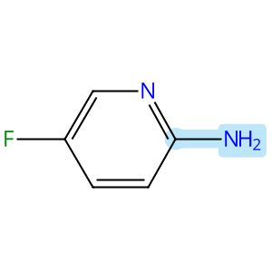

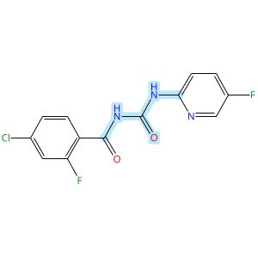

Scheme 95 (Reaction 1 of 1):

Step 1, Yield: 70%

Design, Synthesis, and Preclinical Evaluation of a PET Tracer Targeting Methionine Adenosyltransferase 2A

By: Jiang, Zeng; Huang, Yong; Chen, Hualong; Yu, Ziyue; Cheng, Xuebo; Liu, Yajing; Wu, Zehui

10.1021/acs.jmedchem.5c02532
View All Sources in CAS SciFinder
Company/Organization: Beijing Institute of Brain Disorders, Beijing Key Laboratory of Innovation and Translation of Central Nervous System Radiopharmaceuticals, Capital Medical University, Beijing, 100069, China
Source: Journal of Medicinal Chemistry (2026), 69(3), 2575-2598

Step 1
CAS Reaction Number: 31-614-CAS-49099067
Stage | Reagents | Catalysts | Solvents | Conditions
1 |  |  |  | rt; 30 min, 80 °C; 80 °C → rt
  -
  -
  1,2-Dichloroethane
2 |  |  |  | 1 h, rt
  -
  -
  -
3 |  |  |  | 10 min, rt
  Sodium bicarbonate
  -
  Water
Experimental Protocols
Synthetic Methods
Products | Benzamide, 4-chloro-2-fluoro-N-[[(5-fluoro-2-pyridinyl)amino]carbonyl]-, Yield: 70%
Reactants | Oxalyl chloride  4-Chloro-2-fluorobenzamide  2-Amino-5-fluoropyridine
Reagents | Sodium bicarbonate
Solvents | 1,2-Dichloroethane  Water
Procedure
  1. | Dissolve 4-chloro-2-fluorobenzamide (500 mg, 2.88 mmol) in 20 mL of DCE.
  2. | Add oxalyl chloride (402 mg, 3.17 mmol) to the mixture at room temperature.
  3. | Stir the mixture at 80°C for 30 minutes.
  4. | Cool the mixture to room temperature.
  5. | Add 2-amino-5-fluoro-pyridine (646 mg, 5.76 mmol) to the mixture.
  6. | Stir the mixture continuously at room temperature for 1 hour.
  7. | Add 100 mL of saturated NaHCO₃ solution to the mixture.
  8. | Stir the mixture for 10 minutes.
  9. | Filter the mixture.
  10. | Wash the filter cake with water.
  11. | Dry the residue to afford 4-chloro-2-fluoro-N-((5-fluoropyridin-2-yl)-carbamoyl)benzamide.
Transformation | - Acylation of Nitrogen Nucleophiles by Acyl/ Thioacyl/ Carbamoyl Halides and Analogs
Scale | milligram
Characterization Data
Benzamide, 4-chloro-2-fluoro-N-[[(5-fluoro-2-pyridinyl)amino]carbonyl]-
Proton NMR Spectrum | (300 MHz, DMSO-d₆) δ 11.32 (s, 1H), 10.88 (s, 1H), 8.36 (d, J = 3.0 Hz, 1H), 8.05 (dd, J = 9.2, 4.1 Hz, 1H), 7.85-7.78 (m, 1H), 7.78-7.71 (m, 1H), 7.65 (dd, J = 10.3, 1.9 Hz, 1H), 7.45 (dd, J = 8.4, 1.7 Hz, 1H)
HRMS | calcd for C₁₃H₉ClF₂N₃O₂⁺, 312.0346[M + H]⁺, found: 312.0348
State | white solid
CAS Method Number 3-614-CAS-50416096

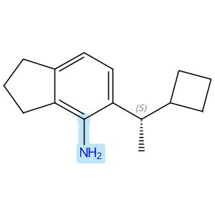
Absolute stereochemistry shown

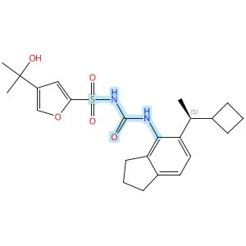
Absolute stereochemistry shown

Scheme 96 (Reaction 1 of 1):

Step 1, Yield: 70%

Discovery of novel and potent NLRP3 inflammasome inhibitors with new lipophilic moieties

By: Chu, Hongzhu; Wei, Yonggang; Zhao, Hongchuan; Ye, Fei; Qian, Xinying; Su, Huilin; Sun, Ying; Zhang, Jing; Jia, Zhilong; Li, Zhiyong; Liang, Xueya

10.1016/j.ejmech.2025.118227
View All Sources in CAS SciFinder
Company/Organization: No. 14, Tianshun Street, Kangbaida (Sichuan) Biotechnology Co. Ltd., Huayang Street, Chengdu, 610213, China
Source: European Journal of Medicinal Chemistry (2026), 301, 118227

Step 1
CAS Reaction Number: 31-614-CAS-47753143
Stage | Reagents | Catalysts | Solvents | Conditions
1 |  |  |  | 1 h, rt
  Diisopropylethylamine
  -
  Dichloromethane
2 |  |  |  | rt
  Water
  -
  -
3 |  |  |  | 0 °C
  Sodium hydride
  -
  Tetrahydrofuran
4 |  |  |  | 0 °C; 2 h, rt
  -
  -
  Tetrahydrofuran
5 |  |  |  | rt
  Water
  -
  -

Notes: intermediate from stage 2 added in stage 4 (stage 4)
Experimental Protocols
Synthetic Methods
Products | N-[[[5-[(1S)-1-Cyclobutylethyl]-2,3-dihydro-1H-inden-4-yl]amino]carbonyl]-4-(1-hydroxy-1-methylethyl)-2-furansulfonamide, Yield: 70%
Reactants | 2,2,2-Trichloroethyl chloroformate  5-[(1S)-1-Cyclobutylethyl]-2,3-dihydro-1H-inden-4-amine  4-(1-Hydroxy-1-methylethyl)-2-furansulfonamide
Reagents | Diisopropylethylamine  Water  Sodium hydride
Solvents | Dichloromethane  Tetrahydrofuran
Procedure
  1. | Add 2,2,2-trichloroethyl chloroformate (69 mg, 0.32 mmol) to a stirred solution of amine (58 mg, 0.27 mmol) and N,N-diisopropylethylamine (52 mg, 0.4 mmol) in DCM at room temperature.
  2. | Stir the reaction mixture for 1 hour at room temperature.
  3. | Quench the reaction with water.
  4. | Extract the reaction mixture with ethyl acetate three times.
  5. | Dry the combined organic layers over anhydrous sodium sulfate.
  6. | Filter the mixture and concentrate in vacuo.
  7. | Add sodium hydride (13 mg, 0.54 mmol) in portions to a stirred solution of sulfonamide (55 mg, 0.27 mmol) in THF at 0°C.
  8. | Add the Troc intermediate solution in THF dropwise into the mixture of sulfonamide at 0°C.
  9. | Stir the resulting reaction mixture for 2 hours at room temperature.
  10. | Quench the reaction mixture with water.
  11. | Extract the mixture with ethyl acetate for three times.
  12. | Dry the combined organic layers over anhydrous sodium sulfate.
  13. | Filter the mixture and concentrate in vacuo.
  14. | Purify the residue by MPLC to obtain (S)-N-((5-(1-cyclobutylethyl)-2,3-dihydro-1H-inden-4-yl)carbamoyl)-4-(2-hydroxypropan-2-yl)furan-2-sulfonamide.
Scale | milligram
Characterization Data
N-[[[5-[(1S)-1-Cyclobutylethyl]-2,3-dihydro-1H-inden-4-yl]amino]carbonyl]-4-(1-hydroxy-1-methylethyl)-2-furansulfonamide
Proton NMR Spectrum | (400 MHz, DMSO-d₆) δ 7.59 (br s, 1H), 7.38 (s, 1H), 6.92 (d, J = 7.7 Hz, 1H), 6.84 (d, J = 7.7 Hz, 1H), 6.69 - 6.62 (m, 1H), 4.92 (s, 1H), 2.96 (m, 1H), 2.78 (t, J = 7.5 Hz, 2H), 2.67 (q, J = 7.5 Hz, 2H), 2.47 - 2.37 (m, 1H), 2.11 - 1.98 (m, 1H), 1.89 (m, 2H), 1.74 - 1.58 (m, 4H), 1.53 - 1.42 (m, 1H), 1.36 (s, 6H), 0.93 (d, J = 6.8 Hz, 3H)
Carbon-13 NMR | (101 MHz, DMSO-d₆) δ 155.7, 142.3, 142.2, 140.9, 139.8, 137.3, 135.7, 134.3, 123.6, 121.0, 109.1, 66.6, 41.2, 32.5, 31.1, 31.0, 27.0, 26.3, 24.5, 19.1, 17.0
HRMS | (ESI): Calcd for C₂₃H₃₀N₂O₅S [M+H]⁺ 447.1948. Found: 447.1948
State | white solid
CAS Method Number 3-614-CAS-49951494

Absolute stereochemistry shown |  |  |  | 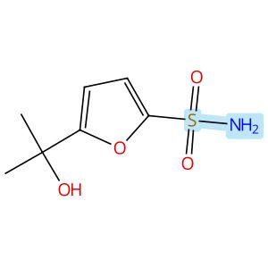
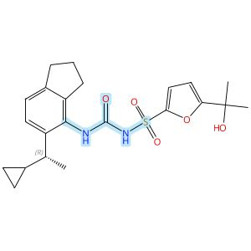
Absolute stereochemistry shown

Scheme 97 (Reaction 1 of 1):

Step 1, Yield: 70%

Discovery of novel and potent NLRP3 inflammasome inhibitors with new lipophilic moieties

By: Chu, Hongzhu; Wei, Yonggang; Zhao, Hongchuan; Ye, Fei; Qian, Xinying; Su, Huilin; Sun, Ying; Zhang, Jing; Jia, Zhilong; Li, Zhiyong; Liang, Xueya

10.1016/j.ejmech.2025.118227
View All Sources in CAS SciFinder
Company/Organization: No. 14, Tianshun Street, Kangbaida (Sichuan) Biotechnology Co. Ltd., Huayang Street, Chengdu, 610213, China
Source: European Journal of Medicinal Chemistry (2026), 301, 118227

Step 1
CAS Reaction Number: 31-614-CAS-47753173
Stage | Reagents | Catalysts | Solvents | Conditions
1 |  |  |  | 1 h, rt
  Diisopropylethylamine
  -
  Dichloromethane
2 |  |  |  | rt
  Water
  -
  -
3 |  |  |  | 0 °C
  Sodium hydride
  -
  Tetrahydrofuran
4 |  |  |  | 0 °C; 2 h, rt
  -
  -
  Tetrahydrofuran
5 |  |  |  | rt
  Water
  -
  -

Notes: intermediate from stage 2 added in stage 4 (stage 4)
Experimental Protocols
Synthetic Methods
Products | 2-Furansulfonamide, N-[[[5-[(1R)-1-cyclopropylethyl]-2,3-dihydro-1H-inden-4-yl]amino]carbonyl]-5-(1-hydroxy-1-methylethyl)-, Yield: 70%
Reactants | 2,2,2-Trichloroethyl chloroformate  5-[(1R)-1-Cyclopropylethyl]-2,3-dihydro-1H-inden-4-amine  5-(1-Hydroxy-1-methylethyl)-2-furansulfonamide
Reagents | Diisopropylethylamine  Water  Sodium hydride
Solvents | Dichloromethane  Tetrahydrofuran
Procedure
  1. | Add 2,2,2-trichloroethyl chloroformate (53 mg, 0.25 mmol) to a stirred solution of amine (42 mg, 0.21 mmol) and N,N-diisopropylethylamine (41 mg, 0.32 mmol) in DCM at room temperature.
  2. | Stir the reaction mixture for 1 hour at room temperature.
  3. | Quench the reaction with water.
  4. | Extract the reaction mixture with ethyl acetate three times.
  5. | Dry the combined organic layers over anhydrous sodium sulfate.
  6. | Filter the mixture and concentrate in vacuo.
  7. | Add sodium hydride (10 mg, 0.42 mmol) in portions to a stirred solution of sulfonamide (44 mg, 0.21 mmol) in THF at 0°C.
  8. | Add the Troc intermediate solution in THF dropwise into the mixture of sulfonamide at 0°C.
  9. | Stir the resulting reaction mixture for 2 hours at room temperature.
  10. | Quench the reaction mixture with water.
  11. | Extract the mixture with ethyl acetate for three times.
  12. | Dry the combined organic layers over anhydrous sodium sulfate.
  13. | Filter the mixture and concentrate in vacuo.
  14. | Purify the residue by MPLC to obtain (R)-N-((5-(1-cyclopropylethyl)-2,3-dihydro-1H-inden-4-yl)carbamoyl)-5-(2-hydroxypropan-2-yl)furan-2-sulfonamide.
Scale | milligram
Characterization Data
2-Furansulfonamide, N-[[[5-[(1R)-1-cyclopropylethyl]-2,3-dihydro-1H-inden-4-yl]amino]carbonyl]-5-(1-hydroxy-1-methylethyl)-
Proton NMR Spectrum | (400 MHz, DMSO-d₆) δ 7.59 (s, 1H), 7.07 (d, J = 7.7 Hz, 1H), 6.96 (d, J = 7.7 Hz, 1H), 6.55 (d, J = 3.2 Hz, 1H), 6.17 (d, J = 3.2 Hz, 1H), 5.20 (s, 1H), 2.79 (t, J = 7.4 Hz, 2H), 2.67 (t, J = 7.4 Hz, 2H), 2.35 - 2.27 (m, 1H), 1.95 - 1.83 (m, 2H), 1.42 (s, 6H), 1.09 (d, J = 6.9 Hz, 3H), 0.98 - 0.88 (m, 1H), 0.47 - 0.40 (m, 1H), 0.23 - 0.16 (m, 1H), 0.11 - 0.01 (m, 2H)
Carbon-13 NMR | (101 MHz, DMSO-d₆) δ 161.9, 153.8, 142.2, 141.5, 140.9, 133.6, 124.1, 121.0, 110.6, 103.7, 67.4, 37.5, 32.6, 31.0, 29.2, 24.6, 21.6, 17.7, 4.6, 3.8
HRMS | (ESI): Calcd for C₂₂H₂₈N₂O₅S [M+H]⁺ 433.1792. Found: 433.1792
State | white solid
CAS Method Number 3-614-CAS-49951602

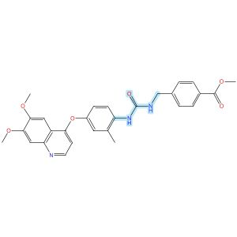

Scheme 98 (Reaction 1 of 1):

Step 1, Yield: 70%

Structure-Based Design and Free Energy Perturbation-Guided Synthesis of Novel VEGFR2 and HDAC Dual Inhibitors with Potent Antitumor Efficacy

By: Li, Yaxin; Liu, Sisi; Hu, Sha; Zhang, Ranran; Wang, Xiaoli; Xu, Jiamin; Yao, Keke; Lu, Chenxuan; Li, Guofeng; Wu, Zhigang; Guo, Chunyan; Yang, Leifu; Hu, Liming

10.1021/acs.jmedchem.5c01650
View All Sources in CAS SciFinder
Company/Organization: Beijing Key Laboratory of Environmental and Oncology, College of Chemistry and Life Science, Beijing University of Technology, Beijing, 100124, China
Source: Journal of Medicinal Chemistry (2026), 69(4), 3762-3778

Step 1
CAS Reaction Number: 31-614-CAS-49395388
Stage | Reagents | Catalysts | Solvents | Conditions
1 |  |  |  | 0 °C
  Triethylamine
  -
  Dichloromethane
2 |  |  |  | 0 °C
  -
  -
  Dichloromethane
Experimental Protocols
Synthetic Methods
Products | Benzoic acid, 4-[[[[[4-[(6,7-dimethoxy-4-quinolinyl)oxy]-2-methylphenyl]amino]carbonyl]amino]methyl]-, methyl ester, Yield: 70%
Reactants | Triphosgene  4-[(6,7-Dimethoxy-4-quinolyl)oxy]-2-methylaniline  Methyl 4-(aminomethyl)benzoate
Reagents | Triethylamine
Solvents | Dichloromethane
Procedure
  1. | Add triethylamine (4.0 equiv) to a solution of quinoline aniline derivative (1.0 equiv) and triphosgene (0.5 equiv) in 5 mL of dichloromethane, held in an ice-water bath, slowly dropwise.
  2. | Monitor complete consumption of the starting materials.
  3. | Add a solution of aniline or benzylamine (1.0 equiv) in 3 mL of dichloromethane dropwise to the reaction mixture.
  4. | Monitor the progress of the reaction by TLC.
  5. | Filter the solid.
  6. | Purify the solid by column chromatography to obtain methyl 4-((3-(4-((6,7-dimethoxyquinolin-4-yl)-oxy)-2-methylphenyl)ureido)methyl)benzoate.
Transformation | - Acylation of Nitrogen Nucleophiles by Acyl/ Thioacyl/ Carbamoyl Halides and Analogs
Characterization Data
Benzoic acid, 4-[[[[[4-[(6,7-dimethoxy-4-quinolinyl)oxy]-2-methylphenyl]amino]carbonyl]amino]methyl]-, methyl ester
Proton NMR Spectrum | (400 MHz, DMSO-d₆): δ (ppm) 8.46 (d, J = 5.2 Hz, 1H), 7.97 (s, 1H), 7.96-7.90 (m, 3H), 7.51 (s, 1H), 7.47 (d, J = 8.1 Hz, 2H), 7.39 (s, 1H), 7.14 (t, J = 6.0 Hz, 1H), 7.10 (d, J = 2.9 Hz, 1H), 7.03 (dd, J = 8.8, 2.9 Hz, 1H), 6.44 (d, J = 5.2 Hz, 1H), 4.42 (d, J = 5.9 Hz, 2H), 3.95 (s, 3H), 3.93 (s, 3H), 3.85 (s, 3H), 2.24 (s, 3H)
Mass Spectrum | MS (ESI⁺): calcd for C₂₈H₂₈N₃O₆ [M + H]⁺, 502.2; found, 502.2
State | white solid
CAS Method Number 3-614-CAS-50459335

Copyright © 2026 American Chemical Society (ACS). All Rights Reserved.

