A Web-Based System for Online Traffic Violation Payment, Document Submission, and Digital Record Management in Marikina City
AUTHORS:
Dequito, Reymark - LFCA333E008
Florendo, Joshua - LFCA333E009
Bucas, Jan Aldrin - LFCA333E009
Eneria, Jan Hazel - LFCA333E009
Hilario, Marc Deniel - LFCA333E009
Verona, Jhon Carlo - LFCA333E009
Esteban, Jeff Ferson - LFCA333E009
Tatad, Rainier - LFCA333E009
Cuarteros, Juncel - LFCA333E009
Rence, Garnace - LFCA333E009
Bachelor of Science in Information Technology (BSIT)
ICCT Colleges Philippines
Adviser: Jerico M. Vilog

Abstract:
Traffic violations in Marikina City are managed through manual processes. This leads to slow transactions, long lines, and a heavier workload for traffic management staff. While other cities have digital tools, Marikina lacks an integrated system for motorists to pay fines, submit documents, and access violation records online. This study proposes creating a web-based system for traffic violation payments, document submission, and digital record management. The system aims to streamline transactions, allow secure document uploads, and centralize violation records. The study uses a development approach that includes requirement analysis, design,
implementation, and evaluation. It assesses the system’s effectiveness in improving operational efficiency and user convenience. The expected result is a platform that reduces processing time, minimizes manual errors, and gives both motorists and traffic management staff easier access to violation information. By integrating digital tools into traffic management, this study aims to make traffic violation handling in Marikina City more transparent, efficient, and user-friendly.
Keywords: Web Application, Traffic Violation Management, Online Payment System, Document Management, Digital Records
I. INTRODUCTION
Traffic management and violation processing are important components for maintaining order and efficiency in urban areas. However, there are still a lot of local government units that adopt manual procedures in the processing of traffic violations which may result in delays, long queues, increased paperwork and heavier workload for personnel. Motorists can have issues paying fines and getting their violation records quickly as well. These issues in Marikina City call for a more efficient and accessible system. To mitigate these issues, this study proposes a web-based traffic violation management system that supports violation payments, document submission, and digital record management. The system aspires to enhance processes, centralize records, and improve efficiency and convenience for motorists and traffic management personnel.
A. Background and Motivation
Currently, traffic operations in Marikina City rely heavily on manual processes, which are time-consuming and error-prone. Motorists often struggle to pay fines or access their records efficiently, while traffic personnel face increasing workloads. While other cities have successfully implemented digital tools to improve traffic management, Marikina lacks a system that supports online payments, secure document submission, and centralized record management
This study is motivated by the need to improve traffic violation management with a web-based system. The proposed solution aims to cut down on errors, simplify transactions, and offer a more effective and clear service for drivers and traffic staff.
B. Problem Statement
Traffic violation processing in Marikina City faces challenges due to manual procedures, in-person transactions, and scattered record-keeping systems. Violators often need to go to government offices to pay fines or submit documents. It takes time, costs delays, and inconveniences both citizens and government staff.
This makes it hard to track violation histories and ensure compliance. The lack of an integrated digital system limits transparency, slows down verification, and increases the workload for traffic enforcement and administrative staff.
Given these issues, there is a clear need for a web-based traffic violation system. This system should allow online payments, electronic document submission, and organized digital record management. Such a system would enable faster transactions, improve data accuracy, provide better accessibility, and enhance the traffic violation process in Marikina City.
C. Objectives of the Study
General Objective
The main goal of this study is to create and assess an online system for paying traffic violations, submitting documents, and managing digital records. The system seeks to speed up and simplify the process for both drivers and traffic authorities. It also aims to cut down on manual work, lower the chances of mistakes, and ensure secure and accurate record-keeping.
Specific Objectives
1. To have an online payment feature where motorists can pay traffic violation fines electronically via the system
2. To enable motorists to upload and submit necessary traffic-related documents such as identification cards, receipts and supporting files through the web-based platform.
3. To develop a centralized digital database for storage, management and retrieval of the record of traffic violations in an efficient manner.
4. To decrease errors in the recording, updating and tracking of traffic violation information through an automated digital record management system.
D. Scope and Limitations
The research focuses on designing and analyzing a web-based system for maintaining digital records, submitting documents, and making online payments for traffic violations in Marikina City. This system involves analyzing requirements and creating a conceptual design for drivers, traffic enforcers, and administrators. The goal is to improve record management and transaction processes through a web-based platform.
Under Capstone Research 1, the study is limited to system analysis and design. It does not cover the development, implementation, testing, or deployment of the system. There is no interface with national government databases or third-party payment systems; the discussion is strictly conceptual.
II. RELATED WORK
A. Review of Relevant Literature
The use of web-based systems in public service delivery has been studied widely because they can improve efficiency, transparency, and accessibility. Several studies highlight that digitizing traffic violation processing lowers manual workload, reduces human error, and improves the accuracy of records. Online traffic violation management systems, based on e-challan platforms, let motorists see violations and pay fines electronically. This significantly simplifies enforcement and payment procedures [1].
Research on improving transaction systems that shows online payment speeds up transactions and makes them more convenient compared to traditional over-the-counter payments. Findings indicate that secure payment, centralized records and increased user trust and compliance with traffic laws [2]. Digital record management systems allow authorities to store, retrieve, and analyze violation data efficiently, supporting better decision-making and policy development.
Literature on e-government systems stresses the need for usability, data security, and real-time access to information. Public web-based platforms must ensure confidentiality, authentication, and data integrity to gain public acceptance [3]. Recent advancements also focus on integrating traffic management systems into unified digital government platforms. This gives citizens centralized access to public services. These studies lay the groundwork for developing a web-based traffic violation system that supports online payment, document submission, and digital record management.
B. Review of Related Systems and Studies
Several existing systems and previous studies relate closely to the proposed web-based traffic violation management system. One commonly referenced system is the E-Challan System. It automates the processing of traffic violation penalties and allows for online fine payment. This system shows improved efficiency and reduces paperwork. However, it mainly focuses on tracking violations and processing payments, lacking features like digital document submission and effective record management [1].
In the Philippines, government initiatives led by agencies such as the Metropolitan Manila Development Authority (MMDA) aim to combine traffic violation checking and online payment into centralized platforms like the eGovPH Super App. These systems give motorists online access to violation records and payment services, marking progress toward better digital public service. Despite
These new advancements, current implementations are still limited and may not fully support document uploads, detailed violation histories, or analytics tools for local government units [4].
Several academic studies and capstone projects have also suggested web-based systems for monitoring traffic violations and digitizing records. These systems improve data organization and reduce dependence on paper records. However, they often lack complete integration, such as merging online payments, document submission, and centralized digital record storage into a single platform [5].
C. Research Gap Analysis
Existing traffic violation management systems in many local government units mainly focus on basic record-keeping and manual payments. Although some cities have introduced digital tools, these are often scattered and handle only one function, such as online payment or record storage. They still require violators to visit offices in person for document submission or payment confirmation. This leads to long lines, delays, and more work for administrators.
Additionally, few systems provide real-time integration between payment processing, document submission, and record management. This results in inconsistent records, limited transparency, and challenges for traffic enforcers and administrators. Local issues in medium-sized cities like Marikina, such as staffing, infrastructure, and budget limits, are often overlooked, which increases the risks of data loss, duplication, and mistakes.
This study aims to fill these gaps by suggesting a web-based system that combines online payment, secure document submission, and centralized digital record management specifically for Marikina City. The system seeks to simplify transactions, allow remote access for drivers, and provide accurate, real-time records for traffic personnel. By concentrating on local needs and
practical realities, this study offers a useful and scalable solution that boosts efficiency, transparency, and access in traffic violation management.
III. METHODOLOGY

A. Research Design
This study uses a developmental and design-focused research approach. It is developmental because the research involves creating, developing, and testing a web-based system for online traffic violation payments, document submissions, and digital record management in Marikina City. The study aims to build a functional system that tackles slow transactions, long queues, and manual record handling.
At the same time, the study adopts a design-focused research approach since it includes designing and assessing an information system as a solution to a real-world problem. The system is built based on user needs and is evaluated for efficiency, usability, and effectiveness in improving traffic violation management.
This research design is suitable because the main goal of the study is not just to analyze a problem but also to develop and implement a practical technological solution. By using this approach, the study ensures that the proposed system speeds up transactions, reduces the workload for traffic personnel, and offers a more convenient experience for motorists in Marikina City.

B. Conceptual Framework / System Model
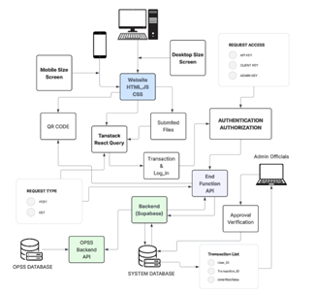
C. Proposed System Overview
The proposed system is a web-based platform for managing traffic violations in Marikina City. It aims to improve efficiency, transparency, and convenience. The system replaces the old manual process with an online system that lets motorists view traffic violations, submit necessary documents, and pay fines remotely. This change removes the need for in-person visits to city offices. As a result, it cuts down on long lines, speeds up transaction processing, and enhances the user experience.
For traffic management personnel, the system offers tools to manage violation records, verify submitted documents, monitor online payments, and create reports for traffic analysis and policy support. All records, payments, and documents are securely stored in a centralized database. This ensures accuracy, traceability, and data integrity. Specific IT personnel handle the system maintenance, security, and performance monitoring.
The system combines online payment, document submission, and centralized record management into one platform. This streamlines the traffic violation process and supports organized and effective traffic enforcement in Marikina City. The design focuses on user-friendly, secure information and real-time access to information, while also considering the city’s operational needs and local limitations.
D. Requirements Analysis
The requirements analysis identifies the key functional and non-functional needs of the proposed web-based traffic violation management system for Marikina City. The system supports three main user groups: motorists, traffic enforcers, and administrators. Motorists can view traffic violations, pay fines online, and submit necessary documents. Traffic enforcers can record violations and check submitted documents, while administrators manage user accounts, keep a centralized digital database, and create system reports.
The system is designed to be user-friendly, secure, and reliable. It works with standard web browsers. It protects confidential data, supports user interaction, and allows for accurate digital record management. These requirements aim to replace the current manual process with a more efficient, organized, and accessible online system.
E. Ethical, Legal, and Technical Considerations
The proposed web-based system for online traffic violation payment, document submission, and digital record management in Marikina City takes ethical, legal, and technical requirements into account. The system processes personal data such as motorist information, vehicle details, traffic violation records, and submitted documents only for legitimate purposes and in line with the principle of informed consent. To keep data safe, the system uses encrypted data transmission, secure authentication, and role-based access control to limit sensitive information to authorized traffic enforcers and administrators. Digital records and uploaded documents are stored securely, with regular backups and system monitoring to prevent data loss, unauthorized access, or data manipulation. The system also complies with the Data Privacy Act of 2012 (Republic Act No. 10173) and relevant local government policies on traffic management and electronic transactions. Ethically, the system encourages transparency, fairness, and accountability by providing clear violation information, payment status, and safeguards against data misuse.
IV – RESULTS AND DISCUSSION

1. Login and Verification Feature
The Login and Verification Feature allows motorists to securely access the system by entering their registered plate number. Upon submission, the system automatically verifies the input and checks the database for any associated traffic violation records.
If a matching record is found, the system displays the corresponding violation details, including the offense committed and other relevant information. If no record is found, the system displays a message indicating that there are no recorded violations associated with the entered plate number.
This feature provides a fast and convenient way for motorists to check their violation status without the need for manual inquiries or physical visits to the traffic office.
System Output:
- The plate number is used as the login input
- The system verifies the input against the database records
- If a record exists, violation details are displayed
- If no record exists, a “No violation record found” message appears
Figure 4.1 Login and Violation Checking Interface
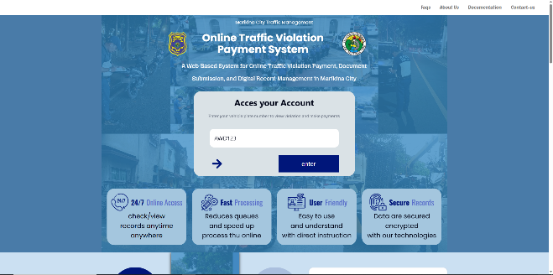

2. Traffic Violation Payment Feature
The Traffic Violation Payment Feature allows motorists to view detailed information about their traffic violations and proceed with the corresponding payment process within the system.
Once a violation record is accessed, the system displays complete vehicle and driver information, along with the full violation details. This ensures that users have clear visibility of their offenses before proceeding with payment.
The feature includes the following information:
- Vehicle Information (plate number, vehicle type, model, and color)
- Driver Information (name and address)
- Violation Details (type of violation, location, and date issued)
- Transaction Status (e.g., approved or pending)
- Total Amount to be Paid
System Output:
- Displays complete vehicle and driver information
- Shows violation details such as type, location, and date
- Indicates transaction status
- Automatically computes the total amount to be paid
- Provides a payment button for transaction processing
Figure 4.2 Traffic Violation Payment Interface
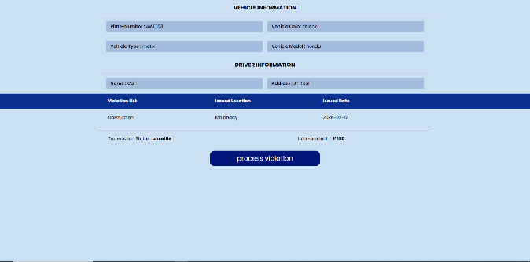

3. Document Submission Feature
The Document Submission Feature allows motorists to securely upload required documents related to their traffic violation cases through the web-based system. This eliminates the need for physical submission and improves processing efficiency.
The interface provides a structured upload system where users can submit necessary documents such as a driver’s license, valid identification card, and Ordinance Violation Receipt (OVR). Each document type is clearly labeled to guide users in proper submission.
The feature includes the following functions:
- Driver’s License or valid identification upload section
- Ordinance Violation Receipt (OVR) upload section
- Click-to-upload function for easy file selection
- Secure storage of uploaded documents in the system database
All uploaded files are properly categorized and stored for verification by authorized personnel. This ensures organized document handling and faster validation processes.
Figure 4.3 Document Submission Interface (Driver’s License and OVR Upload)

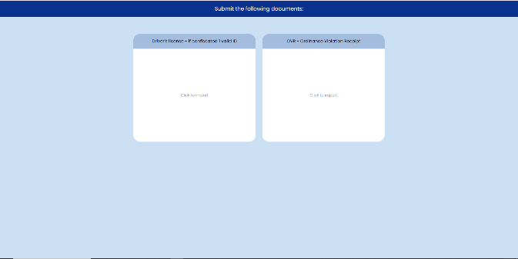

B. Testing Results

1. Functional Testing Results
Functional testing was conducted to evaluate whether all system features perform their intended functions correctly. The results show that all features operated as expected during testing.
The Login and Verification Feature successfully validates plate numbers and retrieves corresponding violation records. The Payment Feature displays complete violation details and accurately computes total fees. Meanwhile, the Document Submission Feature successfully uploads and stores files in the database.
Table 4.1 Functional Testing Results
Test Case | Expected Result | Actual Result | Status
Login Verification | System verifies plate number | Correct output displayed | Passed
View Violation | Display violation details | Correct data displayed | Passed
Payment Processing | Show amount and details | Working properly | Passed
Document Upload | Save files successfully | Successfully stored | Passed

2. System Integration Testing
System integration testing was conducted to ensure that all features work together properly as a unified system. The results show that the Login and Verification Feature is properly connected to the database, violation records are successfully passed to the Payment Feature, and uploaded documents are correctly linked to user records. No major issues were encountered during testing.

3. User Testing / Evaluation
User testing was conducted to assess system usability and overall user experience. Respondents reported that the system is easy to use and understand. They were able to successfully verify violations, process payments, and submit documents efficiently. Overall, the system improved convenience compared to traditional manual processes.

4. Performance Testing
Performance testing results show that the system operates efficiently under normal conditions. It loads quickly, retrieves data accurately, and does not exhibit noticeable delays or system errors during execution.

C. Evaluation
The system was evaluated based on functionality, usability, and reliability.
In terms of functionality, the system successfully performs login verification, violation record retrieval, payment processing, and document submission. In terms of usability, users found the interface simple, clear, and easy to navigate. In terms of reliability, the system demonstrated consistent performance with no significant errors during testing.
Overall, the evaluation results indicate that the system meets its intended objectives and provides an efficient solution for traffic violation management.

D. Analysis
Based on the results of testing and evaluation, the system effectively fulfills its purpose as a web-based traffic violation management system.
The Login and Verification Feature enables fast and accurate access to violation records using plate numbers, reducing the need for manual inquiries. The Traffic Violation Payment Feature streamlines the payment process by integrating violation details and transaction processing within a single interface. The Document Submission Feature enhances convenience by allowing users to submit requirements online, eliminating the need for physical documentation.

Overall, the system improves efficiency, accessibility, and convenience in managing traffic violation records and transactions. The results indicate that the system successfully meets its design objectives and provides a practical solution for modernized traffic management.

V – DATA PREPARATION AND CLEANING

A. Data Wrangling and Formatting
Data wrangling and formatting were performed to ensure that all traffic violation records are consistent, accurate, and suitable for system processing and analysis. This process involved standardizing text formats, correcting inconsistent entries, unifying date formats, and converting data values into appropriate types.

Example of Data Wrangling and Formatting
Before Cleaning the Dataset:
Name | Violation List | Issued Location | Date Issued | Violation Fee
rainier tatad | obstruction | malanday | 05/15/2026 | 3000
JOSHUA FLORENDO | OBSTRUCTION | MALANDAY | May 24, 2026 | Three Thousand
Janhazel Eneria | Obstruction | Malanday | 2026-05-08 | 3000.00
After Data Wrangling and Formatting:
Name | Violation List | Issued Location | Date Issued | Violation Fee
Rainier Tatad | Obstruction | Malanday | 2026-05-15 | 3000.00
Joshua Florendo | Obstruction | Malanday | 2026-05-24 | 3000.00
Janhazel Eneria | Obstruction | Malanday | 2026-05-08 | 3000.00

Formatting Changes Applied:
- Standardized text capitalization for all names and locations.
- Unified all date formats into YYYY-MM-DD.
- Converted violation fees into numeric format with two decimal places.
- Replaced inconsistent text values (e.g., “Three Thousand”) with numeric equivalents (3000.00).

B. Handling Missing Values
Handling missing values ensures that incomplete traffic violation records do not affect system accuracy and data integrity. Missing fields such as violation type, date issued, and transaction status were either corrected using available system data or replaced with appropriate standardized values.

Before Handling Missing Values:
Name | Violation List | Issued Location | Date Issued | Violation Fee
rainier tatad | obstruction | malanday | 05/15/2026 | 3000.00
JOSHUA FLORENDO | OBSTRUCTION | MALANDAY | May 24, 2026 | Three Thousand
Janhazel Eneria | obstruction | Malanday | 2026-05-08 | 3000.00

After Handling Missing Values:
Name | Violation List | Issued Location | Date Issued | Violation Fee
Rainier Tatad | Obstruction | Malanday | 2026-05-15 | 3000.00
Joshua Florendo | Obstruction | Malanday | 2026-05-24 | 3000.00
Janhazel Eneria | Obstruction | Malanday | 2026-05-08 | 3000.00

Methods Used:
- Replaced missing transaction status with “Pending” when no payment confirmation was available.
- Filled missing violation details with “Unknown” when no record was found.
- Standardized missing date entries using verified system records when available.
- Ensured no blank fields remain in the dataset to maintain data completeness and system reliability.

C. Organizing Datasets
Organizing datasets involves structuring cleaned traffic violation records into a standardized tabular format. This ensures that the data can be efficiently processed, stored, and retrieved by the system.

Before Organizing Dataset:
Name | Violation List | Date Issued | Transaction Status
Rainier Tatad | No Helmet | 2026-05-15 | Transaction Paid
Joshua Florendo | Illegal Parking | 2026-05-15 | (blank)
Janhazel Eneria | Illegal Parking | (blank) | Unsettled
Marc Hilario | (blank) | 2026-05-11 | Transaction Paid

After Organizing Dataset:
Name | Violation List | Date Issued | Transaction Status
Rainier Tatad | No Helmet | 2026-05-15 | Transaction Paid
Joshua Florendo | Illegal Parking | 2026-05-15 | Pending
Janhazel Eneria | Illegal Parking | 2026-05-15 | Unsettled
Marc Hilario | Unknown | 2026-05-11 | Transaction Paid

What Was Done:
- Converted raw text records into a structured relational table.
- Separated information into defined attributes: Name, Violation List, Date Issued, and Transaction Status.
- Ensured each record corresponds to a single row for database compatibility.

D. Documentation of Data Preprocessing Steps
This section summarizes the preprocessing workflow applied to the dataset to ensure consistency, accuracy, and usability within the system.

Step 1: Requirement Gathering
Initial information was gathered from users and stakeholders regarding common issues encountered in traffic violation payment systems. The feedback highlighted the need for a more efficient, accessible, and organized system for managing violations and payments.

Step 2: Data Cleaning
The dataset was cleaned by:
- Standardizing capitalization for text fields.
- Converting all dates into YYYY-MM-DD format.
- Replacing non-numeric fee values with numeric equivalents.
- Correcting inconsistent or invalid data entries.

Step 3: Handling Missing Values
Missing or incomplete data were addressed by:
- Replacing missing transaction status with “Pending”.
- Using “Unknown” for missing violation details.
- Ensuring all records contain complete and usable values.

Step 4: Data Organization
The cleaned dataset was structured into a tabular format with clearly defined columns. This structure allows efficient storage, retrieval, and processing within the web-based traffic violation system.
References
[1] A. Pranshu, S. K. Ijju, and S. P. Swarnalatha,
“E-Challan: Online Traffic Rules Violation Penalty and Management System,” International Journal of Computer Applications, vol. 176, no. 37, pp. 1–5, Jul. 2020.
[2] S. Srikanth, A. Sadaria, H. Bhatia, K. Gupta, P. Jain, and P. K. Kumaraguru,
“Don’t cross that stop line: Characterizing traffic violations in metropolitan cities,” arXiv preprint arXiv:1909.08106, Sep. 2019.
[3] J. A. C. Jose et al.,
“Artificial intelligence software application for contactless traffic violation apprehension in the Philippines,” Journal of Advanced Computational Intelligence and Intelligent Informatics, vol. 25, no. 4, pp. 410–415, 2021.
[4] Philippine Information Agency,
“MMDA traffic systems to integrate with eGovPH Super App for online violations, payments,” Philippine Information Agency, Jan. 29, 2026. [Online]. Available: https://pia.gov.ph/.
Accessed: Feb. 10, 2026.
[5] Philippine Information Agency,
“NCAP’s ‘May Huli Ka’ gets new features for motorists’ convenience,” Philippine Information Agency, Dec. 8, 2025. [Online]. Available: https://pia.gov.ph/.
Accessed: Feb. 10, 2026.
[6] Presidential Communications Office (PCO),
“Motorists can check traffic violations via eGovPH – DICT,” Philippine Information Agency, Jun. 5, 2025. [Online]. Available: https://pia.gov.ph/.
Accessed: Feb. 10, 2026.
Appendix
APPENDIX A – Interview Questions
The following interview questions were used to gather information regarding the current traffic violation management process in Marikina City and to identify the challenges encountered by motorists and traffic personnel.
- Kamusta po ang experience sa pag gamit ng aming system?
- Malinaw po bang nakikita ang detalye, oras at petsa ng inyong violation?
- Sa tingin ninyo po mas makakatulong ang system namin na mas mapabilis ang transaction sa pag bayad ng mga traffic violation?
- Kung i-rrate po ninyo 1 to 10 ano po number ibibigay ninyo?
APPENDIX B – Letter of Permission / Request Letter
This appendix contains the formal letters of permission and request addressed to the relevant authorities, including schools, offices, respondents, Local Government Units (LGUs), and other concerned institutions involved in the conduct of the study.

APPENDIX C – Screenshots of the System Interface
C.1 Login Page 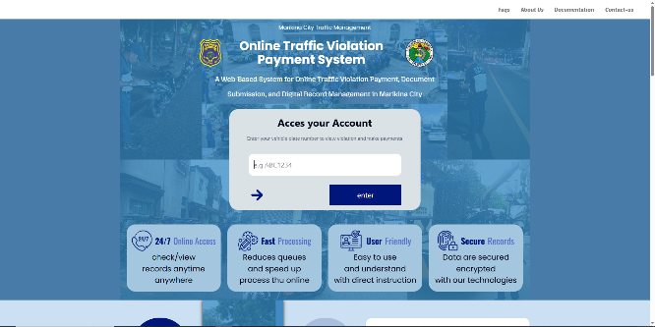
The Login Page serves as the entry point of the Online Traffic Violation Payment System. Motorists enter their registered license plate number to access their traffic violation records, submit required documents, and process payments online.
C.2 Admin Panel 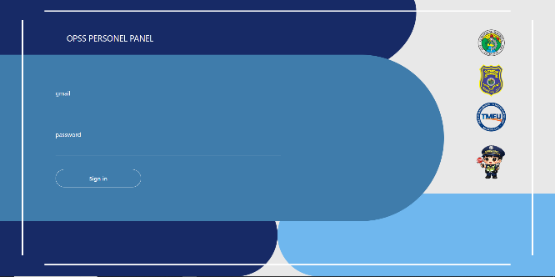
The Violation Records Page displays the details of traffic violations associated with a registered license plate number. Information such as the violation committed, date, location, and corresponding fine amount is presented to the user. Motorists may review these details before proceeding to the payment process.
C.3 Violation Records Page 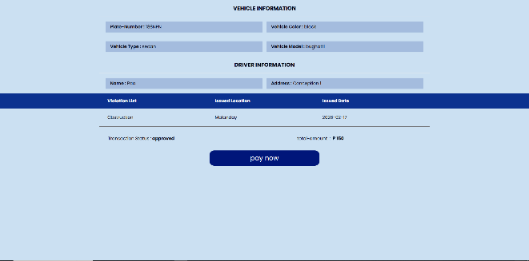
The Violation Records Page displays the details of traffic violations associated with a registered license plate number. Information such as the violation committed, date, location, and corresponding fine amount is presented to the user. Motorists may review these details before proceeding to the payment process.
C.4 Payment Page 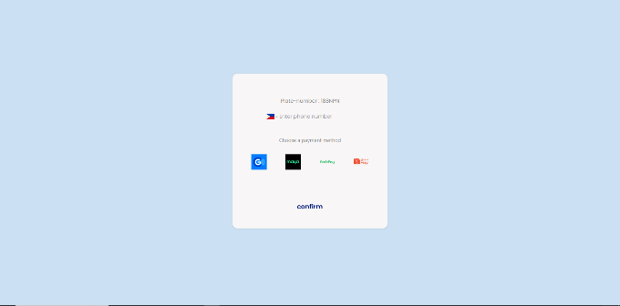

The Payment Page allows motorists to settle traffic violation fines through available digital payment methods. It provides a convenient and efficient alternative to in-person payments, helping reduce processing time and improve accessibility.
APPENDIX D – Data Gathering
This appendix presents the data gathering process used in the development of the proposed web-based traffic violation management system. The purpose of this phase is to collect relevant information from target users and stakeholders to identify system requirements and validate the need for the proposed solution.

A. Data Gathering Method
The study utilized a qualitative data gathering approach, primarily through interviews and informal surveys. This method was chosen to obtain direct feedback from motorists and traffic personnel regarding their experiences with the current manual traffic violation processing system.

B. Respondents of the Study
The respondents of the study include:
- Motorists in Marikina City
- Traffic enforcement personnel
- System end-users who are affected by traffic violation processing procedures
These respondents were selected because they directly interact with the current system and can provide relevant insights regarding its limitations and challenges.

C. Data Gathering Instrument
The primary instrument used in data collection was a semi-structured interview guide. The interview questions were designed to gather information regarding:
- User experience in processing traffic violations
- Challenges encountered in manual payment systems
- Suggestions for system improvement
- Perceived usefulness of a web-based traffic management system

D. Summary of Findings
Based on the responses gathered, the following issues were identified:
- Manual processing of traffic violations causes delays and inconvenience.
- Motorists experience difficulty in accessing violation records.
- In-person transactions contribute to long queues and increased workload for personnel.
- There is a strong need for a centralized and digital system to improve efficiency and transparency.
The findings strongly support the development of a web-based traffic violation management system that integrates online payment, document submission, and digital record management.

E. Ethical Considerations in Data Gathering
All data collected were used solely for academic purposes. Respondents were informed about the purpose of the study, and participation was voluntary. No sensitive personal information was disclosed or recorded beyond the scope of the research objectives.
APPENDIX E – Timeline
The Capstone project follows a structured 6-month timeline from December 21, 2025 to June 4, 2026, divided into 16 distinct phases. The schedule covers the complete development lifecycle: from initial brainstorming and requirements gathering, through UI/UX design and system development, to manuscript writing and final defense. The longest phase is Development Implementation at 77 days, while several key milestones include Capstone 1 Defense on February 26, 2026 and Capstone 2 Defense on June 4, 2026. Some phases run in parallel, such as manuscript preparation during development, to ensure efficient use of time and meet all academic deadlines.
Figure C.6 Capstone Project
