StudentVerse

Building Your Universe by Building Yourself
Poorna Siri Karanam, University of Edinburgh, s2849986@ed.ac.uk

Abstract
International master’s students often navigate an intense blend of academic rigour, cultural adjustment, and personal growth. StudentVerse reimagines this experience by fusing generative AI and gamification into a single intelligent ecosystem that turns self-development into play.
Its AI Micro-Manager decomposes coursework, research, and personal goals into effortless micro-tasks, while every completed action expands a user’s virtual universe of stars and planets. Complementary features such as AI-generated prerequisite roadmaps, coursework feedback, and peer connections through collaborative gameplay make StudentVerse a comprehensive academic ally. By translating effort into visible cosmic progress, it transforms procrastination into purpose, isolation into connection, and daily study into an engaging journey of mastery. StudentVerse is not just a productivity app; it is the digital orbit where academic life, wellbeing, and motivation converge.

1. Introduction / Problem Statement
Postgraduate life abroad demands strong self-management and adaptability. The major challenges commonly faced by Postgraduate students are:
- Heavy workload and poor time management – difficulty managing coursework, job shifts, gym, and personal care.
- Lack of motivation/procrastination – overwhelming task lists reduce productivity.
- Complex prerequisite roadmaps – students struggle to understand what prior concepts are needed for advanced topics.
- Adapting to UK academic style – challenges in meeting coursework expectations, referencing, and scoring patterns.
- Lack of peer interaction – difficulty forming social and academic circles.
Existing tools address isolated aspects of these struggles. StudentVerse unifies them through AI-driven micro-planning, structured feedback, and gamified motivation, empowering students to work efficiently, learn deeply, and feel connected.

2. Proposed Solution
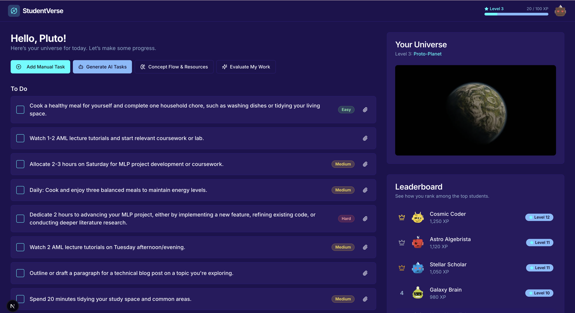
StudentVerse transforms productivity into play. Each user’s progress builds their own evolving universe i.e stars for daily wins, planets for milestones, galaxies for consistency.

AI Micro-Manager + Gamified Motivation Engine
- An intelligent scheduler analyses course timetables, deadlines, job hours, and extracurriculars to generate concise, attainable daily micro-tasks.[1]
Example tasks: “Review Lecture 2 notes (15 min)”, “Write coursework outline (20 min)”, “Prepare lunch”, “Play badminton”, “Read 2 pages from ANLP Reading”, etc:-
- Each task is rated by difficulty (Easy, Medium, Hard, or Bonus) and rewards you with Experience Points (XP) upon completion.
Fig 1. Home page
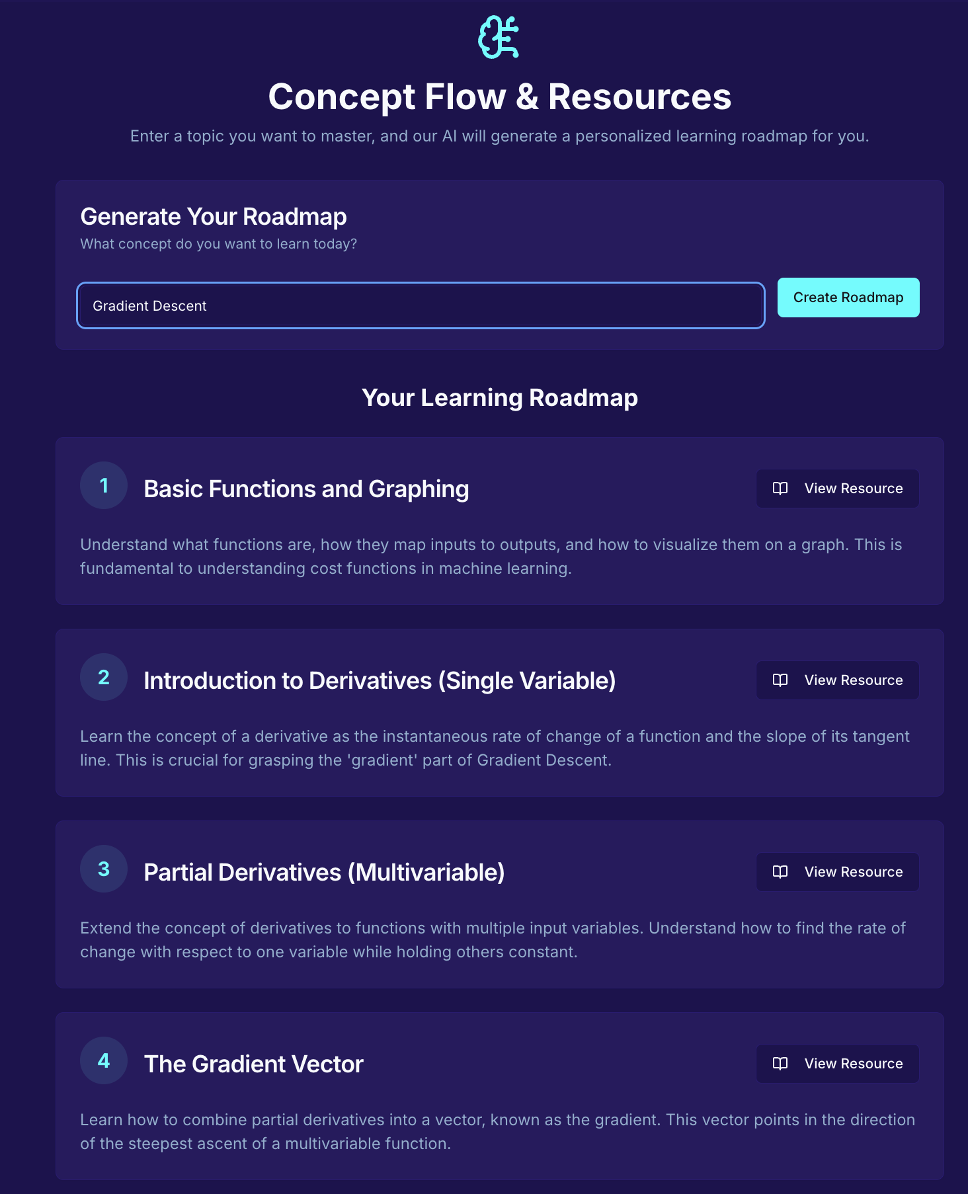
- Completing tasks grants XP and triggers animated cosmic growth. Streaks unlock bonuses, while an optional leaderboard adds light competition.
The system rewards discipline through incremental success, preventing burnout while maintaining momentum.

2.2 Prerequisite Roadmap Generator
- When students upload a topic or document, the AI generates a concept roadmap:
Example: Gaussian Distribution → PDF → Random Variables → Probability Basics.
- Each node links to curated resources (YouTube, articles, notes).
- Helps students self-learn complex material step-by-step instead of getting lost.
Fig 2. Roadmap page

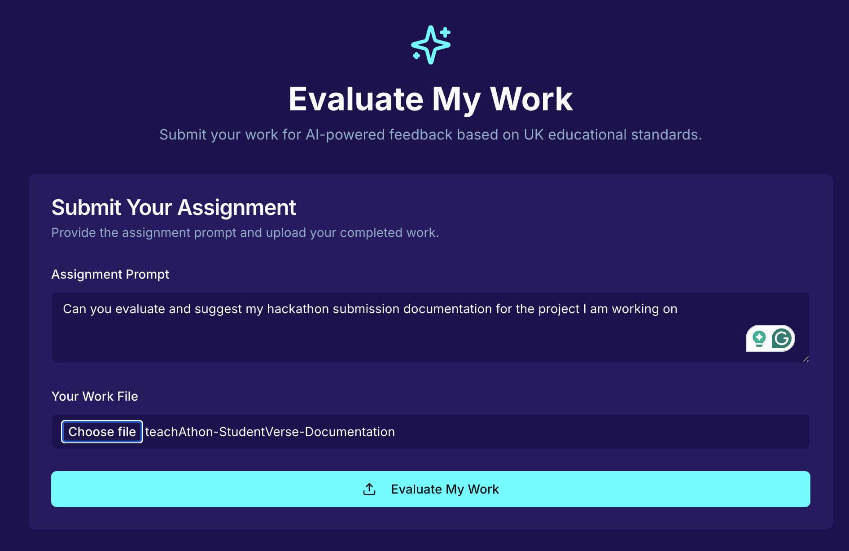
2.3 Feedback & Mock Exam Assistant
- Students can upload coursework or reports to receive AI-generated, UK-aligned feedback on structure, analysis, referencing, and clarity.
- A mock-exam mode enables timed practice and reflective scoring, building confidence and familiarity with assessment expectations.
A functional prototype of StudentVerse has been developed, integrating Firebase Studio with the Google API. The system currently supports secure login, personalized micro-task generation, proof uploads, XP-based progression, and the core gamified universe interface. The current prototype (v1) collects schedule and lifestyle information during sign-up, as Outlook API integration for automatic data retrieval will be implemented in the next version.
Fig 3. Feedback page
The live prototype can be accessed through the web link below:
Web App: https://studio--studio-3052859438-44d0a.us-central1.hosted.app

3. Implications & Ethical Considerations
3.1 Educational Impact:
StudentVerse promotes a balanced and structured approach to postgraduate learning. By turning daily study and personal goals into achievable micro-tasks, it builds consistency and motivation while reducing stress. The system encourages self-regulated learning enabling students to plan, reflect, and progress confidently.
3.2 Trustworthy AI:
StudentVerse is designed on the principles of transparency, fairness, and privacy.
· Transparency: AI-generated tasks are explainable and easy to interpret.
· Fairness: The system adapts to each user’s goals without bias or comparison.
· Privacy: All user data and uploads are stored securely with consent; nothing is shared or reused.
· Human Control: Students remain decision-makers; AI acts only as a supportive guide.
3.3 Wellbeing & Social Responsibility:
Gamified elements are balanced with pacing and reflection to prevent overuse. The Friend Constellation feature fosters collaboration and motivation through shared goals, using avatars instead of personal details, thus promoting safe, positive engagement.
3.4 Global Relevance:
StudentVerse exemplifies how ethical and human-centered AI can make learning more productive, inclusive, and wellbeing-focused for students worldwide.

4. Future Scope

The current prototype (v1) includes task generation, proof uploads, and universe progression. Future updates will expand scope and intelligence:
- Outlook Integration: Connecting to Microsoft Outlook/Teams APIs to auto-import schedules and deadlines for adaptive daily planning.[2]
- Enhanced AI: Using frameworks like LangChain for deeper personalization, learning patterns, and multi-step reasoning.
- Collaborative Play: Users will form study constellations and unlock shared XP or rewards through co-op challenges, maintaining full privacy.
- Long-Term Vision: StudentVerse aims to become a trusted academic co-pilot, uniting intelligent planning, motivation, and wellbeing support into one ethical, gamified ecosystem.
References

[1] Habitica. (2024). Gamified Task Management for Habit Building.
Available at: https://habitica.com/static/home
[2] Microsoft Graph API. (2024). Access Data in Microsoft 365. Microsoft Documentation. Available at: https://learn.microsoft.com/en-us/graph/overview
[3] Smith, J. (2021). Gamification and Motivation in Higher Education. Journal of Learning Science, 28(3), 245–259.

