MindfuLLM: LLM Comprehension Quiz Generation

University of Edinburgh 2025 Teachathon

Jason Latz, Benedek Labancz, Ivan Sowerby, Dhyey Mehta, Alp Niksarli, Ömer Tuğrul, Barış Tekdemir
20 October 2025

Problem:
According to a recent study conducted by the Higher Education Policy Institute, 92% of UK students use some form of Generative AI, up from 66% last year. A large portion (58%) of students say that they use AI to “explain concepts.” While this may be helpful in the short-term, the cognitive effort present when learning new information and concepts correlates with learning outcomes and task performance. Thus, if students are able to get answers and explanations quickly and easily, their actual understanding of the content may decrease. New research is already beginning to support this idea. Stanford’s Graduate School of Education recently published a paper simply titled “Generative AI Can Harm Learning,” which noted that using GPT-4 “as a ‘crutch’ prevents [students] from fully engaging with or understanding the material.”
In other words, the incredibly common use of Generative AI may harm long-term learning outcomes for students, due to their ability to engage shallowly with the material “learned” through LLM usage. We do not claim that this is guaranteed to happen in all cases (there are many ways to effectively use LLMs to learn), but there is a significant risk that many students may take the easy way out, at least until they begin to see negative results.

Solution:
There is deep consensus in the psychological research community that being quizzed and tested on content is a significant predictor of long-term learning outcomes., Thus, we propose leveraging this to enhance learning outcomes for LLM users. In order to do this, we put forward a simple concept:

MindfuLLM: Custom-generated quizzes on academic content discussed with LLMs.

Users will be able to more deeply understand and engage with content they have learned using LLMs, directly benefitting from the testing effect while simultaneously benefitting from the power of LLM usage. A combination of open-ended and multiple choice questions would provide students with the opportunity to reengage with the content, generate their own explanations for concepts, and actively recall previously seen terms, all of which are incredibly effective empirically supported learning methods.
Every psychology student learns that studying by reading from a textbook is grossly ineffective compared to quizzing yourself and explaining concepts. These quizzes provide students with the modern equivalent of the same wisdom.

Idea Implementation and Feasibility:
In order to prove feasibility for the above idea, we have created a functional proof of concept. It begins with a chrome extension that tracks content discussed on ChatGPT and ELM (a University of Edinburgh-licensed platform for accessing LLMs). This then sends the conversation data to Google Gemini, which parses the conversation data. It then undergoes the following process:
- Filter out non-academic topics
- Generates n multiple choice and m free-response questions (defaults to n=7, m=3)
- Generates answers to above questions (suggested answers in the case of free response)
- Send data to Google Forms API, which creates the form and returns a link to it

The user can then access the form through the link in their email. Upon completion of the quiz, the user will receive a grade for the multiple choice portion, as well as answers to all questions.
One benefit of the email format that we would like to highlight is that it automatically creates what is essentially a unified, searchable database of all quizzes generated, in the form of their inbox. This allows the user to access and take quizzes again at a later date without manually tracking the links. In line with this idea, users have the ability to edit the quizzes and otherwise use them however they like, which we believe will be beneficial in long-term study planning.
For further detail, see the code on our github at this link. A working demo of the main functionality can also be viewed here.

Photos of Demo:
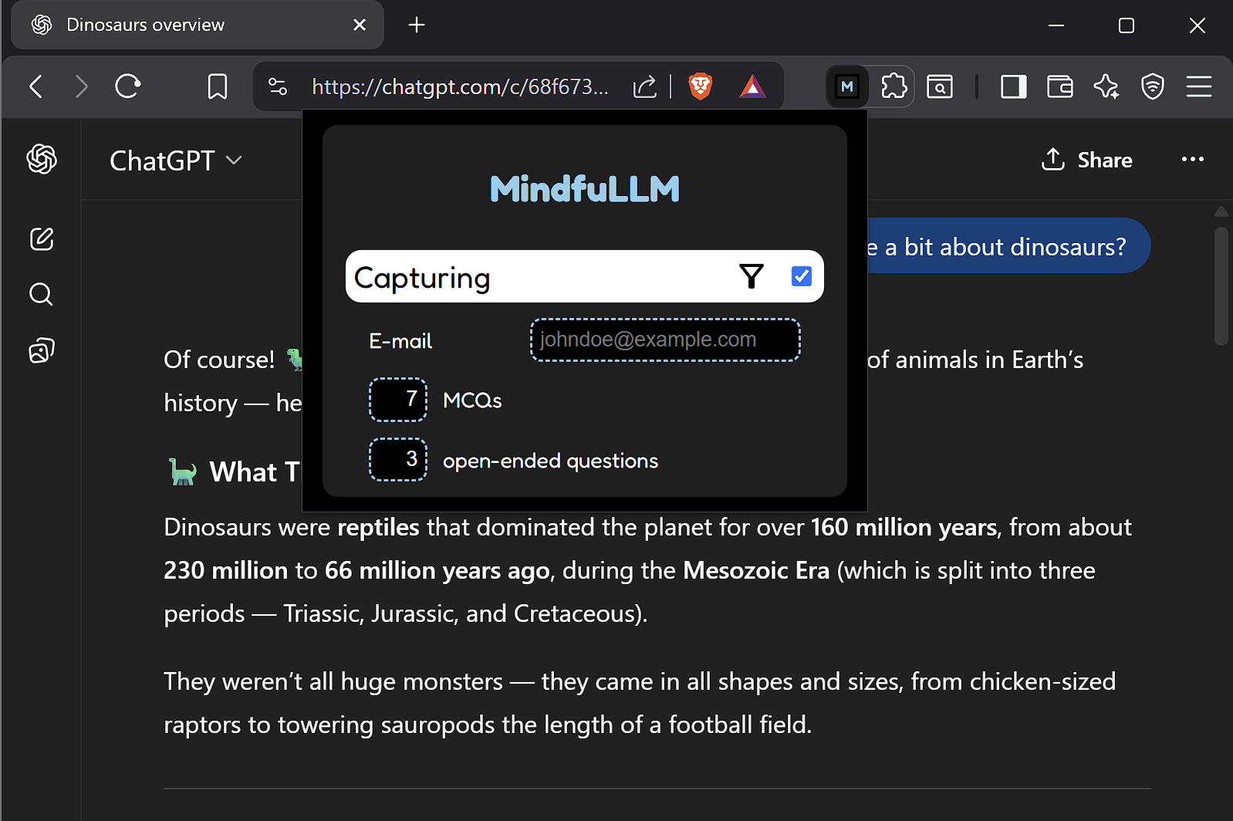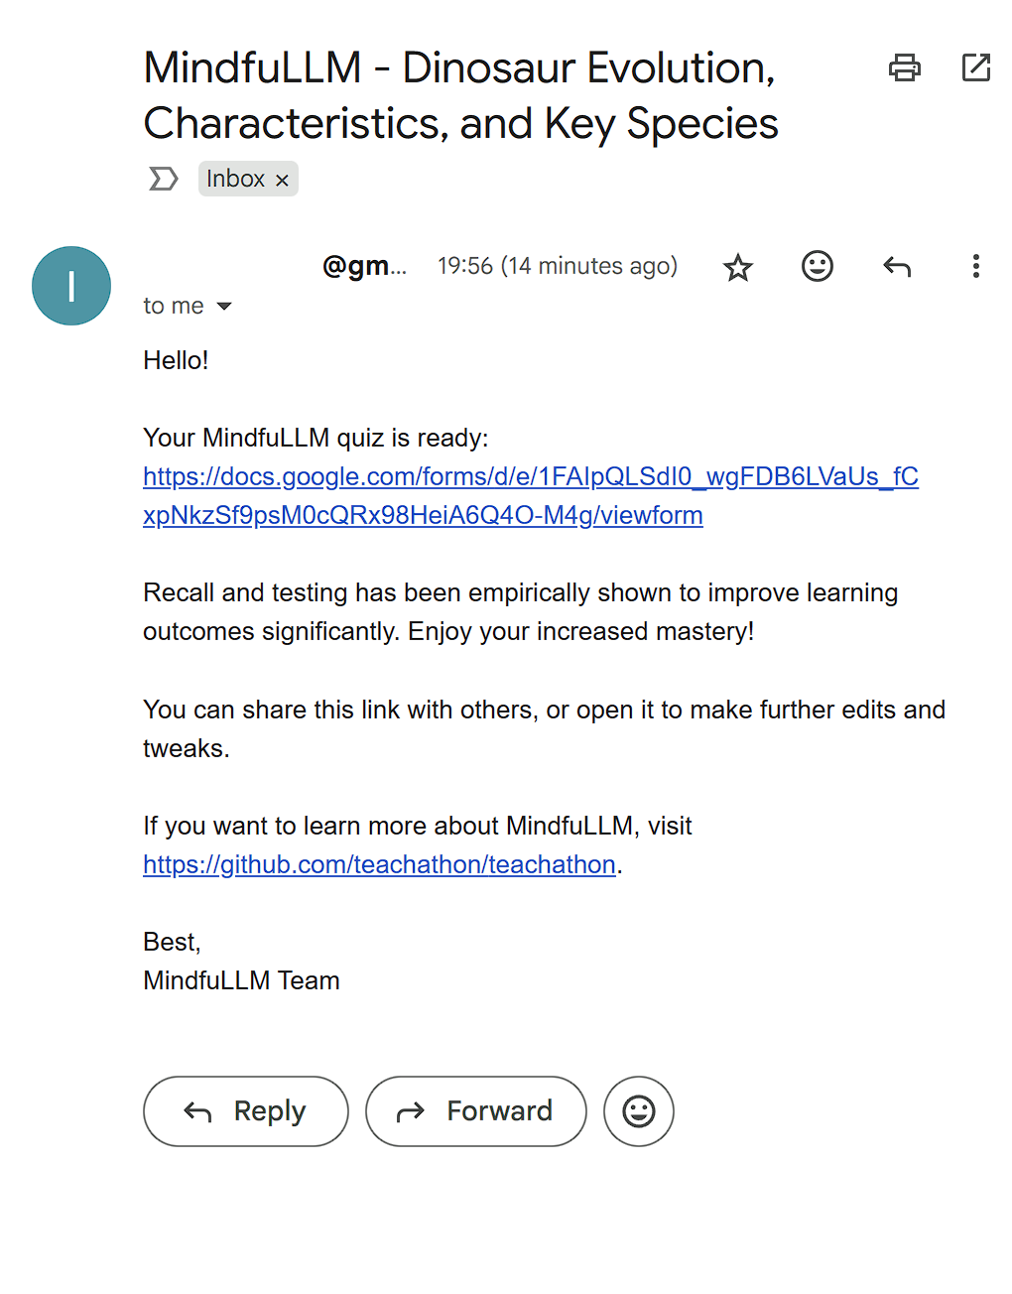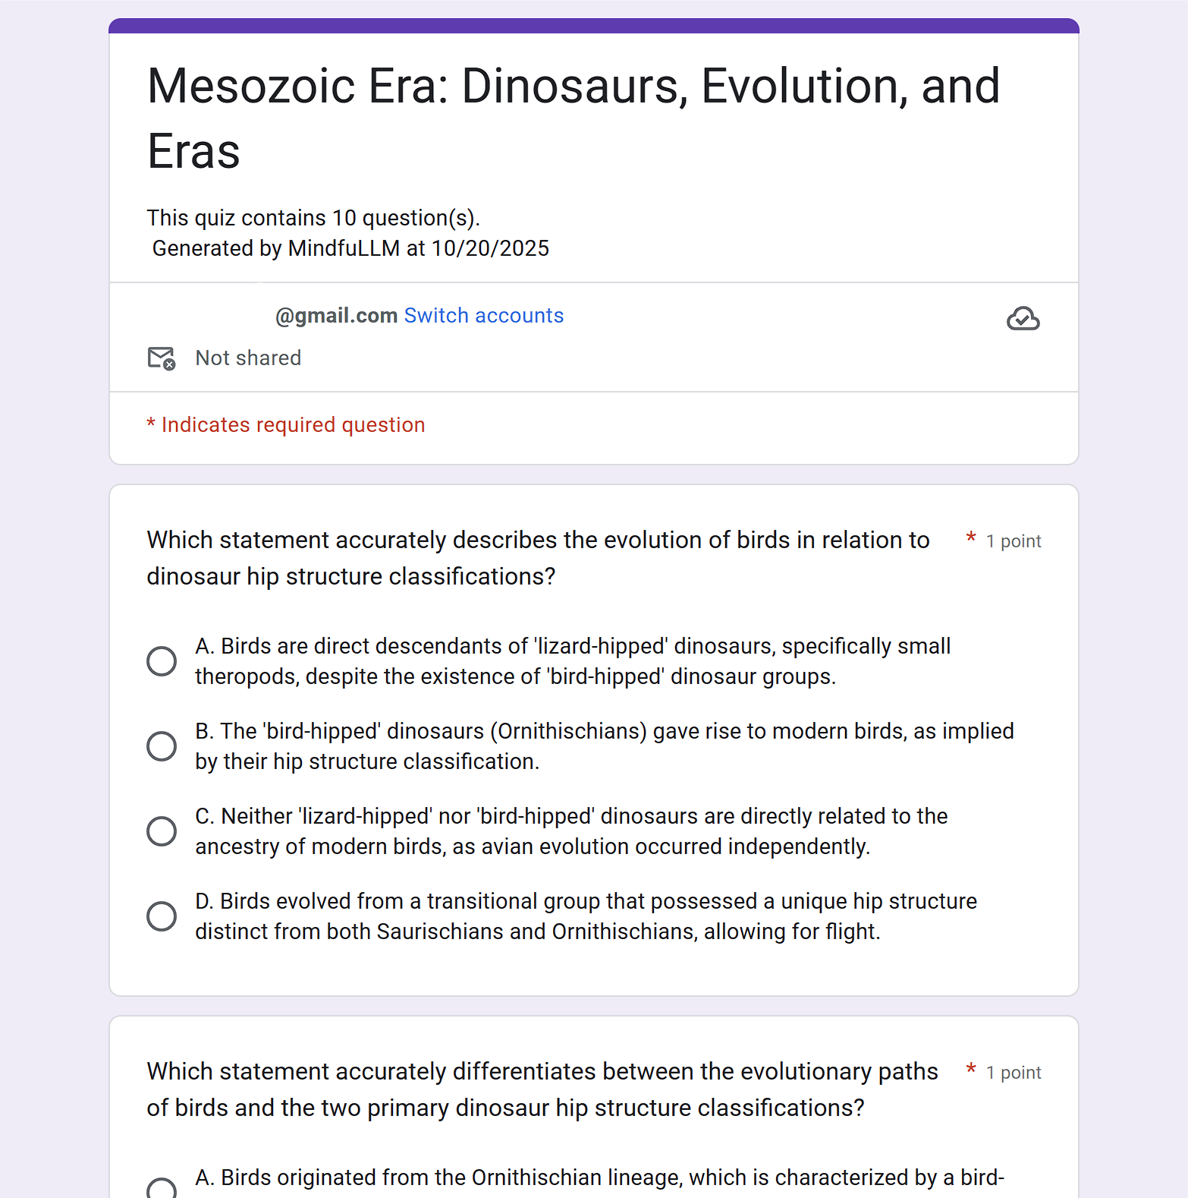
Extension Interface Quiz Email Notification Google Form Quiz

Ethical Considerations:
Due to the particular nature of the product, we believe that privacy concerns are the most important potential issue MindfuLLM may encounter. A vast amount of topics are discussed on LLM platforms, many of which users may not want to be tracked, much less quizzed on. We propose addressing this in 2 main ways:
- Opt-in tracking: The chrome extension will only gather data on LLM conversations that the user selects. Instead of automatically tracking everything, the user will have to manually opt for certain conversations to be viewed.
- User-based quiz hosting: The google form is located within the user’s own google account, meaning that, unless they choose to share the link, only they have access to any content in it. Thus, their information stays private by default, utilizing Google’s own privacy protections. Additionally, should they wish to erase any content, they can edit the quiz or simply delete it.

Next Steps
While we already have a working prototype, we recognise several directions for future development, which are mainly centered around adding additional use cases to the main functionality.

- Timing Strategies for Quiz Deployment
Both a daily email quiz and an interleaved delivery model during active LLM use offer pedagogical benefits. A user-configurable setting within the extension would provide the most adaptable implementation, giving learners control over their preferred engagement pattern.

- Fostering Long-Term Recall and Cross-Concept Synthesis
The next natural enhancement to the learning experience is the integration of memory, enabling the system to connect new ideas with previously explored topics. Before generating each quiz, the LLM’s context would be enriched with past conversations and questions retrieved through similarity search over the vector database of all tracked sessions, by use of embeddings. This would allow the quizzes to promote long-term recall and deeper synthesis across different areas of knowledge.

- Dedicated Backend for Privacy and Analytics
To support long-term recall, the next step is to introduce a dedicated backend with a database for storing messages and their vector embeddings. This infrastructure will enable secure data handling with encryption and transparent data policies, giving users control over their information. With this foundation, we can expand toward features such as an interactive web interface, ELM integration for institutional or student-level insights, and performance statistics over time.

Conclusion
While the idea may be rather simple, we firmly believe that MindfuLLM could significantly improve learning outcomes for students across different areas of study, especially due to the increased prevalence and volume of generative AI use across the board. Utilising active recall and explanation of ideas has been empirically proven to significantly improve learning outcomes, and the ability to apply this to one of the most ubiquitous ways that students in the modern day learn is a critical next step in moving our education system forward.

Freeman, J., & Carden, G. (2025, February 26). Student Generative AI Survey 2025. HEPI. https://www.hepi.ac.uk/reports/student-generative-ai-survey-2025/
Sayalı, C., Heling, E., & Cools, R. (2023). Learning progress mediates the link between cognitive effort and task engagement. Cognition, 236, 105418. https://doi.org/10.1016/j.cognition.2023.105418
Bastani, H. (2024, July 18). Generative AI Can Harm Learning by Hamsa Bastani, Osbert Bastani, Alp Sungu, Haosen Ge, Özge Kabakcı, Rei Mariman. SSRN. https://papers.ssrn.com/sol3/papers.cfm?abstract_id=4895486
Pastötter, B., & Bäuml, K.-H. (2014). Retrieval practice enhances new learning: The forward effect of testing. Frontiers in Psychology, 5, 286. https://doi.org/10.3389/fpsyg.2014.00286
Azzam, M. B., Martin, J., & Vemulapalli, K. (2021). Retrieval practice for improving long-term retention in undergraduate gross anatomy. Advances in Physiology Education, 45(4), 710-716. https://doi.org/10.1152/advan.00145.2021

