Earned Value Management & Estimate at completion

So, how is your project going? This is a question project managers are frequently asked by management and the customer. One technique often used by project managers is to plot the plan spend curve and the actual cost expenditures curve as shown in Exhibit 1 below. The curve looks good, but what can you tell about the health of this project based on this graph? Is the project team accomplishing the planned work and doing it for less money? Or is the team behind schedule? The point is: this curve does not provide sufficient information to communicate how the project is going!

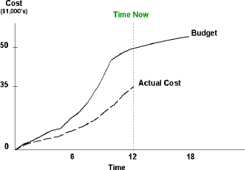

**Exhibit 1 – What can you tell about the health of this project based on the cost curve?**

This paper will explain the terminology, formulas, and key metrics to monitor when using earned value analysis. In addition, the different techniques commonly used to evaluate progress will be described, along with the top ten items needed on projects when implementing earned value.

### EVA Terminology and Calculations

Let's start out by clarifying the terminology associated with earned value, because many people incorrectly use the terms below interchangeably, and they are distinct. The terms are (Lukas, 2008, p.1):

* **Earned Value Analysis (EVA)** — a quantitative project management technique for evaluating project performance and predicting final project results, based on comparing the progress and budget of work packages to planned work and actual costs.
* **Earned Value Management (EVM)** — a project management methodology for objectively measuring project performance using an integrated schedule and budget based on the project WBS.
* **Earned Value Management System (EVMS)** — the process, procedures, tools, and templates used by an organization to do earned value management.

The point is that you can do earned value analysis calculations on any project, but unless you have complete earned value management in use on your project, it will be extremely unlikely to obtain correct results. In order to easily use EVM, your organization really needs to have an earned value management system in place.

#### **Earned Value Definitions**

Earned value analysis uses three key pieces of project information: the planned value, actual cost, and earned value, which are shown in Exhibit 2 below. The first two terms are not new, they are the plan spend curve and the actual cost expenditures curve many project teams have been using for years.

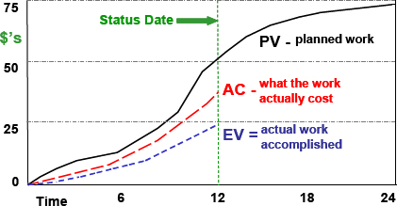

**Exhibit 2 – Typical Graph Showing PV, EV, and AC.**

**Planned Value (PV)** is the budgeted cost for the work scheduled to be done. This is the portion of the project budget planned to be spent at any given point in time. This is also known as the budgeted cost of work scheduled **(BCWS).**

**Actual Costs (AC)** is simply the money spent for the work accomplished. This is also known as the actual cost of work performed **(ACWP).**

**Earned Value (EV)** is the percent of the total budget actually completed at a point in time. This is also known as the budgeted cost of work performed **(BCWP).** EV is calculated by multiplying the budget for an activity or work package by the percentage progress:

### EV = % complete x budget

For example, if a Work Package is the installation of 500 new computers in an office, and 350 computers are installed, the Work Package progress is 70% complete (350/500). If the budget for this Work Package is US$200,000, the earned value is US$140,000 (0.70 x $200,000).

An effective method to show the relationship between PV, EV, and AC is shown in Exhibit 3 below.

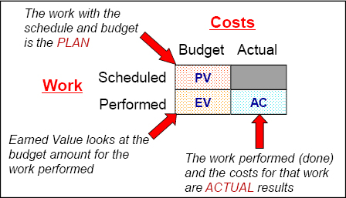

**Exhibit 3 – Relationship of Earned Value Terms.**

#### Earned Value Calculations

With the terms PV, EV, and AC defined, along with how to determine progress, some key calculations can easily be done, which provide important information on how the project is doing. The formulas for earned value calculations are:

|  |  |
| --- | --- |
| **• Cost Variance: CV = EV – AC** | **• Cost Performance Index: CPI = EV/AC** |
| **• Schedule Variance: SV = EV – PV** | **• Schedule Performance Index: SPI = EV/PV** |

A CPI value of 0.83 implies that for every project dollar spent, only US$0.83 in earned value was accomplished. A CPI of less than one and a negative CV indicates project cost performance is below the plan.

A SPI value of 1.05 implies that for every dollar of work the project had planned to accomplish at this point in time, US$1.05 worth of work was actually done. A SPI greater than one and a positive SV indicates more work has been accomplished than was planned. Note how this is worded, since a SPI > 1.0 does not necessarily mean you are ahead of schedule! You can accomplish more work than planned by working on non-critical path Work Packages. You need to look at the critical path to determine whether you are ahead, on or behind schedule.

Exhibit 4 shows the Planned Value, Actual Cost, and Earned Value for a project. Note that when the planned spend curve is compared to the actual spent, it shows a variance of +US$15. An uneducated observer is likely to conclude the project team is accomplishing the planned work and doing it for less money.

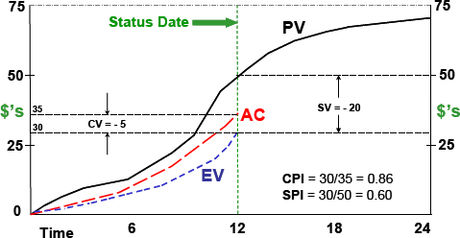

**Exhibit 4 – Earned Value Analysis shows this project is in trouble!**

However, analyzing the project using earned value gives a different picture. Reading from the graph shows a cost variance of -US$5 and a schedule variance of -US$20. The project team has accomplished (“earned”) $US30. However, at this point in time, the schedule plan was to accomplish US$50 of work. Therefore, the project team is US$20 behind in schedule work. In addition, the actual cost for the work accomplished was US$35 and the budget for the work accomplished was only US$30. This means the project team has overspent for the work done. The bottom line Earned Value Analysis clearly demonstrates this project is in trouble!

### Progressing Techniques

On projects, determining realistic progress for Work Packages (WP) can be difficult, but is essential for ensuring the earned value analysis is accurate and meaningful.

So, how much work was accomplished? This is a common question project managers ask team members. Too often, progress is reported in a qualitative manner. One frequent expression is: “I'm almost complete” or “I'm 90% done.” After weeks of hearing that same progress report, the project manager begins to suspect that just maybe the person responsible for the Work Package really doesn't know how much progress has been made.

Quantitative techniques are obviously much better than qualitative (subjective) techniques for measuring project progress. One thing to keep in mind when measuring project progress is that it's an estimate! Many people spend too much time trying to generate a very exact number, especially when using quantitative techniques. The key is to make it ‘fit for use.’ Don't spend exorbitant amounts of time determining exact numbers on a small Work Package. Focus your efforts on the larger value Work Packages. Remember that measuring progress is an estimate, and that the inherent errors on each Work Package will tend to cancel out as you roll up the progress numbers to the project level.

Since the types of Work Packages on a project vary, no single progress reporting method is suitable. The seven most common methods for reporting project progress are described below (Lukas, 2002, pp 2–3).

Quantitative progressing techniques are:

* **Units completed** — tasks that involve repeated production of easily measured pieces of work, when each piece requires approximately the same level of effort.
* **Incremental milestones** — Work Packages (WP) that can easily be divided into a series of tasks handled in sequence. The work is divided into separate, measurable tasks, and completing each task is considered achieving an ‘incremental milestone.’ Progress is earned only when reaching each milestone.
* **Start-finish** — used with low value and/or short duration activities without readily definable intermediate milestones. Either no or some limited progress is ‘earned’ when the activity is started, and 100% progress is earned at the completion of the activity.

Qualitative (subjective) progressing techniques are:

* **Level of effort (LOE)** — used when it's very difficult to measure what work was accomplished for the budget spent. My preferred approach with LOE assumes the progress is equal to the actual costs divided by the budget. For example, if the project manager's budget on a project is US$20,000, and US$10,000 has been charged to the project, then the progress is calculated as 50%. However, some publications use a different approach and set the EV = PV.
* **Individual judgment** — used for complex work not easily measured by other methods. Even though this is subjective, getting multiple opinions on the work accomplished by knowledgeable team members helps establish a reasonable estimate on progress.

Two other progressing techniques commonly used are listed below. They can be either quantitative and/or qualitative, depending on how they are used. The techniques are:

* **Combination techniques** — good for complex work occurring over a long time period and use two or more of the other progressing techniques. An example would be installing a building foundation. The excavation progress would be units completed (cubic yards of earth removed), the formwork incremental milestones, and pouring the concrete start-finish (0%/100%).
* **Apportioned relationship** — has a direct intrinsic performance relationship to another discrete Work Package, which is called the ‘measurement base.’ For determining progress, the apportioned Work Package progress is the same value as the measurement base Work Package.

### Forecasting Using Earned Value

#### SPI: A Barometer on Schedule Performance

Exhibit 5 shows a useful graph, which is a plot of the project SPI versus time. A SPI greater than 1.0 implies the team is accomplishing more work than planned, and a SPI less than 1.0 indicates the team is accomplishing less work than planned. You need to be careful when using SPI, because you really can't determine the project health without knowing how the team is doing against the critical path in the project schedule. A team can achieve an SPI > 1.0 by working on non-critical path activities. Therefore, it is possible to have an SPI > 1.0 and be behind schedule! You need to look at the project float to determine the complete schedule performance for the project.

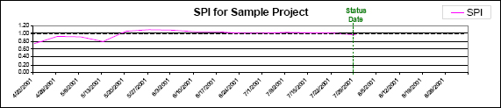

**Exhibit 5 – Plotting SPI is a good schedule performance metric.**

Exhibit 5 is from an actual project (Lukas, 2003, p. 7), and like many projects, the SPI for the first few reporting periods is less than 1.0, since the team is in start-up mode and project activities are just being started. A SPI of less than 1.0 can happen early in the project when start-finish progressing is being used for many of the Work Packages. However, if the SPI does not move toward 1.0 after the first few reporting periods, it is an indication of possible schedule problems and therefore probably time to start taking corrective action.

#### **Using CPI To Determine Final Project Cost**

The Cost Performance Index is an excellent indicator of the cost efficiency for completed work. One main use of **CPI** is **forecasting the final project cost**. Before listing the common formulas used, a few terms need to be defined (PMI, 2008, p.184):

* **Estimate to Complete (ETC)** - the **expected additional cost** **needed** to complete the project.
* **Estimate at Completion (EAC)** - The **expected total cost of the project** when the defined scope of work is completed.
* **Budget at Completion (BAC)** - The **total approved budget** when the scope of the project is completed (including any project contingencies).

**Most techniques for forecasting EAC include** some adjustment of the original cost estimate based on project performance to date. The three common formulas are:

* **EAC1 = AC + (BAC - EV).** This formula is called the ‘mathematical’ or ‘overrun to date’ formula in some textbooks. However, using the term ‘overrun to date’ is misleading because the project could be under on costs and ahead of schedule. This formula **assumes the plan will be met for the remaining work (CPI = 1.0)**, and yields **the most optimistic EAC when a project is not doing well.**
* **EAC2 = BAC/CPI.** This formula is called the ‘cumulative CPI’ in some textbook and **assumes the entire project will be done at the same cost performance (current CPI does not change)**.
* **EAC3 = AC + ((BAC - EV) / (CPI x SPI)) or BAC/(CPI x SPI).** This formula **considers both cost and schedule impact on the EAC**, and usually yields **the most pessimistic EAC for a project not doing well**. Note that these **two calculations are not equivalent**! From my experience, the ‘simplified’ formula works as well or better on many projects.

Exhibit 6 shows the **relationship of BAC, ETC, and EAC**. Note that the project cost contingency is not spread as part of the Planned Value curve. Contingency is a provision in the project plan (extra cost and time) to mitigate the typical (but undefined) unplanned events that happen on projects — to cover ‘known unknowns.’ When calculating the ETC and EAC, some thought should be given as to whether an adjustment is needed for the remaining contingency.

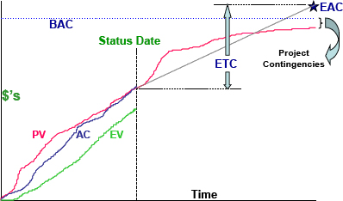

**Exhibit 6 – Displaying ETC, EAC, and BAC on the EV graph.**

#### **To Complete Performance Index**

Another useful evaluation tool is the ‘**To Complete Performance Index**’ (TCPI), which provides a forecast of the required performance level, expressed as the CPI, which must be achieved on the remaining work in order to meet the project financial goal. The TCPI calculation can look at either the current authorized budget or the current estimate-at-completion.

TCPI provides a “sanity check” for the project manager on whether the required CPI for the rest of the project is realistically obtainable. Of the two formulas, looking at the CPI required to complete the project based on the estimate-at-completion is probably more meaningful. The two TCPI formulas are (PMI, 2008, p.185):

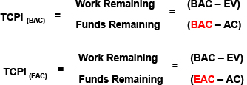

**Exhibit 7 – TCPI Formulas Based on BAC and EAC.**

Research has shown the cumulative CPI will stabilize as early as the 20% completion point of the project, and “researchers found the cumulative CPI does not change by more than 10% once a contract is 20% complete; in most cases, the cumulative CPI only worsens as a contract proceeds to completion” (Christensen, 1994, p.19). This may be too pessimistic, but once 30% completion is reached, it's reasonable to expect the CPI won't change by more than 10% unless the project is stopped and re-planned. For example, if the project CPI is 0.80 at 30% completion, the best you can expect is a final CPI of 0.88, which means your budget will overrun by at least 13.6% (1/0.88).

Bron:<https://www.pmi.org/learning/library/make-earned-value-work-project-6001>

**Een praktisch voorbeeld:**

[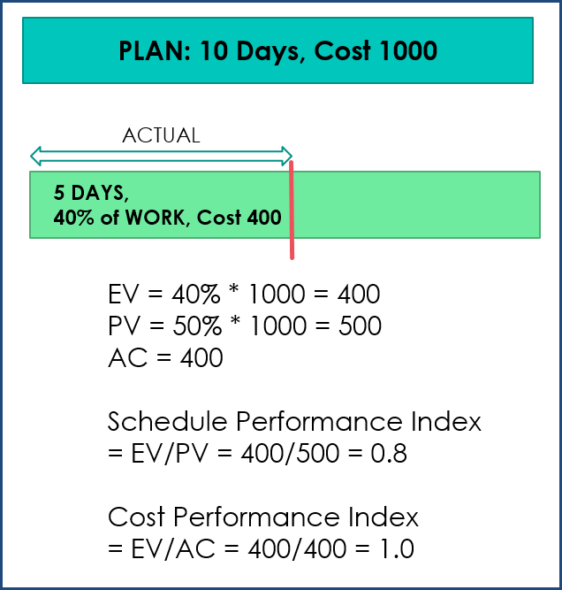](https://indzara.com/wp-content/uploads/2016/02/EVMCalc_1.png)

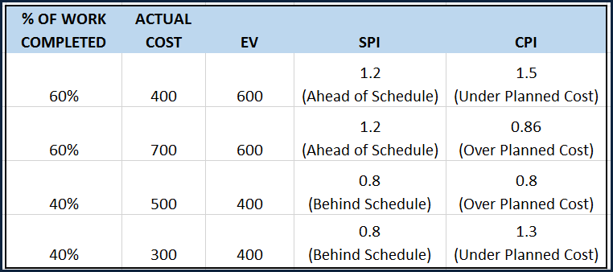

1. PLANNED VALUE (PV): Authorized Budget assigned to the scheduled work **500**
2. EARNED VALUE (EV): Measure of actual work performed expressed as budget authorized for that work **400**
3. ACTUAL COST (AC): Actual cost incurred for the work performed **400**
4. SCHEDULE VARIANCE (SV): Amount by which project is ahead or behind plan = EV – PV = **-100**
5. COST VARIANCE (CV): Amount by which actual cost is ahead or behind planned cost = EV – AC = **0**
6. BUDGET AT COMPLETION (BAC): Total Budget assigned to the entire plan **1000**
7. SCHEDULE PERFORMANCE INDEX (SPI): Measure of Schedule efficiency expressed as Earned Value to Planned Value  = EV/PV = **0.8**
8. COST PERFORMANCE INDEX (CPI): Measure of Cost efficiency expressed as Earned Value to Actual Cost = EV/AC = **1.0**

### FORECASTING

An extension of the *Earned Value* calculations is **Forecasting**, which deals with estimating how the rest of project will go.

**Estimate at Completion** (EAC) is the expected total cost by the end of the project. It is the sum of Actual Cost (AC) so far and **Estimate To Complete** (ETC). EAC can be calculated using different forecasting methods. The following are three common methods.

* **Budget Rate**: If we assume the rest of the project will cost at the original planned budget rate, then
* EAC = AC + (BAC – EV)
* **CPI**: If we assume the rest of the project will cost at the cost efficiency we have seen so far, then EAC = BAC/CPI
* **SPI & CPI**: If we assume the rest of the project will cost based on the cost and schedule efficiencies we have seen so far, then EAC = AC + [(BAC-EV) /(CPI*SPI)]

ETC = EAC – AC

Once we know the EAC, we can calculate the **Variance at Completion** (VAC) which represents the cost difference between project’s planned budget and current estimate. VAC = BAC – EAC.

The final index we will calculate is the **To-Complete Performance Index (TCPI)** which represents **the cost performance that is needed from now onwards to achieve the goal**. It can be thought of as ‘**Work Remaining / Funds available**’.

**Work Remaining = BAC – EV. Funds available = BAC – AC**  
TCPI = (BAC – EV)/(BAC – AC)

If your new estimate has been approved, Funds Available will be EAC – AC. Then, the formula for TCPI will be  
TCPI = (BAC – EV)/(EAC – AC)

***If TCPI is >1, it is ‘Harder to Complete’ and if it is <1 it is ‘Easier to Complete’.***

I have also added a term **Estimated Calculation Date** (ECD), calculated as Project Start Date + (Planned Duration/SPI).

**Bron**: <https://indzara.com/2016/02/earned-value-management-free-excel-template/>

**Met 2 video’s in deze web-pagina:**

[**https://www.youtube.com/watch?time_continue=6&v=O9zOpWiErOk&feature=emb_logo**](https://www.youtube.com/watch?time_continue=6&v=O9zOpWiErOk&feature=emb_logo)

**Template**

<https://www.youtube.com/watch?v=R-zEGp5h4FU&feature=emb_logo>

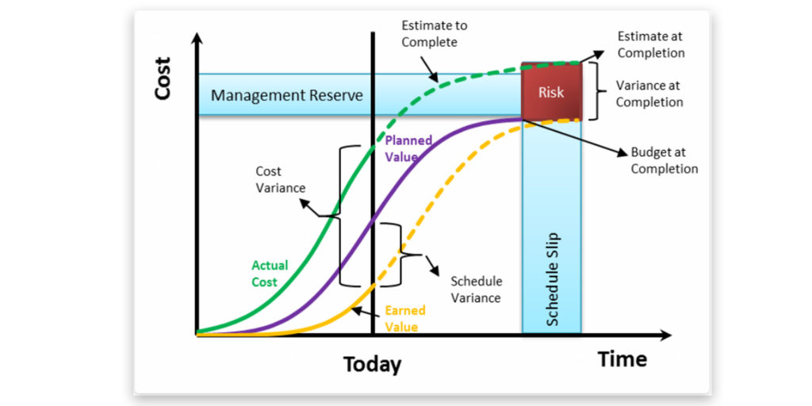

Earned Value Management

**Key parameters :**

***Actual Cost (AC) :*** This is how much we have spent so far.

***Planned Value (PV) :*** This is what we planned for the project.

***Earned Value (EV) :*** This is how much of the project work has been accomplished.

***Budget At Completion (BAC) :*** This is the total budget of the project.

**Key Performance Variance :**

**Cost Variance (CV = EV – AC) :**That means : Am I over budget or under budget ?

**Cost Performance Index (CPI = EV / AC) :**

That means :

|  |  |  |
| --- | --- | --- |
| **CV < 1** | **CV = 1** | **CV > 1** |
| **Over budget** | On budget | Under budget |

**Schedule Variance (SV = EV – PV) :**

That means : Am I ahead schedule or behind Schedule ?

**Schedule Performance Index (SPI = EV / PV) :**

That means :

|  |  |  |
| --- | --- | --- |
| **CV < 1** | **CV = 1** | **CV > 1** |
| **Behind schedule** | On Schedule | Ahead schedule |

**Estimate At Completion (EAC = AC + ETC) :** That means : What will be spent on whole project ?

**Performance Variance :**

**Estimate To Complete (ETC = BAC – EV) :**

That means : What will be spent on remaining project ?

**To Complete Performance Index**

That means : This index gives you the future cost performance index that you must follow for the remaining work if you want to complete it within the given budget.

**(TCPI = (BAC – EV)/(BAC – AC))** (Use this formula if you are **under** budget)

**(TCPI = (BAC – EV)/(EAC – AC))** (Use this formula if you are **OVER** budget)

**Variance At Completion**

**(VAC = BAC – EAC) :**That means : Variance at total project cost from budget

**Variance At Completion**

**EAC = Estimate At Completion**

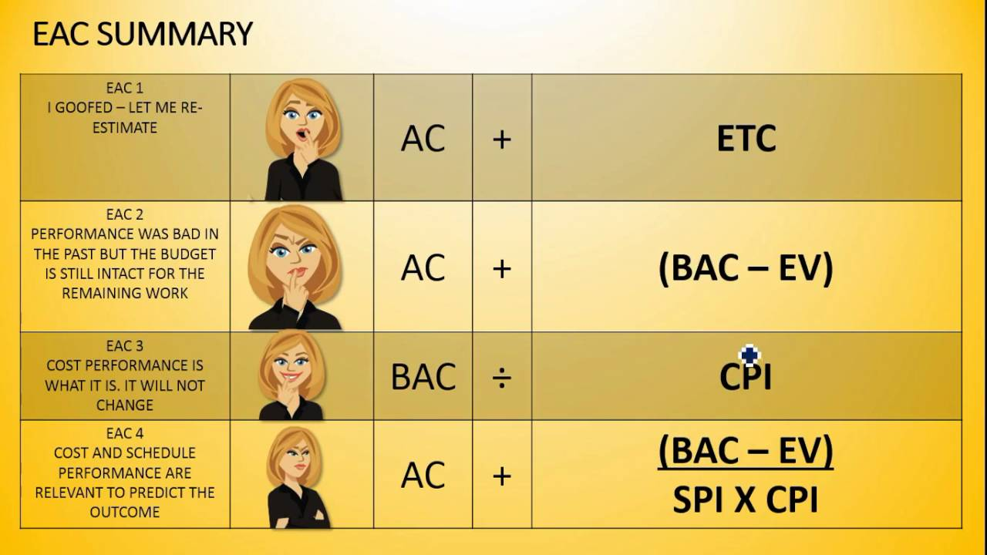

<https://www.youtube.com/watch?v=HcnDVFrX0Ro>

<https://praizion.com>

<https://martinsitconsulting.com/cost-earned-value-management/>

**Samenvatting formules**

|  |  |  |  |  |
| --- | --- | --- | --- | --- |
| **Symbol** | **Name** | **Formula** | **Description** | **Interpretation of Result** |
| **Inputs** | | | | |
| PV | Planned Value |  | The value of the portion of the task that is supposed to have been completed |  |
| EV | Earned Value |  | The value of the portion of the task that is actually completed |  |
| AC | Actual Cost |  | The actual cost of the task to date |  |
| BAC | Budget at Completion |  | Total overall project budget (planned) |  |
| **Basic Outputs** | | | | |
| SV | Schedule Variance | SV = EV – PV | The amount that the task is ahead or behind schedule, expressed as a task value | SV < 0 = behind schedule SV > 0 = ahead of schedule |
| SPI | Schedule Performance Index | SPI = EV/PV | The amount that the task is ahead or behind schedule, expressed as a percentage of the task | SPI < 1 = behind schedule SPI > 1 = ahead of schedule |
| CV | Cost Variance | CV = EV – AC | The amount that the task is over or under budget, expressed as a task value | CV < 0 = over budget CV > 0 = under budget |
| CPI | Cost Performance Index | CPI = EV/AC | The amount that the task is ahead or behind schedule, expressed as a percentage of the task | CPI < 1 = over budget CPI > 1 = under budget |
| **Complex Outputs** | | | | |
| EAC | Estimate at Completion | * EAC = BAC/CPI * EAC = AC + (BAC – EV) * EAC = AC + [(BAC – EV)/(SPI x CPI)] * EAC = AC + ETC | The estimated project budget at the end of the project, given current project budget status |  |
| ETC | Estimate to Complete | * ETC = EAC – AC * ETC = new estimate | The expected cost to finish the project |  |
| VAC | Variance at Completion | * VAC = BAC – EAC | The expected cost variance at the end of the project, given current project status | VAC < 0 = over budget VAC > 0 = under budget |
| TCPI | To Complete Performance Index | * TCPI = (BAC – EV) / (BAC – AC) * TCPI = (BAC – EV) / (EAC – AC) | The CPI required to complete the project on budget | TCPI < 1 = under budget TCPI > 1 = over budget |

Bron: <https://www.projectengineer.net/the-earned-value-formulas/>

# Meer Referenties met voorbeelden

<https://www.fool.com/the-blueprint/earned-value-management/>

<https://www.projectengineer.net/tutorials/earned-value-tutorial/earned-value-example/>