LinkedIn Automation · vi-writer
LinkedIn Automation
Purpose, how it works, when it runs, and its architecture: one document for owners, clients and builders
Owner: Pravin
Version: 1.0 · 1 November 2026
Audience: Section 1–4 for clients and decision makers · Section 5–9 for technical readers
Location: C:\Users\PRAVIN\Desktop\LinkedInAutomation

Contents
1. Purpose 3
1.1 The problem it solves 3
1.2 Goals 3
1.3 Benefits 3
2. At a glance (client view) 3
3. How it works: step by step 5
3.1 The review panel in detail 5
4. When it runs and when it posts 7
4.1 Recommended cadence 7
4.2 Automatic scheduling (optional, not yet built) 7
5. Architecture 8
5.1 Detailed workflow 8
6. Quality and safety controls 10
7. Who does what 10
8. Outputs and where they are stored 10
9. Example: one real run 11
Appendix A. Detailed workflow diagram 12
Appendix B. Glossary 13

1. Purpose
Posting consistently on LinkedIn about AI and AI product management takes hours per post: finding what is new, checking facts, writing in a format that performs, and making sure nothing is wrong, risky or repetitive. This automation does that work end to end, so the author spends minutes, not hours, and only on decisions that need a human.

1.1 The problem it solves
Without automation | With this automation
Hours searching news for something worth saying | An agent scans the last 3 days of industry news and ranks the best story for LinkedIn
Numbers copied from secondary blogs, sometimes outdated | Every number is verified at its original source by an independent fact-checker
Posts that read like generic AI hype | Posts follow a researched post anatomy and the author’s own opinions and voice
Risk of defamation, copyright or insensitive wording | A compliance reviewer screens 8 risk areas before anything is published
Repeating the same point across posts | Every draft is compared with already-published posts; ≥25% overlap fails
No record of where facts came from | Every source, review and draft is saved in an auditable folder

1.2 Goals
- Publish-ready posts with zero placeholders and zero invented facts.
- Topics grounded in what is happening now in AI, AI product management and enterprise AI adoption.
- Content that always agrees with the author’s stated opinions (my-views.md).
- Independent quality gates: facts, legal/sensitivity, engagement.
- The author stays in control: nothing goes live without an explicit “Post now”.

1.3 Benefits
Benefit | How
Speed | Research, writing and review run automatically; the author reviews one final post
Credibility | Primary-source numbers, named sources in the post, links in the first comment
Safety | Defamation, copyright, disclosure and cultural checks; risky claims softened or removed
Consistency | Same proven structure every time; engagement scored and improved by an editor agent
Traceability | A run folder per post with sources, debates, reviews, drafts and publishing evidence

2. At a glance (client view)
The simplest way to explain the system: five steps, with the author in control at the start and at the end.
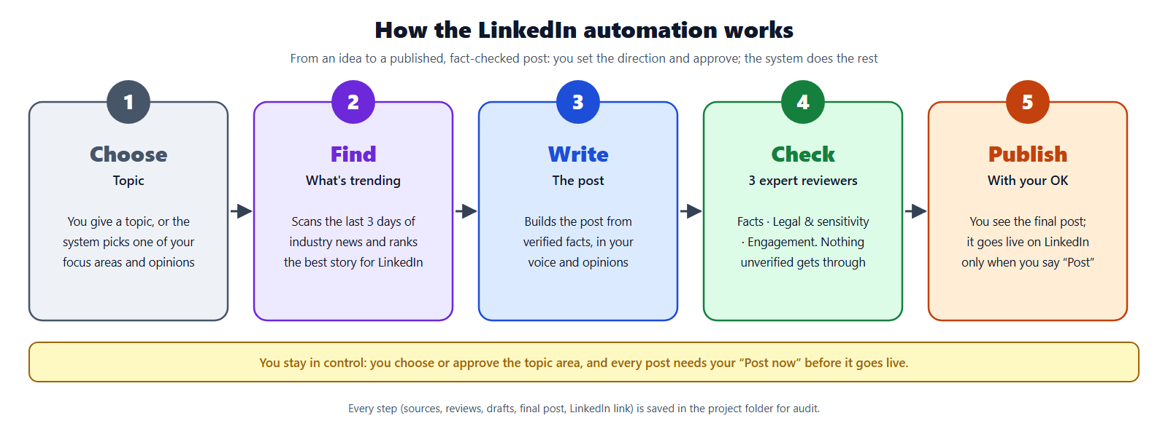
Figure 1. How the LinkedIn automation works, in five steps (docs/client-overview.png).
Step | What happens | Who
1 Choose | The author gives a topic (e.g. “genai is good for finance”), a domain (“AI agents”), or nothing; then the system picks one of the author’s focus areas and opinions | Author or system
2 Find | The trend agent scans the last 3 days of news, papers, regulator updates and company announcements and picks the strongest story for LinkedIn | System
3 Write | The writer builds the post from verified facts, in the author’s voice and opinions, following the post anatomy | System
4 Check | Three reviewers: fact-checker, compliance, editorial. Problems are fixed and re-checked | System (author decides escalations)
5 Publish | The author sees the final post and either copies it or lets the system post it via Chrome after saying “Post now” | Author approves

3. How it works: step by step
Every run follows the same ordered steps. Each step saves its output before the next one starts, so an interrupted run still leaves its work behind.
# | Step | What happens | Saved to
S | Start a run | Create a run folder research/runs/<date>_<topic>/ and record the request; load the author’s opinions (my-views.md) and the list of published posts. | request.md
1 | Decide what to write about | No input → pick the focus area used longest ago from my-views.md. Topic → find its wider domain. Domain → scan it. --no-trend → skip trend search. | request.md
2 | Find trends (trend-captain) | 6–10 web searches; keep stories published in the last 3 days; score each out of 100 for LinkedIn (relevance, evidence, practical angle, debate potential, freshness, originality, durability, hype risk); bonus if it fits the author’s opinions, penalty if it repeats a published post; pick the top 3. | trend-scan/, sources/
3 | Accept the top trend | The #1 trend must have ≥4 sourced facts including a real number and a named example, all recent, and a thesis not already published. Otherwise use #2/#3. | backlog.md
4 | Verify and plan | Re-open the key sources to confirm the 1–3 most important numbers; choose post type (e.g. contrarian note, research translation) and format (text, image, document). | analysis/
5 | Write | Hook ≤140 characters (3 options), context, 3–5 evidence beats with a caveat, one-line takeaway, a question for practitioners, and a first comment holding the source links. | writing/draft-v1.md
6 | Automatic checks | Quality (length, hook, bait phrases, links, hashtags, placeholders), overlap with published posts (≥25% fails), angle overlap, and alignment with the author’s opinions. | writing/draft-vN.md
7 | Review panel | Fact-checker and compliance review in parallel → fixes applied → re-check of changed lines (max 2 rounds) → editorial improves engagement → final re-check of edited claims. | review/
8 | Deliver and save | The author receives the final post, first comment, evidence list, review summary and posting notes; everything is filed and indexed. | final/, posts/, INDEX.md
9 | Publish | Option A copy-paste · Option B Claude in Chrome (exact-text check, preview, “Post now”, post once, first comment) · Option C later. The post is then marked published with its URL. | publish/, posts/

3.1 The review panel in detail
Reviewer |  | Checks | Can change the post?
fact-checker |  | Every number, date, name, quote and comparison against primary sources; recomputes derived figures; flags opinions written as facts | No: gives exact corrections
compliance |  | Defamation, copyright, trademarks, financial/regulatory claims, disclosure, privacy, LinkedIn policy, cultural sensitivity | No: gives safer wording; escalates legal judgement to the author
editorial |  | Hook, clarity, rhythm, audience value, voice, comment potential (scored 1–5); predicts critical comments | Yes, wording only: never facts, numbers, sources or stance
Panel rules
Conflicts: compliance wins over fact-checker, which wins over editorial.
Lines fixed by reviewers are locked; editorial cannot reword them.
If a blocking problem remains after two rounds, the post is not delivered.

4. When it runs and when it posts
Today every run is started by the author; nothing runs or posts on its own. The table lists every trigger, what it does, and whether a human is involved.
Trigger | Example | What happens | Human step
Topic or opinion | /vi-writer genai is good for finance | Trend search focused on the topic → full run → final post | Author starts it
Domain | /vi-writer AI agents | Trend search across the domain → best trend → full run | Author starts it
No input | /vi-writer | Picks the focus area used longest ago in my-views.md (D1 GenAI in marketing, D2 Claude/GPT updates → marketing) with its opinions | Author starts it
Exact topic | /vi-writer <topic> --no-trend | Skips trend search; researches that topic directly | Author starts it
Follow-up | “write #2” | Writes the runner-up trend from the last run’s backlog | Author asks
Revision | “make it shorter / a carousel” | New draft version, checks and review again | Author asks
Review only | /review-panel <post> | Runs the three reviewers on any post | Author starts it
Publish | Choose option B after a run | Chrome opens LinkedIn, fills the post, shows a preview | Author must say “Post now”
Mark published | “I published the UBS post: <url>” | Post marked published; counts for future overlap checks | Author tells the system

4.1 Recommended cadence
- 3–5 posts per week (research data: 2–5 posts/week raises impressions per post; 4–5 has the highest median engagement rate).
- Post Tuesday to Thursday, at a time when the author can reply to comments for 60–90 minutes.
- Never two posts within 24 hours.
- Topical posts (e.g. company results) within 1–3 days of the news.

4.2 Automatic scheduling (optional, not yet built)
Runs could be started on a schedule (for example every Tuesday and Thursday morning) with Claude Code scheduled tasks, and posts could be timed with LinkedIn’s own scheduler. Even then, the design keeps one rule: a post goes live only after the author approves it.
What never happens automatically
Posting without the author’s explicit “Post now”.
Liking, commenting on other people’s posts, sending messages or connection requests, or changing the profile.
Posting a draft that failed any check or still has an open blocking issue.

5. Architecture
The system has six layers. The numbers on the diagram follow the order of a run; dashed lines are human checkpoints or optional parts.
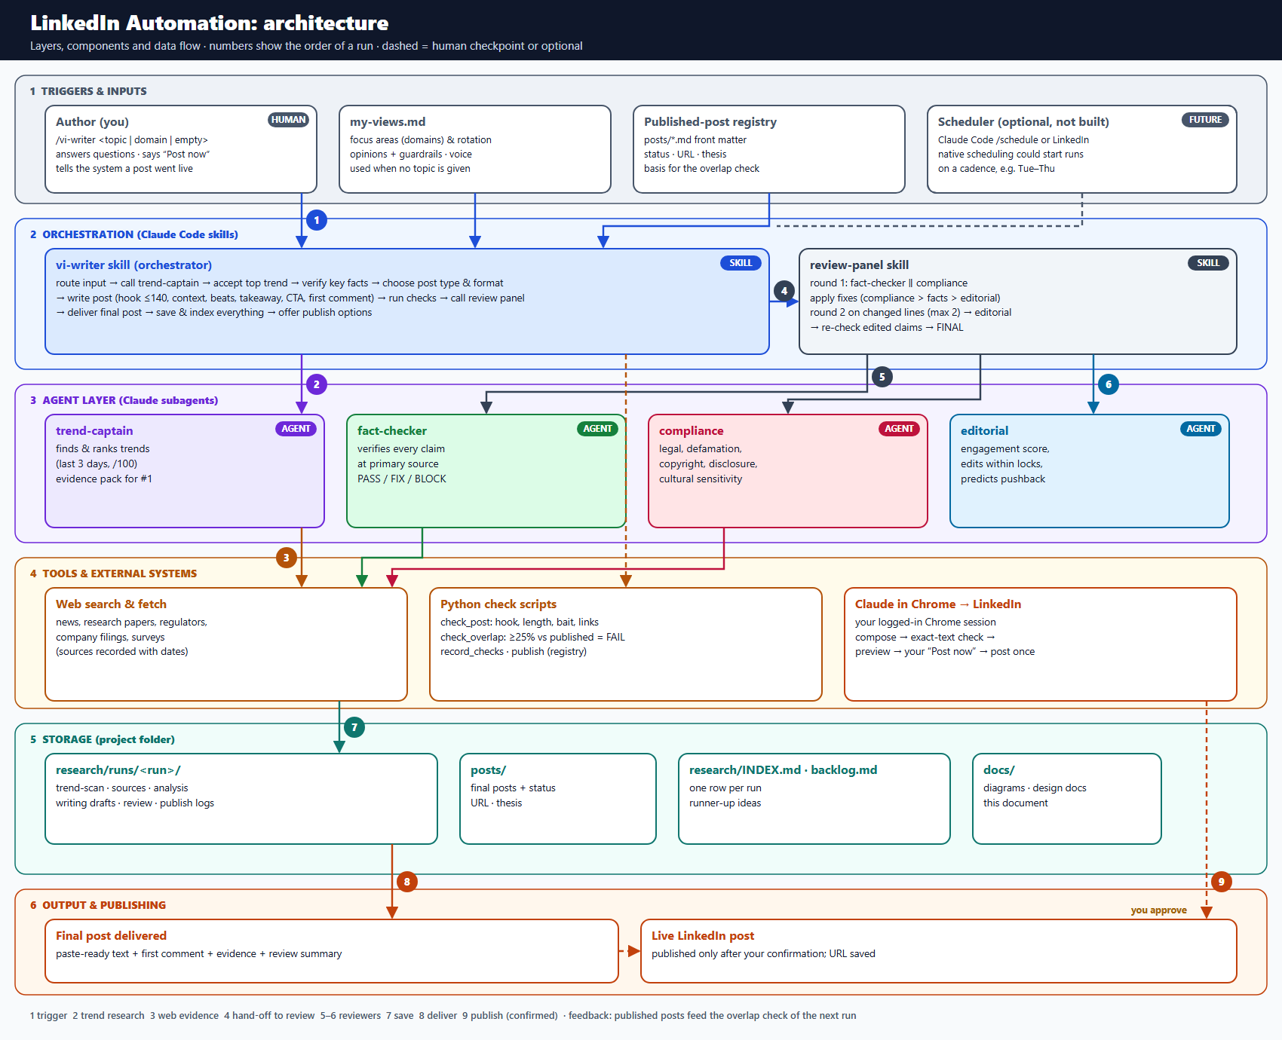
Figure 2. Architecture-level flow (docs/architecture.png).
Layer | Components | Role
1 Triggers & inputs | Author · my-views.md · published-post registry · scheduler (future) | Start a run and supply opinions and history
2 Orchestration | vi-writer skill · review-panel skill | Control the order of steps, decisions and hand-offs
3 Agents | trend-captain · fact-checker · compliance · editorial | Specialist work, each with its own instructions and tools
4 Tools & external | Web search & fetch · Python check scripts · Claude in Chrome → LinkedIn | Evidence gathering, automatic checks, publishing
5 Storage | research/runs · posts · INDEX & backlog · docs | Audit trail and memory between runs
6 Output & publishing | Final post · live LinkedIn post | What the author receives and what goes live

5.1 Detailed workflow
The full step-level diagram with every rule and threshold is in docs/vi-writer-workflow.png; it is reproduced in the appendix.

6. Quality and safety controls
Control | Rule | Effect
No invented content | No placeholders, no unverified facts, no invented personal experiences | Script fails the draft
Source verification | Key numbers re-opened at source; independent fact-check | Outdated data caught (real case: archived benchmark replaced)
Risk screen | 8 compliance areas; escalation to the author | Real case: wording about a listed bank softened
Overlap | ≥25% similarity with a published post | Draft rewritten or another trend chosen
Views alignment | Must agree with my-views.md; opinions in first person | Never argues against the author
Engagement | Editorial edits if average score <4.5 | Real case: scores 3.7 → 4.2 and 4.0 → 4.3
Publishing | Exact-text check, preview, “Post now”, post once | No duplicates, no unapproved posts

7. Who does what
The author | The system
Keeps my-views.md up to date (focus areas, opinions, voice) | Finds and ranks current trends
Starts a run (or asks for a revision / the next trend) | Researches, verifies and writes
Answers escalations and the disclosure question | Checks quality, overlap and opinion alignment
Approves publishing with “Post now”, or posts manually | Runs fact, compliance and editorial review
Tells the system when a manual post went live | Saves, indexes and (when approved) publishes and logs

8. Outputs and where they are stored
Output | Location
Final post (paste-ready) and first comment | posts/<date>-<topic>.md and research/runs/<run>/final/
Trend ranking and research | research/runs/<run>/trend-scan/, sources/, analysis/
Every draft with its checks | research/runs/<run>/writing/draft-vN.md
Reviewer reports and log | research/runs/<run>/review/
Publishing evidence (log, screenshots, recording) | research/runs/<run>/publish/
Run index and future ideas | research/INDEX.md, research/backlog.md
Diagrams and documents | docs/

9. Example: one real run
Stage | What happened
Input | “gen ai for finance is bad” (1 Nov 2026)
Research | Benchmarks (Vals AI Finance Agent), Fin-RATE paper, Gartner CFO survey
Write | Stance sharpened to “strong at retrieval, weak where one wrong number costs money”
Review | Fact-checker BLOCKED: the benchmark version had been archived; post rebuilt on current data (57.0% modeling vs 93.0% earnings)
Compliance | “written by experts” corrected to “reviewed by experts”; idiom simplified; disclosure confirmed
Editorial | Score 4.0 → 4.3; trimmed to 1,509 characters
Publish | Posted via Chrome after “Post now”; text verified 1,509/1,509 characters; sources added as first comment; URL recorded

Appendix A. Detailed workflow diagram
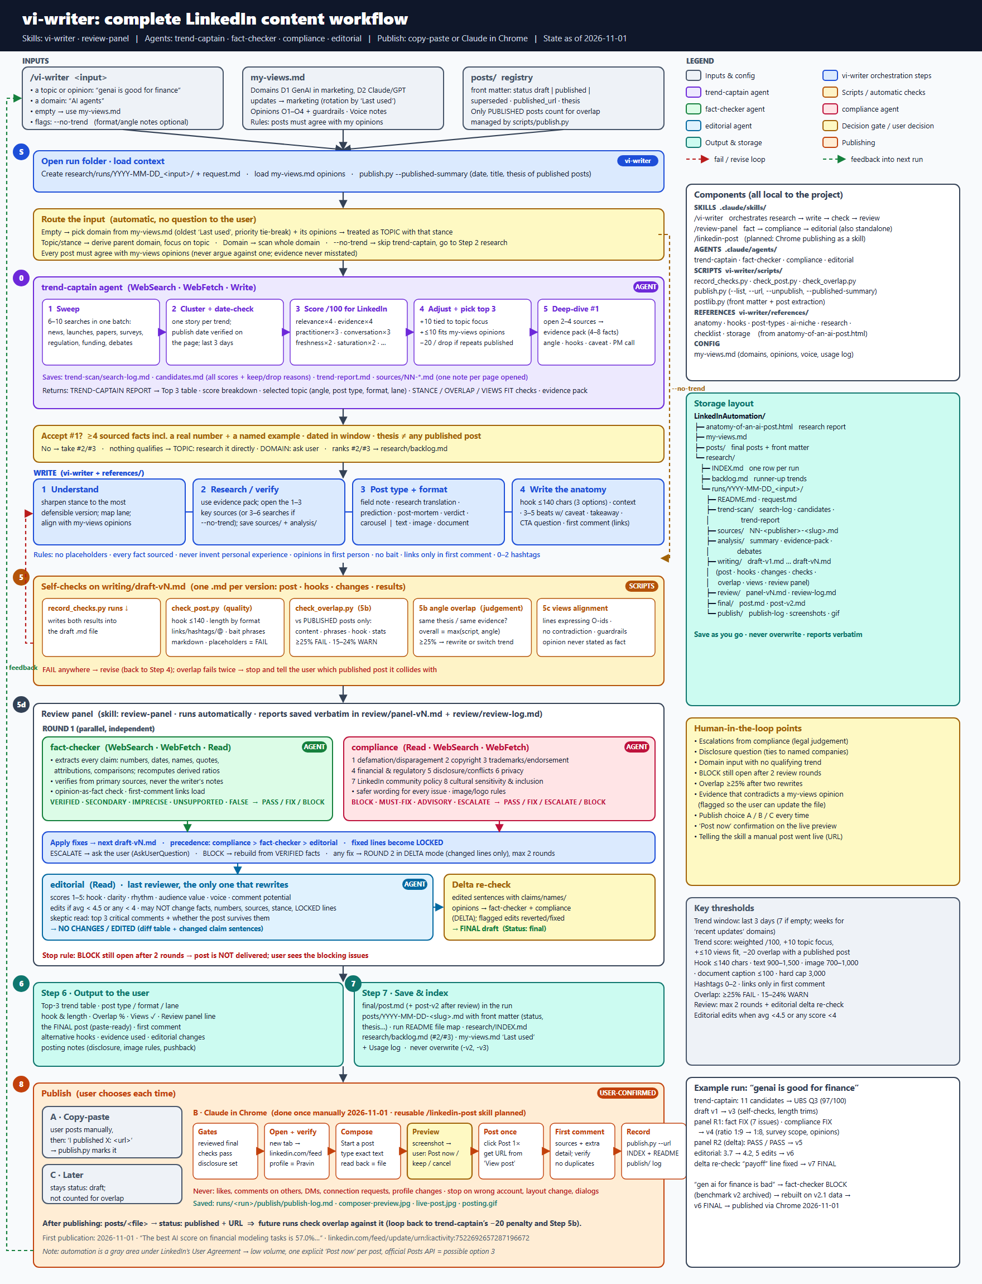
Figure 3. Complete step-level workflow (docs/vi-writer-workflow.png).

Appendix B. Glossary
Term | Meaning
Skill | A reusable instruction set Claude Code runs on command (e.g. /vi-writer)
Agent | A specialist Claude helper with its own instructions and tools (e.g. fact-checker)
Run folder | The folder holding everything produced for one post
my-views.md | The author’s focus areas, opinions and voice
Overlap | Similarity between a draft and an already-published post
Hook | The first one or two lines shown before LinkedIn’s “…see more”
First comment | The comment added right after posting, holding source links
BLOCK / FIX / PASS | Reviewer verdicts: stop, correct, or approve
Colour key used in this document
Input / config | vi-writer skill
review-panel skill | trend-captain agent
Scripts / checks | fact-checker agent
compliance agent | editorial agent
User / decision | Storage / references
Publishing

