LinkedIn Automation · vi-writer
Technical Design Document
vi-writer: an agentic system that researches, writes, reviews and publishes evidence-based LinkedIn posts
Version: 1.0 · 1 November 2026 (as built)
Owner: Pravin
Location: C:\Users\PRAVIN\Desktop\LinkedInAutomation (project-local; nothing in the user-level .claude folder)
Runtime: Claude Code (skills + subagents), Python 3.13 scripts, Claude in Chrome extension

Contents
1. Overview 3
1.1 Goals 3
1.2 Non-goals 3
2. Architecture 3
2.1 Components 4
3. Workflow specification 5
4. Agent contracts 6
4.1 trend-captain 6
4.2 fact-checker 6
4.3 compliance 6
4.4 editorial 6
4.5 Panel protocol 7
5. Data model and storage 7
5.1 Folder layout 7
5.2 Post file front matter (posts/*.md) 7
5.3 Draft file (writing/draft-vN.md) 7
6. Algorithms and thresholds 8
6.1 Quality gate (check_post.py) 8
6.2 Overlap score (check_overlap.py) 8
6.3 Angle-overlap judgement (Step 5b) 8
7. Publishing design (Claude in Chrome) 8
8. Risk, security and compliance 9
9. Verification performed 9
10. Known limitations and roadmap 9
11. Appendix: file inventory 10

(If the table is empty, right-click it in Word and choose Update Field.)

1. Overview
vi-writer turns a topic, a domain, or nothing at all into one final LinkedIn post that can be pasted or published without edits. Each post is grounded in verified, current industry evidence, follows a research-based post anatomy, agrees with the author’s recorded opinions, avoids overlap with posts already published, and passes an independent review panel before delivery. Every artifact of every run is stored in a fixed folder structure.

1.1 Goals
- Final, paste-ready posts with zero placeholders and zero invented facts or experiences.
- Evidence from the last 3 days of industry news (trend-captain), verified at source.
- Consistent structure: hook ≤140 characters, context, 3–5 beats, takeaway, CTA, first comment with links.
- Alignment with the author’s opinions in my-views.md; never argue against one.
- No significant overlap (≥25%) with published posts.
- Independent fact, compliance and editorial review with an auditable trail.
- Optional browser publishing with an explicit human ‘Post now’ for each post.

1.2 Non-goals
- Bulk or scheduled auto-posting without a human in the loop.
- Engagement actions on other people’s content (likes, comments, DMs, connection requests).
- Writing from the author’s private experience unless the author supplies it.
- Legal advice: compliance is a risk screen that escalates to the author.

2. Architecture
The system is an orchestrator skill (vi-writer) that delegates to specialised subagents, deterministic Python checks, and a second skill (review-panel). The colour key below is used throughout this document.
Input / config | vi-writer skill
review-panel skill | trend-captain agent
Scripts / checks | fact-checker agent
compliance agent | editorial agent
User / decision | Storage / references
Publishing
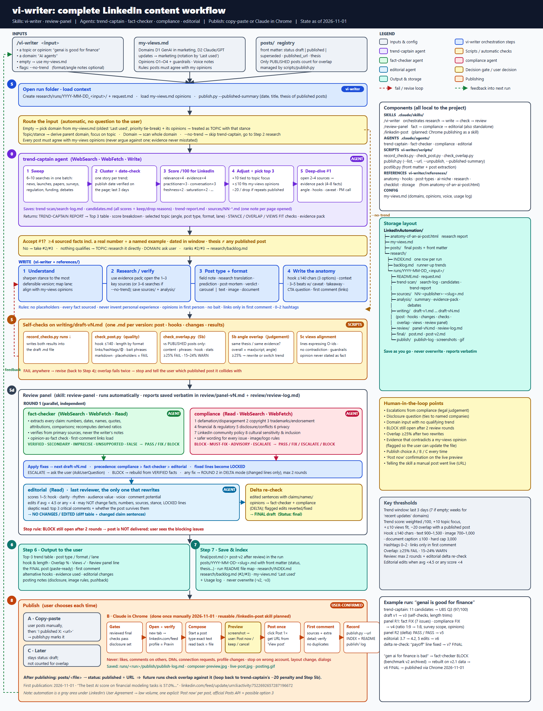
Figure 1. End-to-end workflow (docs/vi-writer-workflow.png).

2.1 Components
Component | Type | Responsibility | Tools / runtime
vi-writer | Skill (orchestrator) | Routes input, calls agents, writes the post, runs checks, invokes the review panel, saves and indexes everything | Agent, Skill, AskUserQuestion, WebSearch, WebFetch, Read, Write, Edit, Bash
trend-captain | Subagent | Finds trends from the last 3 days, scores them for LinkedIn, returns top 3 + evidence pack for #1 | WebSearch, WebFetch, Write, Read, Glob
review-panel | Skill | Runs fact-checker + compliance, applies fixes, runs editorial and delta re-checks, finalises | Agent, Read, Write, Edit, Bash
fact-checker | Subagent | Independently verifies every claim against primary sources; flags opinions stated as facts | WebSearch, WebFetch, Read
compliance | Subagent | 8-area risk screen: defamation, copyright, trademarks, financial/regulatory, disclosure, privacy, LinkedIn policy, cultural sensitivity | Read, WebSearch, WebFetch
editorial | Subagent | Scores engagement, edits wording within locks, predicts critical comments | Read
check scripts | Python | record_checks, check_post, check_overlap, publish, postlib | Python 3.13 (stdlib only)
my-views.md | Config | Domains, opinions, guardrails, voice, usage log | Markdown
Claude in Chrome | Browser tool | Opens LinkedIn in the author’s logged-in Chrome, composes, posts after confirmation | Chrome extension MCP tools

3. Workflow specification
Step | Name | Behaviour
S | Open run folder | Create research/runs/YYYY-MM-DD_<input-slug>/ and request.md; load my-views.md; run publish.py --published-summary.
R | Route input | Empty → domain from my-views.md (oldest ‘Last used’, priority tie-break) + its opinions. Topic/stance → derive parent domain. Domain → scan domain. --no-trend → skip trend-captain.
0 | trend-captain | Sweep 6–10 searches → cluster and date-check (≤3 days) → score /100 → adjust (+10 focus, +≤10 views fit, −20 overlap) → top 3 → deep-dive #1 into an evidence pack.
G | Accept #1 | ≥4 sourced facts incl. a number and a named example, dated in window, thesis ≠ any published thesis. Else #2/#3 or fallback.
1–2 | Understand + research | Sharpen stance to the most defensible version aligned with my-views; verify the 1–3 key numbers at source; save source notes and analysis (summary, evidence pack, debates).
3–4 | Type, format, write | Choose post type and format; write hook (3 options), context, beats with caveat, takeaway, CTA, first comment.
5 | Self-checks | draft-vN.md → record_checks.py (quality + overlap); 5b angle-overlap judgement; 5c views alignment.
5d | Review panel | Round 1 fact-checker ∥ compliance → fixes → round 2 DELTA (max 2) → editorial → DELTA re-check of edited claims → final.
6–7 | Output + save | Reply with trend table, post, first comment, evidence, review summary, notes; save final/, posts/, README, INDEX, backlog, my-views usage log.
8 | Publish | A copy-paste · B Claude in Chrome (confirmed) · C later. publish.py marks the post published with its URL.

4. Agent contracts

4.1 trend-captain
Aspect | Specification
Input | Run folder, input type (DOMAIN/TOPIC), domain, focus stance, today’s date, audience, notes, published-post summary, author’s views
Window | Publish date of the triggering event verified on the page, last 72 hours; widen to 7 days only if none qualify (labelled); ‘recent updates’ domains: latest releases over several weeks
Scoring | Weighted 1–5 ratings: relevance ×4, evidence ×4, practitioner angle ×3, conversation ×3, freshness ×2, low saturation ×2, durability ×1, hype-risk (inverted) ×1 → /100; +10 focus, +≤10 views fit, −20 or drop for overlap with a published thesis
Disqualify | Stock/funding gossip without a product angle, rumours/leaks, tragedy or politics without a professional angle, BREAKING-only stories
Output | TREND-CAPTAIN REPORT: Top 3 table, score breakdown, selected topic (angle, post type, format, lane, hook seeds, caveat, PM decision), STANCE / OVERLAP / VIEWS FIT checks, evidence pack, other candidates, notes, files saved
Writes | trend-scan/search-log.md, candidates.md, trend-report.md; sources/NN-*.md

4.2 fact-checker
Aspect | Specification
Independence | Reads only the post, first comment and header; never the writer’s sources/ or analysis/
Checks | Exactness, context (survey vs adoption, benchmark vs production, version), recency, attribution, link support, recomputed ratios, opinion-as-fact, misleading omissions
Verdicts | VERIFIED, VERIFIED-SECONDARY, IMPRECISE, UNSUPPORTED, FALSE, OPINION-OK, OPINION-AS-FACT → overall PASS / FIX / BLOCK
Modes | FULL (whole post) or DELTA (changed sentences only)

4.3 compliance
Aspect | Specification
Checklist | 1 Defamation/disparagement · 2 Copyright · 3 Trademarks/endorsement · 4 Financial & regulatory · 5 Disclosure/conflicts · 6 Privacy · 7 LinkedIn Professional Community Policies · 8 Cultural sensitivity & inclusive language
Severity | BLOCK, MUST-FIX, ADVISORY, ESCALATE → overall PASS / FIX / ESCALATE / BLOCK
Output | Issue table with safer wording, escalations for the author, image/carousel notes, checklist coverage

4.4 editorial
Aspect | Specification
Scores | Hook, clarity, rhythm & length, audience value, voice, comment potential (1–5 each)
Edit rule | Edit only if average <4.5 or any score <4; never change facts, numbers, sources, stance, opinion framing, format or LOCKED lines
Extras | Skeptic read (top 3 critical comments), changed-claim list for delta re-check, advisory

4.5 Panel protocol
- Precedence on conflict: compliance > fact-checker > editorial > original draft.
- Every fixed line becomes LOCKED for editorial.
- Maximum 2 fact/compliance rounds; a BLOCK still open after round 2 stops delivery.
- ESCALATE pauses for the author via AskUserQuestion.
- Narrowing fixes with reviewer-supplied wording may be applied without a third round (logged).
- Reports are saved verbatim; the orchestrator’s decisions are appended as a ‘Resolution’ section.

5. Data model and storage

5.1 Folder layout
LinkedInAutomation/
├─ anatomy-of-an-ai-post.html research report (source of the rules)
├─ my-views.md domains, opinions, voice, usage log
├─ docs/ workflow image, these Word documents
├─ posts/ final posts (one .md per post, with front matter)
├─ research/
│ ├─ INDEX.md one row per run
│ ├─ backlog.md runner-up trends / unused angles
│ ├─ reviews/ standalone /review-panel runs
│ └─ runs/YYYY-MM-DD_<input>/
│ ├─ README.md · request.md
│ ├─ trend-scan/ search-log.md · candidates.md · trend-report.md
│ ├─ sources/ NN-<publisher>-<slug>.md (one per page opened)
│ ├─ analysis/ summary.md · evidence-pack.md · debates.md
│ ├─ writing/ draft-v1.md … draft-vN.md
│ ├─ review/ panel-vN.md · review-log.md
│ ├─ final/ post.md · post-v2.md
│ └─ publish/ publish-log.md · composer-preview.jpg · live-post.jpg · posting.gif
└─ .claude/
├─ skills/vi-writer/ SKILL.md · references/ · scripts/
├─ skills/review-panel/ SKILL.md
└─ agents/ trend-captain · fact-checker · compliance · editorial

5.2 Post file front matter (posts/*.md)
Field | Values | Used by
status | draft · published · superseded | check_overlap.py (only ‘published’ counts), publish.py
published_url | LinkedIn post URL | publish.py, INDEX
published_date | YYYY-MM-DD | publish.py --published-summary
post_type | e.g. Contrarian field note | reporting
run_folder | research/runs/<run>/ | traceability
thesis | one sentence: core claim + key evidence | trend-captain overlap penalty, Step 5b angle judgement

5.3 Draft file (writing/draft-vN.md)
One Markdown file per version containing: header (run, date, format, type, hook pattern, status), ## Post (fenced, paste-ready), ## First comment, ## Hooks considered, ## Changes from previous version, ## Quality check, ## Overlap check, ## Overlap judgement, ## Views alignment, ## Review panel. Earlier versions are marked ‘superseded by vN+1’ and never deleted.

6. Algorithms and thresholds

6.1 Quality gate (check_post.py)
Check | Rule | Result
Hook | Line 1 ≤140 chars; first two lines ≤180 | FAIL / WARN
Length | text 900–1,500 (min 700) · image 700–1,000 · video 400–1,000 · poll 200–800 · document caption ≤100 · cap 3,000 | WARN / FAIL at cap
Rhythm | >4 lines or >400 chars per paragraph; >60% tiny one-liners | WARN
Links / hashtags / mentions | Any URL in body; >2 hashtags; >3 @mentions | FAIL / FAIL / WARN
Bait & cringe phrases | ‘Agree?’, ‘comment YES’, ‘I’ll DM’, ‘BREAKING’, ‘game-changer’, ‘let that sink in’… | FAIL
Markdown | **bold** or # headers | FAIL
Placeholders | [..], TBD, TODO, XX, <..> | FAIL
Invented experience | ‘we tested’, ‘my team’, ‘our clients’… | WARN

6.2 Overlap score (check_overlap.py)
overlap% = 100 × (0.45·content + 0.30·phrases + 0.10·hook + 0.15·stats)
content: TF-IDF cosine over content words (stop-words removed) · phrases: share of the draft’s 3-word phrases found in the published post
hook: TF-IDF cosine of the first two lines · stats: share of the draft’s numbers (years excluded) present in the published post
Computed against every post with status ‘published’; highest score reported. FAIL ≥25%, WARN 15–24%.
Calibration: same-domain different-angle 6% · rewritten same thesis 11% · identical 100% → the semantic angle judgement (Step 5b) is required; overall = max(script, judgement).

6.3 Angle-overlap judgement (Step 5b)
Band | Meaning
0–10% | different topic
10–20% | same domain, different thesis and evidence
25–50% | same thesis with new evidence, or same key evidence reframed
50%+ | same thesis and same evidence

7. Publishing design (Claude in Chrome)
# |  | Step | Control
1 |  | Gates: reviewed final, checks pass, disclosure answered, image ready, not already published | refuse to start otherwise
2 |  | New tab → linkedin.com/feed; verify the logged-in profile (Pravin) | wrong/absent account → stop
3 |  | Start a post; type exact text | read back from the editor; must match file character-for-character (1,509/1,509 verified)
4 |  | Screenshot + AskUserQuestion: Post now / keep draft / cancel | no posting without an explicit answer
5 |  | Click Post once; capture URL from ‘View post’ | never click twice; check activity before any retry
6 |  | Add first comment (sources); verify one post and one comment exist | duplicate check
7 |  | publish.py --url; INDEX/README; publish/ log, screenshots, GIF | audit trail
Prohibited actions
Likes, comments on others’ posts, DMs, connection requests, profile/settings changes, bulk or unattended posting. Stop on dialogs, layout changes after 2–3 attempts, or extension errors.

8. Risk, security and compliance
Risk | Mitigation
Fabricated or outdated facts | Primary-source verification by an independent fact-checker; BLOCK on FALSE/unsupported core claims (real case: archived Vals v2 data caught and replaced by v2.1)
Defamation of named companies | Compliance area 1; opinions framed in first person; real case: ‘What’s missing is the payoff’ → ‘a payoff number’
Bias / undisclosed promotion | Disclosure question to the author; models leading benchmarks not named; reviewer self-disclosure (compliance noted it is an Anthropic model) recorded for the author
LinkedIn automation terms | Human ‘Post now’ per post, low volume, no engagement automation; official Posts API listed as a future option
Prompt injection from web pages | Fetched content treated as data; agents only return reports; publishing requires the user’s explicit confirmation
Credential exposure | No passwords handled; uses the author’s existing Chrome session only
Data loss | Save-as-you-go, versioned files, never overwrite, verbatim reports

9. Verification performed
- check_post.py: verified on a good and a deliberately bad sample (7 FAILs detected on the bad one).
- check_overlap.py: calibrated on test copies (6% / 11% / 100%), leading to the mandatory angle judgement.
- End-to-end runs: ‘gen ai for finance is bad’ and ‘genai is good for finance’ (trend-captain: 11 candidates, UBS 97/100).
- Review panel on both posts: 2 rounds + editorial + delta re-checks; all reports in review/.
- Live publication on 1 Nov 2026 with exact-text verification and duplicate checks; logged in publish/.

10. Known limitations and roadmap
Item | Status / next step
/linkedin-post skill | Planned; publishing so far done by following the plan manually
Finance domain | Both runs fall outside my-views D1/D2; add a finance domain or treat as one-offs
O2 wording | Clarify whether ‘language output’ means writing quality or multilingual output
Voice samples | Add 3–5 real posts to my-views.md for the editorial reviewer
Gartner primary access | Gartner newsroom returns 403; secondary reporting used and labelled
Cost/latency | Each run uses up to ~8 agent calls; consider skipping delta re-checks for non-claim edits
LinkedIn Posts API | Optional compliant publishing path (developer app + OAuth w_member_social)
Carousels / images | Stat card for the UBS post still to be produced with per-number source labels

11. Appendix: file inventory
Configuration and code files
.claude/agents/compliance.md
.claude/agents/editorial.md
.claude/agents/fact-checker.md
.claude/agents/trend-captain.md
.claude/skills/review-panel/SKILL.md
.claude/skills/vi-writer/SKILL.md
.claude/skills/vi-writer/references/ai-niche.md
.claude/skills/vi-writer/references/anatomy.md
.claude/skills/vi-writer/references/checklist.md
.claude/skills/vi-writer/references/hooks.md
.claude/skills/vi-writer/references/post-types.md
.claude/skills/vi-writer/references/research.md
.claude/skills/vi-writer/references/storage.md
.claude/skills/vi-writer/scripts/check_overlap.py
.claude/skills/vi-writer/scripts/check_post.py
.claude/skills/vi-writer/scripts/postlib.py
.claude/skills/vi-writer/scripts/publish.py
.claude/skills/vi-writer/scripts/record_checks.py
anatomy-of-an-ai-post.html
my-views.md

