Full Stack Engineering

Project Report Semester-VI (Batch-2022)

**Doctors Appointment Booking App**



**Supervised By: Submitted By:**

Rahul Sir Shruti Dhiman-2310991053(G-4)

Syona Chandna-2310991062(G-4) Tanisha-2310991064(G-4)

**Department of Computer Science and Engineering Chitkara University Institute of Engineering & Technology,**

**Chitkara University, Punjab**

# ABSTRACT

The Doctor Appointment Application is a web-based platform developed to streamline the process of booking, managing, and tracking medical appointments for patients and healthcare providers. In today’s fast-paced world, patients often face challenges such as long waiting times, scheduling conflicts, and difficulty in accessing reliable healthcare services.

Patients can **register and create personal profiles**, browse available doctors, view their specialties, and book appointments according to available time slots. The application also allows patients to reschedule or cancel appointments easily, providing flexibility and convenience. Real-time updates prevent double-booking and ensure that both patients and doctors have accurate and current information about scheduled appointments.

Healthcare administrators and staff benefit from a comprehensive **admin panel** that provides full control over appointment management. Through the admin panel, staff can confirm or reject appointments, manage doctor schedules, and generate detailed reports on appointment histories, patient statistics, and doctor performance. This enhances hospital management efficiency and supports informed decision-making.

The application uses **MongoDB** as its database, offering a scalable and flexible solution for storing patient, doctor, and appointment information. MongoDB’s document-oriented structure efficiently handles large volumes of unstructured and semi-structured data, which is common in healthcare systems. The database also enables fast queries, secure storage, and seamless integration with backend technologies like Node.js and Express.js.

Security and privacy are key considerations in the system. Authentication and authorization mechanisms ensure that sensitive patient data is protected, while the user-friendly interface makes the application accessible and convenient for patients. By automating appointment scheduling and management, the Doctor Appointment Application reduces manual workload, minimizes errors, improves patient satisfaction, and facilitates better communication between patients and healthcare providers.

# Table of Content

1. Abstract/Keywords
2. Introduction to the project
   1. Background
   2. Problem Statement
3. Problem Definition and Requirements
   1. Methods
   2. Programming/Working Environment
   3. Requirements to run the application
4. Proposed Design / Methodology
5. Results

# Introduction

The healthcare sector is one of the most critical and complex industries in the world. Effective management of healthcare resources, particularly doctors’ schedules and patient appointments, is essential to ensure quality patient care and operational efficiency. Traditionally, appointment management in hospitals and clinics has relied heavily on manual methods, such as phone calls, paper-based logs, or simple in-person scheduling. While these methods have been used for decades, they have significant limitations. Manual appointment booking is not only time-consuming but also prone to errors, miscommunications, and inefficiencies. Patients often face long waiting times, missed appointments, and confusion over available time slots. Healthcare staff, including doctors and administrative personnel, spend a considerable amount of time managing schedules, which reduces the time available for actual patient care.

The **Doctor Appointment Application** is designed to address these challenges by providing a **digital, web-based solution** that automates and streamlines the process of booking and managing doctor appointments. The application is intended to be user-friendly, accessible, and secure, ensuring a seamless experience for both patients and healthcare providers. By integrating modern web technologies with a scalable database system, the platform facilitates **efficient appointment management, accurate record-keeping, and improved communication** between all stakeholders involved in healthcare delivery.

For patients, the application offers a comprehensive set of features aimed at simplifying the appointment process. Patients can register and create personal profiles, which store their basic information and medical history. They can browse through available doctors based on specialty, experience, or ratings, and select convenient time slots for appointments. The system allows for **real-time booking**, which eliminates scheduling conflicts and prevents double-booking. Patients can also reschedule or cancel appointments with ease, receiving instant updates and confirmations. Notifications through email or in-app alerts further enhance the convenience by reminding patients of upcoming appointments, reducing the likelihood of missed visits.

From the perspective of healthcare providers, the application includes a **robust admin panel** that centralizes appointment management. The admin panel allows hospital staff to view all appointment requests, confirm or reject bookings, and manage doctors’ schedules efficiently. Staff can also generate detailed reports regarding patient visits, appointment trends, and doctor availability, which are crucial for **data-driven decision-making** and operational planning. This functionality not only improves hospital management but also enhances accountability and transparency in healthcare service delivery. The backend of the system is powered by **MongoDB**, a modern, document-oriented database known for its scalability, flexibility, and high performance. MongoDB allows the application to store diverse types of data, such as patient profiles, doctor schedules, and appointment records, in a structured yet flexible manner. Its ability to handle large volumes of unstructured or semi-structured data makes it particularly suitable for healthcare applications, where records can vary in format and size. The integration of MongoDB with backend technologies like **Node.js and Express.js** ensures fast data retrieval, reliable storage, and seamless communication between the frontend and database.

Security and privacy are essential aspects of the system. Sensitive patient information is protected using authentication and authorization mechanisms, ensuring that only authorized users can access specific data. The system also maintains **audit trails** for appointment changes, enhancing accountability and compliance with healthcare regulations. The user-friendly interface, combined with secure and reliable backend operations, makes the Doctor Appointment Application a robust solution for modern healthcare management.

In addition to addressing immediate scheduling challenges, the application provides a foundation for **future enhancements**. Features such as SMS or email notifications, mobile application integration, and AI-assisted scheduling can be incorporated to further improve patient engagement and operational efficiency. By automating appointment booking and providing administrators with comprehensive tools for managing schedules, the Doctor Appointment Application reduces manual workload, minimizes errors, improves patient satisfaction, and enhances the overall quality of healthcare services.

## 2.1 Background

Healthcare systems around the world face significant challenges in managing patient appointments effectively. Traditionally, appointment scheduling has relied on manual methods, such as paper-based logs, telephone calls, or in-person registrations. While these methods have served their purpose in the past, they are inherently inefficient, prone to human error, and time-consuming. Patients often encounter long waiting periods, confusion regarding available time slots, and frustration caused by double bookings or last-minute cancellations. At the same time, doctors and hospital staff are burdened with administrative tasks related to scheduling, which reduces the time they can dedicate to actual patient care. This inefficiency in scheduling not only affects operational productivity but also diminishes the overall patient experience, which is a critical factor in healthcare delivery.

In addition to patient inconvenience, manual appointment systems create difficulties in maintaining accurate records. Hospitals and clinics need to track appointment histories, doctor availability, and patient interactions, but traditional methods lack centralization and real-time updates. This makes it challenging for healthcare administrators to monitor workloads, identify trends, and generate insightful reports for operational planning. Moreover, without an automated system, miscommunication between patients and doctors is common, leading to scheduling conflicts and potential delays in treatment. The growing demand for healthcare services, coupled with an increase in patient volumes, has amplified the need for a more structured and technology-driven approach to appointment management.

The increasing adoption of digital technologies has provided a solution to these challenges. Web-based doctor appointment systems offer a convenient and efficient platform for patients to schedule appointments online, check doctor availability, and receive instant confirmations. These systems reduce administrative burden by automating the scheduling process, minimize human errors, and provide patients with greater control over their appointments. Additionally, patients can easily reschedule or cancel appointments with immediate effect, ensuring that time slots are efficiently utilized and accessible to other patients. Real-time updates improve communication between patients and healthcare providers, allowing doctors to manage their time effectively while ensuring patients are kept informed about their appointments.

A critical aspect of any modern appointment system is a robust and scalable database capable of handling large volumes of data. In this application, **MongoDB** is used to store and manage patient information, doctor profiles, and appointment records. MongoDB’s document-oriented design allows the system to handle diverse types of healthcare data efficiently, including structured, semi-structured, and unstructured information. Its flexibility supports variations in appointment details, patient records, and doctor schedules, which is essential in dynamic healthcare environments. The database also ensures secure storage, rapid retrieval, and seamless integration with backend technologies such as Node.js and Express.js. By combining a web-based interface with a scalable and secure database system, the Doctor Appointment Application addresses the inefficiencies of traditional appointment management. It enhances patient-doctor communication, optimizes scheduling, and provides a foundation for improved operational efficiency in healthcare facilities. The system not only simplifies appointment booking but also supports future enhancements, such as reporting, notifications, and analytics, ensuring a comprehensive and reliable approach to healthcare management.

**2.2 Problem Statement**

Despite rapid advancements in medical science, digital health solutions, and healthcare infrastructure, a significant number of hospitals and clinics around the world still rely on outdated methods for managing patient appointments. In most cases, appointment scheduling is handled manually through paper-based records, telephone calls, or in-person requests at hospital counters. While these conventional methods may appear simple and familiar, they introduce major challenges for both patients and healthcare providers. Manual appointment booking is inherently time-consuming, highly prone to human error, and lacks the flexibility required in modern healthcare environments. Patients often invest considerable time and effort in confirming appointments, only to realize later that their preferred doctor is unavailable or that the time slot they were given has already been overbooked. The absence of a real-time scheduling mechanism results in inefficiencies such as overbooking, double bookings, and missed appointments, which collectively degrade the overall quality of healthcare delivery. From the **patient’s perspective**, these inefficiencies create frustration, confusion, and uncertainty. Patients may travel long distances to hospitals or clinics, only to be turned away because appointment slots are unavailable. Others may endure long queues, waiting hours just to schedule or confirm an appointment. In a digital-first era where efficiency, convenience, and transparency are highly valued, such experiences discourage patients from seeking timely medical care. In many cases, delays in securing appointments lead to deterioration in health conditions, particularly for patients with chronic or urgent medical needs. Additionally, the lack of automated reminders and real-time notifications increases the likelihood of patients missing their scheduled appointments. This not only wastes valuable consultation slots but also results in inefficiency for doctors, who could have used that time to attend to other patients in need.

From the **healthcare provider’s perspective**, the absence of an automated scheduling system creates a substantial administrative burden. Hospital staff are often tasked with manually checking availability, recording appointments, and following up with patients. This repetitive, clerical workload consumes a significant portion of staff time that could otherwise be dedicated to assisting doctors, managing patients, or handling other critical healthcare operations. Moreover, manually maintained records are often fragmented, incomplete, or outdated. Without a centralized and accurate record-keeping system, it becomes difficult for administrators to monitor appointment patterns, generate reports, or make data-driven decisions. For example, staffing decisions, doctor workload distribution, and resource allocation require reliable appointment data—something manual systems fail to consistently provide. Another critical issue lies in the **communication gap** between patients, doctors, and hospital administrators. Often, patients are not notified promptly when doctors are unavailable, when appointments are rescheduled, or when emergencies disrupt normal scheduling. This lack of timely communication causes dissatisfaction and reduces patient trust in the healthcare system. In addition, without a secure digital record, sensitive patient information remains vulnerable to being misplaced, damaged, or misused. The lack of proper data management also hinders integration with other healthcare systems, such as electronic health records (EHRs), billing systems, and diagnostic platforms.

These challenges clearly highlight the urgent need for an effective solution. Healthcare providers require a **web-based, automated doctor appointment application** that addresses the inefficiencies of manual systems while ensuring scalability, security, and ease of use. Such a solution must allow patients to book, reschedule, or cancel appointments conveniently from their devices, while providing instant confirmation and real-time updates to minimize scheduling conflicts. For doctors and administrators, the system should provide comprehensive tools to manage availability, confirm or reject appointments, and generate detailed operational reports.

## Features and Functionality

The Doctor Appointment Application is designed with a comprehensive set of features that address the needs of patients, doctors, and hospital administrators. The system provides an end-to-end solution for appointment booking, schedule management, and reporting, ensuring that the process is seamless, efficient, and user-friendly. Its functionality is carefully structured to cover every aspect of healthcare appointment management, while maintaining flexibility, scalability, and data security.

**1.** **Patient Features** :- The patient module focuses on providing an intuitive and accessible interface that allows individuals to interact with the healthcare system without unnecessary complications. Key patient features include:

* User Registration and Login: Patients can create an account using basic details such as name, age, gender, contact information, and email. Secure login with authentication ensures privacy and data protection.
* Profile Management: Patients can update their personal information, view appointment history, and manage preferences.
* Doctor Search and Availability Check: Patients can browse doctors by specialty, name, or location. Real-time availability allows them to see which doctors are free at specific times.
* Appointment Booking: A core feature that enables patients to select a doctor, choose a time slot, and confirm appointments instantly.
* Rescheduling and Cancellation: Patients can modify or cancel existing appointments without needing to visit the hospital physically, reducing delays and confusion.
* Notifications and Reminders: Automated SMS or email alerts remind patients about upcoming appointments and notify them of any changes or cancellations.
* Medical History Access: Patients can review past appointments, prescriptions, and consultation notes if integrated with electronic health record (EHR) systems.

**2. Doctor Features :-** The doctor module ensures that healthcare providers can manage their schedules effectively, minimize conflicts, and maximize time utilization. Functionalities include:

* Doctor Registration and Profile Setup: Doctors can maintain a profile with details such as specialization, qualifications, consultation fees, and working hours.
* Schedule Management: Doctors can set their available slots, block out unavailable times, and update their schedule dynamically.
* Appointment Dashboard: A personalized dashboard allows doctors to view upcoming appointments, patient details, and consultation history.
* Patient Records Access: With proper authorization, doctors can review patient history before consultations, ensuring continuity of care.
* Notifications: Doctors receive alerts for new bookings, cancellations, or rescheduled appointments to stay updated in real-time.

**3. Admin Features :-** The admin panel is one of the most critical components of the application. It is designed to give hospitals and clinic administrators centralized control over the entire system.

* Appointment Confirmation and Monitoring: Admins can approve, reject, or reschedule patient appointments to avoid conflicts.
* Doctor Management: Admins can add, update, or remove doctor profiles and assign consultation timings.
* Patient Management: Admins can view and manage patient records, ensuring accuracy and completeness of information.
* Report Generation: Detailed reports can be generated on appointment statistics, doctor utilization, patient flow, and cancellation rates. These reports support decision-making and improve hospital efficiency.
* Analytics and Insights: Advanced features include charts and trends that help administrators identify peak hours, workload distribution, and resource requirements.
* Security Control: Admins monitor system access, enforce data privacy policies, and ensure compliance with healthcare data standards.

**4. Database Functionality (MongoDB) :-** The system uses MongoDB to store and manage data efficiently. Functionality includes:

* Patient Data Storage: All patient details, including demographics, login credentials, and medical history, are stored securely.
* Doctor Records: Profiles, specializations, schedules, and availability are managed dynamically.
* Appointment Records: Every booking, cancellation, or rescheduling request is recorded with timestamps for accuracy and tracking.
* Scalability and Flexibility: MongoDB’s schema-less structure ensures that the system can accommodate evolving requirements without major redesigns.

**5. Additional Functionalities :-** To further enhance usability and efficiency, the application includes:

* Search and Filter Options: Patients can filter doctors by specialization, language, or consultation mode (online/offline).
* Role-Based Access Control: Different access privileges are assigned to patients, doctors, and admins for security.
* Responsive Web Design: The application adapts to desktops, tablets, and mobile devices, ensuring accessibility anytime and anywhere.
* Integration Support: The system is designed to be extended with APIs for integration with payment gateways, telemedicine platforms, or hospital management systems.

## Technology Stack

The Doctor Appointment Application is designed using a modern technology stack that combines web development frameworks, a NoSQL database, and an admin management system. Each component is selected to ensure scalability, security, and efficiency, while specifically supporting appointment booking, real-time confirmations, and healthcare data management.

**1. Frontend (User Interaction Layer)**

The frontend is the interface through which patients, doctors, and administrators interact with the system. Its main role is to ensure a smooth user experience during appointment booking and confirmation.

* **HTML5, CSS3, and JavaScript**: Core technologies for structuring, styling, and adding interactivity to the application.
* **React.js (preferred framework)**: A component-based library used to build dynamic and responsive interfaces. It ensures real-time updates when patients book, reschedule, or cancel appointments.
* **Responsive Design Frameworks**: Libraries such as Bootstrap or Material UI allow the application to run seamlessly across devices (desktop, mobile, tablet), which is essential for healthcare users.

**2. Backend (Application Logic Layer)**

The backend handles system logic, validation, and communication between the frontend and the

database. It ensures that bookings, rescheduling, cancellations, and confirmations are processed securely.

* **Node.js**: A fast, event-driven runtime environment that supports handling multiple patient requests simultaneously, which is vital during high booking volumes.
* **Express.js**: A lightweight framework for Node.js that simplifies routing and request handling. It manages APIs for operations like booking an appointment, confirming slots, and generating reports.
* **Authentication and Role Management**: Implemented using JSON Web Tokens (JWT) to provide secure login and role-based access (patients, doctors, and admins).

**3. Database Layer (MongoDB)**

Data storage and retrieval form the backbone of the system. Since healthcare involves variable and evolving data formats, MongoDB is chosen for its flexibility and scalability.

* **MongoDB**: A NoSQL database that stores records in a document-oriented format (JSON-like).
  + **Patient Data**: Includes personal details, booking history, and preferences.
  + **Doctor Data**: Includes specialization, availability, and consultation schedules.
  + **Appointments**: Each booking, cancellation, or rescheduling is stored with timestamps, ensuring accurate tracking.
* **Mongoose ODM**: Provides schema validation, query building, and structured interaction with MongoDB.

MongoDB ensures fast data retrieval for real-time booking updates and can scale horizontally, making it capable of supporting large hospitals with thousands of patients.

**4. Admin Panel and Reporting Tools**

The admin panel is critical for managing confirmations and generating reports. It provides administrators with centralized control of hospital operations.

* **Admin Dashboard**: Built using React.js for an interactive interface, showing pending confirmations, appointment statuses, and doctor schedules.
* **Confirmation Module**: Allows admins to accept, reject, or reschedule appointments based on doctor availability.
* **Report Generation**: Uses backend APIs with MongoDB aggregation queries to generate statistics such as total appointments, cancellations, doctor utilization, and patient trends.

**5. Deployment and Hosting**

* **Cloud Platforms (AWS, Azure, or GCP)**: For hosting the application and database, ensuring uptime and scalability.
* **Docker**: Provides containerization for consistent deployment across development and production.
* **CI/CD Pipelines (GitHub Actions/Jenkins)**: Automates testing and deployment for reliability.

**6. Security and Data Privacy**

Since healthcare involves sensitive patient data, security is a key part of the stack.

* **SSL/TLS Encryption** ensures secure data transmission.
* **Role-Based Access Control** protects sensitive features like the admin panel.
* **MongoDB Security** features like authentication, authorization, and encryption at rest safeguard stored records.

# 3. Problem Definition and Requirements

## 3.1 Methods

The Doctor Appointment Application is developed as a full-stack web-based system designed to address inefficiencies in traditional healthcare scheduling. The methods adopted for development emphasize scalability, efficiency, and data security, while ensuring ease of use for patients, doctors, and administrators.

**1. Backend Development with Node.js and Express.js**

The backend of the application is implemented using **Node.js**, a lightweight and efficient runtime environment that excels in handling multiple concurrent requests. This choice is particularly important in healthcare settings, where many patients may attempt to book or reschedule appointments simultaneously. Node.js ensures that the server can process requests quickly without delays.

On top of Node.js, the **Express.js framework** is used to structure the backend. Express provides tools to define routes for different system operations such as patient registration, appointment booking, rescheduling, and report retrieval. Its middleware architecture also makes it easy to implement authentication, authorization, logging, and error handling. Together, Node.js and Express.js form the backbone of the application’s server-side logic, ensuring reliable communication between the frontend and the database.

**2. Database Implementation with MongoDB**

The system uses **MongoDB**, a NoSQL database, to store and manage patient, doctor, and appointment information. MongoDB’s document-oriented model allows flexibility in handling diverse healthcare data, which often varies between patients and medical practices.

* **Patient Data:** Personal information, login credentials, and appointment history.
* **Doctor Data:** Profile details such as specialization, availability, consultation fees, and schedules.
* **Appointments:** Records of all bookings, cancellations, and rescheduling requests with timestamps for accuracy.

The database is managed using **Mongoose**, an Object Data Modeling (ODM) library that enforces schemas, validates data, and simplifies interaction with MongoDB. By adopting MongoDB, the application achieves high scalability and can handle large volumes of healthcare records while maintaining fast response times.

**3. Admin Panel for Confirmation and Reporting**

A dedicated **admin panel** is developed to give hospitals centralized control over appointments. Administrators can:

* Confirm or reject booking requests based on doctor availability.
* Reschedule appointments in case of emergencies or schedule conflicts.
* Monitor overall system activity through an intuitive dashboard.
* Generate reports on patient flow, doctor workload, appointment trends, and cancellations.

The admin panel ensures smooth communication between patients and doctors, while also providing decision-making insights for hospital management.

**4. REST APIs for CRUD Operations**

The system relies heavily on **RESTful APIs** to handle communication between the frontend, backend, and database. These APIs perform standard **CRUD operations**:

* **Create:** Allows patients to book new appointments and register profiles.
* **Read:** Fetches doctor availability, patient history, and appointment details.
* **Update:** Enables rescheduling of appointments or modification of patient/doctor profiles.
* **Delete:** Cancels appointments or removes outdated records.

By following REST principles, the APIs are lightweight, stateless, and scalable. They can also be extended to integrate with third-party systems such as payment gateways or telemedicine platforms.

**3.2 Programming / Working Environment**

The Doctor Appointment Application is designed and developed within a carefully chosen programming and working environment that balances developer productivity, scalability, and reliability. The working environment incorporates modern tools and frameworks for backend development, frontend design, database management, version control, testing, and deployment.

**1. Development Tools and IDE**

The main development environment for coding the application is **Visual Studio Code (VS Code)**. It is widely used because of its lightweight architecture, cross-platform compatibility, and large ecosystem of extensions. Developers can configure linters, debugging tools, and IntelliSense support for JavaScript and Node.js. For database visualization and management, **MongoDB Compass** is used to create, edit, and query collections such as patients, doctors, and appointments. Additionally, the **Mongo Shell** provides command-line-based interaction with the database, making testing and troubleshooting faster.

**2. Backend Environment**

The backend forms the core of the Doctor Appointment Application, developed using **Node.js** with the **Express.js framework**. Node.js provides a runtime environment that executes JavaScript on the server side, enabling asynchronous, non-blocking operations, which are essential for handling multiple appointment requests simultaneously. Express.js adds structure by managing routes, middleware, and API endpoints.

**3. Database Environment**

The application uses **MongoDB** as the database. For development, **MongoDB Community Edition** is installed locally, while for deployment, **MongoDB Atlas** provides a cloud-based database solution with higher scalability. The interaction between Node.js and MongoDB is managed by **Mongoose**, an Object Data Modeling (ODM) library. Mongoose enforces schemas and validation rules for patient details, doctor profiles, and appointment records. This ensures data consistency and prevents errors such as duplicate bookings or missing details.

**4. Frontend Environment**

The frontend is developed using **React.js**, which allows creation of reusable UI components for appointment booking forms, schedules, and admin dashboards. For styling and layout, **Bootstrap** or **Material UI** are integrated to provide responsive designs suitable for desktops, tablets, and mobile devices. React Router is used for managing different views such as patient login, booking page, doctor dashboard, and admin panel.

**5. Version Control and Collaboration**

The project uses **Git** for version control and **GitHub** for repository hosting. This ensures that every change is tracked and that multiple developers can collaborate without conflicts. Branching strategies, such as feature branches and pull requests, help manage code contributions. Continuous Integration (CI) is enabled through **GitHub Actions**, which automatically runs tests and deployment scripts whenever new code is pushed. This guarantees that only stable versions of the application are deployed.

**6. Testing Environment**

Testing is an integral part of the programming environment. Unit testing of APIs is carried out using frameworks like **Mocha** or **Jest**, while integration testing is performed with **Supertest**. **Postman** is used to manually test REST APIs, ensuring that booking, rescheduling, and cancellation endpoints work correctly.

**7. Deployment Environment**

The application is deployed on cloud platforms such as **Heroku**, **AWS EC2**, or **Azure App Services** for the backend, and the database is hosted on **MongoDB Atlas**. Docker is used to containerize the application, making it portable across different environments without compatibility issues. Containers package the Node.js server, MongoDB client, and frontend build into isolated environments, ensuring consistent deployments.

**8. Networking and Security Setup**

The working environment also includes secure networking practices. The APIs are tested over **HTTPS** to protect sensitive patient data. Role-based authentication and authorization mechanisms are implemented, ensuring that patients, doctors, and admins have access only to relevant modules. Database users are created with restricted permissions, reducing the risk of unauthorized access.

# 3.3 Requirements to Run the Application

# The Doctor Appointment Application requires specific hardware, software, and networking conditions to run effectively. Since it serves multiple user groups (patients, doctors, and admins), the requirements are divided into development requirements, deployment/production requirements, and user-side requirements.

# 1. Hardware Requirements

# Minimum for Local Development

# Processor: Dual-Core CPU, 2.0 GHz

# RAM: 4 GB

# Storage: 1 GB for Node.js, MongoDB, and project files

# Display: 1280×720 resolution

# Recommended for Development

# Processor: Quad-Core CPU, 2.5 GHz or higher

# RAM: 8 GB or more

# Storage: 10 GB for logs, backups, and local databases

# SSD preferred for faster database access

# Production Deployment Requirements

# Cloud server or VPS with 4 vCPUs

# RAM: 16 GB for handling high user load

# Storage: 50 GB with automated backup

# Redundant servers for high availability

# 2. Software Requirements

# Operating System: Windows 10/11, Ubuntu Linux, or macOS

# Backend Software:

# Node.js (v16 or above)

# Express.js framework

# npm for package management

# Database Software:

# MongoDB Community Edition for local

# MongoDB Atlas for cloud hosting

# Frontend Software:

# React.js with npm dependencies

# Webpack and Babel for builds

# Bootstrap or Material UI for styling

# Development Tools:

# Visual Studio Code (IDE)

# Postman (API testing)

# MongoDB Compass (GUI for database)

# Git and GitHub for version control

# Deployment Tools:

# Docker for containerization

# Heroku/AWS/Azure for hosting

# Nginx for reverse proxy and load balancing

# 3. Network and Connectivity Requirements

# For local testing, a stable LAN or Wi-Fi connection is enough.

# For production, at least 10 Mbps bandwidth with low latency is required.

# Cloud deployment requires a secure domain with SSL/TLS certificates.

# The backend must be accessible via HTTPS to comply with healthcare security standards.

# 4. Security Requirements

# Database authentication with usernames and passwords.

# Encrypted storage of sensitive information using bcrypt or AES.

# Role-based access control for patient, doctor, and admin roles.

# Firewall and intrusion detection for production servers.

# 5. User-Side Requirements

# Patients: A device (desktop, tablet, or mobile) with an updated browser (Chrome, Edge, or Firefox).

# Doctors: Access to a web dashboard for managing appointments and viewing patient details.

# Admins: A secure login to the admin panel for confirmation, rescheduling, and report generation.

# 6. Additional Requirements

# Backup and recovery tools for MongoDB to prevent data loss.

# Notification services like SMTP (emails) or SMS APIs for reminders.

# Monitoring tools such as PM2 (for Node.js processes) and New Relic (for performance tracking).

# The above requirements ensure that the Doctor Appointment Application runs smoothly across different environments, from local development to full-scale production deployment, while maintaining security, scalability, and reliability.

# 4. Proposed Design / Methodology

The design and methodology of the Doctor Appointment Application focus on creating a secure, scalable, and user-friendly platform that addresses the inefficiencies of traditional appointment systems. The design involves defining the architecture, system components, workflow, and user interactions. The methodology describes how the system is planned, developed, and tested to ensure reliability and effectiveness in real-world healthcare scenarios.

**1. System Architecture**

The Doctor Appointment Application follows a **three-tier architecture** consisting of:

1. **Presentation Layer (Frontend):**
   * Provides the user interface for patients, doctors, and administrators.
   * Built using **React.js** to create interactive and responsive views.
   * Includes components such as patient registration forms, appointment booking calendars, and admin dashboards.
   * Ensures cross-device compatibility, supporting desktops, tablets, and mobile devices.
2. **Application Layer (Backend):**
   * Developed using **Node.js with Express.js framework**.
   * Handles business logic, authentication, and communication between frontend and database.
   * Provides RESTful APIs for booking, rescheduling, cancellation, and report generation.
   * Implements middleware for security, validation, and error handling.
3. **Data Layer (Database):**
   * Uses **MongoDB** to store structured and semi-structured data.
   * Collections include patients, doctors, and appointments.
   * Supports fast querying and indexing for real-time scheduling.
   * Managed using **Mongoose ODM** to define schemas and enforce validation rules.

This architecture ensures **modularity, scalability, and maintainability**, making the system adaptable to future healthcare needs.

**2. Key Components**

* **Patient Module:** Allows patients to create accounts, log in, book appointments, view availability, and cancel or reschedule appointments. Patients also receive notifications and reminders about upcoming appointments.
* **Doctor Module:** Enables doctors to update their availability, view scheduled appointments, and manage consultation slots. Doctors can also track patient appointment history for better continuity of care.
* **Admin Panel:** Provides administrators with tools to confirm or reject appointments, manage overall schedules, and generate reports. The admin panel is crucial for monitoring system usage and ensuring operational efficiency.
* **Authentication and Authorization System:** Ensures that patients, doctors, and admins have role-specific access to system features. This is implemented using JWT (JSON Web Tokens) for secure authentication.
* **Reporting and Analytics Module:** Generates reports on appointment trends, cancellations, doctor availability, and patient statistics. This helps hospital administrators make informed decisions about staffing and resources.

**3. Workflow Design**

1. **Patient Registration and Login:**
   * Patients sign up by providing personal details such as name, email, phone number, and medical ID (if applicable).
   * Credentials are stored securely with encryption.
   * On successful login, patients access their personalized dashboard.
2. **Appointment Booking:**
   * Patients select a doctor and choose an available time slot.
   * The system checks for conflicts in real time using MongoDB queries.
   * Upon confirmation, the appointment is stored in the database, and notifications are sent to both patient and doctor.
3. **Admin Confirmation and Management:**
   * Admins review all pending appointments.
   * They confirm, reschedule, or cancel based on doctor availability and hospital policies.
   * Confirmed appointments are locked into the schedule, preventing double bookings.
4. **Report Generation:**
   * Admins generate daily, weekly, or monthly reports.
   * Reports include metrics such as total appointments, cancellations, doctor utilization, and patient flow.

This workflow ensures **real-time updates, conflict prevention, and smooth coordination** between patients, doctors, and administrators.

**4. Design Methodology**

The development follows the **Agile methodology**, which emphasizes iterative progress, collaboration, and continuous improvement.

* **Requirement Analysis:** Stakeholders (patients, doctors, admins) were consulted to gather requirements. Key needs included real-time scheduling, secure data storage, and reporting tools.
* **System Design:** Use case diagrams, ER diagrams, and data flow diagrams (DFDs) were created to visualize system interactions. Wireframes were built for the patient portal, doctor dashboard, and admin panel.
* **Database Design:** Collections were structured in MongoDB with clear relationships:
  + **Patients Collection:** stores personal info, medical history, and login credentials.
  + **Doctors Collection:** stores specialization, availability, and consultation details.
  + **Appointments Collection:** links patients and doctors, with status fields (pending, confirmed, cancelled).
* **API Development:**

RESTful APIs were developed to perform CRUD operations:

* + POST /appointments → Book an appointment
  + GET /appointments/:id → Fetch appointment details
  + PUT /appointments/:id → Reschedule appointment
  + DELETE /appointments/:id → Cancel appointment
* **Testing:**  
  Testing was conducted at multiple levels:
  + Unit testing (using Mocha/Jest) for individual APIs.
  + Integration testing to validate backend-frontend interaction.
  + End-to-end testing using Postman and Cypress to simulate real scenarios.
* **Deployment:**  
  The application is containerized with Docker and deployed on **Heroku/AWS**, while MongoDB Atlas hosts the database. Continuous Integration (CI) ensures updates are tested and deployed seamlessly.

**5. Security and Data Protection**

Security is a core part of the design:

* **Authentication:** JWT ensures only registered users access the system.
* **Data Encryption:** Sensitive data like passwords are hashed with bcrypt.
* **Role-Based Access Control:** Patients cannot access admin features; doctors cannot modify patient records.
* **Secure Communication:** All requests use HTTPS with SSL/TLS certificates.
* **Database Security:** MongoDB Atlas enforces access rules, firewalls, and backups.

This ensures compliance with healthcare data protection standards.

**6. Scalability Considerations**

The design ensures future scalability by:

* Allowing horizontal scaling using load balancers.
* Using MongoDB sharding to distribute large datasets.
* Designing APIs to be stateless, enabling deployment in cloud clusters.
* Supporting additional modules like telemedicine or digital prescriptions in the future.

**7. Advantages of the Proposed Design**

* **For Patients:** Faster booking, fewer delays, real-time updates.
* **For Doctors:** Better schedule management, reduced conflicts.
* **For Admins:** Centralized control, automated reporting, improved planning.
* **For Hospitals:** Higher efficiency, lower administrative costs, better patient satisfaction

# Results

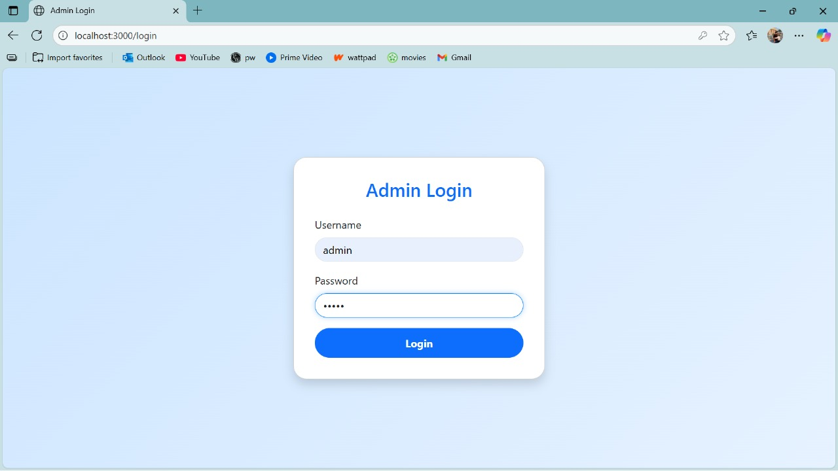

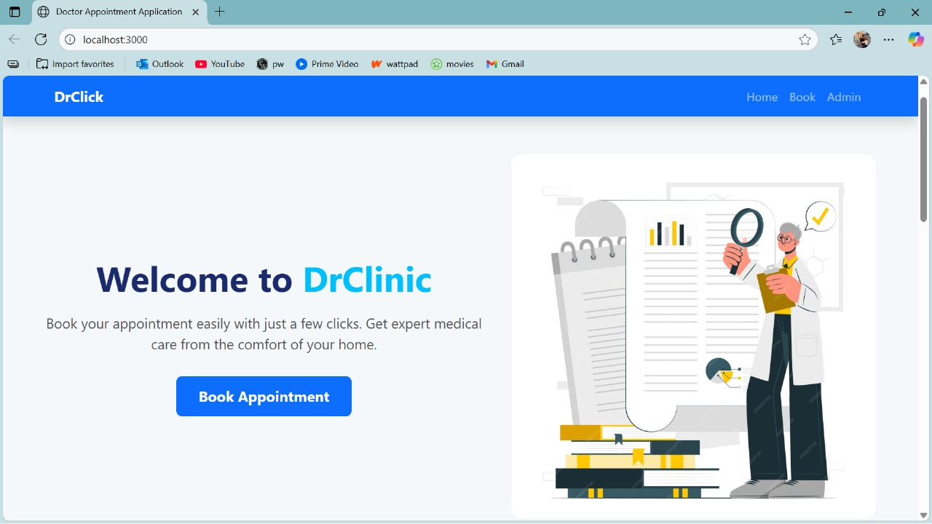

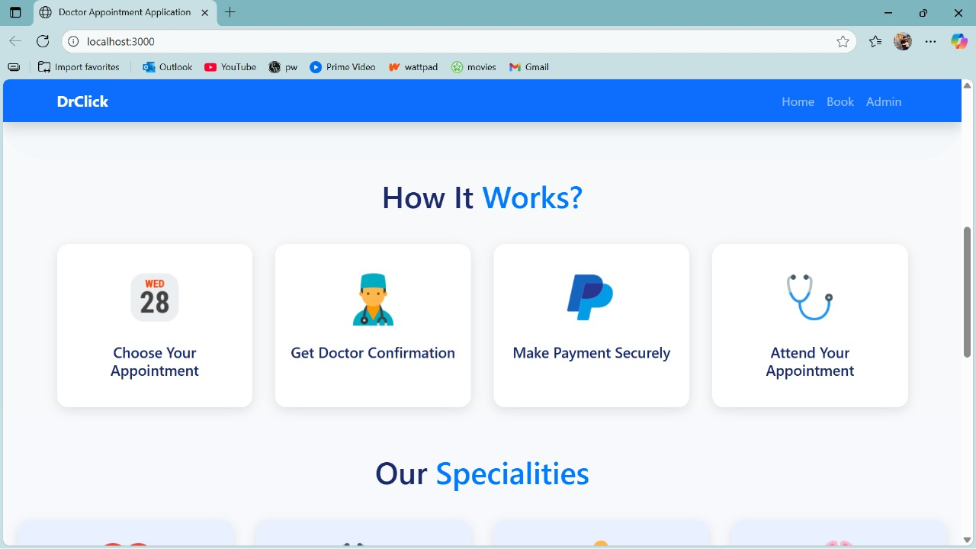

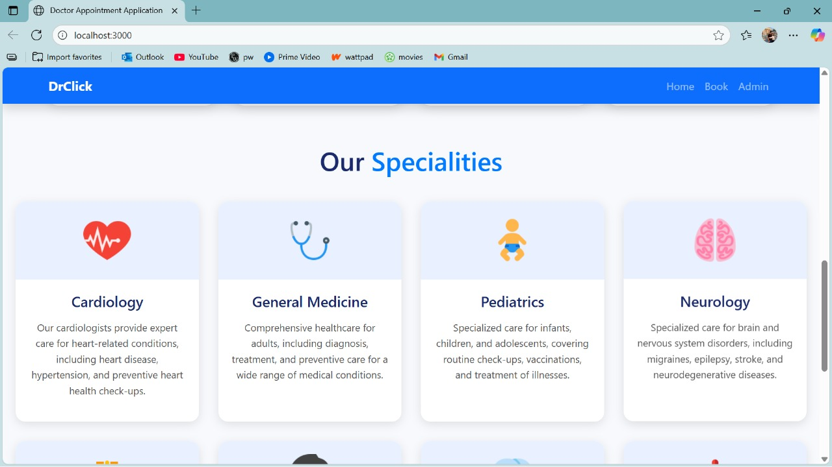

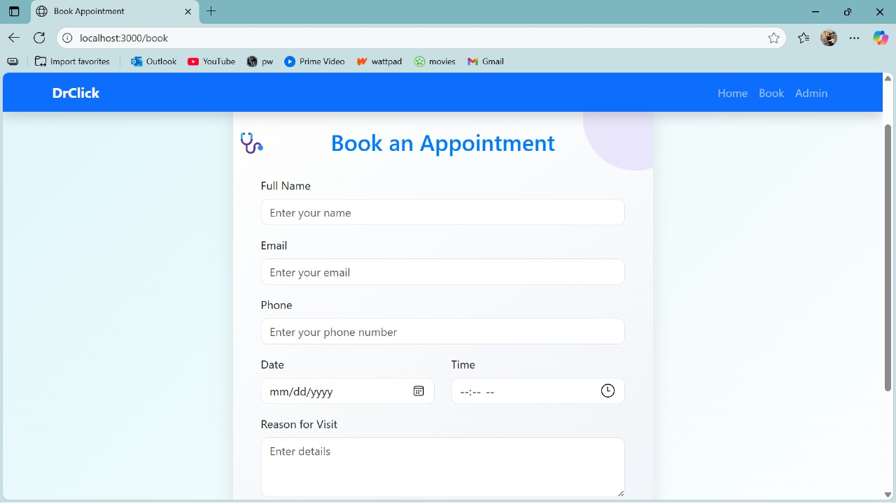

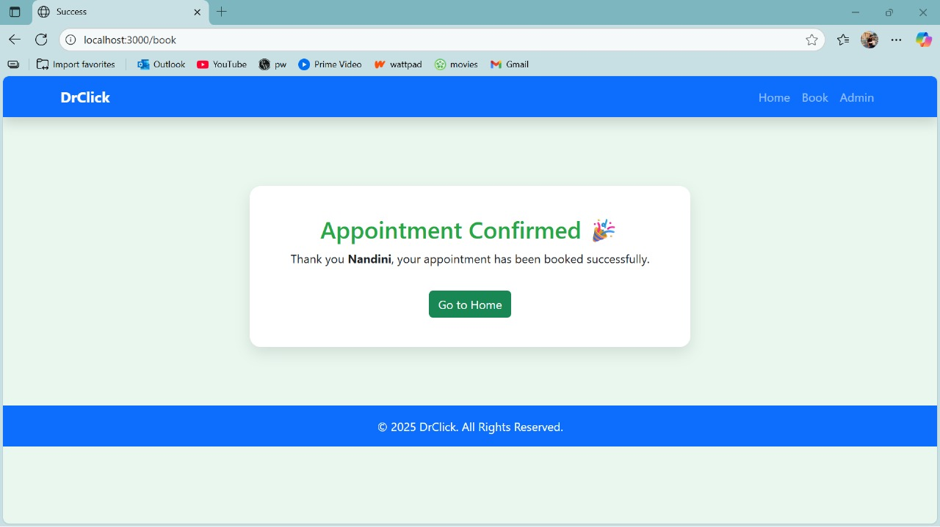

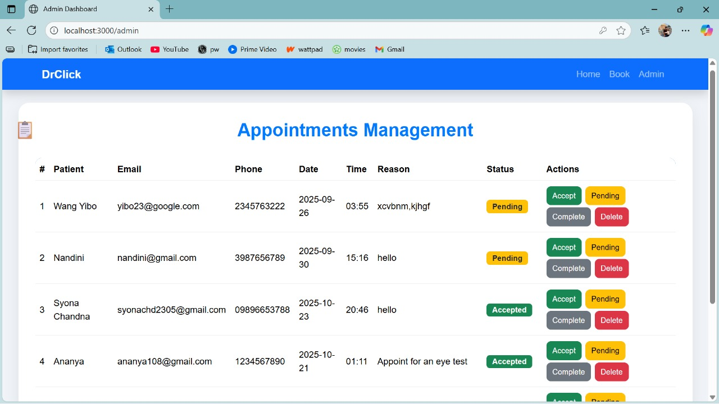

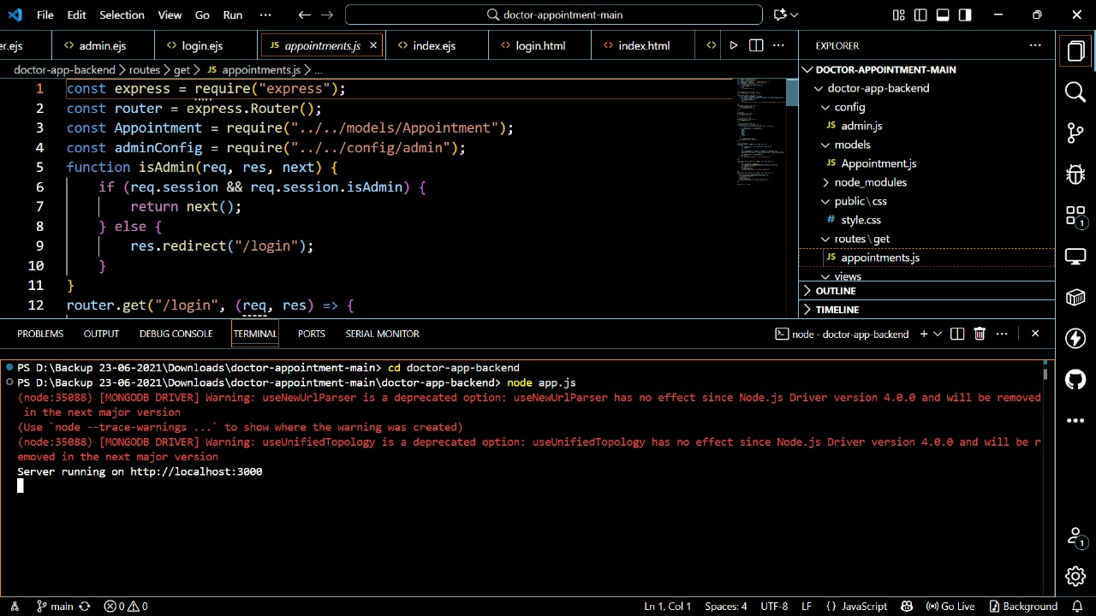

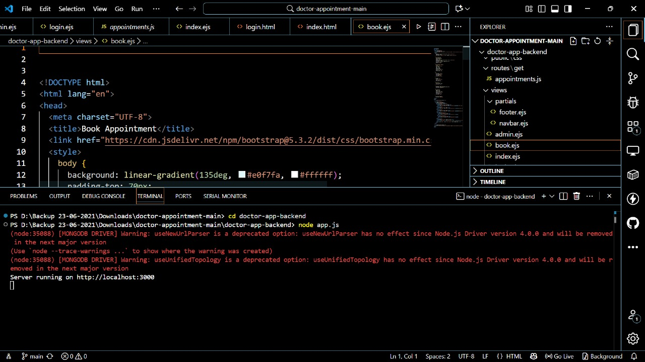

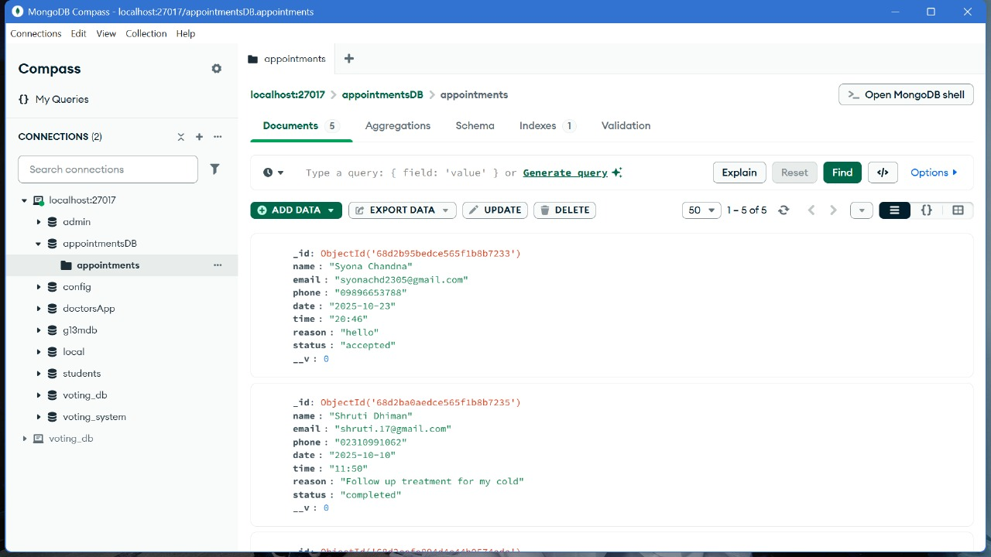

**References:**

* **Official Documentation**: Documentation for libraries, frameworks, and tools used in the project, as well as APIs or services integrated.
* **Tutorials and Guides**: Online tutorials, guides, blog posts, and educational videos that provided assistance or insights during development.
* **Code Repositories**: GitHub repositories or other code repositories where code snippets, examples, or inspiration were found.
* **Forums and Communities**: Online forums, such as Stack Overflow or Reddit, and developer communities where questions were asked, advice was sought, or discussions were participated in.
* **Personal Communication**: Mentors, peers who provided guidance, feedback, or support during development.