Syona Negi

Explore the McDonald’s menus from around the world and write about your discoveries! Please be sure to translate into English through Google Chrome.

You need to complete this for FOUR countries. Please don’t forget to include the language in the first column.

Choose four countries to explore McDonald’s menus. One country must be included from Asia, Europe, the Middle East, and Latin America.

Here are some links to the menus:

McDonald's Japan: https://www.mcdonalds.co.jp/
McDonald's Saudi Arabia: https://www.mcdonalds.com/sa/en-sa/riyadh/ourcompany.html
McDonald's Brazil: https://www.mcdonalds.com.br/
McDonald's India: https://www.mcdonaldsindia.com/
McDonald's Belgium: https://mcdonalds.be/nl
McDonald's Korea: https://www.mcdonalds.co.kr/kor/main.do
McDonald's United Kingdom: https://www.mcdonalds.com/gb/en-gb.html
McDonald's Oman: https://www.mcdonalds.com/om/en-om.html
McDonald's Qatar: https://www.mcdonalds.com/qa/en-qa.html
McDonald's Mexico: https://www.mcdonalds.com.mx/
McDonald's Vietnam: https://mcdonalds.vn/menu

Fill in the table with the information you find and your observations as you explore the menus.

Name of country and language (s) the menu is shown in (one from Europe, Latin America, Asia, and the Middle East) | Describe the cultural vibe displayed in the website. Is there anything that stands out? Any phrases or foods that are emphasized? | Find a breakfast item that interests you. What is the name of it? Describe it and include a photo.  For the picture, highlight item and Cntl+C, then Cntl+V to paste in this box; adjust size to fit appropriately | Find a main meal item that interests you. What is the name of it? Describe it and include a photo. | What kinds of sides or desserts are options? | What is the beverage selection? | Is there a “Happy Meal” option? Describe the happy meal and the toy
India - English | There is no specific cultural vibe, but a popular actor, Ranveer Singh is pictured eating a combo named after him. Foods that are emphasized are the Veg Surprise Burger. | 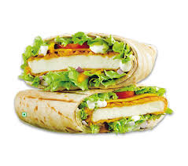There are wraps which include the Spicy Paneer (Cottage cheese) Wrap. | 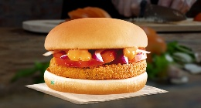 Aloo Tikki – a potato cultural dish similar to a kebab. It includes onions, sauce, and aloo Tikki. | Most of the desserts are cold sundaes or ice creams. Sides include Pizza McPuff and the normal chicken nuggets and fries. | In the beverage section, there are Masala chai, coffees, and iced tea. | There is a Happy Meals option where most toys are educational.
Quatar – Arabic, English | There are Arabic words under English ones. Lotus Biscoff is pictured as cold drinks and ice creams. | 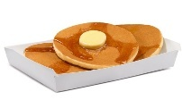 There are Hotcakes, or miniature pancakes. | 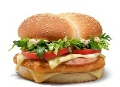 There are separate beef and chicken menu. The picture is a chicken special. | The desserts include ice creams and an apple pie. The sides include fries and a Ceaser salad. | In the beverages, there are Karak chai, coffees, etc. | There is a Happy Meal options where all options are meat.
Brazil –Portuguese | There are more options for bread, ice cream, and have Trento Bites. | 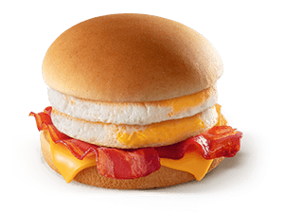This double egg, bacon, and cheese breakfast burger is not special to Brazil but shows the difference between Quatar’s and Brazil’s religious backgrounds. | 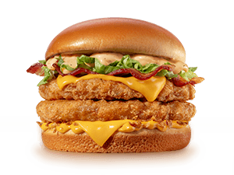 Brabo Brabíssimo Chicken which is breaded chicken, sauce, onion, and lettuce is a recent release as of July 2025. | Most of the desserts are cold ice creams based on location. The sides include cheddar bacon fries, small tomatoes, and the usual fries and chicken nuggets. | In the beverages, there are sodas, juice, and cold drinks. They have no hot beverages except for coffee in the breakfast subcategory. | There is a Happy Meal option which includes little tomatoes, Jello, a main meal, and a choice of mineral water and grape juice. No toys are shown
United Kingdom | There is no specific cultural vibe of the website, but it is organized, so there is a separate menu option for vegetarians. | 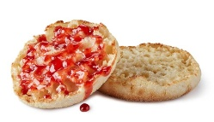This muffin with jam is a classic dish with a blend of various flavors and depicts the United Kingdom’s culture via their food. | 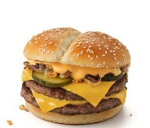There is a limited time Philly Cheese Stack with cheese, pickles, two beef patties, and onions. | The desserts include McFlurrys, donuts, apple pies, and apple slices. The sides include fries, cucumbers, salad, and Mozzarella sticks (cheese sticks). | In the beverages, there sodas, lattes, café, and limited time flavored sprite. | There is a Happy Meal option where a variety of tropical animal toys are shown.

- In the Middle Eastern menus, you may notice the term, “halal”. Read what “halal” means here: https://www.bbc.com/news/uk-27324224; After reading this website, explain how McDonald’s has adapted to cultural norms of Islam in Middle Eastern countries.
McDonald’s has adapted to the Islamic culture of not eating food killed or prepared a certain way or pork. The cultural norms of the Middle East strictly adhere to the laws of the Koran, their religious text. McDonald’s has created a halal menu where almost all the items are halal. In Quatar, there are no pork options, because the country is predominantly Muslim. McDonald adapts to location and cultures of that area including the foods, religious sanctions, and traditions. McDonald’s is a versatile company with understanding of cultural norms and societal norms.

- Explain why countries in the Middle East do not have pork products on the menu, but countries in Asia, Latin America, and Europe do.
Most Middle East countries’ dominant religion is Islam, while there is a lower concentration of Muslims in Asia, Latin America and Europe. Religion dictates many things including food, fasts, and government policies on gender roles and societal norms. Pork is heavily restricted in the Islamic culture as well as meats that are not killed a certain way. This changes business success based on how well the company follows the rules of that location’s religion and dietary restrictions.
- What are some interesting items you found that are distinctly from the culture of the country where the McDonald’s is? Identify at least 4 items from 4 different countries.
- Brazil: Hello Kitty items (donuts, etc.), Petit Suisse of Méqui
- India: Veg Maharaja (King) Mac, The Ranveer Singh Meal
- UK: Porridge with Sugar, Flahavan's® Quick Oats®
- Qatar: Karak Chai
- Are there items on the menu that you have never heard of before? Identify at least 4 of those items, tell me which country they are from, and conduct a quick Google search to tell me what they are.
- Brazil: Tasty Sause Jar – a limited-edition sauce jar that was revealed at the Sauce Jar event. Customers can buy an original sauce in a disposable 190-gram bottle.
- Brazil: Hello Kitty Donuts – a donut with a sweet strawberry glaze that is sold exclusively in Brazil.
- UK: Sweet Cutty Dip – a sauce known for its spice apricot flavored sharpness; it was offered in the U.S. for a limited time while highlighting an international menu.
- Qatar: Karak Chai – a tea originating from India, being slowly adapted to Middle Eastern culture and Gulf culture.
- What is “stimulus diffusion”? Find and describe TWO examples of stimulus diffusion in these McDonald’s menus.
Stimulus diffusion is the spread of underlying principle, even though a specific characteristic is rejected. Two examples of stimulus diffusion in McDonald’s menus are the burgers which vary in ingredients around the world, but the underlying principle is still present, and the making of the website: its organization and the types of meats offered. Many religions prohibit the consumption of specific food during certain times or complete abstinence.

