Introduction to Culture
Name: Syona Negi period 3A
Objective: Define the characteristics, attitudes, and traits that influence geographers when they study culture.
- Culture comprises a society’s shared:
  - Personal beliefs and values
  - Societal norms and behaviors

- Based upon the objective, how would you describe YOUR culture?
Upon objective, I have had a relatively different culture than most Indian girls, as I live in America and visit only once every one or two years. The festivals are less vibrant, and the environment itself is different. I have an interest in Hindu mythology which connects me to more of the culture of why traditions have been made. I have been raised in America where different cultures have been mixed such as American music, societal norms, and a less family-oriented structure system. I have no family in the U.S. which disconnects me to norms they might have and impose upon my cousins my age. My parents were born and raised in Northern India; thus, they are more connected to North Indian Culture. I eat both American and Indian foods and wear mostly American clothing, except for holidays. Holidays are also not as profound as in India, so we hang up multicolored lights in Halloween as a celebration of Diwali.
- Provide examples of “cultural traits”.
Culture traits are attributes concerned with material objects shared by a group including food, language, shared cultural practices, and clothing. Different clothing can be worn for different reasons and based on the country’s cultural norms.

- Fill in the blanks and label the visuals (on the next page) with the correct term.
  - Custom: frequent repetition of an act until it becomes characteristic of a group of people.

  - Taboo: a restriction on behavior imposed by social custom.

  - Cultural relativism: judging a culture based upon its own standards, NOT based on YOUR culture’s standards.

  - Ethnocentrism: judging other cultures based upon the standards of your own culture.
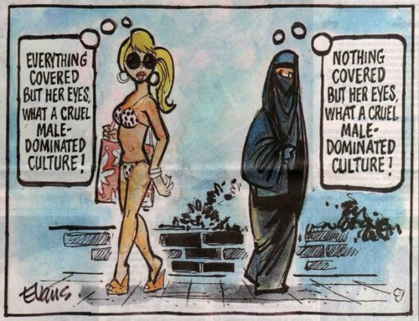

https://natlib.govt.nz/records/22728118

https://japanintercultural.com/free-resources/articles/bow-shake-hands-or-poke-someone-in-the-eye-2/

Ethnocentrism
Custom
Find images and text for the following terms (paste them next to the term-and don’t forget to cite your pictures!):
- Artifact: Visible objects and technologies that a culture creates
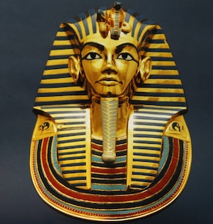 Funeral objects such as this covering were used for the burial process of kings and queens. (https://www.google.com/url?sa=i&url=https%3A%2F%2Fstudy.com%2Flearn%2Flesson%2Fcultural-artifact-social-examples.html&psig=AOvVaw3Ipgj-CuVa6Tv1DUXLxuQ6&ust=1759541776229000&source=images&cd=vfe&opi=89978449&ved=0CBYQjRxqFwoTCLDE94XyhpADFQAAAAAdAAAAABAE)
- Mentifact: Structures and organizations that influence social behavior
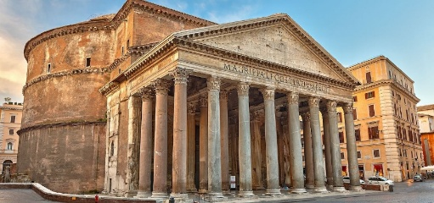 Architecture such as the Pantheon were used as places of worship for many Greeks. (https://www.google.com/url?sa=i&url=https%3A%2F%2Ftheromanguy.com%2Fitaly-travel-blog%2Frome%2Fpantheon%2Fstory-of-the-pantheon-in-rome%2F&psig=AOvVaw2oX6x8U7p6RWGvDzP49qLS&ust=1759541838723000&source=images&cd=vfe&opi=89978449&ved=0CBYQjRxqFwoTCJD31aPyhpADFQAAAAAdAAAAABAE)
- Sociofact: Central enduring elements of a culture that reflects its shared ideas
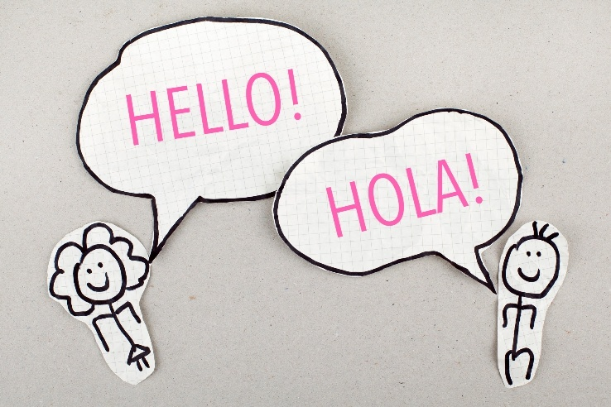 Language defines a group of people and changes relatively slowly. Spanish which is spoke in South America and Spain is a language where dialect is different based on location. (https://studyspanish.com/learning-spanish/getting-comfortable-with-speaking-spanish-to-others)
- Food: Dishes that vary throughout culture and location
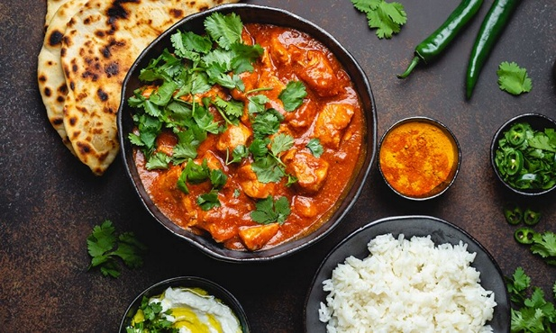 Foods vary through location of the home country or adapted through the ages. This would be considered a North Indian dish—as different parts of India have different foods. (https://www.eatright.org/food/cultural-cuisines-and-traditions)
- Clothing: Traditional clothing worn in religious context or celebrations. 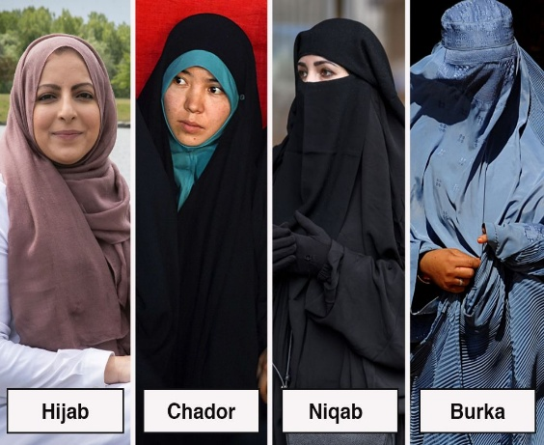 Some Muslim women do not wear hijabs or niqabs—varying on location and the strictness of past generations. Different types of head-coverings can be worn. (https://montrealgazette.com/news/local-news/whats-the-difference-between-a-hijab-chador-niqab-and-burka)
- Sport: A game for leisure; different regions have different popular sports
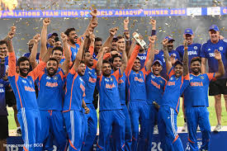 India is very cricket-based, embedded into the culture, while the U.S. is turned away from cricket culture. (This is Team India winning the Asia Cup 2025!!!) (Instagram)
- Language: communication from human-to-human, conveying culture and tradition
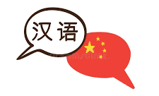Language is unique and much about a culture is revealed. If speakers use different nouns addressing people of different age or status, that culture must be heavily family oriented, such as Mandarin. (https://www.google.com/url?sa=i&url=https%3A%2F%2Fwww.dreamstime.com%2Fvector-illustration-speech-bubbles-chinese-language-two-hand-drawn-doodle-national-flag-china-written-name-image109521234&psig=AOvVaw0RnS7Z8pfzELM1uJjgt12u&ust=1759542956491000&source=images&cd=vfe&opi=89978449&ved=0CBYQjRxqFwoTCNDf4rj2hpADFQAAAAAdAAAAABAE)
- Architecture: structures built by man
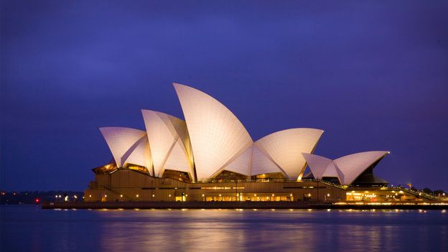 The Sydney Opera in Australia is a vibrant piece of architecture that gathers modern culture of Australia. (https://www.bbc.com/travel/article/20231102-the-sydney-opera-house-the-monument-that-represents-australia, Photo by Bella Falk-Alamy)
- Religion: A series of ideas and beliefs a group believes
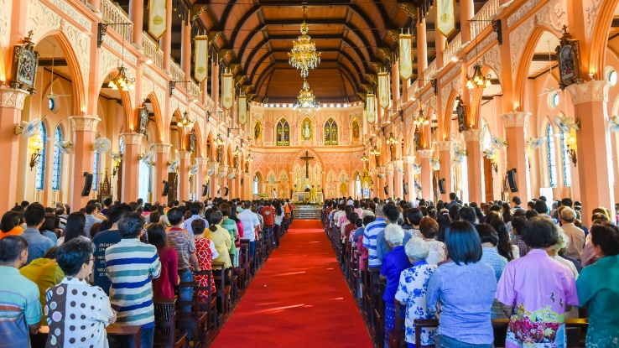 This church in Philadelphia harbors many Christian worshippers every Sunday, the primary religion in the U.S. (https://pcg.church/articles/5591/is-there-anything-wrong-with-sunday-worship)
- Taboo: a restriction on behavior imposed by social custom
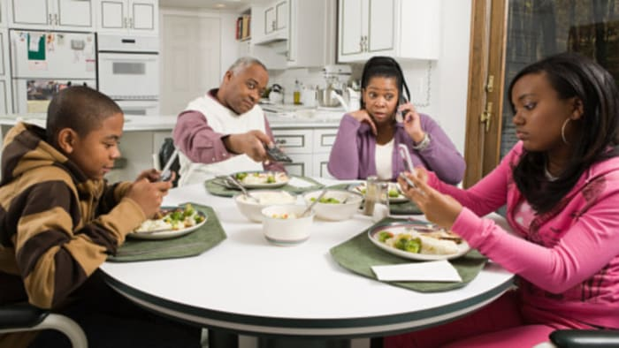 Something so menial as a family policy of “No phones at the dinner table” could be included in taboo culture. Often, it shows what a household looks like under different cultures. (https://www.clickondetroit.com/news/2016/05/11/is-it-appropriate-to-use-cell-phones-at-the-dinner-table/)

- Cultural landscape (climate, environment, industry): an environment that shaped by people’s culture to create a culturally unique place
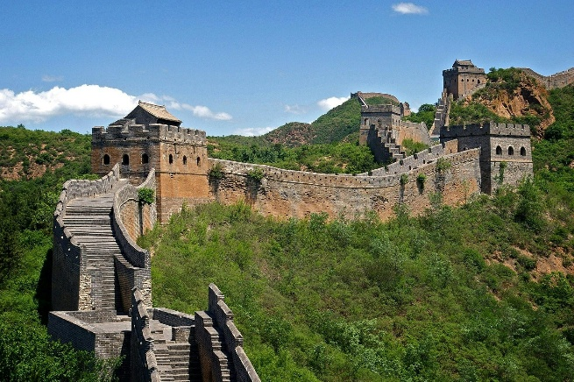 The Great Wall of China shaped the tourist industry and environment, using sticky rice, timber, and stones to build a 21,000-kilometer wall. (https://www.wmf.org/projects/great-wall-china-cultural-landscape)
- Gendered spaces: areas that are socially constructed based on a certain gender
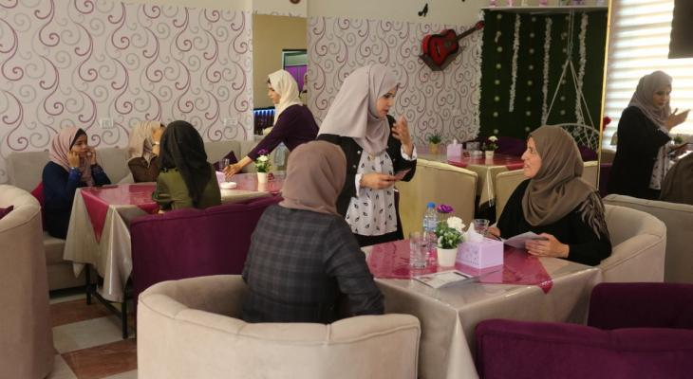 These women-only cafes in Palestine are a perfect example of areas specifically for women to feel save and take off their head-coverings. (https://alexshams.com/2013/11/02/women-only-cafes-offer-new-visions-of-palestinian-public-space/)
- Global culture: shared values and beliefs, transcending material borders with technology
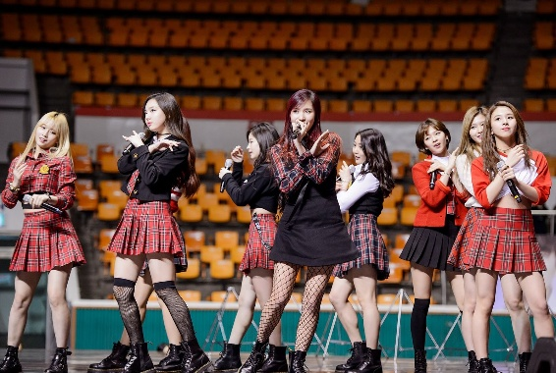 K-pop has become a global culture in recent years with different nationalities being involved and listening. K-pop has become a widespread popular type of music, one of the best examples of global culture. (https://www.google.com/url?sa=i&url=https%3A%2F%2Fhir.harvard.edu%2Fk-pop-a-remedy-for-asian-ethnic-tension%2F&psig=AOvVaw0sGIrwrfW1zG4-vKLIQp4V&ust=1759540563832000&source=images&cd=vfe&opi=89978449&ved=0CBYQjRxqFwoTCOiazcXthpADFQAAAAAdAAAAABAK)
- Traditional/Indigenous culture: beliefs and values of a group of people who have stayed in the region their ancestors settled
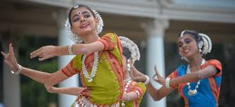 This is the traditional dance of Bharatanatyam which depicts stories and crisp cloth. This dance has been practiced for over 200 years old, used to celebrate festivals. (https://www.google.com/url?sa=i&url=https%3A%2F%2Fwww.entriva.com%2Fen%2Fblog%2Findian-tradition-culture%2F&psig=AOvVaw2HnC4eab0tCMvGBfgsUeKV&ust=1759540906667000&source=images&cd=vfe&opi=89978449&ved=0CBYQjRxqFwoTCLCe0ufuhpADFQAAAAAdAAAAABAE)
- Diffusion: process in which different traits and attributes spread from one location to another
 The culture diffusion of internet and trends includes a variety of global diffusion in the medium of memes, trends, or online communities. (https://www.google.com/url?sa=i&url=https%3A%2F%2Fwww.thealternativeboard.com%2Fblog%2Fhow-a-smartphone-and-some-great-apps-can-help-your-business&psig=AOvVaw21lDOztcdL2xS4TwP1hTOJ&ust=1759543155370000&source=images&cd=vfe&opi=89978449&ved=0CBYQjRxqFwoTCNja4db3hpADFQAAAAAdAAAAABAE)

- Government: process of cultural policy in a region and how governance is affected
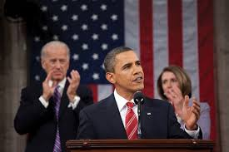 U.S. culture is a broad, ever-evolving thing, starting with Federalists and Anti-Federalists, presently, Republican, Democratic, and third-party candidates. The U.S. has made a variety of cultural policies, such as the banning of TikTok. (https://www.google.com/imgres?q=cultural%20government&imgurl=https%3A%2F%2Fmlpp.pressbooks.pub%2Fapp%2Fuploads%2Fsites%2F1050%2F2022%2F02%2F4bf545ee99062327c2b9f65c853edbbf.jpg&imgrefurl=https%3A%2F%2Fmlpp.pressbooks.pub%2Fpol111mhs%2Fchapter%2F6-1-political-culture%2F&docid=RRN0dnyxLz9j6M&tbnid=qHITOCZCEeSN7M&vet=12ahUKEwjT_83m94aQAxVvOkQIHYiRJMsQM3oECBcQAA..i&w=720&h=480&hcb=2&ved=2ahUKEwjT_83m94aQAxVvOkQIHYiRJMsQM3oECBcQAA)
- Map: The visual representation of a group’s cultural attributes.
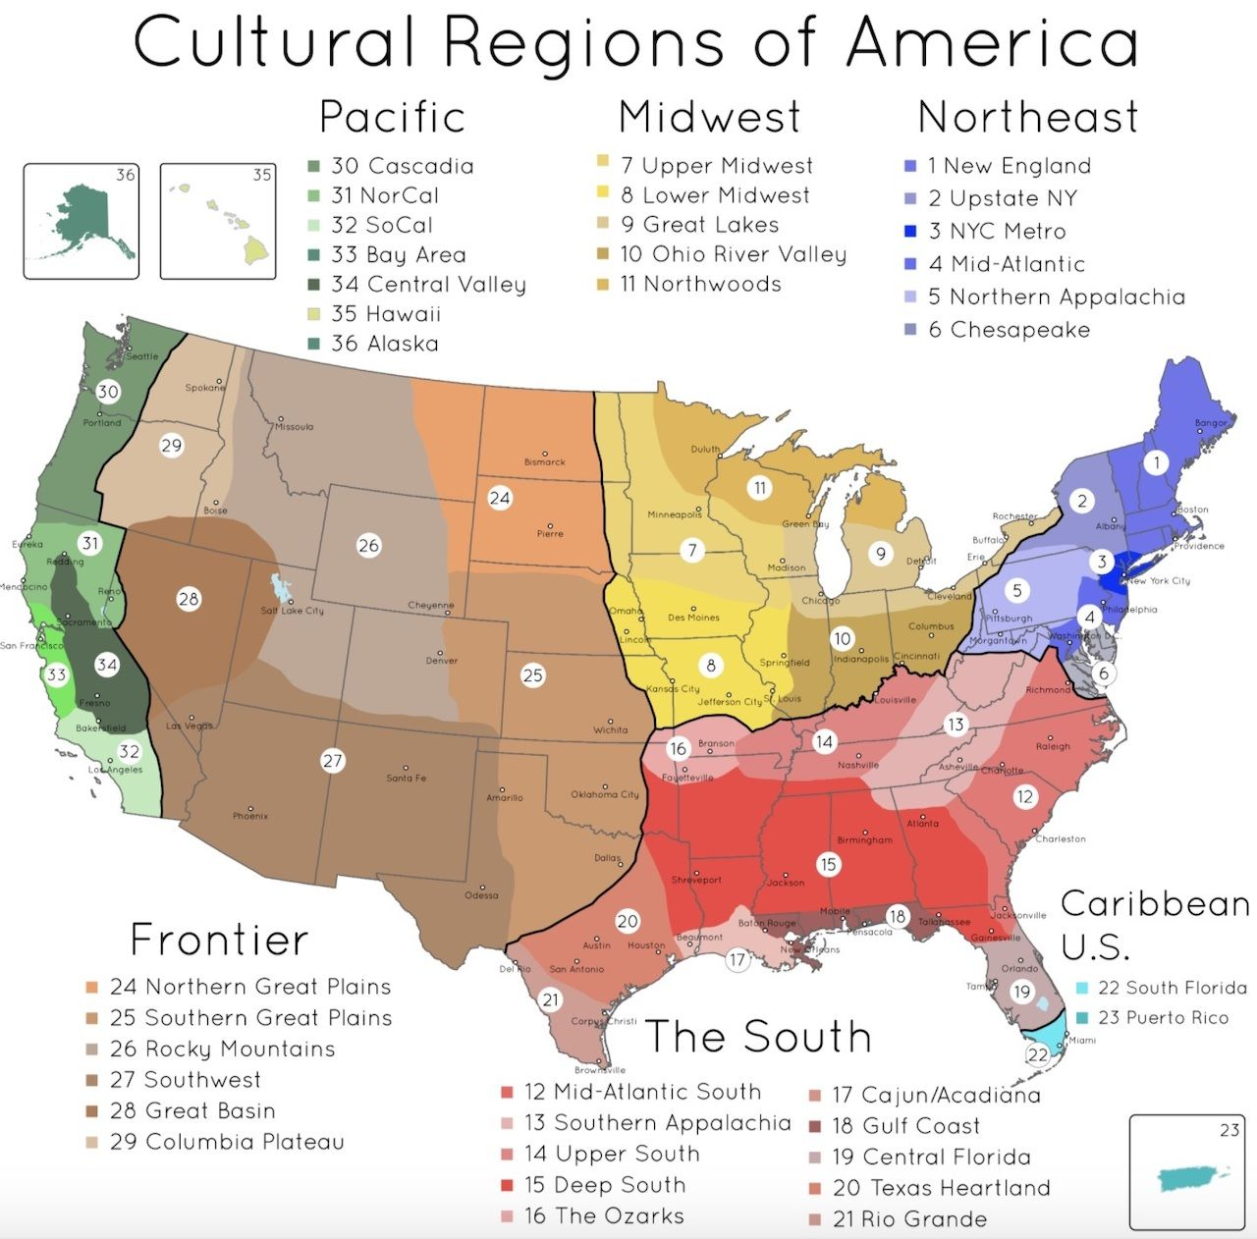
The different cultural regions in the U.S. demonstrate the cultural diversity of the U.S. and how most vary from others. Some regions like Chesapeake and Ozarks are on their own. This demonstrates the varying locations and cultures of regions based on their strengths and other general attributes. This fails to determine the mental attributes of the U.S. and the individual groups in others. (https://www.google.com/url?sa=i&url=https%3A%2F%2Fmatadornetwork.com%2Fread%2Famericas-cultural-regions-mapped%2F&psig=AOvVaw16YhDqW18AfpPdg8y-myQC&ust=1759543646510000&source=images&cd=vfe&opi=89978449&ved=0CBYQjRxqFwoTCMCKmID6hpADFQAAAAAdAAAAABAT)

