Trophic Cascades
1. Go To the HHMI Biointeractive website: https://media.hhmi.org/biointeractive/click/trophiccascades/

2. Take notes on the introduction below:

What are trophic pyramids?
Trophic Pyramids are diagrams to represent the trophic levels, or the consumers and producers, of an environment. It is similar to a food chain.
What happened when sea otters were hunted to near extinction by humans?
When there was an absence in sea otters in an ecosystem, there was no kelp and an overpopulation of
sea urchins. The other species that relied on kelp were in an incredibly rapid decline.
What are direct and indirect effects?
Every costal species is indirectly or directly effected by the absence of otters in an ecosystem. The
effects include an increase in sea urchins while the indirect effects include no seaweed. Thus, many
organisms which rely on kelp die or decline. The overall impact is drastic on kelp forests.

3. Take notes on the sea otter/urchin/kelp example in the box below:
Sea otters and sea urchins have a negative effect as well as sea urchins and kelp. Sea otters and kelp, however, have a positive relationship. With an increase in otters, the urchins won’t be able to eat the kelp, leaving the kelp to grow and thrive. Positive effects demonstrate a simultaneous rise or fall in the populations of a species. Negative effects indicate a decline in one species leads to the rise of another, and vice versa. The loss of kelp forests result in the decrease in the populations of glaucous-winged gulls, bald eagles, and the fish they consume. The sea otter example is a classic example of trophic pyramids.
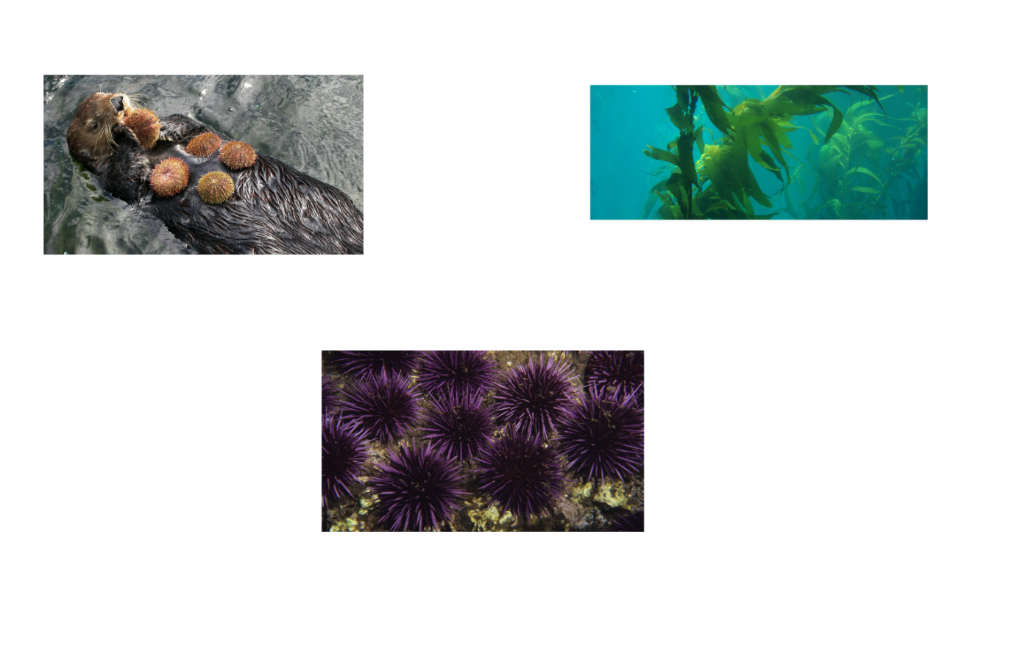

What happened to the diet of the Glaucous winged gull?  The Glaucous-winged gull’s diet is mainly made up of fish but can also include invertebrates or the eggs of other birds. With the absence of kelp, the fish die with no source of energy so, the gulls increase the number of invertebrates in their diet. | What happened to the diet of the Bald Eagle?  Bald Eagles are scavengers but primarily eat birds, fish, and mammals. With a decrease in fish, Bald Eagles shift their main diet to other birds, decreasing that population.

4. Case Studies:
Choose 2 of the Case Studies to complete!
Case Study 1: Title: African Savanna

Organisms present: Wildebeest, rinderpest, and vegetation are all present in this case study. It is learned that as the rinderpest virus is controlled, less fires will break out as a cause of the lack of vegetation. The rinderpest is a virus which effects the wildebeest, leaving the vegetation to grow and increase the likelihood of fires. The rinderpest virus and vegetation have a positive relationship.

Draw out the feedback loop you determined by completing the interactive: Shown in picture

Case Study 2: Title:

Organisms present: The animals present were a variety of large predators, herbivores, and vegetation. The lack of predators in the environment overpopulated the herbivores and devastated the vegetation. The predators and vegetation are shown to have a positive relationship.

Draw out the feedback loop you determined by completing the interactive: Shown in picture

