Where authentication & authorization are needed in YOUR system
Your system has four layers:
AI Agent
↓
MCP Server
↓
Odoo (ERP / CRM / HRIS)
↓
PostgreSQL
Odoo is your enterprise backend (ERP).
👉 Authentication means:
- Who is allowed to talk to Odoo?
- How do we securely access Odoo APIs?
- How does our MCP server prove it is authorized?

Containers in your setup:
- Odoo container
  - ERP / CRM / HRIS logic
  - Handles auth & business rules
- PostgreSQL container
  - Data storage
  - Never exposed directly
- MCP Server container
  - Security boundary
  - Tool enforcement
  - Talks to Odoo only
- (Later) Agent container
  - AI logic
  - No direct enterprise access
Each container has one responsibility.

Why MCP MUST be containerized
This is critical.
If MCP is not containerized:
- It could access your system files
- It could leak credentials
- It could bypass boundaries
By containerizing MCP:
- Credentials stay isolated
- Network access is controlled
- Blast radius is limited
This is mandatory in real companies.

How authentication, authorization & containers work together
Let’s connect everything:
Step-by-step flow
- AI agent sends request to MCP
- MCP verifies agent identity (auth)
- MCP checks tool permission (authz)
- MCP authenticates to Odoo
- Odoo enforces business rules
- Result flows back safely
No shortcuts. No SQL. No raw access.
🔑 How authentication works in APIs (REAL WORLD)
Old way (bad)
- Send username/password every time ❌
Modern way (good)
- Login once
- Receive token
- Use token for all requests

TOKENS (NO CONFUSION, PROMISE)
🔑 What is a token?
A token is just a long secret string.
Example:
eyJhbGciOiJIUzI1NiIsInR5cCI6IkpXVCJ9...
Think of it like:
🎟️ Movie ticket
Once you have it, you can enter without re-authenticating.
Most common token type: JWT
JWT = JSON Web Token
Contains:
- Who you are
- When it expires
- What you can do
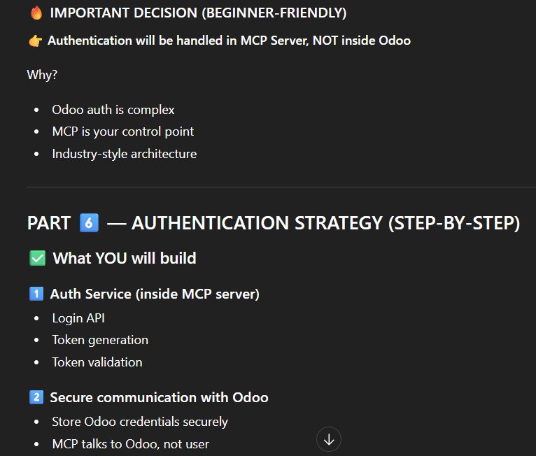
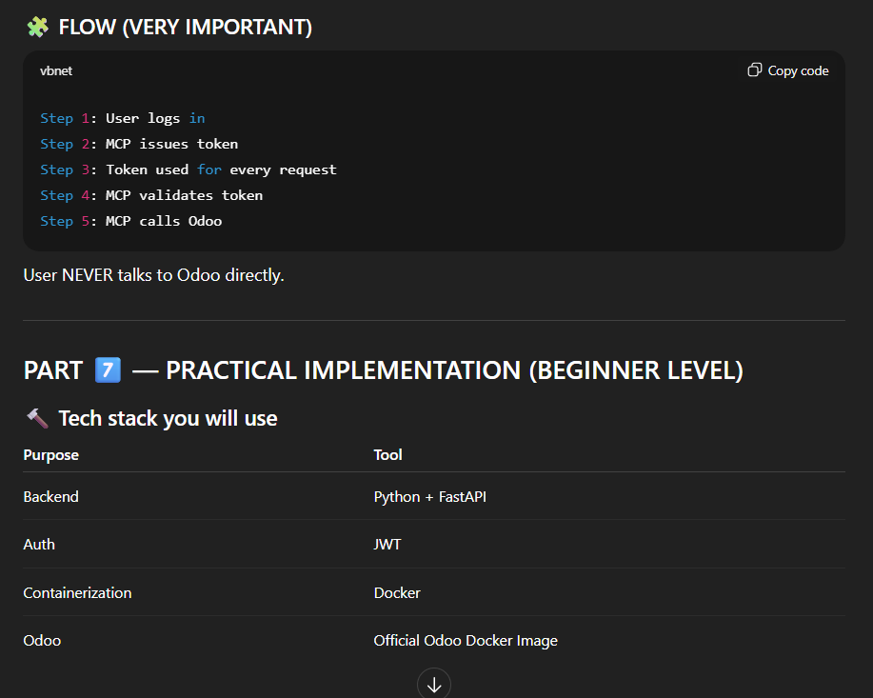
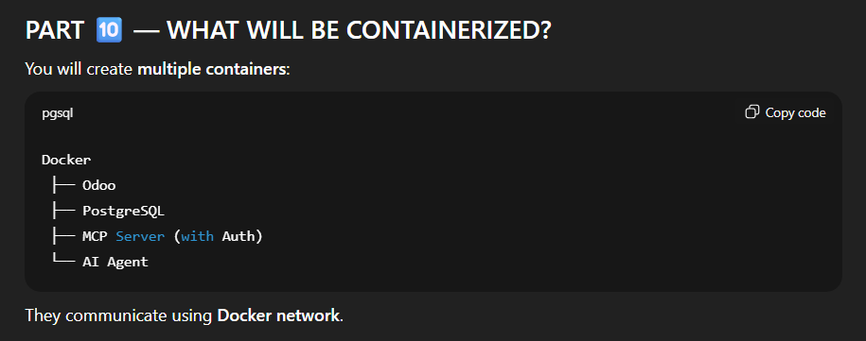
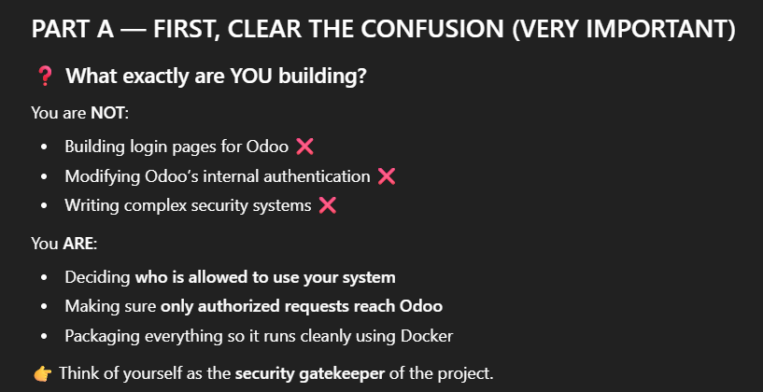
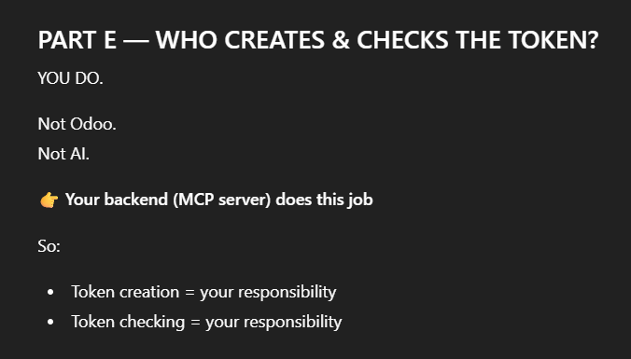

PART K — YOUR EXACT RESPONSIBILITIES (CLEAR LIST)
You are responsible for:
1️⃣ Deciding how login works
2️⃣ Issuing access passes (tokens)
3️⃣ Checking passes on every request
4️⃣ Making sure Odoo is accessed safely
5️⃣ Running everything using Docker
That’s a BIG, CORE role.

Yt video:
Public-private key is a security mechanism
Statefull and Stateless:
Stateless – we never store the state (of anything) in the database
JWT is a stateless mechanism

JWT – JSON WEB TOKEN is an encrypted token
When two resources are talking to each and other and they claim to be able to talk to each other, this claim mechanism is known as JWT
JWT takes your data, encrypts it and who can decrypt it is decided on the server. For encryption there are many encrypting algorithms

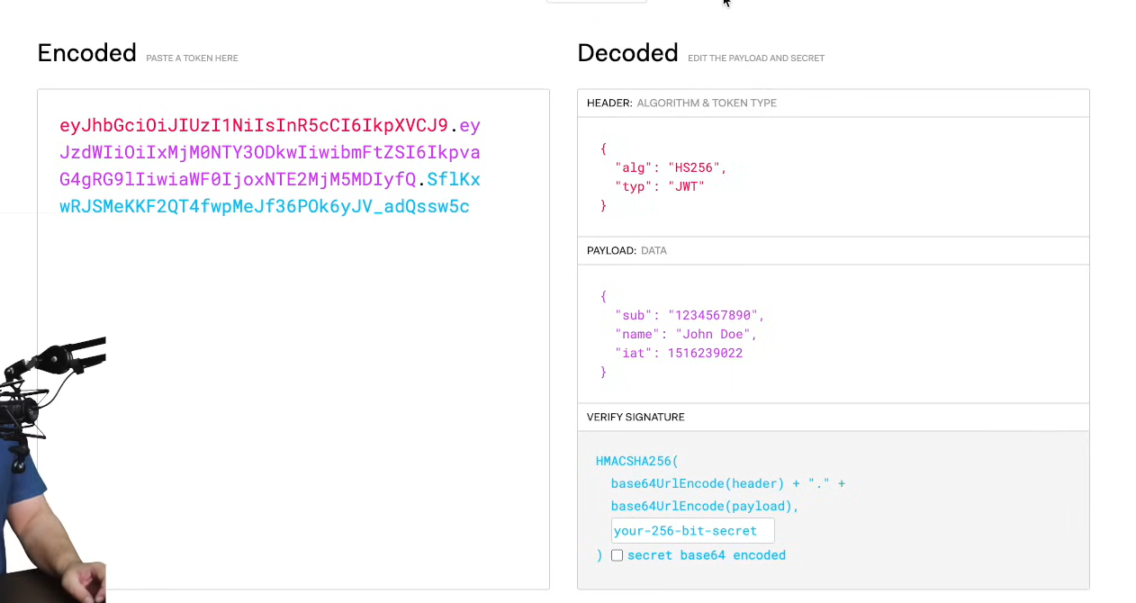
The JWT token is divided into 3 parts:
red string -determines which algorithm are we using
purple string – determines what information is it, the data
blue string – is our signature, whether it is verified and correct or not.
Note that even a little bit of change changes the entire algorithm. Eg:
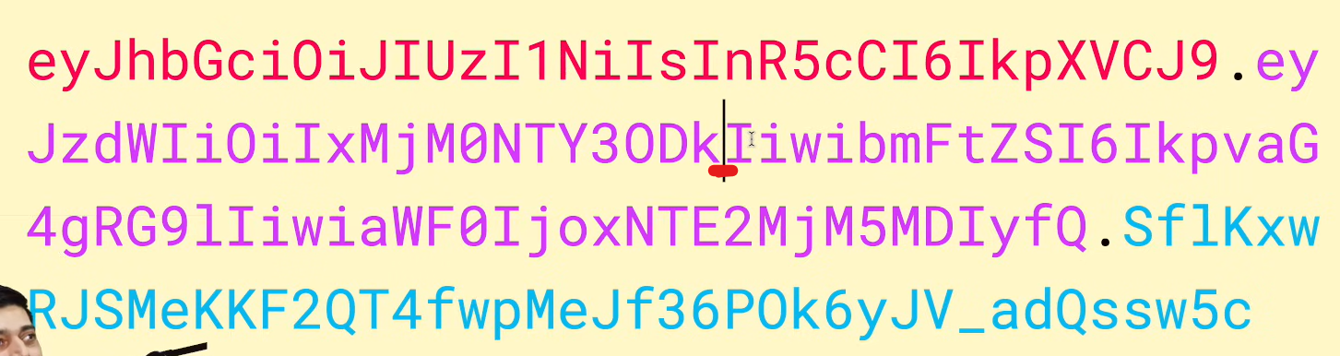
Jwt tokens are very lightweight
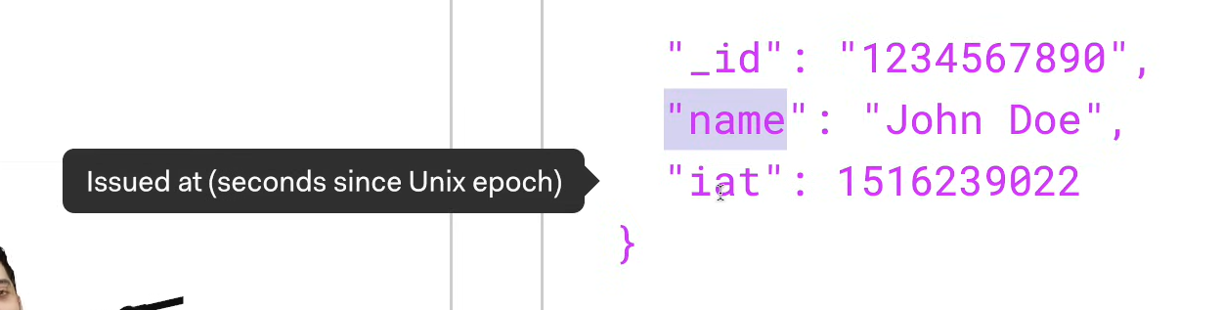
In this, iat is issued at, and there is also a field known as expiring at, which tells us when the token is expring. JWT tokens are also made for short time expiry

Then the jwt token contain your secret key. We need to set a secret key
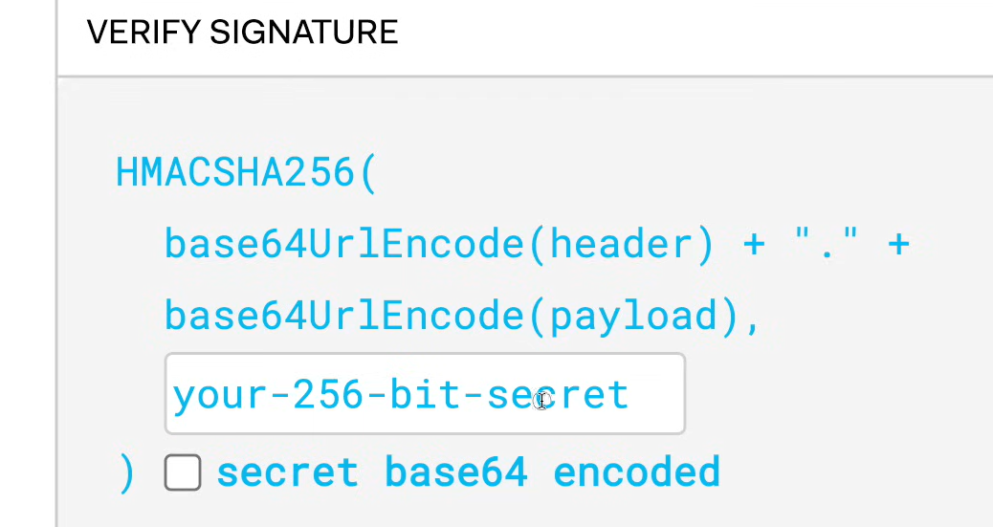
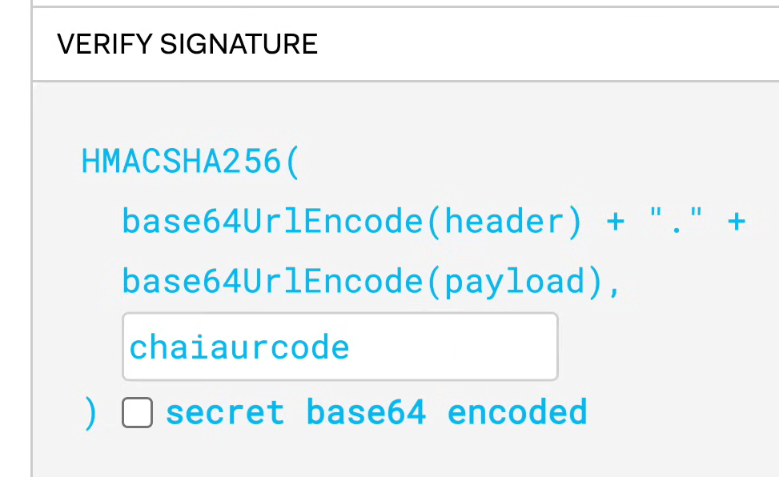
This info can only be decrypted by those who know the secret key(chaiaurcode),
Note: This secret key is kept safe on the server and is never distributed.
So the basic flow is as: if user has the JWT token, decrypt it and let it access the resource

Authentication vs authorization:
Authentication – proof that main wahi user hu jisne isse pehle aapke platform be register kiya tha, hence lets you login
Authorization – after login, it’s decided whether do you have access of user dashboard or admin dashboard. Basically resource access is defined

How do you securely store a JWT on the client-side?
JWT acts as a short-lived token – which means whoever has token can access the resource. So we don’t really need to worry about the security of the token because it is anyways short lived
1. 1st and the most common way to store a JWT token is to store it on the local storage. But javascript attacks can happen and it can access your local storage and steal the token
2. can store it in session storage, just like local storage we also have session storage
3. can store it in cookie storage.
But the best mechanism is to expire the token as soon as possible. You can request again for a new token. This mechanism is also called as refresh mechanism

What are the common use cases of JWT?
1. for authentication
2. For authorization
3. For information exchange – not necessary only client and server can communicate using it, server to server communication is also possible, as long as you have the private secret key

How can you invalidate a JWT?
Whenever you create a JWT token, there is always an option of expiring it. The duration after which it is to be expired is decided by you. This is possible with JWT tokens
There is another mechanism, which is known as refresh token

Flow:
Client sends its info to the server to start the communication, then the server gives a JWT token to the client
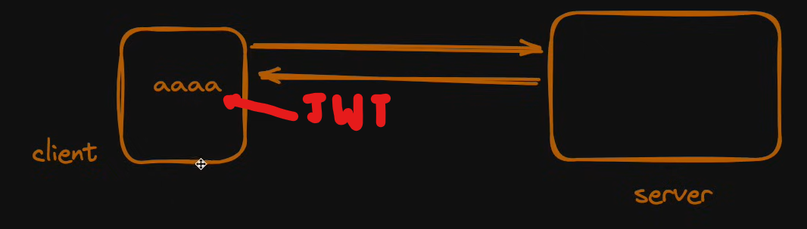
Now whenever the client makes a request, it will attach this token inside it with the request and send it to the server, then the server lets the client access its resources.
But it might happen that the expiry of the token is very short and it gets expired in say 15 mins
eg: the user is idle for 15 mins and send a request after 15 mins and hence receives invalid response
So when the access token is expired, behind the scenes when the info was being exchanged for the first time. Along with the current token the server also gives a refresh token to the client which is stored in the database. So your access token is expired but not the refresh token. So you can renew the access token with very request or whenever you want. We can say this way we managed the state. Yes, this is called stateful. We don’t have to login again and again but whenever our token expires we can request for a new one and our token will get renewed.
Summary: refresh token is a mechanism in which we store the refresh token in the database and whenever the access token expires, we can renew the access token through the refresh token.

JWT vs Sessions:
Note that jitni baar aap database se request kar rahe hain, utni baar aap resources consume kar rahe hain, utni baar network ke andar delay aata hain. Because your machine is accessing the data from the files(database) and is sending it to the client.
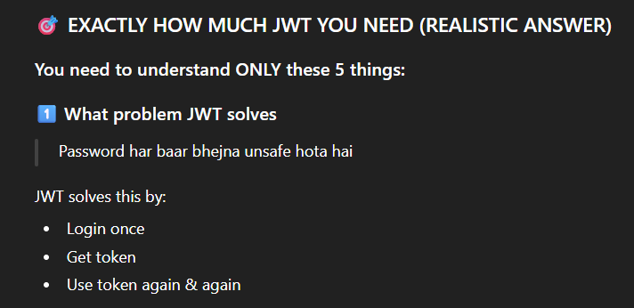
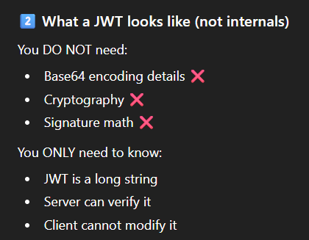
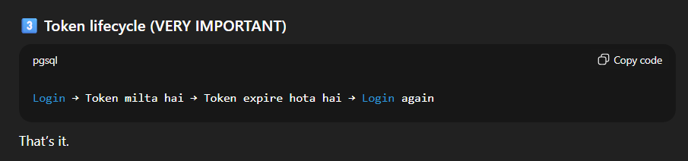
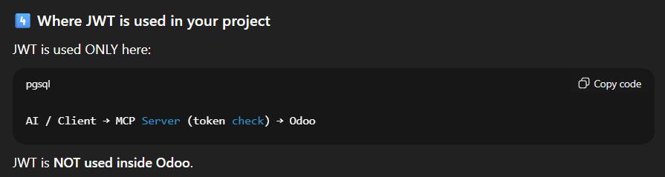
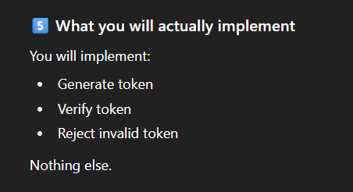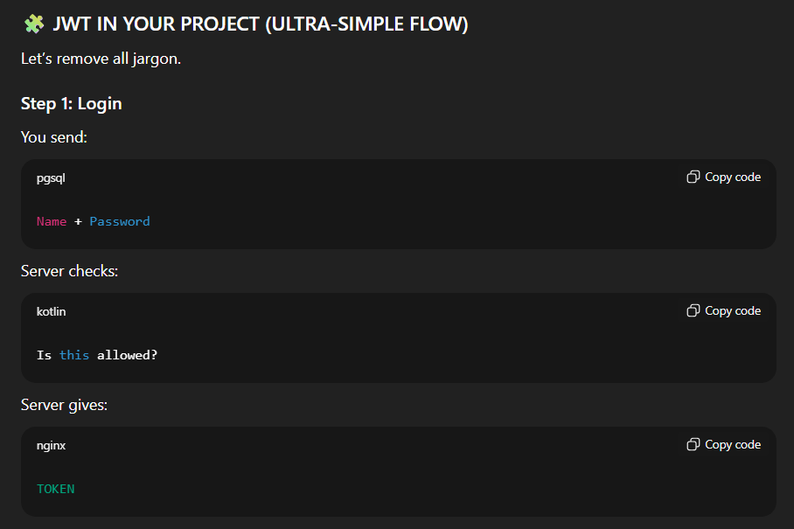
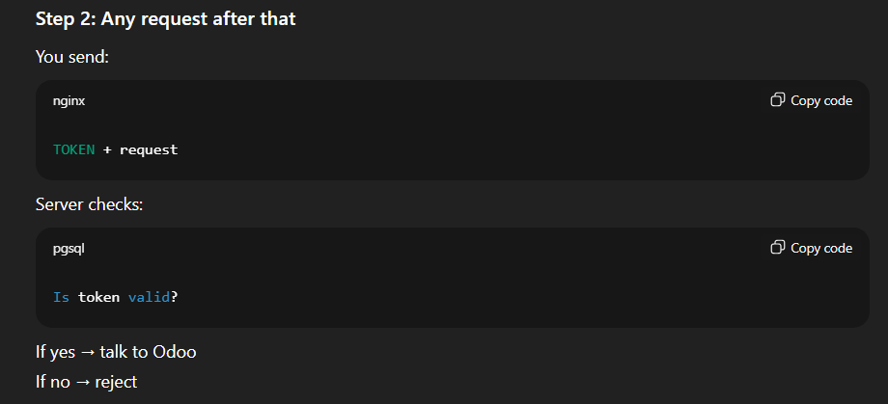
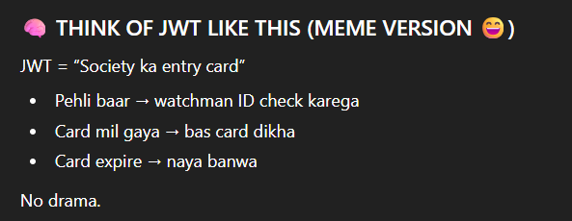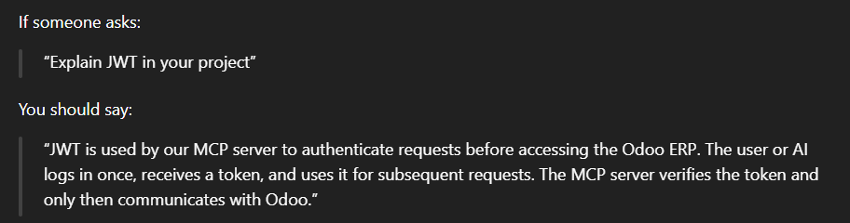

JWT in our project:
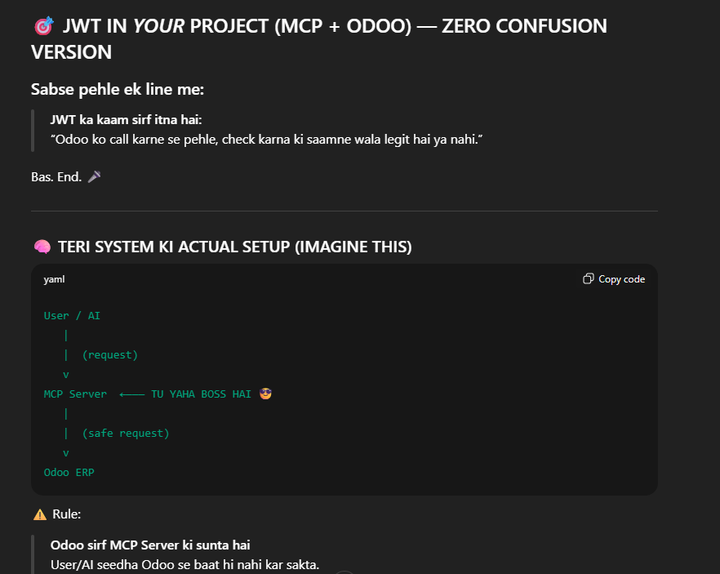
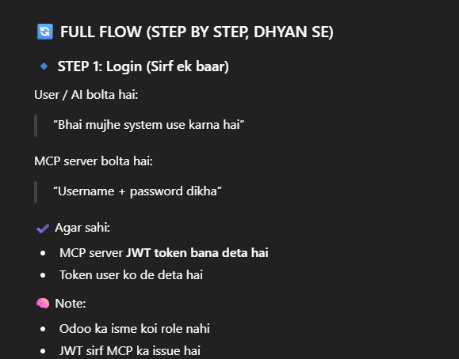
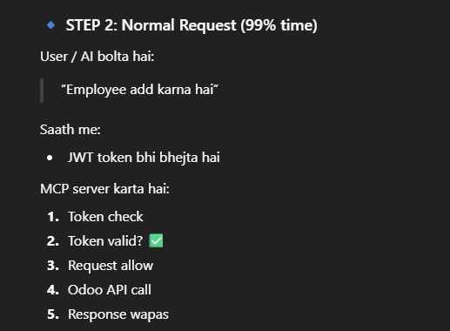
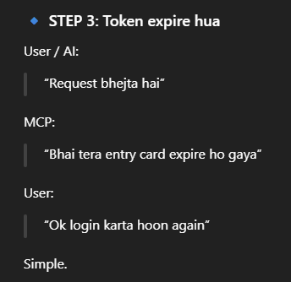
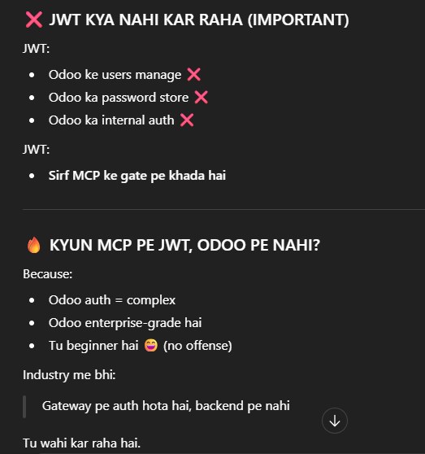
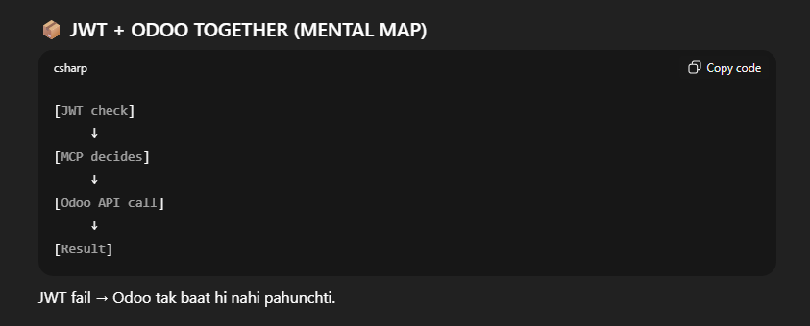
Authentication always takes place at the gateway, not in the backend
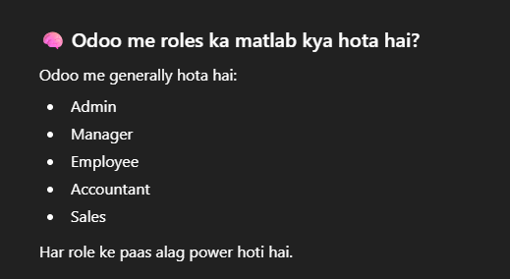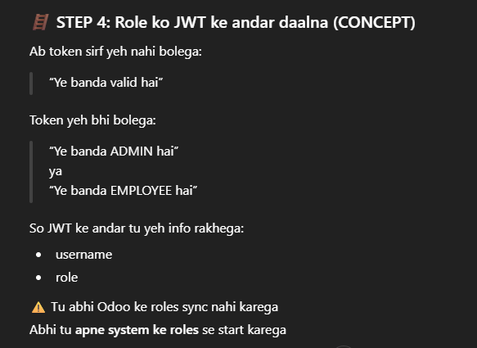
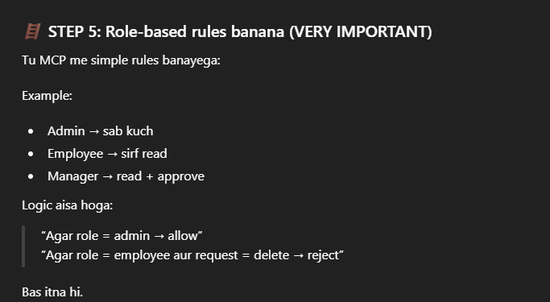
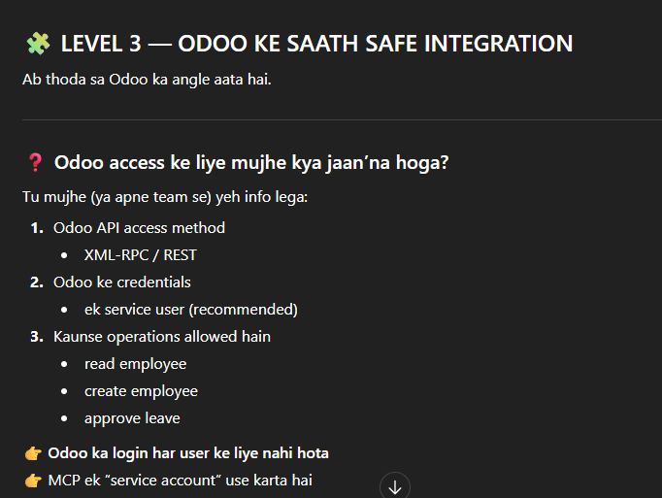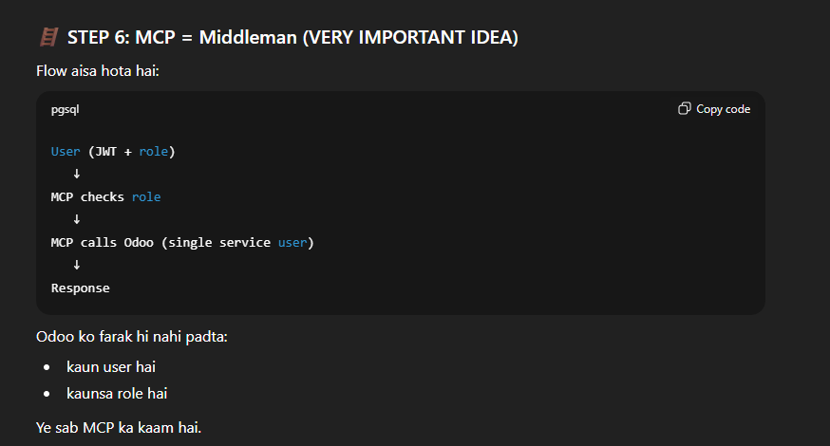
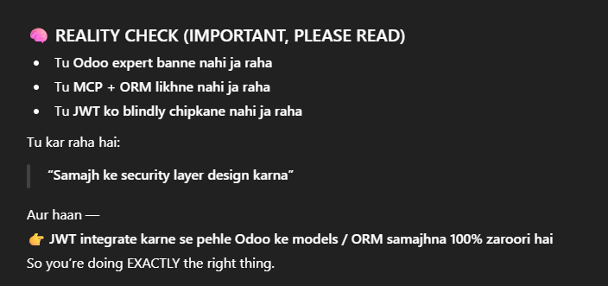
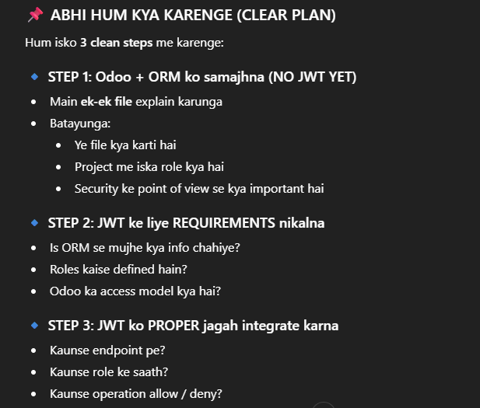

What is Odoo?
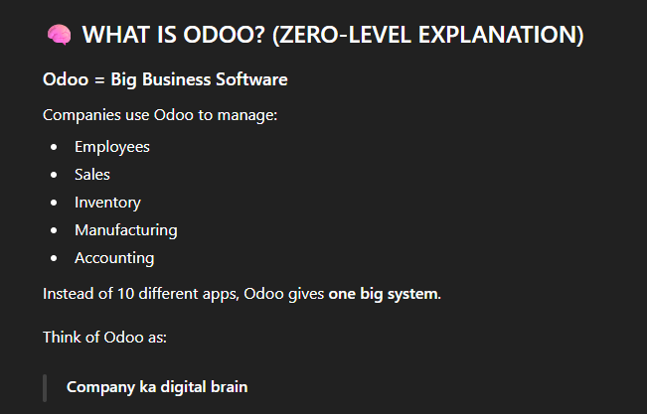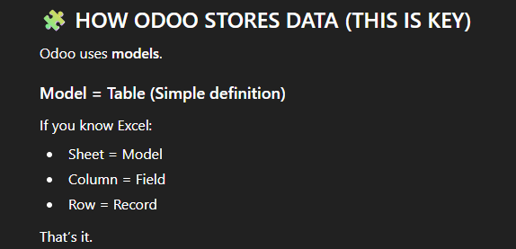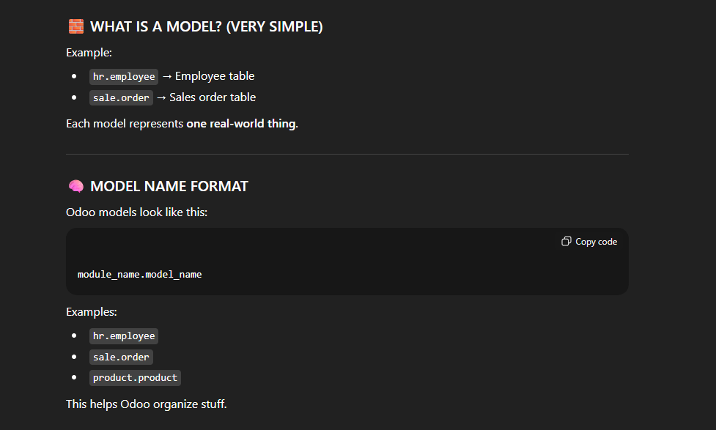
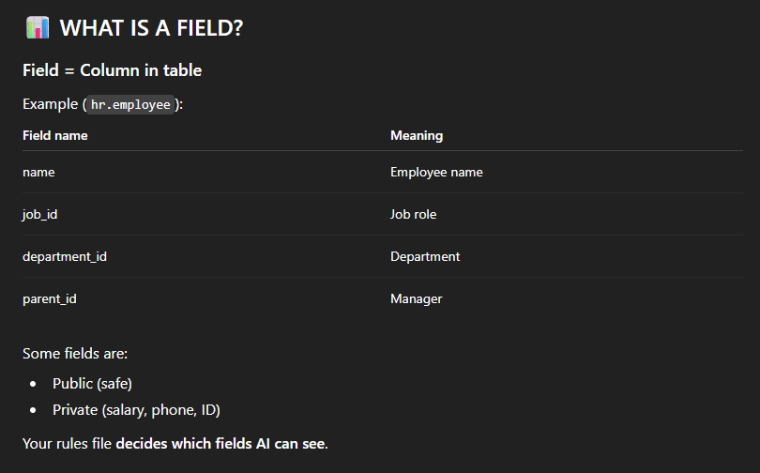
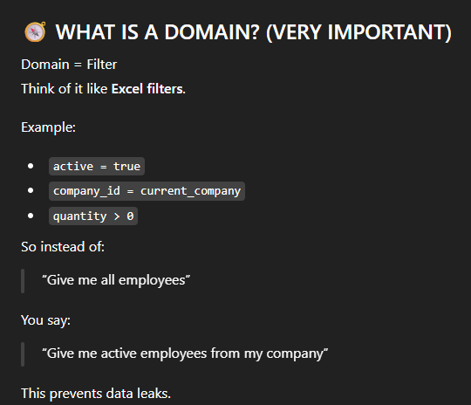
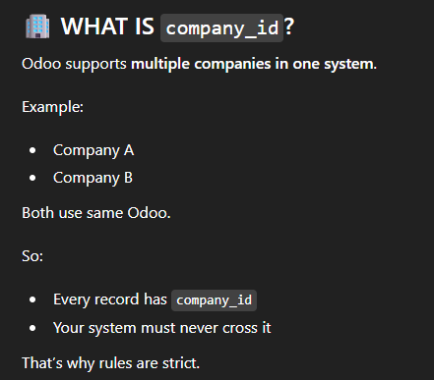

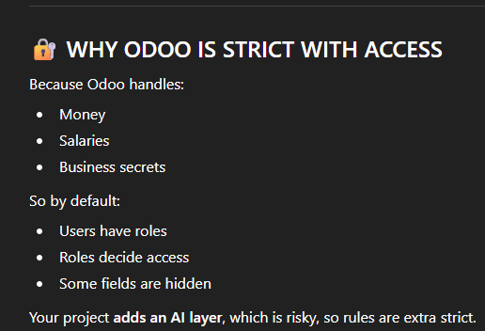
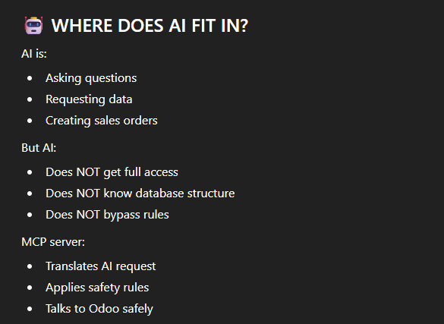

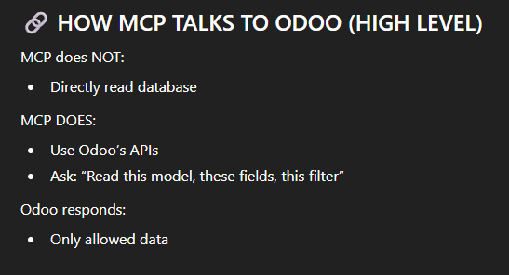
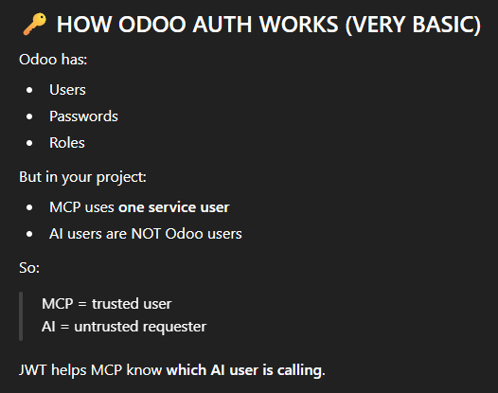
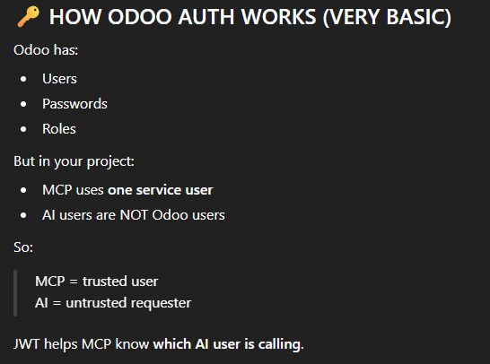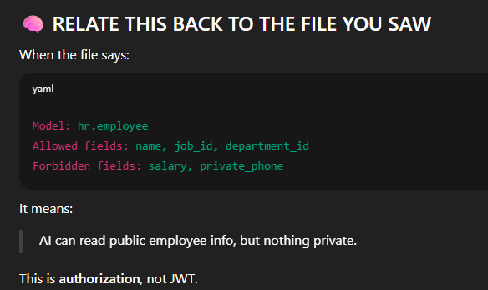
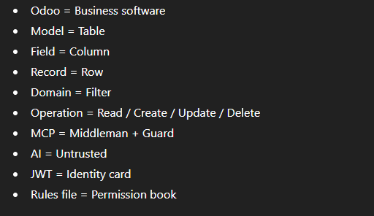

FILE 1: ai_safety_execution_notes.md
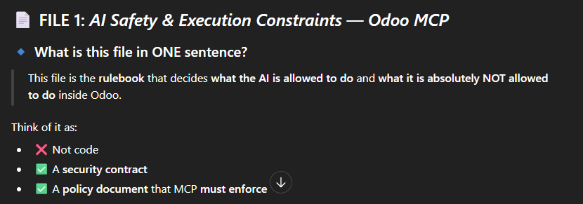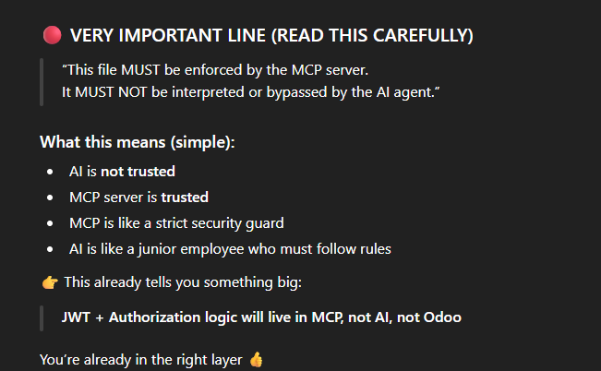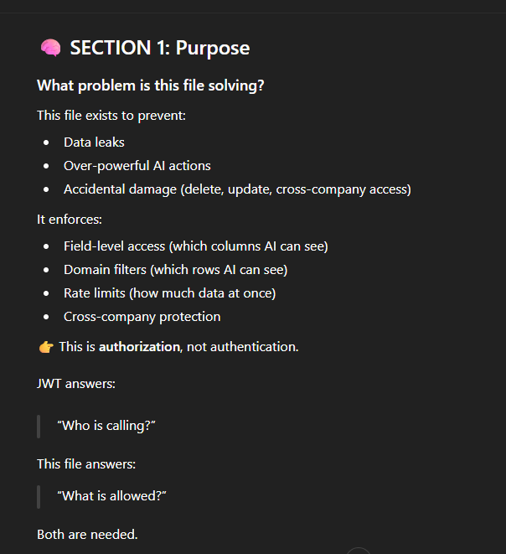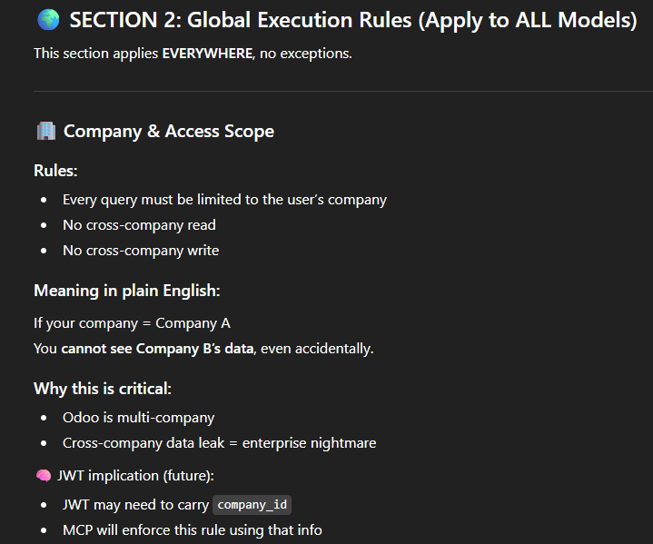
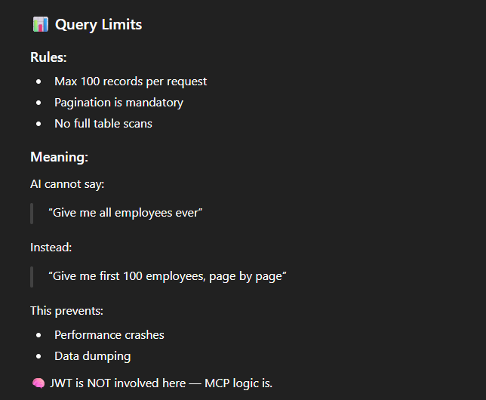
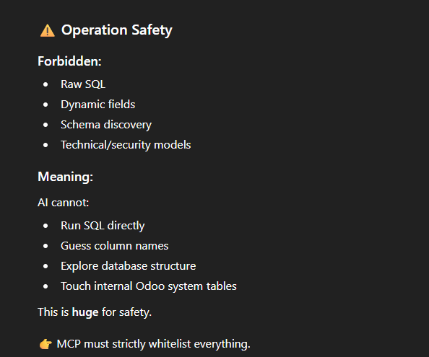
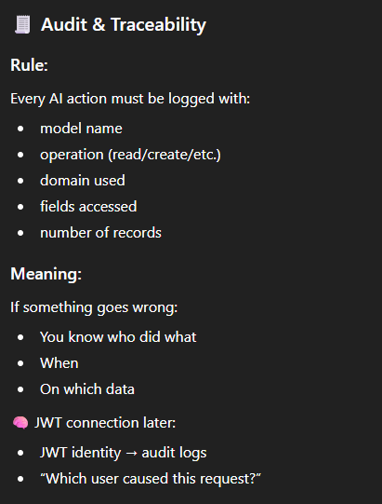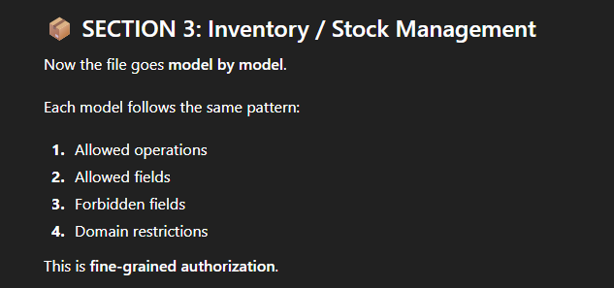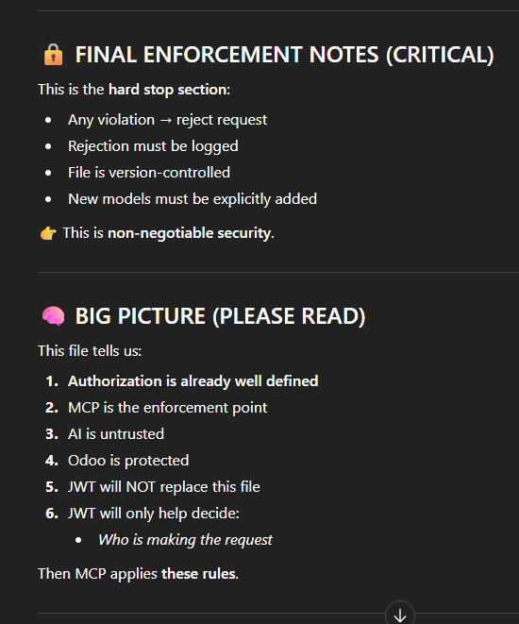
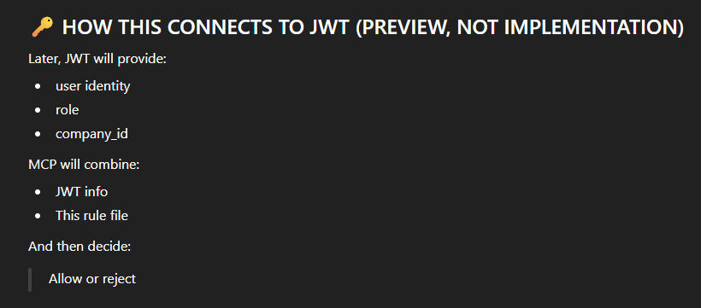

File 2: infra_notes.md

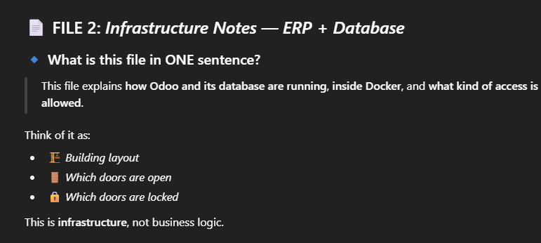
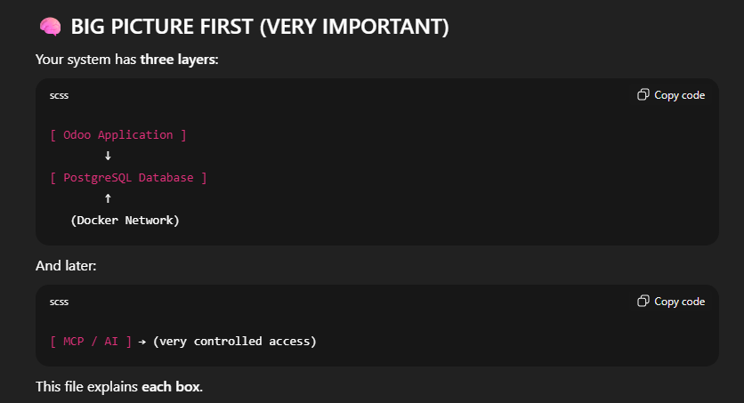
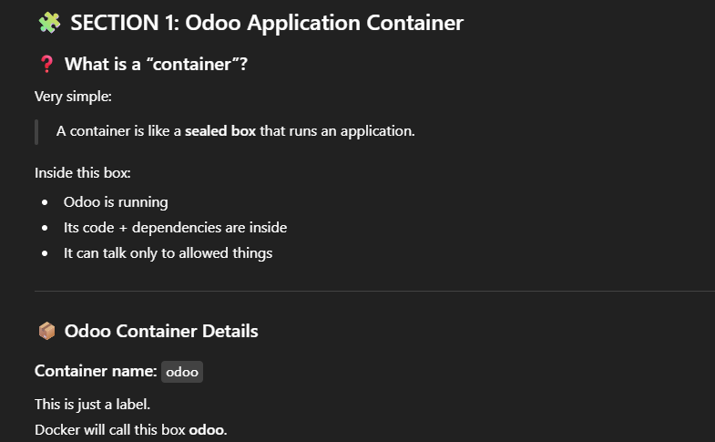
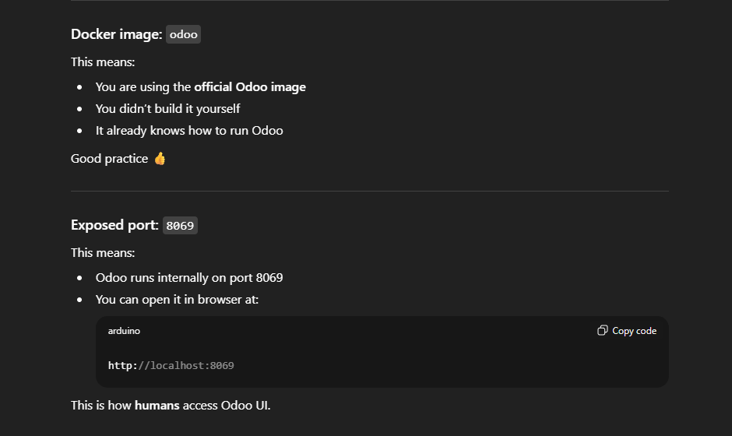
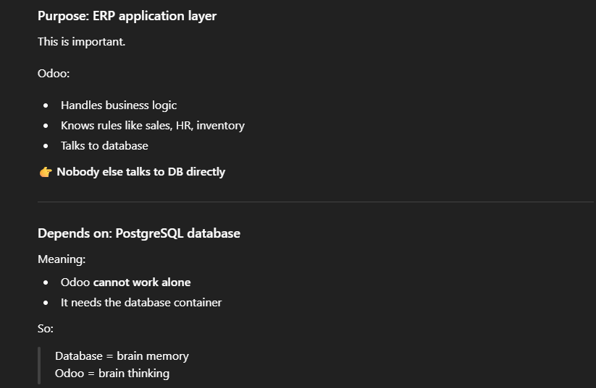
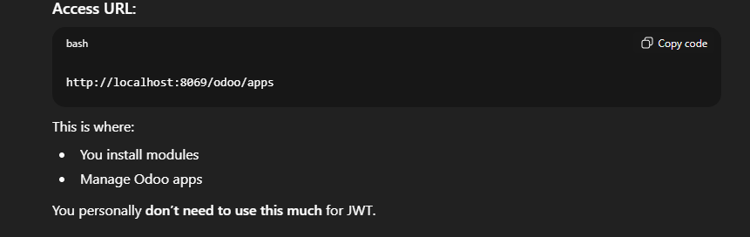
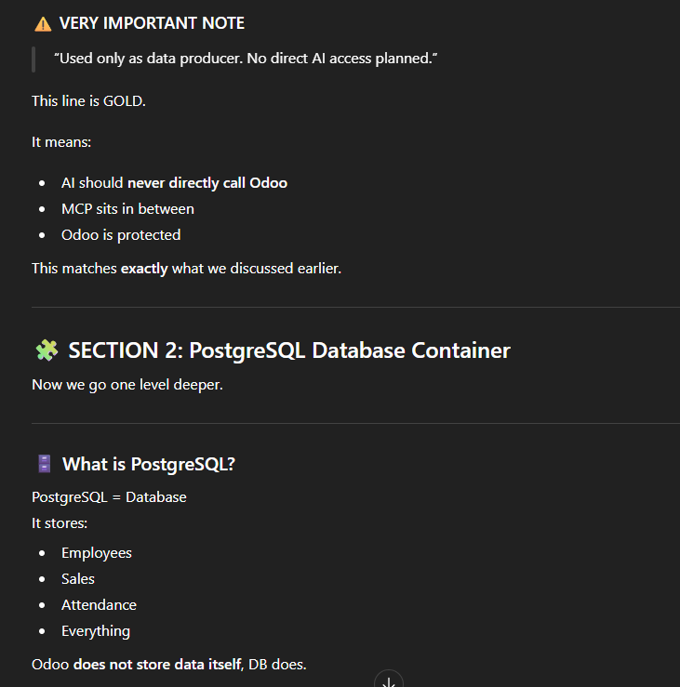
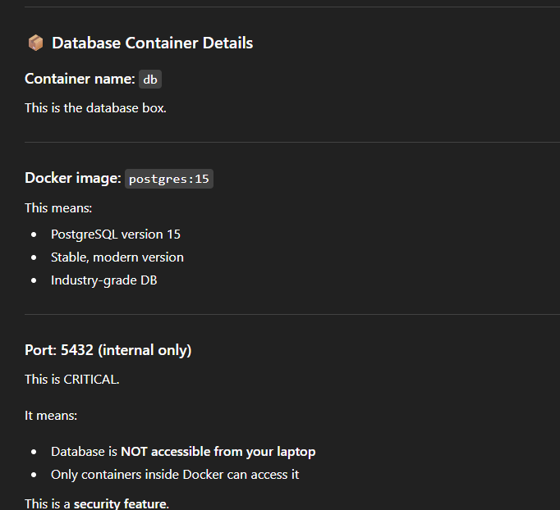
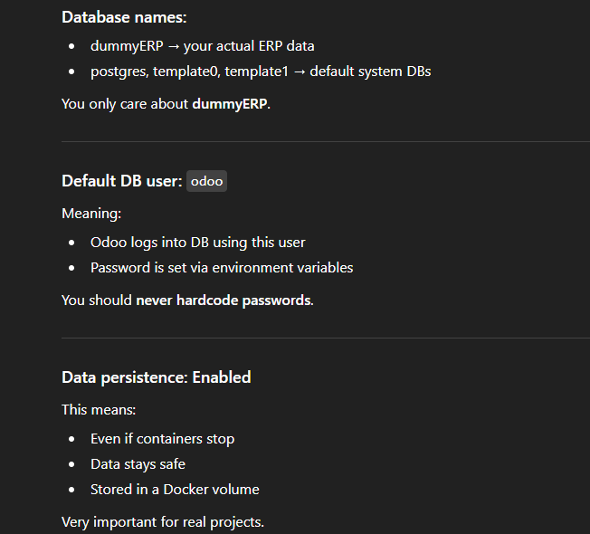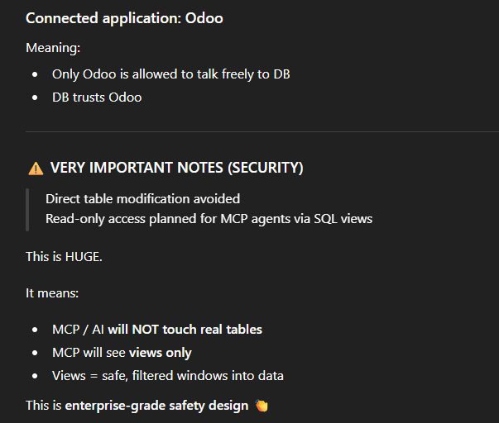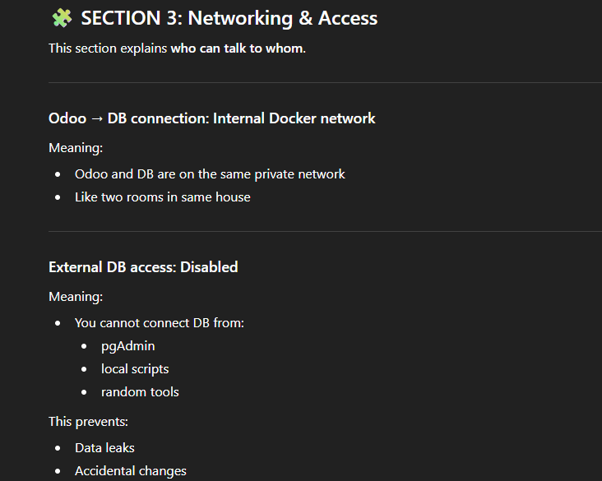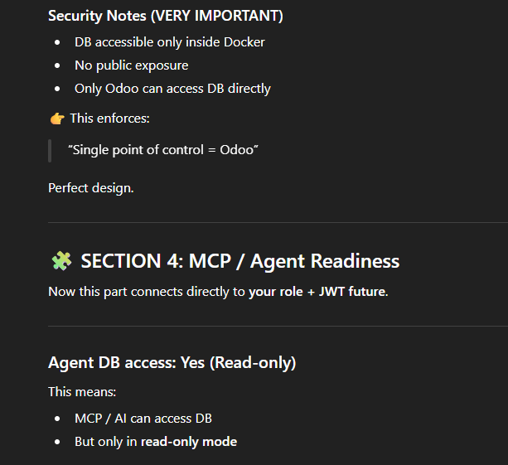
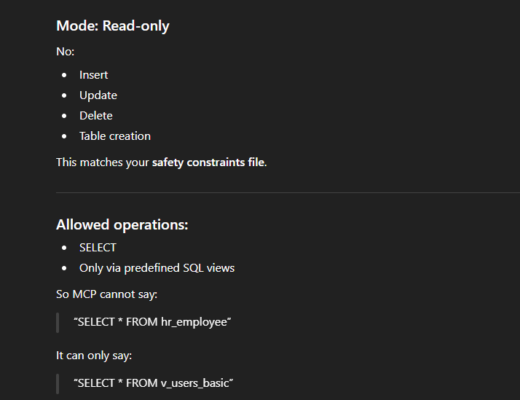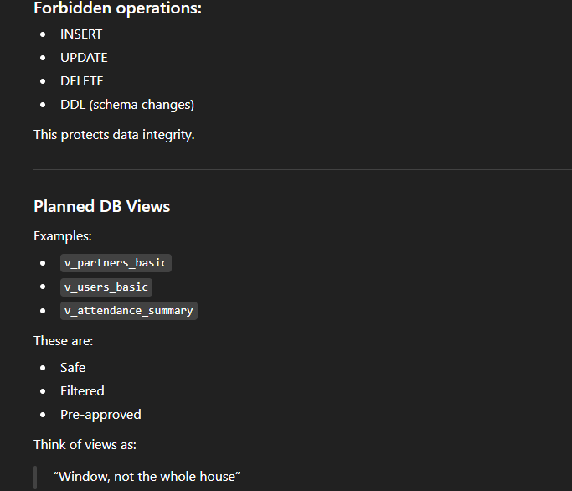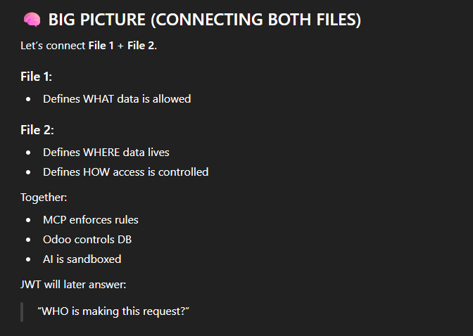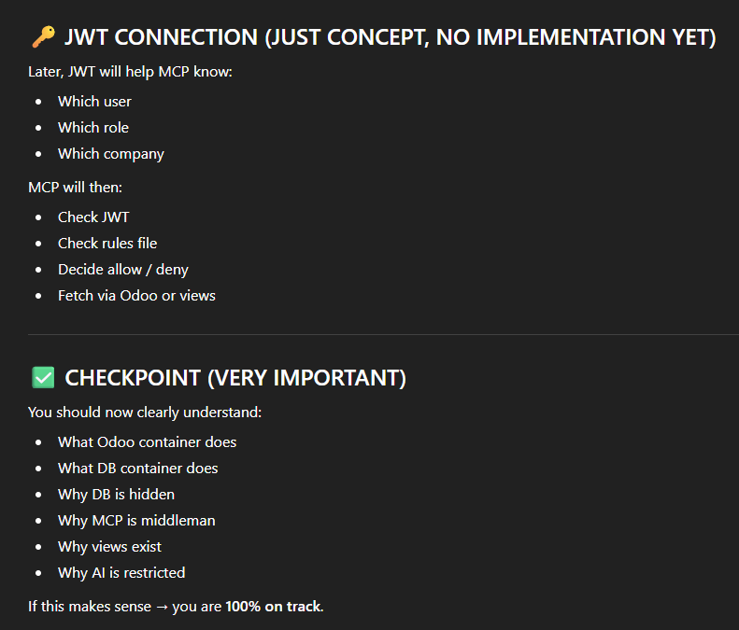

Some points about users in Odoo:
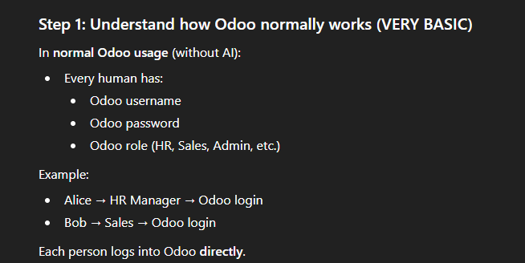
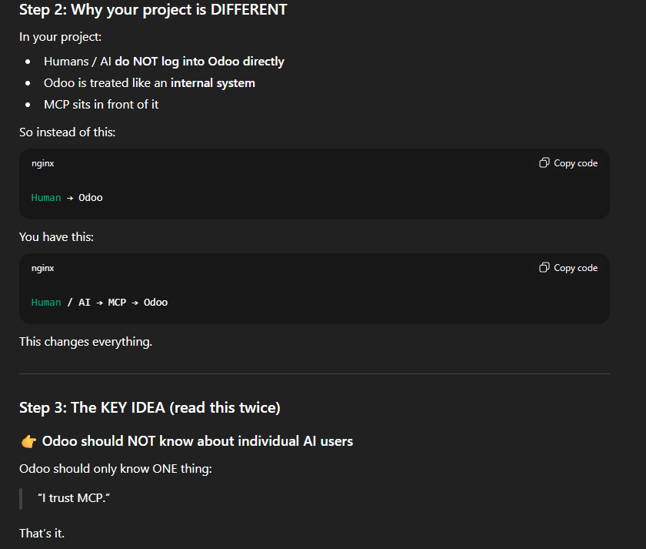
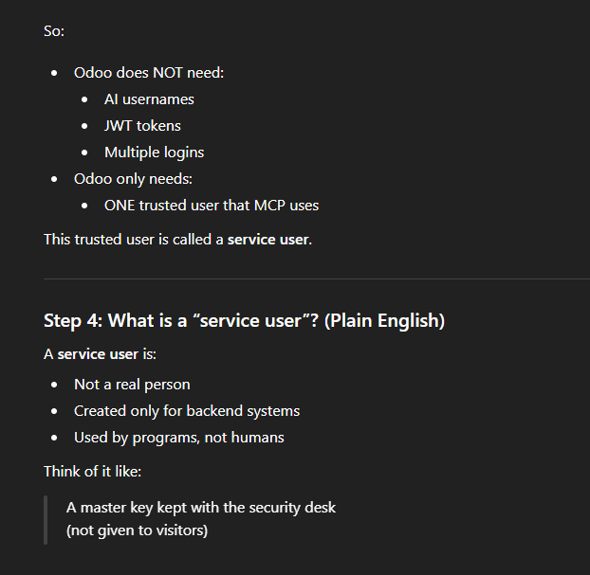
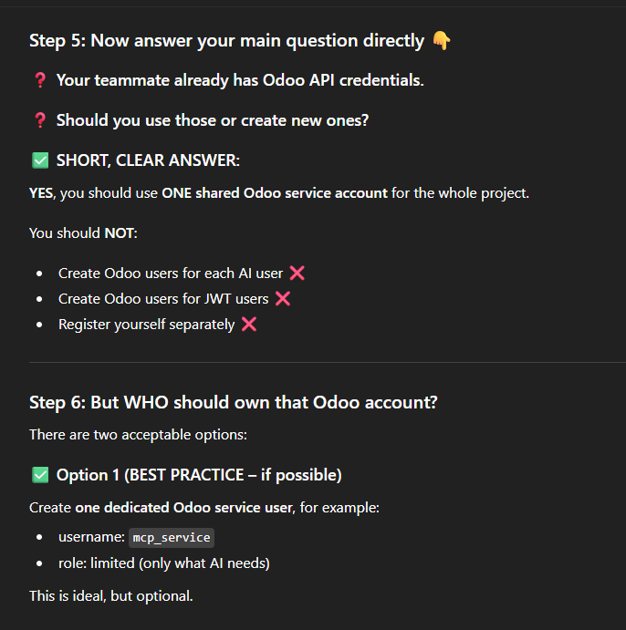
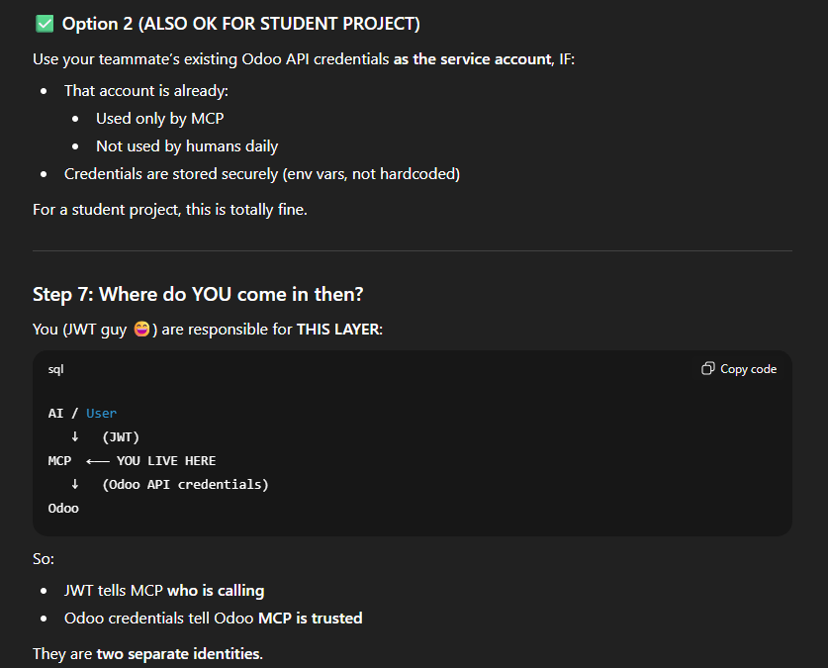
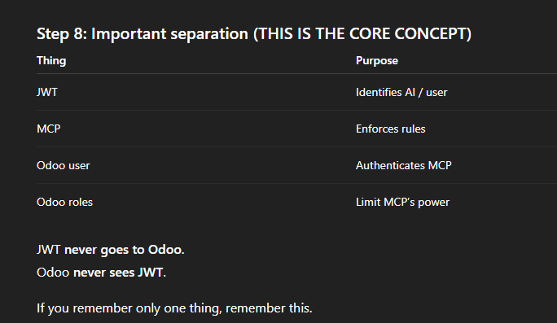
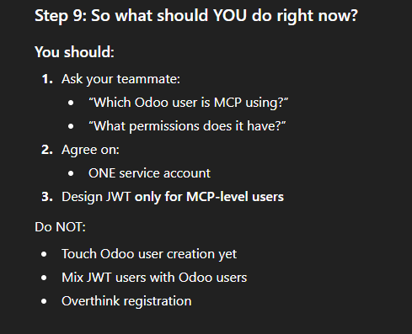

File 3: phase1_models.md
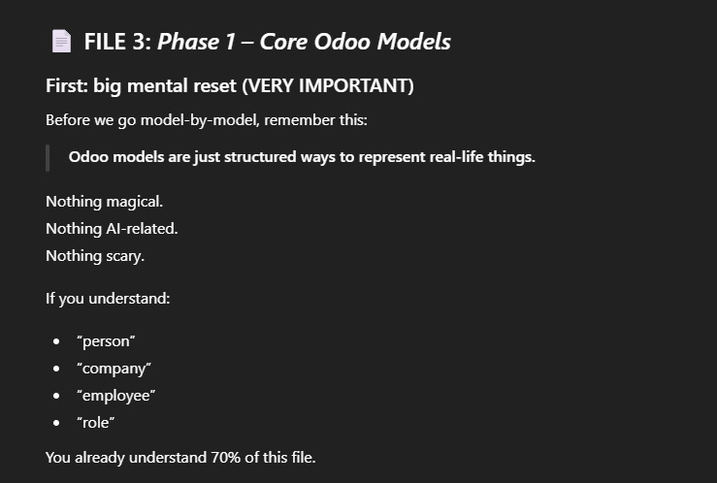
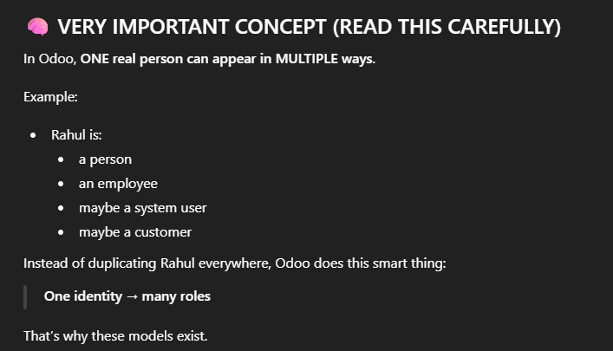
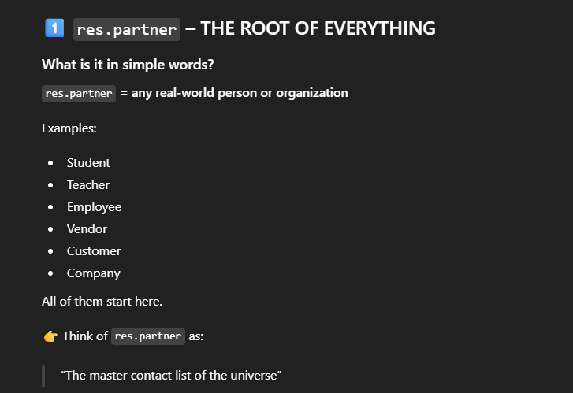
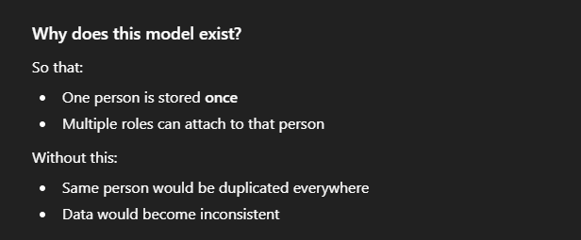
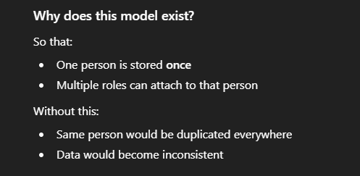
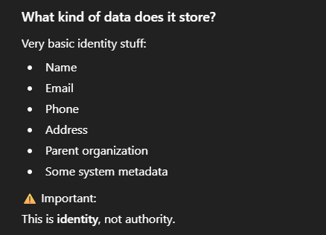
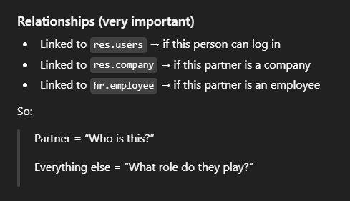
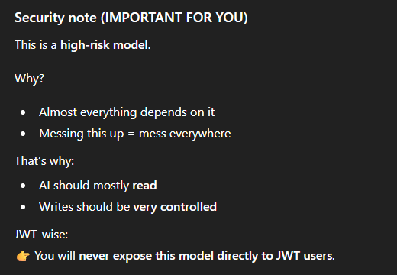
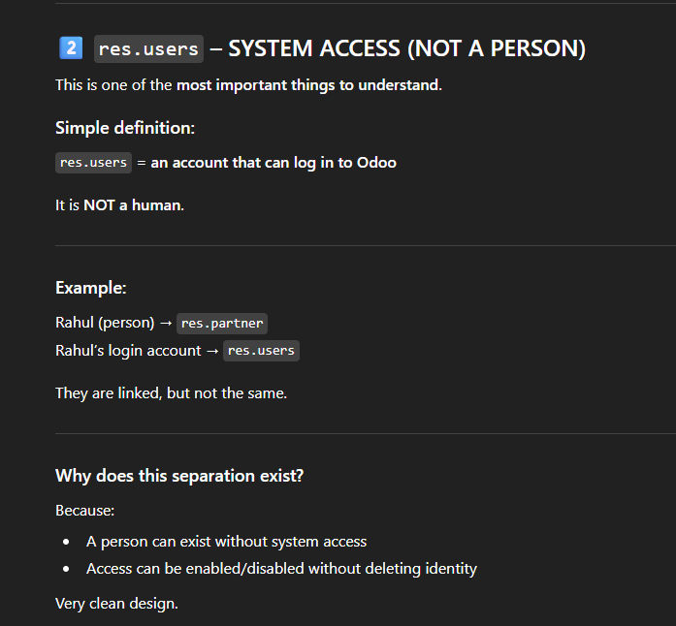
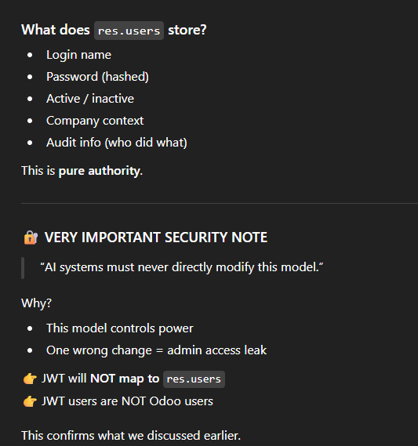
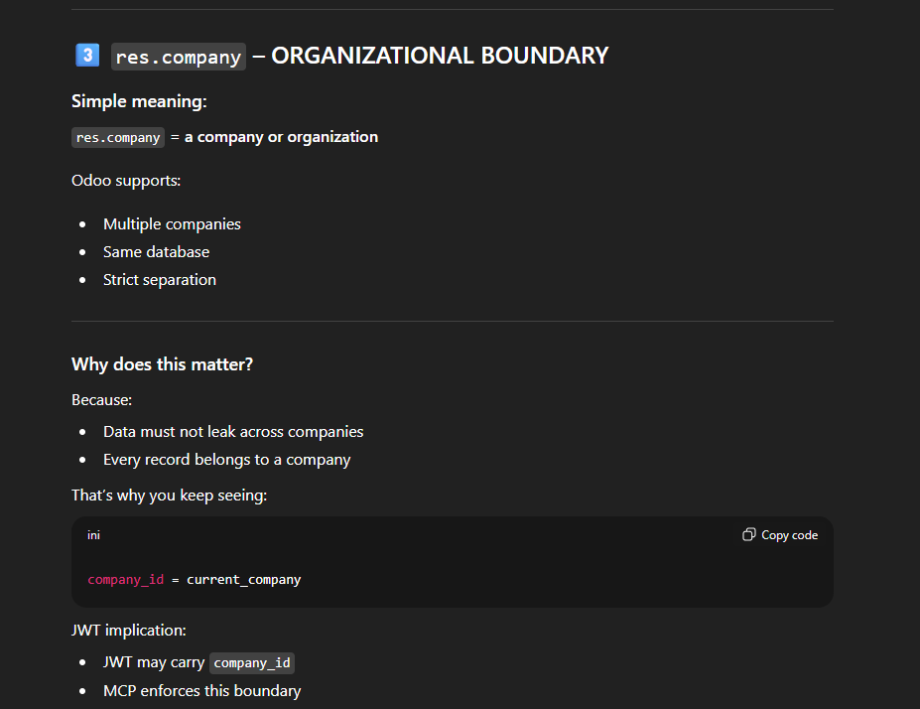
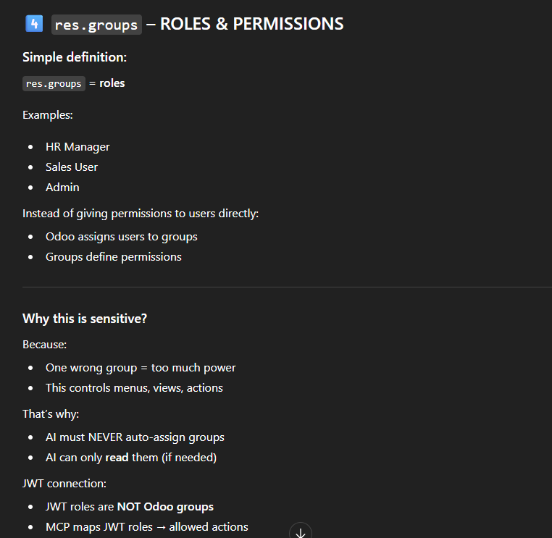
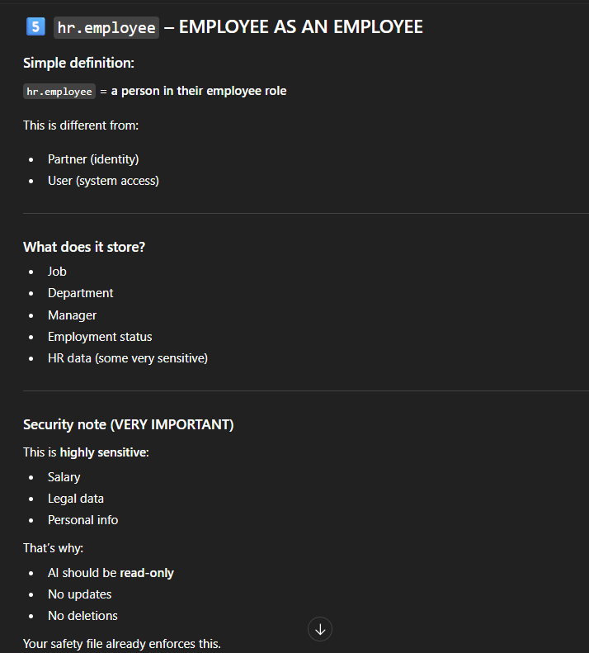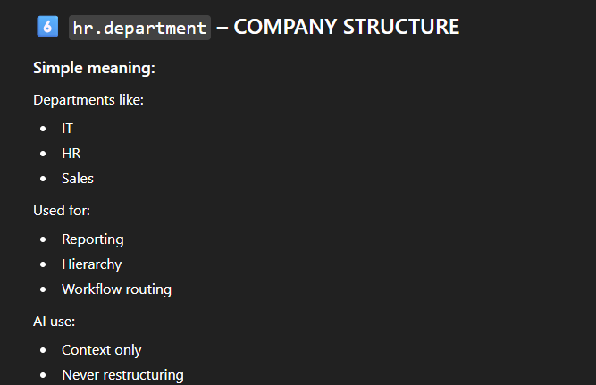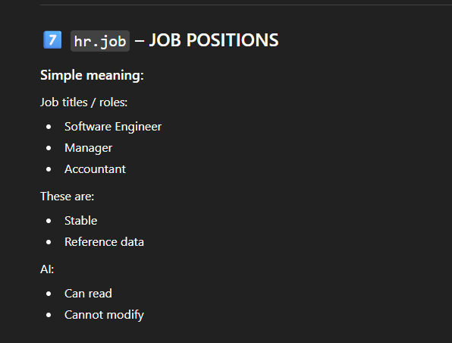
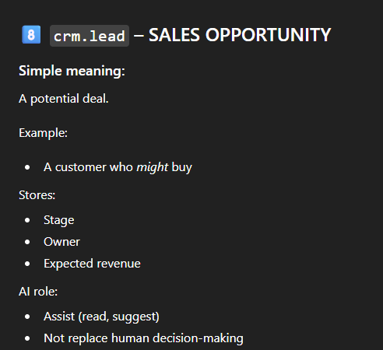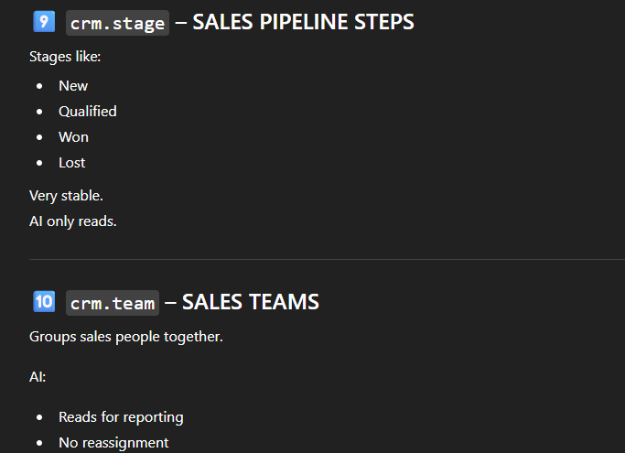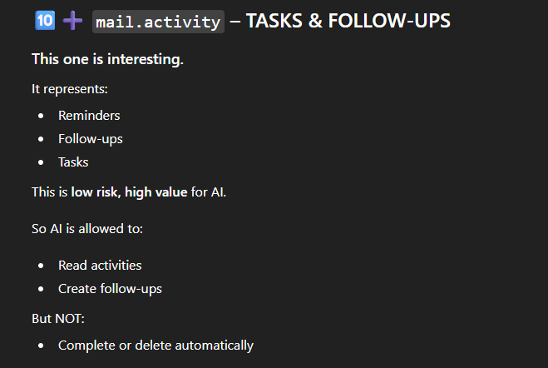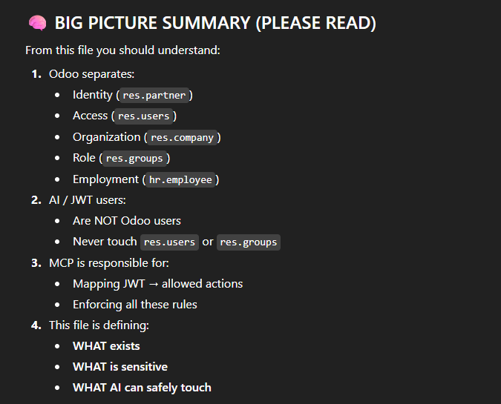
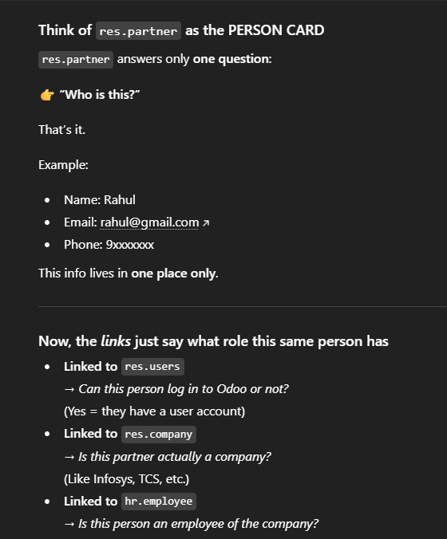
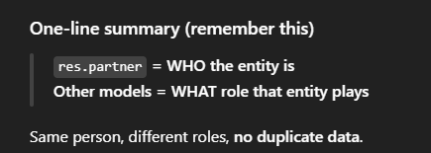

File 4: phase2_business_object_map.md
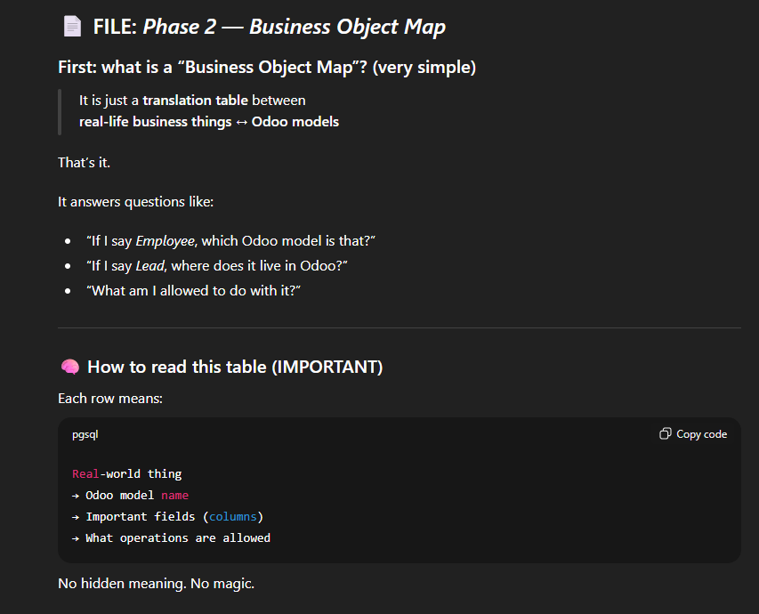
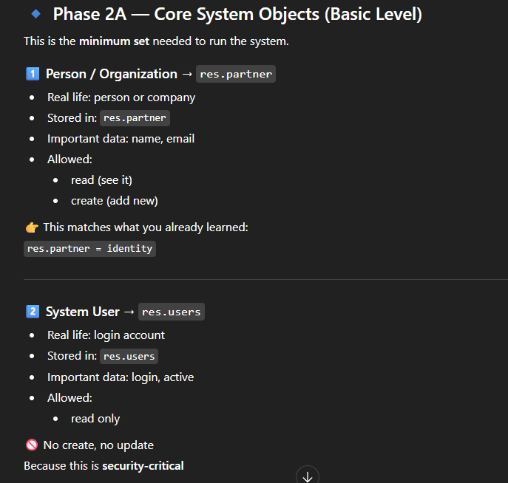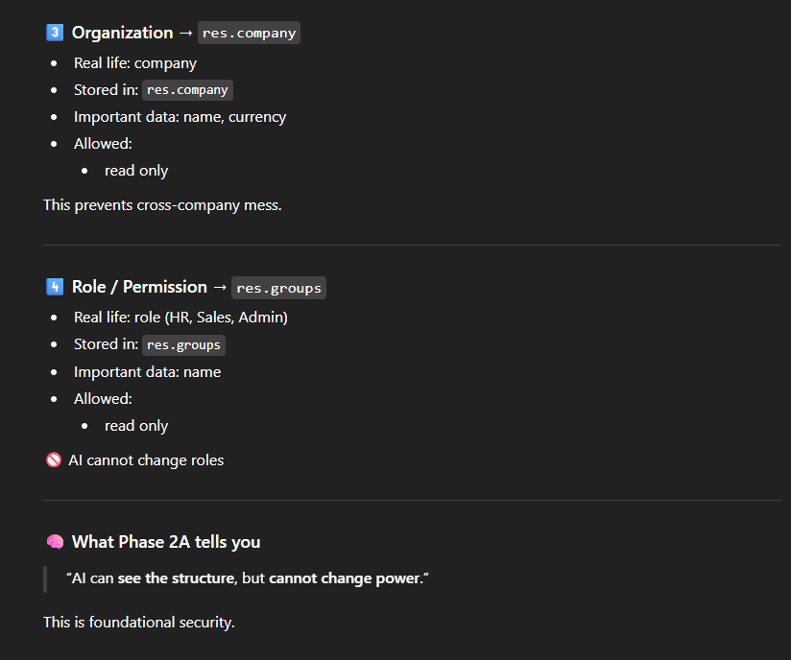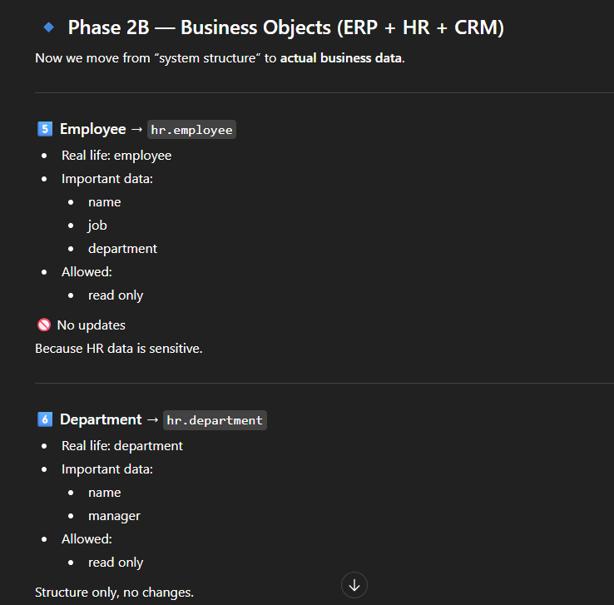
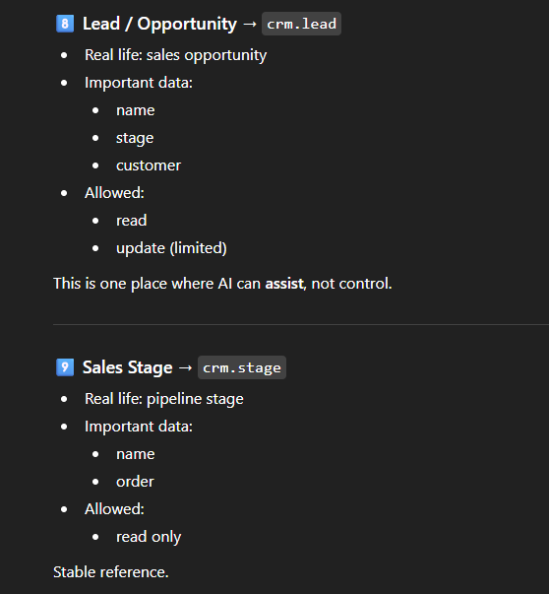
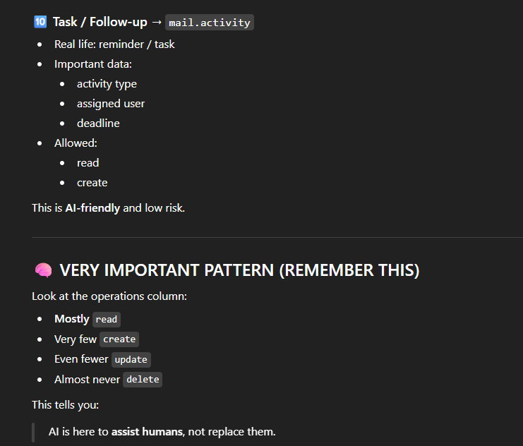
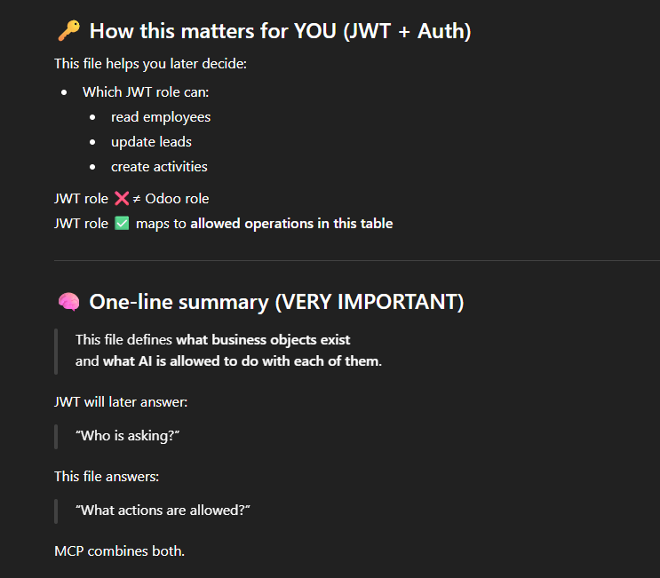
File 5: Phase 2C_Extended_Business_Object_Map.md
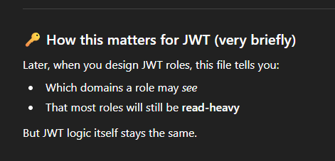

File 6: mcp_tool_list.py
 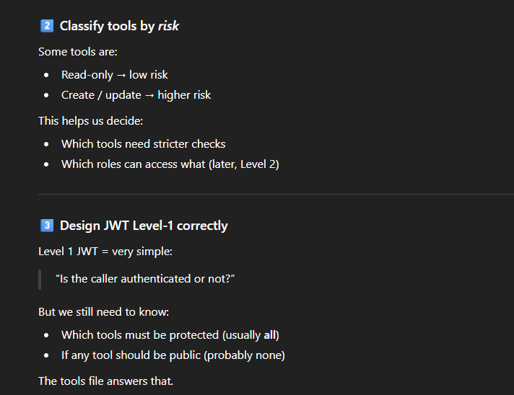’

Some important concepts:
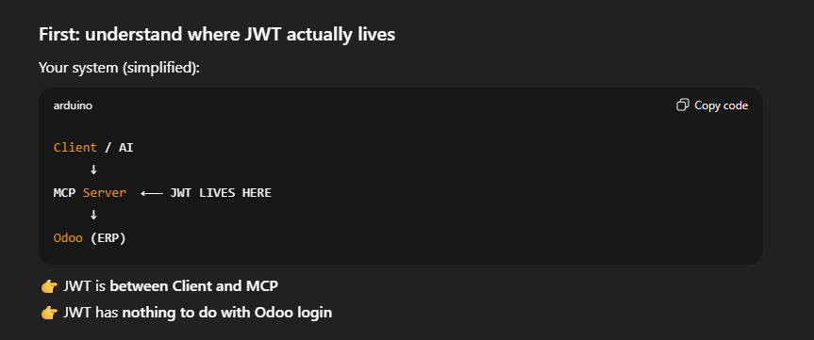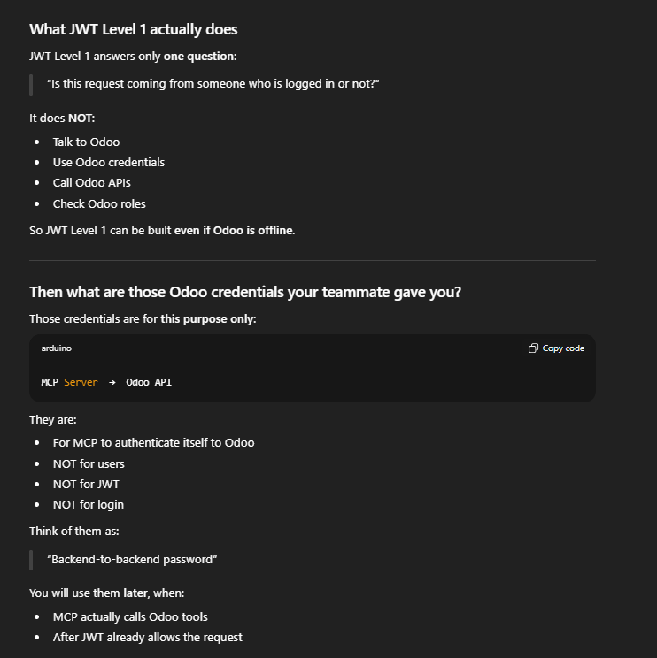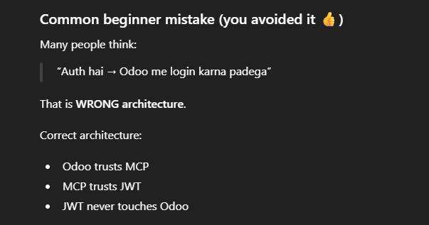

JWT level-1
