Benchy Kira 03 Engineering Project Review Brief
Prepared for Faculty Review
Prepared by Erdene Batbayar
10 September 2026
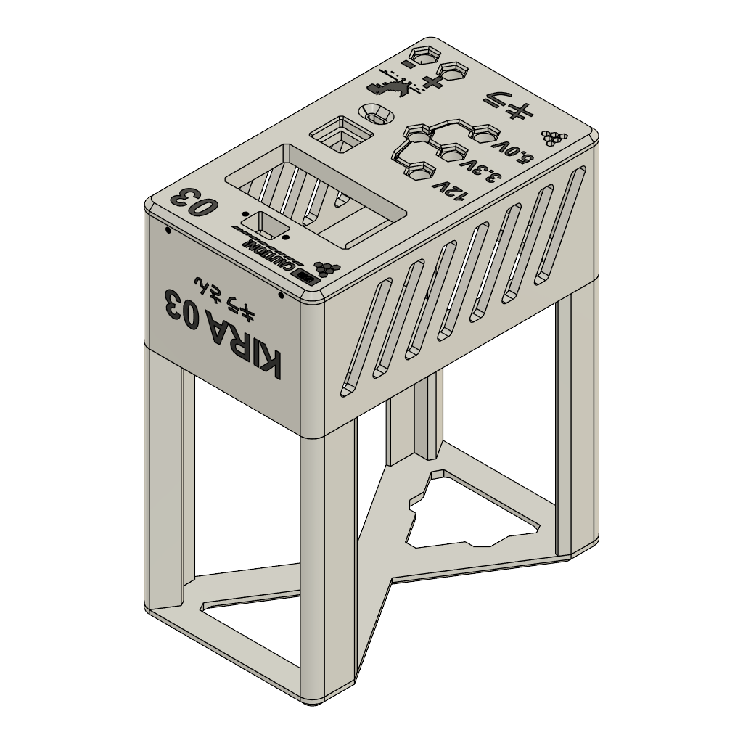
Figure 1 Enclosure model preview from the supplied 3MF file

Purpose of this review
I am asking for feedback on the engineering direction and documentation of Benchy, my Kira 03 bench power supply project. The project repurposes a functional computer power supply that is no longer suitable for a modern desktop computer. My goal is to turn it into a useful bench tool and publish enough information for other makers to understand, reproduce, and improve the design.
The enclosure model, project photographs, preliminary parts list, documentation structure, and a clearly marked preliminary connection schematic are available. Exact as-built wiring, the Arduino Nano program, relay behavior, exact component variants, and measured performance still need to be completed before I describe the project as build-ready. I would value feedback on those gaps and on the tests needed to support the final design.

Project links
Public repository github.com/Syren0914/benchy-kira-03
Public photo gallery Google Drive photo folder

Project motivation
Desktop computers have become more power-hungry, so a power supply that was adequate ten years ago may no longer meet the demands of a modern computer. That does not mean the older unit has stopped working or has become useless. Rather than discard functional hardware, I repurposed it as the basis of a bench power supply. Benchy extends the useful life of the original supply and turns it into a practical source of power for electronics work, prototyping, and testing.
This project lets me explore engineering reuse as a design problem. A successful conversion requires more than placing an old power supply in a new case. I need to document the available rails, safe operating limits, control behavior, output connections, cooling, mechanical fit, and test results so that the finished tool is useful and understandable.

Project overview
Area | Current design | Information still needed
Source hardware | Reused computer power supply | Exact model, rail ratings, connector map, condition, and compatibility checks
Adjustable output | SK120 module | Manufacturer, revision, verified input and output limits, configuration, and thermal behavior
Control | Arduino Nano and relay | Sketch, board variant, pin map, relay model, switched circuit, and startup state
Enclosure | PLA 3MF model with M2 and M3 fasteners | Print orientation and profile, screw quantities and lengths, tolerances, and thermal suitability
User interface | Display, rotary control, fixed-voltage labels, and output connectors | Connector part numbers, polarity, output function, and operating instructions

Design and learning goals
- Recover useful value from functional hardware that no longer meets its original application.
- Integrate mechanical design, additive manufacturing, power conversion, embedded control, and user-interface decisions in one physical system.
- Measure the finished system and separate manufacturer ratings from limits demonstrated by the complete assembly.
- Create public documentation that another person can follow without relying on private explanations from me.

Current project assets
- A public GitHub repository containing the project overview, build-guide structure, preliminary parts list, release checklist, and contribution guidance.
- The supplied power supply v.2.3mf enclosure file and its embedded model preview.
- A public gallery of forty exterior photographs, including front, rear, top, and angled views.
- A preliminary component inventory: PLA, M2 and M3 screws, an SK120 module, a reused computer power supply, an Arduino Nano, and a relay.
- A preliminary color connection schematic showing the intended low-voltage power paths and identifying unconfirmed Nano and relay wiring as TBC.

Engineering status
The prototype enclosure and exterior are documented, but the project is still an engineering draft. The current public documentation intentionally avoids guessing electrical connections or performance. The following work is needed before another person should build or energize the design from the published files.
- Identify the exact computer power supply, SK120, Arduino Nano, relay, connectors, fasteners, and wiring materials.
- Confirm the preliminary schematic and complete a conductor-by-conductor wiring schedule that states connector orientation and polarity.
- Publish the Arduino source code and define the relay state during startup, reset, normal operation, and failure.
- Record validated 3D-print settings, part orientation, assembly order, screw sizes, and fit adjustments.
- Define and perform no-load, loaded-output, combined-load, display-accuracy, protection, ripple, and thermal tests.
- Ask another person to review or reproduce the design using only the released documentation.

Safety and scope
The photographed unit includes a mains-style inlet, so the electrical design and commissioning process require careful review. The public draft does not establish the input protection, protective-earth arrangement, insulation, output isolation, fire suitability of the enclosure, or safe service procedure. These items must be verified for the actual power supply and construction before the project is presented as a repeatable build.
I will keep the enclosure closed during ordinary powered demonstrations and will document internal construction only while the unit is safely disconnected. Electrical ratings in the final report will be tied to the exact components and test conditions rather than inferred from labels or vendor maximum values.

Feedback requested
I would appreciate your comments on the following questions:
- Is the project objective clear and appropriately scoped for an engineering project?
- What additional requirements should I define before finalizing the design?
- Does the proposed documentation separate confirmed facts, assumptions, and unverified limits clearly enough?
- Which electrical safety checks and load tests should be mandatory before public release?
- What measurements would best demonstrate that the converted supply performs reliably for its intended uses?
- What changes would improve the enclosure, cooling, controls, connector layout, or serviceability?
- What evidence should I include to demonstrate learning, design iteration, and responsible reuse?

Faculty feedback
Reviewer name ____________________________________ Date ____________________
Review area | Assessment | Comments and recommendations
Problem definition and motivation | Strong / Adequate / Revise
Technical design and integration | Strong / Adequate / Revise
Testing and evidence | Strong / Adequate / Revise
Safety and responsible practice | Strong / Adequate / Revise
Documentation and reproducibility | Strong / Adequate / Revise
Overall project direction | Strong / Adequate / Revise

Priority recommendations
1 ____________________________________________________________________________
2 ____________________________________________________________________________
3 ____________________________________________________________________________

Additional comments
________________________________________________________________________________
________________________________________________________________________________
________________________________________________________________________________
________________________________________________________________________________
________________________________________________________________________________

