Department of Computer Science

Jamie Birch, Sarah Carter, Ching Chi Chan,

Matthew Ellams, Sam Grant, Alexander Lorimer

**Code** A

**Colony**

___REPORT___

MS50 Computer Science Conversion,

Software Development,

Group **B**ees

2016

**Declaration of Mark Distributions**

We hereby declare that the following distribution of marks have been agreed by all of the undersigned, and that the work detailed in this document is the sole product of the group members.

Jamie Birch % __________________________________

Sarah Carter % __________________________________

Ching Chi Chan % __________________________________

Matthew Ellams % __________________________________

Sam Sutherland Grant % __________________________________

Alex Lorimer % __________________________________

**Contents**

1. **Introduction**
   1. Objective
   2. Target Audience
   3. Purpose
   4. Definitions
2. **Planning**
   1. Concept Development
   2. Market Research
   3. Initial Concepts
      1. Text Adventure Game
      2. CPU Mario
      3. Shrek
      4. Bees
   4. Final Concept
   5. Competitor Analysis
3. **Project Management**
   1. Overall Objectives
   2. Planning and Scheduling
   3. Gantt Chart
   4. Tools
      1. Pair Programming
      2. Sprinting
      3. Unit testing
      4. Version Control
      5. Continuous Integration
   5. Rescheduling
   6. Evaluation
4. **Design and Implementation**
   1. Initial Design
   2. Risk Assessment
   3. Task Allocation
   4. Final Design
   5. Testing and Debugging
   6. Future Development
5. **Results and Feedback**
   1. Testing Feedback
   2. Results
   3. Evaluation
6. **Individual Evaluation**
7. **Appendix**
   1. Meeting Minutes
   2. References

**Introduction 1.2**

**Background 1.1**

Technology has changed the way in which we live our everyday lives, from communicating with friends all over the world with a simple click, to the way in which we find a new recipe, or even how we navigate from A – Z. Computers have emerged as ubiquitous devices; increasingly powerful, portable, and intuitively interactive. But this apparent simplicity belies their growing complexity and sophistication.

In the 1980s (at the very cusp of the personal computer revolution) a gap in the computer literacy of the public had been noticed. This provoked the BBC’s Computer Literacy Project and the launch of the BBC Micro (a personal computer designed for computing education). As described by David Allen, Project Editor of the BBC Computer Literacy Project, “The aim was to democratise computing. We didn’t want people to be controlled by it, but to control it.”[1] This initiative introduced millions of children to the field of computing, and inspired a generation of computer scientists and engineers.[2]

Yet concerns still exist, revolving around a growing disparity between computing education and the demands of the industry. In 2011 Eric Schmidt (then Chairman at Google) criticised Britain’s education system, stating “your IT curriculum focuses on teaching how to use software, but gives no insight into how it is made.”[3] Unfortunately, few of us are capable of moving past the opacity of modern computers to reason about their underlying technologies, despite the vast majority of the population relying on digital technology daily.

Inspired by the success of the BBC Micro, and fuelled by the current discourse surrounding computer science education, this report details our attempt at designing and implementing a system to educate and inspire Key Stage 3 level school children about digital technology.

**Aims and Objectives 1.2**

Computer science is such a broad and multifaceted subject, with many overlapping subfields and applications. In response to the question, "how can computing concepts be demystified to a new audience?" we have identified an aspect of the field that is anticipated to have a continually accelerating impact on daily life, while also capable of being explained in simple terms: problem solving algorithms.

Today autonomous algorithms and artificial intelligences control many aspects of society, from weather forecasting to stock trading activity,[4] and from transport planning & scheduling to date matching[5] (the list is ever growing). Yet, despite the complexity of the problems such algorithms tackle, frequently the approach that is employed can be defined by simple rules that are far easier to understand. Swarm intelligence algorithms, for example, might determine optimally short paths between points by replicating slime mould or social insect behavior. Ants can tackle such problems by individually leaving a trail, signalling whether or not they have recently found food. Other ants can randomly explore, but are inclined to follow attractive trails. Over time the trails that remain stronger (reinforced by other ants) are those which are travelled most frequently. These, on average, tend to be the shortest path between desirable points, while the longer trails require more effort to maintain (tending to weaken). Hence, the problem-solving approach can be defined by just a few simple behaviors (random exploration and conditional trail setting / following). The ubiquity and real-world impact of similar algorithms, along with their definition by relatively simple rules, makes this an appealing educational topic.

Our objective is to develop a system to educate and inspire school children about the underlying mechanism of problem-solving algorithms and simple artificial intelligences. Affecting real change means reaching homes as well as schools, and for this reason we have focused our efforts purely on software (as opposed to costly hardware) for the creation of an engaging, educational game. Influenced by David Allen’s statement (“we didn’t want people to be controlled by it, but to control it”), our aim is to briefly turn the relationship between children and digital algorithms upside-down. The ultimate intention is to facilitate the easy creation and manipulation of custom algorithms, in a visually rich, gamified context, demonstrating that computer science can be both fun and empowering.

**Target Audience 1.3**

Our efforts have been informed largely by primary market research: We have tried (where possible) to engage directly with Key Stage 3 educators as well as a user sample of our target audience (year 9 students of Bristol Grammar School, aged 13–14, both male and female). This has acted as an invaluable source of information, while allowing us to get a feel for the agile programming concept of shortest possible feedback cycles.

**Bristol Grammar School, IT Class Focus Group (Pre-development) 1.3.1**

An initial visit to the school took place on Thursday 8th October, in which we were granted an hour for a focus group with year 9 pupils. For this we devised a series of activities designed to acquire information about IT education, along with opinions and preferences regarding computer games (as well as other topics).

During the first 5 minutes we introduced ourselves and engaged in a class discussion about what the pupils had been doing and learning so far in terms of computer programming. The answers **ranged significantly**, from having little experience at all, to actively engaging in interesting web scripting projects. We were also introduced to their use of Scratch, **a visual programming language**. This acted as a great source of inspiration for our project.

We then divided the class into four lines and set up a relay game where the first person in each line ran up to the front of the class to write an interest on an A2 sheet of paper. After several minutes the group with the longest list would win. We then handed out three coloured stickers to each pupil and asked them to place a sticker next to the three interests that they prefer (on any of the four sheets of paper). This allowed us to get a ranking of the most common interests while sparking class discussion.

Next we organised smaller groups, asking each to pick an interest and brainstorm possible connections to the field of computer science. Finally, we asked the groups to design a game relating to this interest, keeping in mind that it must include an educational computer science element. Pupils were encouraged to draw mind maps, and these materials can be found in Appendix 1. The results from these activities are listed below.

Class Discussion & Groups Concepts

* Emphasis on interactive, **explorable**, non-static, **‘open worlds’**
* Connection to **cartoons**, and perhaps recognisable characters
* ‘Mario’ concept , where a player **collects blocks of code** and has to figure out what order they should go in before handing to the CPU
* Importance of **story**-based progression

Pen Relay Game

Highest Ranking Interests

* South Park (4)
* Xbox (4)
* Hockey (3)
* Family Guy (2)
* Football (2)
* FPS CoD / cs:go (2)
* GTA-game (2)
* Open world games (2)
* Rugby (2)
* Antelopes (1)
* Caramel (1)
* Phone (1)
* Shrek (1)
* Social Media (1)
* Strategy (1)

Cartoons

Digital Technology

Sport

Commonalities

In addition to these activities, we also asked pupils to fill out a questionnaire at the end of the class, ranking twelve game aspects in terms of importance to their experience (see pie chart below; ranks on next page).

Game Aspect Questionnaire (out of 10 – lowers scores rank most highly)

| **Category** | **Combined score** |  | **Rank** |
| --- | --- | --- | --- |
| Graphics | 38 |  | 1 |
| Story | 43 |  | 2 |
| Competing with others | 61 |  | 3 |
| Constant interaction | 68 |  | 4 |
| Innovation | 75 |  | 5 |
| Characters | 76 |  | 6 |
| Cooperation with others | 77 |  | 7 |
| Single player gameplay | 91 |  | 8 |
| Checkpoints | 94 |  | 9 |
| Levelling up | 96 |  | 10 |
| Sound design | 105 |  | 11 |
| Replayability | 115 |  | 12 |

The main insights we gained and took forward from these activities were that:

* Cartoons and comedy seem to be a useful tool to make game ideas more appealing. Game characters that are caricatured, and themes/challenges that contain an element of humor could be useful devices by which to draw in our target audience.
* Story- / stage-based progression (“levelling up”) was also a very popular concept. This could in some way be tied to an aspect of humour, but also would be very useful in the form of a progressive tutorial.
* Game environments that can be openly navigated, and freely explored and interacted with are important.
* A sense of collecting items, points, or “code blocks” could act as the main challenge, allowing for some element of competition (competing against your previous score, or the score of a friend).

**Bristol Grammar School, meeting with the Head of IT (Pre-development) 1.3.2**

On top of our detailed discussions with school pupils, we were also granted a 30 minute meeting with Amy Finney, the head of IT at Bristol Grammar School. Her very informative insights regarding the development of a computer science education game are summarised by three key points.

The game should be:

* **FORGIVING**/robust; “If it is too difficult, and too easy to make mistakes, they will lose interest”. (Block-based scripting like Scratch is very good for this!).
* It should be **RESPONSIVE**, ie. have instant results; “If the children don’t see the results of what they’re doing very quickly, then they will lose interest”. That is to say, we should avoid having long periods where users have to work on code with nothing else happening.
* It should have **DEPTH**; “Users will have all sorts of different skill levels – try to appeal to more than just the most experienced users”. We should thus ensure that the game avoids becoming one-dimensional and has variety in the challenges.

We were also taken through an introduction to Scratch by the teacher, which will be detailed in section “…“ (Currently on the Market). She emphasised the range of different ability and skill levels of pupils within the school, in terms of programming. She also mentioned a large disparity between schools, in terms of the amount of focus that is given to programming and computer science education.

**British Computer Science Education 1.4**

/* space here for secondary market research regarding key stage 3 computer science education

Under the present curriculum, Key Stage 3 level (11–14 year olds), British children are to begin to learn new programming languages and how to program. But with this being such a new aspect of the curriculum, and with 60% of parents not even knowing about its introduction, how can we expect children at this young age to be enthusiastic about programming and motivated to learn this new skill? (S.Dredge, Guardian.com, 2014)

*/

**Other Stakeholders and Issues 1.4**

**/\*** space here tomention other stakeholders, the industry, the economy, international competition and comparisions

GENDER GAP (bee concept)

With the demand from larger technology firms to improve the ICT in schools, as Universities are not providing enough qualified graduates to fulfill the demand of the tech industry, children as young as 5 will now be learning basic computer skills.

*/

Concept Development

Currently On the Market

Initial Concepts

# Text Adventure Game

Our very first concept was based around a text adventure game whereby the player would control a character in a story and program decisions for that character, for example, programming the character to move left or right, or programming the character to defend itself against an enemy, etc. The decision the player made for the character would either progress them through the game, or (if a poor decision was made) move them further back in the game. As players progress, decisions would become harder and therefore programming would become more advanced.

The idea of this story-based game was to introduce players to programming in a fun environment of their choice; the player could choose to control a Rock Star on tour, a soldier in a zombie apocalypse or a wizard fighting enemy trolls – a variety of choices to cater for different audiences and different interests.

However, it was difficult to see where a graphical element could be added to this game. Producing enough graphics for one storyline may have been possible, but producing enough graphics for multiple stories would have been challenging and taken time away from actually developing an interesting, interactive, fun game for the audience to play.

Market research also highlighted that it was important to our target audience that a competitive element be present in the game, and other concepts that we developed catered better to this.

# SWOT Analysis

|  |  |
| --- | --- |
| Strengths  * Story element highlighted as important by target audience. * Fun, programming element to introduce audience to computer science. | Weaknesses  * Difficult to implement enough graphics to enhance game. * Lack of competitive element important to target audience. |
| Opportunities  * Can offer multiple storylines allowing catering to many different audiences ensuring game is compatible for wider audience. | Threats  * Concept has already been used for number of years; therefore game may seem outdated, especially amongst advanced games available today. * Game may not fulfill the purpose of sparking enthusiasm in Computer Science. |

Overall Objectives

The overall objectives of this project are:

1. To produce an interesting game that sparks enthusiasm in 13–14 year old, Year 9 students to learn more about computer science.
2. To produce a game that meets target audience criteria.
3. To finish the game by the deadline provided by the client, producing a well polished, playable, fun, interactive end-product.
4. To produce a game that contains elements that allow the target audience to learn about the subject of computer science.

It is important to us to produce a well made, playable product; however, the product must fulfill the main purpose, which is to interest Year 9 students in computer science, to get them enthusiastic about the subject, and to learn an element of computer science from the game.

Appendix 1

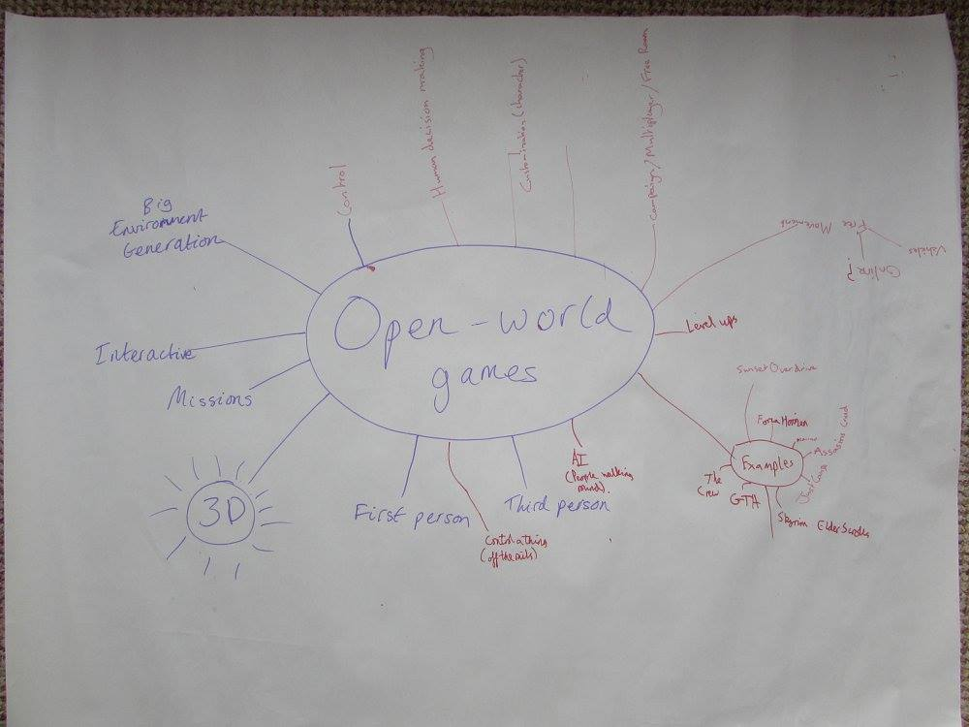

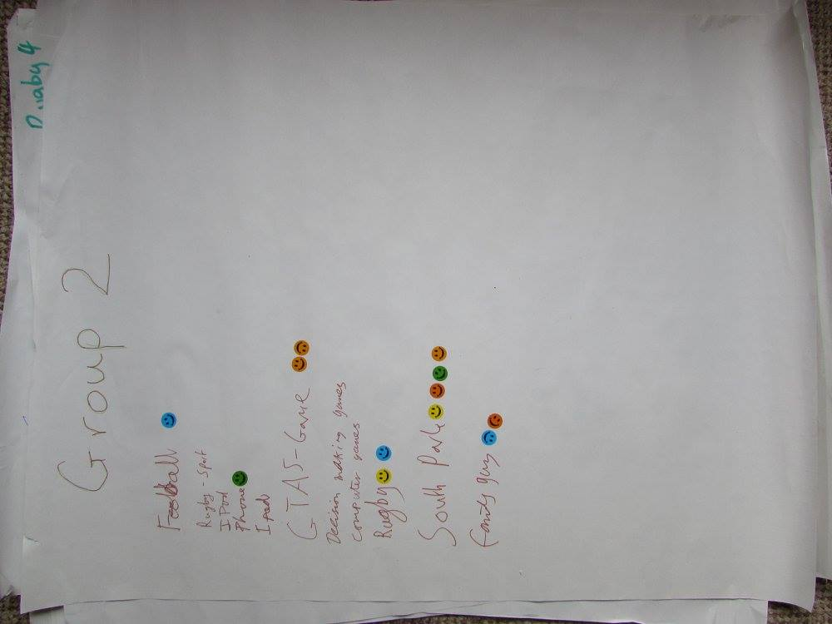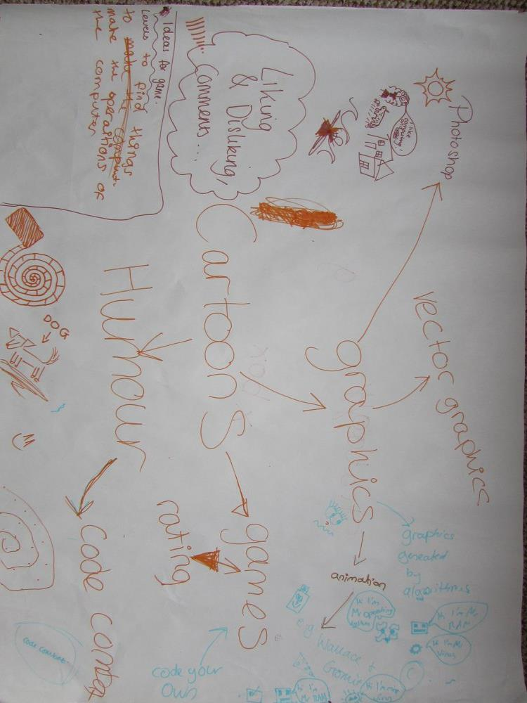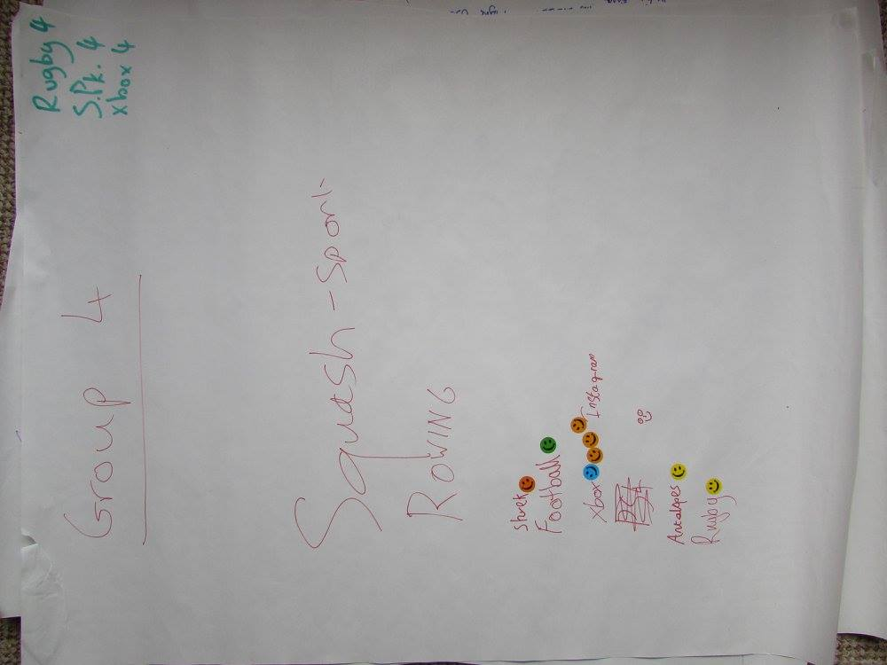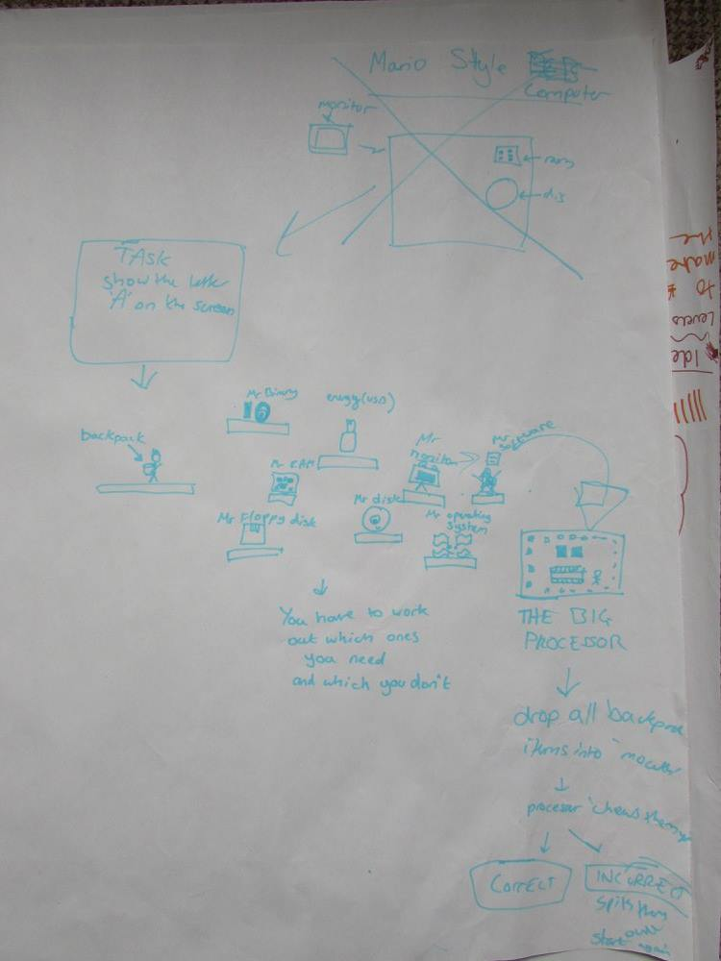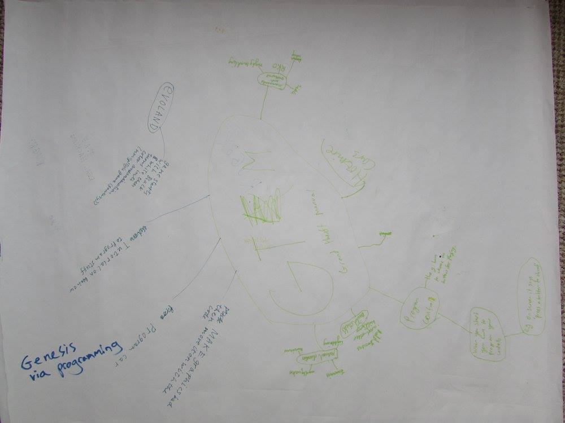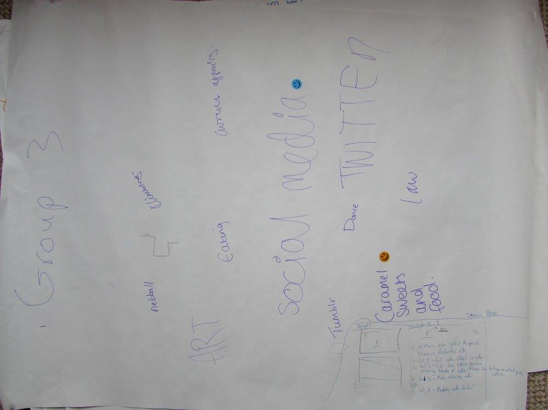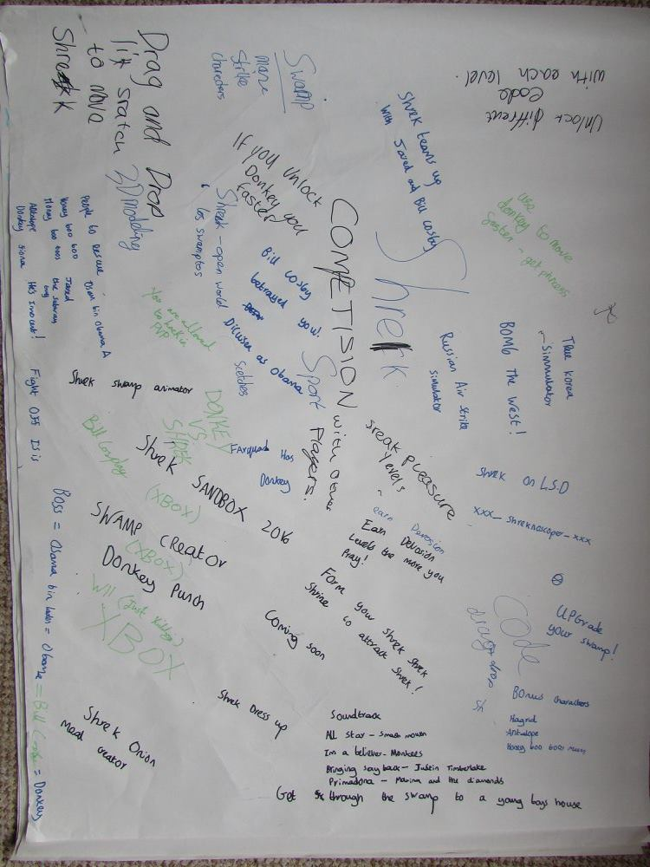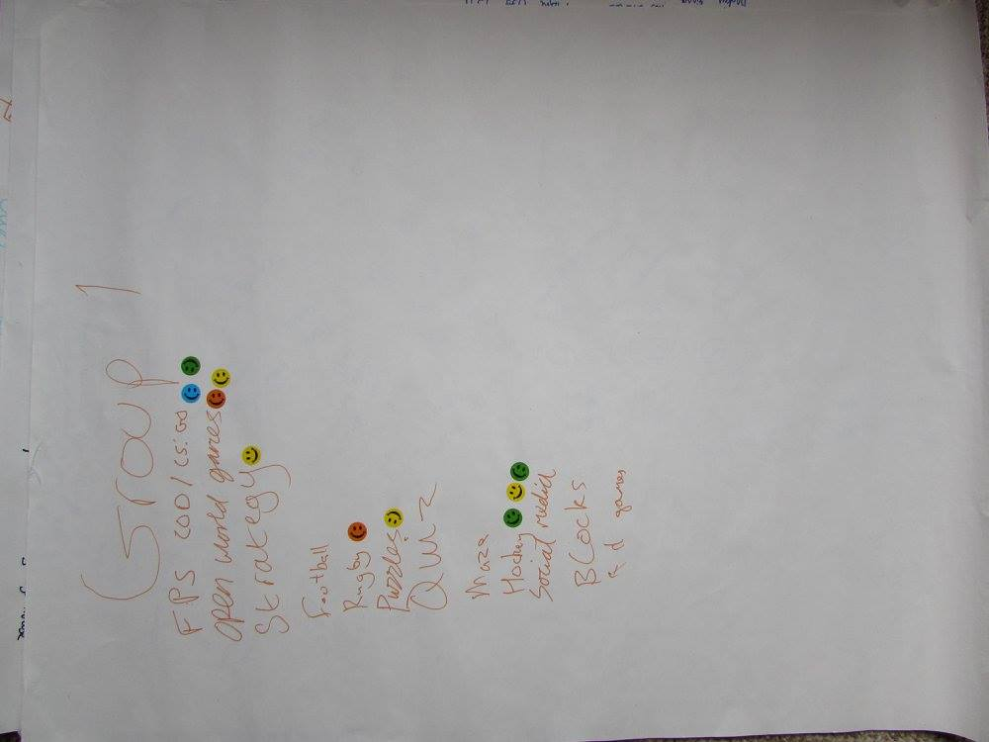

1. https://www.nesta.org.uk/sites/default/files/the_legacy_of_bbc_micro.pdf
2. http://www.ebuyer.com/blog/2015/07/can-the-bbcs-micro-bit-inspire-a-generation/
3. http://www.theguardian.com/media/interactive/2011/aug/26/eric-schmidt-mactaggart-lecture-full-text
4. http://www.bbc.co.uk/iplayer/episode/b03k6ypz/the-joy-of-logic
5. http://www.bbc.co.uk/programmes/p030s6b3