Group: |  |  | Date:
Year, Course & Blk.: |  |  | Total Score:

OBJECTIVE/S:
Create a clear, accurate diagram that explains the system being developed and demonstrates each member’s contribution.

INSTRUCTION:
Prepare a Data Flow Diagram (DFD) or System Flow Diagram showing the system’s major processes and connections. Use appropriate symbols and labels.

RUBRICS — GROUP OUTPUT (60 POINTS)
NOTE: The diagram must be on the page after the rubrics
 | 5 | 10 | 15 | 20 | Score
Accuracy and Logic of Flow | Major flow errors make the diagram difficult to follow. | Flow partly represents the system but has several errors. | Flow represents the system with minor errors. | Flow accurately and logically explains how the system works throughout.
Completeness of Processes | Most major processes and components are missing. | Some processes are shown, but important parts are missing. | Most required processes are included, with minor omissions. | All major processes and required components within the scope are included and connected.
Symbols, Labels, and Readability | Mostly incorrect symbols, missing labels, and confusing layout. | Several symbols or labels need correction; layout needs work. | Mostly correct symbols and labels; readable layout. | Correct symbols for the diagram type, clear labels, and an easy-to-follow layout.
GROUP TOTAL /60

RUBRICS — INDIVIDUAL CONTRIBUTION (40 POINTS)
NOTE: Only the group leader may grade members’ individual contributions. Members must not grade themselves or other members.
 | 0 | 5 | 10 | 15 | 20
Completion of Assigned Work | No verified work. | Completes very little assigned work. | Completes some assigned work with frequent assistance. | Completes most assigned work with occasional assistance. | Completes all agreed tasks on time; contribution is verified and clearly explained.
Participation in Checking and Revision | No verified participation. | Rarely joins checking or revision, even when prompted. | Joins checking or revision only with frequent prompting. | Regularly helps check the diagram and address corrections. | Actively checks connections and labels, suggests useful corrections, and helps finalize the diagram.
INDIVIDUAL TOTAL /40

SYSTEM DATA FLOW DIAGRAM
Notation: circles are processes, rectangles are external entities, open-ended rectangles are data stores, and arrows are data flows. (Yourdon / DeMarco notation)
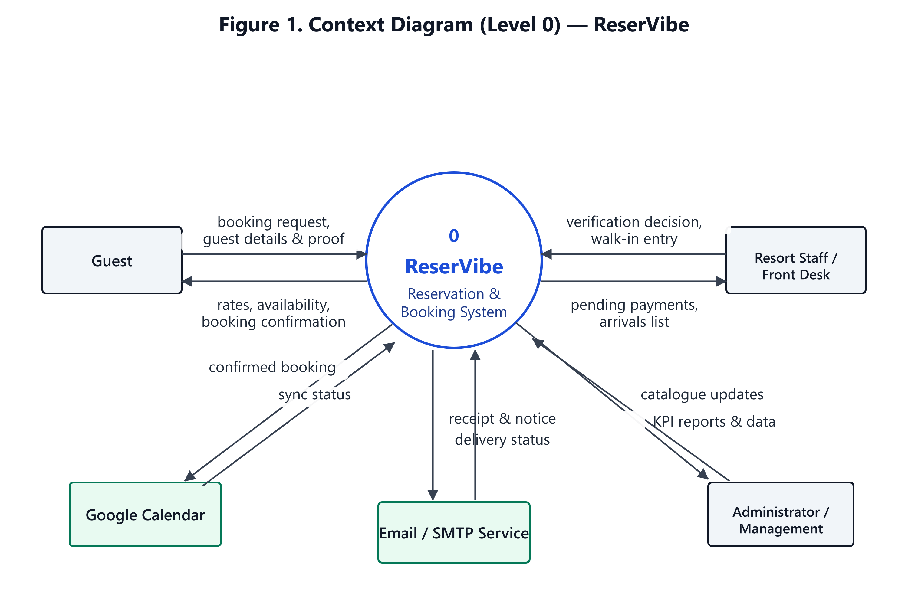

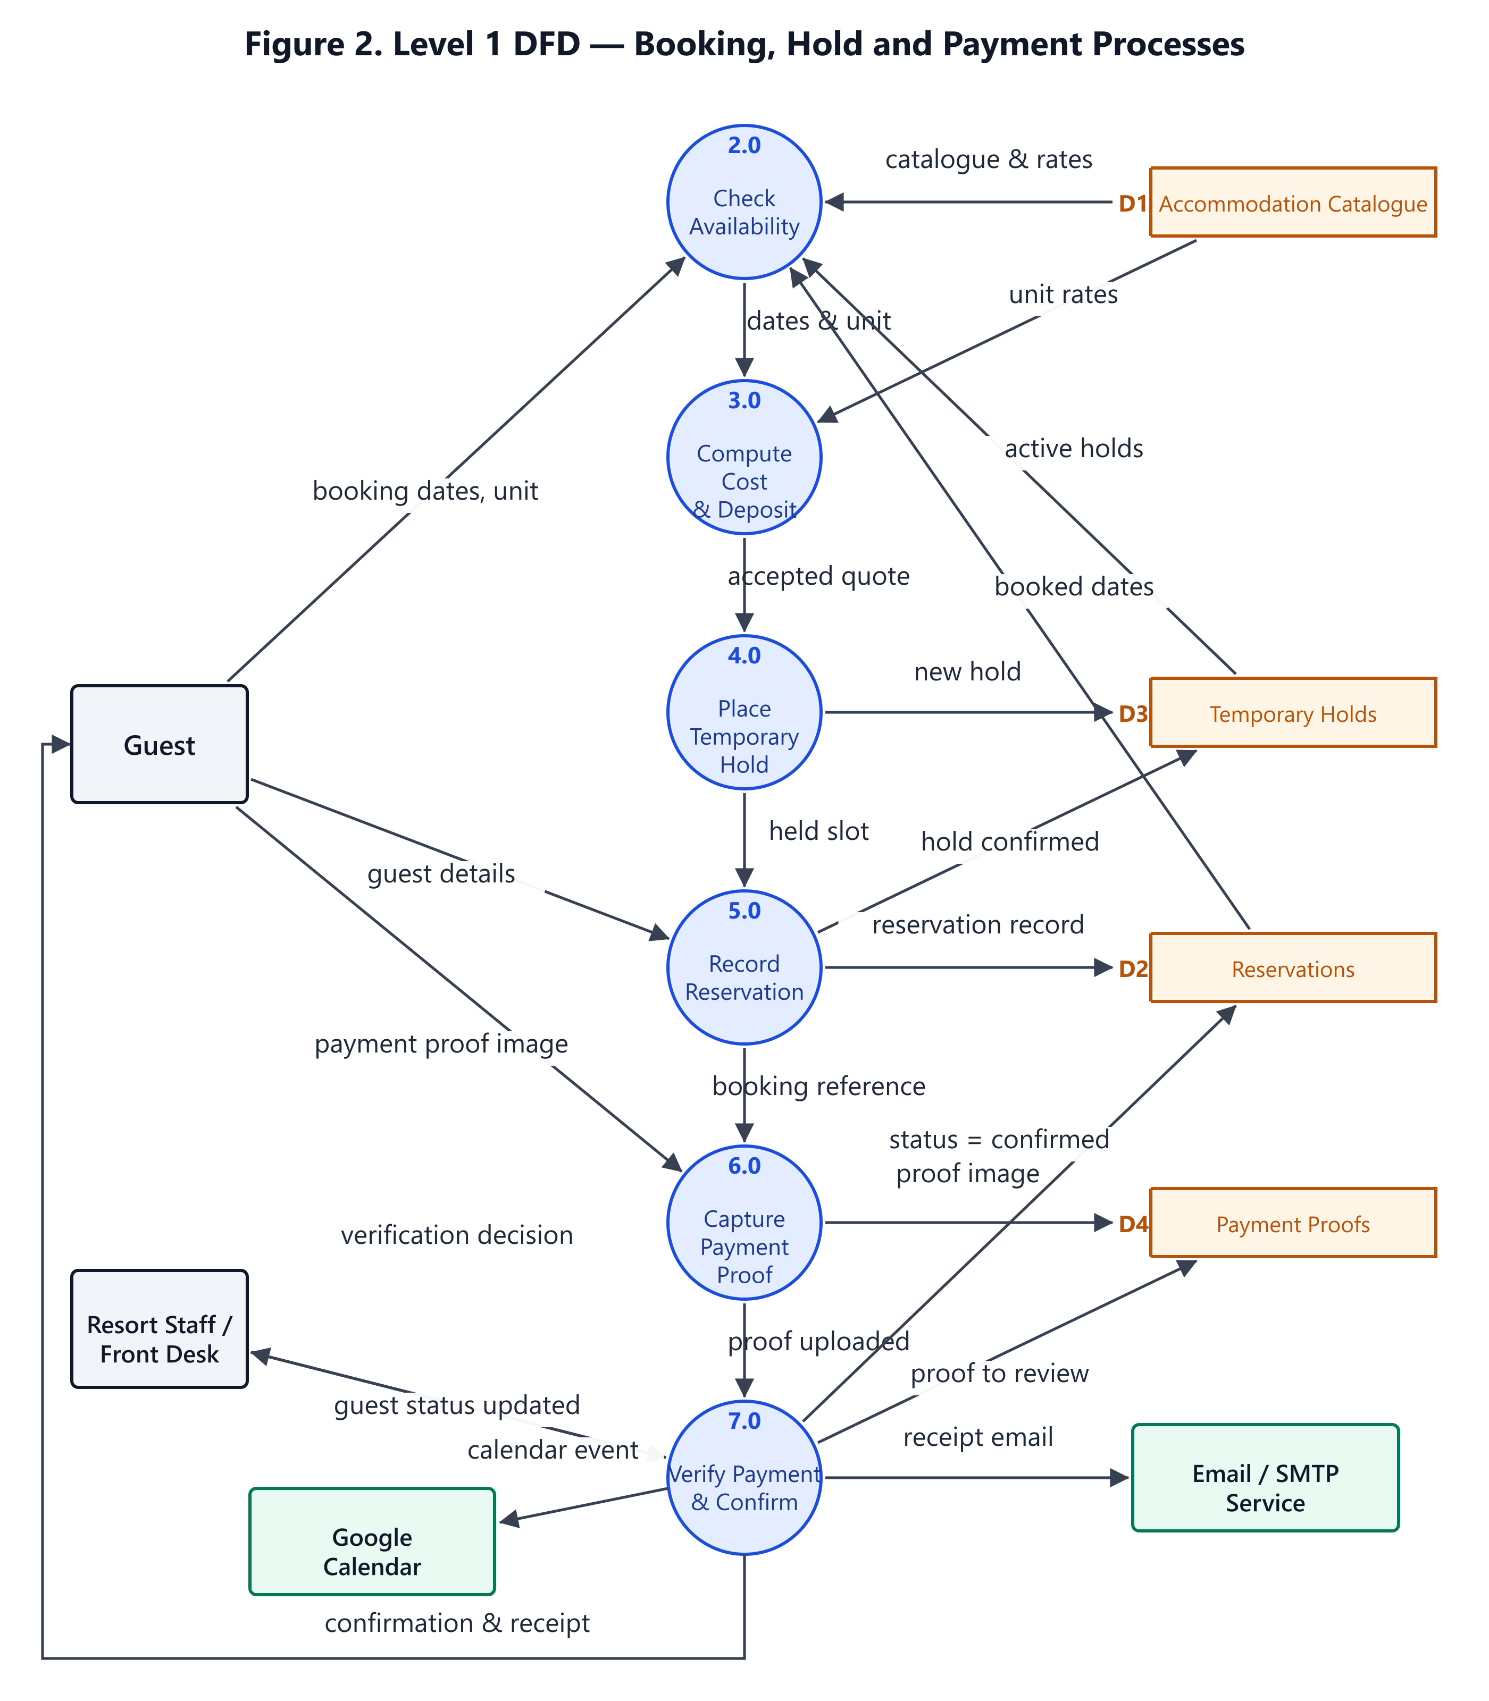

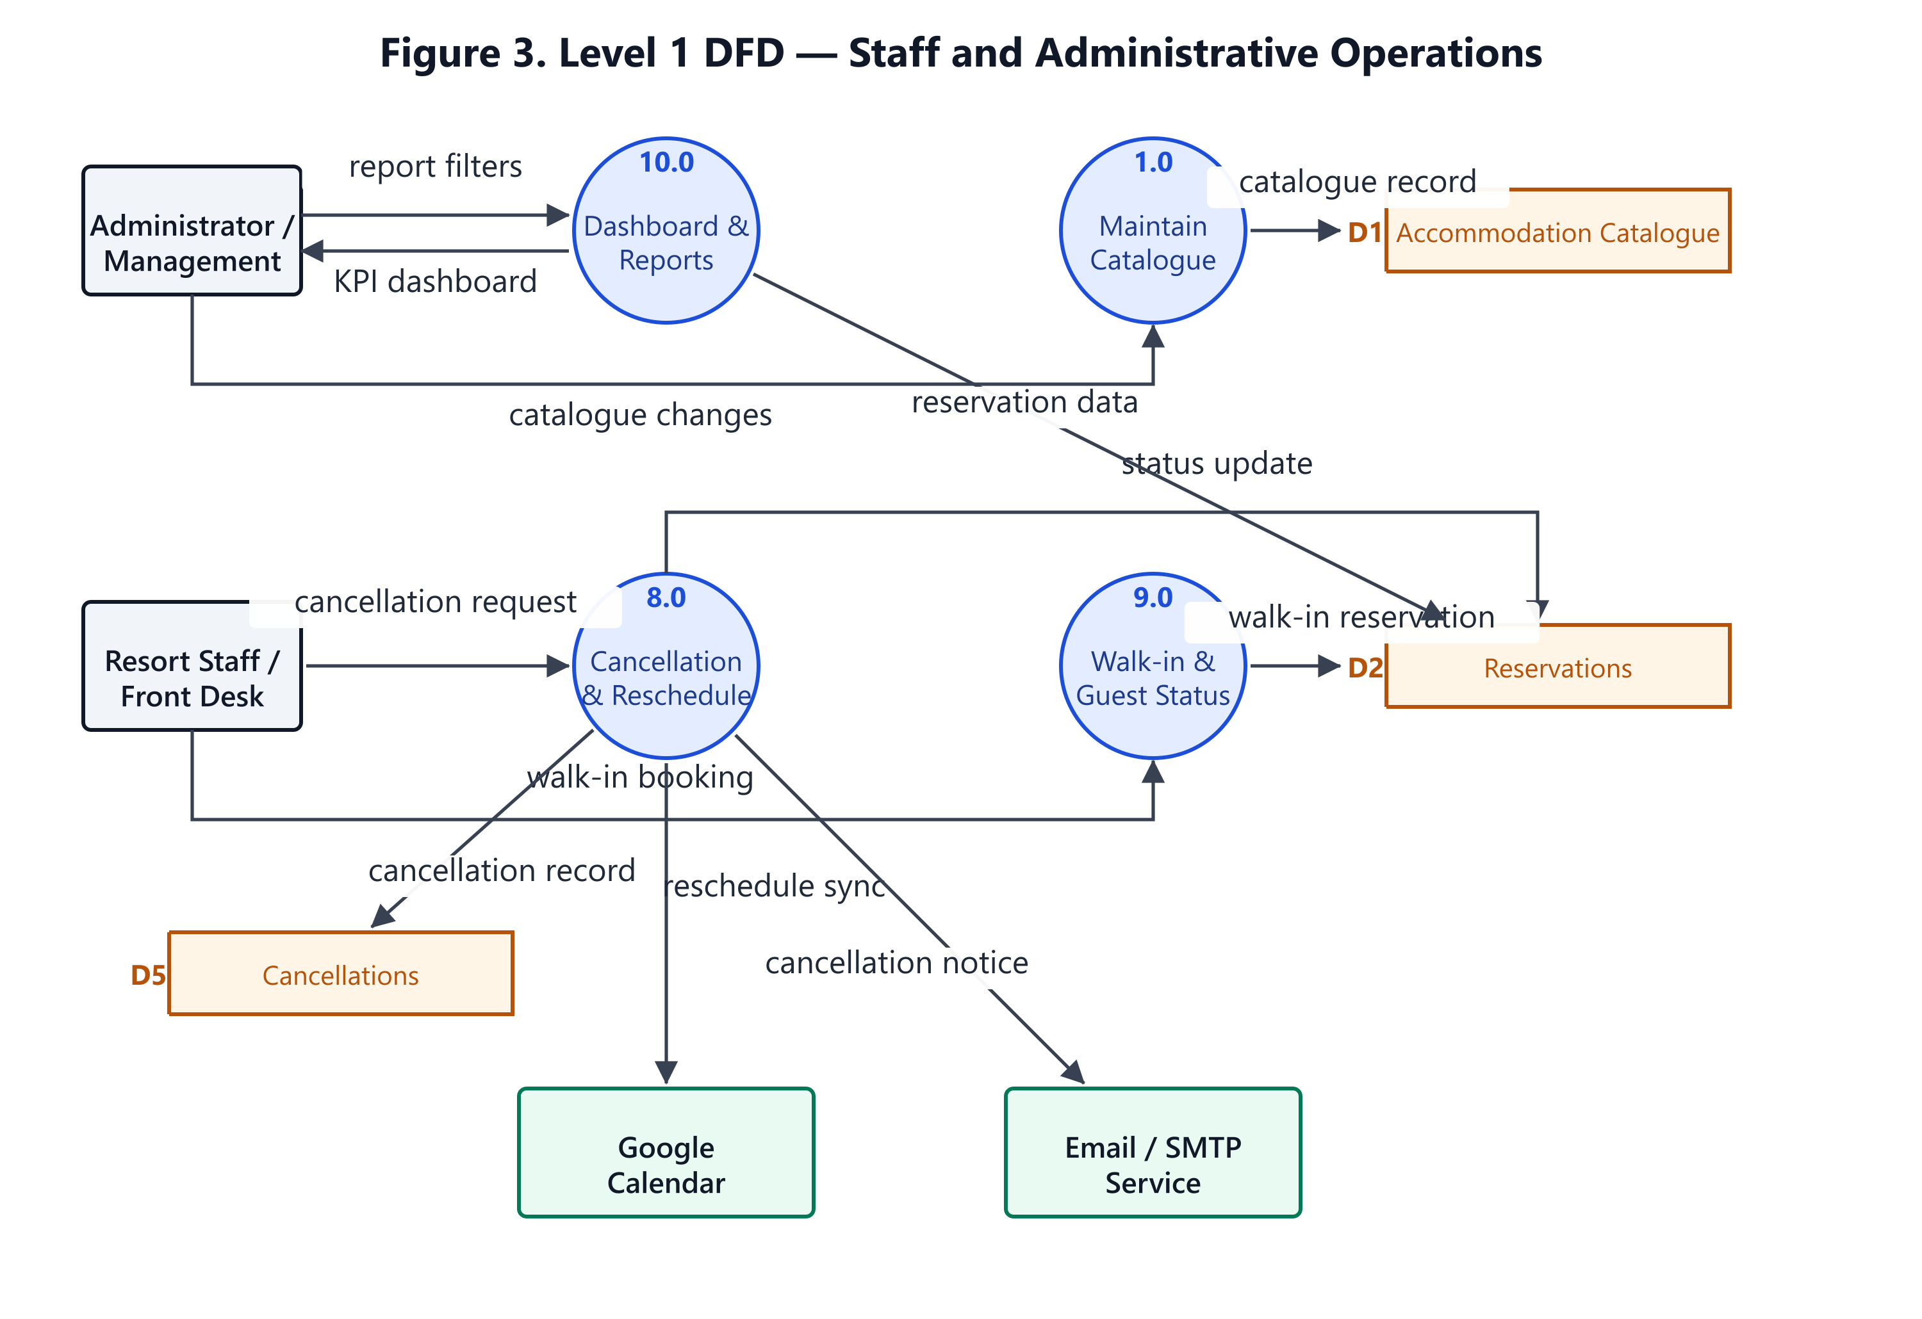

INDIVIDUAL GRADING RECORD

Member’s Name | Specific Contribution | Group /60 | Individual /40 | Total /100
(leader’s name)

Final score per member = Group score (60) + Individual contribution (40) = 100 points

RECEIVED BY:

MR. KYLEDITRI G. MORENO, MIT
INSTRUCTOR, SITE

