INCIDENT MANAGEMENT AND ROUTING APP AND WEB SYSTEM FOR WATER SERVICES USING NATURAL LANGUAGE PROCESSING (NLP)

A Capstone Project
Presented To The Faculty of
College of Computer Studies
Global Reciprocal Colleges
Caloocan City

In Partial Fulfillment of the Requirements
for the degree of Bachelor of Science in Information Technology

Prepared by:
Cabalse, John Lowie
Iray, Jojit Rhey D.
Labutap, Christine Zairah
Miguel, Pamela Joy D.
Susi, Jade Zyrhel

Eduardo S. Rodrigo
Capstone Adviser

October 2026
TABLE OF CONTENTS
PRELIMINARIES PAGE
TITLE PAGE
LIST OF TABLES
LIST OF FIGURES

CHAPTER 1 – INTRODUCTION
1.1 Project Context…………………………………………………………………..1
1.2 Objective of the Study…………………………………………………………...3
1.3 Scope and Delimitation …………………………………………………………4
1.4 Significance of the Study………………………………………………………..7
1.5 Definition of Terms……………………………………………………………...9
CHAPTER 2 – REVIEW OF RELATED LITERATURE AND STUDIES
2.1 Local Literature…………………………………………………………………13
2.2 Foreign Literature……………………………………………………………….17
2.3 Local Studies…………………………………………………………………….21
2.4 Foreign Studies………………………………………………………………….24
2.5 Synthesis of Reviewed Literature and Studies………………………………….28
CHAPTER 3 – METHODOLOGY OF THE STUDY
3.1 Research Method………………………………………………………………..31
3.2 Conceptual Framework…………………………………………………………35
3.3 Software and Hardware Requirements………………………………………….38
3.3.1 Software Requirements………………………………………………....38
3.3.2 Hardware Requirements………………………………………………...40
3.4 Context Diagram ………………………………………………………………..42
3.4.1 Existing System…………………………………………………………42
3.4.2 Proposed System………………………………………………………..44
3.5 Data Flow Diagram……………………………………………………………..46
3.5.1 Existing System……………………………………………………. 46
3.5.2 Proposed System…………………………………………………… 49
3.6 Activity Diagram………………………………………………………………. 63
3.7 Entity Relationship Diagram……………………………………………………95
3.8 Use Case Diagram………………………………………………………………99
3.9 Data Dictionary…………………………………………………………………101
3.10 Gantt Chart…………………………………………………………………….114
3.11 Roles and Responsibilities…………………………………………………….115
3.12 Evaluation Procedure………………………………………………………….117
3.13 Ethical Standards and Considerations…………………………………………121
CHAPTER 4 – RESULTS AND DISCUSSIONS
4.1 Development and Testing………………………………………………………124
4.1.1 Unit Testing…………………………………………………………….124
4.1.2 User Acceptance Testing……………………………………………….124
4.2 Evaluation Result……………………………………………………………….125
4.2.1 Data Interpretation……………………………………………………..126
CHAPTER 5 – SUMMARY, CONCLUSIONS AND RECOMMENDATIONS
5.1 Summary of Findings…………………………………………………………...131
5.2 Conclusions……………………………………………………………………..132
5.3 Recommendations………………………………………………………………134

LIST OF TABLES
Table 3.3.1: Software Requirements ………………………………………………….39
Table 3.3.2: Hardware Requirements …………………………………………………41
Table 3.9.1: Data Dictionary - tbl_users (User Accounts) ……………………………101
Table 3.9.2: Data Dictionary - tbl_incidents (Complaint Incidents) …………………103
Table 3.9.3: Data Dictionary - tbl_assignments (Incident Assignments) …………….105
Table 3.9.4: Data Dictionary - tbl_notifications (System Notifications) ……………...106
Table 3.9.5: Data Dictionary - tbl_availability (Staff Availability) …………………...108
Table 3.9.6: Data Dictionary - tbl_feedback (HITL Feedback) ……………………….109
Table 3.9.7: Data Dictionary - tbl_audit_logs (Audit Trail) …………………………..111
Table 3.9.8: Data Dictionary - tbl_incident_attachments (Photo Proof)………………112
Table 3.12.1: Project Evaluation Questionnaire……………………………………….118
Table 3.12.2: Likert Scale and Interpretation …………………………………………120
Table 4.1: Summary of Evaluation Results per Criterion …………………………….125
Table 4.2: Weighted Mean of Evaluation Results per Statement……………………...126

LIST OF FIGURES
Figure 1: Agile Methodology ………………………………………………………….31
Figure 2: Input-Process-Output (IPO) Model of the Proposed System………………..35
Figure 3: Context Diagram of The Existing System …………………………………..42
Figure 4: Context Diagram of The Proposed System …………………………………44
Figure 5: DFD Level 1 of The Existing System ……………………………………...46
Figure 6: DFD Level 1 of The Proposed System ……………………………………..49
Figure 7: DFD Level 2 User Management Process 1.0 of The Proposed System ……51
Figure 8: DFD Level 2 Complaint Processing (NLP and Sentiment) 2.0
of The Proposed System……………………………………………………………….53
Figure 9: DFD Level 2 AI-Driven Routing (to Offsite) 3.0 of The Proposed System…55
Figure 10: DFD Level 2 HITL Feedback and Adjudication 4.0
of The Proposed System ……………………………………………………………….57
Figure 11: DFD Level 2 Resolution Tracking 5.0 of The Proposed System ………….59
Figure 12: DFD Level 2 Report Analytics 6.0 of The Proposed System………………61
Figure 13: Activity Diagram for Customer – Account Creation ………………………63
Figure 14: Activity Diagram for Customer – Login …………………………………...64
Figure 15: Activity Diagram for Customer – File Complaint………………………….65
Figure 16: Activity Diagram for Customer – Track Complaint ………………….……66
Figure 17: Activity Diagram for Customer – View Notifications ……………………67
Figure 18: Activity Diagram for Customer – Manage Account ……………………...68
Figure 19: Activity Diagram for Customer - Logout …………………………………69
Figure 20: Activity Diagram for Offsite Staff – Login and Queue……………………70
Figure 21: Activity Diagram for Offsite Staff – Accept Assignment …………………71
Figure 22: Activity Diagram for Offsite Staff – Reject Assignment ….……………....72
Figure 23: Activity Diagram for Offsite Staff – Correct Category ……..…………….73
Figure 24: Activity Diagram for Offsite Staff – Update Status…………..…………...74
Figure 25: Activity Diagram for Offsite Staff – Resolve Complaint………………….75
Figure 26: Activity Diagram for Offsite Staff – Upload Photo Proof…………………76
Figure 27: Activity Diagram for Offsite Staff – Manage Availability………………...77
Figure 28: Activity Diagram for Engineer – Login……………………………………78
Figure 29: Activity Diagram for Engineer – View Complaint Modal…………………79
Figure 30: Activity Diagram for Engineer – Manual Route…………………………...80
Figure 31: Activity Diagram for Engineer – Update Status…………………………...81
Figure 32: Activity Diagram for Engineer – Resolve Complaint……………………...82
Figure 33: Activity Diagram for Engineer – Adjudicate………………………………83
Figure 34: Activity Diagram for Admin – Login Dashboard………………………….84
Figure 35: Activity Diagram for Admin – View Complaint…………………………..85
Figure 36: Activity Diagram for Admin – Manage Users…………………………….86
Figure 37: Activity Diagram for Admin – Manage Categories……………………….87
Figure 38: Activity Diagram for Admin – View Reports……………………………..88
Figure 39: Activity Diagram for Admin – Export…………………………………….89
Figure 40: Activity Diagram for Admin – Audit Logs………………………………..90
Figure 41: Activity Diagram for Admin – Settings…………………………………...91
Figure 42: Activity Diagram for Admin – Retrain AI………………………………...92
Figure 43: Activity Diagram of System – Auto Routing……………………………...93
Figure 44: Activity Diagram of System – NLP Process Complaint…………………..94
Figure 45 : Entity Relationship Diagram of the Proposed System …………………...95
Figure 46: Use Case Diagram of the Proposed System ………………………………99

CHAPTER 1
INTRODUCTION

Project Context
The management of customer complaints and service-related incidents is a critical function for water service providers. Efficient handling of these reports directly affects the quality-of-service delivery, customer satisfaction, and overall operational reliability. Delays, miscommunications, and inconsistent prioritization in complaint resolution have been widely observed to contribute to recurring service issues and growing customer dissatisfaction. Information gathered at the point of reporting is often incomplete or misdirected, resulting in prolonged resolution times and increased operational burden for service staff.
Traditional methods of complaint submission such as phone calls, emails, and in-person visits lack the structure needed for rapid classification and routing. Incidents involving billing disputes, water quality concerns, metering issues, and operational breakdowns require immediate classification and assignment to the appropriate personnel. Without a centralized system, reports may be overlooked or handled inconsistently. Li et al. (2022) highlighted that the absence of a unified platform for swift data retrieval compounds these inefficiencies, complicating the delivery of timely and targeted interventions. Similarly, Honavar (2020) noted that the lack of integrated systems in service environments increases the risk of errors and incomplete information during critical assessment phases
The applicability of digital solutions in addressing these systemic gaps has been well- documented. Recent studies highlight the potential of Natural Language Processing (NLP) in transforming incident management. Faheem et al. (2025) emphasized that NLP can significantly reduce delays and improve classification accuracy in IT incident management, minimizing downtime and ensuring continuity of operations. Ricketts et al. (2023) further demonstrated that NLP applied to occurrence reports enhances the detection and categorization of incidents, improving organizational response. Walsh et al. (2023) showed that scalable incident detection using probabilistic language models can strengthen surveillance systems by identifying critical events more effectively.
To better understand the operational gaps in existing complaint management practices, the research team engaged with water service personnel through interviews and process observation. These discussions revealed critical shortcomings: the absence of a structured complaint classification mechanism, the lack of real-time status tracking for customers, and the absence of a centralized platform that integrates classification, routing, and resolution monitoring. Staff frequently relied on manual sorting and verbal coordination, which introduced delays and inconsistencies in handling reported incidents. Additionally, the lack of a formalized scheduling and availability management process for field repair personnel made it difficult to assign the right staff to the right complaints in a timely manner.
The proposed Incident Management and Routing App and Web System for Water Services using Natural Language Processing addresses these pressing gaps. By leveraging NLP for automated complaint classification, sentiment analysis for severity assessment, and AI- driven routing for personnel assignment, the system aims to modernize water service incident management. The system operates across four defined user roles: the
Customer, who submits complaints through the mobile application; the Engineer, who monitors system outputs and the availability of Offsite Staff, and assigns repair personnel to the appropriate Team Leader; the Offsite Staff, who are the field repair personnel responsible for resolving incidents on-site; and the Administrator, who manages user accounts, system settings, incident oversight, and overall operations. This innovation is designed to improve response times, reduce miscommunication, and provide all stakeholders with a transparent and efficient complaint resolution experience.
1.2 Objective of the Study
General Objective:
The general objective of this study is to design and develop an Incident Management and Routing App and Web System for water services that automates the classification, severity assessment, and routing of customer complaints using Natural Language Processing (NLP), while providing structured tools for Engineering personnel to monitor Offsite Staff availability and adjudicate field assignment decisions.
Specific Objectives:
Specifically, the study aims to:
- Develop a Natural Language Processing (NLP) text classification model that categorizes customer complaints into predefined incident types.
- Develop an automated routing module that utilizes NLP to classify complaints and assign them directly to the appropriate Team Leader based on incident category and departmental alignment. Implement a Human-in-the-Loop (HITL) feedback mechanism allowing Team Leaders to accept, reject, or correct the assignment. Rejected or corrected incidents trigger an engineer notification for final review, and all corrective decisions are logged as feedback data to support future retraining of the NLP classification model.
- Create a centralized database system with Role-Based Access Control (RBAC) for Customers, Engineers, Offsite Staff, and Administrators to efficiently manage track, and
monitor incident resolution.
- Implement a sentiment analysis model that evaluates complaint text and assigns corresponding severity levels (High, Medium, Low).
1.3 Scope and Delimitations of the Study
Scope
The proposed system consists of a mobile application for Customers and Offsite Staff and a web-based platform for Engineers and Administrators. Access to system features is governed by Role-Based Access Control (RBAC), ensuring that each user can only perform functions relevant to their designated role.
Administrator – System Manager (Web Portal)
- Login: Authenticates through the web portal with the highest access privileges.
- User Management: Can create, update, and deactivate accounts; assigns roles (Customer, Engineer, Offsite Staff) via RBAC.
- System Configuration: Views the predefined incident categories and their department mappings used by the AI routing module.
- Performance Monitoring: Accesses system-wide dashboards showing resolution rates, incident trends, and personnel efficiency.
- Report Generation: Generates dashboard summaries covering Incident Frequency by Category, Average Resolution Time per Department, Misclassification Trends (from HITL feedback), and Staff Availability status, with a downloadable CSV export of the complaint list. These reports support decision-making on resource allocation and process improvement.
Customer (Mobile App)
- Registration & Login: Can self-register and authenticate using email and password.
- Complaint Submission: Can lodge new complaints with text descriptions.
- Status Tracking: Can view the real-time status of submitted complaints (Open, Assigned, In Progress, Resolved).
- Notifications: Receives push notifications whenever the status of a submitted complaint is updated.
- Dashboard/Profile: Can view personal report history and profile information.
Engineer – Monitoring and Oversight Personnel (Web Portal)
- Login: Authenticates through the web portal using credentials created by the Administrator.
- Incident Oversight: Monitors the automated routing process. Receives notifications when a Team Leader rejects or corrects an NLP-assigned incident. Reviews the flagged incident and provides final adjudication (approve correction, override, or reassign).
- Feedback Logging: The Engineer's final decision is automatically logged as training feedback for future NLP model improvement.
- Personnel Availability Monitoring: Views the availability updates submitted by Offsite Staff.
- Performance Monitoring: Accesses dashboards showing resolution rates, misclassification trends, and department resolution performance.
- Report Analytics: Views performance reports, flagged incident trends, misclassification records, and resolution monitoring summaries.
Offsite Staff – Repair Personnel (Mobile App)
- Login: Authenticates through the mobile application using assigned credentials.
- Availability Management: Submits and updates availability status to the Engineers for scheduling purposes.
- Assigned Incidents: Can view details of incidents routed and assigned to them by the system and Engineers.
- Resolution Module: Can update ticket statuses (In Progress, Resolved), upload resolution notes, and attach images as proof of completion.
- Team Leader: Can manage the ticket by accepting, correcting, and rejecting the Assignment
AI Features
- Sentiment Analysis for Severity Assessment: Evaluates the emotional tone of complaint text to assign severity levels (High, Medium, or Low), ensuring urgent cases receive prioritized attention.
- AI-Driven Complaint Routing: Automatically assigns classified incidents to the appropriate Team Leader based on configured routing rules.
- NLP-Based Incident Classification: Automatically categorizes submitted complaints into predefined incident types using a trained Natural Language Processing model. The model supports both English and Filipino/Tag-lish text inputs, using a synthetic dataset that includes common code-switched complaint phrases observed during data gathering.

Delimitations
The system will be developed as a web and mobile-based application and will not cover advanced multilingual support due to resource and timeline constraints, with complaint text processing limited to the English,Tagalog and Taglish language only. The scheduling module is limited to availability status updates submitted by Offsite Staff to Engineers and does not include automated workforce optimization or predictive scheduling functionality. The study is further limited to the design, development, and evaluation of the proposed system based on predefined functional requirements.
1.4 Significance of the Study
Administrators (System Managers)
The system equips Administrators with real-time performance dashboards and reporting tools that enable data-driven decision-making. By monitoring resolution rates, identifying recurring issues, and reviewing personnel performance, Administrators can implement targeted improvements and ensure greater accountability across all levels of service delivery.
Customers (Complainants)
The proposed system provides customers with a faster, more accessible, and transparent channel for submitting water service complaints. Through automated classification and real-time status tracking, customers are informed of their complaint's progress at every stage and can expect more consistent and timely resolutions. This enhancement fosters trust in the service provider and promotes a more positive customer experience.

Engineers (Monitoring and Scheduling Personnel)
The system empowers Engineers with a centralized monitoring platform that consolidates all incident data in one location, significantly reducing the effort required to oversee complaint resolution. By providing visibility into off-site staff availability through structured update submissions, Engineers can make more informed scheduling and assignment decisions, improving the efficiency and accuracy of field deployment.
Future Researchers
This study contributes to the growing body of knowledge on the application of Natural Language Processing in public utility service management. It provides a practical framework that future researchers may build upon, adapt, or expand to other service sectors, and offers a reference point for exploring AI-driven solutions in complaint management, incident response, and field workforce scheduling.

Offsite Staff (Repair Personnel)
Offsite Staff benefit from a structured, digital assignment process that eliminates ambiguous or informal work instructions. By submitting their availability directly through the system, field personnel are more likely to be assigned tasks that align with their current workload and capacity. The resolution module further supports their work by providing a standardized interface for updating ticket statuses and documenting completed complaints.
1.5 Definition of Terms
Complaint Routing
The process of directing a complaint to the responsible party for resolution. In this study, it refers to the automatic assignment of a classified customer complaint directly to the Team Leader of the appropriate department based on the incident type determined by the NLP classification model. The Team Leader may accept, reject, or correct the assignment. Rejected or corrected incidents are escalated to the Engineer for final review, and the Engineer's decision is logged as feedback data to support continuous improvement of the NLP model.
Incident Classification
The process of organizing complaints into defined categories. In this study, it refers to the automatic categorization of submitted customer complaints into predefined types such as Billing, Water Quality, Metering, and Operations, performed by the trained NLP model upon complaint submission.

Incident Management
The systematic handling of service-related complaints from submission to resolution. In this study, it refers to the end-to-end process handled by the system, covering the submission, classification, routing, tracking, and resolution of water service complaints through the mobile application and web portal.
Mobile Application
A software application designed to run on smartphones and mobile devices. In this study, it serves as the customer-facing interface through which users submit complaints, provide incident details such as text descriptions, location, and attachments, and monitor the status of their reported incidents.
Natural Language Processing (NLP)
A branch of Artificial Intelligence that enables computers to understand and interpret human language in written form. In this study, it is used to automatically analyze and classify the text of submitted customer complaints into predefined incident categories and to evaluate the emotional tone of complaint text for severity assessment.
Role-Based Access Control (RBAC)
A security approach that regulates system access based on the roles assigned to users. In this study, it is used to restrict and manage system access based on user roles Customer, Engineer, Offsite Staff, and Administrator, ensuring that each user can only access and perform functions relevant to their designated role.

Sentiment Analysis
A technique that uses NLP to identify the emotional tone expressed in text. In this study, it is used to evaluate the emotional tone and urgency of complaint text submitted by customers, which is then combined with sentiment polarity, days pending, and urgency keywords to determine the severity level of each complaint.
Web-Based Application
A software platform accessed through a web browser without requiring local installation. In this study, it serves as the platform for Engineers, Offsite Staff, and Administrators, through which complaints are monitored, staff availability is managed, field assignments are issued and updated, and system settings are configured.

CHAPTER II
REVIEW OF RELATED LITERATURE AND STUDIES
Introduction
This chapter presents a comprehensive review of existing literature and studies that serve as the theoretical and empirical foundation for the development of an Incident Management and Routing App and Web System for Water Services using Natural Language Processing (NLP). The review is organized into two major parts: related literature and related studies, each further subdivided into foreign and local sources.
The foreign and local literature covers the core concepts underpinning the proposed system, including Natural Language Processing, automated complaint classification, sentiment analysis for severity assessment, AI-driven complaint routing, incident management systems, and Role-Based Access Control (RBAC). Each literature entry identifies a key author, the year of publication, and the contribution of the work to the theoretical basis of the proposed system.
The related studies section reviews published research with findings directly relevant to the system's key components. Each study is presented with its year, focus, methodology, and findings, to clearly establish how it informs the design and development of the proposed system. The chapter concludes with a synthesis of the reviewed materials, a conceptual framework guided by the Input-Process-Output (IPO) model, and a chapter summary.

2.1 Local Literature
The Philippines has increasingly prioritized the digitalization of public service delivery, including complaint management systems in utility and local government environments. The following local literature situates the proposed system within the Philippine service delivery context, affirming both the demand and feasibility of digital platforms for
incident management in water service settings.
According to Laudon and Laudon (2020), in their textbook entitled “Management Information Systems: Managing the Digital Firm,” well-designed information systems transform raw operational data into structured, actionable information that enables organizations to improve efficiency, reduce errors, and support decision-making. Centralized database management is a foundational component of such systems, providing a single authoritative repository for all data related to a given operational process. In complaint management, a centralized database enables historical tracking, performance monitoring, and report generation across the full resolution lifecycle.
According to Honavar (2020), in a work entitled “Digital Platforms for Incident Management: Reducing Errors and Accelerating Resolution in Service Environments,” the lack of integrated systems in service environments increases the risk of errors and incomplete information during critical assessment and response phases. Structuring incident management through digital platforms with defined workflows significantly reduces the risk of oversight and accelerates resolution timelines. This observation is particularly relevant to water utility complaint handling in the Philippines, where manual processes and fragmented record-keeping remain prevalent in many service areas.
A study on Barangay-level complaint management systems (2022), entitled “Development of a Mobile-Integrated Complaint Management System for Barangay Public Services,” found that integrating a mobile application with a centralized web platform enables faster and more accessible complaint filing for residents while reducing face-to-face transactions and administrative burden. The system’s complaint module demonstrated
that mobile-assisted submission combined with real-time status updates significantly improves resolution efficiency and user satisfaction, validating the structural approach of dual-platform service systems in the Philippine public service context.
The Mamamayan mobile emergency reporting system (2023), entitled “Mamamayan: An Android-Based Emergency Incident Reporting System for Makati City,” developed for the City of Makati, demonstrated that Android-based platforms can effectively support real-time incident submission and notification delivery in a Philippine local government setting. The system affirmed the viability of mobile-integrated reporting tools for improving community-government service interactions and established a practical model for mobile application design serving multiple user roles in public service environments throughout the Philippines.
The Commission on Higher Education (CHED) has advocated for the adoption of digital monitoring and management tools in institutions to improve data accuracy and operational efficiency. For water service utilities operating under national service delivery mandates, the shift toward digitized incident management is both technically feasible and institutionally supported within the Philippine regulatory landscape, reinforcing the appropriateness of the proposed system’s design approach.
Research conducted in Philippine academic and government institutions has consistently demonstrated that transitioning from paper-based to database-backed systems improves data retrieval speed, reduces duplication, and enhances reporting accuracy. These findings provide a strong local precedent for centralized incident databases designed to support real-time status monitoring and historical tracking across all stages of the complaint resolution lifecycle in utility service environments.
According to Dzreke (2025), in a study entitled “Proactive Service Recovery Through AI-Driven Sentiment Analysis of Customer Interactions,” AI-driven sentiment analysis can detect pre-complaint dissatisfaction signals from customer interactions, enabling proactive service recovery. The study found that organizations that act on these signals experience significantly higher customer retention compared to reactive approaches, supporting the integration of sentiment scoring as a contributing factor in complaint severity assessment within water service incident management platforms.
According to Faheem et al. (2025), in a study entitled “Natural Language Processing for IT Incident Classification: Reducing Delays and Improving Routing Accuracy,” NLP applied to IT incident management substantially reduces classification delays and improves routing accuracy, resulting in minimized downtime and more consistent service continuity. The study underscored the practical value of language-based classification models in environments where service disruptions directly affect end users, a principle that translates directly to water utility complaint management in the Philippine operational context.
According to Akuthota (2025), in a work entitled “Role-Based Access Control in Cloud-Integrated Systems: Security, Compliance, and Administrative Efficiency,” RBAC in cloud-integrated systems reduces security incidents, streamlines administrative processes, and ensures regulatory compliance. The study affirmed that granular role-based permissions are particularly valuable in systems where multiple user tiers such as customers, service staff, engineers, and administrators require differentiated access to sensitive operational data, directly informing the design of secure multi-role service management platforms intended for deployment in Philippine water utility environments.
According to Mpamugo and Ansa (2024), in a study entitled “Implementing Role-Based Permission Systems in Android Mobile Applications for Multi-Role Service Environments,” role-based permission systems effectively govern authentication and authorization at a granular level in Android mobile applications, ensuring that access privileges are granted according to hierarchical role structures. Their findings affirm that implementing RBAC within mobile-integrated service platforms is both technically feasible and security-effective, particularly in multi-role environments serving diverse user categories such as those found in Philippine water utility service operations.
2.2 Foreign Literature
Natural Language Processing (NLP) is a branch of Artificial Intelligence (AI) that enables computers to understand, interpret, and generate human language in written or spoken form. Effective incident management in utility services increasingly relies on intelligent systems capable of processing large volumes of unstructured complaint texts submitted by customers. The proposed system is anchored on NLP technologies to automate complaint classification, severity assessment, and routing within a water service operational context.
According to Hirschberg and Manning (2020), in their work entitled “Advances in Natural Language Processing,” modern NLP models trained on large corpora have demonstrated human-level performance on a range of language understanding benchmarks, enabling their deployment in high-stakes operational environments such as customer service management, healthcare, and public utilities. The ability to automatically process complaint text without requiring structured inputs makes NLP particularly suited for customer-facing service systems where unstructured free-text is the primary communication medium.
According to Kuiler (2022), in a work entitled “From Data to Wisdom: Natural Language Processing in the Age of AI,” NLP encompasses a range of computational techniques including tokenization, part-of-speech tagging, named entity recognition, intent classification, and semantic parsing that collectively allow machines to extract structured meaning from unstructured textual data. These capabilities form the technological foundation for complaint classification and severity assessment modules in AI-driven service management systems.
According to Sun, Qiu, Xu, and Huang (2020), in a study entitled “How to Fine-Tune BERT for Text Classification?” fine-tuned pre-trained language models such as BERT
achieve state-of-the-art performance across diverse text classification tasks by leveraging large-scale pretraining to capture deep contextual language representations. Their study demonstrated that domain-adaptive fine-tuning significantly improves classification accuracy in specialized environments, providing a strong technical basis for training NLP classifiers on domain-specific complaint datasets organized around predefined incident categories such as Billing, Water Quality, Metering, and Operations.
According to Li et al. (2022), in a work entitled “Centralized AI-Assisted Classification for Heterogeneous Customer Complaint Management,” the absence of a unified platform capable of rapid data retrieval and complaint classification compounds service inefficiencies, complicating the delivery of timely and targeted interventions. The authors argued that centralized, AI-assisted classification systems are essential for organizations handling large volumes of heterogeneous customer complaints, as they enable more responsive and consistent service resolution outcomes.
According to Tian et al. (2022), in a study entitled “Automated Customer Complaint Processing for Water Utilities Based on Natural Language Processing,” an NLP pipeline applied to real-world complaint data from a Dutch water utility demonstrated that preprocessing techniques combined with supervised classification models can accurately categorize water service complaints into actionable classes such as meter replacement requests, water quality concerns, and service appointments. The study’s use of dependency parsing and semantic component extraction to improve classification fidelity provides a directly applicable technical framework for complaint classification modules in water utility systems.
According to Bordoloi and Biswas (2023), in a study entitled “Sentiment Analysis: A Survey of Methods and Applications,” a systematic survey of sentiment analysis design frameworks found that supervised machine learning approaches consistently outperform rule-based lexicon methods in handling domain-specific language and nuanced expressions of frustration or urgency. Their survey concluded that the selection of sentiment-bearing words, dataset quality, and classification methodology significantly influence model performance in complaint management contexts, affirming the value of supervised approaches for severity assessment.
According to Taherdoost and Madanchian (2023), in a work entitled “Artificial Intelligence and Sentiment Analysis: A Review in Competitive Research,” AI-powered sentiment models accurately distinguish emotional tone beyond simple keyword matching and have become focal tools in decision support systems. The authors emphasized that sentiment analysis is particularly effective in identifying urgency signals within customer feedback. When combined with contextual factors such as the number of days a complaint has been pending and the presence of urgency keywords, sentiment scores can be used to assign meaningful severity levels such as High, Medium, or Low to submitted incidents.
According to Iyer (2024), in a study entitled “AI-Powered Service Desk Automation: Machine Learning and NLP in IT Operations,” modern service desk platforms leverage machine learning, NLP, and predictive analytics to automate ticket classification, prioritization, routing, and resolution. The study found that integrating AI into service desks substantially optimizes workflow efficiency, improves routing accuracy, and reduces operational costs by eliminating the need for manual triage, supporting the case for AI-driven automation in water service complaint management.
According to Koka (2024), in a work entitled “Intelligent Ticketing Systems: AI-Enhanced Routing and Agent Assignment in Customer Support,” AI-enhanced ticketing systems take over the role of human assigners by analyzing sentiment and complaint content to route tickets to the most appropriate agent based on availability and expertise.
This automation frees human agents to focus on complex and nuanced issues, enhancing overall service quality and customer satisfaction. In the context of water service operations, this principle supports the automatic assignment of classified incidents to the appropriate department or personnel based on configured routing rules.
According to Singh, Rani, and Kumar (2024), in a study entitled “Role-Based Access Control: Scalability, Security, and Performance in Large-Scale Information Systems,” Role-Based Access Control (RBAC) mitigates unauthorized access risks and safeguards sensitive data during transmission and storage by implementing granular access control mechanisms based on predefined hierarchical roles. Their study demonstrated that RBAC remains scalable and efficient for large user bases, with measurable improvements in system security and performance, making it directly applicable to multi-tier user models comprising roles such as Customer, Customer Service Staff, Engineer or Responder, and
2.3 Local Studies
The following local studies provide empirical precedents for digital complaint management platforms, mobile application development, and role-based service systems in the Philippine context, affirming the demand and feasibility of the proposed system within the local utility service environment.
According to researchers at Cagayan Valley Computer and Information Technology College (2022), a study entitled “Barangay E-Complaint and Management System for Santiago City” proposed an online complaint filing system allowing residents to submit complaints digitally to reduce paperwork and improve administrative efficiency for barangay officials. Using MySQL for database management, Django for the backend, and Bootstrap for the frontend, the system demonstrated that digitizing complaint submission reduces manual workload and improves record accessibility, establishing a relevant local precedent for interface and database design in complaint management platforms.
According to Jenifa et al. (2023), a study entitled “Development of an Android-Based Municipal Complaint Management Application with Role-Based Access and Administrator Functions” developed an Android application allowing residents to file service-related complaints through a mobile interface with login authentication, administrator and manager roles, and a structured complaint submission interface. The study found that digitizing complaint submissions significantly reduced repeat complaints and improved administrative response times. Its mobile-first approach and role-based structure directly inform the development of multi-role user models in mobile-integrated complaint management platforms.
According to Aglibar, Alegre, del Mundo, Duro, and Rodelas (2022), a study entitled “Ticketing Systems for Project Management and Issue Tracking in Philippine IT Companies: A Descriptive Analysis” found that structured ticketing systems improve issue resolution efficiency and reduce the risk of overlooked requests. The study’s findings affirm the organizational value of structured complaint tracking and departmental routing as core functional components in any service management platform, including those designed for water utility environments.
According to the developers of the Mamamayan mobile emergency reporting system (2023), in a study entitled “Mamamayan: Android-Based Incident Reporting with
Role-Based Access for Makati City Local Government,” Android applications integrated with real-time notification systems can effectively support incident reporting and role-based communication in a Philippine local government context. The system featured role-based access for government officials and community members, and validated the usability and acceptance of mobile-based reporting platforms among Filipino users, providing a direct local precedent for mobile-integrated service reporting systems.
Research on digital service systems implemented in Philippine local government units (2022) has demonstrated that web-based complaint submission platforms significantly reduce face-to-face administrative transactions and improve the accessibility of public services for residents in both urban and peri-urban areas. These findings affirm the practical value of web portal components in dual-platform service systems designed to serve geographically diverse user populations within the Philippine service delivery landscape.
Studies on mobile application adoption in Philippine public service settings have consistently demonstrated that Android-based platforms are effective vehicles for reaching community members who may not have access to desktop computing environments. Given the widespread availability of smartphones in the Philippines, mobile-first complaint submission is a practical and inclusive design choice for water utility service management systems intended to serve a broad and varied customer base across urban and rural service areas.
Philippine studies on information system implementation in local government and utility organizations have identified that role-based access and departmental routing are
key organizational requirements for multi-stakeholder platforms. Systems that fail to differentiate access permissions across user tiers frequently experience accountability gaps and data integrity issues, reinforcing the necessity of RBAC in service management environments with multiple functional user categories such as customers, front-office staff, field engineers, and system administrators.
Studies on digital transformation in Philippine water districts have highlighted persistent operational challenges including manual complaint logging, unstructured record-keeping, and the absence of real-time tracking mechanisms. These deficiencies have been identified as primary drivers of delayed service response and customer dissatisfaction, directly motivating the development of automated complaint management solutions specifically tailored to the operational context of water utility service providers in the Philippines.
Research on user acceptance of digital service platforms among Filipino consumers has found that real-time status updates and transparent complaint tracking are among the most valued features of service management applications. These findings affirm the importance of status notification mechanisms and accessible incident tracking interfaces as core functional requirements for service management systems deployed in the Philippine water utility sector, where customer trust and service transparency are key performance indicators.
Studies on centralized database-backed systems in Philippine institutions have consistently shown that transitioning from manual record-keeping to structured digital repositories improves data retrieval speed, reduces duplication, and enhances reporting
accuracy. These findings provide a strong local precedent for centralized incident databases designed to support real-time status monitoring, historical tracking, and report generation across all stages of the complaint resolution lifecycle in water service management systems.
2.4 Foreign Studies
the following foreign studies present empirical findings on NLP-based complaint classification, sentiment analysis, AI-driven routing, and incident management systems that are directly relevant to the development of the proposed water service incident management and routing system.
According to Tian et al. (2022), a study entitled “Automated Customer Complaint Processing for Water Utilities Based on Natural Language Processing” was conducted in the context of a Dutch water utility. The study developed an NLP pipeline that parsed complaint texts and extracted intents and sentiments to categorize complaints into actionable classes. Using deep recurrent and convolutional neural networks, the model demonstrated the feasibility of automated complaint processing in a real-world water utility setting, reducing the workload of complaint-handling staff and improving classification consistency. This study is the most directly relevant foreign precedent, confirming the viability and effectiveness of NLP for water service complaint classification.
According to researchers at the 2022 International Conference on Digital Futures and Transformative Technologies, a study entitled “NLP-Based Multi-Category Complaint Classification Using Machine Learning Algorithms” developed and evaluated an NLP-based model for complaint classification across multiple predefined categories. The model applied lemmatization, TF-IDF vectorization, and algorithms including Multinomial Naive Bayes, Support Vector Machines, and Random Forest to classify complaints from two datasets. Support Vector Machines showed stronger performance on multi-class complaint datasets, providing a validated algorithmic basis for classification systems organized around predefined incident categories such as those used in the proposed system.
According to Wahba, Madhavji, and Steinbacher (2022), a study entitled “Automatic Classification of IT Support Tickets Using Hybrid Online-Offline Models” developed the Hybrid Online Offline Model (HOOM) by merging Hierarchical SVM with Passive Aggressive Classifiers to automate IT support ticket classification across 194,488 tickets organized into 12 main categories. The model’s ability to adapt to evolving ticket features through online learning demonstrated the importance of building adaptive and scalable classification systems, informing approaches to model retraining as complaint volumes grow over the operational lifetime of a service management platform.
According to Gupta et al. (2023), a study entitled “NLP-Based IT Incident Classification and Routing: Improving Resolution Time Through Intelligent Automation”
demonstrated a reduction in average resolution time of over 30 percent. Incorporating Named Entity Recognition, sentiment analysis, and intent detection into the classification and routing pipeline significantly improved accuracy and response consistency. These findings directly validate the integration of NLP and AI-driven routing as a practical mechanism for improving incident resolution workflows in water service complaint management systems.
According to Arora and Mehta (2023), a study entitled “Ticket Prioritization and Failure Prediction Using Hybrid NLP-LSTM Models in Incident Management Systems” demonstrated that a hybrid NLP and LSTM approach combining ticket prioritization with failure prediction resulted in a 65 percent improvement in response efficiency. The study validated the use of combined machine learning architectures for incident management systems where both accurate classification and timely resolution are critical operational requirements, informing the design of classification and severity assessment modules in the proposed system.
According to Wibowo and Hariyanto (2023), a study entitled “Comparative Analysis of Naive Bayes and SVM for Help Desk Ticket Classification and Departmental Routing” found that SVM achieved 85.38 percent accuracy in routing tickets to the correct department. The study affirmed that SVM-based classification models are well-suited for automated routing mechanisms in complaint management systems, particularly for multi-department service environments where accurate departmental assignment is an operational priority.
According to Harun, Huspi, and Iahad (2023), a study entitled “Two-Tier SVM and TF-IDF Classification Framework for Automated Helpdesk Question Routing” achieved 89.7 percent accuracy and reduced ticket misrouting using a two-tier classification framework. These results further confirm the suitability of SVM-based pipelines for intelligent routing in incident management platforms designed to serve large volumes of incoming complaints across multiple service categories.
According to Ricketts et al. (2023), a study entitled “Enhancing Incident Detection and Categorization Through Natural Language Processing of Organizational Occurrence Reports” demonstrated that language-based processing of incident narratives improves classification fidelity and supports more reliable identification of recurring service issues, even in environments where reporting language is inconsistent or informal, a condition commonly encountered in customer complaint systems.
According to Walsh et al. (2023), a study entitled “Scalable Incident Detection Using Probabilistic Language Models for High-Volume Service Surveillance” demonstrated that scalable incident detection using probabilistic language models can strengthen surveillance systems by identifying and classifying critical events at high text volumes where manual review is impractical. The findings underscore the importance of automated language processing pipelines for high-volume service environments such as water utility complaint management, where complaint submission volumes may exceed the capacity of manual review teams during peak demand periods.
According to Li et al. (2024), a study entitled “GPT-4 for Smart City Citizen Complaint Triage: Automated Categorization and Actionable Summary Generation” demonstrated that a GPT-4-based system fine-tuned on municipal feedback data achieved 90 percent accuracy in categorizing complaints and generating actionable summaries, surpassing traditional classifiers such as Random Forest by 10 to 15 percent in precision for multi-label tasks. This study provides a forward-looking reference for the scalability of complaint classification systems and their potential expansion toward large language model integration as complaint volumes and categories grow.
2.5 Synthesis of the Study
The reviewed literature and studies collectively affirm that the development of an NLP-based incident management and routing system for water services is both technically feasible and academically supported. Foreign literature consistently demonstrates that NLP techniques particularly supervised machine learning classifiers such as Support Vector Machines, Naive Bayes, and fine-tuned pre-trained language models can accurately categorize textual complaint data into predefined incident types, even in domain-specific environments such as water utilities. Tian et al. (2022), the most directly relevant foreign precedent, validated the application of NLP to real-world water utility complaints and confirmed the effectiveness of automated classification in reducing staff workload and improving response consistency.
Sentiment analysis has been established as a reliable mechanism for detecting emotional tone and urgency in customer feedback texts, with AI-driven models consistently outperforming rule-based lexicon approaches in complaint management contexts. The reviewed literature confirms that sentiment analysis is well-suited for complaint severity prioritization. In the proposed system, the sentiment output is combined with additional contextual factors such as the number of days a complaint has been pending and the presence of urgency keywords to produce a composite severity rating of High, Medium, or Low. AI- driven routing mechanisms have similarly been validated across multiple IT service management studies, with documented improvements in routing accuracy and reductions in resolution time exceeding 30 percent.
In the local context, Philippine public service environments are actively transitioning toward digital complaint management platforms, with mobile and web-based systems demonstrating measurable improvements in service delivery efficiency and stakeholder accessibility. However, existing local systems have not yet incorporated NLP-based classification, sentiment-driven severity assessment, or AI-driven routing. The most advanced local implementations provide basic complaint submission and tracking functionality but lack the intelligent automation layer that the proposed system introduces.
A consistent research gap exists across both foreign and local systems reviewed: no existing platform integrates all of the following features within a single, unified application NLP-based incident classification tailored to four predefined water service complaint categories; a multi-factor sentiment analysis model for severity assignment using High, Medium, and Low levels; AI-driven routing to the appropriate department or personnel based on configured rules; real- time status tracking accessible to all stakeholder roles; and RBAC for a four-tier user model comprising Customer, Offsite Staff, Engineer, and Administrator. This gap constitutes the primary research gap that the proposed Incident Management and Routing App and Web System for Water Services is designed to address.

CHAPTER III
METHODOLOGY OF THE STUDY
3.1 Research Method
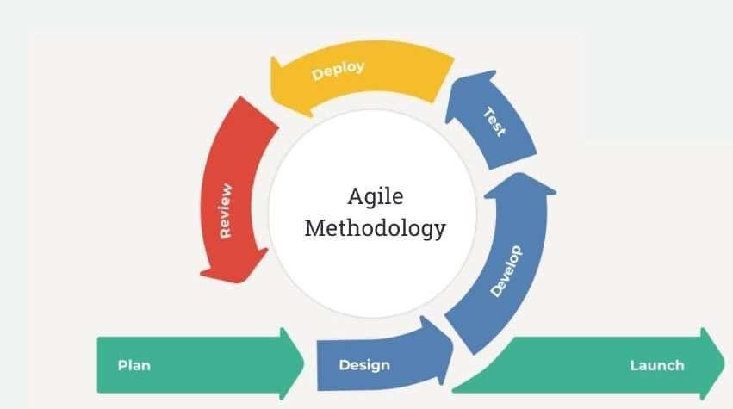
Figure 1: Agile Methodology
For the development of the proposed Incident Management and Routing App and Web System for water services, selecting an appropriate software development methodology is important to ensure efficiency, flexibility, and reliability. The researchers selected the Agile Software Development Life Cycle as the development approach. Agile focuses on building the system through small, continuous improvements rather than completing everything in a single process.
This approach is suitable for the study because the system includes multiple components such as a mobile application, web platform, Role-Based Access Control (RBAC), and AI features like NLP-based classification, sentiment analysis, and automated routing. Agile allows the researchers to develop each feature step by step, test it immediately, and improve it based on results. This is especially important for the AI components since their accuracy and performance may require adjustments during development.
Through this method, system features such as complaint submission, routing, and access control can be validated early, reducing the chances of major errors. Agile also supports continuous improvement, making the system more adaptable to changes and aligned with the objectives of the study.
Phase 1: Plan
This phase identifies the purpose and key features of the Incident Management and Routing App and Web System. The study focuses on improving how water service complaints are handled by addressing delays, misrouting, and lack of prioritization. Core requirements are defined, including NLP-based classification, sentiment analysis for severity levels, AI-driven routing, and a centralized system with Role-Based Access Control (RBAC). User roles such as customers, staff, engineers, and administrators are also determined.
Phase 2: Design
This phase establishes the system structure for both mobile and web platforms. Interfaces are organized based on user roles, covering complaint submission, monitoring, resolution, and administration. The database design supports complaint records, user accounts, routing data, and system logs. AI components are structured to handle classification, severity detection, and routing logic. System diagrams and workflows are prepared to guide development and ensure proper integration of all components.
Phase 3: Develop
System components will be constructed through progressive implementation of features. The mobile app will support complaint entry with text, location, and images, while the web platform will handle verification, assignment, and resolution updates. AI models will process complaint text for classification and severity, then trigger automated routing. RBAC will enforce access restrictions across all user roles.
Phase 4: Test
System behavior will be validated through functional and user- based testing. Processes such as complaint submission, status updates, and notifications will be checked for accuracy. Access permissions will be verified across different roles. AI outputs will be evaluated to confirm correct categorization, appropriate severity levels, and proper routing decisions. Identified issues will be corrected to improve reliability.
Phase 5: Deploy
The completed system will be integrated and prepared for operational use. Mobile and web components will be configured within the deployment environment. All modules, including AI processing and RBAC controls, will be finalized and stabilized to ensure consistent performance.

Phase 6: Review
System performance will be assessed against the study objectives. Efficiency in complaint handling, accuracy of AI decisions, and effectiveness of access control will be examined. Feedback will guide refinements to improve usability, processing speed,
and overall system quality.
Phase 7: Launch
The system will be released for actual use by all intended users. Complaint handling, automated routing, and monitoring features will operate in real-time. Ongoing observation will support system stability and continuous improvement.

3.2 Conceptual Framework
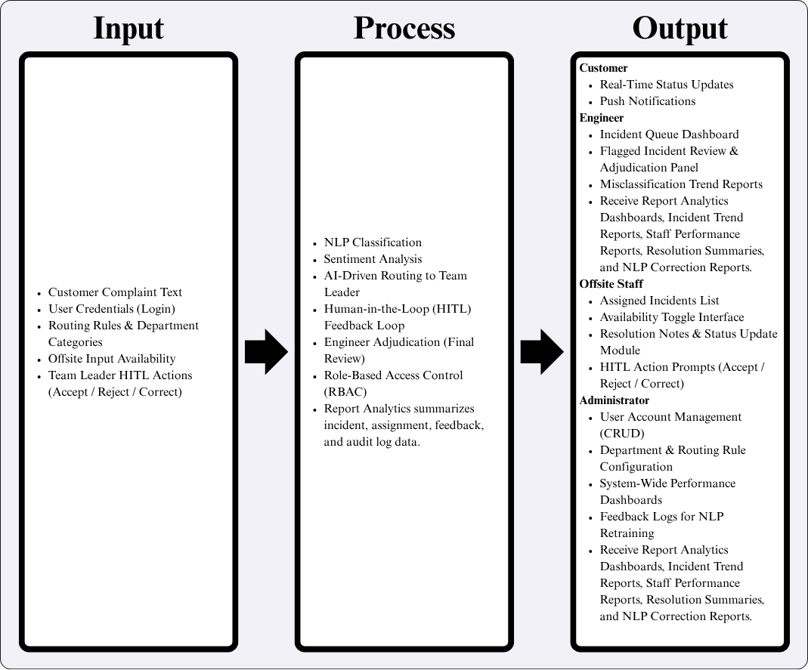
Figure 2: Input-Process-Output (IPO) Model of the Proposed System
The conceptual framework of the proposed system is presented using the Input-Process-Output (IPO) model, as shown in Figure 2. This model illustrates how data enters the system, how it is processed through intelligent and human-assisted mechanisms, and how results are delivered to each type of user. The framework is structured around three components: the inputs that drive system operations, the processes that transform those inputs, and the outputs produced for each stakeholder.
The inputs of the system are the data and configurations that initiate and guide its operations. The primary input is the Customer Complaint Text, which is the unstructured textual complaint submitted by a customer and serves as the main data processed by the natural language processing modules. User Credentials provide the login information needed to authenticate users and enforce role-based access across the system. Incident Categories and Department Mappings are system-defined configurations that determine how complaints are directed to the correct department or personnel. Offsite Staff Availability Toggle Status reflects whether offsite staff members have marked themselves as available or unavailable, which affects how incidents are assigned. Finally, Team Leader HITL Actions consisting of Accept, Reject, or Correct decisions represent the human-in-the-loop feedback that guides the system's learning and adjudication processes.
The processing layer applies a series of intelligent and role-governed operations to the inputs. NLP Classification analyzes and categorizes the complaint text into the appropriate incident type. Sentiment Analysis evaluates the emotional tone of the complaint to help determine urgency and priority. AI-Driven Routing to Team Leader automatically assigns the classified complaint to the relevant team leader based on the configured routing rules. The Human-in-the-Loop (HITL) Feedback Loop allows team leaders to review AI decisions and provide corrective feedback to improve the system over time. Engineer Adjudication serves as a final review stage in which engineers validate and confirm the resolution of incidents. Role-Based Access Control (RBAC) governs all system interactions by ensuring that each user can only access features and data appropriate to their assigned role.
The outputs of the system are tailored to the needs of four distinct stakeholder groups. Customers receive Real-Time Status Updates and Push Notifications, keeping them informed at every stage of their complaint's progress. Engineers are provided with an Incident Queue Dashboard for managing their assigned cases, a Flagged Incident Review and Adjudication Panel for handling escalated items, and Misclassification Trend Reports to identify recurring classification errors. Additionally, engineers receive comprehensive report analytics including dashboards, incident trend reports, staff performance reports, resolution summaries, and NLP correction reports for deeper system evaluation. Offsite Staff are given an Assigned Incidents List showing their current tasks, an Availability Toggle Interface to manage their status, a Resolution Notes and Status Update Module to document their work, and HITL Action Prompts to accept, reject, or correct AI-generated decisions. The system also ensures resolution tracking through resolution notes and status updates for proper documentation of incidents. Administrators receive the most comprehensive set of outputs, including User Account Management (CRUD) tools, Department and Routing Rule Configuration controls, System-Wide Performance Dashboards, and Feedback Logs for NLP Retraining to support continuous model improvement. Administrators also receive detailed report analytics including dashboards, incident trend reports, staff performance reports, resolution summaries, and NLP correction reports to support decision-making and system optimization.

3.3 Software and Hardware Requirements
The proposed IMRAWS-NLP system is composed of three major components: the Flutter-based mobile application used by customers and offsite staff, the Laravel web portal used by administrators and field personnel, and the Python NLP microservice that classifies and assesses incoming complaint reports. This section identifies the software and hardware requirements applied in the development, testing, and deployment of these components.
3.3.1 Software Requirements
The proposed system was developed and deployed using the following software stack. The backend was built with the Laravel framework (PHP) and exposes a RESTful application programming interface secured through JSON Web Token (JWT) authentication. The mobile application was developed using the Flutter framework for Android devices. The natural language processing (NLP) services, which handle text normalization, tokenization, and classification of incoming complaints, were implemented in Python using FastAPI together with the necessary NLP libraries. PostgreSQL served as the relational database management system, while Git was used for version control during collaborative development. XAMPP was utilized during the local development and testing phase, and the system was ultimately hosted on an Oracle Cloud virtual private server.

Table 3.3.1: Software Requirements
Operating System | Windows 10/11 (64-bit) | Host environment used for development and testing
PHP | 8.2 or later | Runtime for the Laravel backend framework
Composer | 2.x | PHP dependency manager used to install and update Laravel packages
Laravel | 12.x | Backend web framework that exposes the RESTful API with JWT authentication
XAMPP | 8.x | Local web server (Apache and PHP) used during the development and testing phase
PostgreSQL | 14 or later | Relational database management system that stores the system records
Node.js | 20 LTS | Runs npm and Vite for compiling the frontend assets of the web portal
Flutter (Dart) | 3.x (Dart 3.0 or later) | Cross-platform framework used to build the Android mobile application
Android Studio | Latest LTS version | Integrated development environment used to build and test the Flutter application
Python | 3.11-3.13 | Runtime used by the NLP microservice
FastAPI and Uvicorn | FastAPI 0.110+; Uvicorn 0.27+ | Web framework and ASGI server that expose the NLP service on port 8001
scikit-learn | 1.5 or later | Builds and loads the TF-IDF and SVM classifier for complaint categorization
PyTorch and Transformers | PyTorch 2.2+; Transformers 4.40+ | Loads the RoBERTa model for sentiment analysis and severity scoring
Docker | Latest stable | Containerizes the NLP service for deployment on the production server
Git | Latest stable | Version control used during collaborative development
3.3.2 Hardware Requirements
Development and testing were carried out on a desktop computer with sufficient processing and memory capacity to run the Laravel backend, the PostgreSQL database, and the Python NLP services simultaneously. An Android smartphone was used as the target physical device for testing the Flutter mobile application in a real-world environment, and a stable internet connection was required to access the hosted web portal and to connect the mobile client to the application programming interface.

Table 3.3.2: Hardware Requirements
Desktop Processor | Intel Core i5 or AMD Ryzen 5, or higher | Runs the Laravel backend, PostgreSQL database, and NLP services simultaneously
Memory (RAM) | 8 GB minimum; 16 GB recommended | Meets the combined requirements of Laravel, PostgreSQL, and the RoBERTa model runtime
Storage | 256 GB SSD minimum; 512 GB recommended | Stores the source code, the training dataset, and the NLP model cache
Workstation Operating System | Windows 10/11 (64-bit) or Linux | Development and testing environment
Android Smartphone | Android 9.0 or later | Physical device used to test the Flutter mobile application
Internet Connection | Stable broadband connection | Accesses the hosted web portal and links the mobile app to the application programming interface
Cloud Server | Oracle Cloud VPS with at least 2 vCPU and 4 GB RAM | Hosts the Laravel web portal and the containerized NLP microservice in production

3.4 Context Diagram
3.4.1 Existing System
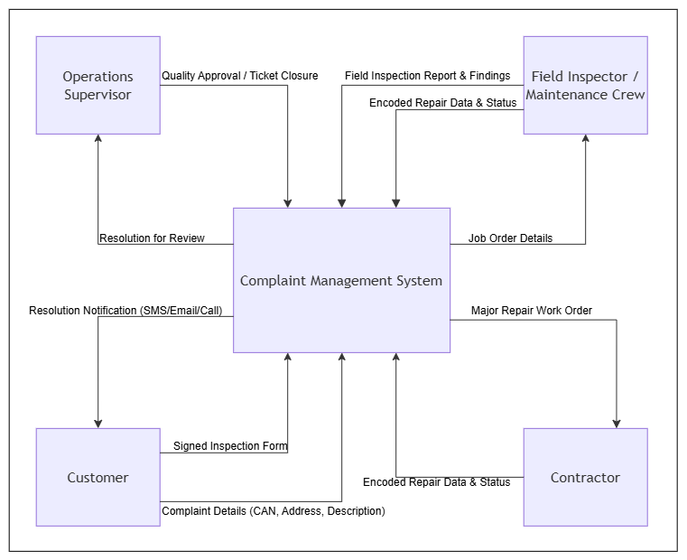
Figure 3: Context Diagram of The Existing System
Figure 3 presents the Context Diagram (Level 0 DFD) for the existing Complaint Management System, illustrating the overall scope of the current system and its interactions with four primary external entities: Customer, Operations Supervisor, Field Inspector / Maintenance Crew, and Contractor. The diagram depicts the system as a single central process (Complaint Management System) that serves as the core hub managing all data exchanges across these entities.
The Customer interacts with the system by providing Complaint Details (CAN, Address, Description) and a Signed Inspection Form, while receiving Resolution Notifications via SMS, Email, or Call.
The Operations Supervisor sends Quality Approval / Ticket Closure decisions to the system and receives Resolution for Review data to evaluate completed tickets.
The Field Inspector / Maintenance Crew receives Job Order Details from the system and transmits Field Inspection Report & Findings as well as Encoded Repair Data & Status back into the process.
The Contractor receives Major Repair Work Orders for extensive issues and submits Encoded Repair Data & Status back to the system upon completing the assigned work.

3.4.2 Proposed System
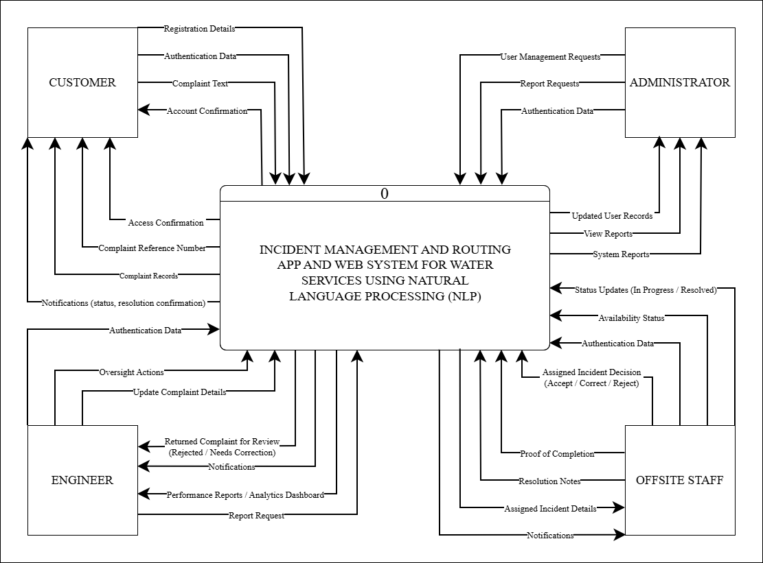
Figure 4: Context Diagram of The Proposed System
Figure 4 presents the Context Diagram (Level 0 DFD) for the proposed Incident Management and Routing App and Web System for Water Services Using Natural Language Processing (NLP), illustrating the overall scope of the system and its interactions with four external entities: Customer, Administrator, Engineer, and Offsite Staff. The diagram depicts the system as a single process (Process 0) that serves as the central hub for all data flows across user roles.
The Customer interacts with the system by submitting Registration Details, Authentication Data, and Complaint Text, while receiving Account Confirmation, Access Confirmation, Complaint Reference Numbers, Complaint Records, and Notifications regarding status updates and resolution confirmation.
The Administrator communicates with the system through User Management Requests, Report Requests, and Authentication Data, and in return receives Updated User Records, View Reports, and System Reports reflecting overall system performance.
The Engineer sends Authentication Data to the system and receives Oversight Actions, Update Complaint Details, Returned Complaints for Review flagged as Rejected or Needing Correction, Notifications, and Performance Reports or Analytics Dashboard for monitoring and adjudication purposes. The Engineer can also submit Report Requests to generate analytical insights from the system.
The Offsite Staff submits Status Updates (In Progress or Resolved), Availability Status, Authentication Data, and Assigned Incident Decisions (Accept, Correct, or Reject), while receiving Assigned Incident Details, Notifications, Resolution Notes, and Proof of Completion from the system. These interactions support the execution and completion of assigned field tasks within the incident management workflow.

3.5 Data Flow Diagram
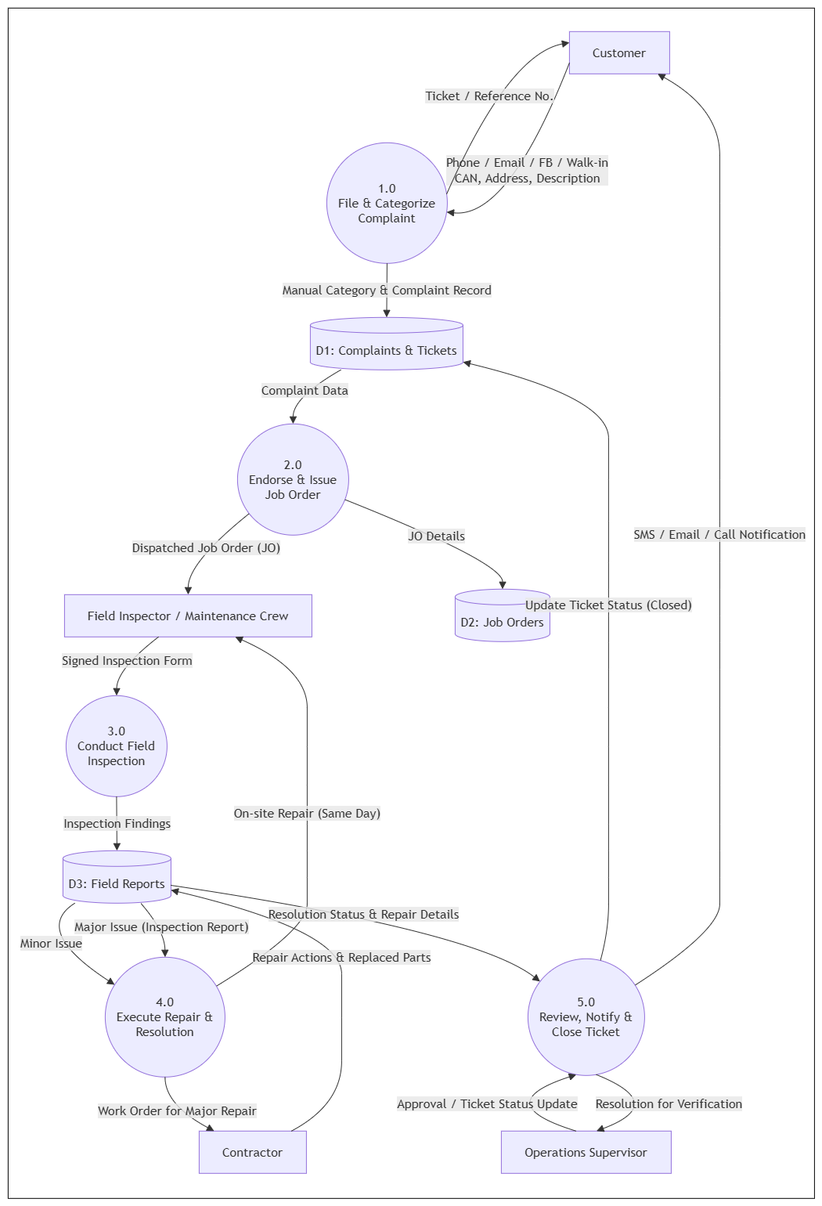
3.5 .1 Existing System

Figure 5: DFD Level 1 of The Existing System

Figure 5 presents the Level 1 Data Flow Diagram (DFD) for the existing Complaint Management System, illustrating the detailed breakdown of the system’s core processes and their interactions with external entities and data stores. The diagram identifies four external entities—Customer, Field Inspector / Maintenance Crew, Contractor, and Operations Supervisor—interacting across five sequential processes: File & Categorize Complaint (1.0), Endorse & Issue Job Order (2.0), Conduct Field Inspection (3.0), Execute Repair & Resolution (4.0), and Review, Notify & Close Ticket (5.0).
The flow begins with the Customer submitting complaint details (via Phone, Email, FB, or Walk-in) to Process 1.0 (File & Categorize Complaint), which issues a Ticket / Reference No. back to the Customer and stores the Manual Category & Complaint Record into D1: Complaints & Tickets. Process 2.0 (Endorse & Issue Job Order) retrieves Complaint Data from D1, outputs JO Details into D2: Job Orders, and dispatches a Job Order (JO) directly to the Field Inspector / Maintenance Crew.
The Field Inspector / Maintenance Crew submits a Signed Inspection Form to Process 3.0 (Conduct Field Inspection), which logs Inspection Findings into D3: Field Reports. Minor Issues proceed directly from D3 to Process 4.0 (Execute Repair & Resolution), while Major Issues (Inspection Report) are also routed from D3 to Process 4.0. Process 4.0 handles execution by issuing a Work Order for Major Repair to the Contractor or coordinating On-site Repair (Same Day) back with the Field Inspector / Maintenance Crew, subsequently returning Repair Actions & Replaced Parts data to D3.

Finally, Process 5.0 (Review, Notify & Close Ticket) pulls Resolution Status & Repair Details from D3, sends Resolution for Verification to the Operations Supervisor, and receives Approval / Ticket Status Update in return. Once approved, Process 5.0 sends an Update Ticket Status (Closed) to D1: Complaints & Tickets and dispatches an SMS / Email / Call Notification back to the Customer, completing the ticket lifecycle.

3.5.2 Proposed System
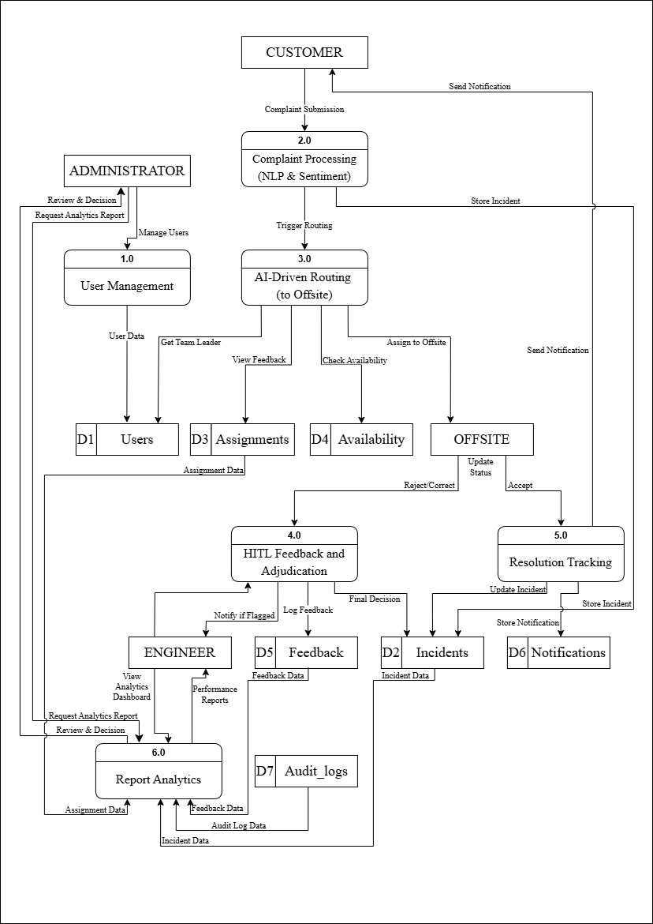
Figure 6: DFD Level 1 of The Proposed System
Figure 6 presents the Level 1 Data Flow Diagram (DFD) for the proposed Incident Management and Routing App and Web System for Water Services Using Natural Language Processing (NLP), precisely illustrating the system's primary processes and their interrelationships through directed data flows. The diagram clearly identifies key external entities Customer, Administrator, Engineer, and Offsite Staff, and their interactions with five core processes: User Management (1.0), Complaint Processing with NLP and Sentiment Analysis (2.0), AI-Driven Routing to Offsite (3.0), HITL Feedback and Adjudication (4.0), and Resolution Tracking (5.0).
The directed arrows meticulously depict the movement of crucial data across these processes and external entities. The Customer initiates the workflow by submitting complaints to Process 2.0, which applies NLP classification and sentiment analysis before triggering routing through Process 3.0. The Administrator manages system users through Process 1.0, with user data stored in data store D1 (Users). Process 3.0 coordinates AI-driven assignment by checking availability from D4 (Availability), retrieving team leader data from D1, and assigning incidents directly to the Offsite Staff entity. The Offsite Staff updates incident status and submits Accept, Reject, or Correct decisions, which feed into Process 4.0 for HITL Feedback and Adjudication. The Engineer interacts with Process 4.0 through Review and Decision flows, receiving notifications when incidents are flagged for adjudication. Logged feedback is stored in D5 (Feedback), while finalized incident decisions are passed to Process 5.0 for Resolution Tracking, with records maintained in D2 (Incidents).
Process 5.0 (Resolution Tracking) further handles the updating of incident status and the storage of resolution details, while also generating notification records in
D6 (Notifications) to inform the Customer of progress and final outcomes. Notifications are sent back to the Customer upon resolution, completing the end-to-end incident management cycle.
Additionally, the system includes Process 6.0 (Report Analytics), which aggregates data from D2 (Incidents), D3 (Assignments), D5 (Feedback), and D7 (Audit Logs). Both the Administrator and Engineer can request analytics reports, which are processed to generate dashboards, performance metrics, and incident trend reports to support monitoring and decision-making.
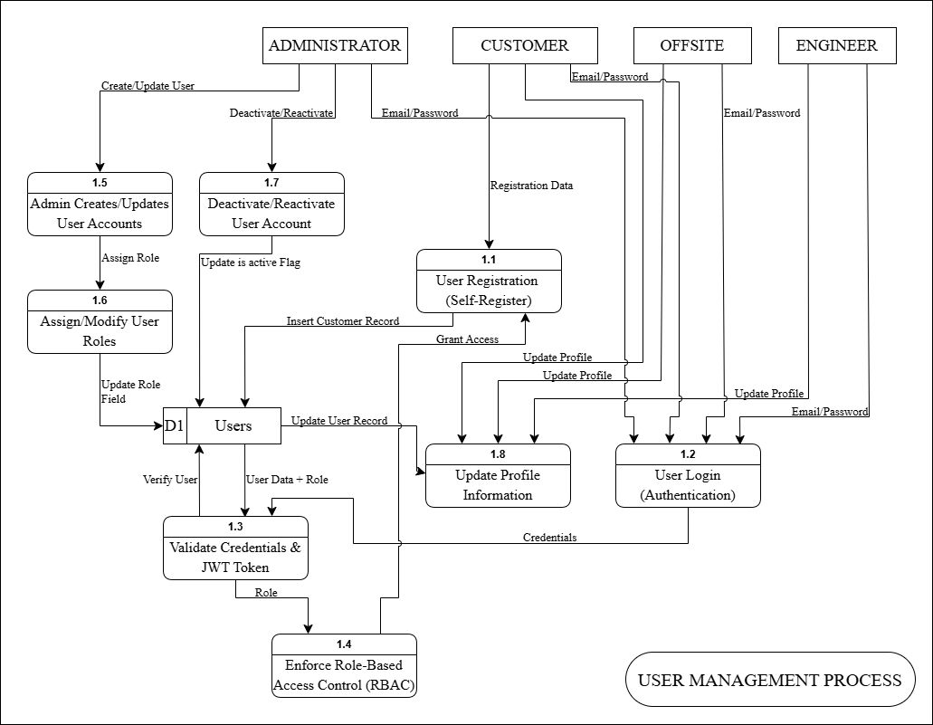
Figure 7: DFD Level 2 User Management Process 1.0 of The Proposed System
The Level 2 DFD for the User Management Process expands on the interactions between four external entities Administrator, Customer, Offsite Staff, and Engineer and eight sub-processes that govern account creation, authentication, and access control within the IMRAWS-NLP system. The Customer initiates the workflow by submitting Registration Data to Process 1.1 (User Registration – Self-Register), which inserts a new customer record into data store D1 (Users) and grants access upon successful registration. All four user roles submit their Email/Password credentials to Process 1.2 (User Login –
Authentication), which forwards credentials to Process 1.3 (Validate Credentials and JWT Token). This process verifies the user against D1 and returns a role-based token to Process 1.4 (Enforce Role-Based Access Control – RBAC), which enforces appropriate system permissions based on the assigned role.
The Administrator exclusively accesses Process 1.5 (Admin Creates/Updates User Accounts), which assigns roles through Process 1.6 (Assign/Modify User Roles) and updates the role field in D1. The Administrator also manages account status through Process 1.7 (Deactivate/Reactivate User Account), which updates the is_active flag in D1. All user roles may update their personal information through Process 1.8 (Update Profile Information), which writes the updated record back to D1. Together, these sub-processes establish a comprehensive and secure user management framework supported by role-based access control throughout the system.

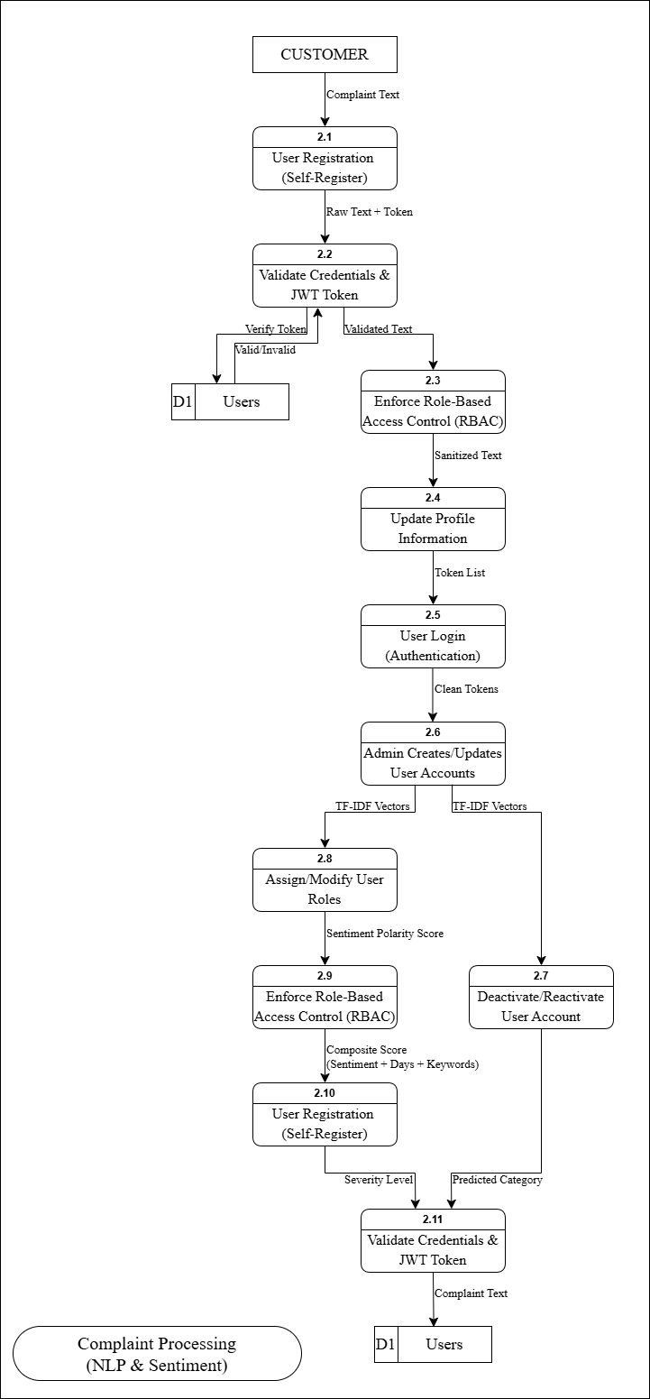
Figure 8: DFD Level 2 Complaint Processing (NLP and Sentiment) 2.0
of The Proposed System
The Level 2 DFD for Complaint Processing details the sequence of eleven sub-processes through which a customer complaint is received, validated, classified, and prepared for routing. The Customer submits Complaint Text to Process 2.1 (Receive Complaint Text), which passes the Raw Text and Token to Process 2.2 (Validate Customer Authentication Token). Process 2.2 verifies the token against D1 (Users), returning a Valid or Invalid status, and forwards Validated Text to Process 2.3 (Sanitize & Normalize Text Input).
The sanitized complaint text then flows through Process 2.4 (Tokenization), which produces a Token List passed to Process 2.5 (Stopword Removal & Lemmatization). Clean tokens are forwarded to Process 2.6 (Feature Extraction), which generates TF-IDF Vectors distributed to both Process 2.8 (Sentiment Analysis) and Process 2.7 (NLP Classification). Process 2.8 produces a Sentiment Polarity Score passed to Process 2.9 (Calculate Composite Severity Score), which computes a Composite Score combining sentiment, days elapsed, and keyword frequency. This composite score feeds into Process 2.10 (Assign Severity Level), which outputs a Severity Level, while Process 2.7 outputs a Predicted Category. Both results are sent to Process 2.11 (Store Incident with Category & Severity), which finalizes the complaint text and stores it in D2 (Incidents) for downstream routing, completing the NLP and sentiment analysis pipeline.

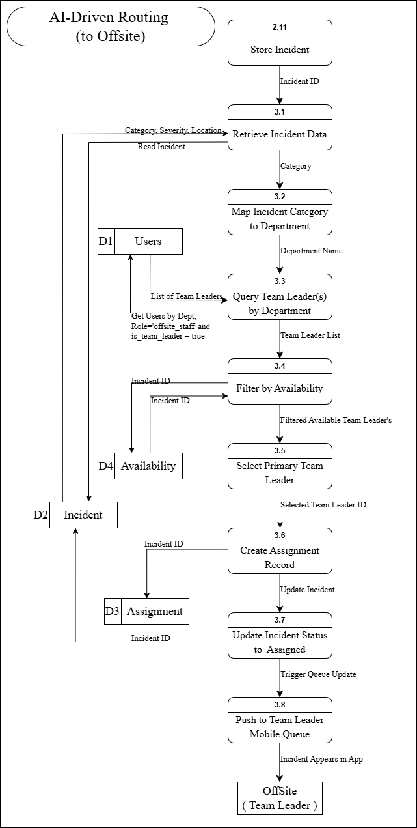
Figure 9: DFD Level 2 AI-Driven Routing (to Offsite) 3.0 of The Proposed System
The Level 2 DFD for AI-Driven Routing illustrates the eight sub-processes through which a classified incident is automatically matched and assigned to the most suitable Team Leader. Following the storage of an incident by Process 2.11 (Store Incident), Process 3.1 (Retrieve Incident Data) fetches the full incident record using the Incident ID, extracting the Category, Severity, and Location fields. Process 3.2 (Map Incident Category to Department) maps the complaint category to the corresponding department name, which is then used by Process 3.3 (Query Team Leader(s) by Department) to query D1 (Users) for staff with the role of offsite_staff and the is_team_leader flag set to true, returning a list of eligible Team Leaders.
Process 3.4 (Filter by Availability) cross-references this list against D4 (Availability) and D2 (Incident) using the Incident ID to identify available personnel, producing a filtered list passed to Process 3.5 (Select Primary Team Leader). The selected Team Leader ID is forwarded to Process 3.6 (Create Assignment Record), which writes the assignment to D3 (Assignment) and triggers Process 3.7 (Update Incident Status to Assigned), which updates D2 (Incident) accordingly. Finally, Process 3.8 (Push to Team Leader Mobile Queue) triggers a queue update that delivers the incident directly to the Offsite Team Leader's mobile application, completing the automated routing workflow.

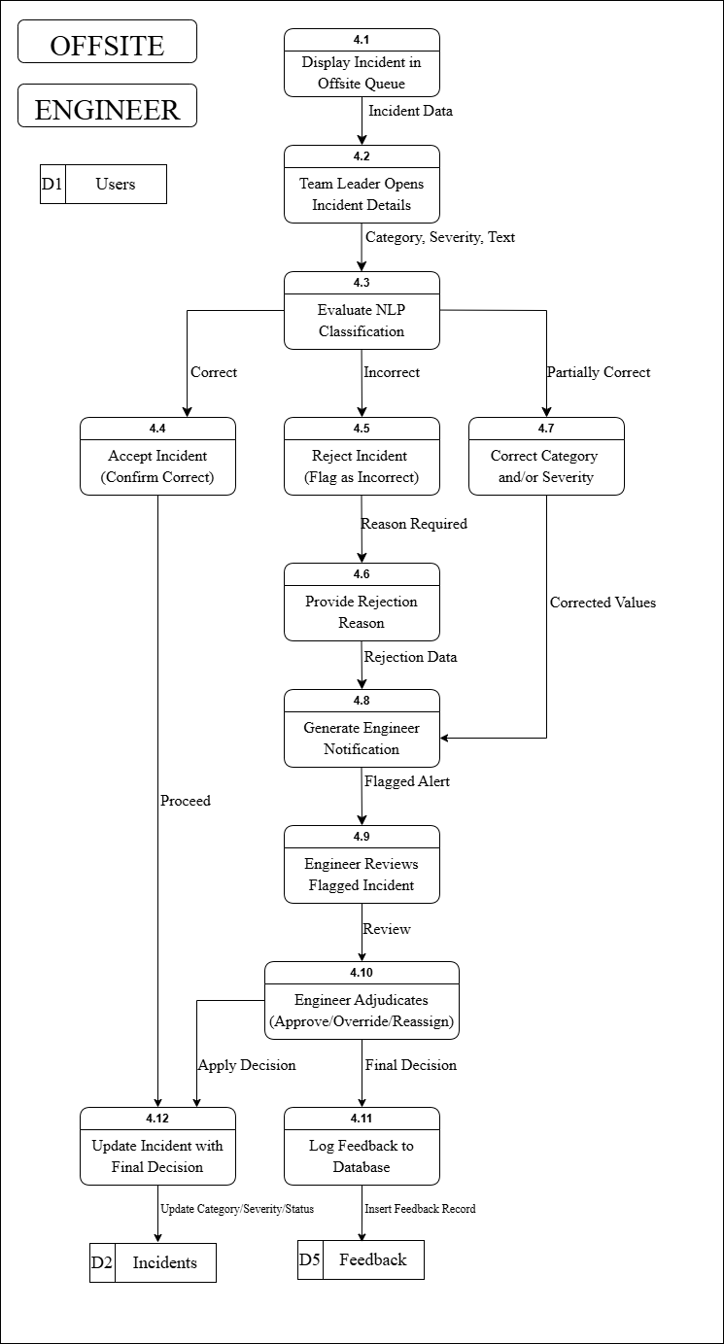
Figure 10: DFD Level 2 HITL Feedback and Adjudication 4.0 of The Proposed System
The Level 2 DFD for HITL Feedback and Adjudication details the twelve sub-processes that govern the Human-in-the-Loop review and correction mechanism involving the Offsite Staff and Engineer. Process 4.1 (Display Incident in Offsite Queue) presents the assigned incident to the Team Leader, who opens the full incident details through Process 4.2 (Team Leader Opens Incident Details), receiving the Category, Severity, and complaint Text. Process 4.3 (Evaluate NLP Classification) presents three possible outcomes: if the classification is deemed Correct, the flow proceeds to Process 4.4 (Accept Incident – Confirm Correct), which allows the workflow to proceed normally. If the classification is Incorrect, Process 4.5 (Reject Incident – Flag as Incorrect) is triggered, requiring the Team Leader to provide a justification through Process 4.6 (Provide Rejection Reason), which produces Rejection Data. If the classification is Partially Correct, Process 4.7 (Correct Category and/or Severity) allows the Team Leader to submit corrected values.
Both the Rejection Data and Corrected Values flow into Process 4.8 (Generate Engineer Notification), which issues a Flagged Alert to Process 4.9 (Engineer Reviews Flagged Incident). The Engineer conducts a formal review and submits the case to Process 4.10 (Engineer Adjudicates – Approve/Override/Reassign), which produces two outputs: an Apply Decision directed to Process 4.12 (Update Incident with Final Decision), which updates Category, Severity, and Status in D2 (Incidents); and a Final Decision directed to Process 4.11 (Log Feedback to Database), which inserts a complete feedback record into D5 (Feedback) for use in future NLP model retraining.

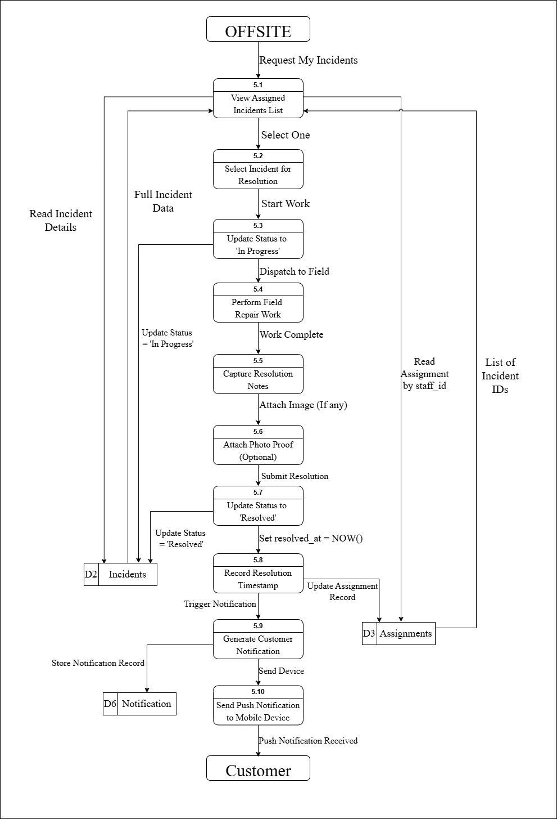
Figure 11: DFD Level 2 Resolution Tracking 5.0 of The Proposed System
The Level 2 DFD for Resolution Tracking illustrates the ten sub-processes through which the Offsite Staff manages and closes an assigned incident, culminating in a push notification delivered to the Customer. The Offsite entity initiates the workflow by requesting their incident list, which is displayed through Process 5.1 (View Assigned Incidents List). This process reads assignment records from D3 (Assignments) by staff_id and retrieves the corresponding list of Incident IDs. The Team Leader selects a specific incident through Process 5.2 (Select Incident for Resolution), triggering Process 5.3 (Update Status to 'In Progress'), which writes the updated status to D2 (Incidents) and dispatches the staff member to the field.
Process 5.4 (Perform Field Repair Work) represents the on-site resolution activity. Upon work completion, the Team Leader captures resolution notes through Process 5.5 (Capture Resolution Notes), with the option to submit photographic evidence through Process 5.6 (Attach Photo Proof – Optional). Process 5.7 (Update Status to 'Resolved') writes the resolved status to D2 (Incidents), after which Process 5.8 (Record Resolution Timestamp) sets the resolved_at field to the current timestamp and simultaneously updates the Assignment Record in D3 (Assignments). Process 5.9 (Generate Customer Notification) is then triggered, storing the notification record in D6 (Notifications) and passing the alert to Process 5.10 (Send Push Notification to Mobile Device), which delivers the Push Notification to the Customer, completing the full resolution tracking cycle.
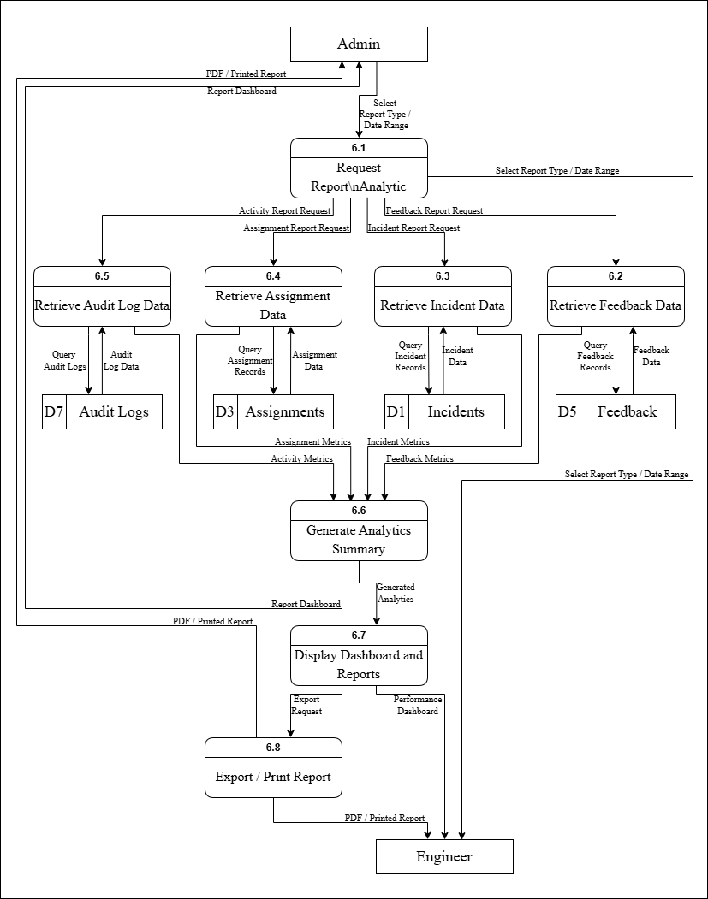
Figure 12: DFD Level 2 Report Analytics 6.0 of The Proposed System
The Level 2 DFD for Report Analytics (Process 6.0) illustrates the series of sub-processes through which the system generates, analyzes, and delivers reports to the Administrator and Engineer. The workflow begins when the Admin initiates a report request by selecting the report type and date range, which is handled by Process 6.1 (Request Report/Analytic). This process distributes specific data requests to multiple retrieval processes depending on the type of report needed.
For incident-related data, Process 6.3 (Retrieve Incident Data) queries records from D2 (Incidents) and returns structured incident data. For feedback and HITL corrections, Process 6.2 (Retrieve Feedback Data) accesses D5 (Feedback) to obtain feedback records. Assignment-related information is gathered through Process 6.4 (Retrieve Assignment Data), which retrieves assignment records from D3 (Assignments). Additionally, system activity and monitoring data are collected through Process 6.5 (Retrieve Audit Log Data), which queries D7 (Audit Logs) to provide a complete history of system actions.
All retrieved datasets including incident metrics, assignment metrics, feedback metrics, and activity logs are then forwarded to Process 6.6 (Generate Analytics Summary). This process consolidates and analyzes the data to produce meaningful insights such as trends, performance metrics, and summary reports. The generated analytics are passed to Process 6.7 (Display Dashboard and Reports), where the results are visualized through dashboards and report interfaces accessible to both Admin and Engineer.
If the user requests a downloadable version, Process 6.8 (Export Report) is triggered, converting the generated reports into a downloadable CSV file. The final output, including dashboards and exported reports, is then delivered to the Admin and Engineer, completing the full report generation and analytics cycle.
3.6 Activity Diagram
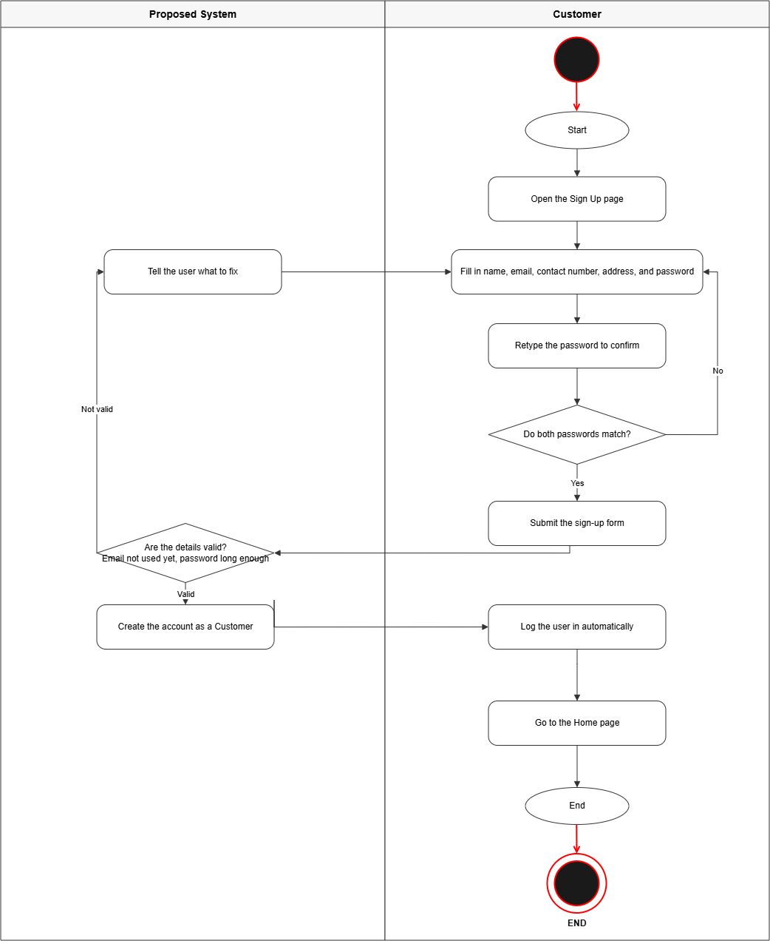
Figure 13: Activity Diagram for Customer – Account Creation
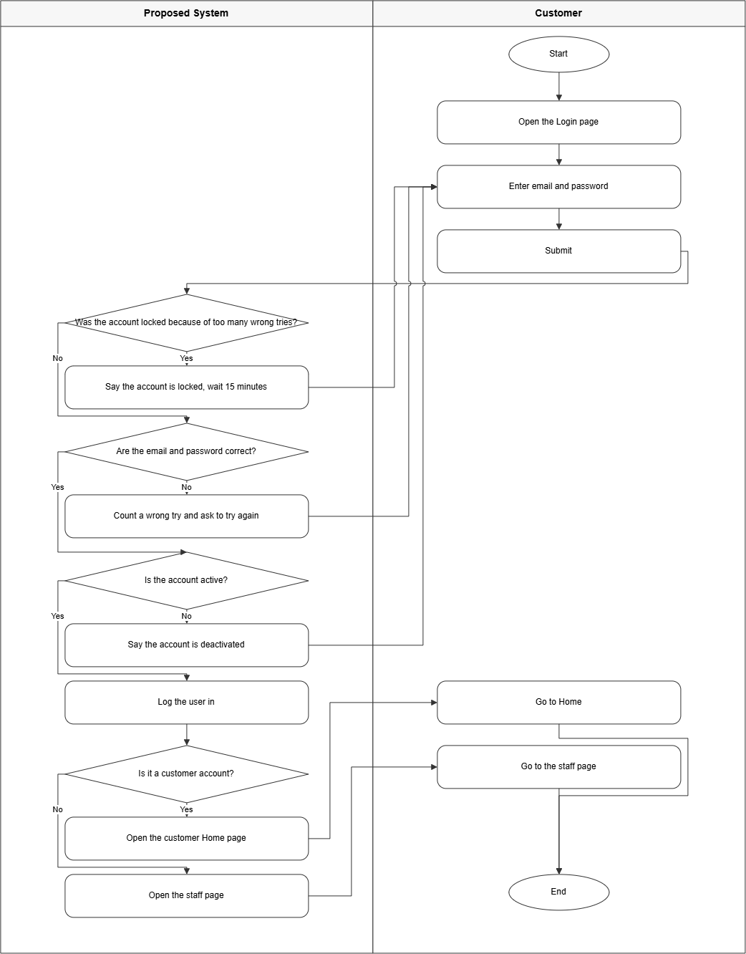
Figure 14: Activity Diagram for Customer – Login
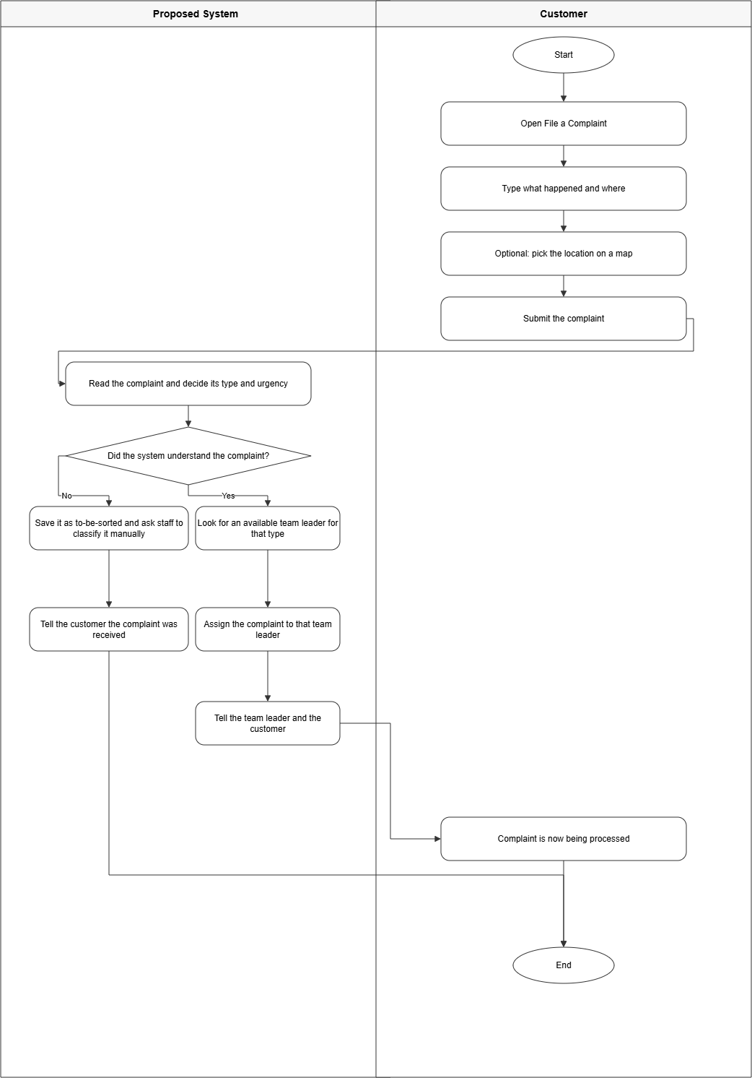
Figure 15: Activity Diagram for Customer – File Complaint
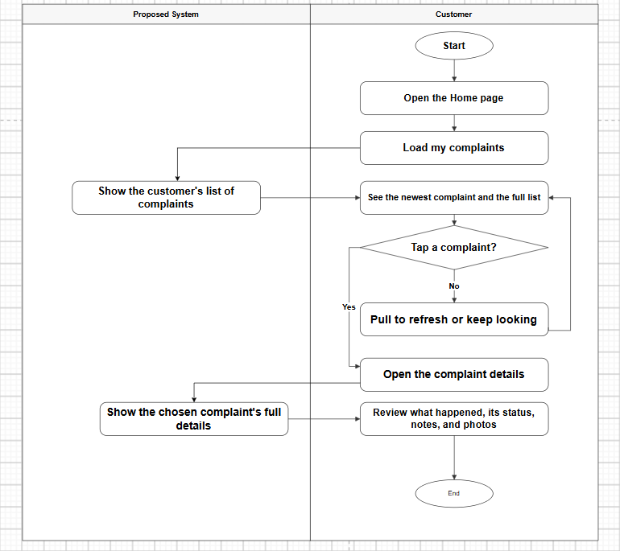
Figure 16: Activity Diagram for Customer – Track Complaint
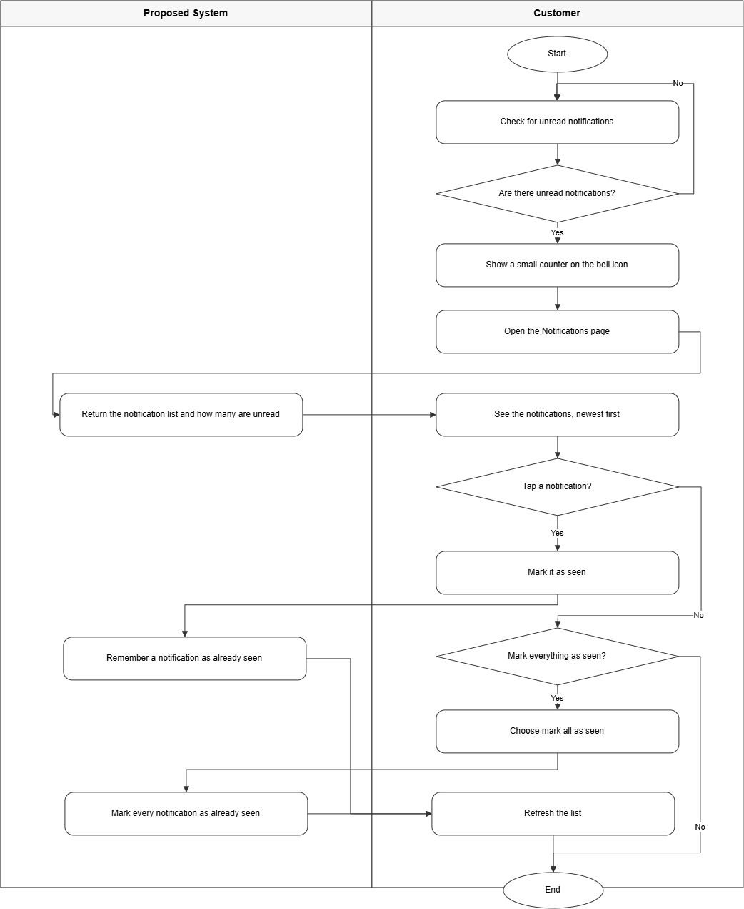
Figure 17: Activity Diagram for Customer – View Notifications
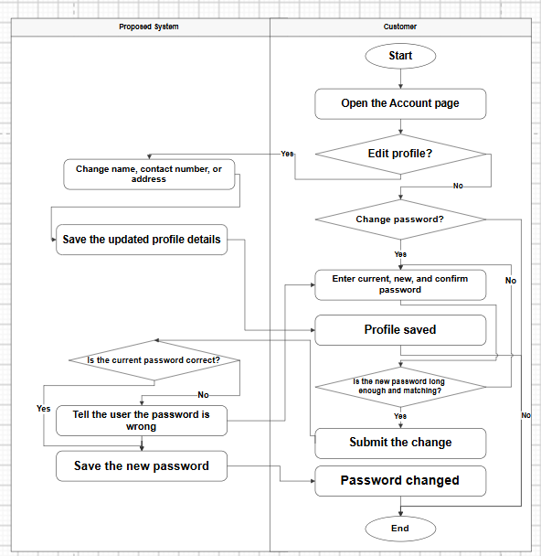
Figure 18: Activity Diagram for Customer – Manage Account

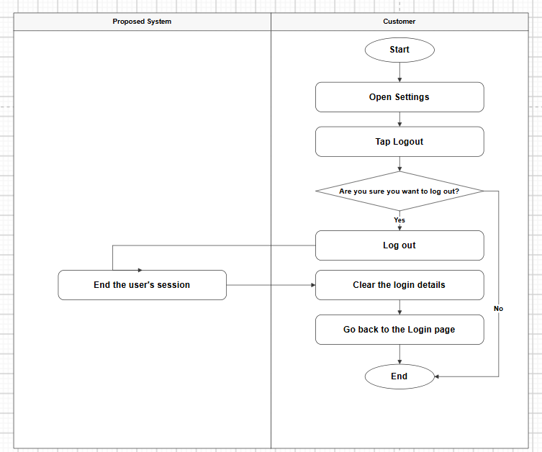
Figure 19: Activity Diagram for Customer - Logout

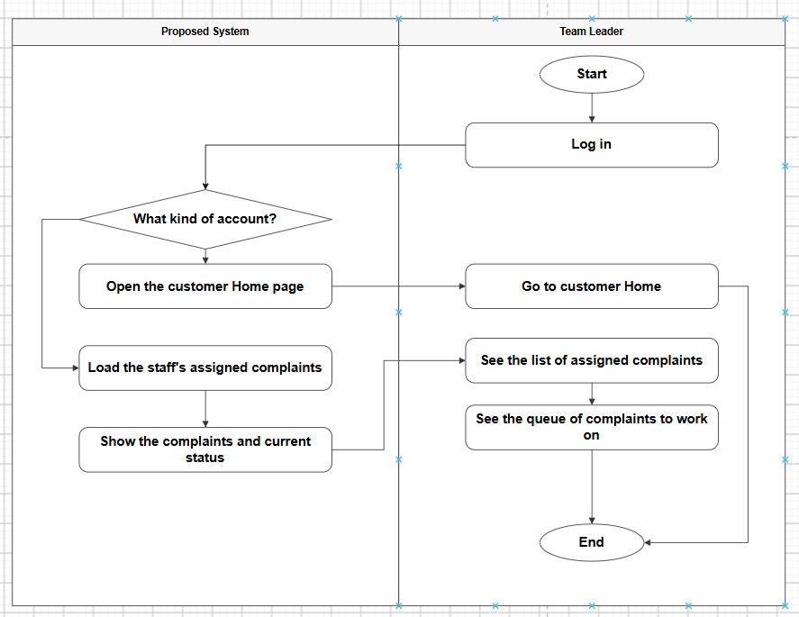
Figure 20: Activity Diagram for Offsite Staff – Login and Queue

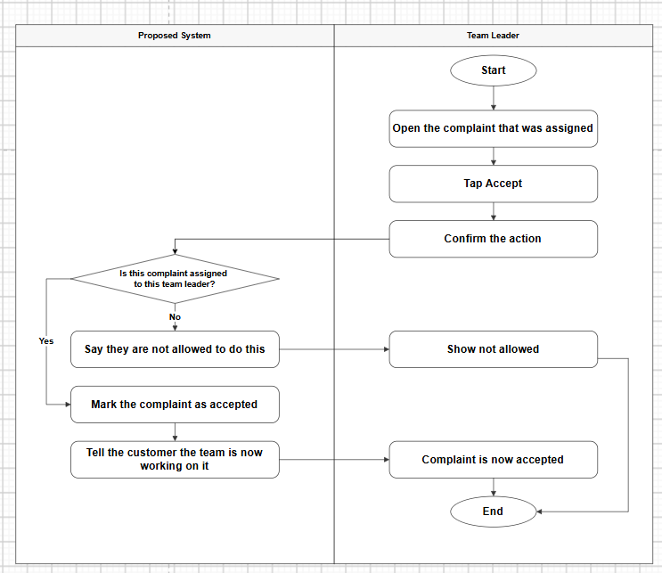
Figure 21: Activity Diagram for Offsite Staff – Accept Assignment

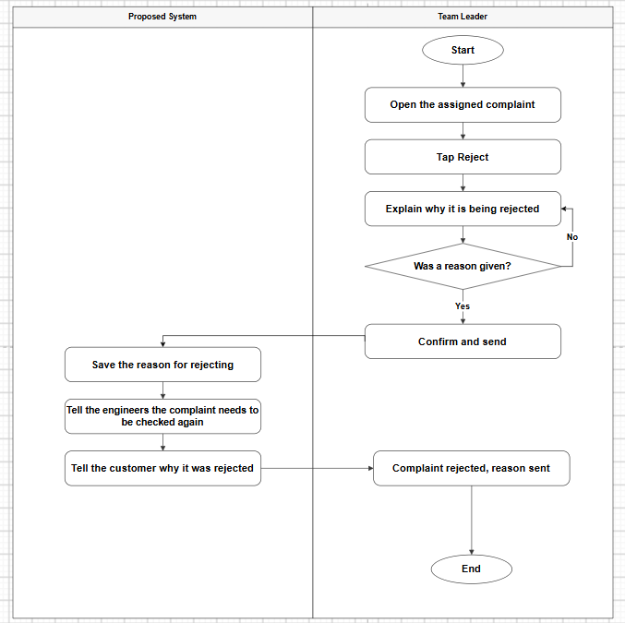
Figure 22: Activity Diagram for Offsite Staff – Reject Assignment

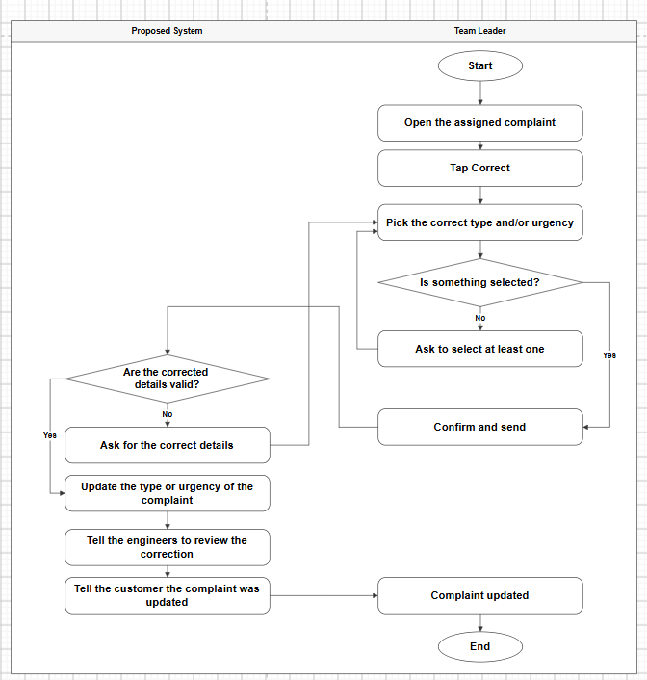
Figure 23: Activity Diagram for Offsite Staff – Correct Category

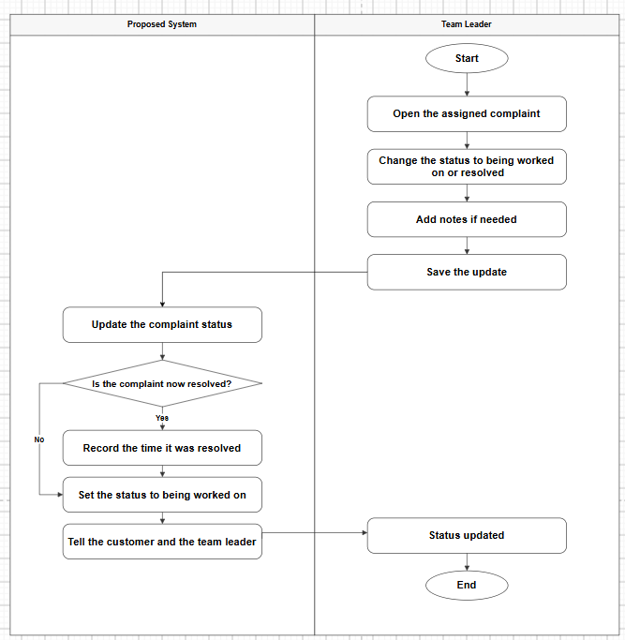
Figure 24: Activity Diagram for Offsite Staff – Update Status

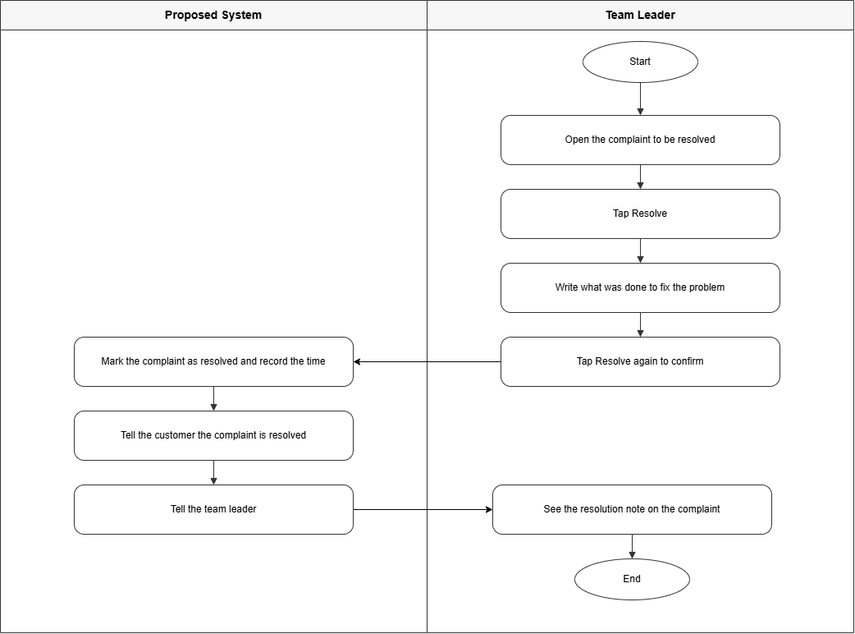
Figure 25: Activity Diagram for Offsite Staff – Resolve Complaint
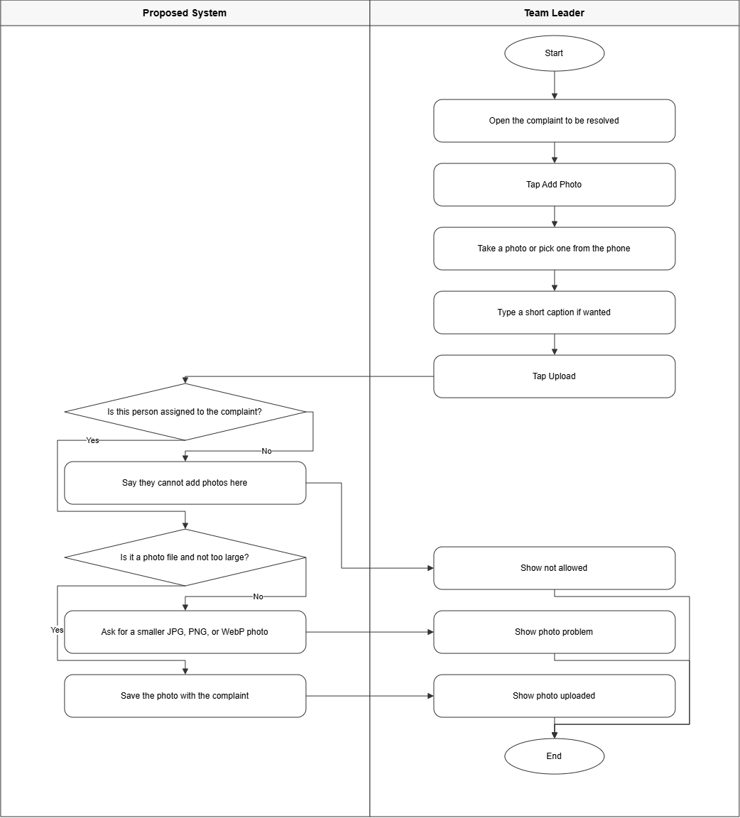
Figure 26: Activity Diagram for Offsite Staff – Upload Photo Proof

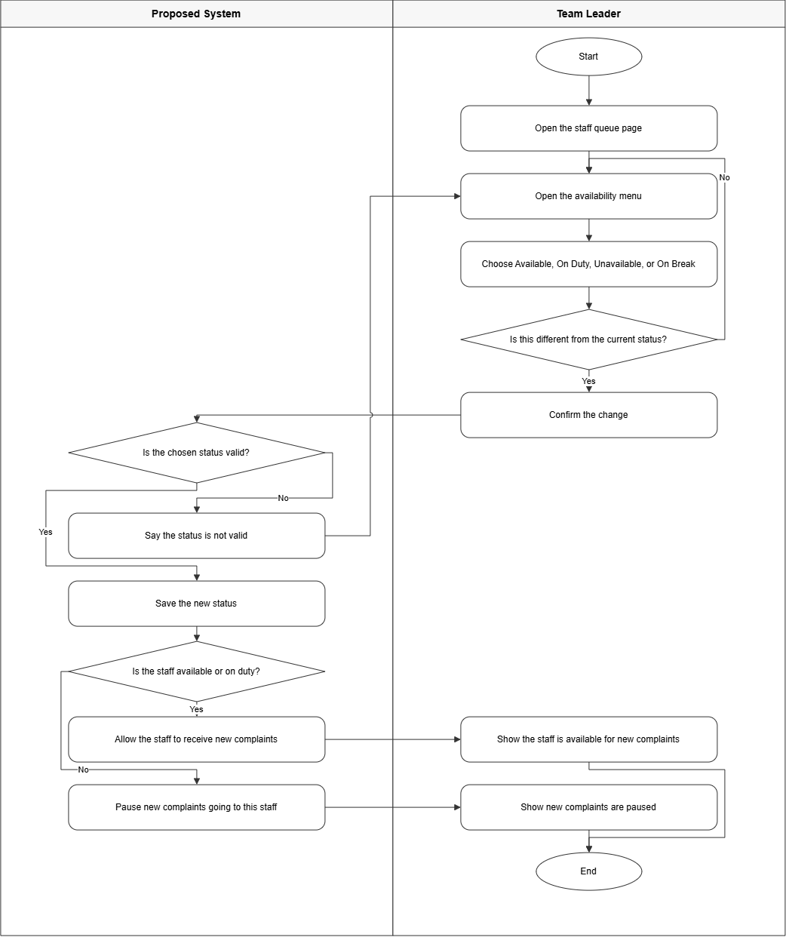
Figure 27: Activity Diagram for Offsite Staff – Manage Availability
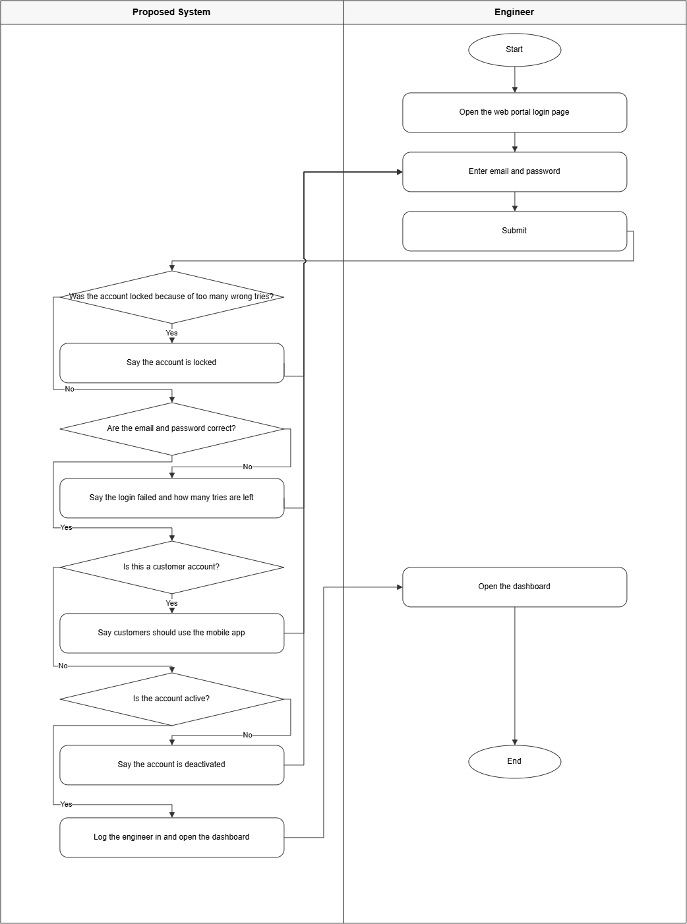
Figure 28: Activity Diagram for Engineer – Login
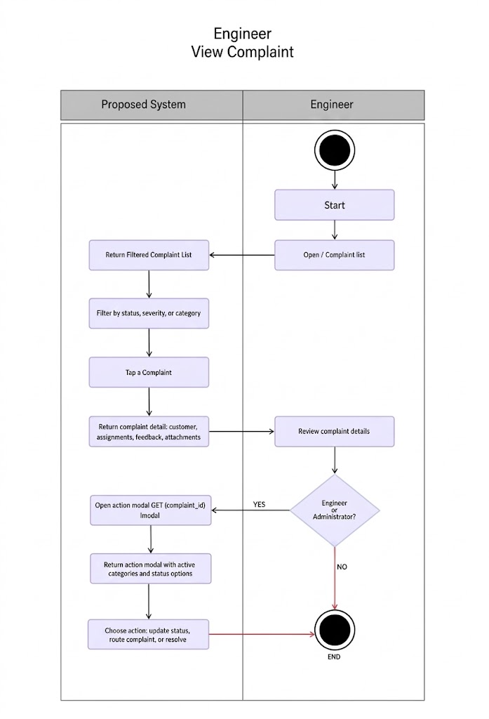Figure 29: Activity Diagram for Engineer – View Complaint Modal
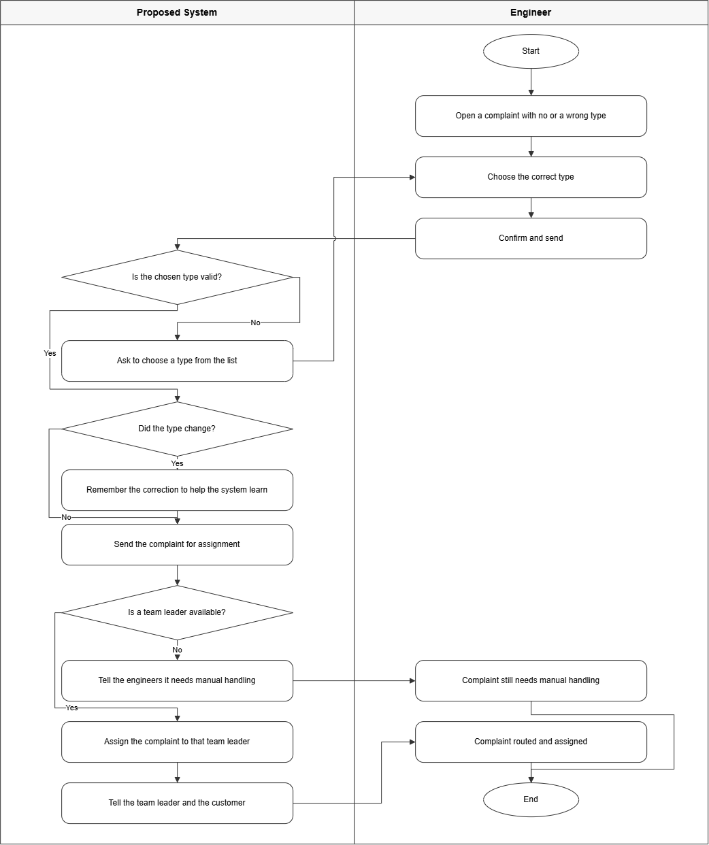
Figure 30: Activity Diagram for Engineer – Manual Route
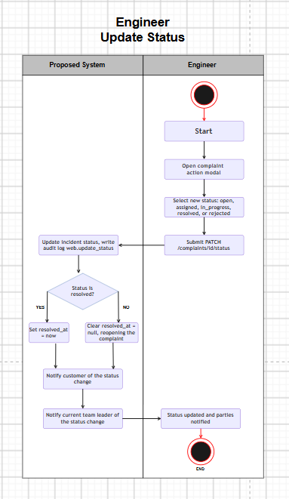
Figure 31: Activity Diagram for Engineer – Update Status

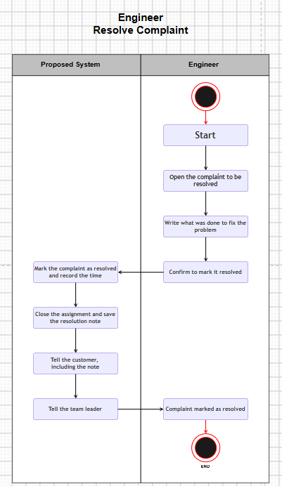
Figure 32: Activity Diagram for Engineer – Resolve Complaint
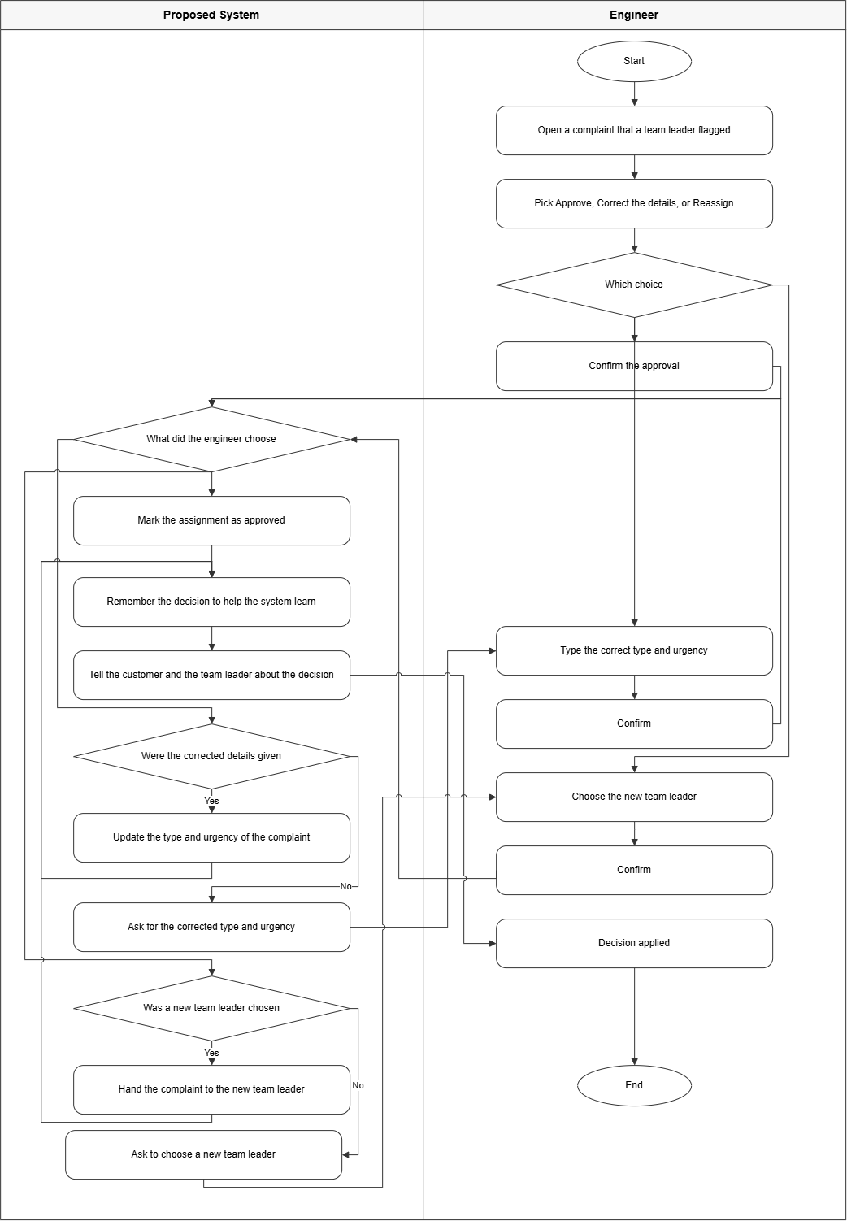
Figure 33: Activity Diagram for Engineer – Adjudicate
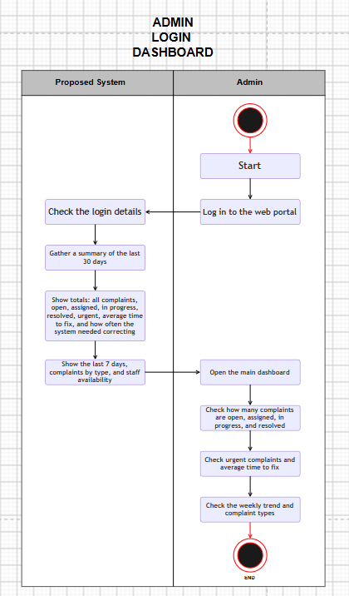
Figure 34: Activity Diagram for Admin – Login Dashboard

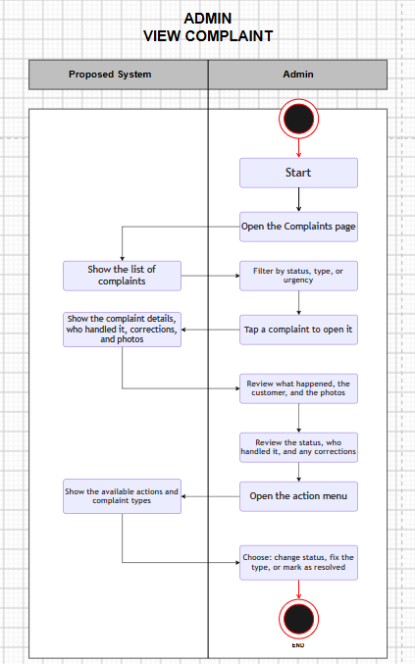
Figure 35: Activity Diagram for Admin – View Complaint
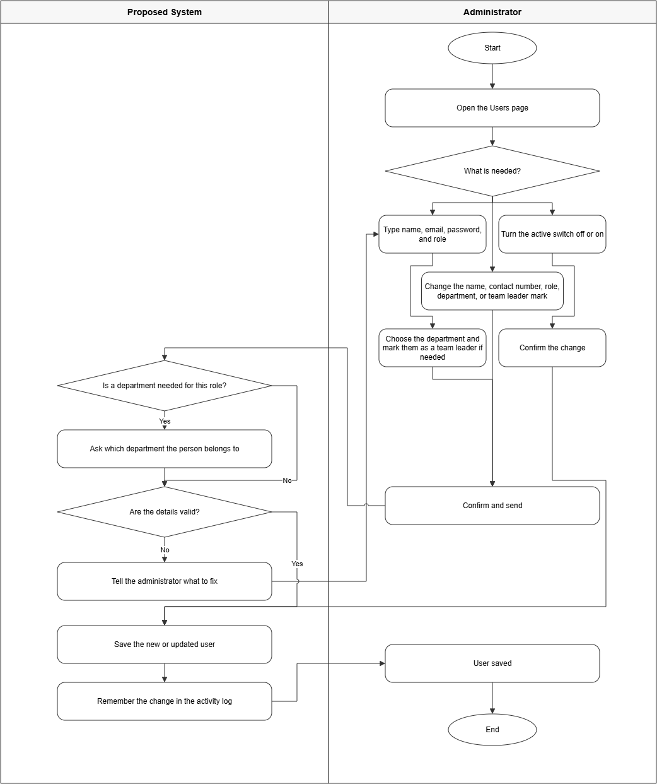
Figure 36: Activity Diagram for Admin – Manage Users
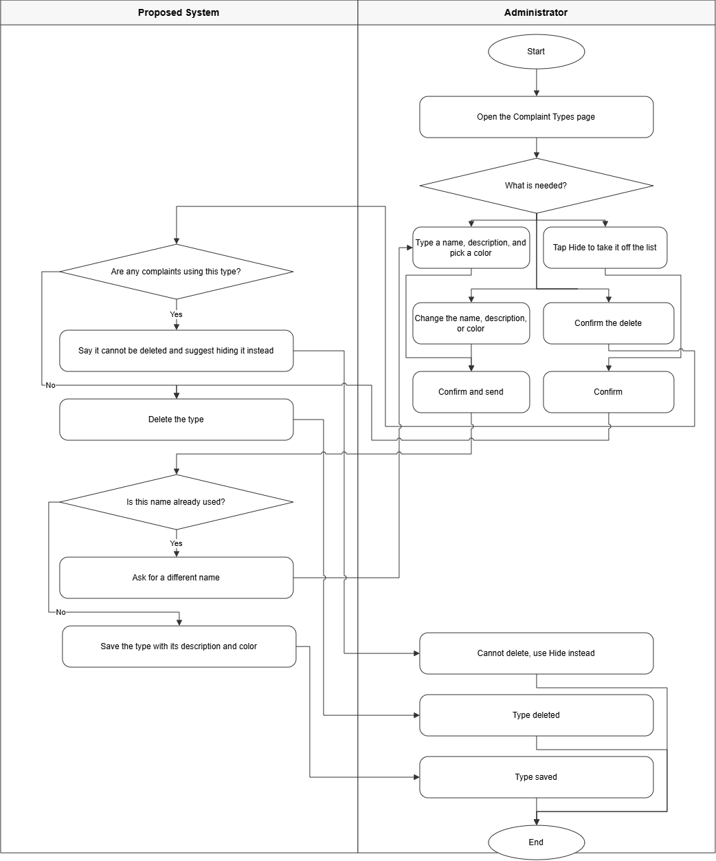
Figure 37: Activity Diagram for Admin – Manage Categories

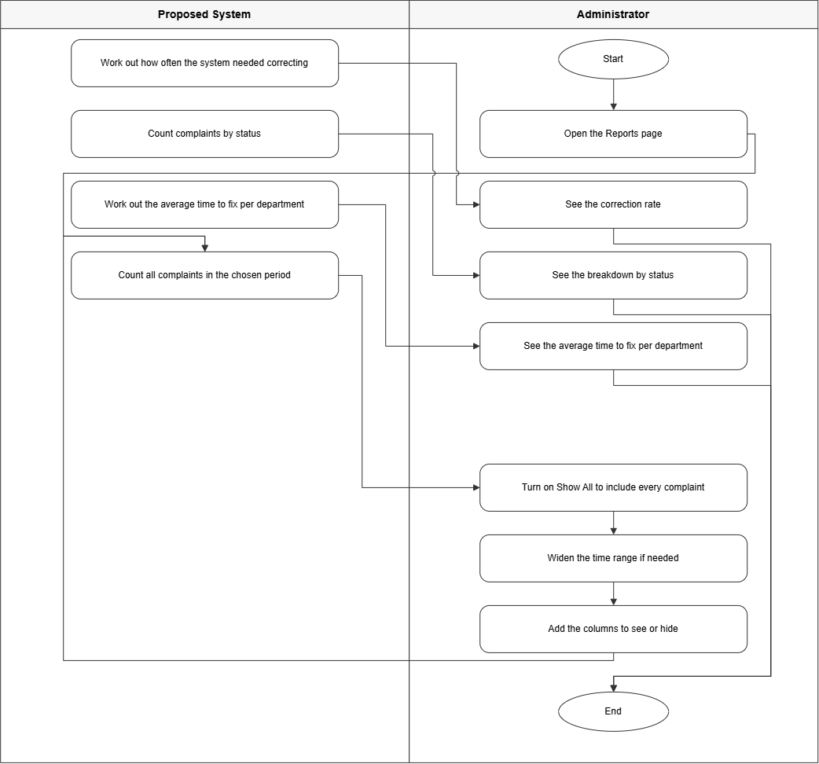
Figure 38: Activity Diagram for Admin – View Reports
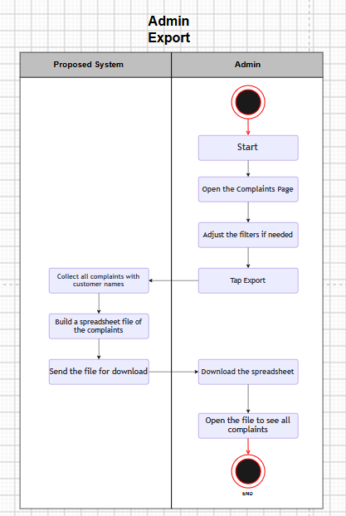
Figure 39: Activity Diagram for Admin – Export

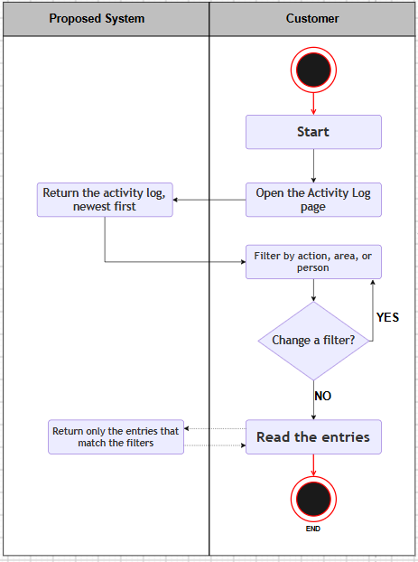
Figure 40: Activity Diagram for Admin – Audit Logs
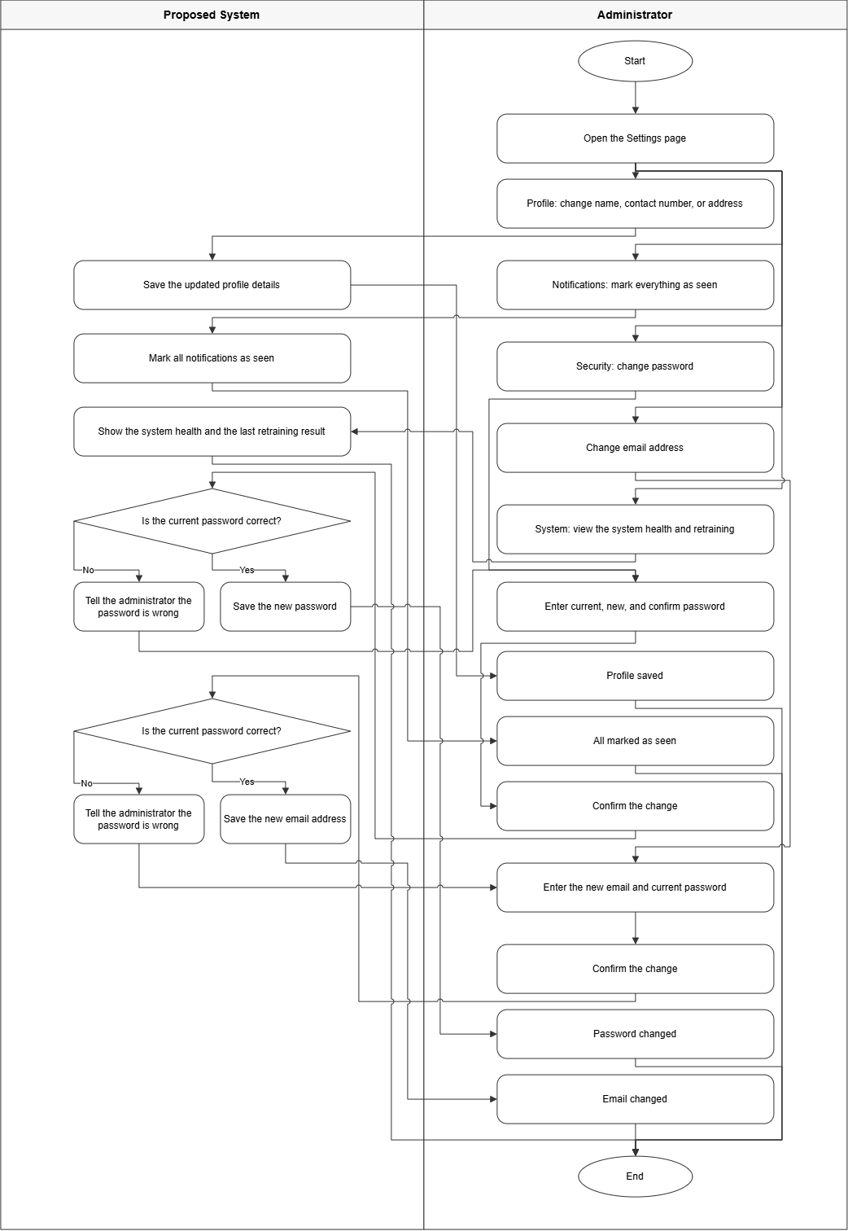
Figure 41: Activity Diagram for Admin – Settings
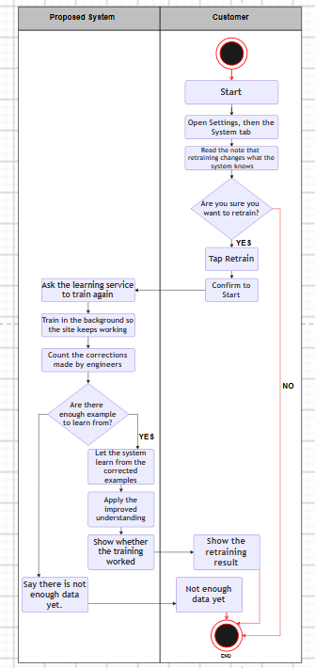
Figure 42: Activity Diagram for Admin – Retrain AI
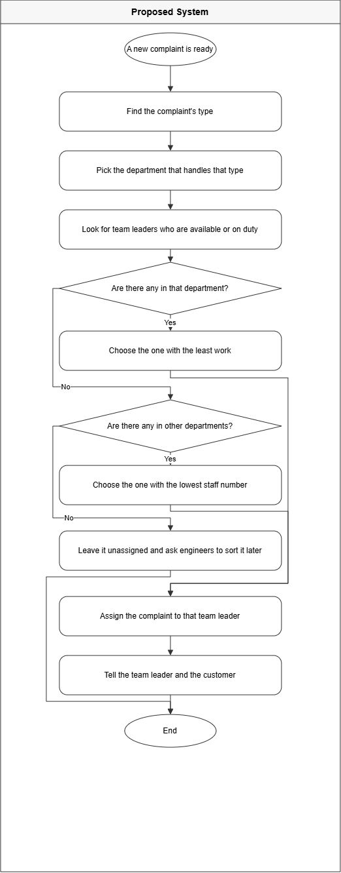
Figure 43: Activity Diagram of System – Auto Routing
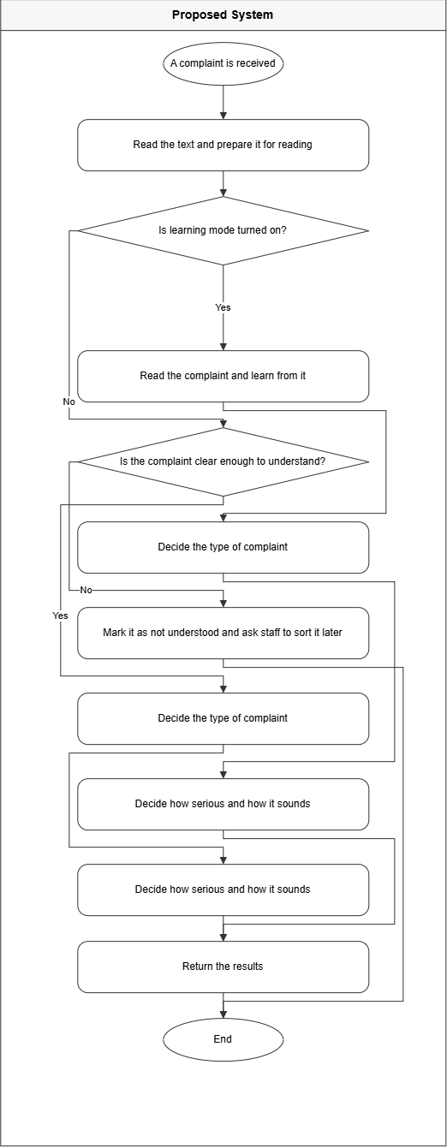
Figure 44: Activity Diagram of System – NLP Process Complaint
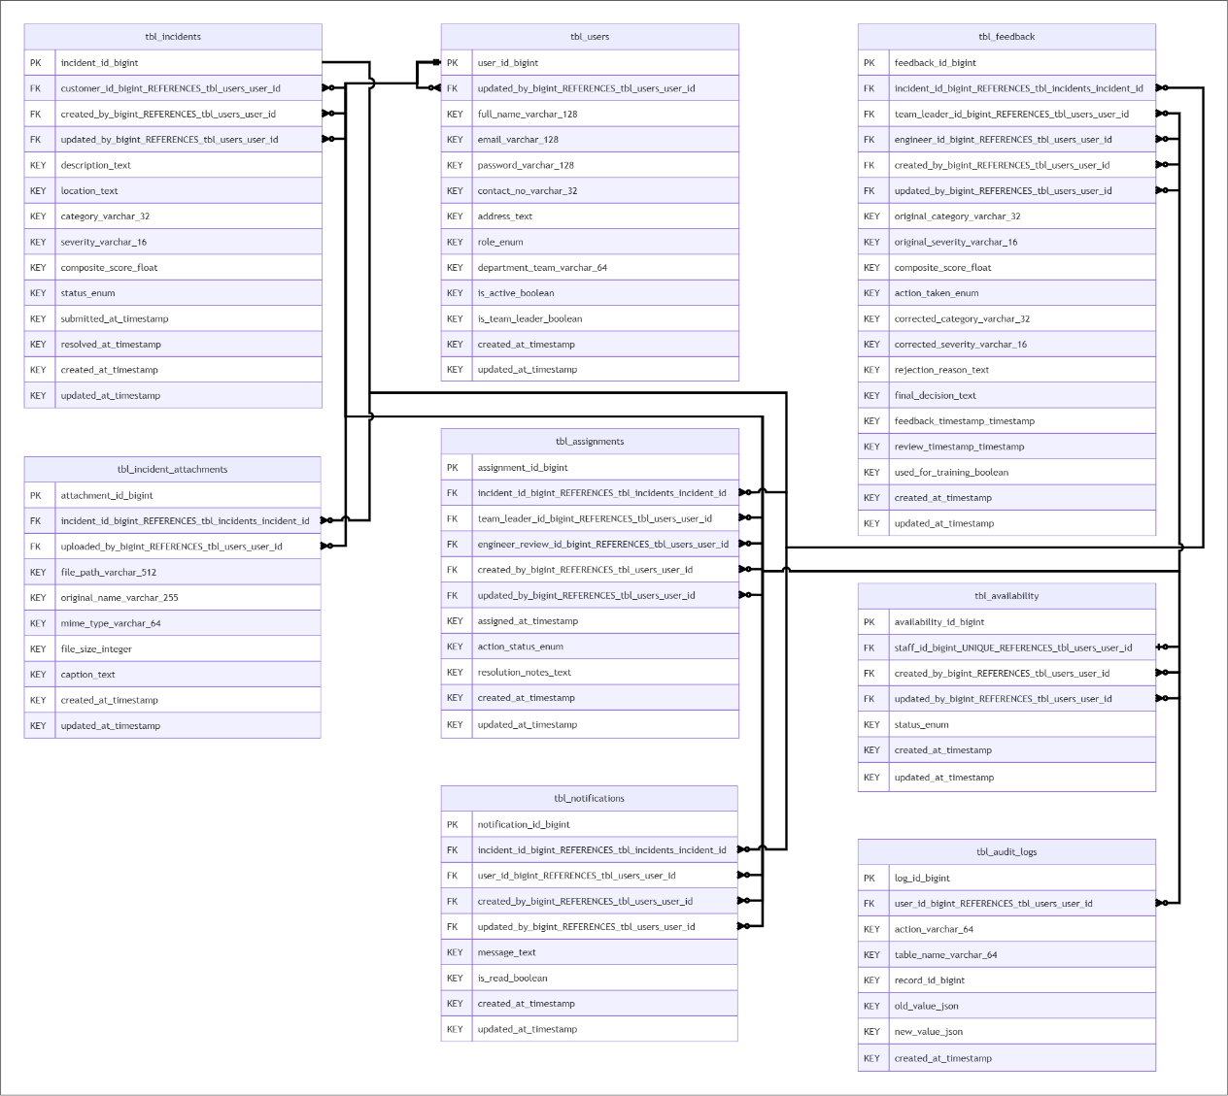
3.7 Entity Relationship Diagram

Figure 45 : Entity Relationship Diagram of the Proposed System
The provided Entity-Relationship Diagram (ERD) visually represents the database structure of the proposed Incident Management and Routing App and Web System for Water Services Using Natural Language Processing (IMRAWS-NLP), illustrating eight core tables, namely tbl_users, tbl_incidents, tbl_assignments, tbl_notifications, tbl_availability, tbl_feedback, tbl_audit_logs, and tbl_incident_attachments, and their interconnections through primary and foreign key relationships. Each table contains specific attributes, with primary keys uniquely identifying records within each table and foreign keys establishing links between related tables. These relationships ensure data integrity, support role-based access control, and enable efficient retrieval of records across the entire incident management workflow.

The central table, tbl_users, serves as the backbone of the database, storing essential user information including full_name, email, password, contact_no, address, role, department_team, is_active, is_team_leader, updated_by, created_at, and updated_at, with user_id as its primary key. The is_team_leader Boolean field distinguishes Team Leaders from regular Offsite Staff, supporting the multi-tier routing logic of the system. This table is referenced by nearly all other tables, reflecting the role-based nature of the proposed system.

The tbl_incidents table records all customer-submitted complaints, capturing fields such as description, location, category, severity, composite_score, status, submitted_at, resolved_at, created_by, created_at, updated_by, and updated_at. Its customer_id field serves as a foreign key referencing tbl_users, linking each incident to the customer who filed it.

The tbl_incident_attachments table stores photo proof and file attachments uploaded by offsite staff during the incident resolution process. It references tbl_incidents via incident_id as a foreign key to link attachments directly to the reported complaint, and references tbl_users via uploaded_by to track which staff member provided the documentation. The table captures the file_path, original_name, mime_type, file_size, and an optional caption, along with created_at and updated_at timestamps to ensure complete traceability of visual evidence supporting incident handling.

The tbl_assignments table manages the routing and assignment of incidents, containing foreign keys for incident_id referencing tbl_incidents, and team_leader_id and engineer_review_id both referencing tbl_users, alongside the fields assigned_at, action_status, resolution_notes, created_by, created_at, updated_by, and updated_at. This table reflects the multi-tier assignment and adjudication workflow of the system.

The tbl_notifications table handles system-generated alerts, with foreign keys for incident_id and user_id linking each notification to the relevant incident and user. It stores the notification message, read status via is_read, created_by, created_at, updated_by, and updated_at to track when alerts were issued and last modified.

The tbl_availability table tracks the real-time availability of Offsite Staff, with staff_id defined as a unique foreign key referencing tbl_users, alongside status, created_by, created_at, updated_by, and updated_at fields. The status field reflects the current availability state of each Offsite Team Leader, enabling the AI-driven routing module to make accurate and timely assignment decisions based on who is currently active and accessible. The created_by and created_at fields record who initially registered the availability entry and when it was created, while the updated_by and updated_at fields capture the most recent modification to the record, ensuring that any changes to a staff member's availability status are fully traceable. Together, these fields allow the system to maintain an accurate and auditable log of staff availability throughout the incident management lifecycle.

The tbl_feedback table supports the Human-in-the-Loop (HITL) mechanism by logging corrective feedback on NLP classification decisions. It references incident_id from tbl_incidents and both team_leader_id and engineer_id from tbl_users, establishing full traceability across the feedback chain. It stores original_category, original_severity, composite_score, action_taken, corrected_category, corrected_severity, rejection_reason, final_decision, feedback_timestamp, review_timestamp, used_for_training, created_by, created_at, updated_by, and updated_at to indicate whether the feedback entry has been incorporated into the NLP model retraining pipeline.

The tbl_audit_logs table provides a complete record of all significant system events and user actions performed within the platform. It is linked to tbl_users through user_id as a foreign key, associating every logged entry with the specific user who triggered the action. Each record captures the action performed via the action field, the name of the affected table through table_name, the specific record involved via record_id, the previous state of the data in old_value, the new state of the data in new_value, and the exact moment the event occurred through created_at. This table supports system monitoring, administrative accountability, and forensic review, enabling engineers and administrators to trace the full history of routing decisions, classification corrections, and data modifications across the entire incident management lifecycle.
3.8 Use Case Diagram
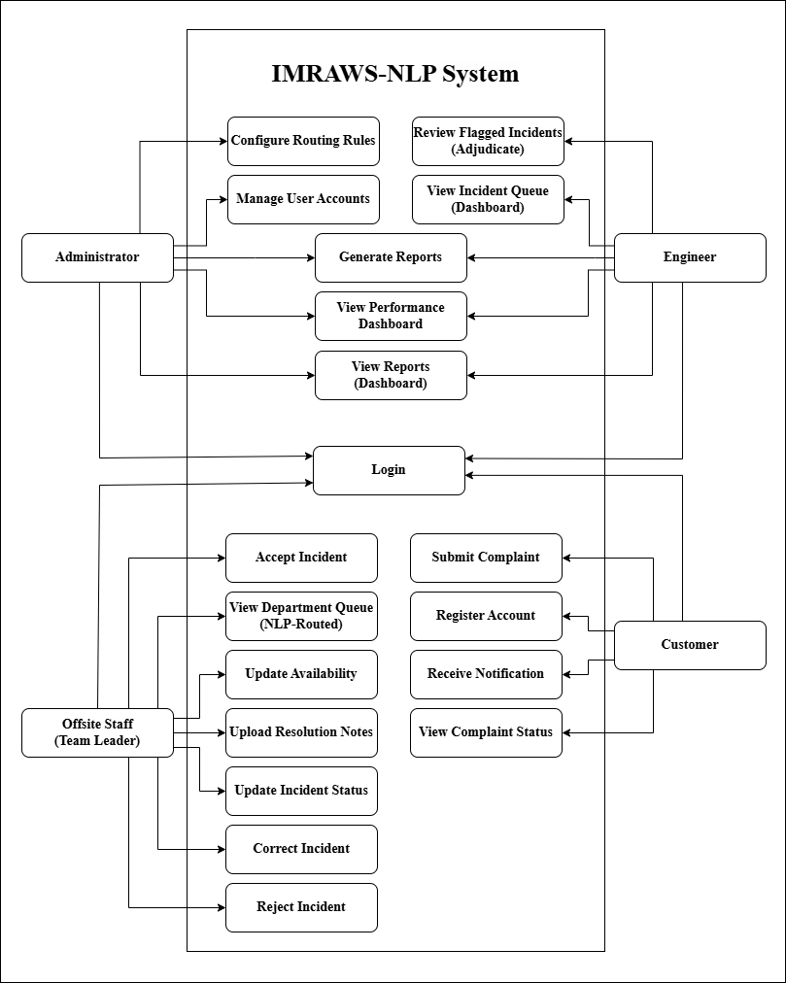
Figure 46: Use Case Diagram of the Proposed System
Figure 46 illustrates the Use Case Diagram of the proposed Incident Management and Routing App and Web System for Water Services Using Natural Language Processing (IMRAWS-NLP), showing how four primary users Administrator, Engineer, Offsite Staff (Team Leader), and Customer interact with the system’s core functionalities within a unified platform.
The Customer interacts with the system through essential services such as Register Account, Submit Complaint, Receive Notification, and View Complaint Status. These use cases represent the user-facing side of the system, allowing customers to report water-related issues and monitor the progress of their complaints in real time.
The Offsite Staff (Team Leader) is responsible for handling and processing incidents at the operational level. This role includes Accept Incident, View Department Queue (NLP-Routed), Update Availability, Upload Resolution Notes, Update Incident Status, Correct Incident, and Reject Incident. These functions support the complaint resolution workflow, enabling team leaders to manage assigned incidents, respond to NLP-routed tasks, and provide corrective feedback through the Human-in-the-Loop HITL process.
The Engineer focuses on monitoring, validation, and decision-making within the system. The available use cases include Review Flagged Incidents (Adjudicate), View Incident Queue (Dashboard), Generate Reports, View Performance Dashboard, and View Reports (Dashboard). These functions allow engineers to review escalated or flagged incidents, oversee system operations, and evaluate performance metrics.
The Administrator holds the highest level of authority, managing system configuration and user control. This role includes View Routing Configuration and Manage User Accounts, while also sharing access to Generate Reports, View Performance Dashboard, and View Reports (Dashboard) with the Engineer. These capabilities ensure proper system setup, maintenance, and overall supervision
3.9 Data Dictionary
The data dictionary defines the physical structure of the IMRAWS-NLP database as implemented in the system. For each of the eight (8) core tables, it enumerates the field name, the data type used in PostgreSQL, the key or constraint applied, and a description of the purpose of the field.
Table 3.9.1: Data Dictionary - tbl_users (User Accounts)
Field Name | Data Type | Constraint / Key | Description
id | bigint | Primary Key, Auto-Increment | Unique identifier of each user account
full_name | varchar(128) | Not Null | Full name of the user
email | varchar(128) | Not Null, Unique | Email address used for login and identification
password | varchar(128) | Not Null | Bcrypt-hashed password of the user
contact_no | varchar(32) | Nullable | Contact number of the user
address | text | Nullable | Address of the customer or staff
role | enum: customer/administrator/engineer/offsite_staff | Not Null, Default customer | System role that governs access rights
department_team | varchar(64) | Nullable | Assigned department or team (billing, metering, water_quality, operations)
is_active | boolean | Not Null, Default true | Indicates whether the account is active or deactivated
is_team_leader | boolean | Not Null, Default false | Identifies offsite staff who act as team leaders
updated_by | bigint | Nullable, FK -> users(id) | User who last modified the record
created_at | timestamp | Nullable | Timestamp when the record was created
updated_at | timestamp | Nullable | Timestamp when the record was last updated

Table 3.9.2: Data Dictionary - tbl_incidents (Complaint Incidents)
Field Name | Data Type | Constraint / Key | Description
id | bigint | Primary Key, Auto-Increment | Unique identifier of the complaint incident
customer_id | bigint | Not Null, FK -> users(id) | Customer who filed the complaint
description | text | Not Null | Text description of the complaint
location | text | Nullable | Location of the reported water issue
category | varchar(32) | Nullable | NLP-predicted category (Billing, Water Quality, Metering, Operations)
severity | varchar(16) | Nullable | Severity level (High, Medium, Low)
composite_score | float | Nullable | Composite severity score from sentiment, days pending, and urgency keywords
status | enum: open/assigned/in_progress/resolved/rejected | Not Null, Default open | Lifecycle status of the incident
submitted_at | timestamp | Not Null, Default current | Time the complaint was submitted
resolved_at | timestamp | Nullable | Time the incident was resolved
created_by | bigint | Nullable, FK -> users(id) | User who created the record
updated_by | bigint | Nullable, FK -> users(id) | User who last updated the record
created_at | timestamp | Nullable | Timestamp when the record was created
updated_at | timestamp | Nullable | Timestamp when the record was last updated

Table 3.9.3: Data Dictionary - tbl_assignments (Incident Assignments)
Field Name | Data Type | Constraint / Key | Description
id | bigint | Primary Key, Auto-Increment | Unique identifier of the assignment record
incident_id | bigint | Not Null, FK -> tbl_incidents(id) | Incident assigned to the team leader
team_leader_id | bigint | Not Null, FK -> users(id) | Offsite team leader to whom the incident was routed
engineer_review_id | bigint | Nullable, FK -> users(id) | Engineer who reviewed the flagged incident
assigned_at | timestamp | Not Null, Default current | Time the incident was assigned
action_status | enum: pending/accept/reject/correct/override/reassign/assigned/in_progress/resolved | Not Null, Default assigned | Current action status of the assignment
resolution_notes | text | Nullable | Notes captured during resolution
created_by | bigint | Nullable, FK -> users(id) | User who created the record
updated_by | bigint | Nullable, FK -> users(id) | User who last updated the record
created_at | timestamp | Nullable | Timestamp when the record was created
updated_at | timestamp | Nullable | Timestamp when the record was last updated
Table 3.9.4: Data Dictionary - tbl_notifications (System Notifications)
Field Name | Data Type | Constraint / Key | Description
id | bigint | Primary Key, Auto-Increment | Unique identifier of the notification
incident_id | bigint | Not Null, FK -> tbl_incidents(id) | Incident related to the notification
user_id | bigint | Not Null, FK -> users(id) | Recipient of the notification
message | text | Not Null | Content of the notification message
is_read | boolean | Not Null, Default false | Whether the recipient has read the notification
created_by | bigint | Nullable, FK -> users(id) | User who created the record
updated_by | bigint | Nullable, FK -> users(id) | User who last updated the record
created_at | timestamp | Nullable | Timestamp when the record was created
updated_at | timestamp | Nullable | Timestamp when the record was last updated

Table 3.9.5: Data Dictionary - tbl_availability (Staff Availability)
Field Name | Data Type | Constraint / Key | Description
id | bigint | Primary Key, Auto-Increment | Unique identifier of the availability record
staff_id | bigint | Not Null, Unique, FK -> users(id) | Offsite staff member whose availability is tracked
status | enum: available/on_duty/unavailable/on_break | Not Null, Default unavailable | Current availability state of the staff member
created_by | bigint | Nullable, FK -> users(id) | User who created the record
updated_by | bigint | Nullable, FK -> users(id) | User who last updated the record
created_at | timestamp | Nullable | Timestamp when the record was created
updated_at | timestamp | Nullable | Timestamp when the record was last updated

Table 3.9.6: Data Dictionary - tbl_feedback (HITL Feedback)
Field Name | Data Type | Constraint / Key | Description
id | bigint | Primary Key, Auto-Increment | Unique identifier of the feedback record
incident_id | bigint | Not Null, FK -> tbl_incidents(id) | Incident that produced the feedback
team_leader_id | bigint | Nullable, FK -> users(id) | Team leader who provided the feedback
engineer_id | bigint | Nullable, FK -> users(id) | Engineer who rendered the final adjudication
original_category | varchar(32) | Nullable | Category predicted by the NLP module
original_severity | varchar(16) | Nullable | Severity predicted by the NLP module
composite_score | float | Nullable | Composite score at the time of the decision
action_taken | enum: accept/reject/correct/override/reassign | Not Null | Decision taken on the NLP output
corrected_category | varchar(32) | Nullable | Corrected category provided by the human
corrected_severity | varchar(16) | Nullable | Corrected severity provided by the human
rejection_reason | text | Nullable | Justification given for the rejection
final_decision | text | Nullable | Final ruling issued by the engineer
feedback_timestamp | timestamp | Not Null, Default current | Time the feedback was logged
review_timestamp | timestamp | Nullable | Time the engineer reviewed the feedback
used_for_training | boolean | Not Null, Default false | Whether the record is used for NLP retraining
created_by | bigint | Nullable, FK -> users(id) | User who created the record
updated_by | bigint | Nullable, FK -> users(id) | User who last updated the record
created_at | timestamp | Nullable | Timestamp when the record was created
updated_at | timestamp | Nullable | Timestamp when the record was last updated
Table 3.9.7: Data Dictionary - tbl_audit_logs (Audit Trail)
Field Name | Data Type | Constraint / Key | Description
id | bigint | Primary Key, Auto-Increment | Unique identifier of the audit entry
user_id | bigint | Nullable, FK -> users(id) | User who performed the action
action | varchar(64) | Not Null | Type of action performed (login, create, update, delete)
table_name | varchar(64) | Not Null | Name of the affected table
record_id | bigint | Nullable | Primary key of the affected record
old_value | json | Nullable | Previous state of the record
new_value | json | Nullable | New state of the record
created_at | timestamp | Not Null, Default current | Time the audit entry was created
Table 3.9.8: Data Dictionary - tbl_incident_attachments (Photo Proof)
Field Name | Data Type | Constraint / Key | Description
id | bigint | Primary Key, Auto-Increment | Unique identifier of the attachment
incident_id | bigint | Not Null, FK -> tbl_incidents(id) | Incident to which the proof belongs
uploaded_by | bigint | Not Null, FK -> users(id) | Team leader who uploaded the proof
file_path | varchar(512) | Not Null | Storage path of the attachment file
original_name | varchar(255) | Not Null | Original file name
mime_type | varchar(64) | Not Null | MIME type of the file
file_size | integer | Not Null | File size in bytes
caption | text | Nullable | Optional caption of the photo proof
created_at | timestamp | Nullable | Timestamp when the record was created
updated_at | timestamp | Nullable | Timestamp when the record was last updated

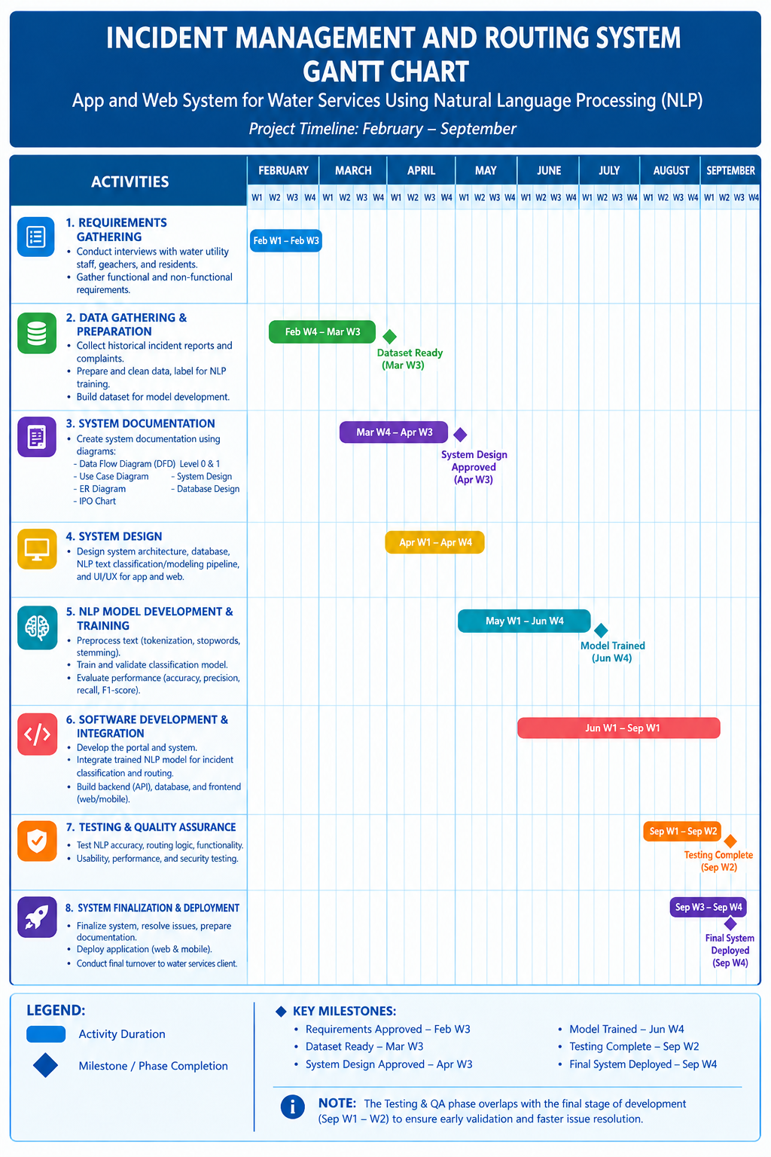
3.10 Gantt Chart
3.11 Roles and Responsibilities
Roles and responsibilities define the functional structure of the research team throughout the system development life cycle (SDLC). For IMRAWS-NLP, each role was assigned to one or more of the researchers, and its core deliverables and duties were carried out across the phases of the Agile methodology described in Section 3.1. The roles established for the project, together with their primary tasks, are presented below.
Project Manager - Oversees the overall project timeline and milestone delivery; coordinates the members of the research team, the capstone adviser, and the water service provider; prepares progress reports; and ensures that each Agile sprint produces the required deliverables.
Systems Analyst - Conducts the interviews, questionnaires, and process walkthrough described in Section 3.3; translates the gathered requirements into system specifications, data flow diagrams, and use cases; and maintains the consistency between the documented requirements and the implemented system.
Database Designer - Designs and administers the PostgreSQL database, including the eight core tables and their relationships, primary and foreign keys, constraints, and role-related fields; executes database migrations; and performs data integrity and consistency tests.
Backend Developer (Laravel) - Develops the application programming interface (API) and the business logic of the system, including JWT-based authentication, role-based access control (RBAC) middleware, the incident lifecycle, AI-driven assignment, human-in-the-loop adjudication, notifications, and report analytics endpoints.
Mobile Developer (Flutter) - Builds the Android mobile application for the Customer and Offsite Staff, covering registration and login, complaint submission, status tracking, notification viewing, the availability toggle, the incident queue, resolution notes, and photo proof attachments.
Web Portal Developer - Builds the Administrator and Engineer web portal, including the report dashboards, user account management, the incident queue, the flagged incident adjudication panel, the routing configuration view, and the report interfaces.
AI and NLP Developer (Python) - Implements the text pre-processing, the NLP classification of complaints into the Billing, Water Quality, Metering, and Operations categories, the sentiment analysis module, and the composite severity scoring; exposes the service through the FastAPI microservice; and supports the retraining of the model from human-in-the-loop feedback records.
Quality Assurance Tester - Validates each sprint deliverable against its acceptance criteria; performs functional testing across the four user roles; verifies the enforcement of RBAC restrictions; tracks and documents defects; and prepares the test scenarios used during the evaluation demonstration.
Statistical Analyst - Prepares the Project Evaluation Tool based on the ISO/IEC 25010 software quality model; administers the evaluation questionnaire to the evaluators; computes the weighted mean of the responses; and interprets the results using the Likert scale interpretation table.
Capstone Adviser - Provides guidance, technical review, and approval of the system design and documentation; monitors the progress of the researchers in each phase; and evaluates the completeness and quality of every deliverable.
3.12 Evaluation Procedure
The researchers will develop a Project Evaluation Tool in the form of a structured questionnaire. The questionnaire is designed based on the ISO/IEC 25010 software quality model, which is the industry standard for evaluating system and software quality. The instrument is divided into five (5) key criteria:
Functional Suitability: Measures whether the system provides functions that meet stated and implied needs (e.g., successful complaint submission, accurate routing, correct RBAC restrictions).
Performance Efficiency: Measures the responsiveness and processing time of the NLP classification and complaint routing features.
Usability: Measures the ease of use, interface intuitiveness, and user experience of both the mobile app and web portal.
Reliability: Measures the system's ability to maintain specified performance under normal operation (e.g., consistent database transactions, accurate status updates).
Security: Measures the effectiveness of authentication mechanisms and Role-Based Access Control (RBAC) in protecting user data.

Table 3.12.1: Project Evaluation Questionnaire
No. | Criteria / Statement | 5 | 4 | 3 | 2 | 1
A. Functional Suitability
1 | The mobile application allows customers to successfully register an account and log in.
2 | The system accurately classifies complaint text into the correct predefined category (Billing, Water Quality, Metering, Operations) using NLP.
3 | The system correctly assigns severity levels (High, Medium, Low) based on sentiment analysis of the complaint text.
4 | The Engineer web portal correctly displays the queue of classified incidents pending review and assignment.
5 | Offsite Staff can successfully update their availability status (Available, On Duty, Unavailable, On Break) via the mobile app.
6 | The Administrator can successfully create, update, and deactivate user accounts through the web portal.
7 | Customers can pin the exact location of the complaint using the integrated map location picker.
8 | Offsite Staff can update the status (Accept, Reject, Correct, In Progress, Resolved) of any assigned complaint, not only the newest one.
9 | Offsite Staff can view resolved and rejected complaints in the Complaint History section.
10 | Correcting a complaint category from the web portal immediately re-routes it to the best available staff in the correct department.
11 | Users receive real-time notifications for complaint assignment, status changes, and adjudication decisions.
12 | Users can change their account password from the mobile application Settings.
B. Performance Efficiency
1 | The NLP classification process returns a result within an acceptable response time (under 3 seconds).
2 | The mobile application loads complaint history and status updates without significant lag.
3 | The web portal dashboards refresh and display updated incident data efficiently.
4 | Notifications and real-time status updates are delivered to users quickly after each action.
C. Usability
1 | The mobile application interface is intuitive and easy for customers to navigate.
2 | The web portal interface is well-organized, making it easy for Engineers to monitor and assign incidents.
3 | The availability toggle feature for Offsite Staff is straightforward and quick to use.
4 | Text sizes, buttons, and color schemes are visually appropriate and readable.
5 | Color-coded category dropdowns make it easy to identify complaint categories across the web portal.
6 | The Complaint History tab makes it easy to track past resolved and rejected complaints.
D. Reliability
1 | Customer complaint submissions are saved successfully to the centralized database without data loss.
2 | Status updates made by Offsite Staff (In Progress, Resolved) are reflected accurately in real-time for all users.
3 | The system behaves consistently when multiple users access it concurrently (e.g., multiple complaints submitted at once).
4 | Assignment records and statuses remain accurate after staff actions such as Accept, Reject, and Correct.
E. Security
1 | Users cannot access pages or features restricted to other roles (e.g., Customer cannot access the Engineer dashboard).
2 | User authentication (email and password) effectively prevents unauthorized access.
Likert Scale and Interpretation
The responses will be measured using a 5-point Likert Scale. The weighted mean will be calculated for each criterion and for the overall system evaluation.
Table 3.12.2: Likert Scale and Interpretation
Scale | Range | Interpretation
5 | 4.21 - 5.00 | Acceptable
4 | 3.41 - 4.20 | Slightly Acceptable
3 | 2.61 - 3.40 | Neutral
2 | 1.81 - 2.60 | Slightly Unacceptable
1 | 1.00 - 1.80 | Unacceptable
Data Analysis Procedure
Data Collection The questionnaire will be administered to the twenty-five (25) evaluators immediately following the system demonstration. Evaluators will be given time to interact with the prototype before completing the form.
Statistical Treatment The researchers will compute the Weighted Mean for each individual statement and for each of the five criteria categories. The formula for the weighted mean is:

Weighted Mean = Σ(f × w) / n
where:
f = frequency of responses for each scale point
w = weight assigned to the scale point (5, 4, 3, 2, 1)
n = total number of respondents (25)
Interpretation The computed weighted mean for each item will be mapped to the Likert scale interpretation table above. The evaluation will be considered successful if the overall weighted mean across all criteria falls within the "Slightly Acceptable" range (3.41 - 4.20) or higher, indicating that the prototype meets the functional and non-functional requirements defined for the Incident Management and Routing App and Web System.
3.13 Ethical Standard and Considerations
The researchers observed appropriate ethical standards throughout the planning, development, implementation, testing, and evaluation of the proposed system. The researchers recognized their responsibility to protect the rights, privacy, confidentiality, and welfare of the individuals and organization involved in the study. All information gathered from the beneficiary, respondents, and other stakeholders was treated responsibly and was used only for purposes directly related to the development and evaluation of the proposed system.
In addition, the researchers adhered to the following ethical standards and considerations throughout the conduct of the study:
Informed Consent and Voluntary Participation - The water service personnel who participated in the interviews, the questionnaire survey, and the system evaluation were informed of the purpose and the procedures of the study. Participation was strictly voluntary, and the participants were given the option to withdraw at any time without any consequence to them.
Privacy and Confidentiality - The personal information of the participants and the complaint records submitted to the system were treated as confidential. Access to the data is limited to authorized users through the role-based access control (RBAC) mechanism, and the data were used only for purposes directly related to the study.
Data Privacy Act Compliance - The collection, processing, and storage of personal and complaint data comply with the provisions of the Data Privacy Act of 2012 (Republic Act No. 10173). The data are stored securely, retained only for the duration of the study, and disposed of properly after the completion of the research.
Non-Maleficence - The data gathering and system testing activities were designed to avoid any harm or disruption to the operations of the water service provider. No sensitive information belonging to third parties was exposed at any point during the study.
Integrity of Findings - The researchers reported the gathered data and the evaluation results truthfully. No data were fabricated, falsified, or manipulated, and any errors encountered during testing were documented accurately.
Acknowledgement of Sources - All literature, tools, frameworks, and materials used in the study and in the development of the system are properly cited and acknowledged. The researchers do not claim ownership of any previously published or authored content.

CHAPTER IV
RESULTS AND DISCUSSIONS
4.1 Development and Testing
4.1.1 Unit Testing
Unit testing was performed on the backend of the system to verify that its core services behave as expected before integration. The tests were implemented using the PHPUnit testing framework integrated with the Laravel framework and were executed in the local development environment against an isolated test database so that they would not affect the live data.
The automated test cases focused on the authentication and access-control layer of the system. One feature test verified that a guest, or unauthenticated user, is automatically redirected to the login page when attempting to access the main application, thereby confirming that protected routes cannot be reached without a valid session. A baseline unit test was also executed to confirm that the test environment itself was correctly configured. All executed test cases passed, indicating that the authentication guard and the role-based access control restrictions of the system are functioning as intended.
4.1.2 User Acceptance Testing
User Acceptance Testing (UAT) was conducted to determine whether the developed system satisfies the needs and expectations of its intended users. During the evaluation, the system was demonstrated to the evaluators, who were given time to interact with the actual mobile application and web portal. The evaluators tested the key features of the
system, which include complaint submission, NLP-based classification and severity assessment, automatic complaint routing, staff availability management, and incident resolution and adjudication.
Immediately after the demonstration, the evaluators completed the Project Evaluation Tool, a structured questionnaire designed based on the ISO/IEC 25010 software quality model. The questionnaire is composed of twenty-eight (28) statements distributed across five evaluation criteria: Functional Suitability (twelve statements), Performance Efficiency (four), Usability (six), Reliability (four), and Security (two). A total of twenty-five (25) evaluators completed the evaluation form, and all responses were collected through Google Forms.
4.2 Evaluation Result
This section presents the results of the user evaluation conducted to measure the quality of the developed system based on the ISO/IEC 25010 software quality model. Each evaluator rated the system using a five-point Likert scale, where 5 corresponds to Strongly Agree and 1 corresponds to Strongly Disagree. Table 4.1 presents the summary of the weighted mean for each evaluation criterion.
Table 4.1: Summary of Evaluation Results per Criterion
Criterion | Number of Items | Weighted Mean | Interpretation
Functional Suitability | 12 | 4.48 | Acceptable
Performance Efficiency | 4 | 4.40 | Acceptable
Usability | 6 | 4.46 | Acceptable
Reliability | 4 | 4.36 | Acceptable
Security | 2 | 4.48 | Acceptable
Overall Weighted Mean | 28 | 4.45 | Acceptable
4.2.1 Data Interpretation
The gathered responses were analyzed using the weighted mean. For each statement, the weighted mean was computed by dividing the summation of the product of the frequency of each response and its corresponding weight by the total number of respondents. The resulting weighted means were then interpreted using the Likert scale presented in Table 3.12.2. Table 4.2 presents the weighted mean and verbal interpretation of each statement in the evaluation questionnaire.
Table 4.2: Weighted Mean of Evaluation Results per Statement
No. | Criteria / Statement | Weighted Mean | Interpretation
A. Functional Suitability
1 | The mobile application allows customers to successfully register an account and log in. | 4.52 | Acceptable
2 | The system accurately classifies complaint text into the correct predefined category (Billing, Water Quality, Metering, Operations) using NLP. | 4.36 | Acceptable
3 | The system correctly assigns severity levels (High, Medium, Low) based on sentiment analysis of the complaint text. | 4.48 | Acceptable
4 | The Engineer web portal correctly displays the queue of classified incidents pending review and assignment. | 4.64 | Acceptable
5 | Offsite Staff can successfully update their availability status (Available, On Duty, Unavailable, On Break) via the mobile app. | 4.52 | Acceptable
6 | The Administrator can successfully create, update, and deactivate user accounts through the web portal. | 4.64 | Acceptable
7 | Customers can pin the exact location of the complaint using the integrated map location picker. | 4.00 | Slightly Acceptable
8 | Offsite Staff can update the status (Accept, Reject, Correct, In Progress, Resolved) of any assigned complaint, not only the newest one. | 4.48 | Acceptable
9 | Offsite Staff can view resolved and rejected complaints in the Complaint History section. | 4.60 | Acceptable
10 | Correcting a complaint category from the web portal immediately re-routes it to the best available staff in the correct department. | 4.40 | Acceptable
11 | Users receive real-time notifications for complaint assignment, status changes, and adjudication decisions. | 4.36 | Acceptable
12 | Users can change their account password from the mobile application Settings. | 4.72 | Acceptable
B. Performance Efficiency
1 | The NLP classification process returns a result within an acceptable response time (under 3 seconds). | 4.24 | Acceptable
2 | The mobile application loads complaint history and status updates without significant lag. | 4.40 | Acceptable
3 | The web portal dashboards refresh and display updated incident data efficiently. | 4.64 | Acceptable
4 | Notifications and real-time status updates are delivered to users quickly after each action. | 4.32 | Acceptable
C. Usability
1 | The mobile application interface is intuitive and easy for customers to navigate. | 4.56 | Acceptable
2 | The web portal interface is well-organized, making it easy for Engineers to monitor and assign incidents. | 4.44 | Acceptable
3 | The availability toggle feature for Offsite Staff is straightforward and quick to use. | 4.48 | Acceptable
4 | Text sizes, buttons, and color schemes are visually appropriate and readable. | 4.48 | Acceptable
5 | Color-coded category dropdowns make it easy to identify complaint categories across the web portal. | 4.40 | Acceptable
6 | The Complaint History tab makes it easy to track past resolved and rejected complaints. | 4.40 | Acceptable
D. Reliability
1 | Customer complaint submissions are saved successfully to the centralized database without data loss. | 4.28 | Acceptable
2 | Status updates made by Offsite Staff (In Progress, Resolved) are reflected accurately in real-time for all users. | 4.52 | Acceptable
3 | The system behaves consistently when multiple users access it concurrently (e.g., multiple complaints submitted at once). | 4.36 | Acceptable
4 | Assignment records and statuses remain accurate after staff actions such as Accept, Reject, and Correct. | 4.28 | Acceptable
E. Security
1 | Users cannot access pages or features restricted to other roles (e.g., Customer cannot access the Engineer dashboard). | 4.44 | Acceptable
2 | User authentication (email and password) effectively prevents unauthorized access. | 4.52 | Acceptable
Under Functional Suitability, the system obtained a weighted mean of 4.48, interpreted as Acceptable. This indicates that the system provides the core functions that meet the needs of its users. The highest rated statements were the account password change feature (4.72), and the administrator ability to manage user accounts and the engineer portal queue display, both at 4.64. The map location pinning feature received the lowest mean of 4.00, still within the Slightly Acceptable range, indicating that the feature operates but can be further improved.
Under Performance Efficiency, the system obtained a weighted mean of 4.40, interpreted as Acceptable. The efficient refreshing of the web portal dashboards received the highest rating (4.64), while the NLP classification response time received the lowest (4.24). These results indicate that the automated processes of the system complete within an acceptable response time as experienced by the users.
Under Usability, the system obtained a weighted mean of 4.46, interpreted as Acceptable. The clarity of the mobile application interface received the highest rating (4.56), while the color-coded category dropdowns and the Complaint History tab received the lowest (4.40). The results show that the system is easy to learn and navigate for its intended users.
Under Reliability, the system obtained a weighted mean of 4.36, interpreted as Acceptable. The accurate real-time reflection of status updates made by Offsite Staff received the highest rating (4.52), while data integrity and assignment record accuracy each received 4.28. Although this criterion obtained the lowest overall mean among the five criteria, it still falls within the Acceptable range, demonstrating that the system reliably stores data and reflects status changes, with minor room for improvement under heavier system loads.
Under Security, the system obtained a weighted mean of 4.48, interpreted as Acceptable. The authentication mechanism received a mean of 4.52 and the role-based access control received 4.44, confirming that user credentials effectively prevent unauthorized access and that restricted features are not accessible across roles.
Overall, the system obtained a weighted mean of 4.45, interpreted as Acceptable and equivalent to the Acceptable interpretation on the Likert scale. Since the overall weighted mean falls within the Acceptable range (4.21 to 5.00), the evaluation is considered successful, and the developed Incident Management and Routing App and Web System is acceptable to its intended users against the functional and non-functional requirements defined in the study.

CHAPTER V
SUMMARY, CONCLUSIONS AND RECOMMENDATIONS
5.1 Summary of Findings
The project focused on the development of an Incident Management and Routing App and Web System for water services using Natural Language Processing to address the problems associated with the existing manual complaint handling process. The manual process relied on phone calls, emails, and in-person visits, which lacked the structure needed for rapid classification and routing. This resulted in delayed responses, difficulty in monitoring incidents, and inconsistent handling of billing, water quality, metering, and operations complaints.
The primary objective of the project was to develop a system that automates the classification, severity assessment, and routing of customer complaints. Specifically, the project aimed to develop an NLP text classification model, an automated routing module with a human-in-the-loop feedback mechanism, a centralized database with role-based access control, and a sentiment analysis model for severity assignment. The system was designed for four types of users: the Customer, the Engineer, the Offsite Staff, and the Administrator. The system was developed using the Laravel framework for the backend, a Flutter-based mobile application for customers and offsite staff, and NLP-based models for text classification and sentiment analysis, following an iterative development and testing process.
The completed system provides a mobile application that allows customers to register, submit complaints with location details, track status in real time, and receive notifications, and allows Offsite Staff to manage their availability, accept or update assigned incidents, and view their complaint history. The web portal enables Engineers to monitor the automated routing, review and approve or correct machine classifications, and adjudicate rejected or corrected assignments, while Administrators manage user accounts, view performance dashboards, and generate reports. NLP-backed features automatically classify complaint text into predefined categories, determine severity levels, and route each complaint to the appropriate team.
After implementation, the system underwent unit testing on the backend to verify its authentication and access control behavior, and user acceptance testing in which the completed system was demonstrated to its intended users. The evaluation was conducted using a twenty-eight statement questionnaire based on the ISO/IEC 25010 software quality model, which was answered by twenty-five (25) evaluators.
The results of the unit testing indicated that the authentication and role-based access control mechanisms of the system operated as expected. The user evaluation produced an overall weighted mean of 4.45, interpreted as Acceptable, and all five evaluation criteria received Acceptable ratings. Overall, the project successfully produced a functional system that addresses the identified problems in complaint classification, routing, and resolution for water services.
5.2 Conclusions
Based on the findings and evaluation results of the study, the researchers conclude that the developed Incident Management and Routing App and Web System using Natural Language Processing successfully addressed the identified problems in the manual complaint handling process of the water service. The system automated the submission, classification, severity assessment, routing, tracking, and resolution of customer complaints.
The system successfully developed and integrated a Natural Language Processing model that automatically classifies customer complaints into the predefined incident categories. The classification of complaint text into the correct category received a weighted mean of 4.36, interpreted as Acceptable, which indicates that the model performs its intended function for the complaints tested.
The system successfully implemented an automated routing module that assigns classified complaints directly to the appropriate team based on incident category and departmental alignment. The category-correction feature and its immediate re-routing received a weighted mean of 4.40, confirming that the routing process operates correctly and is supported by a human-in-the-loop mechanism that allows Engineers to review, approve, or correct machine assignments.
The system successfully established a centralized database with Role-Based Access Control for Customers, Engineers, Offsite Staff, and Administrators. The unit tests confirmed that unauthenticated users are blocked from protected routes, and the evaluation results showed that users cannot access features restricted to other roles (4.44) and that authentication effectively prevents unauthorized access (4.52), both interpreted as Acceptable.
The system successfully implemented a sentiment analysis model that evaluates complaint text and assigns corresponding severity levels. The accurate assignment of severity levels received a weighted mean of 4.48, interpreted as Acceptable, confirming that urgent complaints can be properly prioritized.
Overall, the user evaluation produced an overall weighted mean of 4.45, interpreted as Acceptable, with all five criteria, namely Functional Suitability, Performance Efficiency, Usability, Reliability, and Security, rated Acceptable. The researchers therefore conclude that the developed system is acceptable to its intended users and that the objectives of the study were substantially achieved through the successful development, implementation, testing, and evaluation of the proposed system.
5.3 Recommendations
Based on the findings, conclusions, and the limitations observed during the study, the researchers recommend the following:
1. On-Site Deployment. It is recommended that the developed system be deployed on the servers of the water service provider and integrated with its existing records so that complaint data can be used directly in day-to-day operations.
2. Improved Location Pinning. Future developers may enhance the map location pinning feature, which received the lowest rating in the evaluation, by improving location search accuracy, automatic geolocation retrieval, and offline support.
3. Expanded NLP Coverage. Future developers may expand the language model by including additional incident categories and refined department mappings, and by continuously retraining the model using the logged human-in-the-loop corrections to further improve the classification of Filipino and Taglish complaint texts, as well as other local dialects.
4. Notification Fallbacks. Future versions may add email and SMS notification fallbacks so that users are informed of complaint assignments and status updates even when the mobile application is not connected.
5. Performance Testing Under Load. Future researchers may conduct additional performance and load testing with a larger number of concurrent users to further validate the reliability of the system under heavier transaction volumes, since data integrity under concurrent use was rated lower than the other reliability statements.
6. Enhanced Security. Future developers may strengthen the security of the system by implementing multi-factor authentication, password policies, audit logs, and periodic security assessments.
7. Training and Maintenance. The water service provider is encouraged to provide regular training to its administrators, engineers, and offsite staff, and to establish a maintenance and database backup schedule to ensure the continued and effective use of the system.
8. Evaluation with a Larger Sample. Future researchers may conduct an evaluation with a larger sample of respondents across multiple water service providers, and may investigate the long-term impact of the automated routing process on complaint resolution time and customer satisfaction.

