MESB24

Exercise day 1

Have you first tried to answer the questions for yourself?

- Add reactions and simulate production
Q1: What is the maximum biochemical biliverdin yield in E. coli? (Think about the units!)
A1: The FBA solution is 1.3295. The constraints that we apply to GEMs are typically in mmol/gDCW/h, so the output flux is in the same unit. The question here asks for the biliverdin yield, without explicitly mentioning that it is the yield of biliverdin on glucose. Then, we consider that the glucose uptake was constrained to 10 mmol/gDCW/h, which gives a yield of 1.3195 / 10 = 0.13295 mol/mol. Y_{P/S} = 0.13295.

Q2: Describe what you see in the production envelope graph.
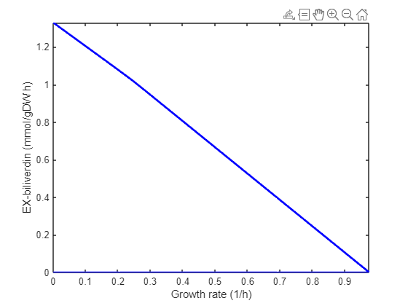
A2: The production envelope is showing the maximum biliverdin production rate and the maximum growth rate, and all potential solutions in between. This is a classical production envelope.

Q3: What challenges will you encounter when you add the required reactions to the model?
A3: You do not know the exact reactions that transform the precursors of the pathway to the final product. You see in the code for biliverdin that you precisely need to define what products and substrates are involved in each reaction. Even if you’d identified the metabolic intermediates of this pathway, you should also know if (and which) cofactors are involved, for instance NAD(P)H. All of this information is likely not known for the gene cluster that you’re studying. This is the biggest challenge. Other problems might be that you do not know if the pathway will be localized to a particular organelle (this might change the behaviour of the model), or you would know the exact gene associations for each reaction. The latter is not critical to know at this point, note that for biliverdin we also did not specify which genes are coding for the catalysing enzymes. So most important is the exact definitions of the chemical reactions, and potentially their organellar localization.

Dynamic flux balance analysis (dFBA)
Q4: Describe the biliverdin titer and yield. Is the yield the same as the maximum biochemical yield? If not, why not?
A4: The biliverdin titer in the simulation reaches 0.1260 mmol/L after 5 hours. At that time, 12.6 mmol/L of glucose has been consumed. This gives a yield Y_{P/S} of 0.126/12.6 = 0.01 mol/mol. This is much lower than the maximum biochemical yield that was calculated in Q2!
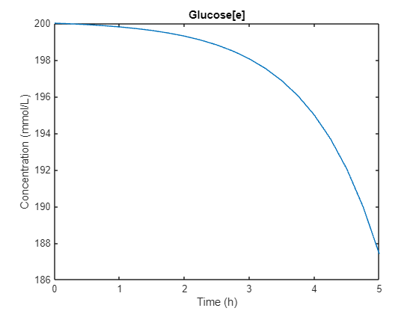
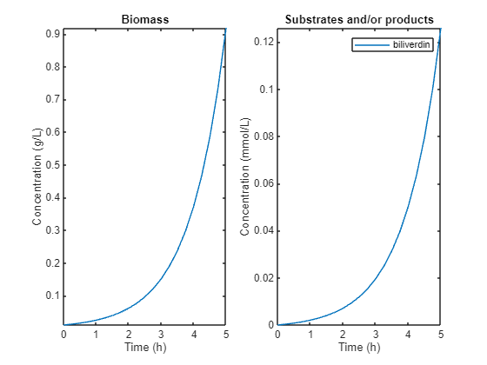
The lower yield is because the cells are not only producing biliverdin in the simulation (and neither would the cells do this in reality). A significant of biomass is produced from the consumed glucose. The production envelope (Q2) clearly demonstrates the competition between growth and biliverdin production (but you would probably have expected this even without having seen the production envelope...).

Q5: Compare and comment on the final biliverdin titers and yields that are reached with a minimum HEMEOX flux of 0.1 mmol/gDCW/h (in Question 4) and 0.5 mmol/gDCW/h (this question).
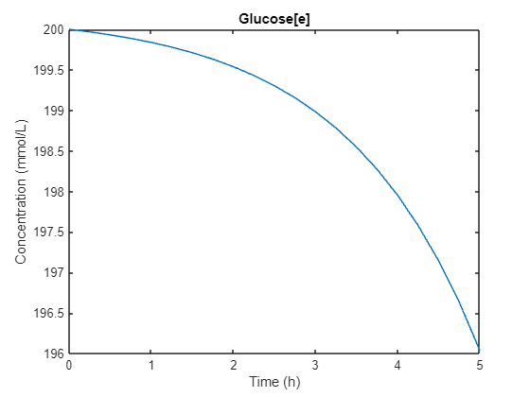
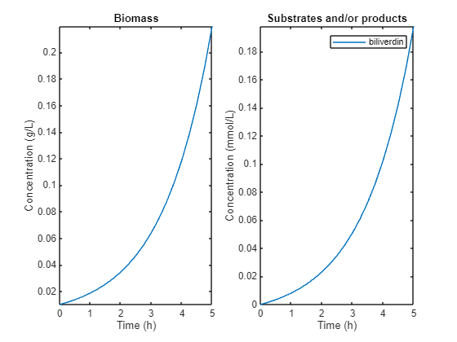
A5: The biliverdin production initially increases to 0.1982 mmol/L when produced at 0.5 mmol/gDCW/h. During that time, only 3.96 mmol/L of glucose is consumed. Together, that gives a yield Y_{P/S} of 0.1982 / 3.96 = 0.0496 mol/mol. As you might have anticipated, more glucose is direct towards biliverdin, resulting in more biliverdin. But will this always increase?

Q6: At what HEMEOX activity do we get the highest biliverdin production? Can you explain what is causing this?
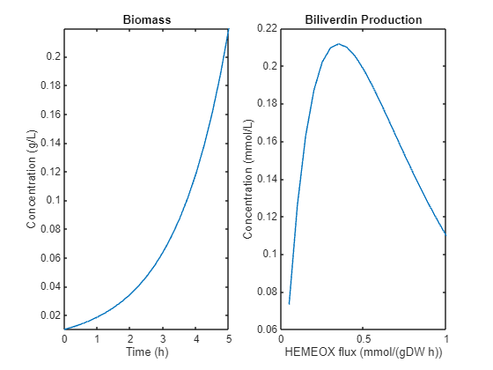
A6: The highest biliverdin production is reached at a production rate of 0.35 mmol/gDCW/h. If the rate gets higher, there will be less biomass, while more biomass would result in a higher overall production rate. Note that the production rate that we fix in the model (e.g. 0.35) is per gram of dry cell weight: having more biomass would result in a higher overall flux. But high biomass cannot be reached if most glucose goes towards biliverdin.

Run FSEOF for overexpression targets
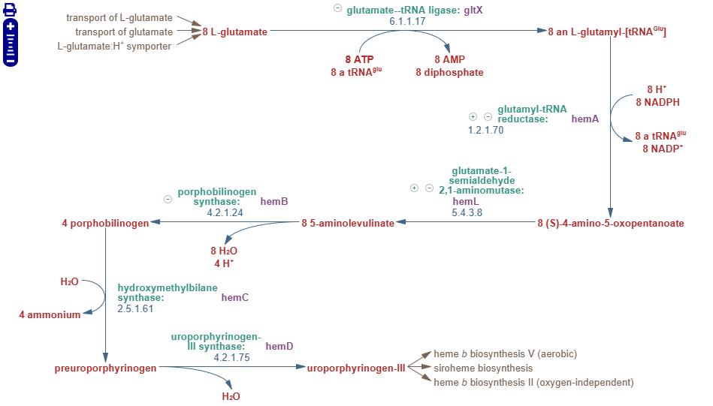
Q7: Can you explain why some of the reactions have a slope of around 8? Why are these slopes not exactly 8? Think about how the FSEOF algorithm works.
A7: To make 1 uroporphyrinogen-III requires 8 glutamate as precursor, as visible in the second link. So for each biliverdin, GLUTRR should run 8 times. But why is the slope slightly less than 8? In FSEOF, we observe what happens if the model moves from making biomass towards making the product of interest. While the biliverdin production increases, the biomass production decreases. The GLUTRR reaction would already have been active for making biomass. When shifting towards biliverdin production, some of that flux towards biomass is "repurposed" to making biliverdin instead, so there is less need for overall increased flux.
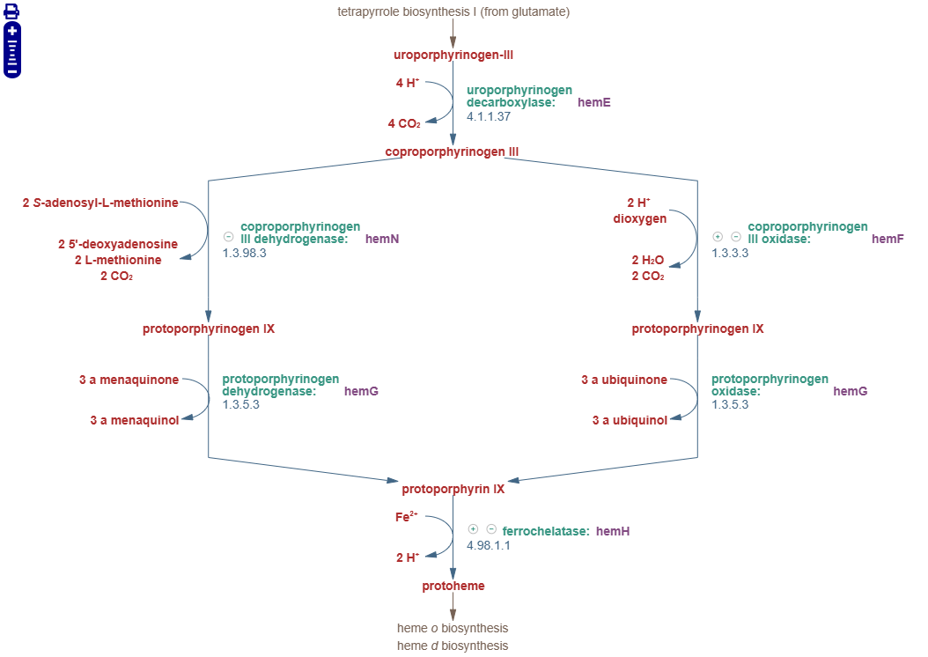

optKnock for knockout targets

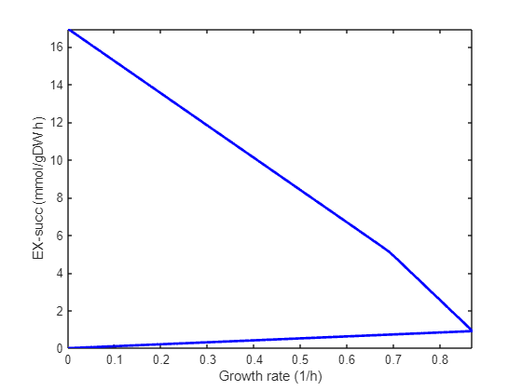
Q8: How does the production envelope show that there is growth-coupled production?
A8: The maximum growth rate (plotted on the x-axis) is reached at a situation where the succinate production (plotted on the y-axis) is non-zero. There is no situation where there is growth, but no succinate production. Or in other words, there are no points where growth-rate is non-zero and EX_succ is zero.

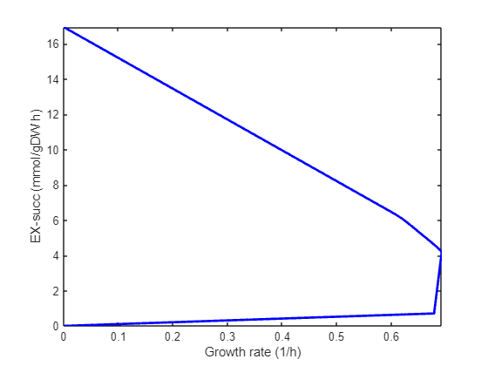
Q9: Describe how the production envelope has changed comparing the triple knockout with the earlier single knockout. Is the optimal solution that is reached after the triple knockout also part of the solution space in the single knockout?
A9: First, to knockout three reactions at the same time, you can run:
modelSucc = setParam(model, 'eq', {'PYK', 'FUM', 'PSP_L'}, 0);
When overlaying the two plots, you see that the solution space of the triple knockout is a subset of the solution space of the single knockout. The optimum point reached in the triple knockout (growth = 0.69 h⁻¹ and EX_succ = 4.22 mmol/gDCW/h) is inside the solution space of the single knockout (there, at growth 0.7 h⁻¹, EX_succ can reach close to 5 mmol/gDCW/h). The maximum EX_succ is identical in both plots, reaching just over 17 mmol/gDCW/h. What this shows is that knockouts always reduce the solution space. When running optimization for growth, then the optimal solution might be different after a knockout, but that same solution could theoretically also be reached without the knockout.

