|  |  |  |
| --- | --- | --- |
| **Enzyme description**  **Supplemetary file: *In silico* pathway analysis and lipid production of *Rhodosporidium toruloides* on mixed substrates**  Metabolic network of *R.toruloides:* The metabolic network of *R.toruloides* has been constructed considering the current knowledge from literature [Liu et al.,(2009), Zhu et al.,(2012) and Kumar et al.,(2012)] and from protein database UniProtKB. Biomass equation is taken from (Gruchattka et al., (2013)). | **ORF/UniProtKB ID** | **Reaction** |
| **Influx** | | |
| Hexose transporter (HXT) | RHTO_03448;RHTO_07706 | --> Gucose[e] |
| Transport |  | --> Glycerol[e] |
| Transport |  | --> Xylose[e] |
| Transport |  | --> Arabinose[e] |
| Transport |  | --> NH3[c] |
| Transport |  | --> SO4[c] |
| Transport |  | --> O2 |
| **Efflux** | | |
| TAG export |  | TAG[c] --> |
| Growth (mmol/gDCW*h) |  | * 1. biomass[c] --> |
| ATP for maintenance |  | ATPmaintenance[c] --> |
| Carbondioxide excretion |  | CO2 --> |
| **Glycolysis** | | |
| Hexokinase (HXK1) | RHTO_06870/M7X0J8 | GLC[c] + ATP --> G6P[c] + ADP |
| Glucose-6-phosphate isomerase (PGI1) | RHTO_04058/M7WNZ9 | G6P[c] <==> F6P[c] |
| 6-phosphofructokinase  (PFK1) | RHTO_00494/M7X6S3 | F6P[c] + ATP --> FBP[c] + ADP |
| Fructose-bisphosphate aldolase (FBA1) | RHTO_03043/M7X5F4 | FBP[c] <==> GAP[c] + DHAP[c] |
| Triosephosphate isomerase (TPI1) | RHTO_01329/M7WME7 | DHAP[c] <==> GAP[c] |
| Glyceraldehyde 3-phosphate dehydrogenase (TDH) | RHTO_03746/M7WI96 | GAP[c] + NAD[c] <==> 13-PG[c] + NADH[c] |
| Glycerol-3-phosphate dehydrogenase (GPD1) | RHTO_02273 /M7WSY9 | DHAP[c] + NADH[c] <==> NAD[c] + GLYC3P[c] |
| Phosphoglycerate kinase (PGK1) | RHTO_00033/M7X689 | ADP + 13-PG[c] <==> ATP + 3-PG[c] |
| Phosphoglycerate mutase (GPM1) | RHTO_03049/M7X4R8;  RHTO_04793/M7XL58 | 3-PG[c] <==> 2-PG[c] |
| Enolase(ENO1) | RHTO_00323/M7X749 | 2-PG[c] <==> PEP[c] |
| Pyruvate kinase (PYK1) | RHTO_01610/ M7WUI5 | PEP[c] + ADP --> PYR[c] + ATP |
| **Pentose phosphate pathway** | | |
| Glucose -6-phosphate 1- dehydrogenase (ZWF1) | RHTO_07853/ M7WR01 | G6P[c] + NADP[c] --> 6-P-Gluconate[c] + NADPH[c] |
| 6-phosphogluconate dehydrogenase (GND) | RHTO_02788/ M7X3Z4 | 6-P-Gluconate[c] + NADP[c] --> RIB-5P[c] + CO2 + NADPH[c] |
| Ribose 5-phosphate isomerase A (RKI1) | RHTO_06311/ M7WUP8 | Ribulose-5-P[c] <==> Ribose-5-P[c] |
| Ribulose-phosphate 3-epimerase (RPE1) | RHTO_05984/ M7XEA2 | Ribulose-5-P[c] <==> Xylulose-5-P[c] |
| Transketolase (TKL1,2) | RHTO_03248/M7XNL9 | Ribulose-5-P [c] + Xylulose-5-P[c] <==> GAP[c] + S7P[c] |
| Transaldolase (NOM1) | RHTO_06955/M7X0R7 | GAP[c] + S7P[c] <==> E4P[c] + F6P[c] |
| Transketolase (TKL1,2) | RHTO_03248/M7XNL9 | E4P[c] + Xylulose-5P[c] <==> GAP[c] + F6P[c] |
| **TCA cycle** | | |
| Pyruvate dehydrogenase complex (PDB, LAT1) | RHTO_03543/M7WIG9 | PYR[m] + NAD[m] --> AcCoA[m] + NADH[m] + CO2 |
| Citrate synthase (CIT1) | RHTO_07345/M7WZV2 | AcCoA[m] + OAA[m] --> CIT[m] |
| Aconitate hydratase 1(ACO1) | RHTO_00539/M7X6X3;  RHTO_08030/M7WQ73 | CIT[m] <==> ICI[m] |
| NAD-Isocitrate dehydrogenase (IDH1) | RHTO_01289/M7XE28 | ICI[m] + NAD[m] --> AKG[m] + CO2 + NADH[m] |
| NADP-Isocitrate dehydrogenase (IDP1) | RHTO_04315/M7WN97 | ICI[m] + NADP[m] --> AKG[m] + CO2 + NADPH[m] |
| α-ketoglutarate dehydrogenase (KGD1) | RHTO_07893/M7WR40;  RHTO_04225/M7WPA9 | AKG[m] + NAD[m] --> SUCC-CoA[m] + NADH[m] + CO2 |
| Succinyl-CoA ligase (LSC1,2) | RHTO_01205/ 7WVW2;  RHTO_05264/M7WM30 | SUCC-CoA[m] + ADP <==> SUCC[m] + ATP |
| Succinate dehydrogenase complex (SDH1-4) | RHTO_00723 / M7XF32 | SUCC[m] + FAD[m] <==> FUM[m] + FADH[m] |
| Fumarate hydratase (FUM1) | RHTO_05746/M7XEU6 | FUM[m] <==> MAL[m] |
| Malate dehydrogenase (MDH1) | RHTO_04363/M7XHF8 | MAL[m] + NAD[m] <==> OAA[m] + NADH[m] |
| NADP-Malic enzyme (MAE1) | RHTO_07218/M7XHV2 | MAL[m] + NADP --> PYR[m] + NADPH[m] + CO2 |
| **Acetyl-CoA formation in cytosol** | | |
| Pyruvate decarboxylase (PDC1) | RHTO_00098/M7X6G2 | PYR[c] --> CO2 + ACETAL[c] |
| Mg(2+)-ACDH; Mg(2+)-activated acetaldehyde dehydrogenase (ALD6) | RHTO_05838 /M7WKL7 | NADP[c] + ACETAL[c] --> Acetate[c] + NADPH[c] |
| Acetyl-CoA synthetase (ACS2) | RHTO_08027/M7XFR0 | ATP + Acetate[c] --> AMP + AcCoA[c] |
| ATP:citrate lyase (ACL1) | RHTO_03915/M7WHC9 | CIT[c] + ATP --> AcCoA[c] + ADP + OAA[c] |
| **Anaplerotic and gluconeogenic reactions** | | |
| Pyruvate carboxylase (PYC1) | RHTO_02628/M7WS17 | PYR[c] + ATP + CO2 --> OAA[c] + ADP |
| Phosphoenolpyruvate carboxykinase (PCK1) | RHTO_07480/M7XSC4 | OAA[c] + ATP --> PEP[c] + ADP + CO2 |
| Fructose-1,6-bisphosphatase (FBP1) | RHTO_03046 /M7XYF6 | FBP[c] --> F6P[c] |
| **Glyoxylate cycle** | | |
| Isocitrate lyase (ICL1,2) | RHTO_05768/M7WLD5;  RHTO_03507/M7WQF1 | ICI[c] --> Glyoxy[c] + SUCC[c] |
| Malate synthase (MLS1,2) | RHTO_01459/M7WMR9 | Glyoxy[c] + AcCoA[c] --> MAL[c] |
| **Glycerol uptake** | | |
| Glycerol kinase (GUT1) | RHTO_07649/M7WRY8 | Glycerol[c] + ATP --> GLYC3P[c] + ADP |
| Mitochondrial Glycerol-3-phosphate dehydrogenase (GUT2) | RHTO_07665/M7XSX2 | GLYC3P[c] + FAD[m] --> DHAP[c] + FADH[m] |
| **D-xylose uptake** | | |
| Xylose reductase (XYL1) | RHTO_03963/M7X8C7 | Xylose[c] + NADPH[c] <==> Xylitol[c] + NADP[c] |
| Xylitol dehydrogenase (XDH) | RHTO_01970/M7WT79 | Xylitol[c] + NAD[c] <==> D-Xylulose[c] + NADH[c] |
| Xylulokinase (XKS1) | RHTO_04556/M7X6R2 | D-Xylulose[c] + ATP --> XYL-5P[c] + ADP |
| **L-arabinose uptake** | | |
| Arabinose reductase (AR) | RHTO_07387 /M7WCH0 | Arabinose[c] + NADPH[c] <==> arabitol[c] + NADP[c] |
| L-arabitol 4-dehydrogenase (LAD) | RHTO_01629/M7XCQ6 | arabitol[c] + NAD[c] <==> L-Xylulose[c] + NADH[c] |
| L-Xylulose reductase (LXR) | RHTO_00373/M7X791 | L-Xylulose[c] + NADPH[c] <==> Xylitol[c] + NADP |
| **TAG synthesis** | | |
| Fatty acid (C16) net reaction | -- | (8) AcCoA[c] + (7) ATP + (14) NADPH[c] --> C16-PAL[c] + (7) ADP + (14) NADP |
| TAG (C51) net reaction | -- | GLYC3P[c] + (3) C16-PAL[c] --> TAG[c] |
| **Oxidative phosphorylation and ATP maintenance** | | |
| NADH dehydrogenase and ATP synthase (NDE1, ATP1,2,16) | RHTO_00388/M7X7A4;  RHTO_03206/M7WXX4 | (20) NADH[m] + (24) ADP + (10) O2 --> (20) NAD[m] + (24) ATP |
| Succinate dehydrogenase complex (SDH1-4) | RHTO_00534/M7X6W8; RHTO_03206/M7WXX4 | (20) FADH[m] + (24) ADP + (10) O2 --> (20) FAD[m] + (24) ATP |
| ATP maintenance | -- | ATP --> ADP + ATPmaintenance[c] |
| Adenylate kinase (ADK1,2) | RHTO_02749/M7XXM8 | AMP + ATP --> (2) ADP |
| **Cytosolic reactions and membrane transport reactions** | | |
| Malate dehydrogenase | RHTO_03745/M7WQ86 | NADH[c] + OAA[c] <==> NAD[c] + MAL[c] |
| Fumarate hydratase | RHTO_05746/M7XEU6 | MAL[c] <==> FUM[c] |
| Fumarate reductase | RHTO_01560/M7WUD3 | NADH[c] + FUM[c] --> NAD[c] + SUCC[c] |
| Citrate synthase | RHTO_06406/M7XE29 | AcCoA[c] + OAA[c] --> CIT[c] |
| Isocitrate dehydrogenase | RHTO_01290/M7WW42 | ICI[c] + NADP --> AKG[c] + NADPH[c] + CO2 |
| Aconitate hydratase | RHTO_00539/M7X6X3 | CIT[c] <==> ICI[c] |
| Malic enzyme | RHTO_03795/M7WHN9 | MAL[c] + NADP --> PYR[c] + NADPH[c] + CO2 |
| Mitochondrial pyruvate carrier | RHTO_02579/ M7WRE9 | PYR[c] <==> PYR[m] |
| Mitochondrial OAA transporter | RHTO_00349/ M7X6E4 | OAA[c] <==> OAA[m] |
| Mitochondrial dicarboxylate transporter | RHTO_07389/M7WJ77 | MAL[c] <==> MAL[m] |
| Carnitine-O-acetyltransferase (active only on non-sugar substrates) | RHTO_01903/M7WLQ0 | AcCoA[c] --> AcCoA[m] |
| Mitochondrial citrate transporter | RHTO_03384/M7WRF8 | CIT[c] + MAL[m] <==> CIT[m] + MAL[c] |
| Mitochondrial citrate transporter | RHTO_03384/M7WRF8 | ICI[m] + CIT[c] <==> ICI[c] + CIT[m] |
| Mitochondrial succinate-fumarate transporter | RHTO_05007/M7WW62 | SUCC[c] + FUM[m] --> FUM[c] + SUCC[m] |
| Mitochondrial dicarboxylate transporter | RHTO_07389/M7WJ77 | SUCC[c] --> SUCC[m] |
| Mitochondrial AKG carrier | -- | AKG[m] <==> AKG[c] |
| NAD-NADH shuttle | -- | NADH[c] + NAD[m] --> NADH[m] + NAD[c] |
| **Sulphate assimilation** | | |
| Sulphate uptake | RHTO_00048 /M7X6A7 | SO4[c] + (4) NADPH[c] + (3) ATP --> H2S[c] + (4) NADP + (3) ADP |
| **Ammonia assimilation** | | |
| Glutamate synthetase (GLT1) | RHTO_00025/M7WY92 | AKG[c] + GLUM[c] + NADH[c] --> (2) GLUT[c] + NAD[c] |
| Glutamine synthetase (GLN1) | RHTO_00673/M7XEY4 | ATP + NH3[c] + GLUT[c] --> GLUM[c] + ADP |
| **Biomass formation** | | |
| Biomass formation | -- | (10) OAA[c] + (6) 3-PG[c] + (3.2) Ribose-5P[c] + (254) ATP + (90) NADPH[c] + (22) NADPH[m] + (16) NAD[c] + (6) NAD[m] + (24) AcCoA[c] + (3) AcCoA[m] + (18) PYR[c] + (11) AKG[m] + (3.2) E4P[c] + (6.2) PEP[c] + (1.53) H2S[c] + (4.5) F6P[c] + (25) G6P[c] + GLYC3P[c] --> biomass[c] + (22) NADP + (90) NADP + (16) NADH[c] + (6) NADH[m] + (254) ADP |
| Hypothetical NADP-transhydrogenase (sthA) | RHTO_06438 | NADP[c] + NADH[c] <==> NADPH[c] + NAD[c] |

**Comparison of solution space on different substrates obtained by Elementary mode analysis**

0.63

0.56

0.50

0.58



0.53

0.32

0.55

0.45



**Figure S1:** The biomass yield [c-mol.c-mol-1] on corresponding substrates is plotted against the TAG yield on the substrate which is in c-mol.c-mol-1. Theoretical maximum yields on each substrate with and without biomass formation are represented.

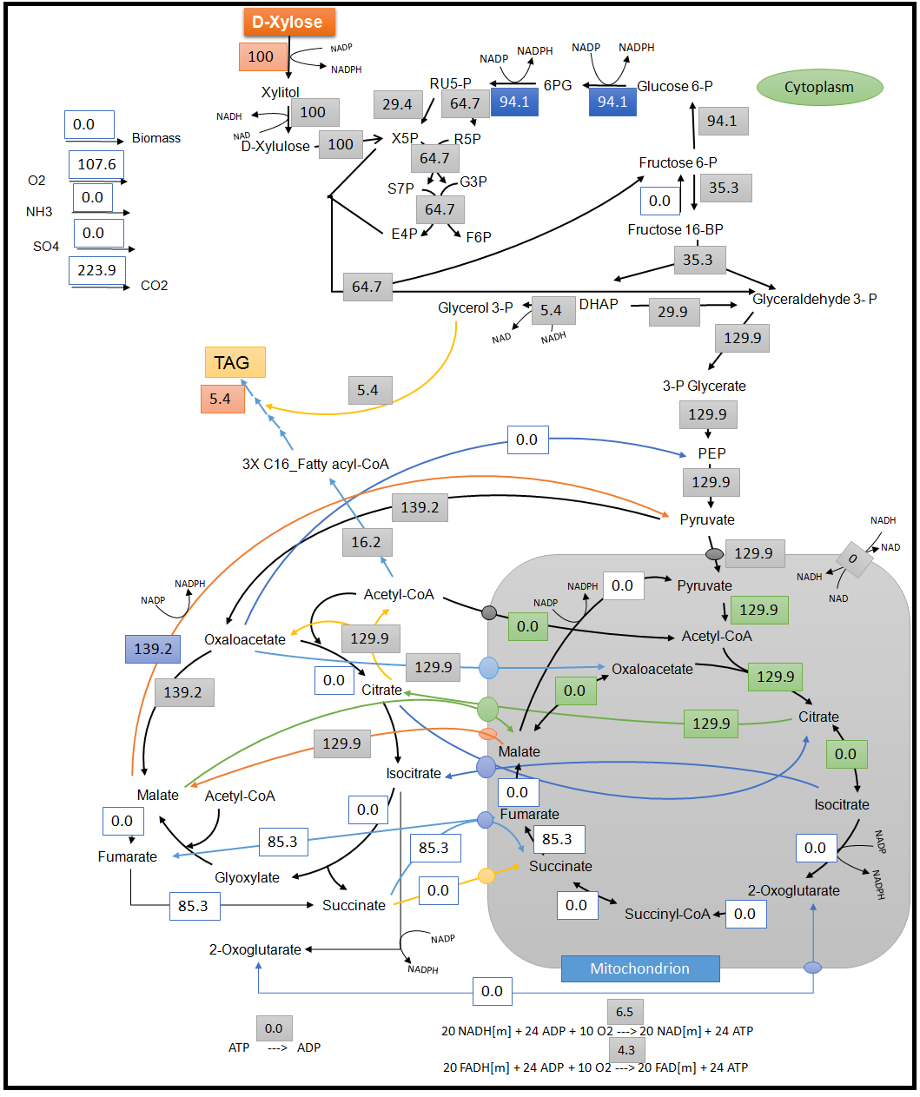

Figure S2: Optimal flux distribution on xylose. All values are relative molar fluxes (mmol.g-1h-1) normalized to the xylose uptake rate

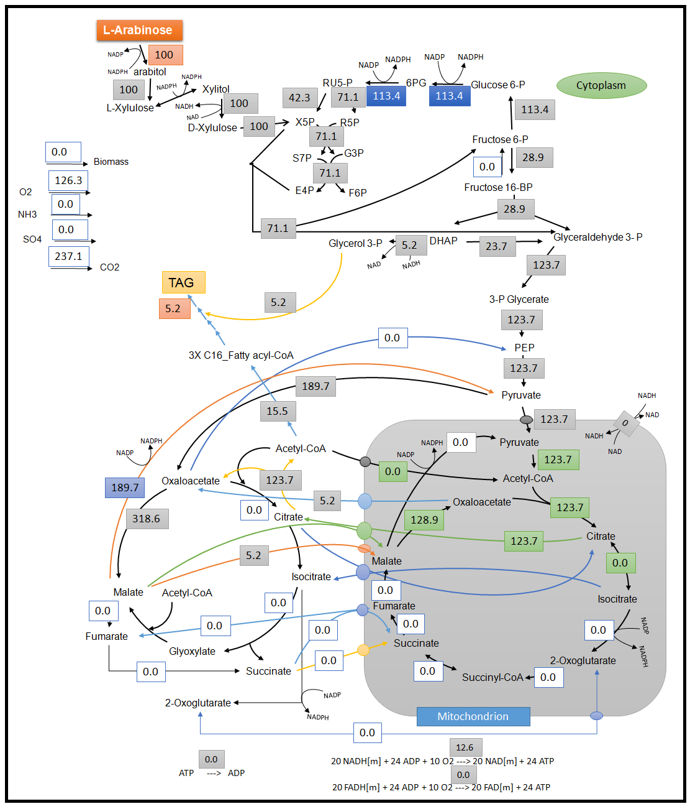

Figure S3: Optimal flux distribution on arabinose. All values are relative molar fluxes (mmol.g-1h-1) normalized to the arabinose uptake rate

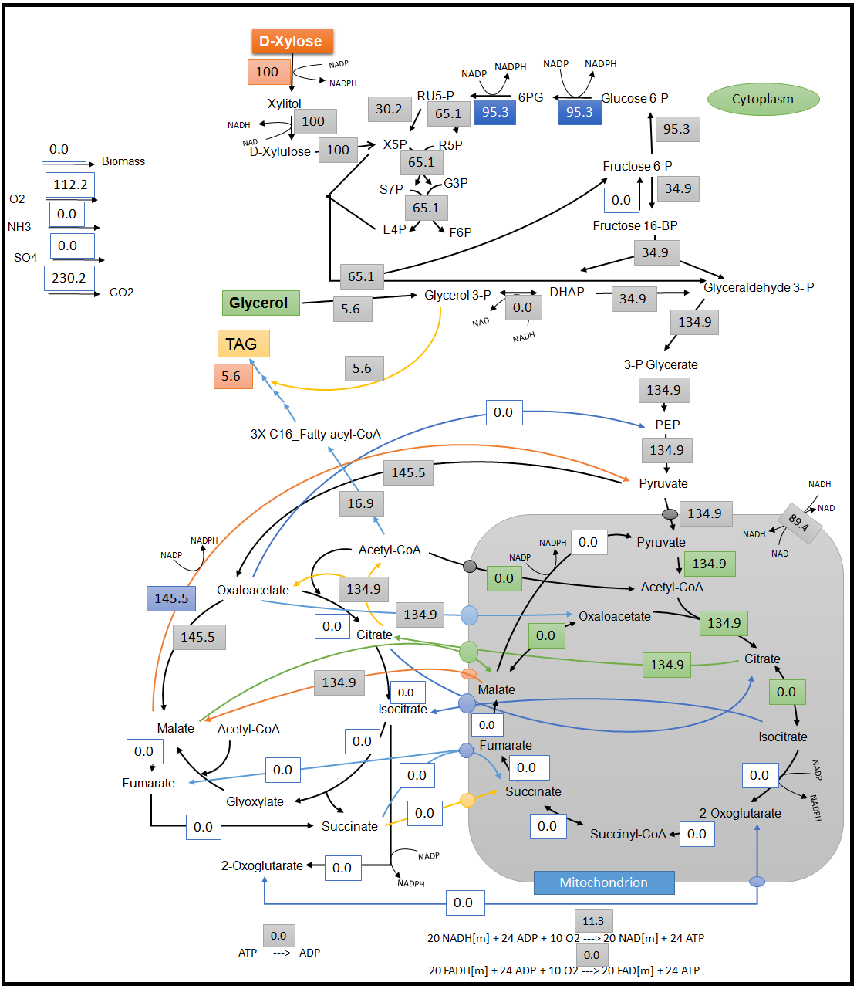

Figure S4: Optimal flux distribution on xylose and glycerol. All values are relative molar fluxes (mmol.g-1h-1) normalized to the xylose uptake rate

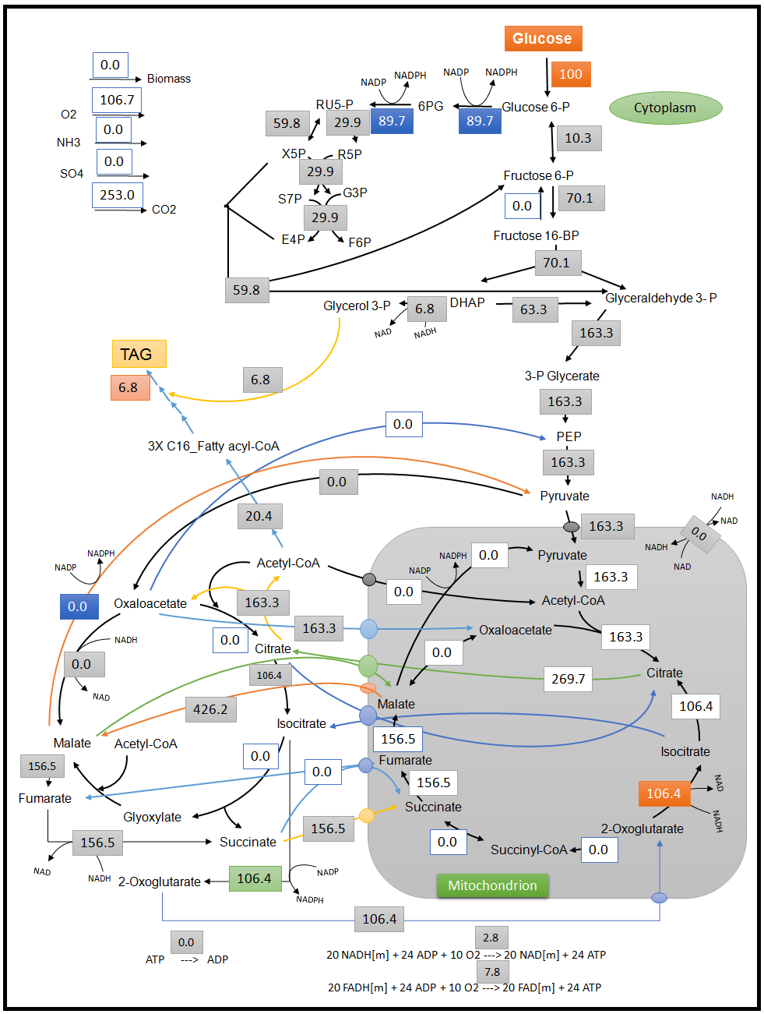

Figure S5: Optimal flux distribution on glucose with ICDH acting in reverse direction and without cytosolic malic enzyme. All values are relative molar fluxes (mmol.g-1h-1) normalized to the xylose uptake rate

**References**

1. Liu H, Zhao X, Wang F, Li Y, Jiang X, Ye M, Zhao ZK, Zou H. **Comparative proteomic analysis of Rhodosporidium toruloides during lipid accumulation**. *Yeast* 2009**,26**: 553-566.
2. Zhu Z, Zhang S, Liu H, Shen H, Lin X, Yang F, Zhou YJ, Jin G, Ye M, Zou H, Zhao ZK. **A multi-omic map of the lipid-producing yeast Rhodosporidium toruloides**.2012, *Nat Commun* **3**: 1112.
3. Kumar S, Kushwaha H, Bachhawat AK, Raghava GP, Ganesan K**.** **Genome sequence of the oleaginous red yeast *Rhodosporidium toruloides* MTCC 457.**2012, *Eukaryot Cell:* **11:**1083-1084.
4. Gruchattka E, Hadicke O, Klamt S, Schutz V, Kayser O. **In silico profiling of Escherichia coli and Saccharomyces cerevisiae as terpenoid factories**.2013, *Microb Cell Fact* **12**: 84.