Wave

Software Requirement Specification

Version 1.0.0

History

|  |  |  |  |
| --- | --- | --- | --- |
| **Date** | **Version** | **Description** | **Author** |
| 2011-10-01 | 1.0 | Create | Shiqing Ma |
|  |  |  |  |
|  |  |  |  |

Contents

1. Introduction 4

1.1 Purpose 4

1.2 Scope 4

1.3 Definition 4

1.4 Related 4

1.5 Introduction of this document 4

2. Requirements 5

2.1.1 Search words Specification 6

2.1.2 View word Specification 6

2.1.3 Save word to local Specification 6

2.1.4 Search history Specification 6

2.1.5 View local word Specification 6

2.1.6 Setting Specification 6

2.1.7 Get word in screen Specification 6

2.2 Usability 6

2.2.1 UI Design 6

2.2.2 Easy to Learn 6

2.2.3 Friendly 6

2.2.4 Help 6

2.3 Availability 6

2.3.1 MTBF 6

2.3.2 MTTR 6

2.3.3 Mistakes 7

2.4 Performance 7

2.4.1 Small actions 7

2.4.2 Big actions 7

2.5 Supportability 7

2.5.1 Encoding 7

2.5.2 Browsers 7

Browsers supporting asp and the website will be tested using Firefox, Chrome, IE and Opera. 7

2.6 Rules 7

2.6.1 Platform 7

2.7 Help Document 7

Software Requirement Specification

# Introduction

## Purpose

We will create a website which is a platform for user to take social activities and for organizations that had been verified by our administrators to held activities.

Users are supposed to be easy to find and take activities provided by organizations which also will have been confirmed by administrators.

Superuser will be the owner of this website who is always the manager of administrators. And administrators are those who work for this website.

They will all be provided account management and they also can manage related information which may be considered a duty.

## Scope

This document is designed for the project called *Wave.*

It is useful for developers and designers who make the fundamental work for this website.

It will be used when developers and customers have a different opinion on the function or purpose of the website.

It will be used for software testers when doing testing work.

## Definition

Glossary

## Related

1.《Software Engineering A Practioner's Approach》6th Edition by Roger S. Pressman

2.《rup_srs.dot》

3.《sdp.htm》

## Introduction of this document

This document will contain the following items:

Use case Specification

Use case diagram

Usability

Availability

Performance

Supportability

**Description**

**Function：**

All actors can do self-account management.

Admin can manage users’ and organizations’ information.

All activities need to be checked and confirm to apply to post.

Organizations can apply and hold activities and do activities management and related work like awarding users who are active in activities.

All people including guests can do search work.

Users use this website to take part in activities.

**Users：**

Those who want an easy way to find activities to take are supposed to be this websites’ users.

# Requirements

Use Case Diagram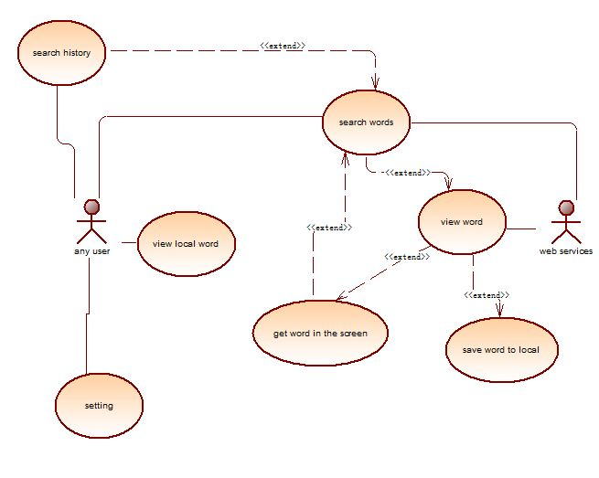

Actor & Use Cases:

*Glossy*

### Use Case Specification

*Use Case Specifications.docx*

## Usability

### UI Design

There are two goals of our system UI design. The first one which is seeking a normal and similar style for all our pages is a basic principle for UI designers. And the other is changing our pages according to the requirements of activities to be held when talking about the activities.

### Easy to Learn

This website is designed to be easy to learn. Anyone who can understand the words on the page can totally get familiar to this whole website during less than one hour. For this goal we also provide some basic suggestions for users and beginners.

### Friendly

The pages trying to be friendly with proper designed layouts and layers which is easy to distinguish important things from others. And we will provide suggestions according habits of users we learn.

### Help

We will provide help pages for users to learn and use this website. Also we will provide lists of contacts for users.

## Availability

### MTBF

The mean time between failure is more than six months。

### MTTR

The mean time to repair is supposed to be less than four hours.

### Mistakes

Important: Bugs which make the whole website down or works inexpertly. Bugs modify data different from the reality. Expected requirements are not created.

Normal: Bugs which works wrong sometimes but do no harm to the whole system or data in the database.

Small: Bad designed UI or warning/suggestive information given.

Our goal: no important mistakes. NO more than 5 middle mistakes. Less than 10 small bugs. Less than 10 bugs per klines.

## Performance

### Small actions

We will provide less than 10 seconds to respond your request without considering the delay during the internet transmission.

Related actions: those actions with little data to handle. For example, modify passwords and other information, sign in, users chose to take an activity etc.

### Big actions

We will provide less than 30 seconds to respond your request without considering the delay during the internet transmission.

Related actions: those actions with much more data to handle. For example, admin chose to add many similar users, organizations chose to post photos or modify photos of activities, users chose to modify personal photo.

## Supportability

### Encoding

We chose to use UTF-8.

### Browsers

### Browsers supporting asp and the website will be tested using Firefox, Chrome, IE and Opera.

## Rules

### Platform

Using C#, ASP.NET

## Help Document

Online help pages providing basic use of the website.

A list of contact will be provided for users to email us.