**Model Name: sldemo_autotrans**

**Date: November 27, 2020**

**Contents**

**sldemo_autotrans** 3

**Engine** 4

**ManeuversGUI** 5

**More Info** 6

**ShiftLogic** 7

**ComputeThreshold** 8

**Transmission** 9

**TorqueConverter** 10

**TransmissionRatio** 11

**Vehicle** 12

**WheelSpeedToLinearSpeed** 13

# **sldemo_autotrans**

**Block Name: sldemo_autotrans**

**Block Path: sldemo_autotrans**

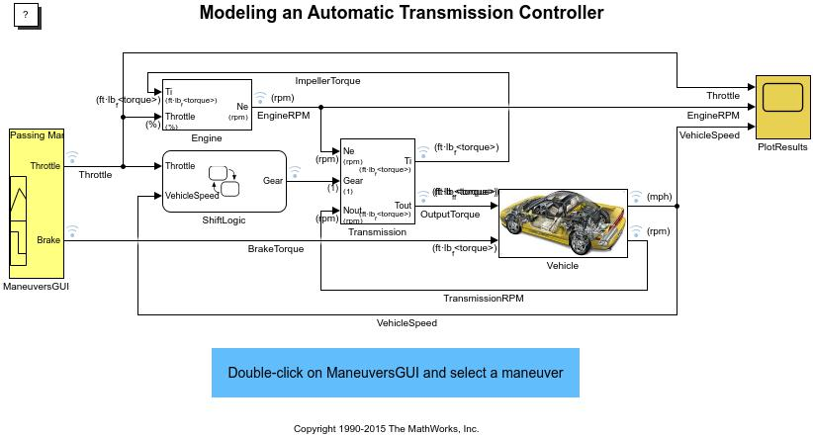

## **Engine**

**Block Name: Engine**

**Block Path: sldemo_autotrans/Engine**

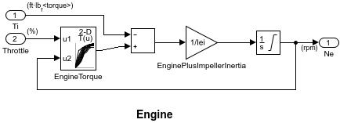

## **ManeuversGUI**

**Block Name: ManeuversGUI**

**Block Path: sldemo_autotrans/ManeuversGUI**

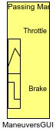

## **More Info**

**Block Name: More Info**

**Block Path: sldemo_autotrans/More Info**



## **ShiftLogic**

**Block Name: ShiftLogic**

**Block Path: sldemo_autotrans/ShiftLogic**

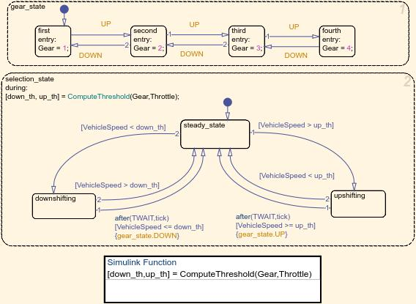

### **ComputeThreshold**

**Block Name: ComputeThreshold**

**Block Path: sldemo_autotrans/ShiftLogic/ComputeThreshold**

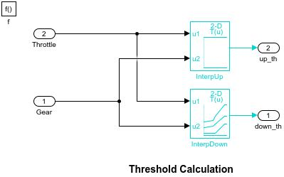

## **Transmission**

**Block Name: Transmission**

**Block Path: sldemo_autotrans/Transmission**

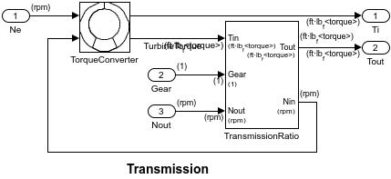

### **TorqueConverter**

**Block Name: TorqueConverter**

**Block Path: sldemo_autotrans/Transmission/TorqueConverter**

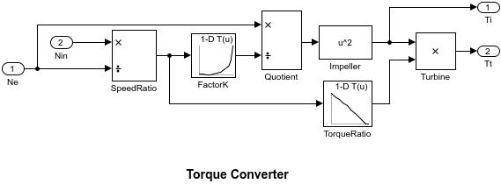

### **TransmissionRatio**

**Block Name: TransmissionRatio**

**Block Path: sldemo_autotrans/Transmission/TransmissionRatio**

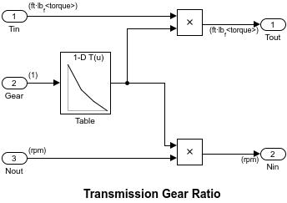

## **Vehicle**

**Block Name: Vehicle**

**Block Path: sldemo_autotrans/Vehicle**

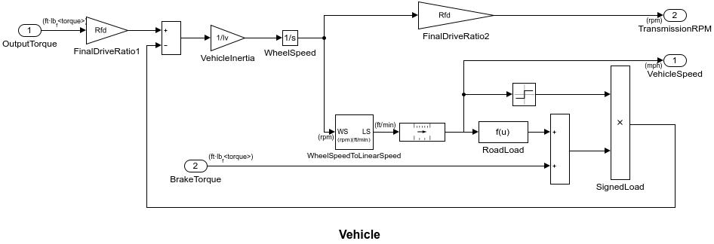

### **WheelSpeedToLinearSpeed**

**Block Name: WheelSpeedToLinearSpeed**

**Block Path: sldemo_autotrans/Vehicle/WheelSpeedToLinearSpeed**

