DDS PROJECT REPORT

ON

Arduino Ultrasonic Sensor Based Distance Measurement

UNDER THE GUIDANCE OF

Ms. Aishwarya and Mr. Gautam

*Submitted By*

Gauri V. Nair [17CO116]

Govardhan GD [17CO117]

Hemanth Reddy [17CO118]



B.TECH

NITK-CSE DEPARTMENT

JULY-DEC 2018

Arduino Ultrasonic Sensor Based Distance Measurement

Ultrasonic transducers (ultrasonic sensors) are used in systems which evaluate targets by interpreting the reflected signals (similar to radar and sonar). For example, by measuring the time between sending a signal and receiving an echo the distance of an object can be calculated. Passive ultrasonic sensors are microphones that detect ultrasonic noise that is present under certain conditions.

Ultrasonic distance sensor provides precise, non-contact distance measurements from about 2 cm to 400 cm.

This project aims to use Arduino to

Measure the distance from an object using an HC-SR04 ultrasonic sensor.

Photos

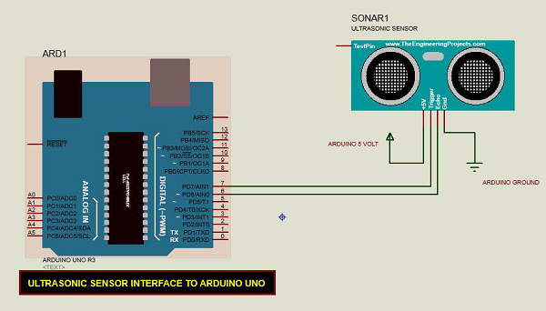

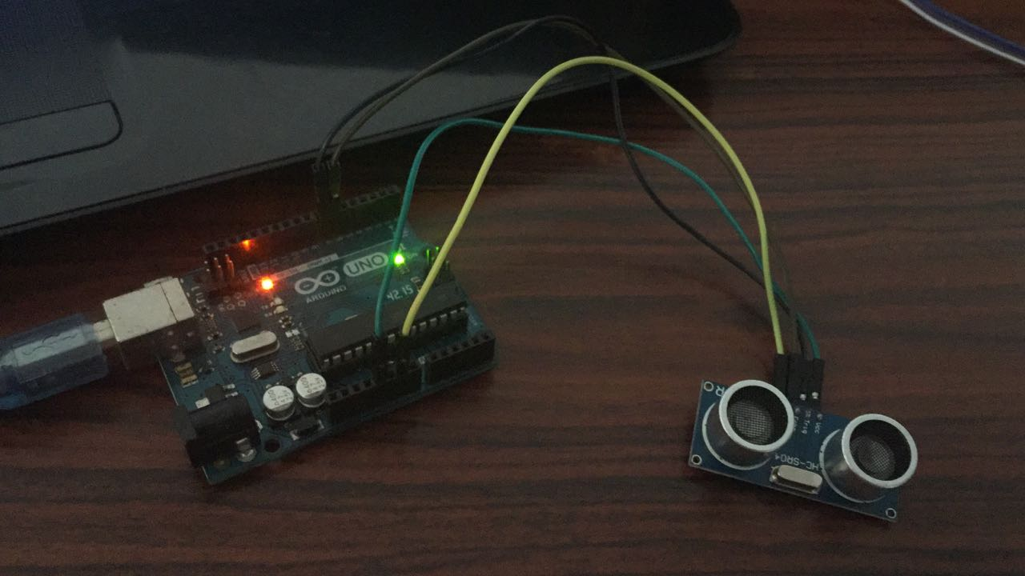

Arduino Code

const int trigger = 7; //Trigger pin of ultrasonic sensor

const int echoPin = 6; //Echo pin of ultrasonic sensor

void setup() {

Serial.begin(9600); //Starting serial terminal

}

void loop() {

long duration, inches, cm;

pinMode(trigger, OUTPUT);

digitalWrite(trigger, LOW);

delayMicroseconds(2);

digitalWrite(trigger, HIGH);

delayMicroseconds(10);

digitalWrite(trigger, LOW);

pinMode(echoPin, INPUT);

duration = pulseIn(echoPin, HIGH);

cm = microsecondsToCentimeters(duration);

Serial.print(cm/100.0);

Serial.print("m ");

Serial.print(cm);

Serial.print("cm");

Serial.println();

delay(1000);

}

long microsecondsToCentimeters(long microseconds) {

return microseconds \* 0.034 \*0.5;

}

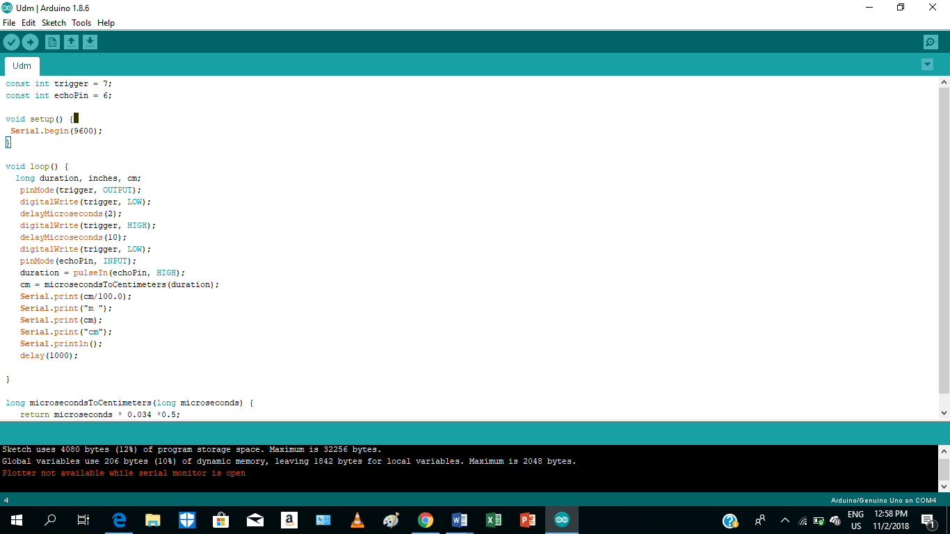

Result/Conclusion

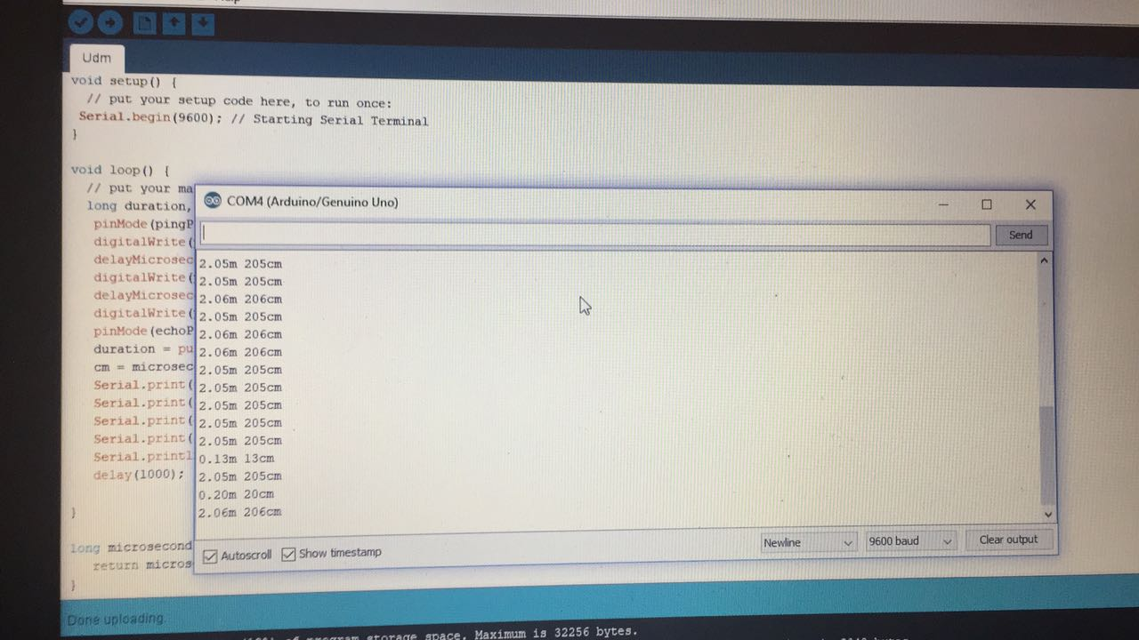

The project is working successfully.

We see the distance measured by sensor in centimeters and meters on Arduino serial monitor.

Further Scope of This Mini Project

1.Building sonar like device 360 degree object detection using ultrasonic sounds (Echolocation).

2.The range can be considerably increased using high power drive circuit.

* Using temperature compensation it can be used over wide temperature range.
* The resolution of the measurement can be improved by incorporating phase shift method along with flight method

3.Can be used as parking assistance system in vehicles with high power ultrasonic transmitter.

References

<https://www.tutorialspoint.com/arduino/index.htm>

<https://www.tutorialspoint.com/arduino/arduino_ultrasonic_sensor.htm>

<https://circuitdigest.com/microcontroller-projects/arduino-ultrasonic-sensor-based-distance-measurement>