Good modularity means low coupling and high cohesion and not using global variables.
The code was already pretty modular since it does not use any global variables, had high cohesion and low coupling.
The code however was in fact refactored, by separating the get_neighbors and character_converter into two separate modules. This was done because the functions have specific functionality and while the character_converter is reliant on get_neighbors, get_neighbors is not reliant on character_converter. This indicates lower coupling and increases cohesion.

(OLD)
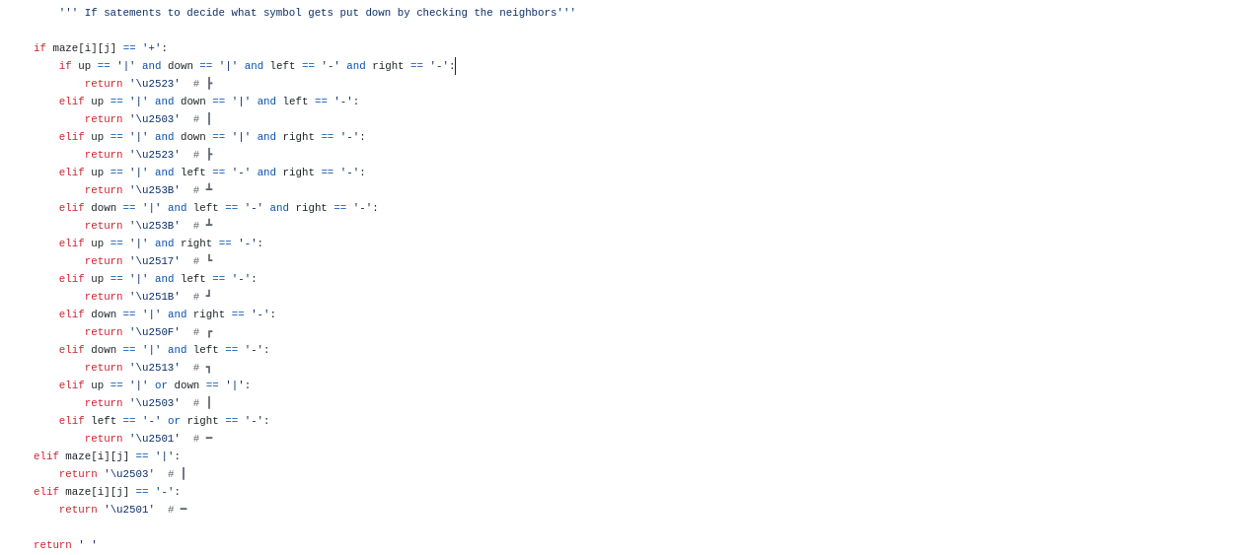
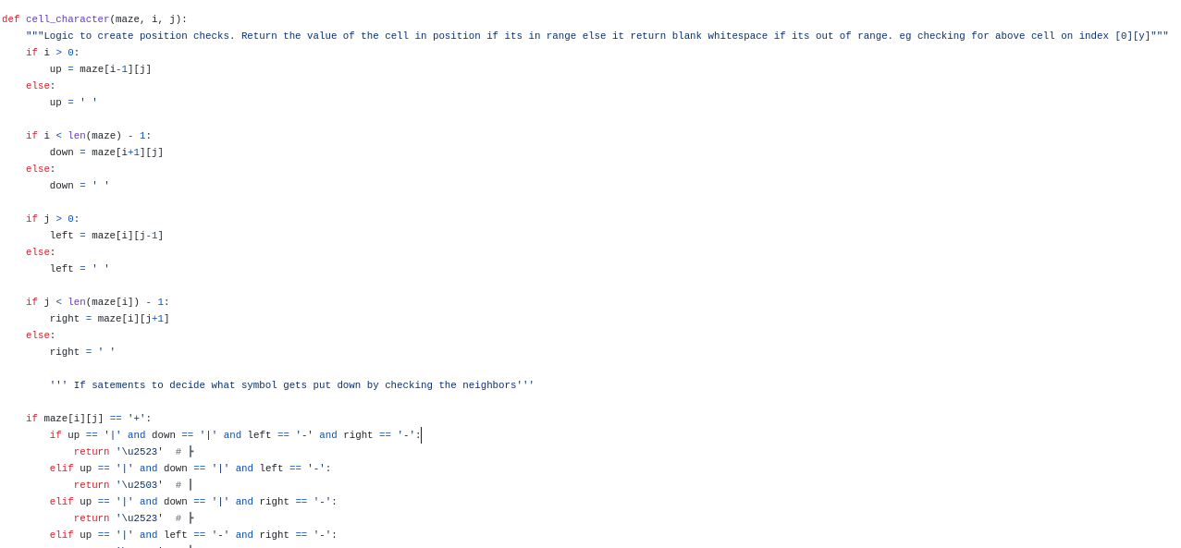

(NEW)

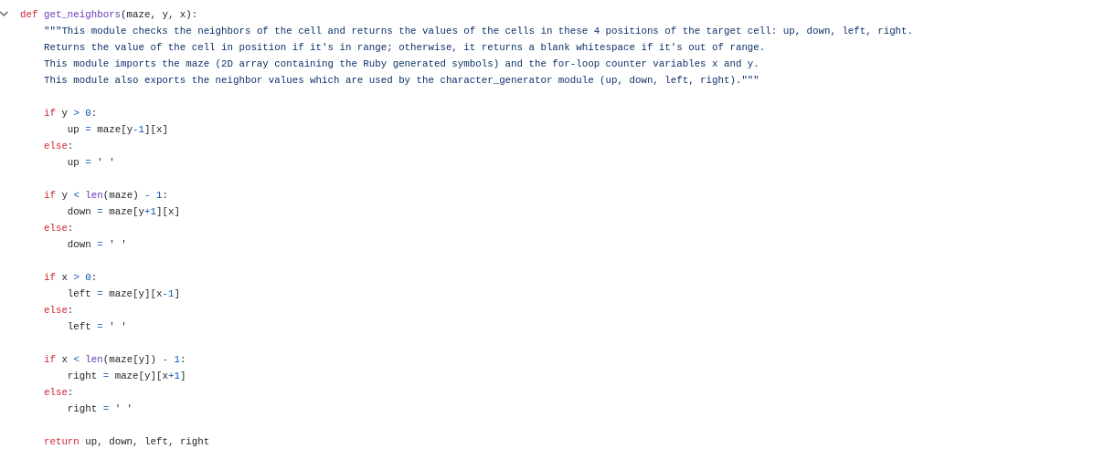
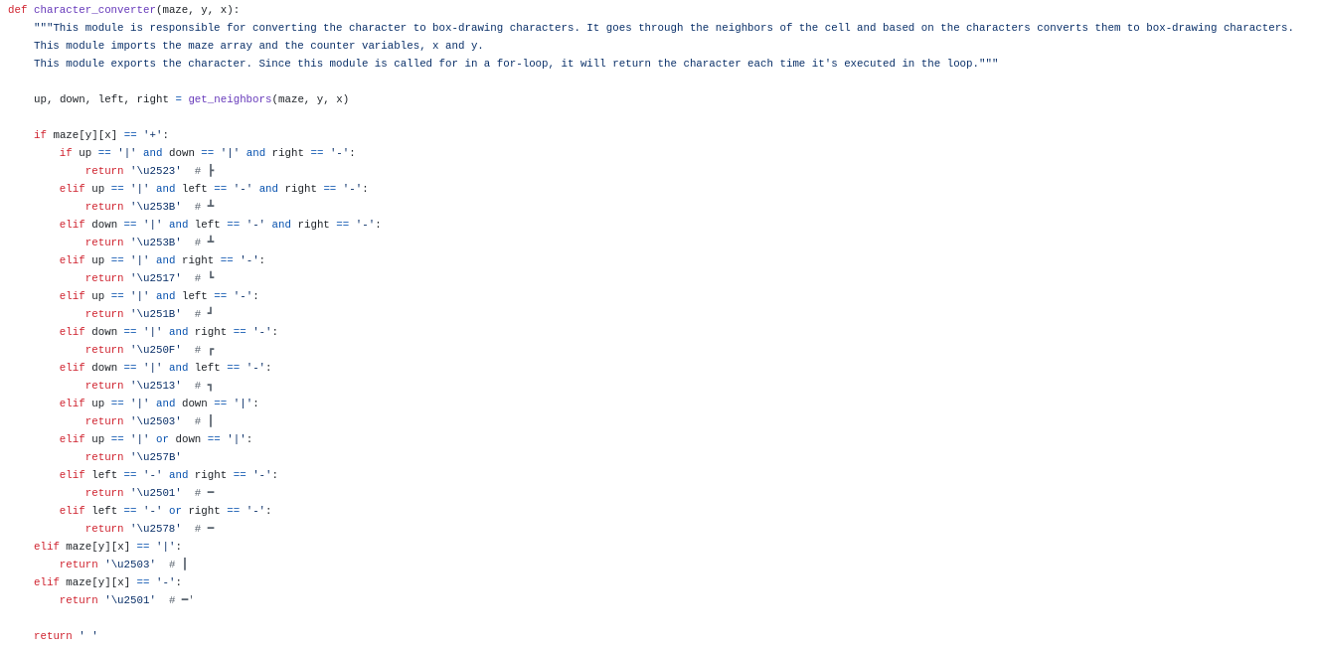

Item | Checklist Question | Yes/No | Justification
Global Variables
Low Coupling
High Cohesion
 | Does the module performs multiple unrelated tasks?
Redundancy/Reusability

Black Box

get_neighbors (maze, y, x)

we will assume the maze input as such for demonstration purposes:
[['|', '|', '|'],
['-', '+', '-'],
['|', '|', '|']]

Category | Test Data | Expected Result
Top left corner  y = 0, x = 0 | Y = 0, x = 0 | Up = ‘ ‘, down = ‘-’, left = ‘ ‘, right = ‘|’
Bottom right corner  y = len(maze) -1, x = len(maze[y]) -1 | Y = 2, x=2 | Up = ‘-’, down = ‘ ‘, left = ‘|’, right = ‘ ‘
Middle Cell  y> 0 AND y < len(maze)-1, X>0 AND X < len(maze[y])-1 | Y = 1, x =1 | Up = ‘|’, down = ‘|‘, left = ‘-’, right = ‘-‘
Bottom Edge  y = len(maze) -1, X>0 AND X < len(maze)-1 | Y = 2, x=1 | Up = ‘+’, down = ‘ ‘, left = ‘|’, right = ‘|‘
Right Edge  y> 0 AND y < len(maze)-1, x = len(maze[y]) -1 | Y = 1, x = 2 | Up = ‘|’, down = ‘|’, left = ‘+’, right = ‘ ‘

These test cases are supposed to cover different positions in the maze: middle, corners, and edges. This ensures the testing of all possible neighbor combinations.
- Corner pieces have been included of different directions. These pieces are missing 2 directions.
- The middle cell that would return values for all directions has been tested.
- Edge pieces that are missing one direction have also been tested.
This covers all the possibilities of the output the module can produce.

character_converter

Category | Test Data | Expected Result
Full Line | Maze = [['|',' ',' '],['+',' ','+'],['|',' ',' ']]; y=1, x=0 | '\u2503' (┃)
Half Line | Maze = [[' ',' ',' '],['-','+',' '],[' ',' ',' ']]; y=1, x=1 | '\u2578' (━)
Intersection right | Maze = [[' ','|',' '],[' ','+','-'],[' ','|',' ']]; y=1, x=1 | '\u2523' (┣)
Intersection up | Maze = [[' ','|',' '],['-','+','-'],[' ',' ',' ']]; y=1, x=1 | '\u253B' (┻)
Corner | Maze = [[' ',' ','|'],['+','-','+']]; y=1, x=2 | '\u251B' (┛)

These test cases were chosen to cover all the mojor types of box-drawing symbols. These include full line, half line, intersection and corner pieces.
- The full line test case expects a ‘|’ above and below the target cell. However, in case of the target cell being a ‘|’ instead of a ‘+’, it simply replaces it with the box symbol.
- The half line is used when the maze has open walls.
- We included an edge case with a non-junction, non-line character to test the function's behavior with unexpected input.
- The test cases cover various positions in a maze (edges, corners, middle) to ensure the function works correctly regardless of the cell's position.
generate_maze
Category | Test Data | Expected Result
Maze[y][x] | Maze = [['|',' ','|'],['+',' ','+'],['|',' ','|']]; | Maze = [[''┃,' ','┃'],['┃',' ','┃'],['┃',' ','┃']];

read_maze

Category | Test Data | Expected Result
Valid filepath\filename | ‘maze_input.txt’ | Maze converted into array and reutrned.  Maze = [[''|,' ','|'],['+',' ','+'],['|',' ','|']];
empty field | ‘’ | Please provide two filenames (input.txt)(output.txt)
Invalid filepath | ‘home/maze.txt’ (file does not exist here) | FileNotFoundError: [Errno 2] No such file or directory: 'home/maze_output.txt'
save_maze

Category | Test Data | Expected Result
Valid name | ‘maze_output.txt’ | Files saved under name maze_output.txt in the same directory as python file
empty field | ‘’ | Please provide two filenames (input.txt)(output.txt)

print_maze

Category | Test Data | Expected Result
Valid Array | Maze = [[''┃,' ','┃'],['┃',' ','┃'],['┃',' ','┃']]; | ┃ ┃  ┃ ┃  ┃ ┃
empty field | ‘’ | Please provide two filenames (input.txt)(output.txt)
Main

Category | Test Data | Expected Result
Valid name | ‘maze_output.txt’ | Files saved and maze generated.  Maze = [[''┃,' ','┃'],['┃',' ','┃'],['┃',' ','┃']];
empty field | ‘’ | Please provide two filenames (input.txt)(output.txt)

Whitebox

The two modules that would benefit from whitebox testing are get_neighbors and character_converter modules.

get_neigbors

Path | Test Data | Result
Enter all if, 1st if:(y > 0), 2nd if:(y<len(maze) – 1), 3rd if: (x>0), 4th if: (x<len(maze[y] - 1) | Maze = [[' ','|',' '],['+','-','+'],[' ','|',' ']]; y = 1, x = 1 | Up = ‘|’, down = ‘|’, left = ‘+’, right = ‘+’
Enter 1st else (not y>0) enter all other if | Maze = [['|','|','|'],['+','-','+'],[' ','|',' ']]; y = 0, x = 1 | Up = ‘ ’(out of maze) down = ‘-’,left = ‘|’ right = |‘’
Enter 2nd else (not y < len(maze) – 1) and enter all other if | Maze = [[' ','|',' '],['+','-','+'],['|','|','|']]; y = 2, x = 1 | Up = ‘-’, down = ‘ ’(out of maze), left = ‘|’, right = ‘|’
Enter 3rd else (not x>0) and enter all other if | Maze = [['|','|',' '],['+','-','+'],['|','|',' ']]; y = 1, x = 0 | Up = ‘|’, down = ‘|’, left = ‘ ’(out of maze), right = ‘-’
Enter 4th else (not x < len(maze[y]) – 1) and enter all other if | Maze = [[' ','|',' '],['+','-','+'],['|',' ','|']]; y = 1, x = 2 | Up = ‘ ’, down = ‘|’, left = ‘-’, right = ‘ ’ (out of maze)
Enter 1st and 3rd else and enter 2nd and 4th if | Maze = [[' ','|',' '],['+','-','+'],['|',' ','|']]; y = 0, x = 0 | Up = ‘ ’ (out of maze), down = ‘+’, left = ‘ ’ (out of maze), right = ‘|’
Enter 2nd and 4th else and enter 1st and 2nd if | Maze = [[' ','|',' '],['+','-','+'],['|','|','|']]; y = 2, x = 2 | Up = ‘+’, down = ‘ ’ (out of maze), left = ‘|’, right = ‘ ’ (out of maze)
Enter 1st and 4th else and enter 2nd and 3rd if | Maze = [['|',' ','|'],['+','-','+'],['|',' ','|']]; y = 0, x = 2 | Up = ‘ ’ (out of maze), down = ‘+’, left = ‘ ’, right = ‘ ’ (out of maze)
Enter 2nd and 3rd else and enter 1st and 4th if | Maze = [['|',' ','|'],['+','-','+'],['|',' ','|']]; y = 2, x = 0 | Up = ‘+’, down = ‘ ’ (out of maze), left = ‘ ’ (out of maze), right = ‘ ’

character_converter

Path | Test Data | Result
Enter both if | Maze = [[' ','|',' '],[' ','+','-'],[' ','|',' ']]; y = 1, x = 1 | \u2523' (┣)
Enter 1st inner elif | Maze = [[' ','|',' '],['-','+','-'],[' ',' ',' ']]; y = 1, x = 1 | '\u253B' (┻)
Enter 2nd inner elif | Maze = [['|',' ',' '],['|',' ','|'],['+','-',' ']]; y = 2, x = 0 | '\u2517' (┗ )
Enter 3rd inner elif | Maze = [['|',' ',' '],['|',' ','|'],[' ','-','+']]; y = 2, x = 2 | \u251B' (┛)
Enter 4th inner elif | Maze = [['+','-',' '],['|',' ',' '],[' ','+','-']]; y = 0, x = 0 | '\u250F' (┏)
Enter 5th inner elif | Maze = [[' ','-','+'],['|',' ','|'],['+',' ','+']]; y = 0, x = 2 | '\u2513' (┓)
Enter 6th inner elif | Maze = [['|',' ','|'],['+','-','+'],['|',' ','|']]; y = 1, x = 2 | '\u2503' (┃)
Enter 7th inner elif | Maze = [['|',' ',' '],['+','-','+'],['|',' ','|']]; y = 1, x = 2 | '\u257B' (╻)
Enter 8th inner elif | Maze = [['|',' ',' '],['-','+','-'],['|',' ','|']]; y = 1, x = 1 | '\u2501' (━)
Enter 9th inner elif | Maze = [['|',' ',' '],['-','+',' '],['|',' ','|']]; y = 1, x = 1 | '\u2578' (╸)
Enter 1st outer elif | Maze = [['|',' ',' '],['+',' ','+'],['|',' ','|']]; y = 0, x = 0 | '\u2503' (┃)
Enter 2nd outer elif | Maze = [['|',' ',' '],['+','-','+'],['|',' ','|']]; y = 1, x = 1 | '\u2501' (━)

