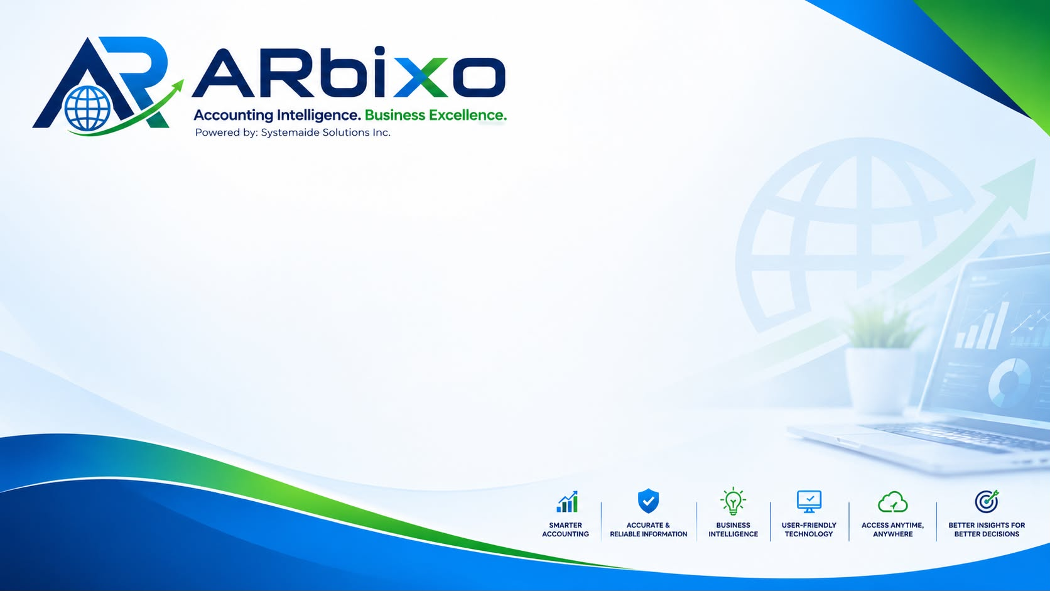
NON-DISCLOSURE AGREEMENT
Systemaide Solutions Inc. — ARbixo Cloud Accounting Platform
This Non-Disclosure Agreement (“Agreement”) is entered into as of the Effective Date indicated below, by and between:
Effective Date: ______________________________
Systemaide Solutions Inc., a corporation duly organized and existing under the laws of the Republic of the Philippines, with a principal business address as indicated in its records (“Provider,” “Systemaide,” or “ARbixo”), being the developer, owner, and operator of the ARbixo cloud-based accounting platform (the “Platform”); and
Client / Company Name: ________________________________________
Business Address: ________________________________________
Represented By / Title: ________________________________________
(collectively, the “Client”), a business entity subscribing to and using the Platform for its accounting, bookkeeping, and related financial management needs.
Systemaide and Client are each referred to individually as a “Party” and collectively as the “Parties.”

RECITALS
WHEREAS, Client wishes to use the ARbixo Platform, provided and operated by Systemaide, for the recording, processing, and reporting of Client's financial and accounting transactions;
WHEREAS, in the ordinary course of providing, hosting, maintaining, and supporting the Platform, Systemaide may necessarily access, process, and store Client's financial, business, and other confidential data; and Client may likewise become privy to Systemaide's proprietary systems, methods, and business information;
WHEREAS, the Parties wish to define their respective rights and obligations with respect to the protection of such confidential information, including an express acknowledgment of the access reasonably required for Systemaide to perform as the Platform provider;
NOW, THEREFORE, in consideration of the mutual covenants and agreements set forth herein, and for other good and valuable consideration, the Parties agree as follows:

1. Definition of Confidential Information
“Confidential Information” means any non-public information disclosed or made accessible by one Party (the “Disclosing Party”) to the other (the “Receiving Party”), whether in oral, written, electronic, or other form, including without limitation:
(a) as to Client: all financial records, accounting entries, ledgers, tax filings, bank and transaction data, payroll information, customer and vendor lists, and any other data entered into, stored in, processed by, or generated through the Platform (“Client Data”);
(b) as to Systemaide: the ARbixo source code, system architecture, security designs, algorithms, pricing, product roadmaps, business plans, and other proprietary technical or commercial information; and
(c) any other information that a reasonable person would understand, given its nature or the circumstances of disclosure, to be confidential.

2. Obligations of Confidentiality
Each Receiving Party agrees to:
(a) hold the Disclosing Party's Confidential Information in strict confidence and protect it using at least the same degree of care it applies to its own confidential information of similar nature, and in no event less than a reasonable standard of care;
(b) not disclose, publish, or otherwise make available any Confidential Information to third parties without the Disclosing Party's prior written consent, except as expressly permitted under this Agreement;
(c) use Confidential Information solely in connection with the service relationship between the Parties, and for no other purpose; and
(d) limit access to Confidential Information to its own employees, contractors, or representatives who have a legitimate need to know such information and who are bound by confidentiality obligations at least as protective as those set out herein.

3. Systemaide's Necessary Access to Client Data as Platform Provider
Client expressly acknowledges and agrees that Systemaide's role as the developer and operator of the Platform inherently and necessarily requires access to Client Data. Accordingly, Systemaide, and its authorized employees, contractors, and service personnel, may access, view, process, and otherwise handle Client Data for purposes that include, without limitation:
(a) providing technical support, diagnosing issues, and troubleshooting reported problems;
(b) performing system maintenance, updates, upgrades, and security monitoring;
(c) performing data backup, recovery, and business continuity procedures;
(d) maintaining, improving, and optimizing the performance, reliability, and security of the Platform; and
(e) verifying compliance with Systemaide's terms of service, this Agreement, and applicable law.
Such access, by itself, is a necessary and ordinary function of Systemaide's role as Platform provider and shall not constitute a breach of this Agreement or an unauthorized use or disclosure of Client Data. For the avoidance of doubt, this access does not authorize Systemaide to disclose Client Data to any third party, or to use Client Data for any purpose unrelated to providing, maintaining, securing, or improving the Platform, except as required by law or as otherwise expressly authorized in writing by Client. Systemaide shall ensure that all personnel granted such access are bound by confidentiality obligations no less protective than those set out in this Agreement.

4. Exclusions
Confidential Information does not include information that:
(a) is or becomes generally available to the public through no fault of the Receiving Party;
(b) was already lawfully known to the Receiving Party, free of any confidentiality obligation, prior to disclosure by the Disclosing Party;
(c) is independently developed by the Receiving Party without reference to or use of the Disclosing Party's Confidential Information;
(d) is rightfully received from a third party without breach of any confidentiality obligation owed to the Disclosing Party; or
(e) is required to be disclosed by law, regulation, or a valid order of a court or government authority, provided that, where legally permitted, the Receiving Party gives the Disclosing Party prompt prior notice so that the Disclosing Party may seek a protective order or other appropriate remedy.

5. Data Security
Systemaide shall implement and maintain reasonable administrative, technical, and physical safeguards designed to protect the confidentiality, integrity, and availability of Client Data, consistent with generally accepted industry standards and applicable data privacy laws, including the Data Privacy Act of 2012 (Republic Act No. 10173) and its implementing rules and regulations.

6. Term and Survival
This Agreement shall take effect on the Effective Date and remain in force for as long as the Parties maintain a service relationship under the Platform. The confidentiality obligations herein shall survive termination or expiration of that relationship for a period of three (3) years thereafter, except that obligations relating to information constituting a trade secret shall survive for as long as such information remains a trade secret under applicable law.

7. Return or Deletion of Data
Upon termination of the service relationship and upon Client's written request, Systemaide shall, within a commercially reasonable period, and subject to its legal, regulatory, and routine backup retention obligations, return or securely delete Client Data in its possession, except for copies that Systemaide is required to retain by law or for legitimate archival or backup purposes, which shall remain subject to the confidentiality obligations of this Agreement for so long as they are retained.

8. No License or Transfer of Ownership
Nothing in this Agreement grants either Party any license, title, or ownership interest in the other Party's Confidential Information, other than the limited right to use such information as necessary to perform obligations under the Parties' service relationship. Client retains all right, title, and interest in and to Client Data.

9. Remedies
Each Party acknowledges that unauthorized use or disclosure of Confidential Information in breach of this Agreement may cause irreparable harm for which monetary damages alone may be an inadequate remedy, and that the non-breaching Party shall be entitled to seek injunctive or other equitable relief, in addition to any other remedies available at law or in equity.

10. Governing Law and Venue
This Agreement shall be governed by, and construed in accordance with, the laws of the Republic of the Philippines. Any dispute arising out of or relating to this Agreement shall be submitted to the exclusive jurisdiction of the proper courts of the city or municipality where Systemaide maintains its principal place of business, to the exclusion of all other venues.

11. Miscellaneous
(a) Entire Agreement. This Agreement constitutes the entire understanding between the Parties regarding the confidentiality of information exchanged in connection with the Platform, and supersedes all prior discussions or agreements on that subject.
(b) Amendment. This Agreement may be amended only by a written instrument signed by both Parties.
(c) Severability. If any provision of this Agreement is held invalid or unenforceable, the remaining provisions shall continue in full force and effect.
(d) Assignment. Neither Party may assign this Agreement without the prior written consent of the other, except that Systemaide may assign this Agreement in connection with a merger, acquisition, reorganization, or sale of substantially all of its relevant assets.
(e) Notices. All notices under this Agreement shall be in writing and delivered to the addresses set forth above, or to such other address as either Party may designate in writing from time to time.
IN WITNESS WHEREOF, the Parties have caused this Agreement to be executed by their duly authorized representatives as of the Effective Date first written above.
SYSTEMAIDE SOLUTIONS INC. (Provider)

Signature
Name: ______________________________
Title: ______________________________
Date: ______________________________
CLIENT

Signature
Name: ______________________________
Title: ______________________________
Date: ______________________________

