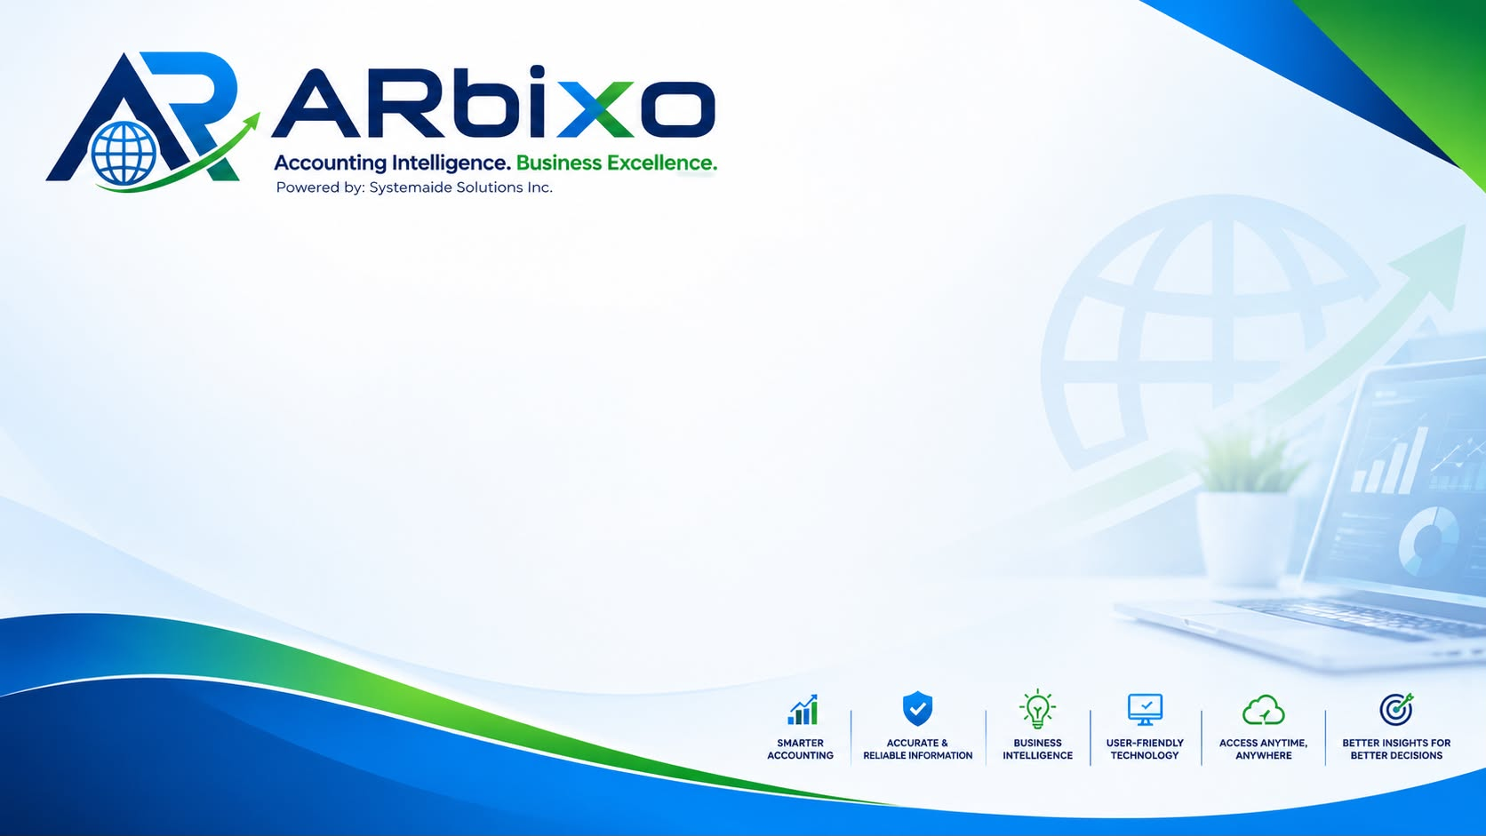
SUBSCRIPTION AGREEMENT
Systemaide Solutions Inc. — ARbixo Cloud Accounting Platform
This Subscription Agreement (“Agreement”) is entered into as of the Effective Date indicated below, by and between:
Effective Date: ______________________________
Systemaide Solutions Inc., a corporation duly organized and existing under the laws of the Republic of the Philippines, with a principal business address as indicated in its records (“Provider,” “Systemaide,” or “ARbixo”), being the developer, owner, and operator of the ARbixo cloud-based accounting platform (the “Platform”); and
Client / Company Name: ________________________________________
Business Address: ________________________________________
Represented By / Title: ________________________________________
(the “Client”), a business entity wishing to subscribe to and use the Platform on a paid basis for its accounting, bookkeeping, and related financial management needs.
Systemaide and Client are each referred to individually as a “Party” and collectively as the “Parties.”

RECITALS
WHEREAS, Systemaide owns and operates the ARbixo Platform, a cloud-based accounting system designed for Philippine businesses;
WHEREAS, Client wishes to subscribe to and use the Platform on a recurring, paid subscription basis, and Systemaide is willing to make the Platform available to Client on that basis;
WHEREAS, the Parties wish to set out the terms governing that subscription, including fees, renewal, access, data handling, and their respective rights and responsibilities;
NOW, THEREFORE, in consideration of the mutual covenants and agreements set forth herein, and for other good and valuable consideration, the Parties agree as follows:

1. Definitions
(a) “Platform” or “Services” means the ARbixo cloud accounting software, including any associated support, updates, and features Systemaide makes available to subscribers from time to time.
(b) “Subscription Period” means a one (1) month period of paid access to the Platform for Client's company account.
(c) “Subscription Fee” means the amount payable for one Subscription Period, at Systemaide's then-current published price, less any validly applied voucher or discount.
(d) “Client Data” means all financial, accounting, and other data and records that Client or its authorized users enter into, upload to, or generate through the Platform.
(e) “Authorized User” means any individual Client permits to access its account on the Platform under a role Client (through its Manager-level users) assigns them.

2. Subscription and Access
Subject to Client's compliance with this Agreement and payment of the applicable Subscription Fees, Systemaide grants Client a non-exclusive, non-transferable right to access and use the Platform during each Subscription Period Client has paid for.
(a) Client is responsible for all activity that occurs under its account and its Authorized Users' credentials, and for ensuring its Authorized Users comply with this Agreement.
(b) Client controls, through the account-management tools within the Platform, how many Authorized Users it has and what access level (e.g., Manager, User, or Report Creator) each is assigned.
(c) Client is responsible for keeping its account credentials confidential and for promptly notifying Systemaide of any unauthorized access it becomes aware of.

3. Subscription Fees and Payment
(a) Billing is prepaid and per Subscription Period — Client pays in advance for the month of access it wants, rather than being enrolled in automatic recurring or stored-card billing. There is no obligation on Client to renew any future Subscription Period.
(b) The Subscription Fee for a given Subscription Period is Systemaide's then-published price for that period. Systemaide may change its pricing for future Subscription Periods at its discretion; a price change never applies retroactively to a Subscription Period Client has already paid for.
(c) Payment is made through Systemaide's designated GCash account, or such other payment channel Systemaide may designate from time to time, by submitting the payment reference number and, where applicable, proof of payment for the Subscription Period being paid for.
(d) Systemaide verifies each submitted payment before activating the corresponding Subscription Period. Verification is a manual step performed by Systemaide personnel and is ordinarily completed within a reasonable time of submission.
(e) Promotional vouchers or discount codes, where issued by Systemaide, reduce the Subscription Fee for the Subscription Period they are validly applied to, subject to whatever conditions Systemaide attached to that voucher (such as being single-use).
(f) All fees are exclusive of any applicable taxes unless stated otherwise, and are non-refundable once a Subscription Period has been activated, except as this Agreement or applicable law expressly provides otherwise.

4. Effect of Non-Renewal or Non-Payment
(a) If a Subscription Period expires without a further verified payment, Client's access changes to view-only: previously entered Client Data remains visible, but Client may not post new transactions until a further Subscription Period is paid for and verified.
(b) Systemaide may additionally suspend or fully disable Client's access after a prolonged lapse in payment, at its discretion. Access is ordinarily reinstated upon a successful renewal payment.
(c) A view-only state or a suspension under this Section is not, by itself, a termination of this Agreement, and does not relieve Client of any Subscription Fees already due for Subscription Periods it has used.

5. Client Data
(a) As between the Parties, Client owns all Client Data. Nothing in this Agreement transfers ownership of Client Data to Systemaide.
(b) Systemaide's access to Client Data in the ordinary course of operating, maintaining, securing, and supporting the Platform is necessary to Systemaide's role as Platform provider, and is not by itself a breach of confidentiality. Where the Parties have executed a separate Non-Disclosure Agreement governing the Platform relationship, that agreement's terms on data access and confidentiality govern; otherwise, Section 9 of this Agreement applies.
(c) Client is solely responsible for the accuracy, completeness, and lawfulness of the data it enters into the Platform, and for reviewing the accuracy of any report, computation, or figure the Platform produces before relying on it or submitting it to any third party, including the Bureau of Internal Revenue or any other government authority. The Platform is a tool to assist bookkeeping, accounting, and tax reporting — it is not a substitute for professional accounting, tax, or legal advice, nor for Client's own review before filing.

6. Data Backup and Export
Systemaide maintains routine backups as part of operating the Platform, and makes data-export tools (such as Excel export and downloadable reports) available within the Platform for Client's own use. Client is encouraged to independently export or back up its critical records from time to time, in addition to relying on Systemaide's own backup practices.

7. Support
Systemaide will use commercially reasonable efforts to keep the Platform available and to respond to support requests submitted through the channels it designates, including the Platform's own in-app help feature and its published support email. Systemaide does not guarantee uninterrupted or error-free operation, and may carry out scheduled or emergency maintenance from time to time.

8. Intellectual Property
Systemaide retains all right, title, and interest in and to the Platform, including its software, design, and underlying technology. Nothing in this Agreement transfers any such right to Client. Client retains all right, title, and interest in Client Data, subject to Section 5.

9. Confidentiality
Each Party will keep confidential the other Party's non-public information disclosed in connection with this Agreement, and use it only for purposes of this Agreement, except information that is or becomes public through no fault of the receiving Party, is independently developed without use of the disclosing Party's information, or is required to be disclosed by law or a valid order of a court or government authority. Where the Parties have separately executed a Non-Disclosure Agreement governing the Platform relationship, that agreement's terms govern in the event of any conflict with this Section.

10. Warranties and Disclaimers
The Platform is provided “as is” and “as available.” Except as expressly stated in this Agreement, Systemaide disclaims all other warranties, express or implied, including any implied warranty of merchantability, fitness for a particular purpose, or non-infringement, to the fullest extent permitted by applicable law.

11. Limitation of Liability
To the fullest extent permitted by law, neither Party is liable to the other for any indirect, incidental, special, consequential, or punitive damages arising out of or relating to this Agreement, even if advised of the possibility of such damages. Systemaide's total aggregate liability arising out of or relating to this Agreement shall not exceed the total Subscription Fees actually paid by Client in the three (3) months immediately preceding the event giving rise to the claim. Nothing in this Section limits any liability that cannot be limited under applicable law.

12. Term and Termination
(a) Term. This Agreement takes effect on the Effective Date and continues until terminated as provided in this Section.
(b) Termination for convenience. Client may discontinue its subscription at any time simply by not renewing; Client remains liable for any Subscription Fees already due for Subscription Periods it has used.
(c) Termination for cause. Either Party may terminate this Agreement on written notice if the other Party materially breaches this Agreement and fails to cure that breach within fifteen (15) days of receiving notice of it, or, in Systemaide's case, immediately if Client's non-payment continues beyond ninety (90) days from the expiration of its last paid Subscription Period.
(d) Effect of termination. Upon termination, Client's right to access the Platform ends. Systemaide will make Client Data available for export for a reasonable period following termination — as further described in the Parties' Non-Disclosure Agreement, or, if none has been executed, for thirty (30) days — before that data may be deleted from Systemaide's systems, except copies Systemaide is required to retain by law or for legitimate backup or archival purposes.

13. Force Majeure
Neither Party is liable for any failure or delay in performance (other than Client's payment obligations) caused by circumstances reasonably beyond its control, including natural disasters, government action, internet or utility outages, or failures of third-party service providers.

14. Relationship of the Parties
The Parties are independent contractors. Nothing in this Agreement creates a partnership, joint venture, agency, or employment relationship between them.

15. Governing Law and Venue
This Agreement shall be governed by, and construed in accordance with, the laws of the Republic of the Philippines. Any dispute arising out of or relating to this Agreement shall be submitted to the exclusive jurisdiction of the proper courts of the city or municipality where Systemaide maintains its principal place of business, to the exclusion of all other venues.

16. Miscellaneous
(a) Entire Agreement. This Agreement, together with the Parties' Non-Disclosure Agreement (if executed), constitutes the entire understanding between the Parties regarding Client's subscription to the Platform, and supersedes all prior discussions or agreements on that subject.
(b) Amendment. Systemaide may update the terms of this Agreement for future Subscription Periods from time to time, with notice given through the Platform or by email to Client's registered address; continuing to renew or use the Platform after such a change takes effect constitutes Client's acceptance of it. Any other amendment must be in writing and signed by both Parties.
(c) Severability. If any provision of this Agreement is held invalid or unenforceable, the remaining provisions continue in full force and effect.
(d) Assignment. Neither Party may assign this Agreement without the prior written consent of the other, except that Systemaide may assign this Agreement in connection with a merger, acquisition, reorganization, or sale of substantially all of its relevant assets.
(e) Notices. All notices under this Agreement shall be in writing and delivered to the addresses set forth above, or to such other address as either Party may designate in writing from time to time.
IN WITNESS WHEREOF, the Parties have caused this Agreement to be executed by their duly authorized representatives as of the Effective Date first written above.
SYSTEMAIDE SOLUTIONS INC. (Provider)

Signature
Name: ______________________________
Title: ______________________________
Date: ______________________________
CLIENT

Signature
Name: ______________________________
Title: ______________________________
Date: ______________________________

