
Oil & Gas
Regulatory Authority

(OFFICE OF THE REGISTRAR)

Date: 12-11-2025
INTER OFFICE MEMO

To:
Mr. Muhammad Musa Haroon, AED (Complaints)/Designated Officer Address: OGRA Regional Office, Lahore
27-Civic Centre, Barkat Market New Garden Town, Lahore Phone No. 042-99332868

FFOfTl° Senior Registrar-on Ex. Pakistan Leave
Subject: LOW/ ZERO GAS PRESSURE
(Complaint No.5346/2025)

This office has received an application/complaint from Mr. Muhammad Jahangir, on the above subject. The complaint has been assessed under Regulation-6 of CRPR, 2003 and is hereby accepted and forwarded to Designated Officer (D.0) for further necessary action, please.

(Imdad Ali Khajjak)
Dy. Assistant Executive Director
For Sr. Registrar

Copy to:
Mr.Muhammad Jahangir
Street No. 6, Near Sonia Beauty Parlor

Wandala Road Shahdra

OIL .4ND GAS REGULATORY AUTHORITY
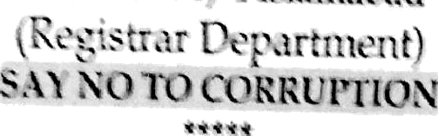

** '” '* • =^»=»R.ms,„,


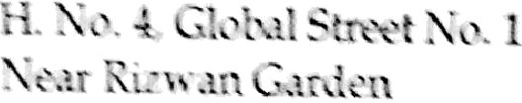

1-ahore.

SLUJECT: CI x$Pl-AlNT .AGAINST ALLEGED IELEGAE TRANFER OF GAS h1ETER BY Si 'GPL

Please rriér ix* ix•ur aFplicati‹ n waived in this oftax* on lY10-2025 on

°pFUcaâcnh ertheCoun‹fi£a ams ›uhaveaboobbUnedsStyCTdermthe
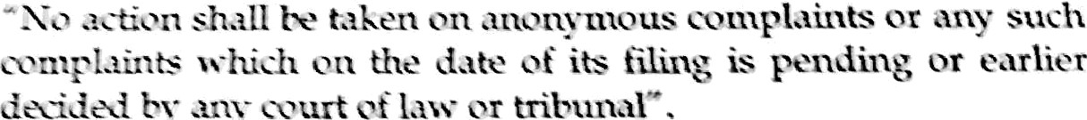
4. In xfiess ‹rj aR» e, your application cannot be entertained/processed further in • •ttivv. at • .•tygm. H ›ssvs-er.you are advised to kin‹lly appiy/apptt›ach S.UGPL W (al<•riguñth Court Stay Order), teing concerned Gas Utility
*k•np°• -1**°•=‘ ei°‘v«lerCompany,pteose
Yours faithfully,

(Dr. Abdul Basit Qureshi}
Senior Registrar

"' A 'A ' UrA1C›rYAUrI—iORfTY
Plot NO. 37 & 39, Mauve Area, ServiceRoad South,

Sector G-10/4 Islamabad
(Registrar Department)
SAY NO TO CORRUPTION

OG8A-6(11)/2025

Syed Israr Shah
S/o Syed Dildar Shah (Late) R/o Bhai Kot, Chak No. 3 Tehsil Patoki, Distt: Kasur.
Cell No. 0300-6545271

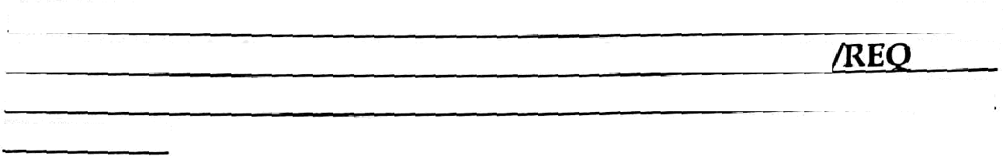
SUBJECT:
ArrucAx rs GAS METnt ON WRONc rnsMiSEs
coMrrAiNr AcAiNST ALLEGED
INSTALLATION OF
UEST For nzsTonATiON OF GAS CONNECTION ON APPLICANT'S PROPERTY

October 21, 2025

Dear Sir,
Please refer to your application received in this office on 20-10-2025 on
the above subject.
2. The perusal of your application revealed that you did not provide any supporting/relevant documents (i.e copy of gas bill or Account ID/Consumer No.) it is, therefore, requested to kindly provide the same immediately, enabling this office to proceed further in the matter, as per OGRA's Complaint Resolution Procedure iteguJation (CitPlt), 2003, please.

Yours faithfully,

(Dr. Abdul Basit Qureshi)
Senior Registrar

