|  |  |
| --- | --- |
| https://mae.usu.edu/student-clubs/asme/images/Utah_State_University_Logo.svg.png | |
|  | David Rosenberg  Utah Water Research Laboratory  8200 Old Main Hill  Logan, UT 84322-8200  Telephone: (435) 797-8689 FAX: (435) 797-1185  Email: [david.rosenberg@usu.edu](mailto:david.rosenberg@usu.edu)  <http://rosenberg.usu.edu>  @WaterModeler |

**November 15, 2021**

Utah Division of Water Resources

1594 W North Temple, Suite 310  
Salt Lake City UT, 84116

**Subject: 9 things I like about the 2021 draft Utah state water plan and 7 suggestions to improve**

# Introduction

This Fall, the Utah Division of Water Resources (hereafter, UDWR) released a draft 2021 Utah state water plan (<https://water.utah.gov/2021waterplan/>). The UDWR solicited public feedback. Below, I describe my involvement with the UDWR, strengths of the 2021 draft plan, and suggestions to improve.

# ****Prior Engagement****

I have worked formally and informally with UDWR since 2008. The UDWR provided a copy of their Fortran model for the Bear River basin. I and Dr. Ayman Alafifi used the data to develop a new model that recommended reservoir operations to enhance aquatic, flood plain, and impounded wetland habitat while sustain water deliveries for agriculture and municipalities (Alafifi and Rosenberg, 2020). I also worked with the UDWR on the Drought Contingency Plan for the Weber Basin that used Utah State University reconstructions of monthly stream flow going back to 1408 AD (JUB Engineers, 2018; Stagge et al., 2018). As part of a follow-on drought vulnerability study, Jacob Everitt and I used and extended the UDWR’s RiverWare model for the Weber Basin. We identified system vulnerabilities to stream flow, future demand, reservoir sedimentation and evaporation rates (Everitt, 2020). I also presented to UDWR staff on research to target households with the most potential to save water, money, and energy (Abdallah and Rosenberg, 2014; James, 2019). From December 2020 to March 2021, the UDWR, Utah State University, and University of Utah developed a proposal to compare Utah per capita water use methods to nearby states and districts.

# ****Strengths of the 2021 Draft Plan****

The major strength of the 2021 draft plan is to present state water supply and state water demand together and to support the analysis with open data. Additional strengths include:

1. **Educated readers.** The plan presents multiple infographics and text that define key concepts like diversion, depletion, and return flow that are central to water planning and management. The plan also includes infographics that explain how cloud seeding and return flows to the Great Salt Lake work. Education is an important goal for a water plan.
2. **Data available.** Data are available through an open water data website. These data include municipal and industrial water use, water related land use, and basin level annual water budget. The portal is easy to use. Data are provided in common formats. The portal provides meta data to interpret the contents. Making data available improves transparency and legitimacy of water planning.
3. **Increased temporal frequency of data reporting.** The municipal and industrial data are reported every year instead of every five years. Water-related land use data are reported every year instead of every six years. This increased temporal frequency helps planners see and react more quickly to anomalies and divergent trends.
4. **Show uncertainty in demand forecasts**. For the first time, the plan acknowledges uncertainty in two factors that have a large impact on demand forecasts (Figure 6-2). The uncertain factors are:
   * **Per-capita water use**. This uncertainty is represented by three scenarios that differ in:
     + **No change**: 2015 rates of use, no climate change.
     + **Baseline**: 2019 conservation practices continued, partial conversion to more efficient household appliances and landscapes, climate change.
     + **Regional water conservation goals**: meet state’s regional conservation goals that vary from 11% to 20% reductions and climate change.
   * **Agricultural to urban conversions.** Low and high rates.

Acknowledging this uncertainty is important. We do not know what future demand will be. We need to plan for different scenarios. And many future demand scenarios stay within the available supply – they do not require Bear River or other development.

1. **The state’s demand model is expanded** to include 9 factors of household size, net evapotranspiration, lot size, green space, home type, commercial industrial, institutional use, population, sprinkler efficiency, and climate change (Chapter 4). Each factor is qualitatively described.
2. **I was excited to see the plan state that Bear River development is not needed for 30 years or longer**. This statement allows state water planning efforts to focus on efforts that deliver water sooner, at lower cost, with fewer environmental impacts, and are less controversial. These efforts include water conservation, water banking, aquifer storage and recovery, and agricultural water use efficiency.
3. **Many water conservation efforts**. The plan describes state wide conservation efforts such as flip your strip, linked land use and water planning, water efficient standards for new development, secondary water meters, agricultural optimization, a weekly lawn watering guide. These conservation efforts help reduce per capita water use and delay the need for new projects such as Bear River development or Lake Powell Pipeline.
4. **Recommended conservation actions.** The plan listed specific conservation actions for individuals, state government, UDWR, municipalities, water systems, and organizations. Everyone has a role to promote conservation. These action items are great because they tell parties how to conserve water now and how to grow conservation efforts over time.
5. **Engaging plan.** The plan has large font size, concise text, many photos, figures, and infographics. All these make the plan easy to read and to share with diverse stakeholders.

# Suggestions to Improve

1. **Make state conservation goals more aggressive than 20% reductions from current use** (Figure 5-2). The UDWR shared 2018 Total gallons per capita per day (gpcd) data in their data portal for 468 Utah water providers (UDWR, 2020). I see that Utahns use from less than 100 to more than 4,000 gpcd!!!! (Figure 1). 60 Utah water providers can reduce their current water use by 20% and achieve the 191 gpcd level of Salt Lake City. 267 Utah providers exceeded 239 gpcd. A 20% reduction will still keep their use higher than the present Salt Lake City level. Utah water providers have lots of opportunities to conserve water. Make state conservation goals much more aggressive.

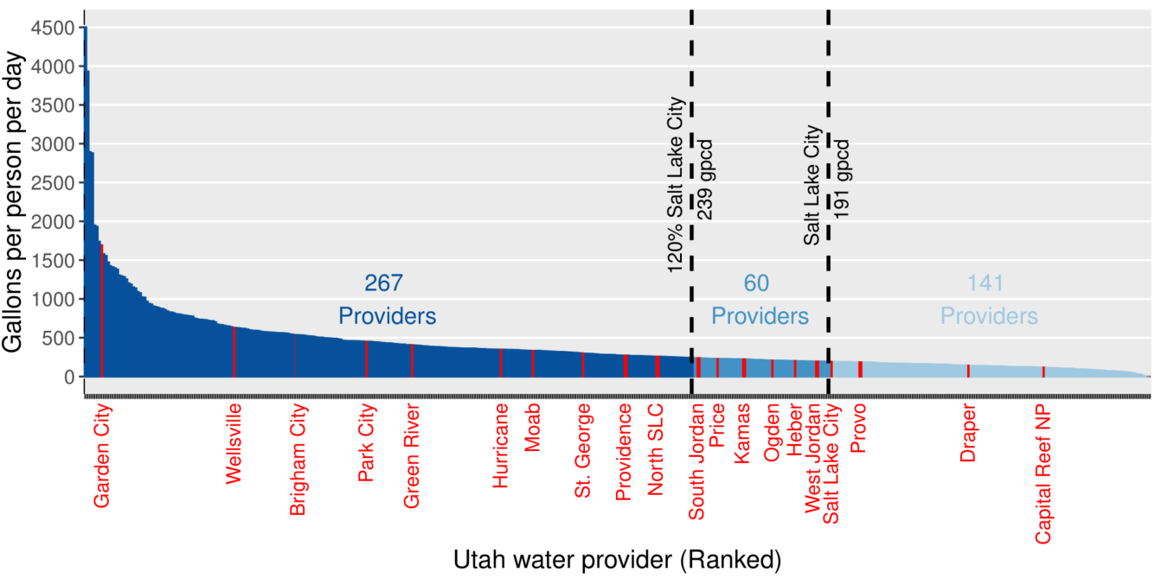

**Figure 1. Utah water providers ranked by 2018 total per capita water use.** Water providers between the two dashed vertical lines can reduce their use by the 20% state conservation target and reach Salt Lake City’s current level. Data from UDWR (2020).

1. **Target conservation efforts to the Utah customers and Utah water providers that can save the most water**. For example, The UDWR reports that Garden City, Wellsville, Brigham City, Park City, and Green River use more than double the amount of Salt Lake City on a per-capita basis (Figure 1). Cities in Washington County like Hurricane and St. George also use 160% or more water on a per capita basis than Salt Lake City and have opportunities to conserve. In the section on the Lake Powell Pipeline (pp. 87-88), point out these numerous targeted conservation opportunities so Utahns get a balanced perspective on the pipeline project and alternatives. Similarly, celebrate accomplishments of providers with low per capita use like Draper and Capital Reef National Park.
2. **Remove the “No change” demand scenario from all plots** (Chapter 4 and Appendix G). The no change scenario references 2015. The “baseline” scenario references 2019. Water use changed – decreased – from 2015 to 2019 (UDWR data, results not shown). The 2015 no change scenario is no longer valid or possible. The 2015 scenario inflates and overstates future water demand. Keep the scenarios for 2019 baseline and regional conservation goals that are possible. Add a new third scenario that is also possible – more aggressive conservation than the regional goals (see suggestions #1 and 2).
3. **Show how demand factors affect future demands.** Chapter 4 starts off by stating “Projecting Utah’s future water needs is complex.” Then Figure 6-1 and many figures in Appendix G show linear growth in water use over time. The two causes for the linear behavior appear to be:
   1. **Population** linearly increases over time (Figure 2-1 and Appendix C).
   2. **Per capita water use** is constant after about 2035.

Provide a quantitative analysis that shows how the 9 demand factors affect future water demand (Strengths #4 and 5). Make the analysis interactive so Utahns can see and learn how demand factors shape future demand. See an interactive example for the Weber Basin (Everitt, 2020; Figure 7 and https://rpubs.com/Jeveritt/612064). To further build credibility with the public, compare prior population and demand forecasts to subsequent observations. Explain what was learned from the comparisons and what was improved.

1. **Support with data** **the unsubstantiated and misleading statement that Utah’s water estimation process “may give the false impression that Utahns use more water than people in other states”** (p. 17). To verify this claim as true, collect water use data from neighboring states and water providers and show the similarities and differences in the methods they and Utah use. These comparisons will tell Utahns if our water use and conservation efforts are on par with our neighbors or if more aggressive state conservation targets are needed. If someone has already gathered the data and made comparisons, I encourage the UDWR to share the results in the state water plan.
2. **Give the Great Salt Lake more prominence** **in the plan and explain how Utahns can protect and restore our great lake** (pp. 129 to 130). The Lake is the namesake for our state’s capital city. The lake and adjoining wetlands benefit Utah’s economy, contribute to Utah’s snow pack as the greatest on earth, and host millions of birds. As the lake level drops, the exposed lake bed generates dust that many Utahns breathe. That dust also diminishes mountain snowpack. Keep the “Great” in Great Salt Lake requires more than a short note in the final two pages of the state water plan. Keep the Great in Great Salt Lake requires more than passing a new law, asking parties to collaborate, and the UDWR provides model support. I want our state water plan to provide a vision for how to keep the Great in the Great Salt Lake. A vision should integrate across all the climate, supply, demand, agricultural, municipal, industrial, infrastructure, land use, development, water quality, legal, and watershed topics discussed in the plan. Another part is to dedicate water for the lake rather than work with whatever is not used in the Bear, Weber, and Provo-Jordan rivers. Further, engage parties in a process that leads to holistic, integrated, and systems management. Many other features are needed. Please make the Utah state water plan articulate a vision for how to protect and recover our Great Salt Lake.
3. **Better emphasize Utah’s promising water situation**. Most demand/supply plots for the baseline and regional conservation scenarios in chapter 5 and Appendix G show demand within supply through 2045 and beyond. Tout this finding! Further improve Utah’s situation by conserving more water (see suggestions #1-3). An exception is the Jordan River basin in 2070 (Figure 4-2). Here the plan can discuss the basin-specific water management strategies to help Jordan River water users.

# Minor Notes

* **Change the infographic on p. 35 to correctly represent water use in Washington County.** This infographic says a person only uses 15 gallons per day. The UDWR data show St. George and Hurricane use more than 300 gallons per person per day (Figure 1).
* **Better explain agricultural-to-urban water use values in Table 6-1**. These values seem low. What percent of the new municipal and industrial water use will occur *inside* and *outside* existing municipal boundaries?

# Data and Code Availability

The data, code, and directions to generate Figure 1 are available at Rosenberg (2021).

# References

Abdallah, A., and Rosenberg, D. (2014). "Heterogeneous Residential Water and Energy Linkages and Implications for Conservation and Management." *Journal of Water Resources Planning and Management - ASCE*, 140(3), 288-297. <http://ascelibrary.org/doi/abs/10.1061/%28ASCE%29WR.1943-5452.0000340>, Preprint: <https://digitalcommons.usu.edu/cee_facpub/1178/>.

Alafifi, A. H., and Rosenberg, D. E. (2020). "Systems modeling to improve river, riparian, and wetland habitat quality and area." *Environmental Modelling & Software*, 126, 104643. <http://www.sciencedirect.com/science/article/pii/S1364815218305309>.

Everitt, J. (2020). "Weber Basin Water Conservancy District Bottom-Up Climate Vulnerability Study Using RiverWare," Utah State University, Logan. <https://digitalcommons.usu.edu/gradreports/1474>.

James, R. (2019). "Agent-Based Model to Manage Household Water Use Through Social-Environmental Strategies of Encouragement and Peer Pressure," Utah State University, Logan, Utah. <https://digitalcommons.usu.edu/etd/7581/>.

JUB Engineers. (2018). "Drought Contingency Plan." Weber Basin Water Conservancy District, Layton, UT. <https://github.com/jacobeveritt/WeberBasinVulnerability/blob/master/5%20-%20BackgroundInfo/WBWCD-DroughtContingencyPlanReport-Final.pdf>.

Rosenberg, D. E. (2021). "Comments on draft 2021 Utah State Water Plan." <http://doi.org/10.5281/zenodo.5701542>. [Accessed on: November 14, 2021].

Stagge, J. H., Rosenberg, D. E., DeRose, R. J., and Rittenour, T. M. (2018). "Monthly paleostreamflow reconstruction from annual tree-ring chronologies." *Journal of Hydrology*, 557, 791-804. <https://www.sciencedirect.com/science/article/pii/S0022169417308855>.

UDWR. (2020). "2015 Municipal and Industrial Water Use Data: 2020 Version 3." Utah Division of Water Resources. <https://drive.google.com/file/d/1aD9SorKQauIfiDW0wdMXlafd0VKsdX-F/view>.