|  |
| --- |
|  |
| Avatax Integration |
|  |

|  |
| --- |
| Avatax integration components and Site Genesis 2 implementation |



Contents

Overview 4

Component Overview 5

Functional Overview 5

Compatibility 5

Integration with SiteGenesis 2 6

Integration Cartridge 6

Customizing SiteGenesis 9

Testing 15

Integration Partner Documentation 16

**Intended Audience**

This document is intended for technical personnel who will be setting up and integrating Avatax with the Demandware SiteGenesis 2 Storefront.

**Revision History**

| Date | Version | Notes | Author |
| --- | --- | --- | --- |
| August 8, 2010 | Version 0.1 | * Initial Release | Chris Chang |
| April 6, 2011 | Version 1.1 | * Shipping Address Validation call added | Chris Chang |
| May 4, 2011 | Version 1.2 | * Shipping Address Validation standalone call added | Chris Chang |
| July 29, 2013 | Version 2.0 | * Avatax Testing Center added for clients and developers * Test Connection, Commit and Cancel Tax features added * AVS enhancements added * Transaction logging added * Customer and Entity/Use code added * Fixed order level promotion bugs * Fixed documentation and added enhancement steps * Added more custom preferences and configurations for the enhancements displayed above * Cleaned up code and added detailed comments | Shane Soifert |

# Overview

The Avatax Demandware cartridge will provide rapid integration for Demandware implementations. TheAvataxcartridgeisaselfcontainedcartridgethatcaneasilyintegrateintoanyproject. This cartridge can be configured in the Business Manager and contains all elements necessary to perform a successful best practices implementation of Avatax.

# Component Overview

## Functional Overview

1. AvaTax OnDemand is a powerful, online sales tax compliance solution that provides businesses with sales tax automation. -based service model and seamless integration into business applications gives you rapid access to all jurisdiction assignments and real-time sales tax calculations.
2. During check out shopping cart and customer information is transmitted via the Avatax API web service specifications. Tax information is sent back and applied to products in the cart.
3. Advanced Address Validation logic has been added to assist with filtering certain countries (configured in the custom site preferences) and to enable/disable the AVS calls.
4. A testing center has been added to assist clients and developers with testing connections and committing tax requests to the Avatax console.
5. Detailed transaction logging on the Avatax console.
6. A customer code has been added to the Customer object in Business Manager so each customer will have a unique code.

An Entity/Use code has been added for tax exemptions for the following. A) Federal government (United States)

B) State government (United States)

C) Tribe / Status Indian / Indian Band (both)

D) Foreign diplomat (both)

E) Charitable or benevolent org (both)

F) Religious or educational org (both)

G) Resale (both)

H) Commercial agricultural production (both)

I) Industrial production / manufacturer (both)

J) Direct pay permit (United States)

K) Direct mail (United States)

L) Other (requires Exempt Reason Desc) (both)

N) Local government (United States)

P) Commercial aquaculture (Canada)

Q) Commercial Fishery (Canada)

R) Non-resident (Canada)

## Compatibility

Compatible with Site Genesis 2 version 13.4

# Integration with SiteGenesis 2

## Integration Cartridge

**Cartridge name**

* *int_avatax*

**Pipelines**

* *Avatax.xml*

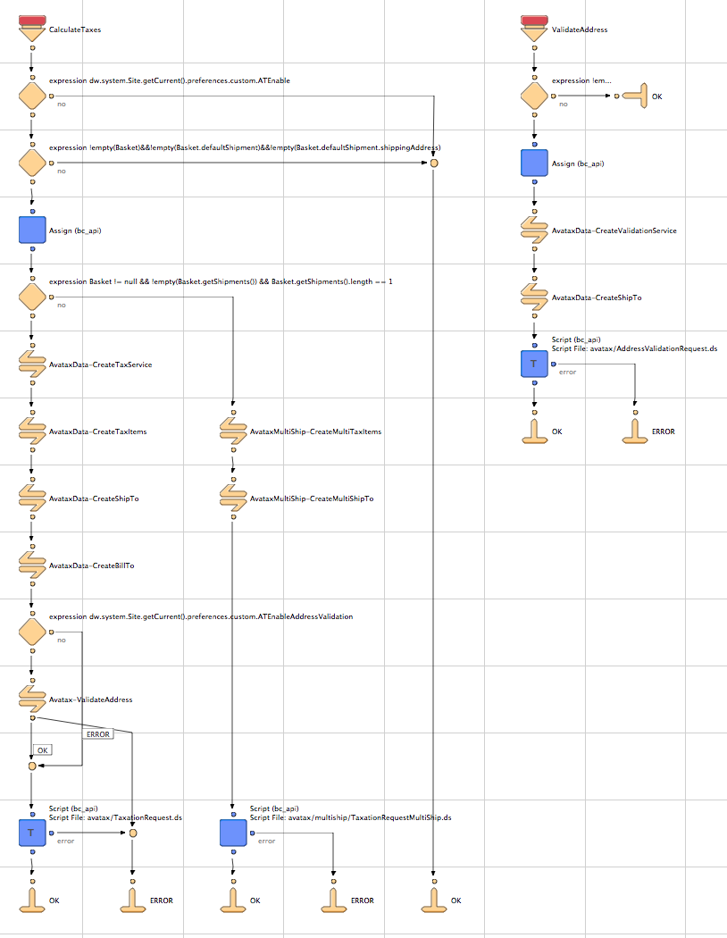

* *AvataxData.xml*

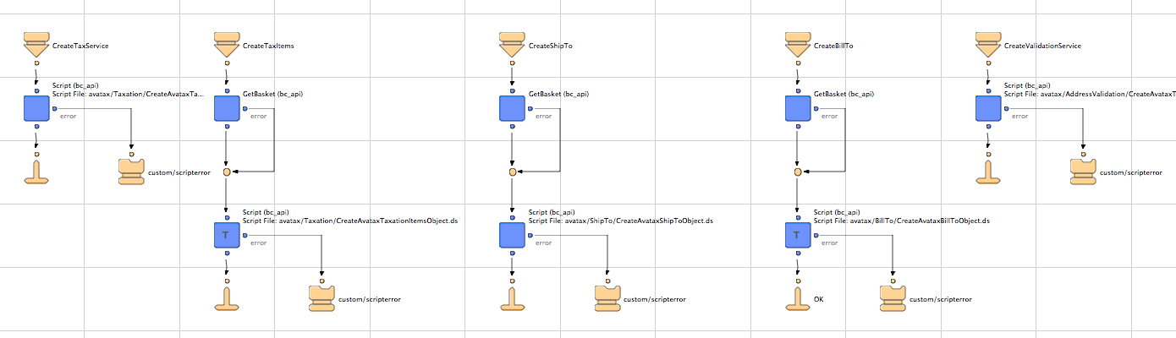

* *AvataxMultiShip.xml*

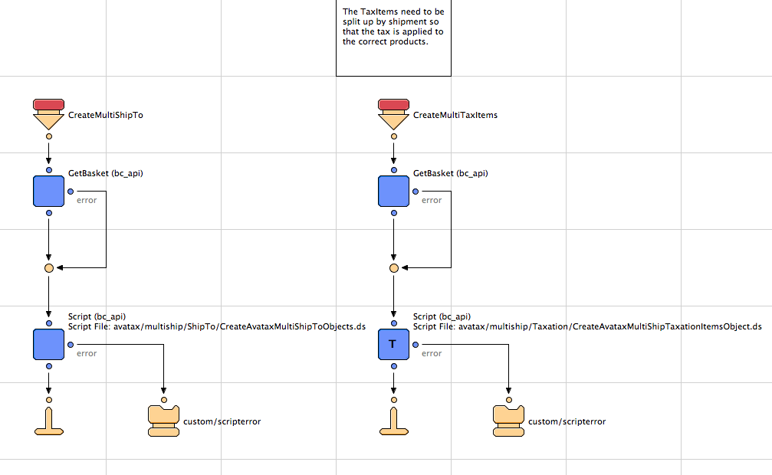

* *AvataxTest.xml*

**Scripts**

* *CreateAvataxTaxRequestObject.ds*
* *CreateAvataxBillToObject.ds*
* CreateReturnAvataxBillToObject.ds
* CreateAvataxMultiShipToObjects.ds
* CreateAvataxMultiShipTaxationItemsObject.ds
* TaxationRequestMultiShip.ds
* *CreateAvataxShipToObject.ds*
* CreateReturnAvataxShipToObject.ds
* *CreateAvataxTaxationItemsObject.ds*
* CreateAvataxTaxRequestObject.ds
* CreateAvataxTaxRequestObject.ds
* *Avatax_BillTo_Object.ds*
* *Avatax_Card_Object.ds*
* *Avatax_Item_Object.ds*
* *Avatax_PayerAuthEnrollService_Object.ds*
* *Avatax_PurchaseTotals_Object.ds*
* *Avatax_ShipFrom_Object.ds*
* *Avatax_ShipTo_Object.ds*
* CancelTaxationRequest.ds
* *Creditcardinfo.ds*
* *GetAvataxHelper.ds*
* *GetPaymentInstrument.ds*
* *libAvatax.ds*
* PostTaxationRequest.ds
* ReturnTaxationRequest.ds
* *TaxationRequest.ds*
* VerifyAvataxSubscription.ds

**Templates**

* *BillingAddress.isml*
* *modules.isml*
* *scripterror.isml*
* *ShippingAddress.isml*
* *StandardizedAddress.isml*
* calculatetax-output.isml
* cancel-output.isml
* committax-output.isml
* failed-committax-output.isml
* failed-ping-output.isml
* ping-output.isml
* returntax-output.isml
* testcenter.isml

**Properties**

* *int_avatax.properties*

**Metadata**

* *avatax_metadata.xml*
* *bm_extensions.xml*

**Webreferences**

* *taxsvc.wsdl*
* addresssvc.wsdl

## Customizing SiteGenesis

1) Import the int_avatax cartridge into the Demandware Studio Workspace:

a) Open Demandware Studio

b) Click File -> Import -> General -> Existing Files Into Workspace

c) Browse to the "int_avatax" directory.

d) Click Finish.

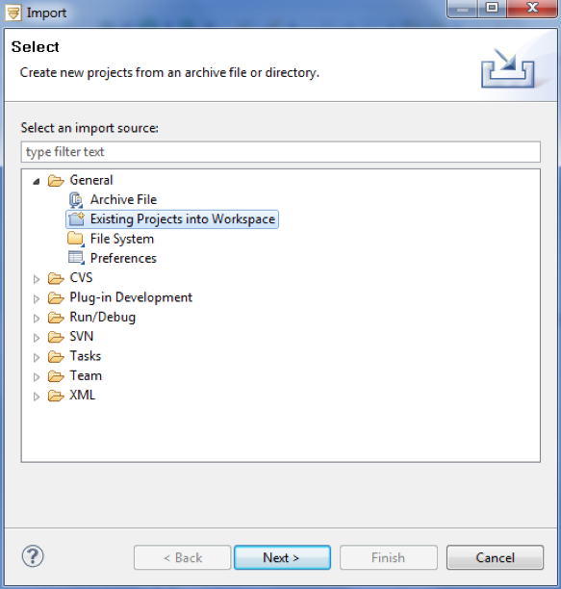

2) Import the Custom Site Preferences into the Demandware Business Manager on the Staging Server

a) Log into the Demandware Business Manager for the Staging Server.

b) Click Administration -> Sites Development -> Import/Export

c) Browse for the avatax_metadata.xml file

d) Click Upload

e) Click the "<< Back" button at the bottom of the page.

f) Click Import

g) Select the avatax_metadata.xml file

h) Click Next

i) When validation is complete, click Next.

3) Configure Avatax Custom Preferences using the Demandware Business Manager on the Staging Server

a) Log into the Demandware Business Manager on the Staging Server. For each site Avatax is to be configured on:

b) Select the correct site from the tabs across the top of the page.

c) Click Site Preferences -> Custom Preferences -> Avatax

d) Fill in the Site Preferences as directed by Avalara. This includes the Avatax Merchant Id, Avatax Merchant Key, and Avatax Company Code. Avatax ShipFrom City, Avatax ShipFrom StateCode, Avatax ShipFrom ZipCode, and Avatax ShipFrom Country Code should also be filled out to match the address of the distributor.

## Macintosh HD:Users:shanesoifert:Desktop:Screen Shot 2013-08-05 at 10.59.46 AM.png

4) Append int_avatax to the Effective Cartridge Path.

a) Log into the Demandware Business Manager on the Staging Server.

b) Click Administration -> Sites -> Manage Sites

For each site listed:

c) Select the site from the list.

d) Click on the Settings tab.

e) Append ":int_avatax" to the "Cartridges:" field.

f) Click Apply

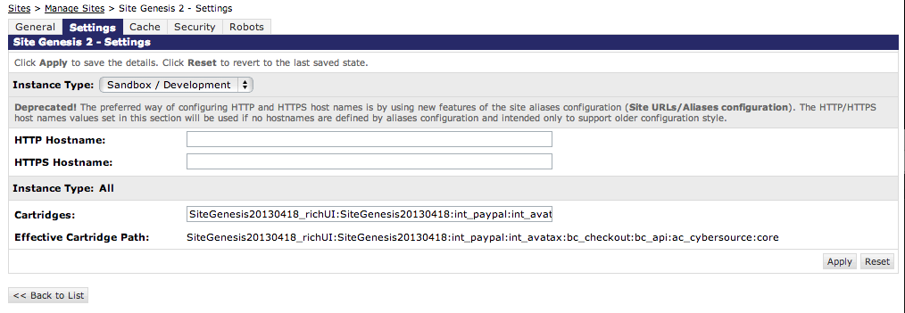

5.) Add the following assign node and CreateOrderNo pipelet to the “COPlaceOrder –Start” pipeline before the “Cart-Calculate” call node.

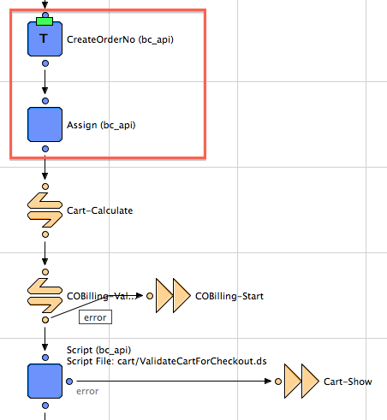

6.) Add the following values to the properties of the CreateOrderNo pipelet.

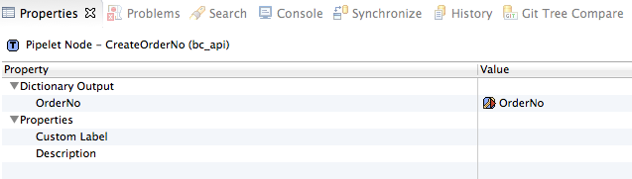

7.) Add the following values to the Assign node below the CreateOrderNo pipelet.

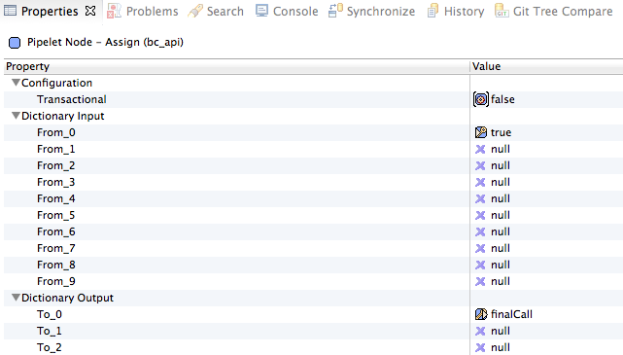

8) Add the following call node “Avatax-CalculateTaxes” in the “Cart-Calculate” pipeline after the CalculateCart.ds script.

Also add the ERROR and OK connectors after the call node “Avatax-CalculateTaxes” in the “Cart-Calculate” pipeline.

Note- Client will need to advise how they would like to handle an error from the Avatax tax calculation system.

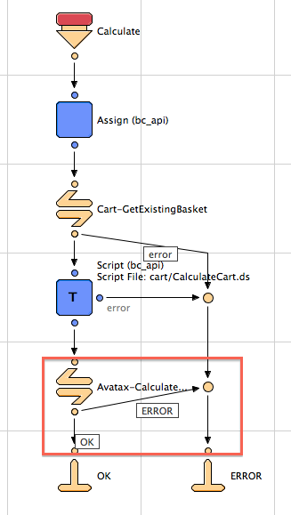

9.) Add the following names to the property attributes of the two end nodes in the pipeline “Cart-Calculate”.

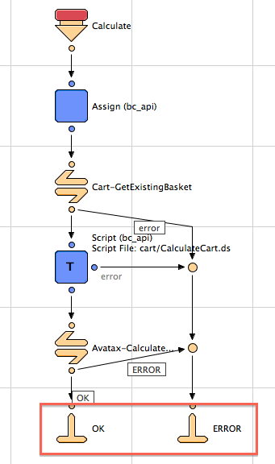

10.) Perform a regression test against the development server to ensure the site is still functional.

## Testing

To test that the Avatax integration is working properly, follow these steps:

* go to the Demandware Storefront and add products to the cart
* checkout with the products that have been added
* on the shipping or billing page, enter the address of a taxable area that was setup throughthe  admin console. Billing address is used for calculating taxes, but it will default to the shipping  address if the billing address is not available.
* verify that the correct tax amount is being calculated in the order summary
* Avatax now returns corrected address and suggestion. It is up to the client to apply this address  back into their system or to prompt the customer that there is a problem with the address.

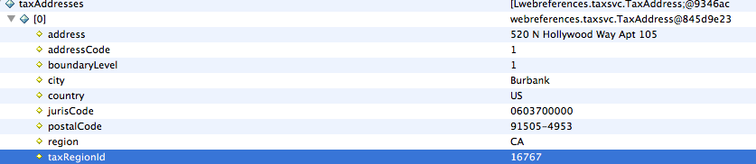

* Avatax-ValidateAddress will check for the shipping address being passed and will return the following information data:

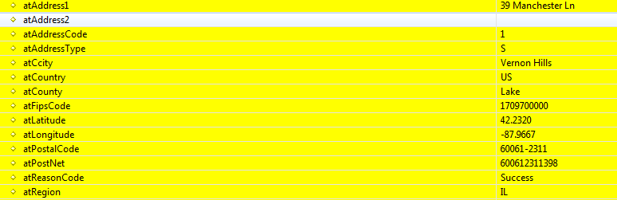

atReasonCode -- Reason Code will indicate the Success or Failure on the address validation.

This test verifies that the AvaTax is configured properly and address correction functionality is returning data back if needed.

# Integration Partner Documentation

If you encounter any issues related to configuring or testing this integration, you may contact Avalara customer support for assistance. You can submit a case by email, online web-to-case, telephone or chat. Please go to http://avalara.com/Technical-Support for more details as availability will vary depending on your support package.