brokerId
Field Registro
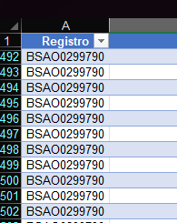

brokerName
Static Value ‘DSV’

country
Static Value ‘BR’

costumerId
Field Ref. Cliente
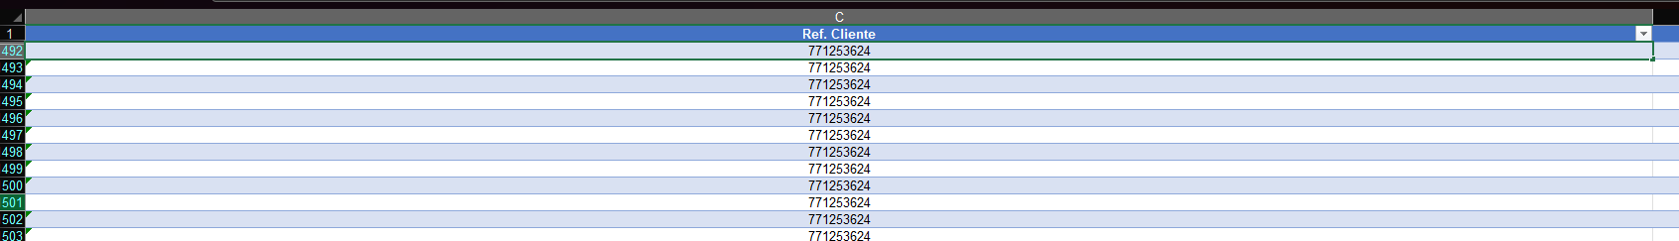

division
Field Via de Transporte (and then converted to it’s respective numeric code)
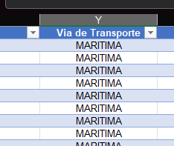

header.declarationType
Static Value ‘DU-E’

header.lrn
null \\ We don’t have any reference to the lrn number in the DU-E. The DU-E’s equivalent number seems to be, actually, the mrn, since it’s assigned by the Receita Federal

header.mrn
Field Número DUE
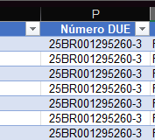

header.incoterms.code
Field Condição de Venda (Only the 3 characters code)
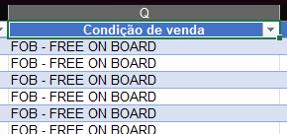

header.incoterms.location
null \\ There isn’t any information in the DU-E declaration (neither in the FollowNet) about any other element related to an incoterm that is not the code itself. What could be the incoterm location?

header.incoterms.unlocode
null \\ There isn’t any information in the DU-E declaration (neither in the FollowNet) about any other element related to an incoterm that is not the code itself. What could be the incoterm location

header.incoterms.country
Field País importador (and then converted to it’s respective ISO 2 character code)
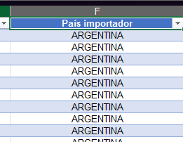

header.dispatchingCountry
Static Value ‘BR’

header.portOfLoading
Field URF Despacho (Sigla)
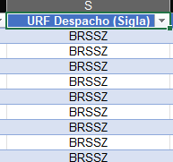

header.portOfDischarge
null \\ There isn’t any information in the DU-E declaration (neither in the FollowNet) about the port of discharge of an Export Process/Declaration

header.goodsLocation
Field Recinto Alfandegado (Despacho) (only the 7 number code)
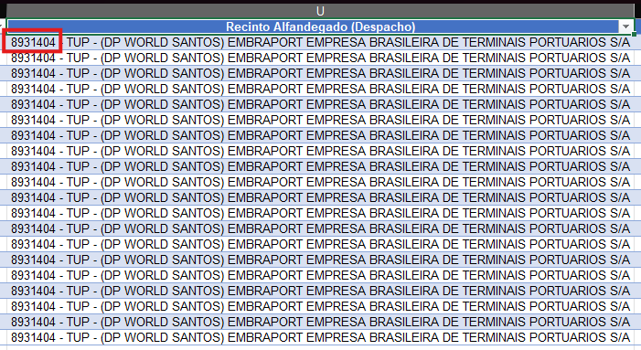

header.destinationCountry
Field Países de destino (only the 2 character ISO code)
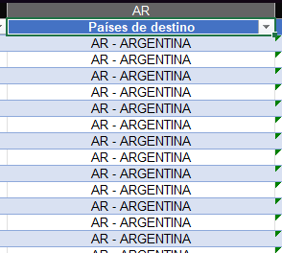

header.containers.containerNumber
Field Container (Módulo Container) (each container number will be separated by the ‘;’ and will be responsible for one individual object in the container array)
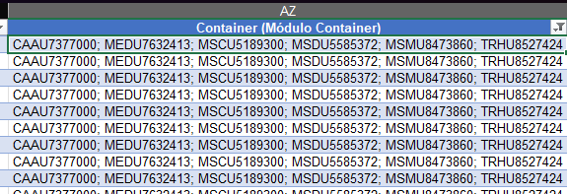

header.containers.containerSeal
null \\ There is no information about the container seal in the DU-E (neither in the FollowNet)

header.borderTransportNationality
null \\ There’s no information in the DU-E declaration (neither in the NF-e) about the shipment nationality of the goods in an export declaration. Any shipment from any country could do the transport

header.borderModeOfTransport
Field Via de Transporte (and then converted to it’s respective numeric code)


header.inlandTransportMode
Static Value ‘3’ (which means, Road transport, since this is the inland transport mode in most of the cases here in Brazil)

header.previousDocuments.category
Static Value ‘NF-e’ (since the necessary previous documents for the creation of the DU-E is the NF)

header.previousDocuments.type
null \\ Since we don’t have much information on what is exactly expected here

header.previousDocuments.reference
Field Número documento (and for each unique value for this field, there’s a object in the previousDocuments array, so, in this case, there are 5 different objects)
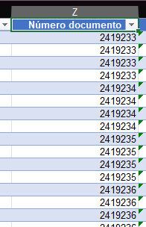

header.previousDocuments.identifier
null \\ Since we don’t have much information on what is exactly expected here

header.warehouseId
Field Recinto Alfandegado (Despacho) (only the 7 number code)
header.authorizationHolders.type
Field Enquadramento (only the text after the code). If the Enquadramento field value is “80000 - Exportação normal”, header.authorizationHolders.type is set as null
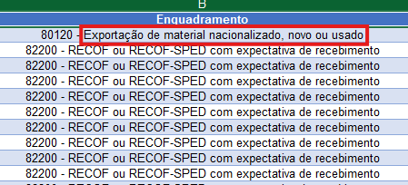

header.authorizationHolders.reference
Field Enquadramento (only the 5 digit number). If the Enquadramento field value is “80000 - Exportação normal”, header.authorizationHolders.type is set as null
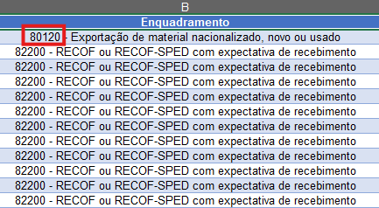

header.authorizationHolders.identifier
null \\ Since we don’t have much information on what is exactly expected here

header.presentationOffice
Field URF Despacho (only the 7 number code)
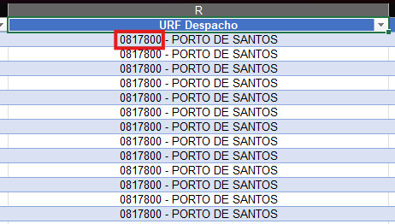

header.supervisingOffice
Field URF Despacho (only the 7 number code)


header.transactionNature
Field Enquadramento (only the 5 digit number. This numeric code will be used in the TransactionNature code conversion, as seen bellow)
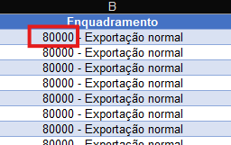
Enquadramento | TransactionNature code
80000 | PURCHASE/SALE
82200 | SUPPLY FOR SALE
90005 | GOODS EXPECTED TO RETURN TO INITIAL COUNTRY OF EXPORT
99101 | GOODS NOT EXPECTED TO RETURN TO INITIAL COUNTRY OF EXPORT
80170 | GOODS RETURNING TO INITIAL COUNTRY OF EXPORT
90009 | GOODS EXPECTED TO RETURN TO INITIAL COUNTRY OF EXPORT
90003 | GOODS EXPECTED TO RETURN TO INITIAL COUNTRY OF EXPORT
90001 | HIRE, LOAN, AND OPERATIONAL LEASING LONGER THAN 24 MONTHS
99199 | OTHER
80120 | PURCHASE/SALE
99106 | GOODS NOT RETURNING TO INITIAL COUNTRY OF EXPORT
99103 | GOODS NOT RETURNING TO INITIAL COUNTRY OF EXPORT

header.acceptanceDate
Field Data do Registro da DUE (in the ‘yyyy-mm-dd’)
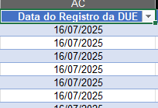

header.clearanceDate
Field Data do Registro da DUE (in the ‘yyyy-mm-dd’)
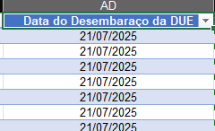

header.additionalDocuments.type
null \\ Fields related only to additional documents in a DU-E declaration. There isn’t any information about them in the DU-E declaration.

header.additionalDocuments.reference
null \\ Fields related only to additional documents in a DU-E declaration. There isn’t any information about them in the DU-E declaration.

header.additionalDocuments.identifier
null \\ Fields related only to additional documents in a DU-E declaration. There isn’t any information about them in the DU-E declaration.

header.awb
Field Hawb/HBL. If the Via de Transporte field value is different than ‘AEREA’, then value of header.awb is set as null

header.officeOfExit
Field Recinto Alfandegado (Despacho) (only the 7 digit numeric code)
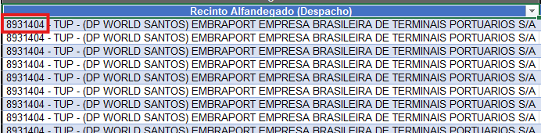

header.declarationCategory
Field Enquadramento (only the 5 digit number)
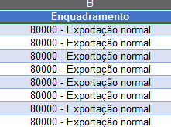

header.ucr
null \\ There’s no information about UCR in the DU-E declaration (neither in the FollowNet).

header.additionsAndDeductions.code
null \\ There’s no informations related to Additions or Deductions in the DU-E (neither in the FollowNet).

header.additionsAndDeductions.amount
null \\ There’s no informations related to Additions or Deductions in the DU-E (neither in the FollowNet).

header.additionsAndDeductions.currency
null \\ There’s no informations related to Additions or Deductions in the DU-E (neither in the FollowNet).

header.additionalInformation.code
null \\ There’s no additional informations in the DU-E (neither in the FollowNet).

header.additionalInformation.information
null \\ There’s no additional informations in the DU-E (neither in the FollowNet).

header.additionalInformation.identifier
null \\ There’s no additional informations in the DU-E (neither in the FollowNet).

header.fiscalReference.id
null \\ There’s no fiscal informations in the DU-E (neither in the FollowNet).

header.fiscalReference.role
null \\ There’s no fiscal informations in the DU-E (neither in the FollowNet).

header.guarantee.guaranteeType
null \\ There’s no guarantee informations in the DU-E (neither in the FollowNet).

header.guarantee.guaranteeNumber
null \\ There’s no guarantee informations in the DU-E (neither in the FollowNet).

header.taxes.taxType
null \\ There are no informations on taxes in the DU-E (neither in the FollowNet), since the exports in Brazil don’t envolve them on their process.

header.taxes.taxBase
null \\ There are no informations on taxes in the DU-E (neither in the FollowNet), since the exports in Brazil don’t envolve them on their process.

header.taxes.taxRate
null \\ There are no informations on taxes in the DU-E (neither in the FollowNet), since the exports in Brazil don’t envolve them on their process.

header.taxes.payableAmount
null \\ There are no informations on taxes in the DU-E (neither in the FollowNet), since the exports in Brazil don’t envolve them on their process.

header.taxes.totalTax
null \\ There are no informations on taxes in the DU-E (neither in the FollowNet), since the exports in Brazil don’t envolve them on their process.

header.taxes.paymentMethod
null \\ There are no informations on taxes in the DU-E (neither in the FollowNet), since the exports in Brazil don’t envolve them on their process.

header.defermentAccount
null \\ There is no information on the deferment account in the DU-E (neither in the FollowNet).

jobType
Static Value ‘BrokerStandardExport’, since we’re working with DU-E declarations

lines.tariffCode
Field Código NCM
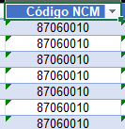

lines.customsProcedureCode
Field CFOP
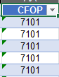

lines.additionalProcedureCode
Field Código produto
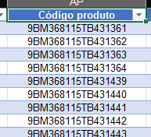

lines.previousDocumentsItem.category
Static Value ‘NF-e’

lines.previousDocumentsItem.type
null \\ Since we don’t have much information on what is exactly expected here

lines.previousDocumentsItem.reference
The Field Número documento, the value in the same row as the lines.additionalProcedureCode of a line object
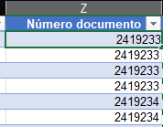

lines.previousDocumentsItem.identifier
null \\ Since we don’t have much information on what is exactly expected here

lines.additionalInformationItem.code
null \\ We don’t have any information about it in the DU-E declaration (neither in the FollowNet)

lines.additionalInformationItem.information
null \\ We don’t have any information about it in the DU-E declaration (neither in the FollowNet)

lines.additionalInformationItem.identifier
null \\ We don’t have any information about it in the DU-E declaration (neither in the FollowNet)

lines.additionalDocumentsItem.type
null \\ We don’t have any information about it in the DU-E declaration (neither in the FollowNet)

lines.additionalDocumentsItem.reference
null \\ We don’t have any information about it in the DU-E declaration (neither in the FollowNet)

lines.additionalDocumentsItem.identifier
null \\ We don’t have any information about it in the DU-E declaration (neither in the FollowNet)

lines.additionalDocumentsItem.quantity
null \\ We don’t have any information about it in the DU-E declaration (neither in the FollowNet)

lines.additionalDocumentsItem.units
null \\ We don’t have any information about it in the DU-E declaration (neither in the FollowNet)

lines.additionalDocumentsItem.authorityName
null \\ We don’t have any information about it in the DU-E declaration (neither in the FollowNet)

lines.additionalDocumentsItem.validityDate
null \\ We don’t have any information about it in the DU-E declaration (neither in the FollowNet)

lines.amount
Field Quantidade do Valor da Mercadoria no Local de Embarque
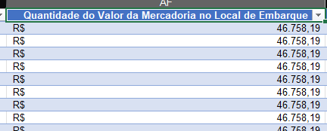

lines.currencyItem
Field Abreviação moeda
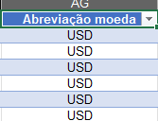

lines.originCountry
Static Value ‘BR’

lines.netWeight
The Field Peso líquido total, the value in the same row as the lines.additionalProcedureCode of a line object
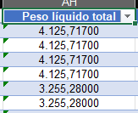

lines.netWeight
The Field Peso líquido total, the value in the same row as the lines.additionalProcedureCode of a line object


lines.grossWeight
null \\ We don’t have any information about it in the DU-E declaration (neither in the FollowNet)

lines.packageMarks
null \\ We don’t have any information about it in the DU-E declaration (neither in the FollowNet)

lines.firstAdditionalCode
Field Identificador item
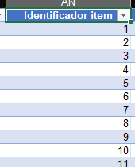

lines.secondAdditionalCode
null \\ We don’t have any information about it in the DU-E declaration (neither in the FollowNet)

lines.supplementaryUnits
null \\ We don’t have any information about it in the DU-E declaration (neither in the FollowNet)

lines.description
Field Descrição mercadoria
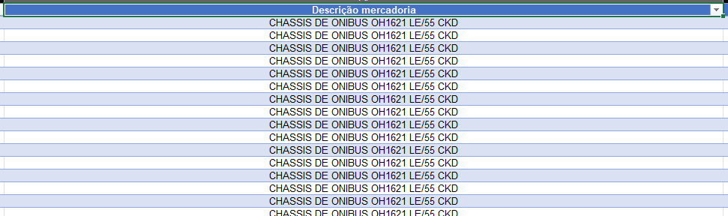

lines.transactionNatureItem
Field Enquadramento (only the 5 digit number. This numeric code will be used in the TransactionNature code conversion, as seen bellow)

Enquadramento | TransactionNature code
80000 | PURCHASE/SALE
82200 | SUPPLY FOR SALE
90005 | GOODS EXPECTED TO RETURN TO INITIAL COUNTRY OF EXPORT
99101 | GOODS NOT EXPECTED TO RETURN TO INITIAL COUNTRY OF EXPORT
80170 | GOODS RETURNING TO INITIAL COUNTRY OF EXPORT
90009 | GOODS EXPECTED TO RETURN TO INITIAL COUNTRY OF EXPORT
90003 | GOODS EXPECTED TO RETURN TO INITIAL COUNTRY OF EXPORT
90001 | HIRE, LOAN, AND OPERATIONAL LEASING LONGER THAN 24 MONTHS
99199 | OTHER
80120 | PURCHASE/SALE
99106 | GOODS NOT RETURNING TO INITIAL COUNTRY OF EXPORT
99103 | GOODS NOT RETURNING TO INITIAL COUNTRY OF EXPORT

lines.invoiceNumberItem
Field Invoice
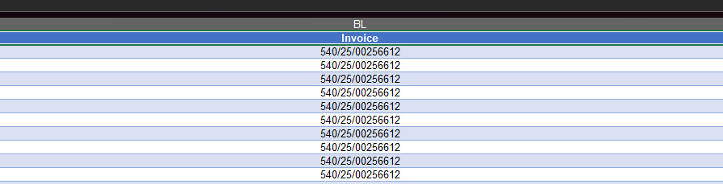

lines.statisticalValue
Field Quantidade unidade estatística
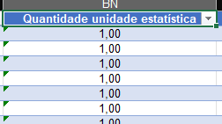

lines.quantityItem
Field Quantidade unidade
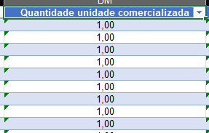

lines.numberOfPackages
null \\ We don’t have any information about it in the DU-E declaration (neither in the FollowNet)

lines.valuationIndicator.partyRelationship
null \\ We don’t have any information about it in the DU-E declaration

lines.valuationIndicator.buyerRestrictions
null \\ We don’t have any information about it in the DU-E declaration

lines.valuationIndicator.conditionsOnSaleOrPrice
null \\ We don’t have any information about it in the DU-E declaration

lines.valuationIndicator.proceedsOfSaleOrUse
null \\ We don’t have any information about it in the DU-E declaration

lines.valuationMethod
null \\ We don’t have any information about it in the DU-E declaration

lines.taxesItem.taxType
null \\ We don’t have any information about it in the DU-E declaration

lines.taxesItem.taxBase
null \\ We don’t have any information about it in the DU-E declaration

lines.taxesItem.taxRate
null \\ We don’t have any information about it in the DU-E declaration

lines.taxesItem.payableAmount
null \\ We don’t have any information about it in the DU-E declaration

lines.taxesItem.totalTax
null \\ We don’t have any information about it in the DU-E declaration

lines.taxesItem.paymentMethod
null \\ We don’t have any information about it in the DU-E declaration

lines. additionsAndDeductionsItem.code
null \\ We don’t have any information about it in the DU-E declaration

lines. additionsAndDeductionsItem.amount
null \\ We don’t have any information about it in the DU-E declaration

lines. additionsAndDeductionsItem.currency
null \\ We don’t have any information about it in the DU-E declaration

lines. preference
null \\ We don’t have any information about it in the DU-E declaration

lines. preferentialOriginCountry
null \\ We don’t have any information about it in the DU-E declaration

lines. quota
null \\ We don’t have any information about it in the DU-E declaration

parties.importer.id
????

parties.importer.cityName
Static Value ‘EXTERIOR’

parties.importer.country
Field País importador (and then converted to its respective 2 character ISO code)
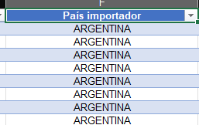

parties.importer.name
Field Importador
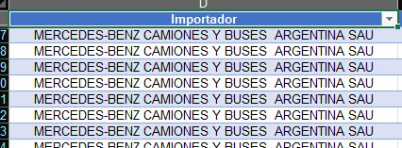

parties.importer.zipCode
null \\ We don’t have any information about it in the DU-E declaration

parties.importer.streetName
Field Endereço Importador (only the part right before ‘- EXTERIOR –‘)
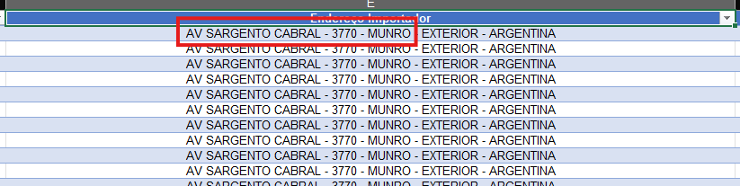

parties.importer.streetNumber
Field Endereço Importador (only the number)


parties.importer.eori
null \\ We don’t have any information about it in the DU-E declaration

parties.importer.representativeStatus
null \\ We don’t have any information about it in the DU-E declaration

parties.exporter.id / declarant / seller
?????

parties.exporter.cityName / declarant / seller
Field Cidade (Endereço)
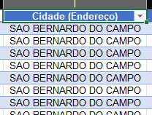

parties.exporter.country / declarant / seller
Static Value ‘BR’

parties.exporter.name / declarant / seller
Field Declarante
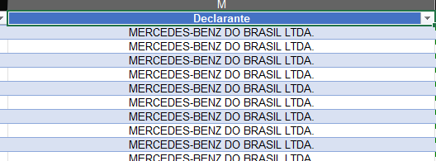

parties.exporter.zipCode / declarant / seller
Field CEP
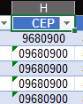

parties.exporter.streetName / declarant / seller
Field Endereço
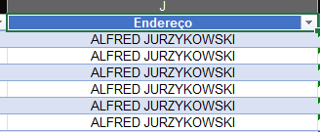

parties.exporter.streetNumber / declarant / seller
Field Numero (Endereço)
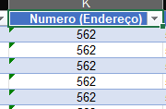

parties.exporter.eori / declarant / seller
null \\ We don’t have any information about it in the DU-E declaration

parties.exporter.representativeStatus / declarant / seller
null \\ We don’t have any information about it in the DU-E declaration

parties.representative.id / broker
?????

parties.representative.cityName / broker
Static Value ‘SANTOS’

parties.representative.country / broker
Static Value ‘BR’

parties.representative.name/ broker
Static Value ‘DSV Air & Sea Brasil’
parties.representative.zipCode/ broker
Static Value ‘11035260’

parties.representative.streetName/ broker
Static Value ‘Alameda Armenio Mendes’

parties.representative.streetNumber/ broker
Static Value ‘66’

parties.representative.eori/ broker
null \\ We don’t have any information about it in the DU-E declaration

parties.representative.representativeStatus/ broker
null \\ We don’t have any information about it in the DU-E declaration

parties.buyer.id
???????

parties.buyer.cityName
null \\ We don’t have any information about it in the DU-E declaration

parties.buyer.country
null \\ We don’t have any information about it in the DU-E declaration

parties.buyer.name
null \\ We don’t have any information about it in the DU-E declaration

parties.buyer.zipCode
null \\ We don’t have any information about it in the DU-E declaration

parties.buyer.streetName
null \\ We don’t have any information about it in the DU-E declaration

parties.buyer.streetNumber
null \\ We don’t have any information about it in the DU-E declaration

parties.buyer.eori
null \\ We don’t have any information about it in the DU-E declaration

parties.buyer.representativeStatus
null \\ We don’t have any information about it in the DU-E declaration

parties.forwarder.id
???????

parties.forwarder.cityName
null \\ We don’t have any information about it in the DU-E declaration

parties.forwarder.country
null \\ We don’t have any information about it in the DU-E declaration

parties.forwarder.name
Field Agente
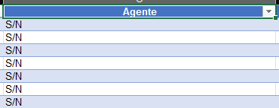

parties.forwarder.zipCode
null \\ We don’t have any information about it in the DU-E declaration

parties.forwarder.streetName
null \\ We don’t have any information about it in the DU-E declaration

parties.forwarder.streetNumber
null \\ We don’t have any information about it in the DU-E declaration

parties.forwarder.eori
null \\ We don’t have any information about it in the DU-E declaration

parties.forwarder.representativeStatus
null \\ We don’t have any information about it in the DU-E declaration

parties.carrier.id
???????

parties.carrier.cityName
null \\ We don’t have any information about it in the DU-E declaration

parties.carrier.country
null \\ We don’t have any information about it in the DU-E declaration

parties.carrier.name
null \\ We don’t have any information about it in the DU-E declaration

parties.carrier.zipCode
null \\ We don’t have any information about it in the DU-E declaration

parties.carrier.streetName
null \\ We don’t have any information about it in the DU-E declaration

parties.carrier.streetNumber
null \\ We don’t have any information about it in the DU-E declaration

parties.carrier.eori
null \\ We don’t have any information about it in the DU-E declaration

parties.carrier.representativeStatus
null \\ We don’t have any information about it in the DU-E declaration

stateOfData
Static Value ‘SUBMITTED_BY_BROKER_TO_CUSTOMS’

stateOfShipment
Static Value ‘DEPARTED’

stateOfEntry
Static Value ‘CLEARED

programId
null \\ We don’t have any information about it in the DU-E declaration

purchaseOrder
null \\ We don’t have any information about it in the DU-E declaration

assetId
null \\ We don’t have any information about it in the DU-E declaration

internalPartNumber
?????

