Programming Project 2: RPC-Based Multi-Threaded Server
COMP 7212 Operating/Distributed Systems
Sudarshan Balaji | Due 10/31/2026

1. How to Compile and Execute
Requirements: Python 3.8+. Only the standard library is used, so there is nothing to install and no compilation step (Python is interpreted). Keep server.py, client.py and test_rpc.py in the same folder.
- Start the server in one terminal. It listens on port 5000 and creates a new thread for every client.
python server.py (or: python server.py <host> <port>)
- Start one or more clients, each in its own terminal.
python client.py (or: python client.py <host> <port>)
- Invoke procedures at the prompts. Type QUIT to disconnect.
Enter operation: ADD
Enter first integer: 10
Enter second integer: 20
Result from server: 30
- Optional: with the server running, python test_rpc.py runs all four test scenarios automatically.

2. Source Code
- server.py - TCP server, one thread per client. Unmarshals requests, runs ADD / SUBTRACT / MULTIPLY / MAX, marshals results, and returns errors for invalid requests.
- client.py - interactive client. Its RPCClient stub marshals requests, sends them, waits for the reply, and unmarshals it. No calculation is done on the client.
- test_rpc.py - script that runs the four required test scenarios.

3. Parameter Marshaling and Unmarshaling
Every message is one line of UTF-8 text with comma-separated fields, ended by a newline.
- Request: PROCEDURE,a,b e.g. ADD,10,20
- Response: OK,result e.g. OK,30 or ERROR,message
Since TCP is a byte stream, one recv() may return part of a message or two messages joined together. The newline marks where each message ends. Both sides read with readline() on socket.makefile(), so each side always handles exactly one complete message.
A call to ADD(10, 20) goes through these steps:
- Client marshals: joins the procedure and parameters into ADD,10,20\n, rejecting any field that contains a comma or newline.
- Client sends the message and waits for one reply line.
- Server unmarshals: splits on commas, checks there are exactly 3 fields, checks the procedure is supported, and converts both parameters to int. Any failure produces an error.
- Server executes ADD(10, 20) = 30 by looking up the function in a dispatch table.
- Server marshals the result into OK,30\n, or ERROR,<reason>\n if the request was invalid.
- Client unmarshals by splitting at the first comma into status and value, then prints "Result from server: 30" or the error message.

4. Error Handling
- An unknown procedure (e.g. DIVIDE,10,2), non-integer parameters, or a wrong number of fields gets an ERROR reply. The server does not terminate, and the client's connection stays open.
- Each client runs in its own thread. A sudden disconnect, such as a connection reset, is caught inside that thread and the socket is closed, so other clients are not affected.

5. Test Scenarios
Scenario 1: Single client, all four procedures
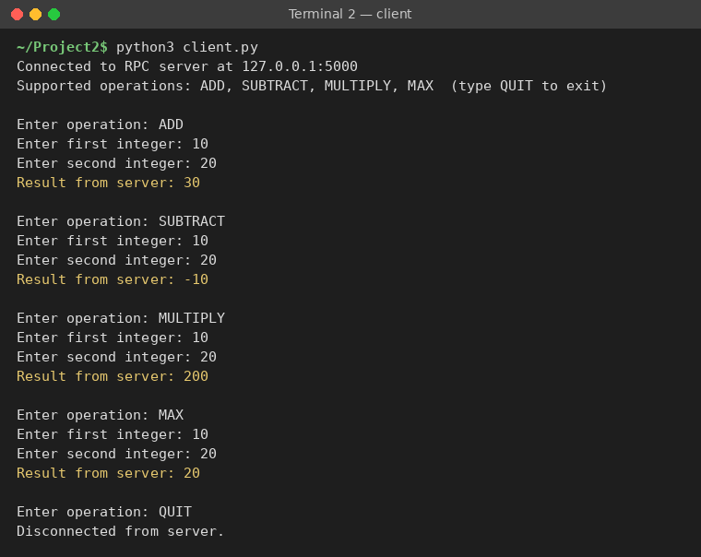
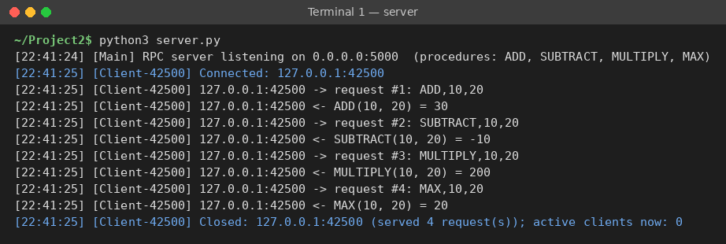
Scenario 2: Multiple requests without reconnecting
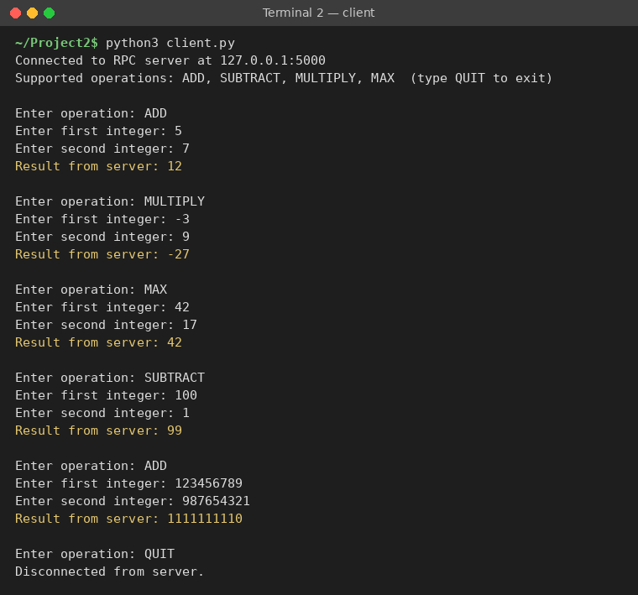
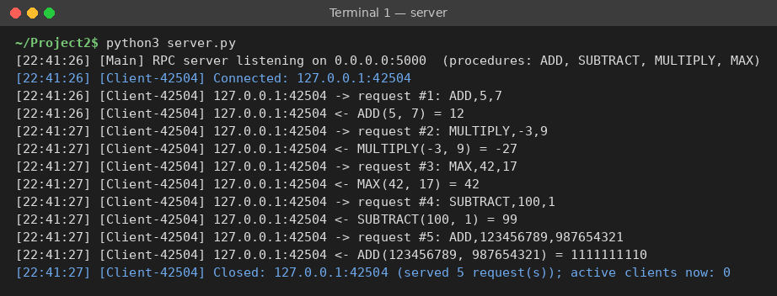
Scenario 3: Invalid procedure
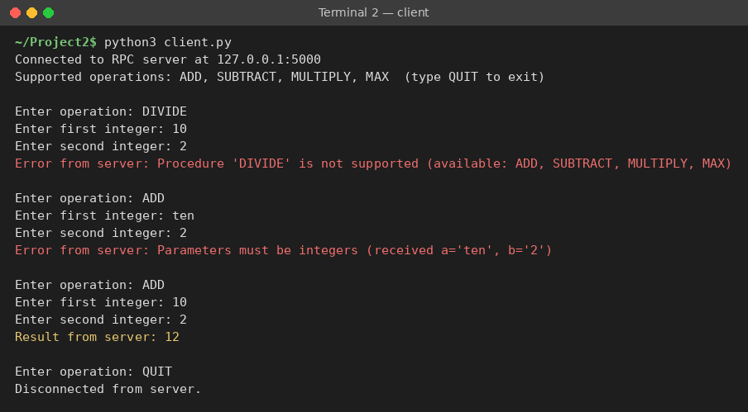
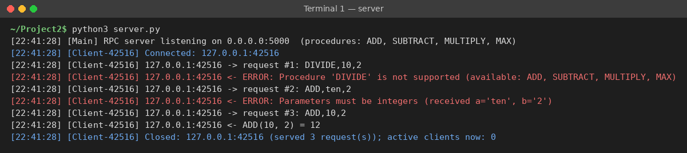
Scenario 4: Client disconnection


