University of Memphis
Department of Computer Science
COMP 7212 Operating/Distributed Systems
Instructor: Dr. Myounggyu Won
Fall 2026, Midterm 1
Total – 100 points

Student Name (Last, First):

Instructions:
- Put your name on the exam books.

- You have the entire class time (85 mins) to complete the exam. The point’s value of each problem is provided, so allocate your time accordingly.

- Be a smart exam taker - if you get stuck on one problem go on to another problem. Also, don't waste your time giving irrelevant (or not requested) details or material.

- Show all your work. Partial credit is possible.

- Please write as neatly as possible - poorly written answers and poor handwriting will make it difficult to earn full marks on a particular question if the reader cannot understand what you are saying.

[Chapter 1]

1. Explain the two key characteristics of a distributed system.

1. A collection of autonomous computing elements: A distributed system consists of multiple independent nodes. A node can be a hardware device or a software process. Each node operates independently and makes decisions based on its own local information, but the nodes collaborate by exchanging messages to achieve a common goal.

2: A single coherent system: Even though the system consists of multiple nodes distributed across a network, users perceive them as one system. Users should not need to know where a process is running or where data is stored.

2. Explain two types of distribution transparency.

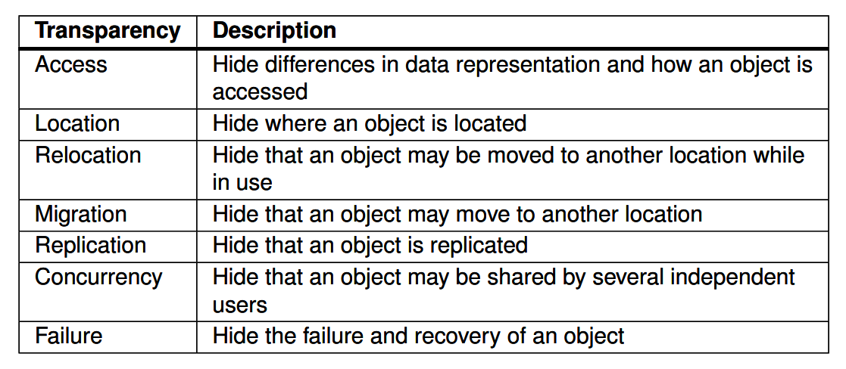

[Chapter 2]

3. Explain application layering using an example application.

Application layering divides an application into three levels:
- Application interface level: handles interaction with users or other applications.
- Processing level: performs the main application operations.
- Data level: stores and represents the application's data.
For example, consider an Internet search engine. At the interface level, a user enters a keyword and receives a list of web pages. At the processing level, the system converts the keyword into database queries, ranks the results, and generates HTML pages. At the data level, the system maintains a large database of web pages.

4. Explain the key characteristics of RESTful architecture.

A RESTful architecture views a distributed system as a collection of resources that are managed individually. Its key characteristics include:
- Resources are identified using a single naming scheme, such as URLs.
- Services provide a common interface consisting of a small number of operations for manipulating resources.
- Messages are self-describing, meaning that a request or response contains enough information for the receiver to understand and process it.
- Communication is stateless. After completing an operation, the service does not retain information about the caller.

5. Event-based communication is temporally coupled but referentially decoupled. Explain what this means.

Referentially decoupled means that communicating processes do not need to know or specify each other's names. In event-based communication, a process simply publishes an event, and interested subscribers receive it.

Temporally coupled means that the communicating processes need to be active at the same time. Therefore, when an event is published, subscribers generally need to be running in order to receive the notification.

6. Explain the concept of multi-tiered architecture.

A multi-tiered architecture is a variation of the client-server architecture in which different application layers are distributed across different machines.
The application can be divided into:
- the application interface level,
- the processing level, and
- the data level.
Instead of having all three layers on the same machine, they can be placed on separate machines or servers.

[Chapter 3]

7. Explain user-level threads, kernel-level threads, and thread mapping.

User-level threads are created and managed by a user-level thread library. The operating system is not aware of individual threads. They are fast and inexpensive to create and switch because the kernel is not involved. However, when using a many-to-one mapping, multiple user threads are mapped to one kernel schedulable entity. Therefore, if one thread performs a blocking system call, the entire process becomes blocked.

Kernel-level threads are created and managed by the operating system kernel. In the one-to-one mapping, each user thread corresponds to a kernel thread and is independently schedulable. Therefore, one blocking thread does not block all other threads. Kernel-level threads can also achieve true concurrency on multiple processors. However, they have more overhead because thread operations require system calls.

Tread mapping:
- Many-to-one: many user threads map to one kernel schedulable entity.
- One-to-one: each user thread maps to its own kernel thread.

8. Explain how a superserver works and how it helps save system resources.

Some services do not need to run continuously. Instead of keeping a separate server process running for every service, a superserver listens for requests on multiple endpoints or ports.

When a request arrives for a particular service, the superserver creates, or forks, the appropriate server process to handle that request.

This saves system resources because individual server processes do not have to remain running when they are not being used. They are created only when requests arrive.

9. Compare Type 1 and Type 2 hypervisors.

A Type 1 hypervisor, also called a native virtual machine monitor, runs directly on the underlying hardware. It virtualizes the hardware interface and does not require a host operating system. Multiple guest operating systems can run independently and concurrently on the same hardware. Examples include VMware ESXi and Microsoft Hyper-V.

A Type 2 hypervisor, also called a hosted virtual machine monitor, runs on top of an existing host operating system. It virtualizes the system-call interface and the general hardware interface to provide an environment in which guest operating systems can run. Examples include VMware Workstation and Oracle VM VirtualBox.

The main difference is that Type 1 runs directly on hardware, whereas Type 2 depends on a host operating system.

10. Explain how replication transparency is achieved from the client’s perspective.

Replication transparency hides the fact that multiple copies of a server or resource exist.
From the client's perspective, client-side middleware or a wrapper handles communication with the replicated servers. The middleware forwards the client's request to the replicas, transparently collects the responses, and then provides a single response to the client application.
Therefore, the client behaves as though it is communicating with one server and does not need to know that multiple replicas exist.

