Exercise 8
Name:________________

1. Stretch. Consider a network with nodes and edges as follows
- Nodes: A, B, C, D, E, F
- Edges with Weights: A-B: 4, A-D: 1, B-C: 1, B-E: 5, C-E: 1, D-C: 2, D-E: 8, E-F: 1
- Draw this network.
- The shortest path from A to F is A → D → C → E → F. Calculate the path stretch for this path: A → D → E → F.

2

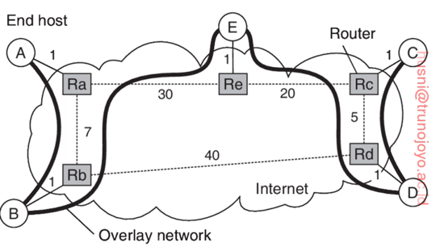
2. Consider the example network. Assume that each overlay link follows the corresponding shortest path in the underlying network:
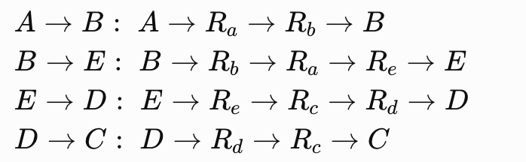

Calculate the link stress of each physical router-to-router link. Assume a traffic A → B → E → D → C.

S(Ra, Rb) = 2
S(Ra, Re) = 1
S(Re, Rc) = 1
S(Rc, Rd) = 2
S(Rb, Rd) = 0

3. Tree cost. Assuming the same traffic A → B → E → D → C. Calculate the total tree cost of the multicast tree.

82

