Insert your name, centre number and candidate number into the header above.
Save this evidence document as evidence_ followed by your centre number_ candidate number. For example: evidence_ zz999_9999.doc
Screenshots or program listings must be copied into appropriate cells in the following tables.
Examiners must be able to read the contents including any screenshots without the use of a magnifying glass. Answers that are not readable or missing will not be awarded any marks.
Save this evidence document at regular intervals, for example, every 10 minutes.
Question 1
Part 1(a)
def ReadWords(filename):
global num
global WordArray
file = open(filename, 'r')
for line in file:
if line != "":
WordArray.append(line)
else:
break

num = len(WordArray) -1

Part 1(b)
x = str(input("Please enter (easy), (medium), (hard): "))
file_name = "9618_s24_qp_42/" + x.capitalize() + ".txt"
ReadWords(file_name)

Part 1(c)(i)
def Play():
global WordArray
global num
print(f"Main word: {WordArray[0]}\n{num} answers")
count = 0

while True:
ans = str(input("Enter word: "))

if ans == "no":
break

if ans in WordArray:
print("Correct")
count += 1
index = WordArray.index(ans)
WordArray[index] = None

else:
print("Incorrect")

Part 1(c)(ii)
def Play():
global WordArray
global num
print(f"Main word: {WordArray[0]}\n{num} answers")
count = 0

while True:
ans = str(input("Enter word: "))

if ans == "no":
perc = 100*count / num
print(f"You got {perc:.2f}% of the answers!")
print("Remaining answers:")
for word in WordArray:
if word != None and word != WordArray[0]:
print(word.strip())
break

if ans in WordArray:
print("Correct")
count += 1
index = WordArray.index(ans)
WordArray[index] = None

else:
print("Incorrect")

Part 1(d)(i)
Play()

Part 1(d)(ii)
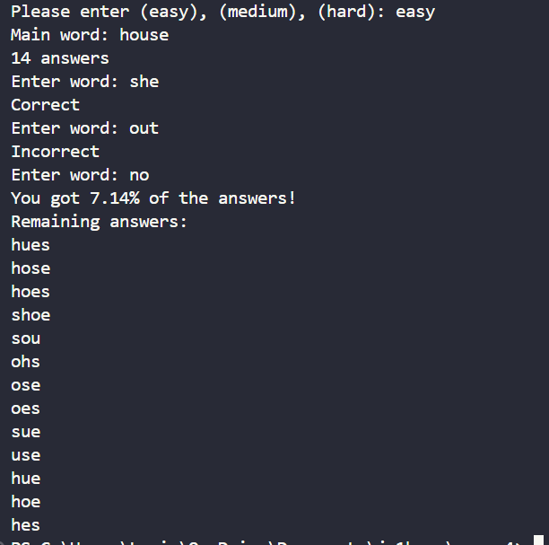

Part 1(d)(iii)
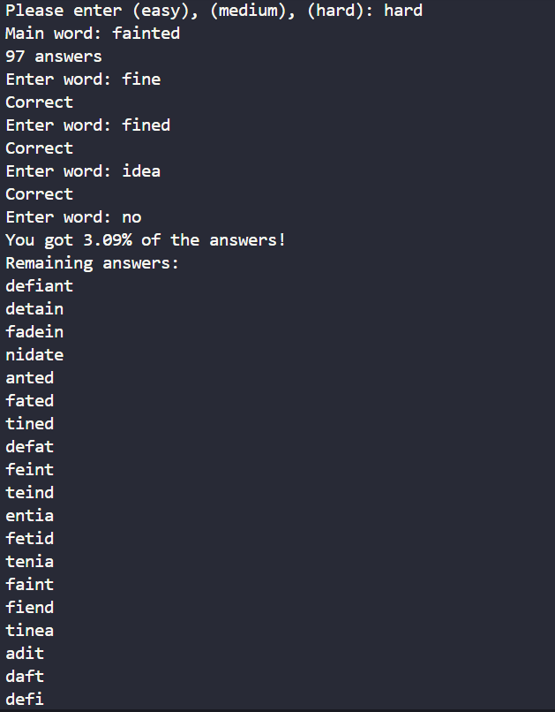

Question 2
Part 2(a)(i)
class Node:
def __init__(self, LeftPointer: int = -1, Data: int = 0, RightPointer: int = -1):

self.LeftPointer = -1
self.Data = 0
self.RightPointer = -1

Part 2(a)(ii)
def GetLeft(self):
return self.LeftPointer

def GetData(self):
return self.Data

def GetRight(self):
return self.RightPointer

Part 2(a)(iii)
def SetLeft(self, LeftPointer):
self.LeftPointer = LeftPointer

def SetData(self, Data):
self.Data = Data

def SetRight(self, RightPointer):
self.RightPointer = RightPointer

Part 2(b)(i)
class TreeClass:

def __init__(self, Tree: list = [Node(0,0,0) for _ in range(20)], FirstNode: int = -1, NumberNodes: int = 0):
self.Tree = [Node(0,0,0) for _ in range(20)]
self.FirstNode = -1
self.NumberNodes = 0

Part 2(b)(ii)
def InsertNode(self, NewNode: Node):

self.Tree[self.NumberNodes] = NewNode

if self.FirstNode == -1:
self.NumberNodes += 1
self.FirstNode = 0

else:
CurrentNode = self.FirstNode
while True:
if NewNode.GetData() < self.Tree[CurrentNode].GetData():
if self.Tree[CurrentNode].GetLeft() == -1:
self.Tree[CurrentNode].SetLeft(self.NumberNodes)
self.NumberNodes += 1
break
else:
CurrentNode = self.Tree[CurrentNode].GetLeft()
else:
if self.Tree[CurrentNode].GetRight() == -1:
self.Tree[CurrentNode].SetRight(self.NumberNodes)
self.NumberNodes += 1
break
else:
CurrentNode = self.Tree[CurrentNode].GetRight()

Part 2(b)(iii)
def OutputTrees(self):
if self.NumberNodes > 0:
for i in range(self.NumberNodes):
print(f"{self.Tree[i].GetLeft()} | {self.Tree[i].GetData()} | {self.Tree[i].GetRight()}")
else:
print("No nodes")

Part 2(c)(i)
TheTree = TreeClass()

Part 2(c)(ii)
for _ in range(7):
x = int(input("Enter data: "))
NewNode = Node()
NewNode.SetData(x)
TheTree.InsertNode(NewNode)
TheTree.OutputTrees()

Part 2(c)(iii)
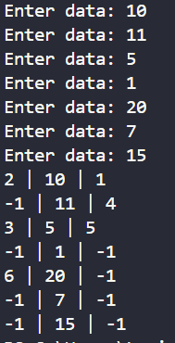

Question 3
Part 3(a)
NumberArray = [100, 85, 644, 22 , 15 , 8, 1]

Part 3(b)(i)
def RecursiveInsertion(IntegerArray: list, NumberElements: int) -> list:
if NumberElements <= 1:
return IntegerArray

else:

RecursiveInsertion(IntegerArray, NumberElements - 1)
LastItem = IntegerArray[NumberElements - 1]
CheckItem = NumberElements - 2

LoopAgain = True

if CheckItem < 0:
LoopAgain = False
else:
if IntegerArray[CheckItem] < LastItem:
LoopAgain = False

while LoopAgain:
IntegerArray[CheckItem + 1] = IntegerArray[CheckItem]
CheckItem -= 1
if CheckItem < 0:
LoopAgain = False
else:
if IntegerArray[CheckItem] < LastItem:
LoopAgain = False

IntegerArray[CheckItem + 1] = LastItem
return IntegerArray

Part 3(b)(ii)
print("Recursive")
print(RecursiveInsertion(NumberArray, len(NumberArray) ))

Part 3(b)(iii)
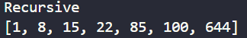

Part 3(c)(i)
def IterativeInsertion(IntegerArray: list, NumberElements: int) -> list:
if NumberElements <= 1:
return IntegerArray

for i in range(1, NumberElements):

LastItem = IntegerArray[i]
CheckItem = i - 1
LoopAgain = True

if CheckItem < 0:
LoopAgain = False
else:
if IntegerArray[CheckItem] < LastItem:
LoopAgain = False

while LoopAgain:

IntegerArray[CheckItem + 1] = IntegerArray[CheckItem]
CheckItem -= 1
if CheckItem < 0:
LoopAgain = False
else:
if IntegerArray[CheckItem] < LastItem:
LoopAgain = False

IntegerArray[CheckItem + 1] = LastItem

return IntegerArray

Part 3(c)(ii)
print("iterative")
print(IterativeInsertion(NumberArray, len(NumberArray) ))

Part 3(c)(iii)
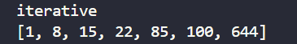

Part 3(d)(i)
def BinarySearch(IntegerArray: list, First: int, Last: int, ToFind: int) -> int:
Mid = (First + Last) //2
if First > Last:
return -1
if IntegerArray[Mid] == ToFind:
return Mid
if IntegerArray[Mid] < ToFind:
return BinarySearch(IntegerArray, Mid + 1, Last, ToFind)
return BinarySearch(IntegerArray, First, Mid - 1, ToFind)

Part 3(d)(ii)
i = BinarySearch(NumberArray, 0, len(NumberArray) - 1, 644)
if i != -1:
print(f"Found at index {i}")
else:
print("Not found")

Part 3(d)(iii)

