Insert your name, centre number and candidate number into the header above.
Save this evidence document as evidence_ followed by your centre number_ candidate number. For example: evidence_ zz999_9999.doc
Screenshots or program listings must be copied into appropriate cells in the following tables.
Examiners must be able to read the contents including any screenshots without the use of a magnifying glass. Answers that are not readable or missing will not be awarded any marks.
Save this evidence document at regular intervals, for example every 10 minutes.
Question 1
Part 1(a)(i)
class Bird:
def __init__(self, DistancePerHour: float, Species: str):
self.DistancePerHour = DistancePerHour
self.Species = Species #STRING
self.XPosition = 500.0 #REAL
self.YPosition = 500.0 #REAL

Part 1(a)(ii)
def GetSpecies(self):
return self.Species

Part 1(a)(iii)
def GetPosition(self):
return f"X = {self.XPosition} Y = {self.YPosition}"

Part 1(a)(iv)
def Move(self, dir: str, time: int):
DistanceTravelled = (self.DistancePerHour/60)*time
match dir:
case 'N':
self.YPosition += DistanceTravelled
case 'S':
self.YPosition -= DistanceTravelled
case 'E':
self.XPosition += DistanceTravelled
case 'W':
self.YPosition -= DistanceTravelled

Part 1(b)
Bird1 = Bird(71.0, "Cockatiel")
Bird2 = Bird(56.0, "Macaw")

Part 1(c)(i)
Bird1.GetSpecies()
Bird1.GetPosition()
Bird2.GetSpecies()
Bird2.GetPosition()
while True:
chosen = int(input("Please select a bird to move: "))
if chosen == 1 or chosen == 2:
break
while True:
dir = str(input("Please enter the direction of travel: "))
match dir:
case 'W' | 'E' | 'N' | 'S': break
while True:
time = int(input("Please enter the time of travel to the nearest minute: "))
if time <= 500 and time >= 0:
break
if chosen == 1:
Bird1.Move(dir, time)
print(Bird1.GetPosition())
else:
Bird2. Move(dir, time)
print(Bird2.GetPosition())

Part 1(c)(ii)
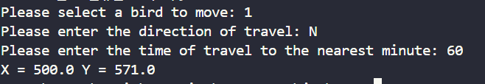

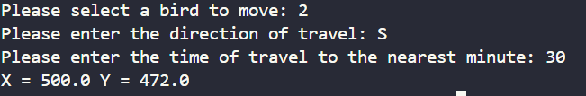

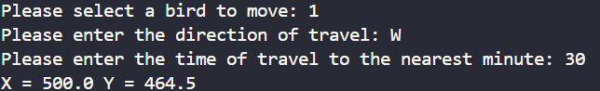

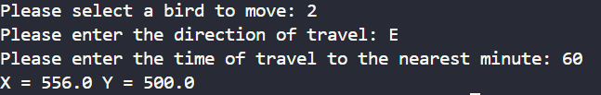

Question 2
Part 2(a)
import random

randomarr = [None for _ in range(20)]
for i in range(20):
while True:
x = random.randint(0, 100)
if x not in randomarr:
randomarr[i] = x
break

Part 2(b)
def PrintArray(intarr: int): #intarr is an array of type integer
line = "" #string
for i in range(20):
line += str(intarr[i]) + " "
print(line)

Part 2(c)
def BubbleSort(intarr: int) -> int:
#intarr is an array of type integer
#returns an array of type integer
#top, bot integer
top = len(intarr) - 1
bot = 0
for _ in range(len(intarr)-1):
for j in range(bot, top):
if intarr[j] > intarr[j+1]:
intarr[j] , intarr[j+1] = intarr[j+1], intarr[j]
top -= 1

return intarr

Part 2(d)(i)
PrintArray(randomarr)
print("Sorted")
print(BubbleSort(randomarr))

Part 2(d)(ii)

Part 2(e)
def RecursiveBinarySearch(intarr: int, lb : int, ub: int, val: int):
mid = (lb + ub) //2 #int
found = False #boolean
if lb > ub:
return -1
if val == intarr[mid]:
return mid
elif val > intarr[mid]:
return RecursiveBinarySearch(intarr, mid+1, ub, val)
else:
return RecursiveBinarySearch(intarr, lb, mid-1, val)

Part 2(f)(i)
se = int(input("Please enter an integer: "))
i = RecursiveBinarySearch(randomarr, 0, 19, se)
if i == -1:
print("Not found")
else:
print(f"Found at position {i+1}")

Part 2(f)(ii)
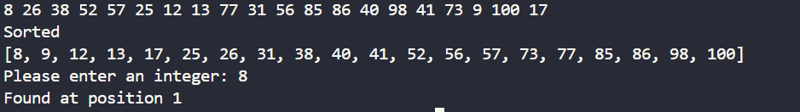

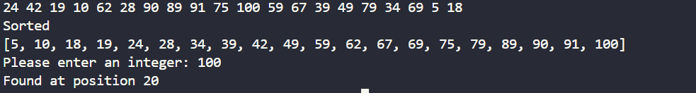
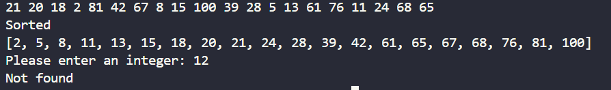

Question 3
Part 3(a)
TreeArray = [[-1 for _ in range(3)] for _ in range(50)]
#2D Array of 50 rows 3 cols of type integer
RootPointer = -1 #int
FreeNode = 0 #int

Part 3(b)
def AddNode(x: int):
global FreeNode
global RootPointer
if FreeNode != -1:
TreeArray[FreeNode][1] = x
if RootPointer == -1:
RootPointer = FreeNode
FreeNode += 1
else:
CurrentNode = RootPointer
while True:
if x < TreeArray[CurrentNode][1]:
if TreeArray[CurrentNode][0] == -1:
TreeArray[CurrentNode][0] = FreeNode
FreeNode += 1
break
else:
CurrentNode = TreeArray[CurrentNode][0]

else:
if TreeArray[CurrentNode][2] == -1:
TreeArray[CurrentNode][2] = FreeNode
FreeNode += 1
break
else:
CurrentNode = TreeArray[CurrentNode][2]
else:
print("The tree is full")

Part 3(c)
try:
file = open("TreeData.txt", 'r')
for line in file:
AddNode(int(line.rstrip('\n')))

file.close()

except FileNotFoundError:
print(f"File not found")

Part 3(d)
def WriteAllToFile():
try:
file = open("Tree.txt", 'w')
for i in range(50):
line = str(TreeArray[i][0]) + "," + str(TreeArray[i][1]) + "," + str(TreeArray[i][2])
file.write(line)
file.write("\n")

file.close()

except IOError:
print("Error")

Part 3(e)(i)
WriteAllToFile()

Part 3(e)(ii)
