SYSTEM DESIGN ARCHITECTURE: SATURN_AI

4.1 MODULE DESCRIPTION

5. IMPLEMENTATION
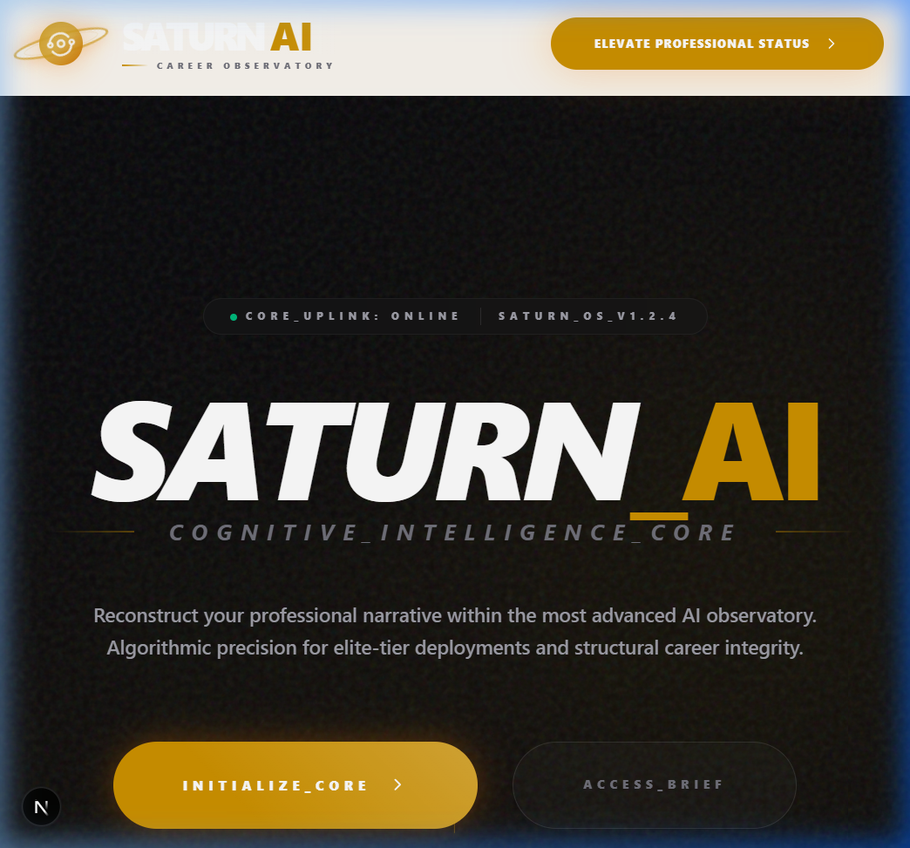

6. SOFTWARE TESTING

7. CONCLUSION

8. BIBLIOGRAPHY

8.1 TECHNICAL DOCUMENTATION
- • Next.js Official Documentation: https://nextjs.org/docs
- • React Documentation: https://react.dev
- • Tailwind CSS v4 Specification: https://tailwindcss.com
- • Prisma ORM Reference: https://prisma.io/docs
- • Firebase Admin SDK Documentation: https://firebase.google.com/docs/admin
- • OpenRouter API Specification: https://openrouter.ai/docs

8.2 RESEARCH & STANDARDS
- • ATS Parsing Standards: Modern Applicant Tracking System matching algorithms.
- • JSON Resume Schema: https://jsonresume.org

